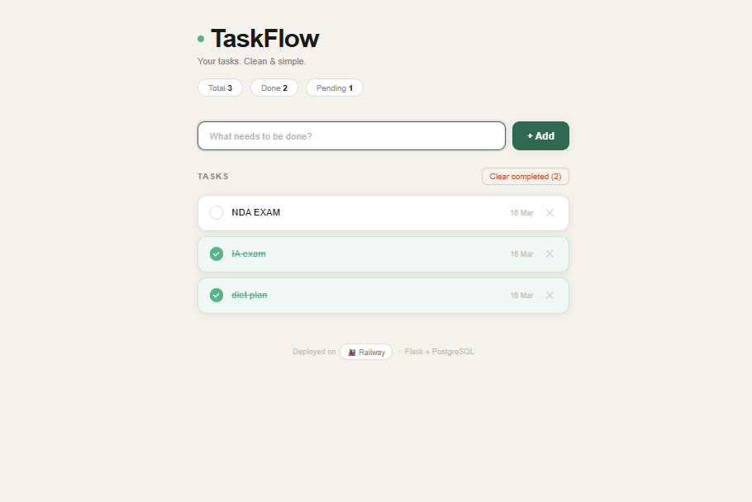

Deploying a Flask Todo List Application on Railway (Full Procedure)

1. Project Overview
This project is a simple Todo List Web Application built using Flask (Python) and PostgreSQL database.
The application allows users to:
- Add a task
- Mark task as completed
- Delete tasks
- Store tasks in a PostgreSQL database
The project is deployed on the Railway cloud platform.

2. Technologies Used
Technology | Purpose
Python | Backend programming language
Flask | Web framework
PostgreSQL | Database
psycopg2 | PostgreSQL connector for Python
Gunicorn | Production server
Railway | Cloud deployment platform
GitHub | Version control & deployment source

3. Project Folder Structure
todo_list/
│
├── app.py
├── requirements.txt
├── Procfile
├── railway.toml
├── .gitignore
├── README.md
│
└── templates/
└── index.html

File Purpose
File | Description
app.py | Main Flask application
requirements.txt | Python dependencies
Procfile | Command to start the server
railway.toml | Railway configuration
templates/index.html | Frontend UI
.gitignore | Prevents unnecessary files from uploading

4. Setting Up the Project in VS Code

Step 1: Open Project Folder
Open the project folder in Visual Studio Code.
File → Open Folder → Select todo_list

Step 2: Create Virtual Environment
Open terminal in VS Code and run:
python -m venv venv

Step 3: Activate Virtual Environment

Windows
venv\Scripts\activate
Terminal will show:
(venv) PS C:\Users\User\todo_list>

Step 4: Install Required Packages
pip install -r requirements.txt
Example dependencies:
flask
psycopg2-binary
gunicorn

5. Running the Project Locally
Before deploying, run the application locally.
python app.py
Server output:
Running on http://127.0.0.1:5000
Open browser:
http://127.0.0.1:5000

6. Creating GitHub Repository

Step 1: Create Repo on GitHub
Go to:
https://github.com
Create repository:
todo-list

Step 2: Push Project to GitHub
Run these commands in terminal:
git init
git add .
git commit -m "first commit"
git branch -M main
git remote add origin https://github.com/YOUR_USERNAME/todo-list.git
git push -u origin main

7. Fixing Git Issues
The venv folder should not be uploaded to GitHub.
Remove it using:
git rm -r --cached venv/
Make sure .gitignore contains:
venv/
__pycache__/
Push changes again:
git add .
git commit -m "fix project structure"
git push

8. Deploying on Railway

Step 1: Open Railway
Go to:
https://railway.app
Login using GitHub account.

Step 2: Create New Project
Click:
New Project
Select:
Deploy from GitHub Repository
Choose repository:
todo-list
Railway will start building the application automatically.

9. Adding PostgreSQL Database
After deployment:
- Click + New
- Select Database
- Choose PostgreSQL
Railway will create the database service.

10. Connecting Database to Web App

Step 1
Click the web service.

Step 2
Open the Variables tab.

Step 3
Click:
Add Variable
Select:
DATABASE_URL
Railway automatically links the PostgreSQL database.

11. Generating Public Domain
To access the application online:
- Click Web Service
- Open Settings
- Scroll to Networking
- Click
Generate Domain
Example URL:
https://todo-list-production.up.railway.app

12. Application Deployment Result
After successful deployment:
- Flask application runs on Railway servers
- PostgreSQL stores todo tasks
- Public domain allows internet access
Users can:
- Add tasks
- Mark tasks as completed
- Delete tasks
All data is stored in the PostgreSQL cloud database.

13. Conclusion
The Todo List project demonstrates how to:
- Develop a web application using Flask
- Connect to PostgreSQL database
- Use GitHub for version control
- Deploy applications using Railway cloud platform
Railway simplifies deployment by automatically building the project, installing dependencies, and hosting the application online.
This approach is suitable for small web applications, APIs, and backend services.

