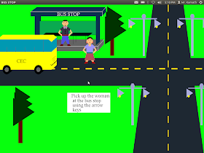

Fig: In this picture shows the girl waiting for a bus .

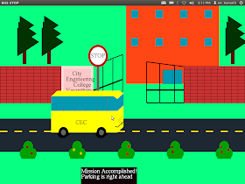

Fig: this picture shows as soon as bur arrive the girl is get the bus and reach the college.