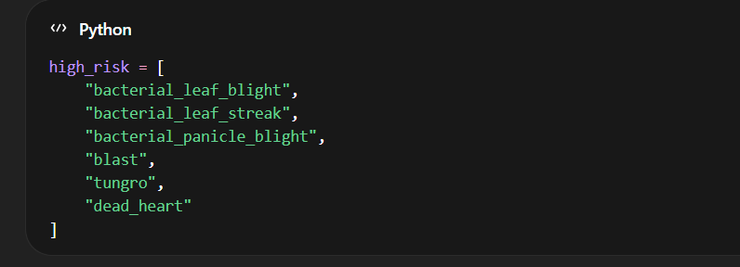
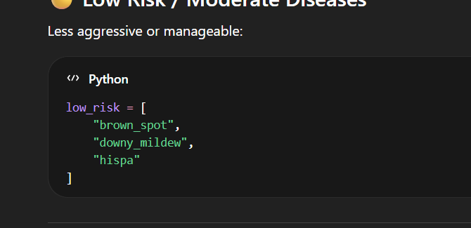
High - Risk
1)"bacterial_leaf_blight"
Kasugamycin
Quantity
Kasugamycin → 2.5 ml / liter
⏰ WHEN to spray
- At first yellowing/wilting symptoms
- Repeat after 7–10 days
- Best stage: tillering to early booting
🌦️ Weather trigger
- High humidity + standing water
- Temp: 25–35°C
🚿 HOW to spray
- Use knapsack sprayer
- Spray in fine mist
- Cover:
  - Upper + lower leaf surface
- Focus on infected patches first
2) bacterial_leaf_streak"
Best Treatment
- Copper Hydroxide (better than oxychloride here)
📏 Dose
Copper Hydroxide → 2 g / liter
⏰ WHEN
- As soon as thin streaks appear
- Repeat every 7 days
🌦️ Weather
- Rainy + windy spreads fast
🚿 HOW
- Spray preventively around nearby plants too
- Keep low pressure spray
- Avoid runoff (don’t drench)

3)"bacterial_panicle_blight"
Oxolinic Acid
Dose
Oxolinic Acid → 1 ml / liter

4)"blast" –
Fungicide
- Tricyclazole 75% WP
📏 Quantity
0.6 g per liter water
🚿 Spray timing
- At first symptom
- Repeat every 10–14 days
🌦️ Conditions
- High humidity = danger zone
- Spray before rain, not after

5)"tungro" –
Control vector (insects)
- Imidacloprid 17.8% SL
📏 Quantity
0.3 ml per liter water
🚿 Spray
- Focus on base + leaves
- Repeat after 7 days
⚠️ Important
- Remove infected plants immediately

5)"dead_heart" –
Insecticide Chlorantraniliprole 18.5% SC
📏 Quantity 0.4 ml per liter water 🚿
Spray Target stem base area

Low – Risk
"brown_spot" -
"downy_mildew" -
"hispa" –

High Risk
high_risk_management = {
"bacterial_leaf_blight": {
"pesticide": "Kasugamycin 3% SL + Copper Oxychloride",
"quantity": "Kasugamycin 2.5 ml/L + Copper Oxychloride 2.5 g/L",
"when_to_spray": [
"At first yellowing/wilting symptoms",
"Repeat every 7–10 days",
"Best stage: tillering to booting"
],
"how_to_spray": [
"Fine mist spray using knapsack sprayer",
"Cover both sides of leaves",
"Focus on infected areas first"
],
"weather_condition": [
"Temperature: 25–35°C",
"Avoid rain within 6 hours",
"High humidity favors disease → spray early"
]
},
"bacterial_leaf_streak": {
"pesticide": "Copper Hydroxide",
"quantity": "2 g/L water",
"when_to_spray": [
"At first appearance of streaks",
"Repeat every 7 days"
],
"how_to_spray": [
"Light spray (avoid runoff)",
"Cover surrounding plants preventively"
],
"weather_condition": [
"Avoid spraying during rain/wind",
"Best in dry, calm conditions"
]
},
"bacterial_panicle_blight": {
"pesticide": "Oxolinic Acid or Kasugamycin",
"quantity": "1 ml/L (Oxolinic Acid)",
"when_to_spray": [
"Booting stage",
"Flowering stage (critical)"
],
"how_to_spray": [
"Target panicles directly",
"Uniform spray across field"
],
"weather_condition": [
"Warm humid weather increases risk",
"Spray before rain, not after"
] },
"blast": {
"pesticide": "Tricyclazole 75% WP",
"quantity": "0.6 g/L water",
"when_to_spray": [
"At first leaf spots",
"Repeat every 10–14 days",
"Critical: tillering & booting stage"
],
"how_to_spray": [
"Uniform full-field spray",
"Ensure even leaf coverage"
],
"weather_condition": [
"Temp: 20–30°C",
"High humidity/cloudy = high risk",
"Avoid rain"
]
},
"tungro": {
"pesticide": "Imidacloprid 17.8% SL",
"quantity": "0.3 ml/L water",
"when_to_spray": [
"When leafhoppers appear",
"Early stage (15–30 days after planting)"
],
"how_to_spray": [
"Spray base and underside of leaves",
"Remove infected plants immediately"
],
"weather_condition": [
"Warm humid conditions",
"Spray in calm weather"
]
},

"dead_heart": {
"pesticide": "Chlorantraniliprole 18.5% SC",
"quantity": "0.4 ml/L water",
"when_to_spray": [
"When central shoot dries (dead heart symptom)"
],
"how_to_spray": [
"Target base of plant",
"Can apply in standing water (granules optional)"
],
"weather_condition": [
"Warm temperature favors pests",
"Avoid rain during spray"
]
}
}
Low Risk
low_risk_management = {
"brown_spot": {
"bio_solution": "Neem Leaf Extract Spray",
"preparation": [
"Take 1 kg neem leaves",
"Grind with 5 L water",
"Filter and dilute to 10 L"
],
"when_to_spray": [
"At early spotting stage",
"Repeat every 7–10 days"
],
"how_to_spray": [
"Uniform spray on leaves",
"Focus on older leaves"
],
"weather_condition": [
"Spray morning/evening",
"Avoid rain"
]
},

"downy_mildew": {
"bio_solution": "Fermented Buttermilk Spray",
"preparation": [
"Take 1 L sour buttermilk",
"Mix with 5 L water",
"Ferment for 1–2 days"
],
"when_to_spray": [
"Early infection stage",
"Spray in early morning"
],
"how_to_spray": [
"Spray underside of leaves",
"Use light mist"
],
"weather_condition": [
"Cool humid conditions",
"Avoid direct sunlight"
]
},

"hispa": {
"bio_solution": "Garlic + Chili Extract Spray",
"preparation": [
"Grind 100 g garlic + 50 g chili",
"Mix in 5 L water",
"Add few drops of liquid soap"
],
"when_to_spray": [
"At first leaf scraping signs",
"Repeat weekly"
],
"how_to_spray": [
"Spray directly on insects",
"Cover leaf surfaces"
],
"weather_condition": [
"Spray in calm weather",
"Avoid rain"
]
}
}

