Prepare the lab file (lab_file.pdf) with the following content:
1. Introduction:
1. What is Git?
Git is a free, open-source distributed version control system that helps developers track changes, collaborate on code, and manage multiple versions of projects efficiently. It was originally created by Linus Torvalds in 2005 and is now the most widely used version control tool worldwide.
● Define Git as a version control system
Git is a distributed version control system (VCS) that records changes to files, especially source code, enabling developers to track history, collaborate, and revert to earlier versions when needed. It is the most widely used VCS in modern software development
● Explain its purpose (tracking changes, collaboration, etc.)
Tracking Changes:
- Git records every modification made to files in a project.
- Developers can see who changed what, when, and why.
- It allows rolling back to earlier versions if something breaks.
Collaboration:
- Multiple developers can work on the same project without overwriting each other’s work.
- Git’s branching and merging system lets teams experiment independently and then integrate their work.
- It supports distributed workflows, meaning everyone has a full copy of the project history.
Reliability & Redundancy:
- Because Git is distributed, every developer’s machine contains a full copy of the repository.
- This eliminates a single point of failure—if the central server goes down, the project is still safe.
2. What is Version Control?
Version control is a system that manages changes to files over time, allowing you to record, track, and organize modifications. It’s most commonly used in software development to handle source code, but it can apply to any set of files that evolve over time.
● Explain the concept of version control
The concept of version control is about managing the evolution of files and projects over time. Think of it as a system that acts like a history keeper and collaboration manager for your work.
Core Idea:
Version control records every change made to a file (or set of files), so you can:
- Track history: See what changed, when, and by whom.
- Restore past versions: Roll back if something breaks.
- Work together: Multiple people can edit the same project without overwriting each other’s work.
How It Works:
- Repository: A storage space where all files and their history live.
- Commits: Snapshots of the project at a given point in time.
- Branches: Parallel lines of development where new features or experiments can happen safely.
- Merging: Combining changes from different branches into one unified version
● Importance in software development
The importance of version control in software development is enormous.
Preserving Project History:
- Every commit acts like a snapshot of the project at that moment.
- This history is invaluable for auditing, learning from past decisions, and understanding how the project evolved.
- You can roll back to earlier versions if something breaks.
Supporting Experimentation:
- Developers can create branches to test new ideas without affecting the main codebase.
- If the experiment fails, the branch can be discarded safely.
- If successful, it can be merged back into the main project

3. What is GitHub?
GitHub is a cloud-based platform built on top of Git that hosts repositories, enables collaboration, and provides tools for managing software projects. It’s widely used by developers to share code, track changes, and work together remotely.
● Define GitHub as a platform for hosting repositories
- GitHub provides a centralized online space where developers can upload their Git repositories.
- It builds on Git’s version control system by adding collaboration tools, project management features, and community sharing
● Mention its role in collaboration
Key Roles in Collaboration:
- Shared Repository Hosting: Teams can store their code in one central place, accessible to all members.
- Pull Requests: Developers propose changes, and teammates can review, discuss, and approve them before merging into the main project.
- Code Reviews: Built-in review tools allow comments, suggestions, and approvals, ensuring quality and consistency.
- Issue Tracking: Teams can log bugs, feature requests, and tasks, keeping everyone aligned on priorities.

4. Difference Between Git and GitHub .Write at least 3–5 clear differences .
Aspect | Git | GitHub
Definition | A distributed version control system (VCS) used to track changes in code. | A cloud-based platform that hosts Git repositories and adds collaboration tools.
Functionality | Manages code history, branching, merging, and version tracking locally. | Provides online repository hosting, pull requests, issue tracking, and project management.
Usage | Works offline; developers can commit and manage code on their own machines. | Requires internet access to share repositories and collaborate with others.
Collaboration | Collaboration requires manual sharing of repositories (e.g., via email or file transfer). | Built-in collaboration features like code reviews, discussions, and team management.
Scope | Focused purely on version control. | Extends Git with social coding, automation (GitHub Actions), and community contributions.
2. Basic Git Commands
● Include a list of all Git/Git Bash & vi Editor commands performed during the previous lab.
Git Configuration Commands
- git --version
- git config --global user.name "Your Name"
- git config --global user.email "email@gmail.com"
- git config user.name
- git config user.email
- git config --list
- git help
Navigation Commands
- pwd
- cd folder_name/location
File and Folder Listing Commands
- ls
- ls -l
- ls -a
- ls -d */
File Operations
- touch filename
- touch file1 file2 file3
- rm filename
Folder Operations
- mkdir folder_name
- mkdir folder1 folder2 folder3
- rmdir folder_name
- rm -r foldername
Viewing File Content
- cat filename
Writing Text to a File
- echo "text-content" > filename
- echo "text" >> filename
Writing Text Using cat
- cat > filename
- cat >> filename
Copy Content Between Files
- cat file1.txt > file2.txt
- Editing with Nano
- nano file.txt
  - Save: Ctrl+O
  - Exit: Ctrl+X
Editing with Vi/Vi
- git var GIT_EDITOR
- git config --global core.editor "vi"
- vi filename.txt
- Insert Mode commands:
  - i
  - I
  - a
  - A
  - o
  - O
  - Esc
Save & Quit in Vi
- :w
- :q
- :wq or :x
- :q!
Delete Commands in Vi
- x
- dd
- d$
- dθ
Copy & Paste in Vi
- y
- p
- P
● For every command, write an explanation of what it does.
Git Configuration
- git --version → Shows the installed Git version.
- git config --global user.name "Your Name" → Sets your Git username globally (applies to all repositories).
- git config --global user.email "email@gmail.com" → Sets your Git email globally.
- git config user.name → Displays the current username setting.
- git config user.email → Displays the current email setting.
- git config --list → Lists all Git configuration settings.
- git help → Opens Git help documentation.
Navigation Commands
- pwd → Prints the current working directory path.
- cd folder_name/location → Changes directory to the specified folder.
File and Folder Listing
- ls -l → Lists files with detailed info (permissions, size, date).
- ls -a → Lists all files including hidden ones.
- ls -d */ → Lists only directories.
- ls → Lists files and folders in the current directory.
File Operations
- touch filename → Creates an empty file.
- touch file1 file2 file3 → Creates multiple empty files at once.
- rm filename → Deletes a file.
Folder Operations
- mkdir folder_name → Creates a new folder.
- mkdir folder1 folder2 folder3 → Creates multiple folders at once.
- rmdir folder_name → Removes an empty folder.
- rm -r foldername → Removes a folder and its contents recursively.
Viewing File Content
- cat filename → Displays the contents of a file.
Writing Text to a File
- echo "text-content" > filename → Writes text to a file (overwrites if it exists).
- echo "text" >> filename → Appends text to a file without deleting existing content.
Writing Text Using cat
- cat > filename → Creates a file and lets you type content directly (save with Ctrl+D).
- cat >> filename → Appends typed content to an existing file (save with Ctrl+D).
Copy Content Between Files
- cat file1.txt > file2.txt → Copies content of file1 into file2 (overwrites file2).
Editing with Nano
- nano file.txt → Opens Nano editor for editing a file.
  - Ctrl+O → Save changes.
  - Ctrl+X → Exit Nano.
Editing with Vi/Vim
- git var GIT_EDITOR → Checks default editor.
- git config --global core.editor "vi" → Sets Vi as default editor.
- vi filename.txt → Opens file in Vi editor.
Insert Mode commands:
- i → Insert before cursor
- I → Insert at beginning of line
- a → Append after cursor
- A → Append at end of line
- o → New line below cursor
- O → New line above cursor
- Esc → Exit insert mode
Save & Quit in Vi
- :w → Save file
- :q → Quit editor
- :wq or :x → Save and quit
- :q! → Quit without saving
Delete Commands in Vi
- x → Delete character
- dd → Delete current line
- d$ → Delete from cursor to end of line
- dθ → Delete from cursor to start of line
Copy & Paste in Vi
- y → Yank (copy)

- p → Paste after cursor
- P → Paste before cursor
● After each command and its description, attach a relevant screenshot showing: Command execution in terminal (Git Bash) Output/result of the command
Git Configuration Commands
- git --version → Shows the installed Git version.
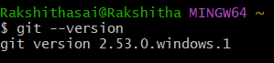
- git config --global user.name "Your Name" → Sets your name globally for all repositories.
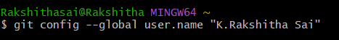
- git config --global user.email "email@gmail.com" → Sets your email globally for all repositories.
- git config user.name → Displays the username set for the current repository.
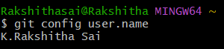
- git config user.email → Displays the email set for the current repository.
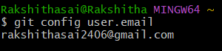

- git config --list → Lists all Git configuration settings.
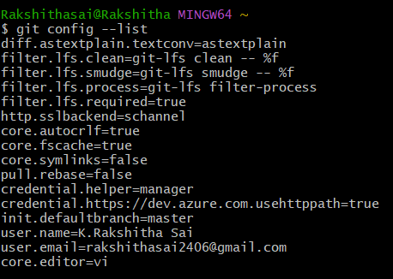
- git help → Opens Git help documentation.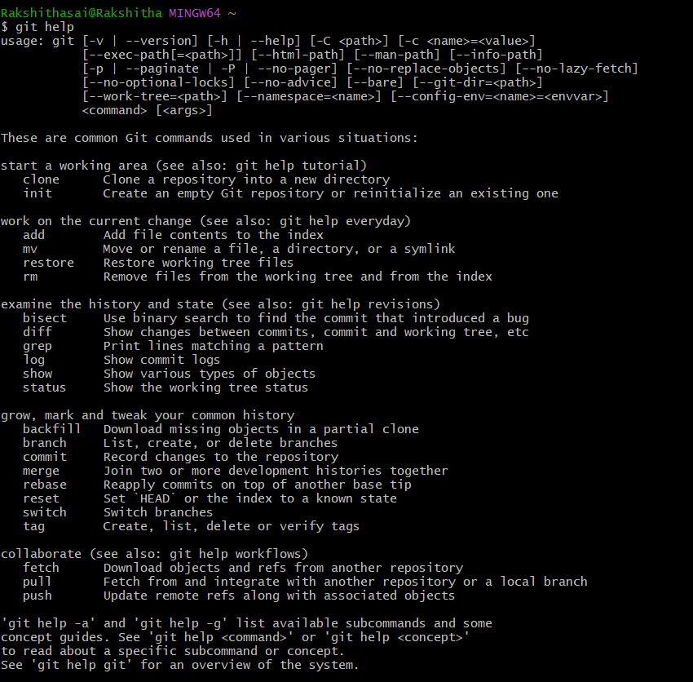
Navigation Commands
- pwd → Prints the current working directory path.
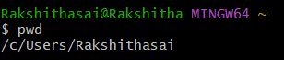
- cd folder_name/location → Changes directory to the specified folder.
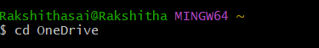

- cd folder_name/location → Changes directory to the specified folder.
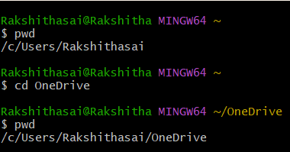

File and Folder Listing Commands
- ls → Lists files and folders in the current director
- ls -l → Lists files with detailed info (permissions, size, date).
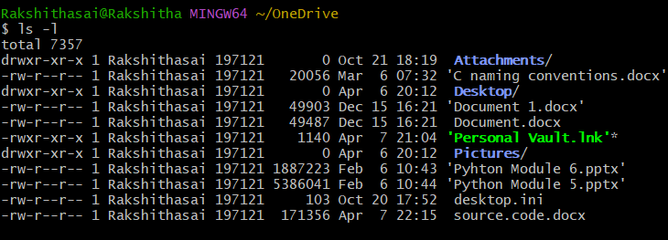
- ls -a → Lists all files including hidden ones.
- ls -d */ → Lists only directories.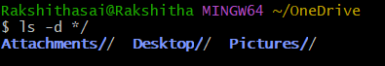

File Operations
- touch filename → Creates an empty file.
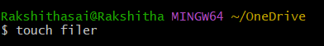
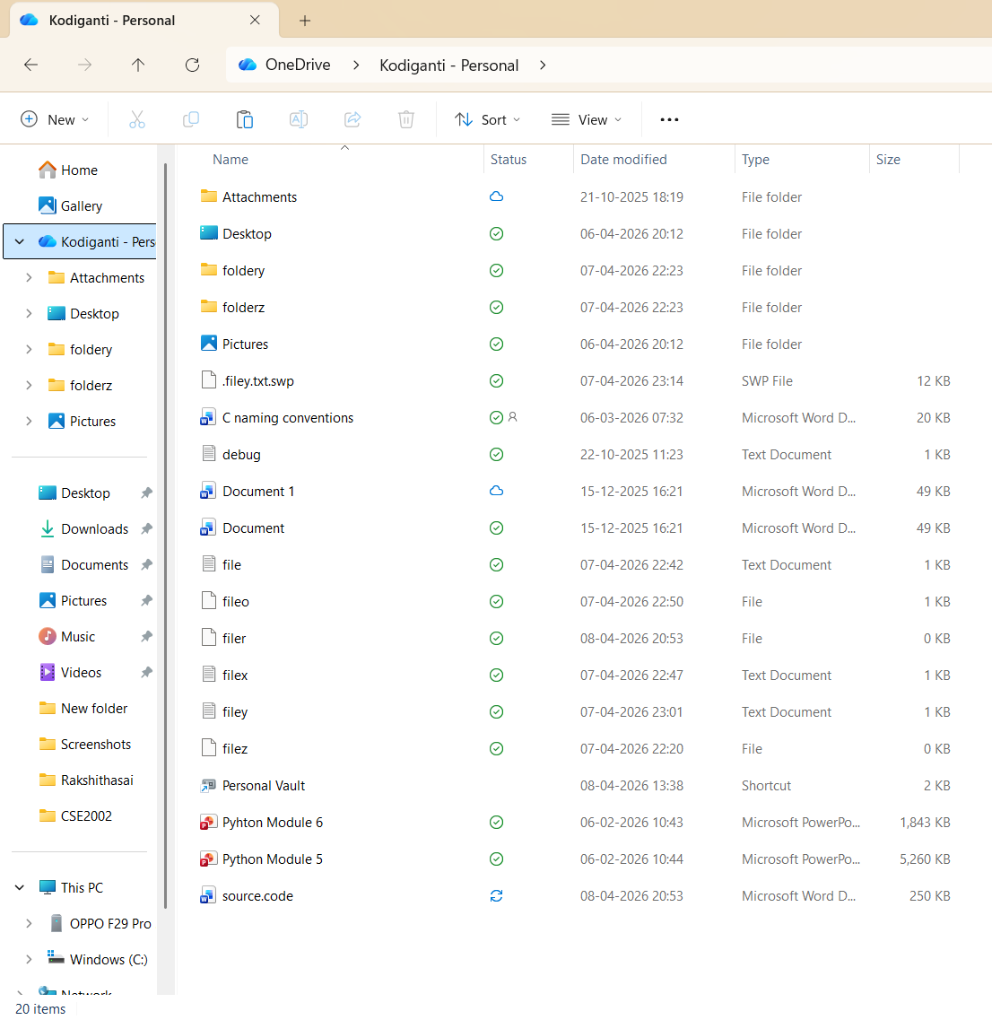
- touch file1 file2 file3 → Creates multiple empty files at once.
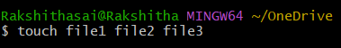
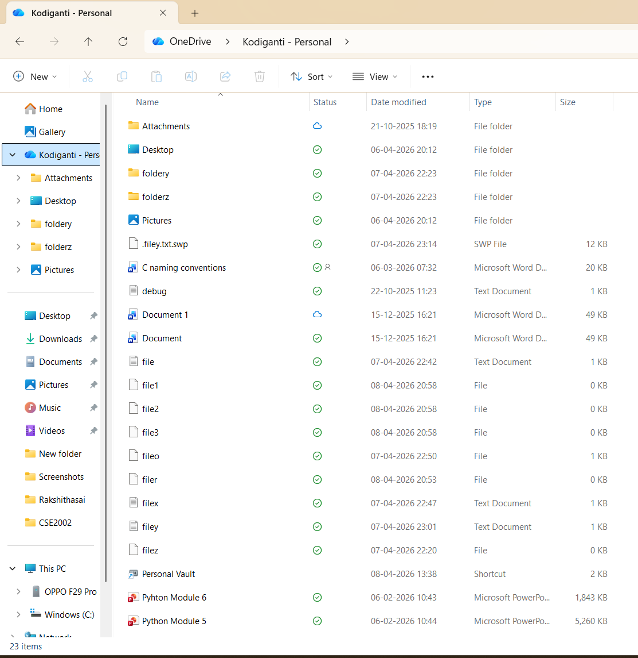
- rm filename → Deletes a file.
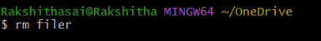
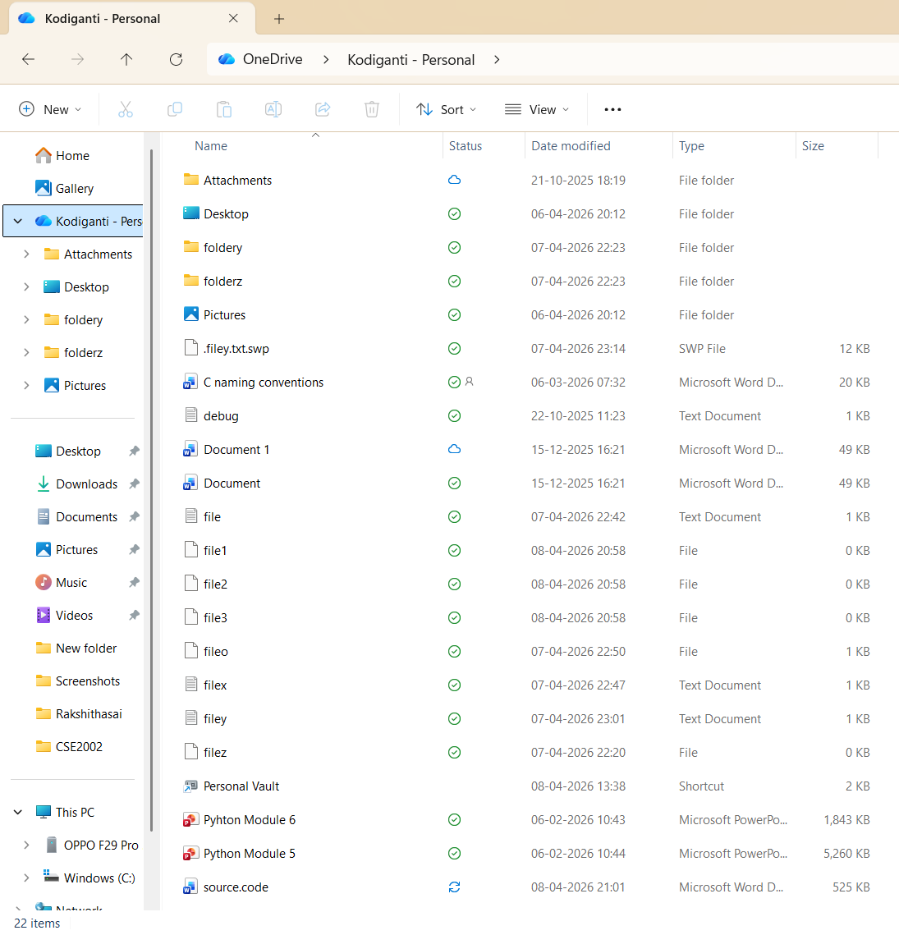
In the above image file “filer” is removed.
Folder Operations
- mkdir folder_name → Creates a new folder.
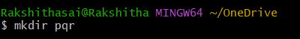
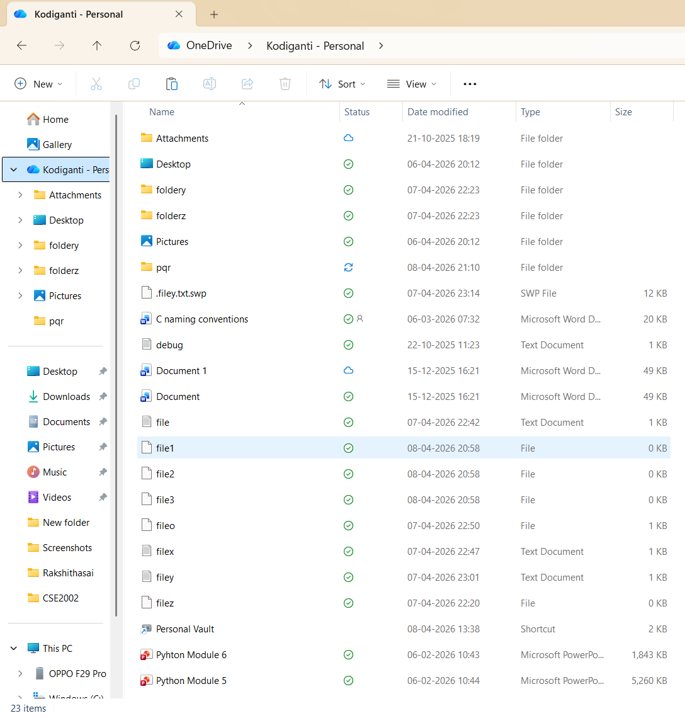
- mkdir folder1 folder2 folder3 → Creates multiple folders at once.
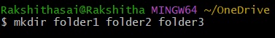
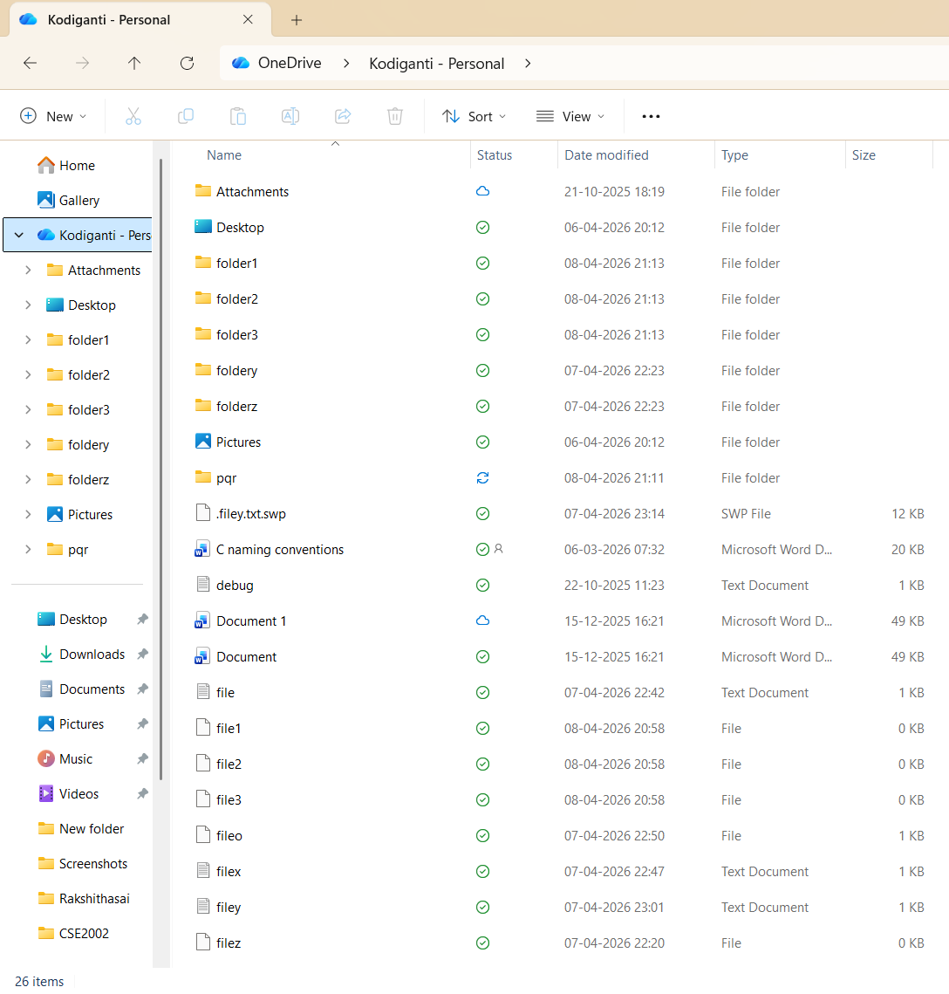

- rmdir folder_name → Removes an empty folder.
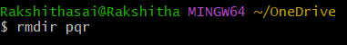
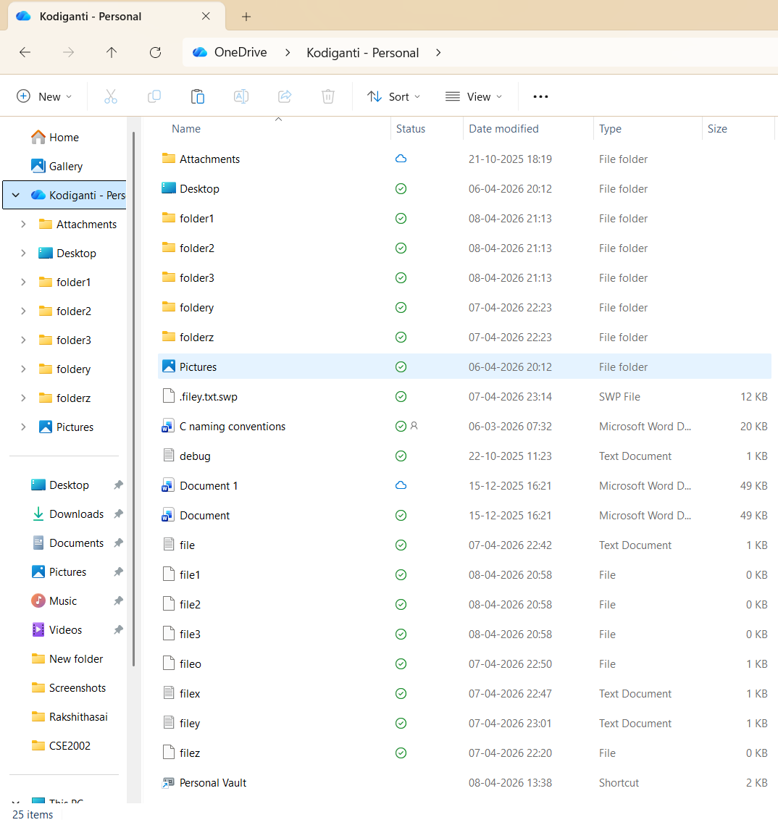
In the above image folder ”pqr” is removed.
- rm -r foldername → Removes a folder and its contents recursively.
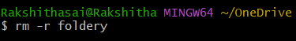
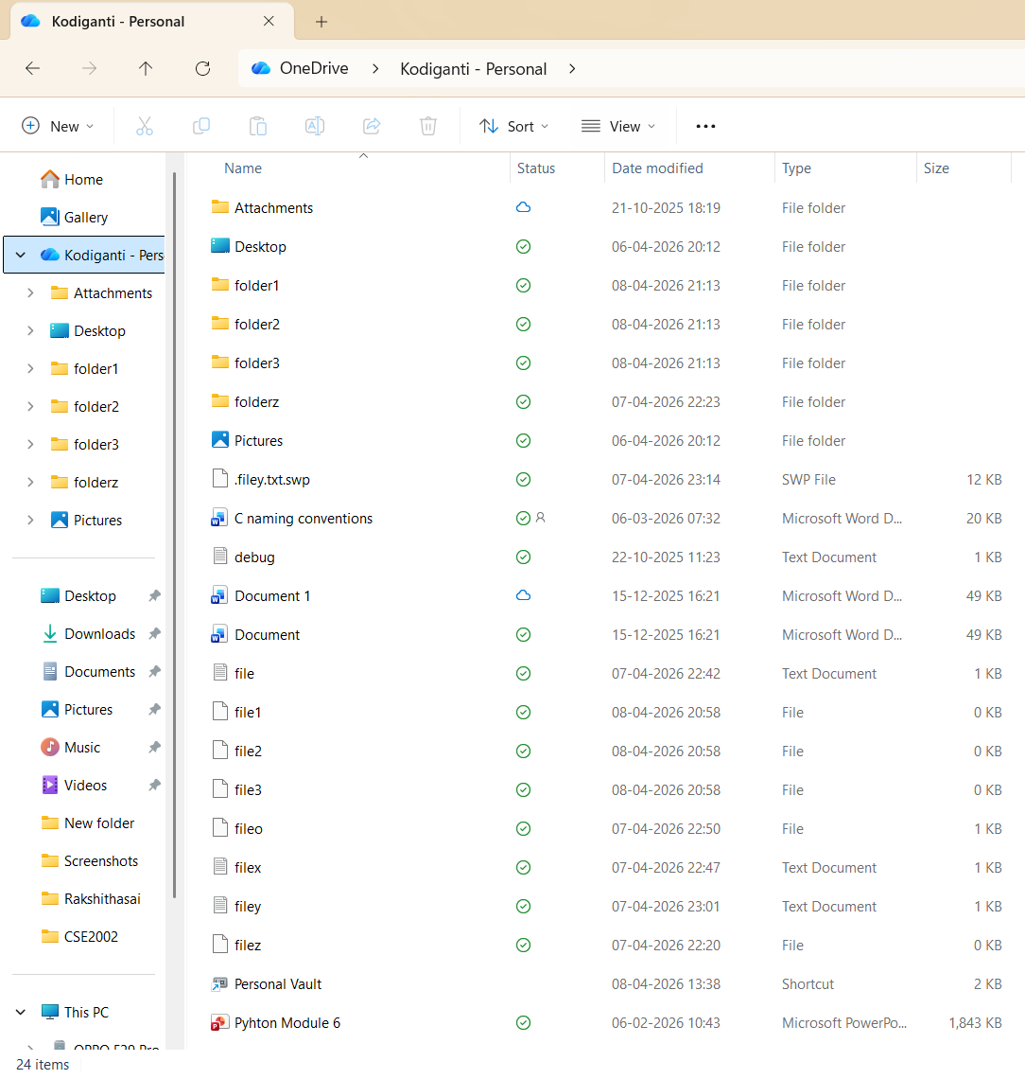
In the above image folder “foldery” is removed.
Viewing File Content
- cat filename → Displays contents of a file.
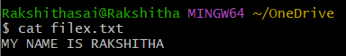
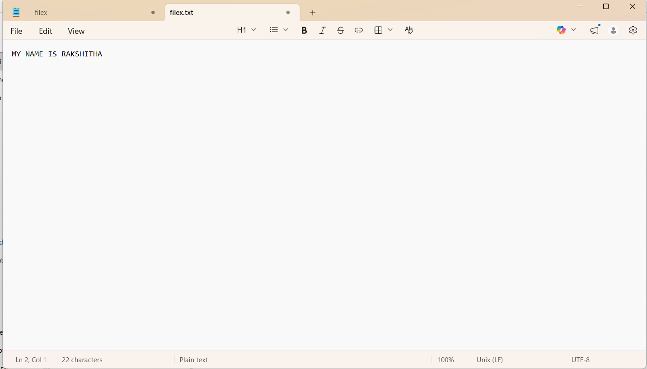
In the above image shows content of “filex”.

Writing Text to a File
- echo "text-content" > filename → Writes text to a file (overwrites if exists).
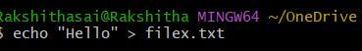
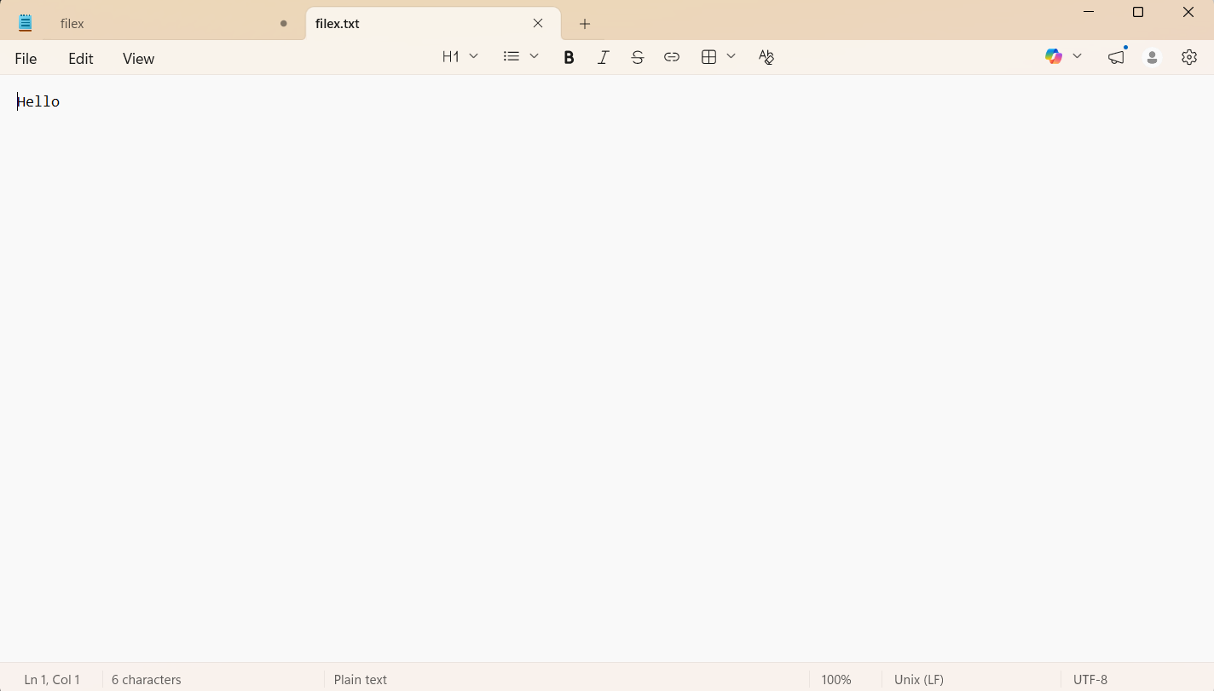

- echo "text" >> filename → Appends text to a file without deleting existing content.
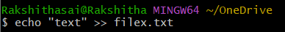
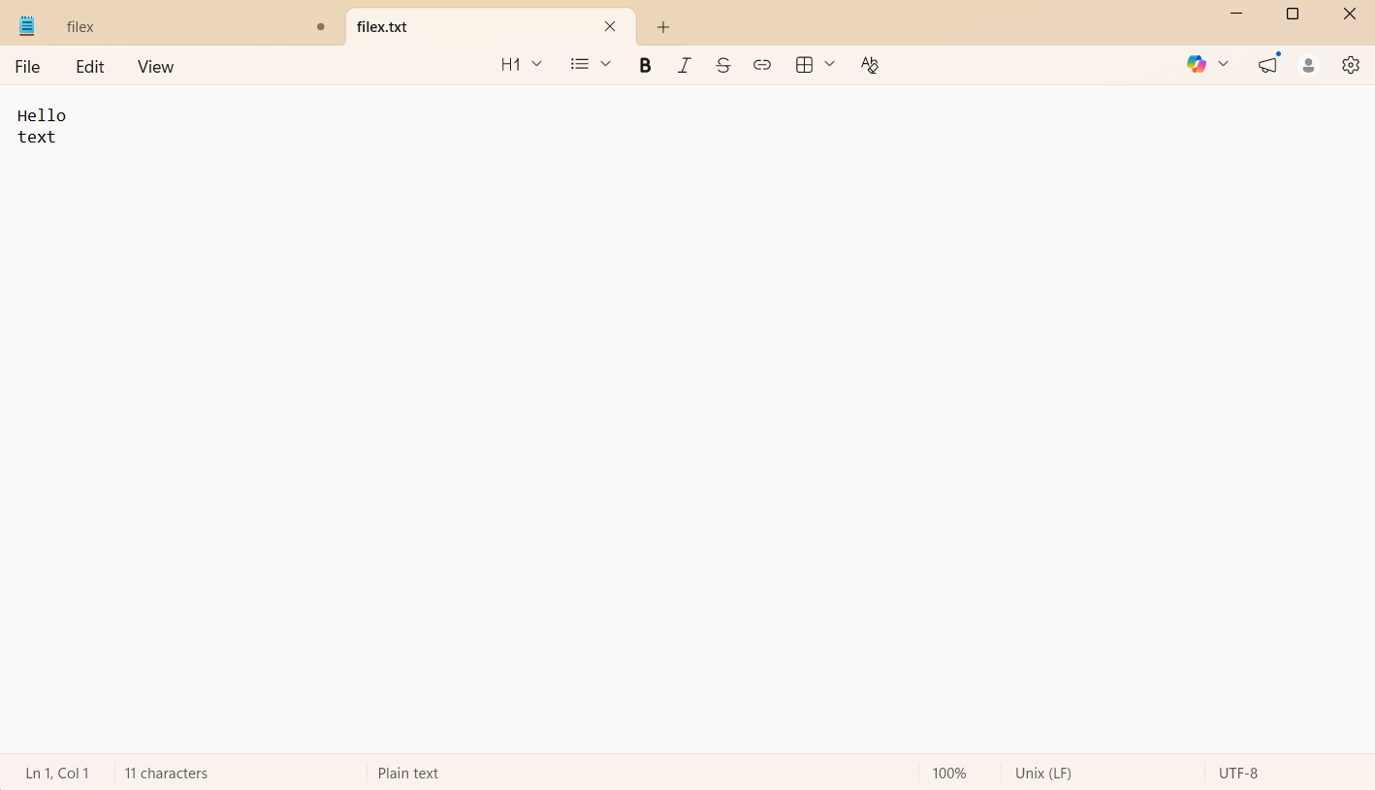

Writing Text Using cat
- cat > filename → Creates a file and lets you type text directly (save with Ctrl+D).
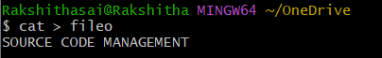
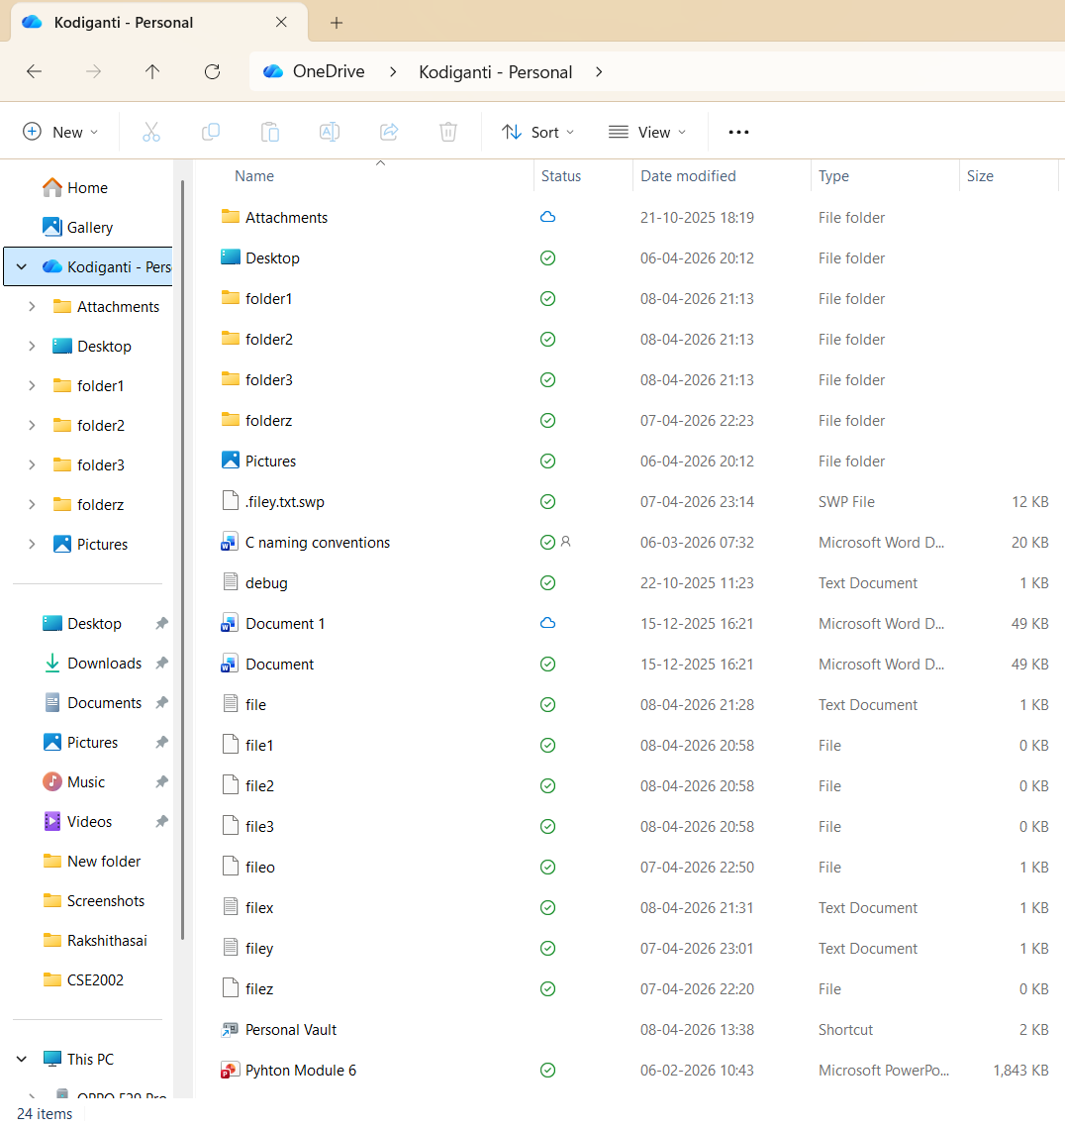
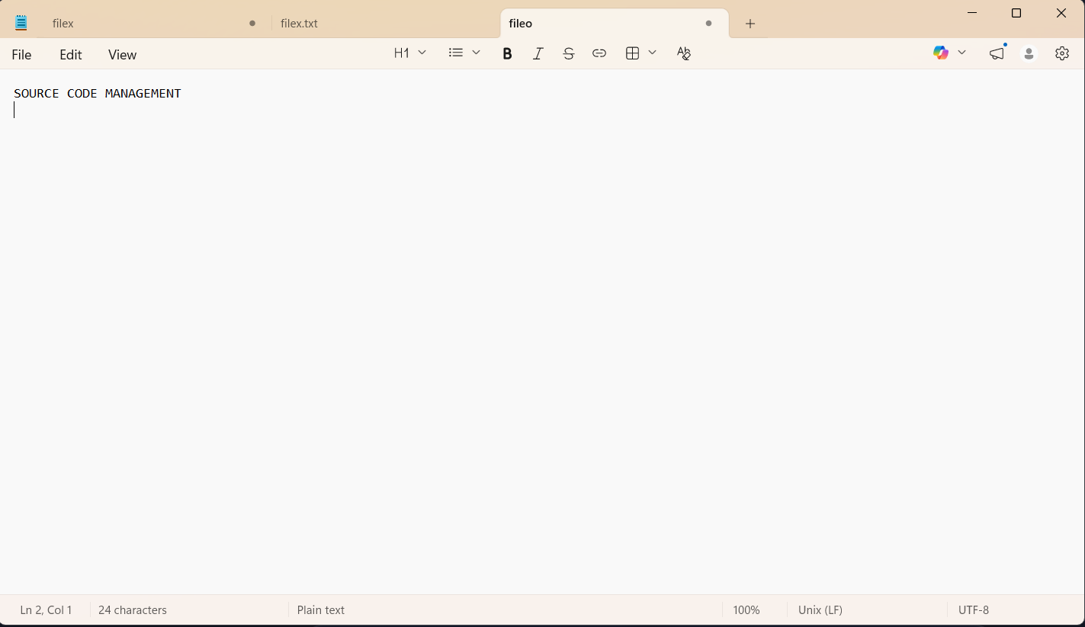
- cat >> filename → Appends text to an existing file (save with Ctrl+D).
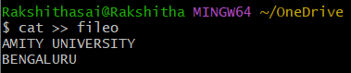
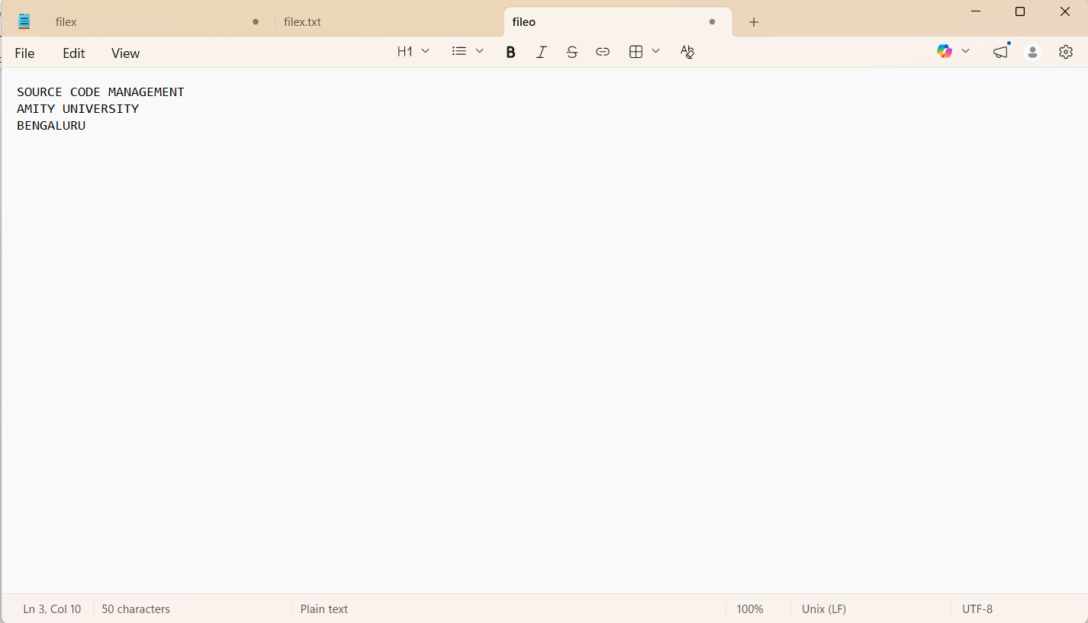

Copy Content Between Files
- cat file1.txt > file2.txt → Copies content of file1 into file2.
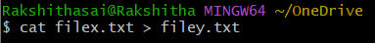

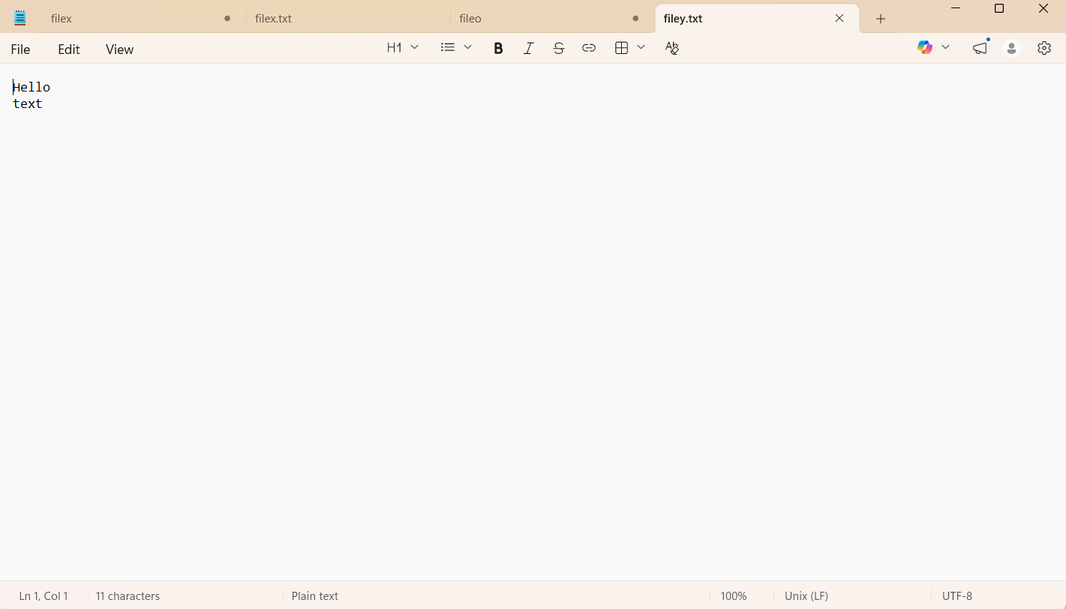
In the above two images we can observe that content of “filex.txt” is copied to “filey.txt”.

Editing with Nano
- nano file.txt → Opens Nano editor.
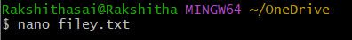
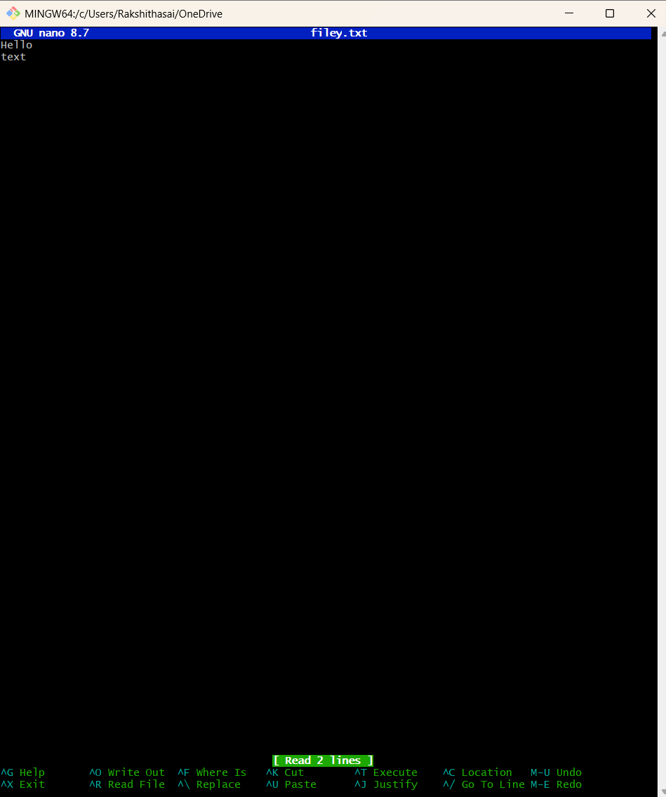

  - Save: Ctrl+O
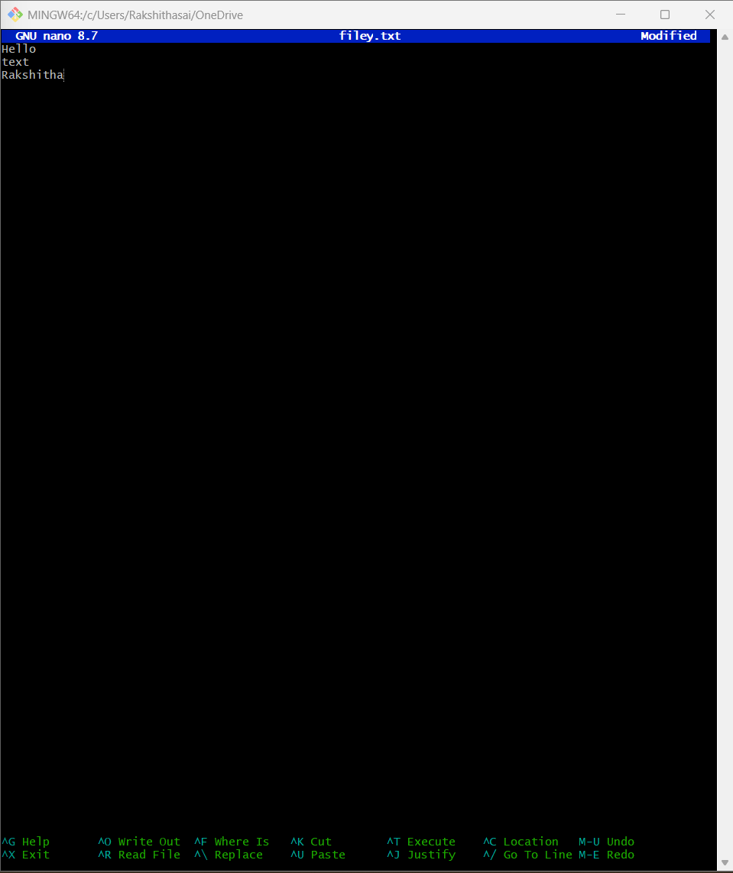

  - Exit: Ctrl+X
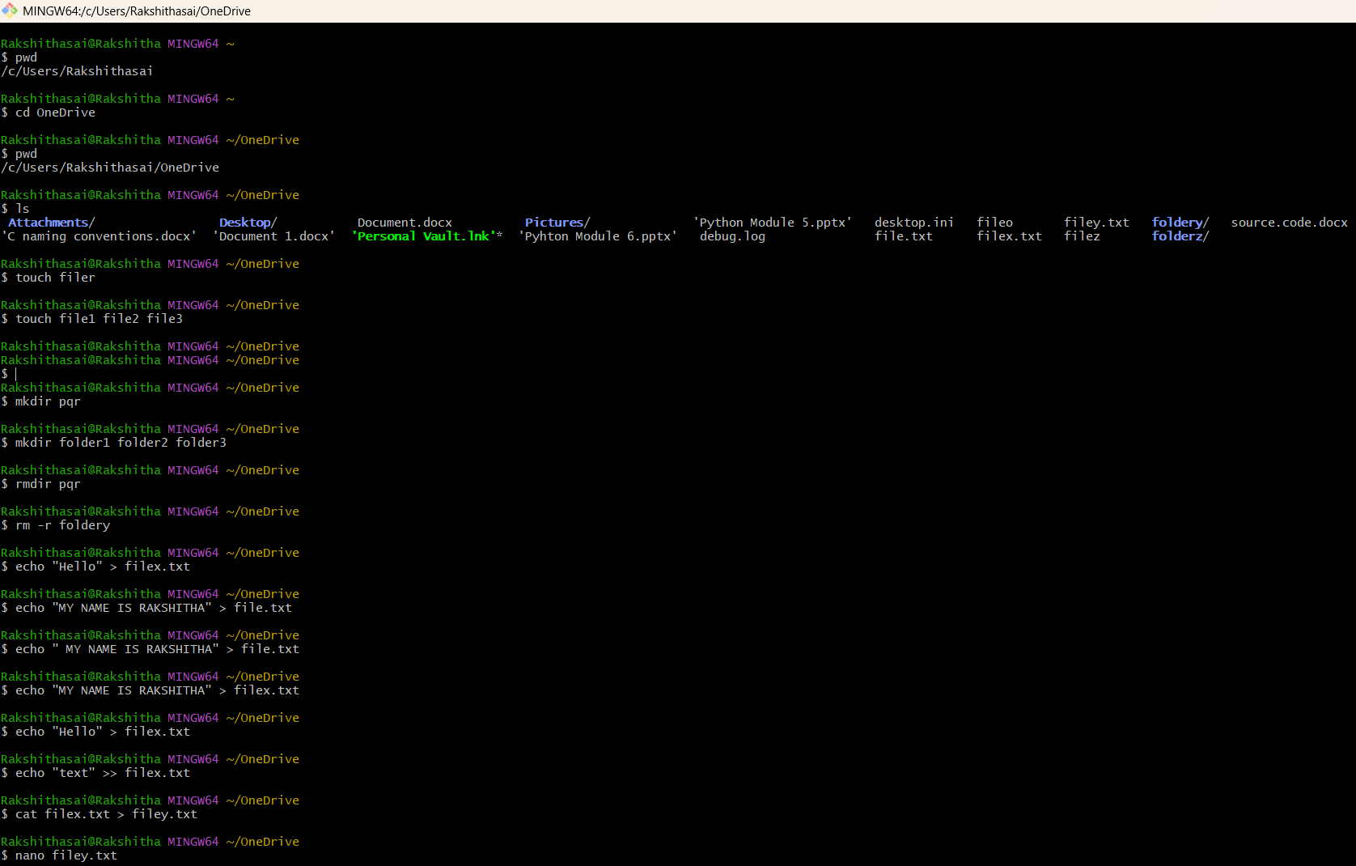
Ctrl+X is used to return to Git Bash.In the above image Ctrl+X is used to retrun to Git bash
Editing with Vi/Vim
- git var GIT_EDITOR → Checks default editor.
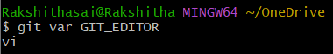
- git config --global core.editor "vi" → Sets Vi as default editor.
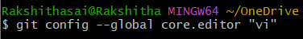
- vi filename.txt → Opens file in Vi editor.
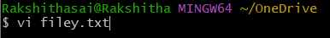
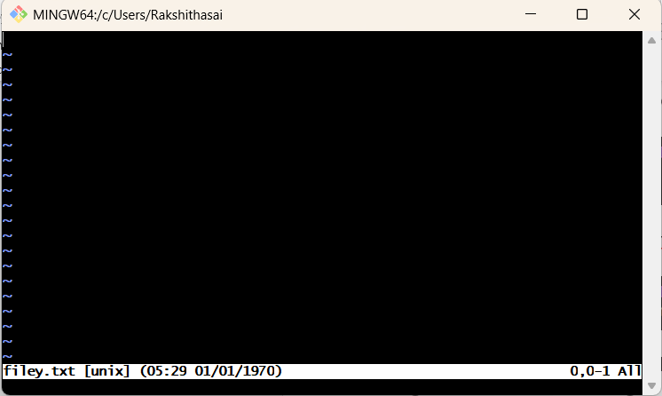

Insert Mode commands:
- i → Insert before cursor
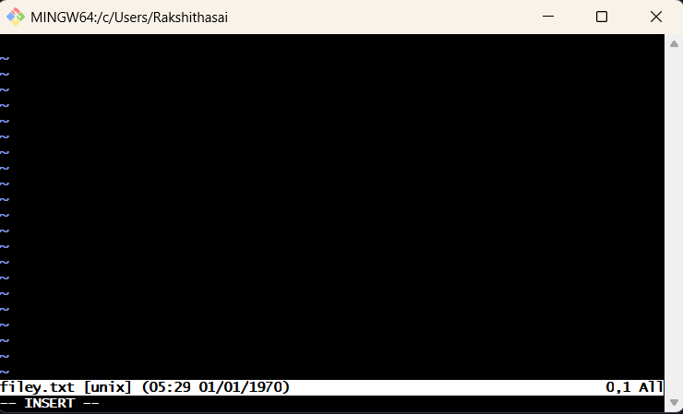
In the above image it is in insert mode.
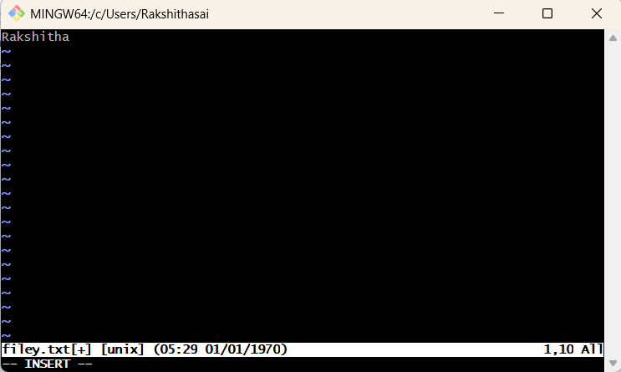
The insert mode allows to write the text in vi editor.
- I → Insert at beginning of line
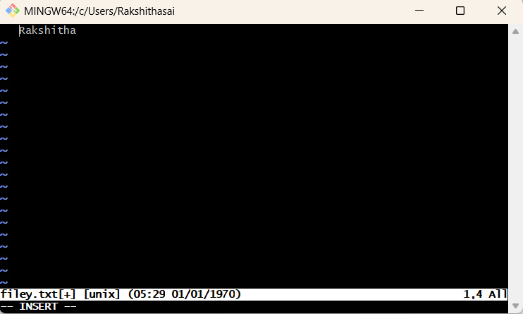
If your cursor is anywhere in the line (say on the word “Rakshitha”), press: “I”. The cursor jumps to the start of the line , and you’re now in insert mode.
- a → Append after cursor
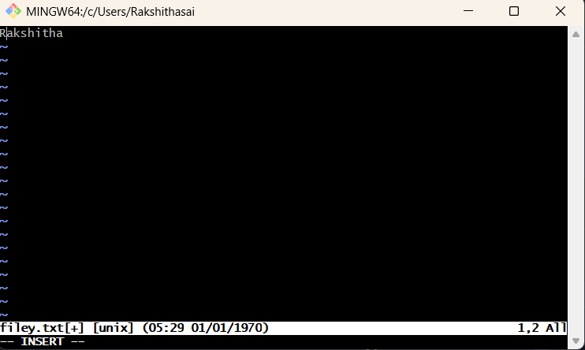
In the above image cursor moves to the right to append the text.
- A → Append at end of line
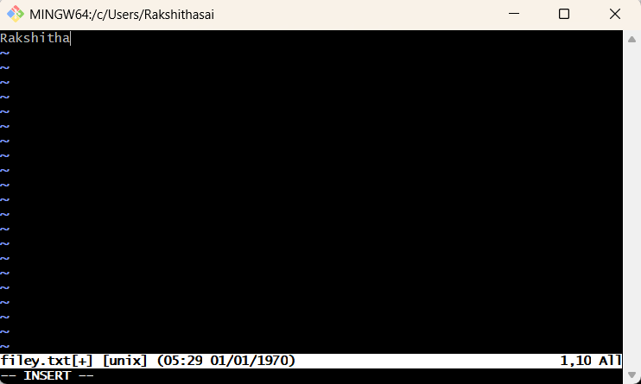
In the above image cursor moves to end of the line to append the text.

- o → New line below cursor
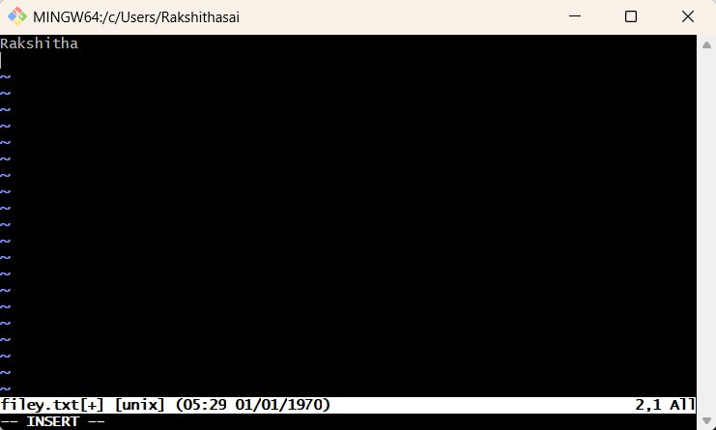
By using ”o” the cursor is moved to below new line.

- O → New line above cursor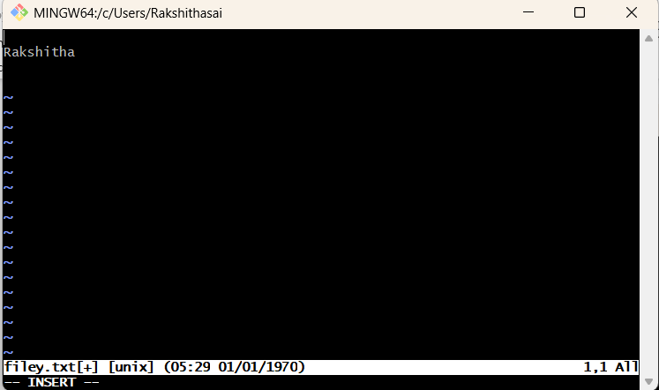
By using ”O” the cursor is moved to above new line.
- Esc → Exit insert mode
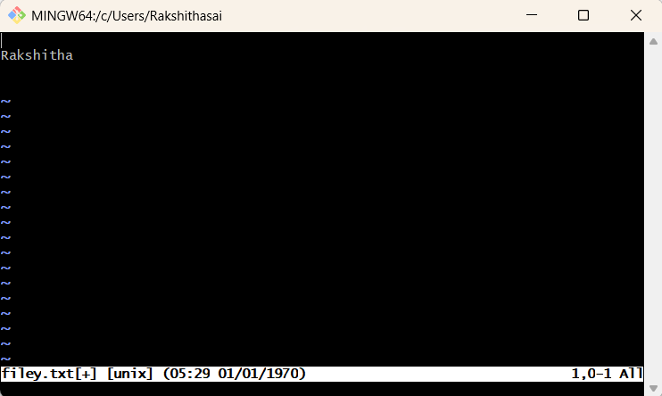
In the above image “Esc” exits insert mode.
Save & Quit in Vi
- :w → Save file
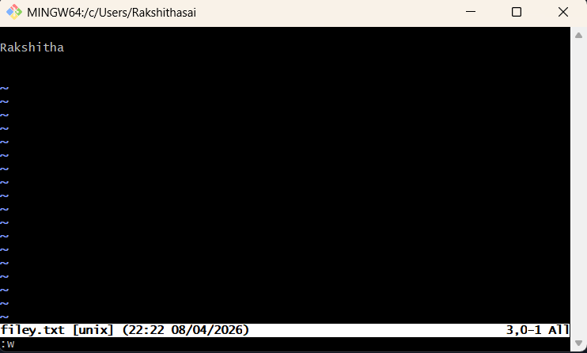
After exiting insert mode, It saves the file by using ”:w” command.
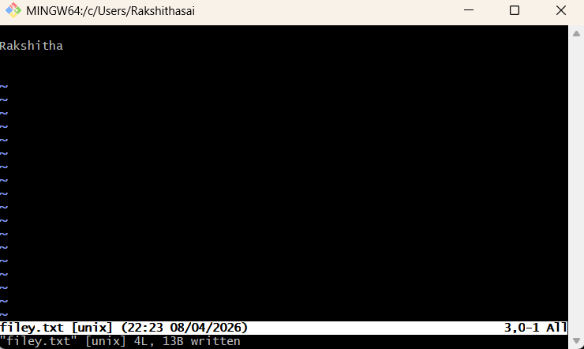
- :q → Quit editor
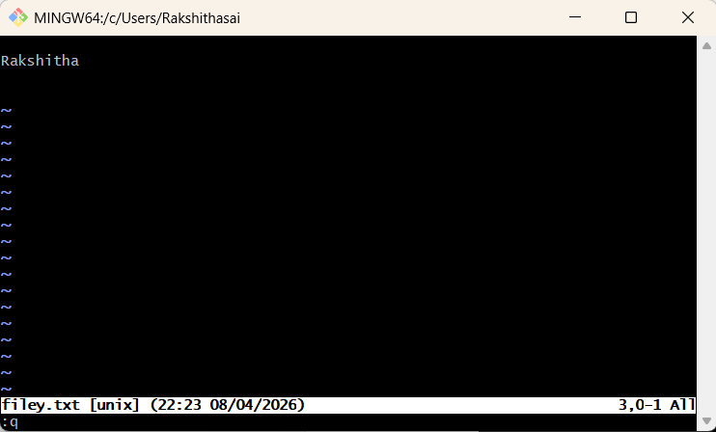
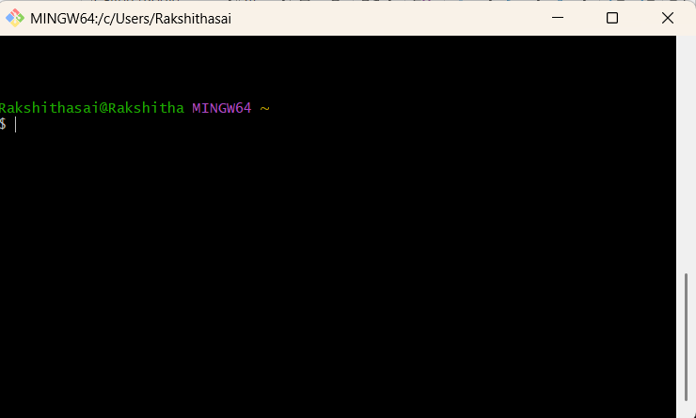
By using “:q” we quit vi editor to Git Bash.
- :wq or :x → Save and quit
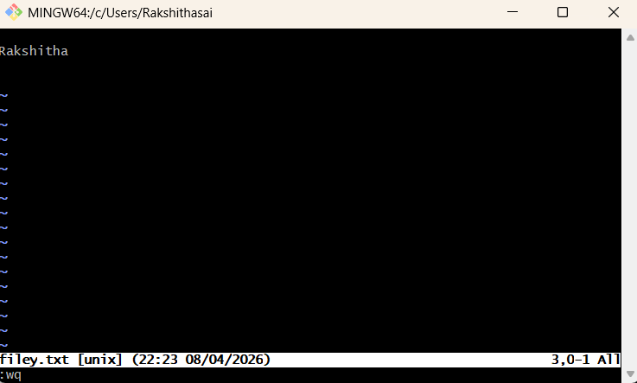
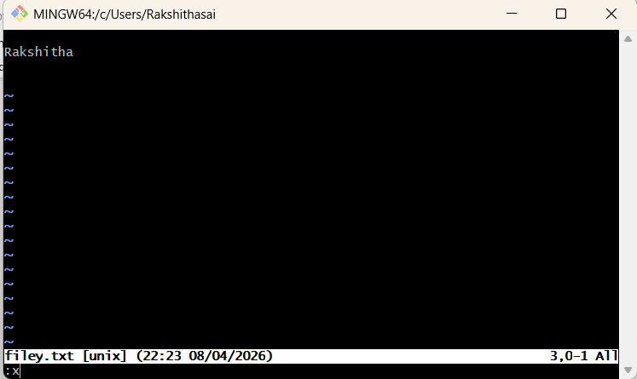

By using “:wq or :x” it saves and quit to the Git Bash.

- :q! → Quit without saving
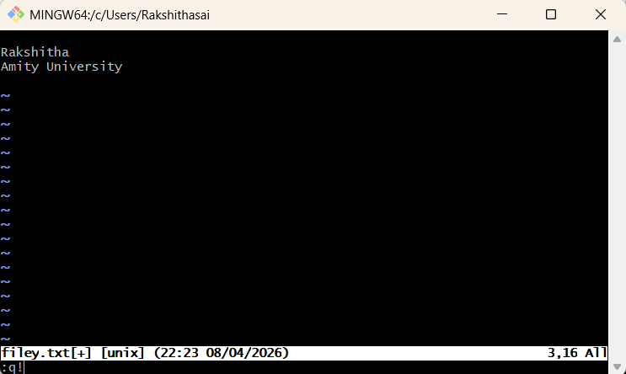
In the above txt “Rakshitha (new line) Amity University”, Amity University is not saved in the file because we used “:q!” command here it does not save the changes of the text and quit to the Git Bash.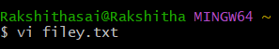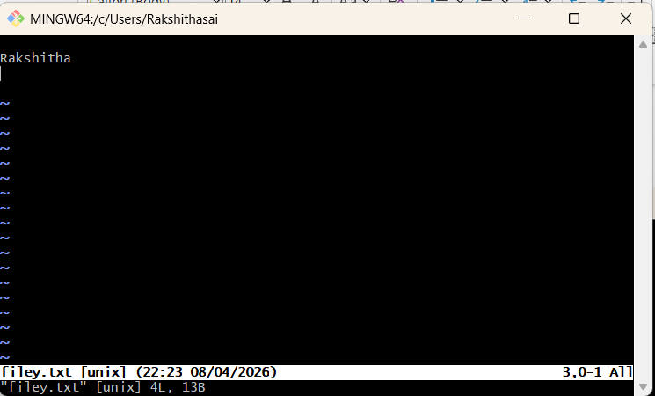
Delete Commands in Vi
- x → Delete character

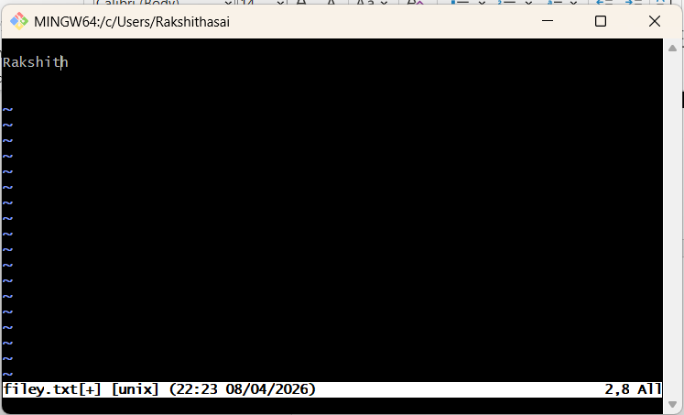
It deletes a character before the cursor you can observe in the above image that in ”Rakshitha”, “a” is deleted.

- dd → Delete current line

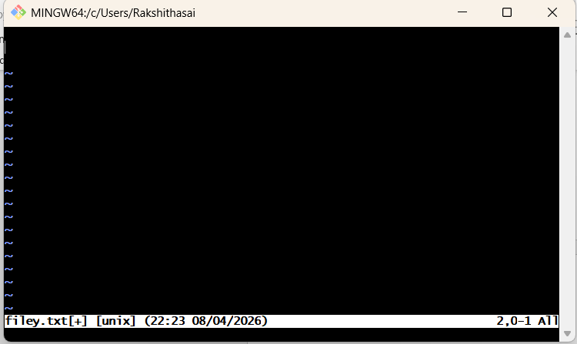
In the above text I have used “dd” command ,it deleted the line.

- d$ → Delete from cursor to end of line
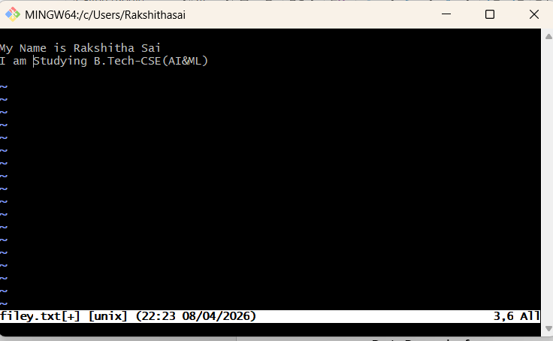
In the above image the cursor is present at second line.
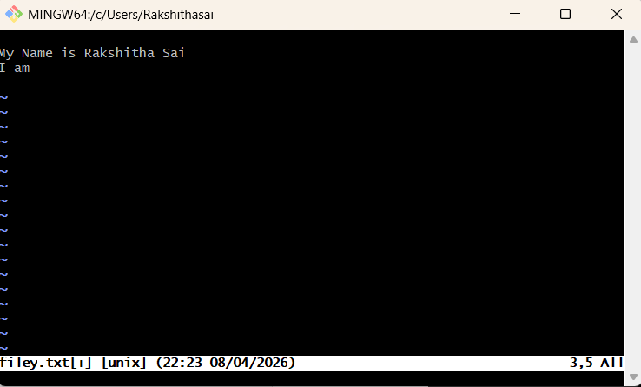
In the above line I have used “d$” command it deleted all the text from cursor to end of the line.

- d^ → Delete from cursor to start of line

In the above image the cursor is in the second line.
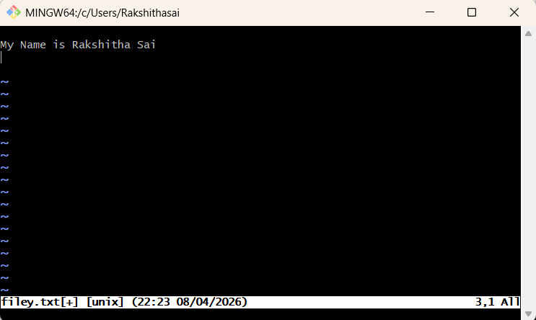
We can observe that the “d^” command deleted all the text from coursor to start of the line.

Copy & Paste in Vi
- yy→ Yank (copy)
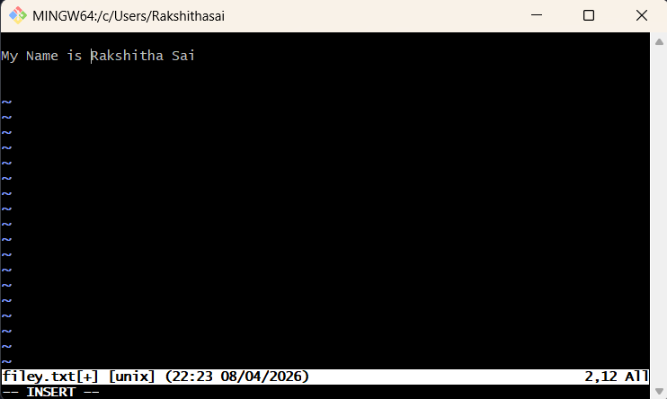
Move the cursor to the line you want to copy and Make sure you’re in command mode.
I have used the command “yy” it does not display on vi editor,it only copies the line where the cursor is present.

- p → Paste after cursor
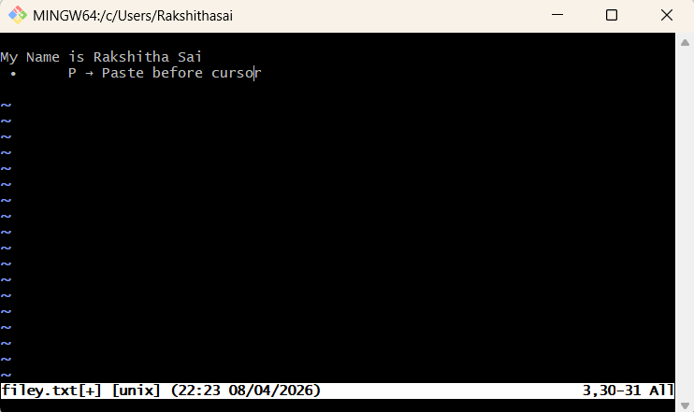
In the above image “p” command mentions” Paste before cursor”.
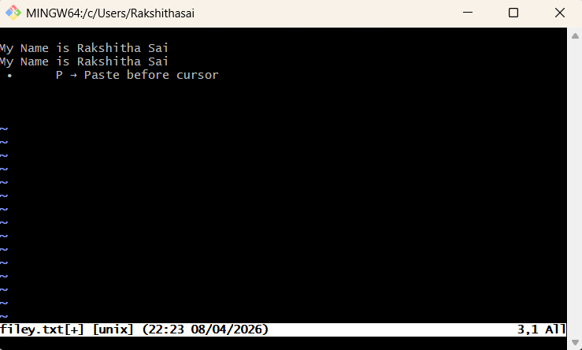
In the above image the copied line is pasted after the cursor.

- P → Paste before cursor
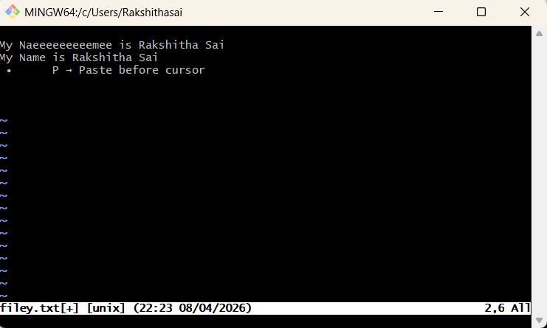
In the above image I have placed the cursor before “e”, the more time I use “P” command the more “e” character is printed in the line before the cursor.

