SOFTWARE ENGINEERING
LAB 2:
NAME:Rakshitha T S SRN:PES1UG25CS834
CLASS:5J

1.Backlog:
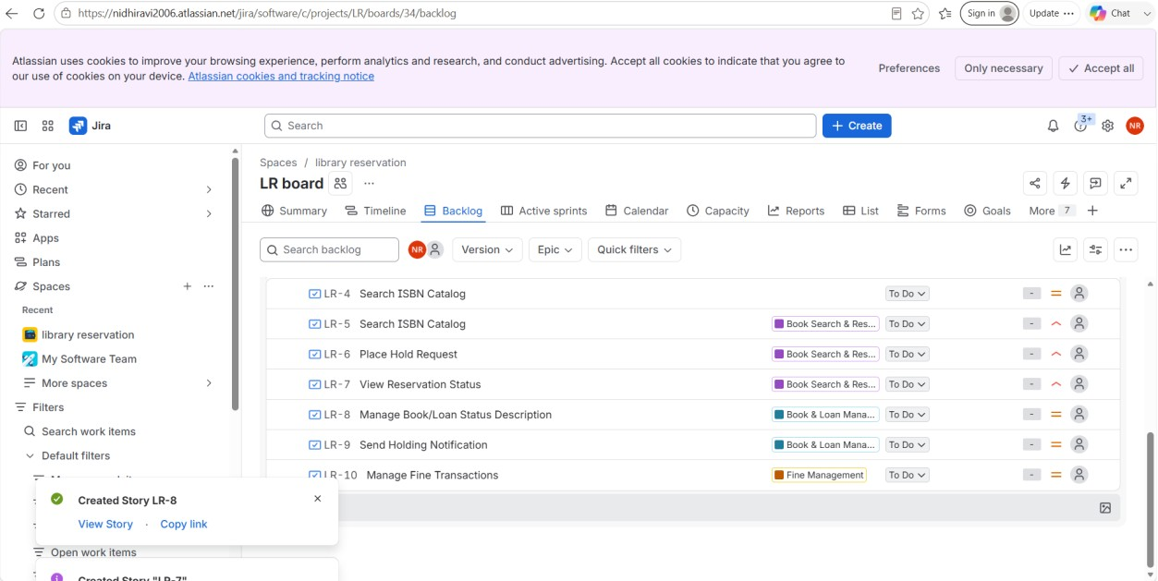

2.Story point assignment:
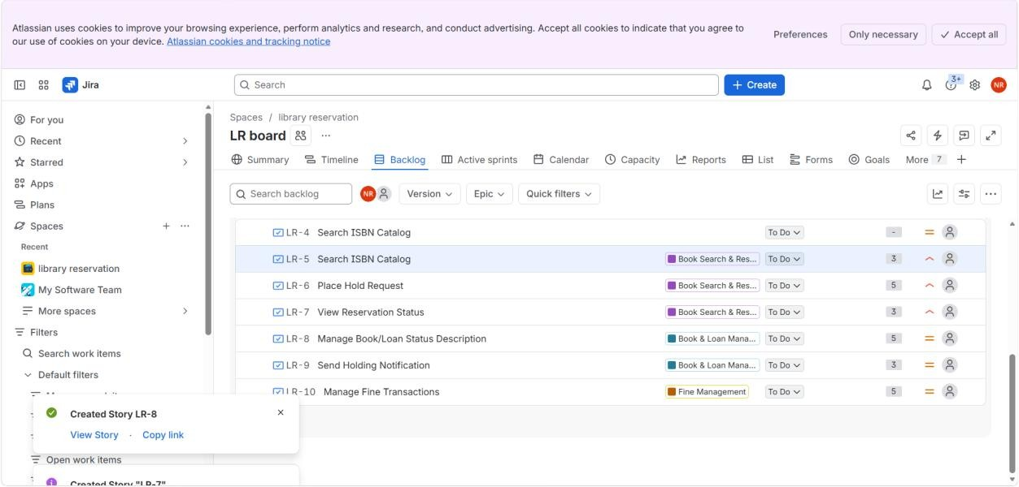

3.Active sprint:
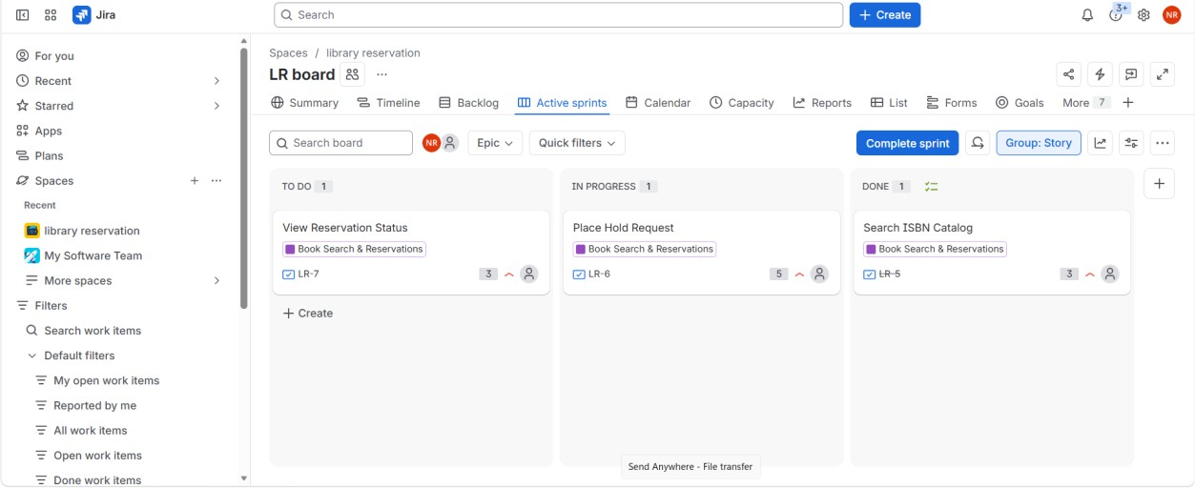

4.Burndown Chart:
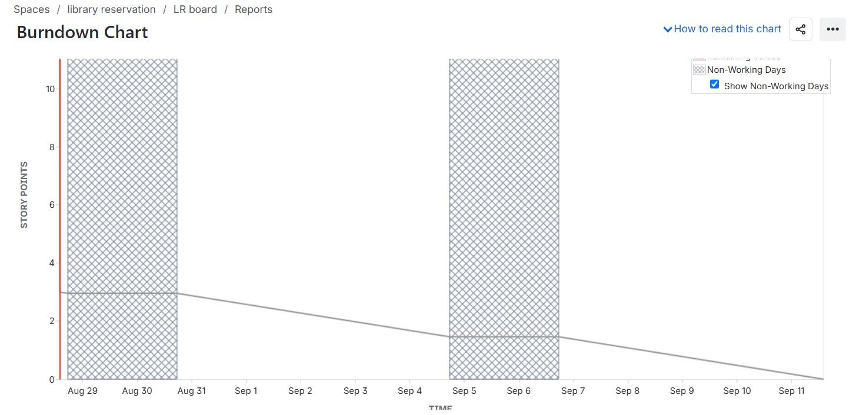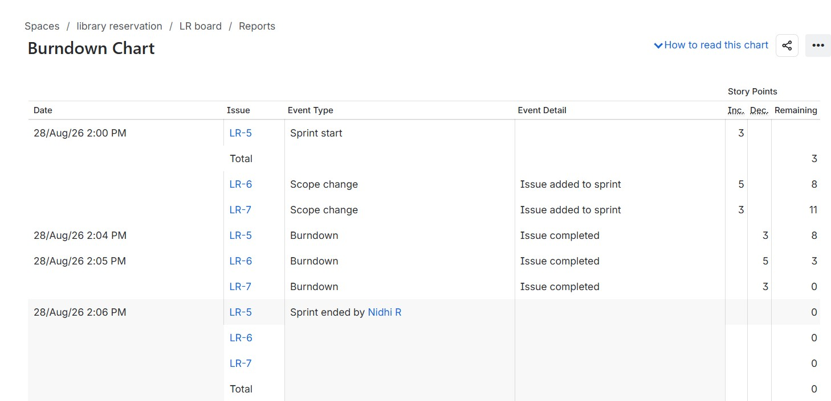

- Did your estimations reflect the actual effort?
Yes, the story points reasonably reflected the effort required for each user story.
Simple stories were given fewer points, while more complex stories were given higher points. The estimates considered complexity, effort, and uncertainty.

- Was your backlog well-prioritized?
Yes, the backlog was prioritized based on importance and user impact.
Core features such as searching books and placing holds were given higher priority.
Other supporting features were given medium priority.

- How did your simulated sprint align with your plan?
The sprint followed our planned scope with one Epic and three User Stories.
The stories were moved through To Do → In Progress → Done as planned.
All three selected stories were successfully completed.

- What insights did the burndown chart give about your team’s capacity?
The burndown chart showed how the remaining work decreased as stories were completed.
It helped us understand the amount of work completed during the sprint.
It also showed whether our planned workload was manageable.

