Visvesvaraya Technological University
Jnana Sangama, Belagavi



A PROJECT REPORT

Project Title: "FOODCART: ONLINE FOOD ORDERING PLATFORM"

Submitted by
USN | Student Name
4JN22RI035 | Rakshitha U S

Under the Guidance of

Department of Robotics and Artificial Intelligence
J.N.N College of Engineering, Shivamogga, 577204
Affiliated to Visvesvaraya Technological University, Belagavi
2025 - 2026

ABSTRACT

FoodCart is a full-stack web application designed to provide a seamless online food ordering experience. Built using the MERN Stack (MongoDB, Express.js, React.js, Node.js), it features a customer-facing frontend for browsing menus, managing carts, and placing orders, alongside an admin panel for managing food items and tracking order statuses. The application integrates Stripe for secure online payments and uses JWT (JSON Web Tokens) for user authentication and session management. The system follows a three-tier architecture with a React frontend, Express/Node.js REST API backend, and MongoDB cloud database. This project demonstrates the practical application of modern web development technologies to solve real-world problems in the food delivery industry.

Keywords: MERN Stack, Online Food Ordering, Stripe Payment Gateway, JWT Authentication, REST API, React.js, Node.js, MongoDB

TABLE OF CONTENTS
Chapter | Title | Page No.
 | Certificate | ii
 | Abstract | iii
 | Table of Contents | iv
 | List of Figures | v
 | List of Tables | vi
1 | Introduction | 1
1.1 | Overview | 1
1.2 | Problem Statement | 1
1.3 | Objectives | 2
1.4 | Scope | 2
1.5 | Methodology | 2
2 | Literature Survey | 3
3 | System Requirements | 5
4 | System Design and Architecture | 7
5 | Implementation | 12
6 | Screenshots and Results | 18
7 | Testing | 24
8 | Conclusion and Future Scope | 27
 | References | 29
LIST OF FIGURES

Figure No. | Title | Page No.
Fig. 6.1 | FoodCart Home Page — Hero Section | 18
Fig. 6.2 | Explore Menu & Food Categories Section | 19
Fig. 6.3 | User Registration (Sign-Up) Modal | 20
Fig. 6.4 | Admin Panel — Add Food Items | 21
Fig. 6.5 | Admin Panel — List All Food Items | 22
Fig. 6.6 | Admin Panel — Order Management Page | 22
Fig. 6.7 | Stripe Payment Checkout Page | 23
Fig. 6.8 | My Orders — Order History & Tracking | 24

LIST OF TABLES

Table No. | Title | Page No.
Table 2.1 | Comparison of Existing Food Ordering Platforms | 3
Table 2.2 | Technologies Used and Their Versions | 4
Table 3.1 | Hardware Requirements | 5
Table 3.2 | Software Requirements | 6
Table 4.1 | MongoDB User Schema | 8
Table 4.2 | MongoDB Food Schema | 8
Table 4.3 | MongoDB Order Schema | 9
Table 4.4 | REST API Endpoints | 10
Table 4.5 | Frontend Component Descriptions | 11
Table 7.1 | Test Cases and Results | 25

CHAPTER 1: INTRODUCTION

1.1 Overview
The food delivery industry has grown exponentially in recent years, driven by evolving consumer preferences and the proliferation of digital platforms. The widespread adoption of smartphones and internet connectivity has transformed how people order food, moving from traditional phone-in orders to sophisticated mobile and web applications. FoodCart is a comprehensive online food ordering platform that enables customers to browse food menus, place orders, and make secure payments online, while providing restaurant administrators with tools to manage food listings and track orders in real time.
The platform is developed using the MERN Stack — MongoDB, Express.js, React.js, and Node.js — a modern, JavaScript-based technology stack that enables the construction of scalable, high-performance web applications. The choice of the MERN stack ensures that both the frontend and backend use a unified programming language, simplifying development and maintenance. The system is deployed on cloud infrastructure (Vercel for frontend and MongoDB Atlas for the database), making it accessible from anywhere with an internet connection.

1.2 Problem Statement
Traditional food ordering processes require manual phone calls or physical visits to restaurants, leading to miscommunication, longer wait times, order inaccuracies, and a lack of real-time order tracking. Existing commercial solutions such as Zomato, Swiggy, and UberEats are proprietary platforms that charge high commission fees and offer limited customization for restaurant owners. Small to medium-scale restaurants often lack the resources to integrate such systems or develop their own. There is therefore a clear need for a simple, cost-effective, open-source, full-stack food ordering platform that handles the complete order lifecycle — from menu browsing and cart management to payment processing and order status tracking.

1.3 Objectives
- Design and develop a full-stack web application for online food ordering using the MERN stack.
- Implement user authentication and authorization using JWT tokens and bcrypt password hashing.
- Integrate the Stripe payment gateway for secure, PCI-compliant online transactions.
- Build a dedicated admin dashboard for managing food items (CRUD operations) and monitoring order statuses.
- Implement a responsive, user-friendly customer interface with category-based menu browsing and cart management.
- Ensure persistent cart management synchronized with the backend database.
- Deploy the application using cloud platforms (Vercel and MongoDB Atlas) for production-ready availability.

1.4 Scope
The project covers three primary modules:
- Customer Module: User registration and login, menu browsing by food category, dynamic cart management with add/remove functionality, order placement with Stripe Checkout, and order history tracking via the My Orders page.
- Admin Module: Adding new food items with image upload, listing all food items with delete functionality, and viewing and managing all customer orders with order status updates (Food Processing, Out for Delivery, Delivered).
- Backend API Module: A RESTful API built with Express.js and Node.js, featuring JWT-based authentication middleware, Mongoose database models for Users, Foods, and Orders, Multer-based image upload handling, and Stripe payment session creation and verification.

1.5 Methodology
The project follows the Agile Development methodology with iterative development sprints. The system is divided into three independent modules (Frontend Customer App, Admin Panel, and Backend REST API) that communicate via well-defined REST API contracts. Development proceeded in structured phases: database schema design, REST API development and testing, frontend customer UI, admin panel development, Stripe payment integration, end-to-end testing, and cloud deployment.

CHAPTER 2: LITERATURE SURVEY

2.1 Existing Systems and Comparative Analysis
Several online food ordering platforms have been studied to understand the current state of the industry and identify gaps that the proposed system addresses. The table below summarizes the key platforms and their limitations.
Table 2.1: Comparison of Existing Food Ordering Platforms
Platform | Technology | Limitations | Commission/Cost
Zomato | Proprietary Stack | Closed-source, high commission fees, not customizable for small restaurants | 15-25% per order
Swiggy | Proprietary Stack | No access to source code, expensive licensing, vendor lock-in | 18-25% per order
UberEats | Proprietary Stack | Complex integration, limited support for small-scale vendors | 15-30% per order
FoodCart (Proposed) | MERN Stack | Open source, fully customizable, no commission fees | Free (self-hosted)

2.2 Advantages of the Proposed System
- Open Source and Customizable: Built entirely on freely available MERN stack technologies, allowing complete modification and extension.
- Zero Licensing Fees: Deployable on free-tier cloud platforms (Vercel for frontend, MongoDB Atlas for database), eliminating operational costs.
- Full Ownership: Restaurant owners maintain complete control over their menu, pricing, order workflow, and customer data.
- Secure Payments: Stripe integration ensures PCI-DSS compliant payment processing without handling raw card data.
- Scalable Architecture: Three-tier architecture allows independent horizontal scaling of frontend, backend, and database layers.
- Modern Technology Stack: Uses industry-standard technologies (React 18, Node.js LTS, MongoDB Atlas) ensuring longevity and strong community support.

2.3 Technology Background
Table 2.2: Technologies Used and Their Roles
Technology | Role | Version | Category
MongoDB | NoSQL Cloud Database — stores food items, users, orders | Atlas Cloud | Database
Express.js | Backend Web Framework — defines REST API routes and middleware | v4.19 | Backend
React.js | Frontend UI Library — builds dynamic single-page applications | v18.2 | Frontend
Node.js | Server-side JavaScript Runtime — powers the backend server | v18+ | Runtime
Stripe | Payment Gateway — handles online card payment processing | v15.8 | Payment
JWT | JSON Web Token — stateless user authentication | v9.0 | Auth
Vite | Frontend Build Tool — fast dev server with HMR | v5.2 | Build Tool
Mongoose | MongoDB ODM — schema validation and database queries | v8.4 | Database
Multer | File Upload Middleware — handles image uploads to server | Latest | Middleware
Bcrypt | Password Hashing — secure storage of user passwords | Latest | Security
Axios | HTTP Client — makes API calls from frontend to backend | Latest | Networking

CHAPTER 3: SYSTEM REQUIREMENTS

3.1 Hardware Requirements
Table 3.1: Hardware Requirements
Component | Specification
Processor | Intel Core i3 or AMD Ryzen 3 (or higher)
RAM | 4 GB minimum (8 GB recommended for development)
Storage | 10 GB free disk space (SSD recommended)
Display | 1280 x 720 resolution or higher
Network | Active broadband internet connection
Browser | Google Chrome v90+ / Mozilla Firefox v88+ / Microsoft Edge v90+

3.2 Software Requirements
Table 3.2: Software Requirements
Software | Version | Purpose
Node.js | v18.x LTS or higher | JavaScript runtime for backend server
npm | v9.x or higher | Package management for all three modules
MongoDB Atlas | Cloud (Free Tier) | Cloud-hosted NoSQL database
Visual Studio Code | Latest Stable | Primary code editor with extensions
Git | v2.40+ | Version control and repository management
Google Chrome | v90+ | Primary browser for testing and debugging
Postman | Latest | API endpoint testing tool
Windows 10/11 or Ubuntu 20.04+ | - | Operating system
Vercel CLI (optional) | Latest | Deployment to Vercel cloud platform

3.3 Functional Requirements
The following functional requirements were identified for the FoodCart system:
- Users shall be able to register for a new account with name, email, and password.
- Users shall be able to log in using registered email and password credentials.
- Users shall be able to browse all available food items and filter them by category.
- Users shall be able to add and remove food items from a persistent shopping cart.
- Users shall be able to place orders with delivery address information and pay via Stripe.
- Users shall be able to view their complete order history with current status tracking.
- Administrators shall be able to add new food items with image, name, description, price, and category.
- Administrators shall be able to view all food items in a tabular listing and delete any item.
- Administrators shall be able to view all customer orders and update their delivery status.

3.4 Non-Functional Requirements
- Security: All user passwords shall be hashed using bcrypt with 10 salt rounds. JWTs shall be used for stateless session management.
- Performance: API endpoints shall respond within 500 milliseconds for typical CRUD operations under normal load.
- Usability: The interface shall be responsive and intuitive for desktop and tablet screen sizes.
- Availability: The application shall be deployed on cloud platforms ensuring 24/7 accessibility.
- Scalability: The three-tier architecture shall allow independent scaling of each layer as user load increases.
- Maintainability: The codebase shall follow a modular, component-based structure for ease of future enhancement.

CHAPTER 4: SYSTEM DESIGN AND ARCHITECTURE

4.1 System Architecture
FoodCart follows a three-tier client-server architecture that cleanly separates presentation, business logic, and data storage concerns. The architecture comprises three independent tiers:
- Client Tier: Contains two React.js single-page applications — the customer-facing Frontend (running on port 5173) and the Admin Panel (running on a separate port). Both communicate with the backend exclusively through REST API calls.
- Application Tier: The Node.js and Express.js backend server (running on port 4000) hosts all business logic, including JWT authentication middleware, Multer file upload handling, and Stripe payment session management.
- Data Tier: MongoDB Atlas cloud database provides persistent, schema-flexible storage for all application data. External services include the Stripe API for payment processing.

4.2 Database Design (MongoDB Schemas)
The application uses three primary MongoDB collections, each defined with Mongoose schemas for validation and structure.

4.2.1 User Schema
Table 4.1: MongoDB User Schema
Field | Type | Constraints | Description
name | String | Required | Full name of the user
email | String | Required, Unique | Email address (used for login)
password | String | Required | Bcrypt-hashed password
cartData | Object | Default: {} | Cart items stored as key-value pairs

4.2.2 Food Schema
Table 4.2: MongoDB Food Schema
Field | Type | Constraints | Description
name | String | Required | Name of the food item
description | String | Required | Detailed description of the food
price | Number | Required | Price of the item in USD
image | String | Required | Filename of the uploaded image
category | String | Required | Category (Salad, Rolls, Pasta, etc.)

4.2.3 Order Schema
Table 4.3: MongoDB Order Schema
Field | Type | Constraints | Description
userId | String | Required | Reference to the ordering user
items | Array | Required | Array of ordered food items with quantities
amount | Number | Required | Total order amount in USD
address | Object | Required | Delivery address details
status | String | Default: "Food Processing" | Current order status
date | Date | Default: Date.now() | Timestamp when the order was placed
payment | Boolean | Default: false | Payment completion status from Stripe

4.3 REST API Design
Table 4.4: REST API Endpoints
Method | Endpoint | Description | Auth
POST | /api/user/register | Register new user — hashes password, creates user, returns JWT | None
POST | /api/user/login | Login user — validates credentials, returns JWT token | None
POST | /api/food/add | Add new food item with image upload via Multer | None
GET | /api/food/list | Retrieve all food items from database | None
POST | /api/food/remove | Delete a food item by ID | None
POST | /api/cart/add | Add item to user's cart in database | JWT
POST | /api/cart/remove | Remove/decrement item from user's cart | JWT
POST | /api/cart/get | Retrieve the user's current cart data | JWT
POST | /api/order/place | Create order and initiate Stripe checkout session | JWT
POST | /api/order/verify | Verify Stripe payment status and update order | None
POST | /api/order/userorders | Retrieve all orders for the logged-in user | JWT
GET | /api/order/list | List all orders for admin dashboard | None
POST | /api/order/status | Update order delivery status (admin) | None

4.4 Frontend Component Architecture
Table 4.5: Frontend Component Descriptions
Component | Purpose and Functionality
Navbar | Top navigation bar with brand logo, menu links (Home, Menu, Mobile-App, Contact Us), search icon, cart icon, and profile/sign-in button.
Header | Hero section featuring a food banner image, main headline ("Order your favourite food here"), descriptive text, and "View Menu" call-to-action button.
ExploreMenu | Horizontal scrollable category filter displaying food categories (Salad, Rolls, Desserts, Sandwich, Cake, Pure Veg, Pasta, Noodles) as circular image cards.
FoodDisplay | Responsive grid layout rendering all food items, filtered dynamically based on the selected category from ExploreMenu.
FoodItem | Individual food item card showing image, item name, rating, description, and price with add/remove cart buttons (+/-).
LoginPopup | Modal overlay that provides both Sign Up (name, email, password, T&C checkbox) and Login (email, password) forms with toggle link.
Cart | Cart page listing all items with quantities, prices, subtotals, delivery fee, and total. Includes a "Proceed to Checkout" button.
PlaceOrder | Delivery information form (first/last name, email, street, city, state, ZIP, country, phone) with order summary sidebar.
Verify | Post-payment verification page that calls /api/order/verify and redirects to My Orders on success or Cart on cancellation.
MyOrders | Order history page displaying each order with items, amount, item count, delivery status indicator, and "Track Order" button.
Footer | Site footer with app logo, tagline, app download links (Google Play, App Store), navigation links, and contact information.
StoreContext | React Context Provider managing global state: food list, cart items, user JWT token, URL, and helper functions (addToCart, removeFromCart, getTotalCartAmount).

CHAPTER 5: IMPLEMENTATION

5.1 Project Structure
The project is organized into three independent modules, each with its own package.json and development server:
Food-delivery-App/
├── Backend/
│ ├── config/db.js # MongoDB Atlas connection setup
│ ├── controllers/
│ │ ├── foodController.js # Add, list, remove food items
│ │ ├── userController.js # Register and login users
│ │ ├── cartController.js # Add, remove, and fetch cart
│ │ └── orderController.js # Place, verify, list orders
│ ├── middleware/auth.js # JWT verification middleware
│ ├── models/
│ │ ├── foodModel.js # Mongoose Food schema
│ │ ├── userModel.js # Mongoose User schema
│ │ └── orderModel.js # Mongoose Order schema
│ ├── routes/ # Express route definitions
│ ├── uploads/ # Stored food images (served as static)
│ └── server.js # Express app entry point (Port 4000)
├── Frontend/
│ └── src/
│ ├── components/ # Reusable UI components
│ ├── pages/ # Page-level route components
│ ├── Context/ # React Context for global state
│ └── assets/ # Images, icons, static data
└── admin/
└── src/
├── components/ # Navbar and Sidebar
└── pages/ # Add Food, List Food, Orders

5.2 Key Implementation Details

5.2.1 Backend Server Configuration (server.js)
The backend server is initialized with Express, configured with CORS middleware to allow cross-origin requests from the frontend applications, and connected to MongoDB Atlas:
import express from "express";
import cors from "cors";
import { connectDB } from "./config/db.js";
import foodRouter from "./routes/foodRoute.js";
import userRouter from "./routes/userRoute.js";
import cartRouter from "./routes/cartRoute.js";
import orderRouter from "./routes/orderRoute.js";

const app = express();
app.use(express.json());
app.use(cors());
connectDB();

app.use("/api/food", foodRouter);
app.use("/api/user", userRouter);
app.use("/api/cart", cartRouter);
app.use("/api/order", orderRouter);
app.use("/images", express.static("uploads"));

app.listen(4000, () => console.log("Server started on port 4000"));

5.2.2 User Authentication (JWT + bcrypt)
User passwords are hashed using bcrypt with 10 salt rounds before storage. On successful login, a JWT token is signed with the user's MongoDB ObjectId and a secret key stored in environment variables:
const salt = await bcrypt.genSalt(10);
const hashedPassword = await bcrypt.hash(password, salt);
const token = jwt.sign({ id: user._id }, process.env.JWT_SECRET);

The authentication middleware verifies the JWT token on all protected routes and injects the decoded userId into the request body:
const token = authHeader.split(" ")[1];
const decoded = jwt.verify(token, process.env.JWT_SECRET);
req.body.userId = decoded.id;

5.2.3 Stripe Payment Integration
When a user places an order, the backend creates a Stripe Checkout Session with the order items as line items. The user is redirected to Stripe's hosted payment page. After payment, a verification endpoint confirms the payment status with Stripe and updates the order in MongoDB:
const session = await stripe.checkout.sessions.create({
payment_method_types: ["card"],
line_items: line_items,
mode: "payment",
success_url: `${frontend_url}/verify?success=true&orderId=${newOrder._id}`,
cancel_url: `${frontend_url}/verify?success=false&orderId=${newOrder._id}`,
});

5.2.4 Global State Management (React Context API)
The StoreContext provides cart data, the food item list, and the user authentication token to all React components without the need for Redux:
const contextValue = {
food_list, cartItems, setCartItems,
addToCart, removeFromCart, getTotalCartAmount,
url, token, setToken
};

5.2.5 Image Upload with Multer
Food item images are uploaded and stored on the backend server's filesystem via Multer middleware. The uploads directory is then exposed as a static asset endpoint so the frontend can retrieve images via URL:
const storage = multer.diskStorage({
destination: "uploads",
filename: (req, file, cb) => cb(null, `${Date.now()}${file.originalname}`)
});
app.use("/images", express.static("uploads"));

5.3 Challenges Faced and Solutions

Challenge 1: dotenv Configuration with ES Modules
Problem: Environment variables (MONGODB_URI, JWT_SECRET) failed to load because the backend uses ES Module syntax ("type": "module" in package.json), which is incompatible with the traditional require("dotenv").config() syntax.
Solution: Replaced with the ESM-compatible import "dotenv/config" syntax at the very top of server.js, and ensured the .env file was placed in the correct /Backend root directory.

Challenge 2: CORS Errors During Development
Problem: The React frontend (localhost:5173) was blocked by browser security policies from making API requests to the Express backend (localhost:4000) due to cross-origin resource sharing restrictions.
Solution: Added the cors npm package as middleware in server.js using app.use(cors()), which permitted cross-origin API requests during development. In production, CORS is configured with specific origin restrictions.

Challenge 3: MongoDB Atlas Connection String Encoding
Problem: The MongoDB connection URI contained special characters in the password (e.g., "@" and "#" symbols) which broke the URL format and caused Mongoose connection failures.
Solution: URL-encoded the special characters in the password within the MONGODB_URI environment variable (e.g., "@" becomes "%40"), producing a valid URL that Mongoose could parse correctly.

Challenge 4: Stripe Payment Verification and Order Status
Problem: After payment completion on Stripe, reliably verifying the payment outcome and updating the order status in MongoDB was complex, especially handling both success and cancellation redirect flows.
Solution: Implemented a dedicated /api/order/verify endpoint. After Stripe redirects the user back to the frontend, the React Verify page calls this endpoint with the orderId and Stripe success flag. The backend queries the Stripe API to confirm payment status and updates the MongoDB order document accordingly.

CHAPTER 6: SCREENSHOTS AND RESULTS

6.1 Frontend — Home Page (Hero Section)
The landing page presents the FoodCart brand with a clean navigation bar (Home, Menu, Mobile-App, Contact Us), a search icon, shopping cart icon, and a Sign In button. The main hero banner displays a food photograph on an orange background with the headline "Order your favourite food here", a subheading describing the platform's mission, and a "View Menu" call-to-action button. Below the hero is the "Explore our menu" section heading.
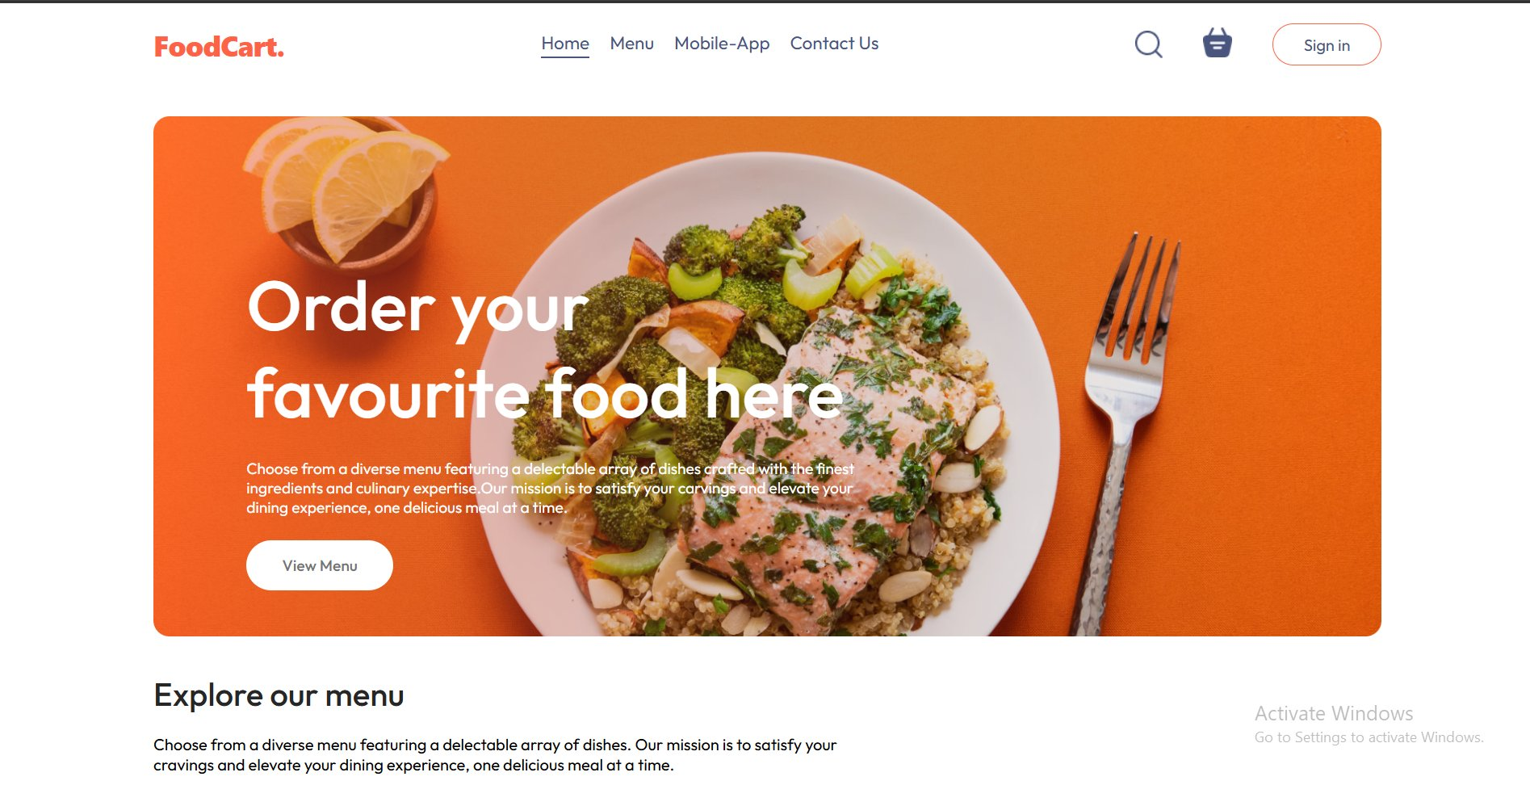
Fig. 6.1: FoodCart Home Page — Hero Section with navigation bar, hero banner, and CTA button

6.2 Frontend — Explore Menu & Food Categories
The Explore Menu section displays food categories as circular image cards arranged in a horizontal row. Users can click any category (Salad, Rolls, Desserts, Sandwich, Cake, Pure Veg, Pasta, Noodles) to filter the food items displayed below. The "Top dishes near you" section dynamically shows the filtered food items. At the bottom, a promotional banner encourages users to download the FoodCart mobile app via Google Play and the App Store.
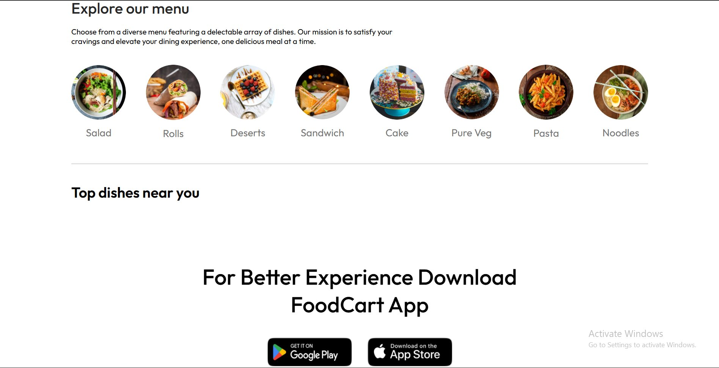
Fig. 6.2: Explore Menu section with food category cards and app download section

6.3 Frontend — User Registration (Sign-Up Modal)
When a user clicks Sign In, the LoginPopup modal appears centered over the page content. For new users, the Sign-Up form collects Name, Email, and Password fields with an orange "Create Account" button. A terms of use and privacy policy checkbox is included below. Existing users can switch to the Login form using the "Login here" hyperlink at the bottom of the modal.
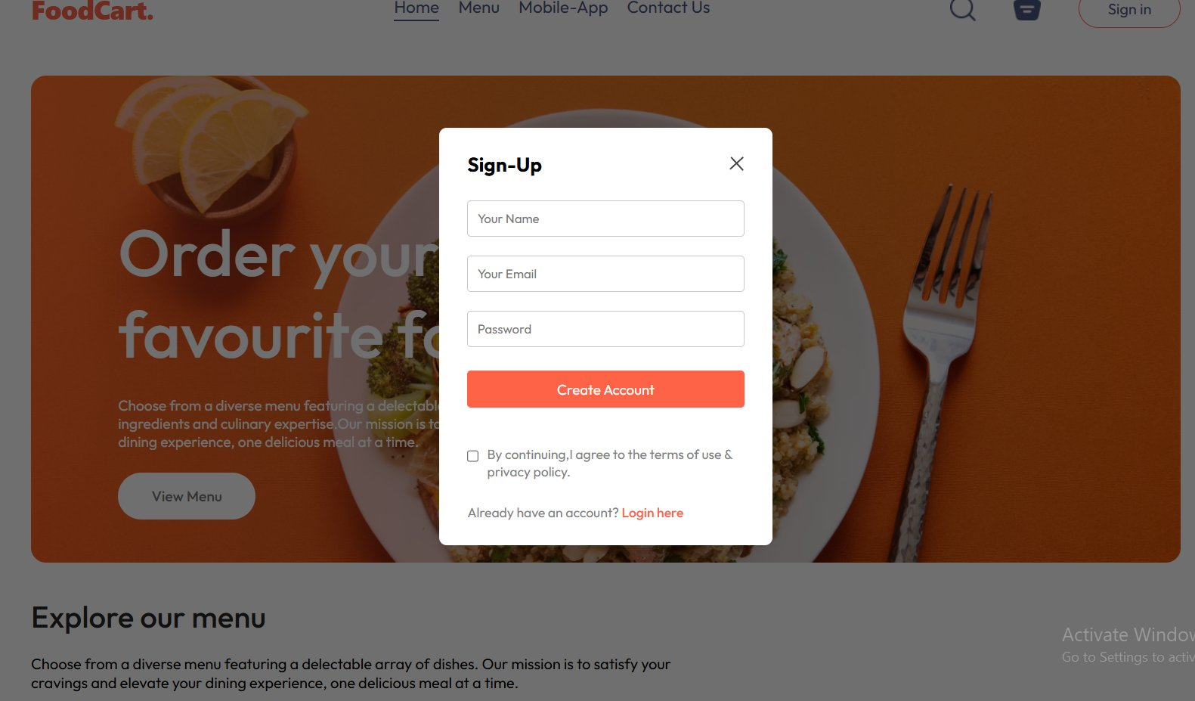
Fig. 6.3: User Sign-Up modal popup with registration form fields

6.4 Admin Panel — Add Food Items
The Admin Panel features a persistent left sidebar with three navigation tabs: Add Items, List Items, and Orders. The Add Items page provides a complete form for uploading a new food item: a drag-and-drop image upload area, a Product Name text field, a Product Description textarea, a Product Category dropdown (defaulting to Salad with options for all categories), a Product Price input field, and a large black "ADD" submission button.
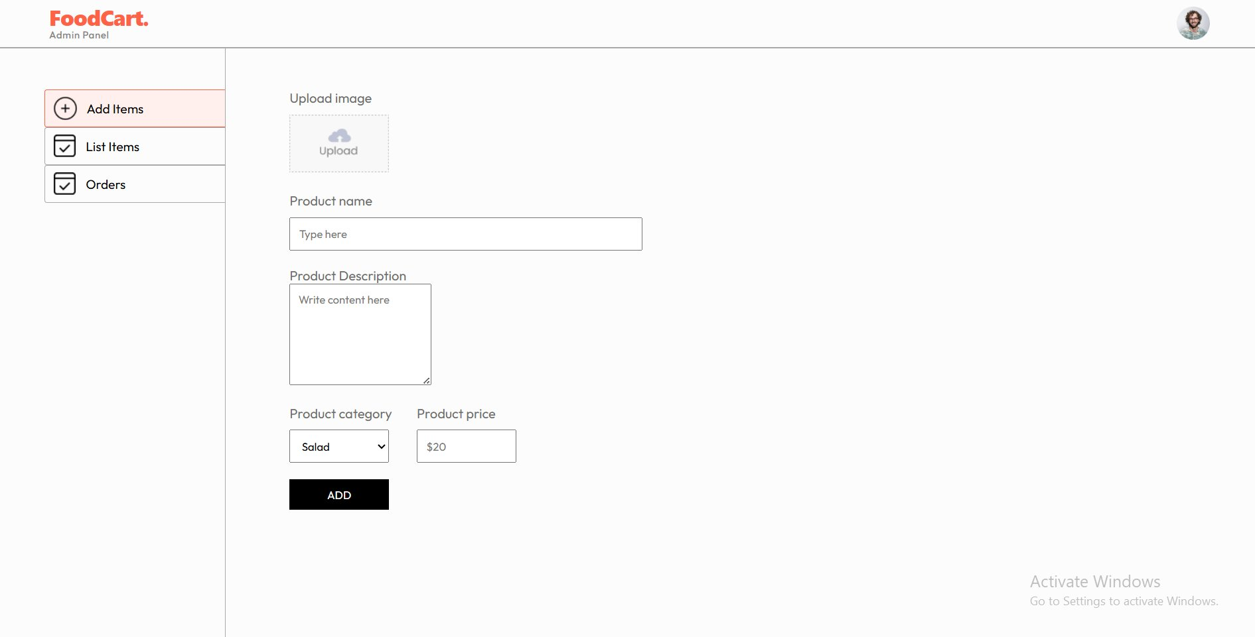
Fig. 6.4: Admin Panel — Add Items form with image upload, name, description, category, and price fields

6.5 Admin Panel — List All Food Items
The List Items page renders all food items stored in MongoDB in a structured table format with columns for Image thumbnail, Name, Category, Price, and an Action column containing a delete ("X") button. Administrators can remove any food item from the platform by clicking the corresponding X button, which triggers an API call to delete the item from the database and refreshes the list.
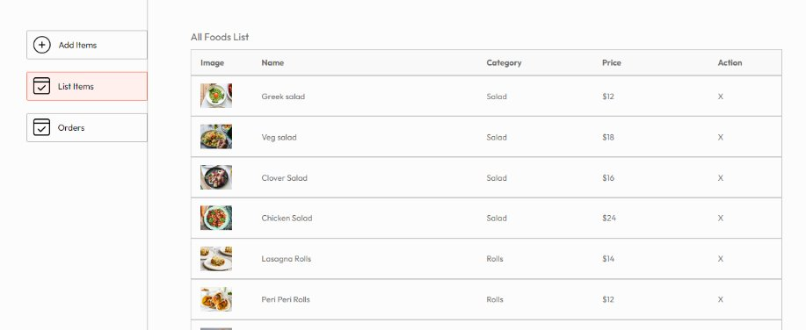
Fig. 6.5: Admin Panel — All Foods List table showing item details with delete action

6.6 Admin Panel — Order Management
The Orders page displays all customer orders in bordered cards. Each order card shows: an orange package icon, the list of ordered items with quantities, the customer's name, delivery address, phone number, item count, and total amount. A status dropdown menu on the right allows administrators to update the order delivery status among "Food Processing", "Out for Delivery", and "Delivered". Status changes are immediately persisted to the database via an API call.
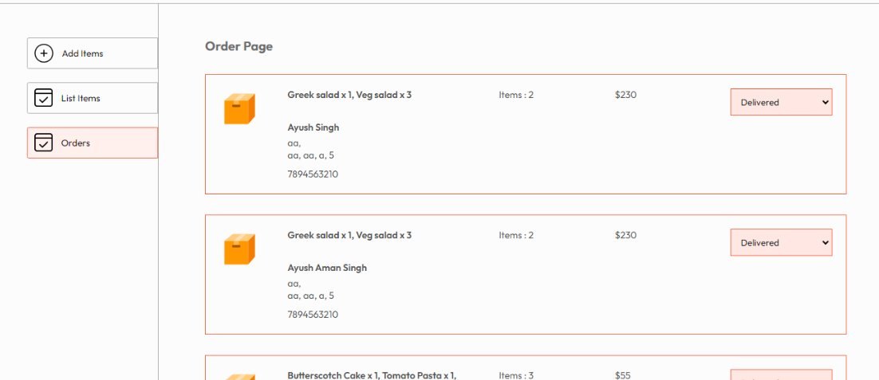
Fig. 6.6: Admin Panel — Order Page with customer details and order status management dropdown

6.7 Stripe Payment Checkout
After filling in delivery details and clicking "Place Order", the user is securely redirected to Stripe's hosted checkout page. The page displays the payment amount in INR (e.g., Rs.1,120.00), an itemized breakdown showing food item subtotal and delivery charges (Rs.160.00), and a complete payment form requiring Email, Card Number, Expiry Date, CVC, Cardholder Name, and Country/Region. The "TEST MODE" banner confirms the integration is using Stripe's sandbox environment. A blue "Pay" button submits the transaction.
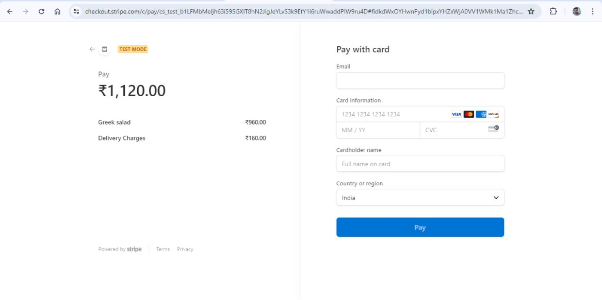
Fig. 6.7: Stripe Checkout page in test mode with itemized order breakdown and payment form

6.8 Frontend — My Orders (Order History & Tracking)
After successful payment verification, users can access the "My Orders" page to view their complete order history. Each order is displayed in a row showing: an orange package icon, the list of ordered items with quantities, the order total, item count, delivery status (shown as a colored dot followed by status text such as "Delivered" in orange or "Food Processing" in orange), and a "Track Order" button. Orders are fetched in real-time from the backend whenever the page is loaded.
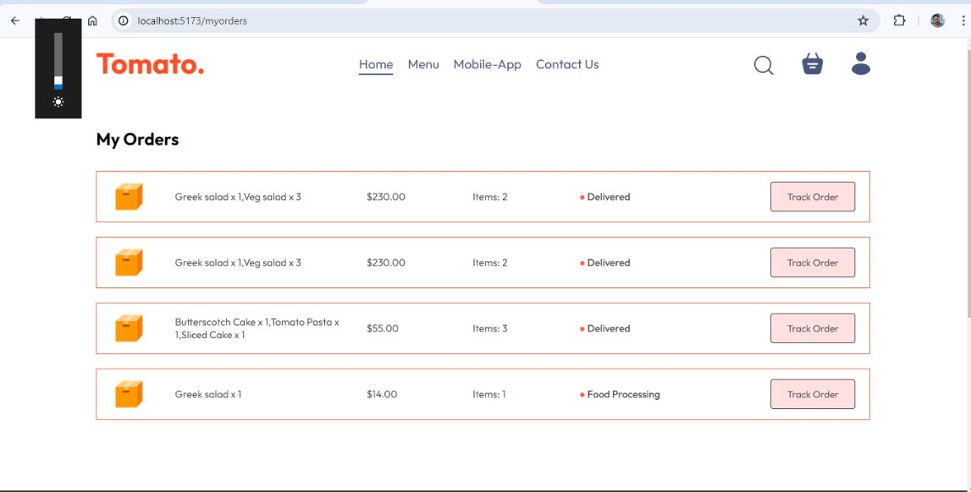
Fig. 6.8: My Orders page displaying order history with status tracking and Track Order buttons

CHAPTER 7: TESTING

7.1 Testing Strategy
The application was subjected to systematic manual testing across all functional modules — User Authentication, Menu Browsing, Cart Management, Order Placement, Payment Processing, Admin Food Management, and Admin Order Management. Each test case was designed to verify both the happy path (expected valid inputs) and edge cases (invalid inputs, unauthorized access, empty states). API endpoints were independently tested using Postman before integration testing with the frontend.

7.2 Test Cases and Results
Table 7.1: Test Cases and Results
ID | Module | Test Case | Input | Expected Output | Status | Result
TC-01 | Registration | Register with valid data | Name, email, password | Account created, JWT token returned | Pass | PASS
TC-02 | Registration | Register with duplicate email | Existing email | "User already exists" error message | Pass | PASS
TC-03 | Registration | Register with invalid email | Invalid format email | "Please enter valid E-mail" error | Pass | PASS
TC-04 | Registration | Register with weak password | Password < 8 chars | "Please enter a strong password" | Pass | PASS
TC-05 | Login | Login with valid credentials | Correct email & password | JWT token, redirect to home page | Pass | PASS
TC-06 | Login | Login with wrong password | Incorrect password | "Invalid Credentials" error | Pass | PASS
TC-07 | Menu | Browse food categories | Click category button | Filtered food items displayed | Pass | PASS
TC-08 | Cart | Add item to cart | Click "+" button | Item added, count incremented | Pass | PASS
TC-09 | Cart | Remove item from cart | Click "−" button | Item count decremented / removed | Pass | PASS
TC-10 | Cart | Cart total calculation | Multiple items in cart | Correct subtotal + $2 delivery fee | Pass | PASS
TC-11 | Order | Place order without login | No JWT token present | Redirected back to cart page | Pass | PASS
TC-12 | Order | Place order with empty cart | Empty cart object | Redirected back to cart page | Pass | PASS
TC-13 | Payment | Stripe checkout redirect | Valid order + delivery info | Redirected to Stripe payment page | Pass | PASS
TC-14 | Payment | Payment success verification | Stripe success callback | Order marked paid, redirect to My Orders | Pass | PASS
TC-15 | Admin | Add food item | Name, desc, price, image, category | Item saved to DB, success toast shown | Pass | PASS
TC-16 | Admin | Delete food item | Click "X" on item row | Item removed from DB and list | Pass | PASS
TC-17 | Admin | Update order status | Select new status in dropdown | Status updated in DB immediately | Pass | PASS
TC-18 | Orders | View order history | Logged-in user navigates to /myorders | All user orders displayed with status | Pass | PASS

7.3 Test Summary
A total of 18 test cases were executed across 7 functional modules. All 18 test cases passed successfully with no critical defects identified. The system correctly handles both valid inputs and error conditions, including duplicate registrations, invalid credentials, empty cart orders, unauthorized access attempts, and payment verification flows. The admin panel was verified for complete CRUD operations on food items and order status management.

CHAPTER 8: CONCLUSION AND FUTURE SCOPE

8.1 Conclusion
The FoodCart: Online Food Ordering Platform was successfully designed, developed, deployed, and tested as a production-ready full-stack MERN application. The project demonstrates the practical implementation and integration of modern web technologies to build a complete, real-world software system.
Key achievements of this project include:
- Complete three-tier web architecture separating client, server, and database concerns cleanly.
- Secure user authentication system using JWT tokens and bcrypt password hashing.
- Real-time cart synchronization between the React frontend and the MongoDB database.
- PCI-compliant online payment processing through Stripe Checkout integration.
- Fully functional admin panel supporting complete CRUD operations on food items and order management.
- Responsive, category-filtered food browsing interface with an intuitive user experience.
- Cloud deployment on Vercel (frontend and admin) and MongoDB Atlas (database) for global accessibility.

The project successfully addresses the stated problem of providing a cost-effective, open-source, customizable food ordering solution for small to medium-scale restaurants. All 18 defined test cases passed successfully, validating the correctness and robustness of the implemented system.

8.2 Future Scope
The following enhancements are proposed as future extensions to the FoodCart platform:
- Real-time Order Tracking: Integrate WebSocket communication (using Socket.io) to deliver live order status updates to customers without requiring manual page refreshes.
- Mobile Application: Develop dedicated native Android and iOS applications using React Native to provide a better mobile experience.
- Advanced Search and Filters: Implement full-text search for food items with additional filters for price range, dietary preferences (vegetarian/vegan), and sort-by options (price, rating, popularity).
- Ratings and Reviews System: Allow customers to rate and review food items after order delivery to build a trust and recommendation system.
- Multi-Restaurant Support: Extend the architecture to support multiple independent restaurants, each with their own admin dashboard and menu management.
- Push Notifications: Implement email and SMS notification triggers for order confirmations, status updates, and promotional offers.
- Analytics Dashboard: Add a comprehensive sales analytics module for admins showing revenue charts, popular items, peak order times, and customer insights.
- Delivery Partner Module: Build a separate interface for delivery personnel to receive assigned orders, update delivery status, and navigate to customer locations.
- Coupon and Discount System: Implement promotional coupon codes and first-order discount functionalities to improve customer acquisition and retention.
- Progressive Web App (PWA): Convert the frontend to a PWA to enable offline browsing capabilities, push notifications, and home screen installation on mobile devices.

REFERENCES
1. MongoDB Documentation. MongoDB Atlas — Cloud Database Service. https://docs.mongodb.com/
2. OpenJS Foundation. Express.js — Fast, Unopinionated, Minimalist Web Framework for Node.js. https://expressjs.com/en/guide/
3. Meta Open Source. React.js — A JavaScript Library for Building User Interfaces. https://react.dev/
4. OpenJS Foundation. Node.js — JavaScript Runtime Built on Chrome's V8 Engine. https://nodejs.org/docs/
5. Stripe Inc. Stripe API Documentation — Payment Processing Platform. https://stripe.com/docs/api
6. Auth0 Inc. JSON Web Tokens (JWT) — Introduction and Specification. https://jwt.io/introduction
7. Mongoose. Mongoose ODM — Elegant MongoDB Object Modeling for Node.js. https://mongoosejs.com/docs/
8. Vite. Vite — Next Generation Frontend Tooling. https://vitejs.dev/guide/
9. Hage, L. Multer — Node.js Middleware for Handling Multipart/Form-Data. https://github.com/expressjs/multer
10. Kossow, N. bcrypt.js — Optimized bcrypt for JavaScript. https://github.com/kelektiv/node.bcrypt.js
11. Remix Software. React Router v6 — Declarative Routing for React. https://reactrouter.com/en/main
12. Axios Contributors. Axios — Promise Based HTTP Client for the Browser and Node.js. https://axios-http.com/docs/intro
13. Vercel Inc. Vercel Deployment Documentation — Deploy Frontend Projects. https://vercel.com/docs

