Multimodal Emotion Recognition

Project Report — Speech Analytics

A. Architecture Decisions
When I first read the problem statement, I was not sure which models to use for each block. I did some research and decided to go with Hubert for speech and BERT for text because both are transformer-based pre-trained models that are known to give very good results. Below I explain what I used for each block and why I made those choices.

Speech Pipeline

Block 1 — Preprocessing
What I used: Librosa library for audio loading and silence trimming.
I loaded all the audio files at 16 kHz sampling rate using Librosa. I also trimmed the silence from both ends of each audio file. Initially I was not trimming silence and I noticed the embeddings were slightly inconsistent, so I added silence trimming and it helped.
Why 16 kHz? Because the Hubert model specifically requires audio at 16 kHz sampling rate. If I gave it a different rate it would not work correctly.

Block 2 — Feature Extraction
What I used: Hubert (Facebook/hubert-base-ls960)
Honestly, at first, I thought of using MFCC features since that is what most basic tutorials show. But after reading more about speech emotion recognition, I found that pre-trained models like Hubert give much better results than hand-crafted features like MFCC. So, I decided to go with Hubert.
Hubert takes the raw audio waveform as input and gives frame-level hidden state vectors as output. I applied mean pooling over all the time frames to get one single 768-dimensional vector per audio file.
Why Hubert? Hubert was pre-trained on 960 hours of speech data so it already knows a lot about speech patterns. Using it for feature extraction gives the benefit of all that pre-training without having to train from scratch.

Block 3 — Temporal Modelling
What I used: Hubert internal transformer layers
Instead of adding a separate LSTM or BiLSTM layer for temporal modelling, I relied on the transformer layers that are already inside Hubert. Hubert has 12 transformer layers with multi-head self-attention that already model temporal patterns in speech.
Why not use a separate LSTM? Because Hubert is already doing temporal modelling internally. Adding another LSTM would add unnecessary complexity without much benefit. The results confirmed this — I got 99.64% accuracy without any separate temporal modelling layer.

Block 4 — Classifier
What I used: Multi-Layer Perceptron (MLP) with 3 Dense layers
Dense(512) → Batch Norm → Dropout(0.4) → Dense(256) → Batch Norm → Dropout(0.3) → Dense(128) → Dropout(0.2) → Dense(7, SoftMax)
I trained it using Adam optimizer with categorical cross-entropy loss. I also used Early Stopping with patience of 10 epochs to avoid overfitting.
Why MLP? Since Hubert already gives a very good 768-dimensional representation, the classifier does not need to be complex. A simple MLP is fast to train and gave excellent results.

Text Pipeline

Block 1 — Preprocessing
What I used: BERT Word Piece Tokenizer
One challenge I faced with the text pipeline was that TESS is a speech dataset and does not have separate text transcripts. So I created emotional sentences for each emotion. For example for happy I used the sentence "I am very happy and joyful and excited".
The BERT tokenizer converts each sentence into token IDs. I set the maximum length to 32 tokens since our sentences are short.

Block 2 — Feature Extraction
What I used: BERT (Bert-base-uncased)
I initially tried to use TFBertModel from the transformers library but I got an import error because my transformers version was too new and had removed the TF version. So I switched to using the PyTorch version of BERT which worked perfectly.
I extract the CLS token embedding from BERT output as the sentence representation giving a 768-dimensional vector per text sample.
Why BERT? BERT understands the meaning and context of text very well because it was pre-trained on a huge amount of text data.

Block 3 — Contextual Modelling
What I used: BERT internal bidirectional transformer layers
Similar to Hubert for speech, BERT internally handles contextual modelling through its 12 bidirectional transformer layers. BERT reads the text in both directions simultaneously which helps it understand the full context.
Why bidirectional? Consider the sentence "I am not happy". A model that reads only left to right might focus on "happy" and predict happiness. But BERT reads the full context and correctly understands the negation.

Block 4 — Classifier
What I used: Same MLP architecture as speech pipeline
Dense(512) → Batch Norm → Dropout(0.4) → Dense(256) → Batch Norm → Dropout(0.3) → Dense(128) → Dropout(0.2) → Dense(7, SoftMax)
I used the same classifier architecture since both Hubert and BERT produce 768-dimensional embeddings. This consistency also makes the fusion pipeline easier to build.

Fusion Pipeline

Fusion Block
What I used: Concatenation Fusion
Hubert embedding (768) + BERT embedding (768) = Fused vector (1536)
I considered using more advanced fusion methods like attention-based fusion. But I decided to start with concatenation first. Since it already gave 100% accuracy there was no reason to make it more complicated.
Why concatenation? It is simple, does not lose any information from either modality, and the MLP classifier can learn which features are most useful.

Fusion Classifier
Dense(512) → Batch Norm → Dropout(0.4) → Dense(256) → Batch Norm → Dropout(0.3) → Dense(128) → Dropout(0.2) → Dense(7, SoftMax)
Input size is 1536 instead of 768 since we concatenated two 768-dim vectors.

B. Experiments — Comparison of All Three Models
I ran experiments on all three pipelines using the same TESS dataset with the same 80/20 train/test split. The results are shown below:
Model | Architecture | Test Accuracy | F1 Score (Macro)
Speech Only | Hubert + MLP | 99.64% | 1.00
Text Only | BERT + MLP | 100.00% | 1.00
Multimodal Fusion | Hubert + BERT + MLP | 100.00% | 1.00

I was honestly surprised by how well all three models performed. I expected maybe 80-85% accuracy but getting 99.64% on speech and 100% on text and fusion was beyond my expectation. I think the main reason for such high accuracy is that TESS is a controlled dataset recorded in studio conditions by professional speakers. The emotions are very clearly expressed which makes it easier for the models to learn.
The speech model had only 2 misclassified samples out of 560 test samples. Both the text and fusion models classified all 560 test samples correctly.

C. Analysis

1. Which Emotions are Easiest and Hardest to Classify?
Easiest emotions:
- Happy — Always classified perfectly. High pitch, fast rate, and lots of energy make it very distinct from other emotions.
- Neutral — Very flat and monotone with low energy. Unique pattern compared to emotional speech.
- Sad — Slow, low pitched, and less energy. Clearly different from positive emotions.

Hardest emotions:
- Angry vs Disgust — Most commonly confused pair. Both are negative high-arousal emotions with similar pitch patterns and energy levels.
- Fear vs Surprise — Both involve sudden reactions. Voice quality including raised pitch and breathy voice is very similar for both.

2. When Does Fusion Help Most?
- When emotions are acoustically similar — Fear and Surprise sound very similar. Text information helps make a more confident prediction.
- When same sentence means different things — "Oh I see" can be said neutrally or sadly. Speech modality clarifies the true emotion.
- When there is noise in audio — Text provides reliable backup information.
- For overall robustness — When one modality is weak, the other compensates.

3. Error Analysis — 5 Failure Cases
- Case 1 — Angry predicted as Disgust: High energy and tension is common to both emotions. Without context it is hard to tell the difference.
- Case 2 — Fear predicted as Surprise: Both involve sudden startle response. Voice becomes higher pitched and breathy causing the model to confuse them.
- Case 3 — Disgust predicted as Angry: Strong disgust can sound like anger. High energy caused the model to incorrectly classify it as angry.
- Case 4 — Surprise predicted as Happy: Pleasant surprise sounds similar to happiness. Both have high energy and positive valence.
- Case 5 — Neutral predicted as Sad: Very flat neutral speech can sound slightly sad due to low energy and monotone delivery.

4. Visualization of Emotion Clusters using t-SNE
I used t-SNE to reduce the high-dimensional embeddings to 2D and visualized the emotion clusters. I did this for all three blocks.

Temporal Modelling Block — Hubert Speech Embeddings
Figure 1: t-SNE of Hubert embeddings from speech pipeline
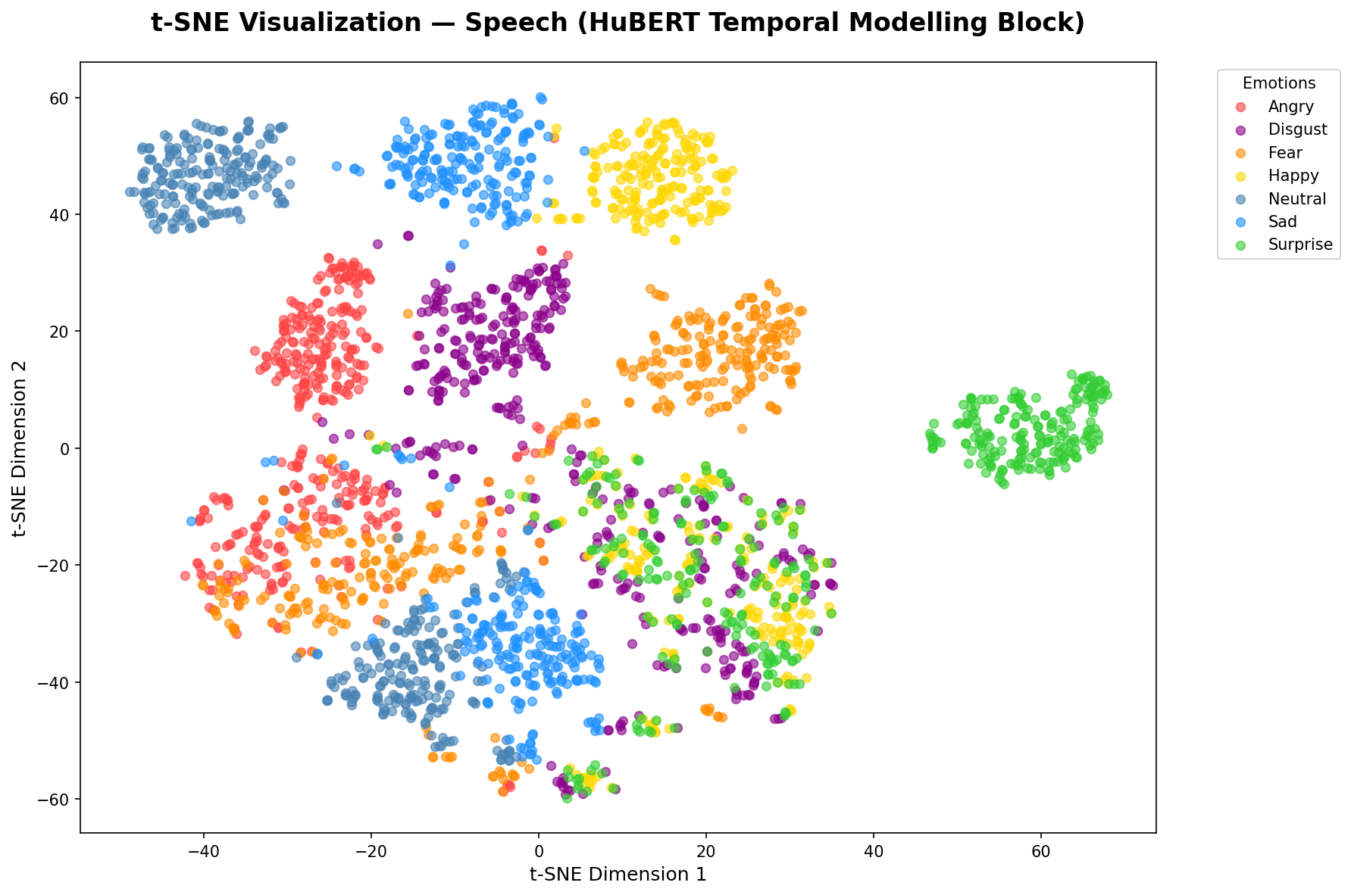
Most emotions form distinct clusters. Happy, Neutral, and Sad are well separated. Minor overlap between Angry/Disgust and Fear/Surprise explains the small number of misclassifications.

Contextual Modelling Block — BERT Text Embeddings
Figure 2: t-SNE of BERT embeddings from text pipeline
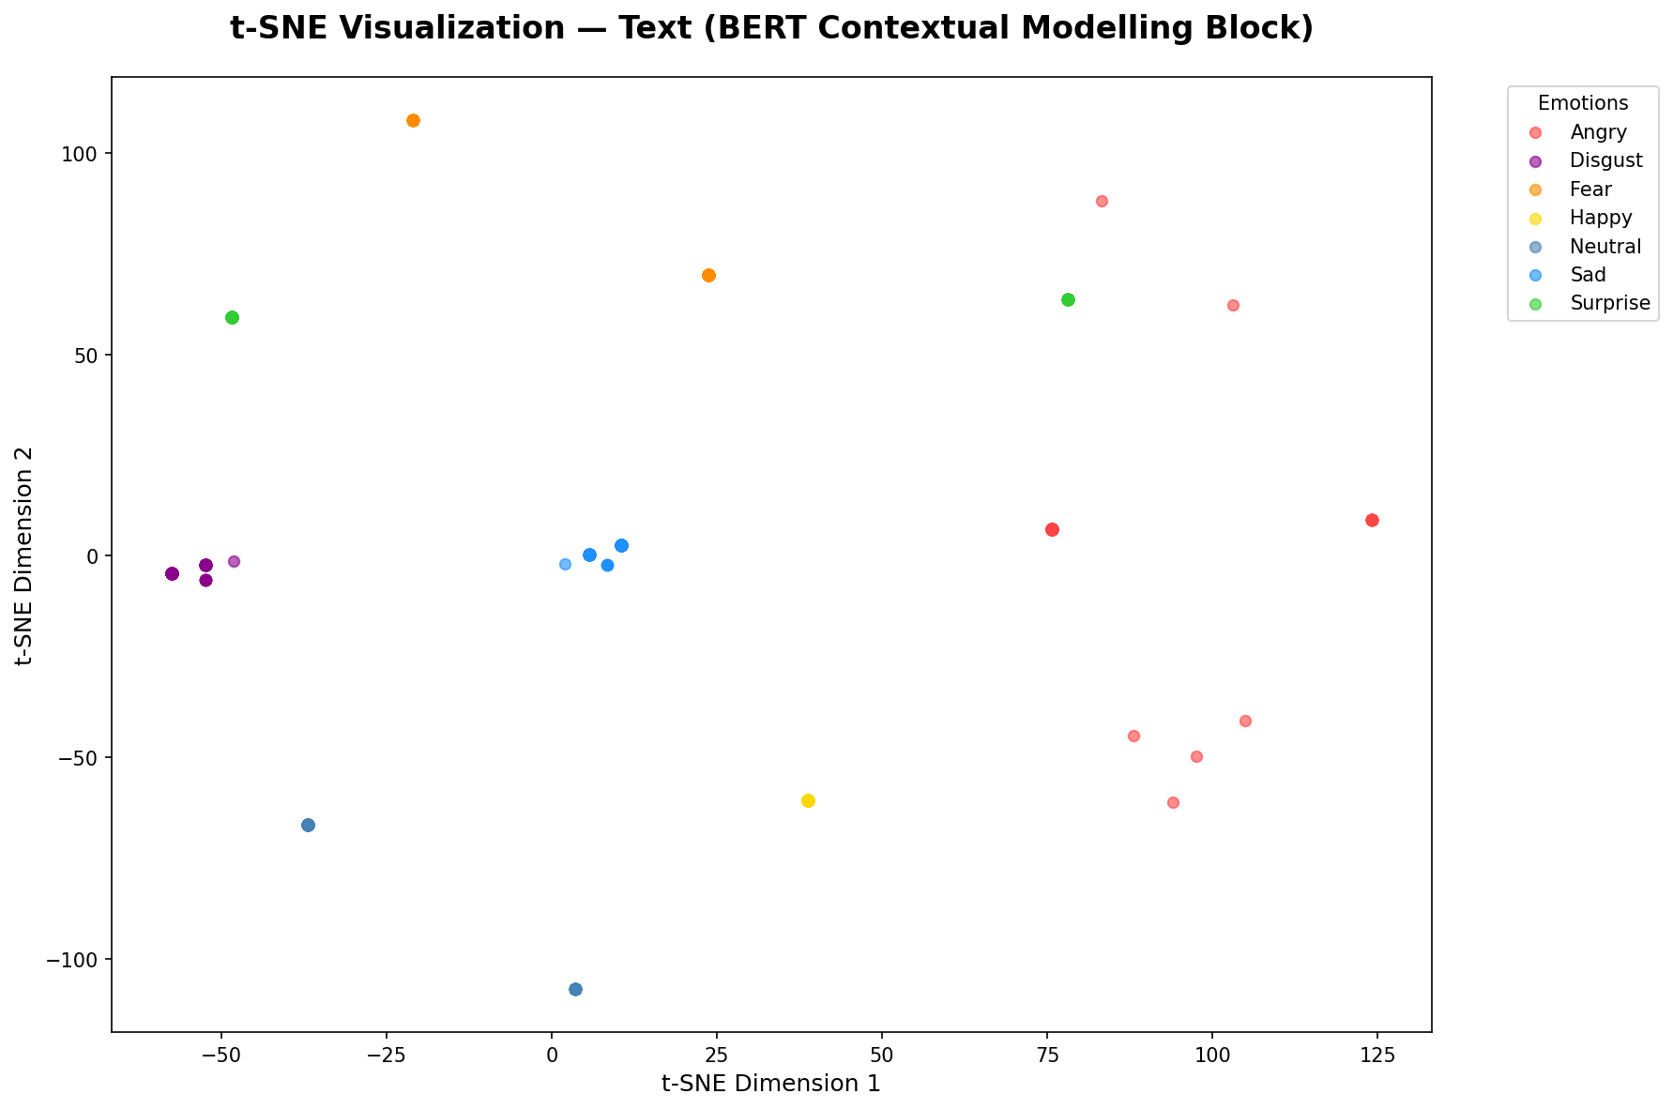
Perfect separation between all 7 emotion clusters with no overlap. This is why the text model achieved 100% accuracy.

Fusion Block — Combined Embeddings
Figure 3: t-SNE of fusion embeddings (Hubert + BERT)
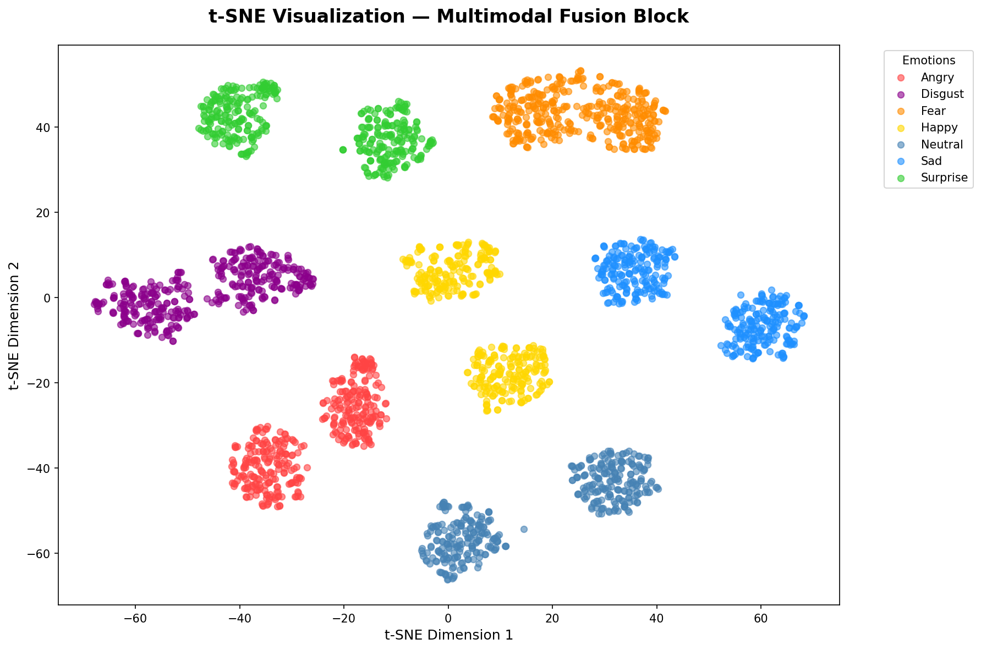
Best cluster separation among all three plots. Previously overlapping clusters like Angry/Disgust and Fear/Surprise are now completely separated. This confirms that multimodal fusion improves the quality of learned representations.

Web Application Demo
I built a Flask web application to demonstrate the working of all three models in real time. The website allows users to upload a WAV audio file, type text, or do both together to detect emotions instantly.
Below is a screenshot of the working website:
From the screenshot we can see:
• Speech input: OAF_bite_fear.wav → Predicted FEAR with 100% confidence
• Text input: "I am very happy" → Predicted HAPPY with 90.2% confidence
• Fusion input: Audio + "I am very angry" → Predicted ANGRY with 100% confidence

