**Locators:-**

##### For Reference ######

// public By = By.id("");

// public By = By.xpath("");

// public By = By.name("");

// public By = By.classname("");

// public By = By.linktext("");

// public By = By.partiallinktext("");

// public By = By.tagname("");

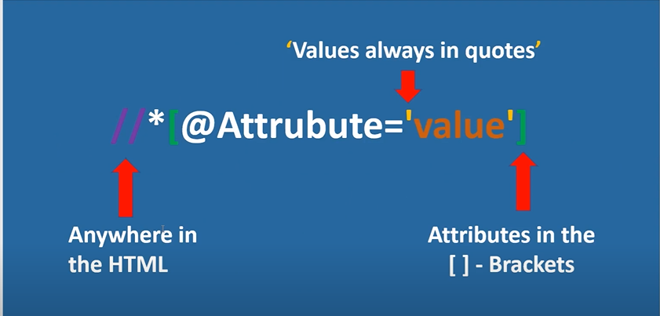

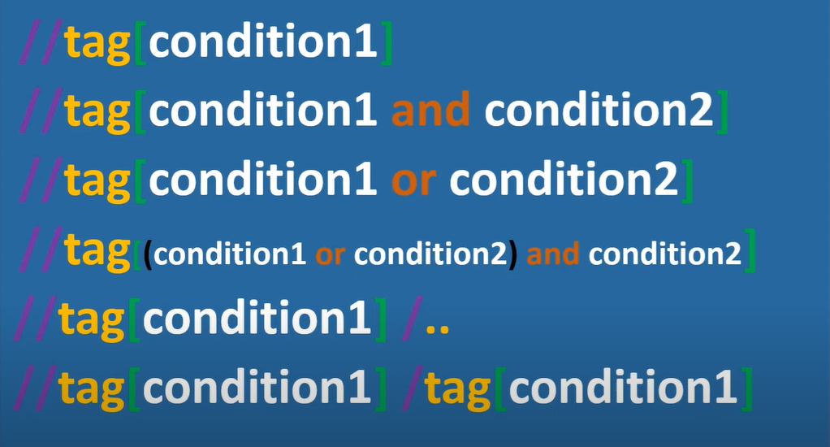

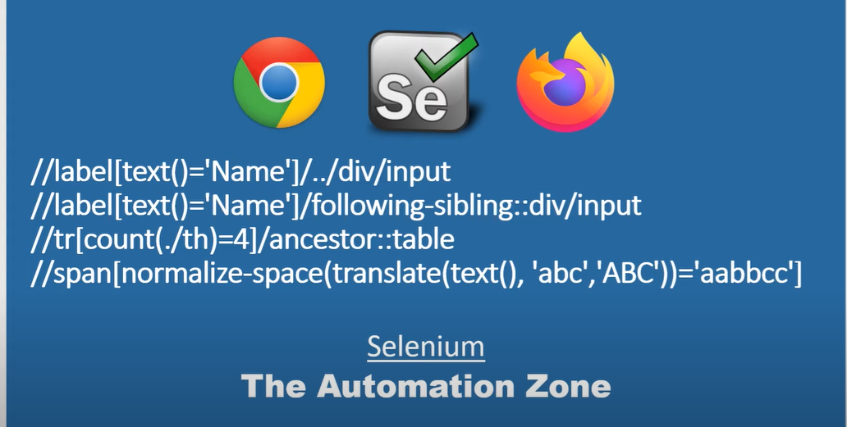

Note:- If you don’t have static attribute in present but you will have in child then use the below methods

1) //tag [ Immediate Child static xpath ]🡪 Locate the parent element

2) //tag [ .//Child xpath]🡪 locate the parent element

**XPaths:**

1. Basic XPath:

//tagname[@AN=’AV’]

### Contains() and Starts-with

**Contains()** is a method used in XPath expression. It is used when the value of any attribute changes dynamically,

Xpath=//*[contains(@type,'sub')]

**XPath starts-with()** is a function used for finding the web element whose attribute value gets changed on refresh or by other dynamic operations on the webpage

For example -: Suppose the ID of particular element changes dynamically like:

Id=" message12"

Id=" message345"

Id=" message8769"

Xpath=//label[starts-with(@id,'message')]

### Using OR & AND:

In OR expression, two conditions are used, whether 1st condition OR 2nd condition should be true. It is also applicable if any one condition is true or maybe both. Means any one condition should be true to find the element.

Xpath=//*[@type='submit' or @name='btnReset']

In AND expression, two conditions are used, both conditions should be true to find the element. It fails to find element if any one condition is false.

Xpath=//input[@type='submit' and @name='btnLogin']

### XPath Text() Function

The **XPath text() function** is a built-in function of selenium webdriver which is used to locate elements based on text of a web element. It helps to find the exact text elements and it locates the elements within the set of text nodes. The elements to be located should be in string form.

Xpath=//td[text()='UserID']

### XPath axes methods:

### These XPath axes methods are used to find the complex or dynamic elements. Below we will see some of these methods.

### Remove space in attribute value by using normalize-space function

### Note:- It should remove the space start and end space only, It will not remove mid space between the value

### //tag[normalize-space(@AN=’Value’)]

### 

### 

### Covert the attribute value into upper or lower case

### //tag[translate(@AN , ‘A-Z’, ‘a-z’)= ‘Attribute value’🡪 Convert from upper to lower

### //tag[translate(text() , ‘a-z, ‘A-Z’)= ‘Attribute value’🡪 Convert from LOWER to Upper

### 

### 

### Convert cases and remove space in the attribute value

### //tag[normalize-space(translate(@AN , ‘A-Z’, ‘a-z’))= ‘Attribute value’

### 

### Floor Function is used to round off the text value

### 

### Tree Structure

### Parent:-It used to traverse child from its Immediate parent same as /.. function.

### 

### ancestor:- It is used to traverse from child to any Parent.

### 

### following:- It is used to traverse below of the matching element in the whole html

### 

### following-sibling:- It is used to traverse below of the matching elements within the same tag or only siblings.

### 

### preceding:- It used to traverse above from the matching elements in the html.

### //tag[Xpath]/preceding::tag

### preceding-sibling:- It is used to traverse above from the matching element within the same tag .

### //tag[xpath]/preceding-sibling::tag

**Xpaths:- Ross Application Geneic Xpaths**

**1) Text Box**

//span[text()='{0}']/ancestor::label/following-sibling::div[contains(@class, 'x-form-text-field-body-default ')]//input

2) Grid inside another grid xpath

//div[@ref='rootWrapperBody']/following::div[@row-index='”+RowIndex+”']/div[“+ColumnIndex+”]

// ##### For Reference ######