**J-Meter**

1. Install Jmeter by accessing below link

<https://archive.apache.org/dist/jmeter/binaries/>

Steps:-

1. Extract the Zip file
2. Install Jmeter plugins manager by downloading plugins

<https://jmeter-plugins.org/install/Install/>

Steps:-

1. After downloading place that file under lib/ext location in the Jmeter file.

Once Jmeter and plugins installed launch the Jmeter.

Steps to launch the Jmeter

1. Go to C:\apache-jmeter-5.4\bin and launch

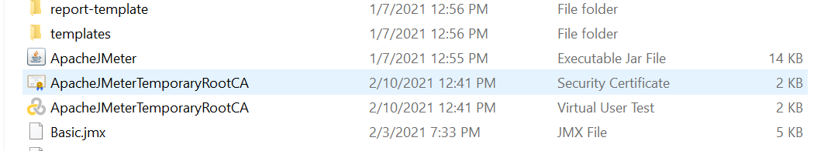

1. UI Should be displayed like this

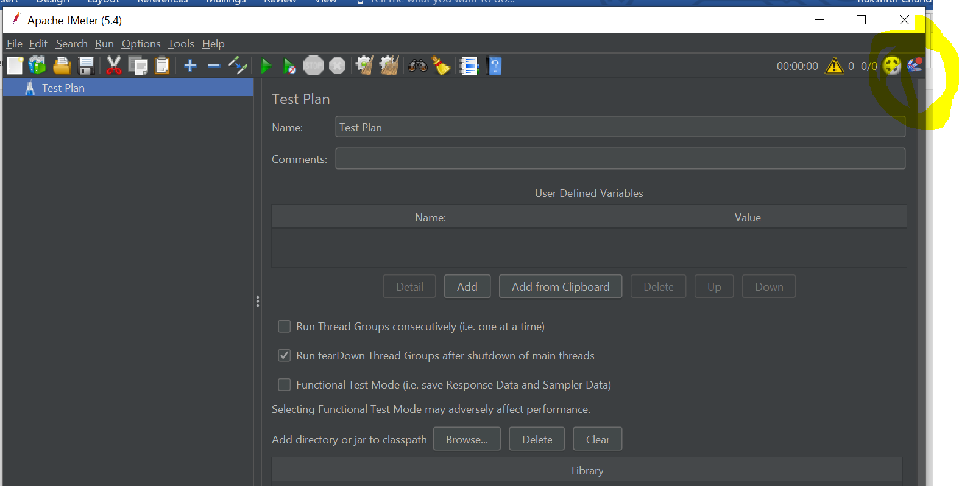

Note:- That highlighted icon should be displayed only when the plugins were installed correctly.

**How to install plugins:-**

1. Click on that plugin icon in the Jmeter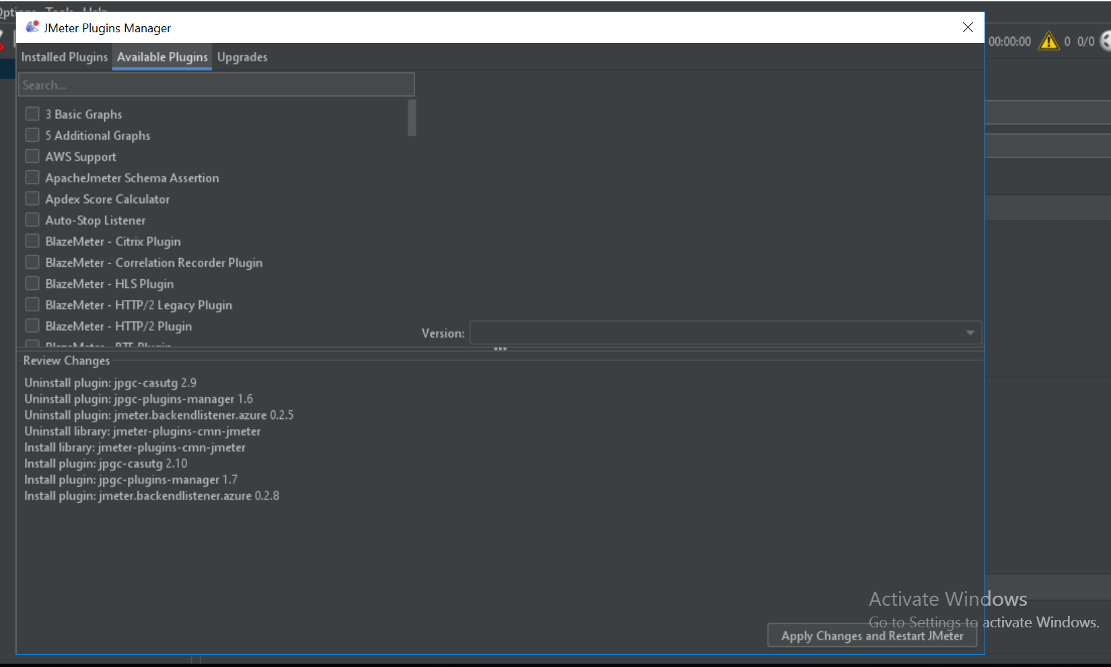
2. Search for the required plugins in the Available Plugins tab.
3. Required plugins:-
4. Custom thread groups:- This thread groups will provide different types of thread groups, It will used in the execution.
5. Listeners:-

Azure backend listener, Elastic search backend listener, Graphs generator listener, Promethus listener.

J-Meter is a open source performing testing tool.

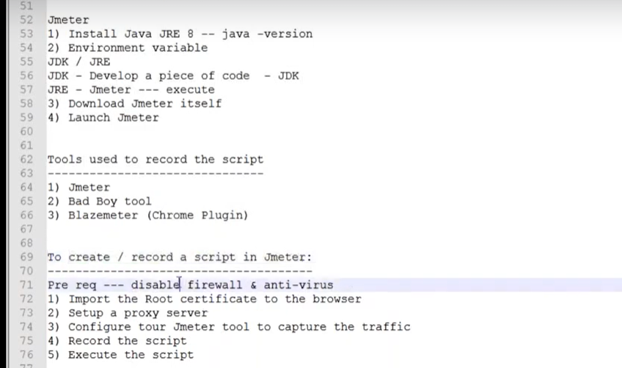

**Jmeter Components:-**

1. **Test Plan:-** It’s a parent component which contains all the child components like Thread groups , Samplers , Pre-processor, Post-Processor , global parameters , CSV Files ,etc.
2. **Thread group:-** is used run our scripts, and each scenarios need’s to be created under the tread groups.
3. **Samplers:-** is a component which used to send a request to server.
4. **Listeners:**- are used to see the results and output.
5. **Controller :**- is used to group or combine all the samplers to one place.
6. **Transaction Controller:**- It will capture the response time.
7. **Pre-Processor:-** It is the process which you are doing before the request send to server.

**Ex:**- Parameters.

1. **Post-Processor:-** It is the process which you will do after the response come from the server.

**Ex:**- Capture the value and save it in variable (Correlation)

**Correlation in Jmeter:-**

1. Identify the dynamic values by comparing 2 scripts with same flow.
2. Search the Identified value in the recording view result tree

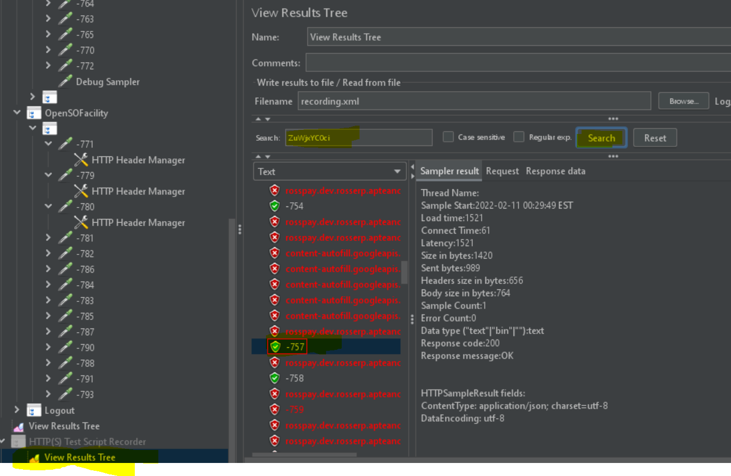

1. Select 1st occurrence and search the same value to get LB And RB

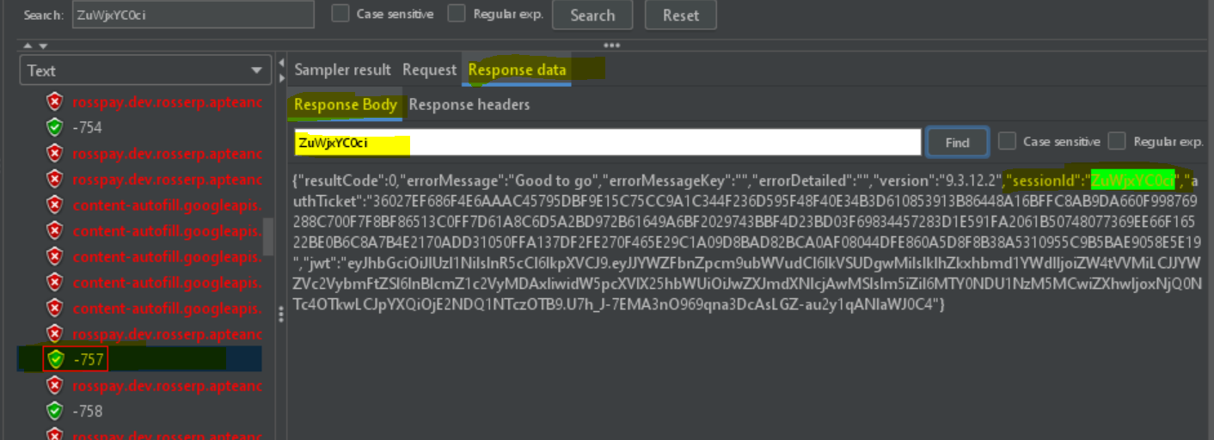

1. Verify with LB And RB Whether that value will be captured or not

Select Boundary extractor tester in the drop down then enter LB AND RB

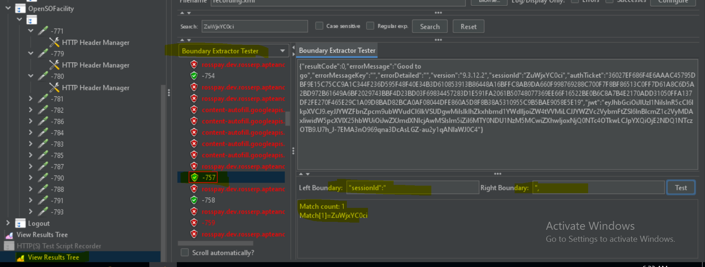

1. Add boundary extractor in the same request which you were getting dynamic value

Add🡪Post Processor🡪 Boundary extractor

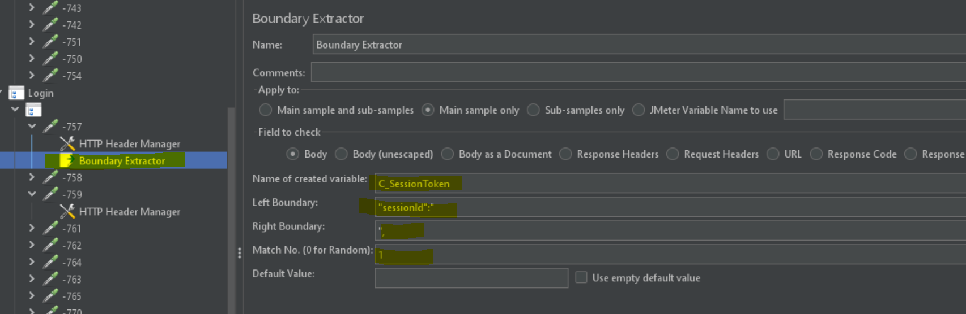

1. Replace the value in samplers or request

Ctrl+f then enter value in search box which needs to be replace and enter the correlation variable in ${C_Variable} in the replace by field then click replace all button

