**Controller**: Used to execute the Scripts. Here we set the scenario.

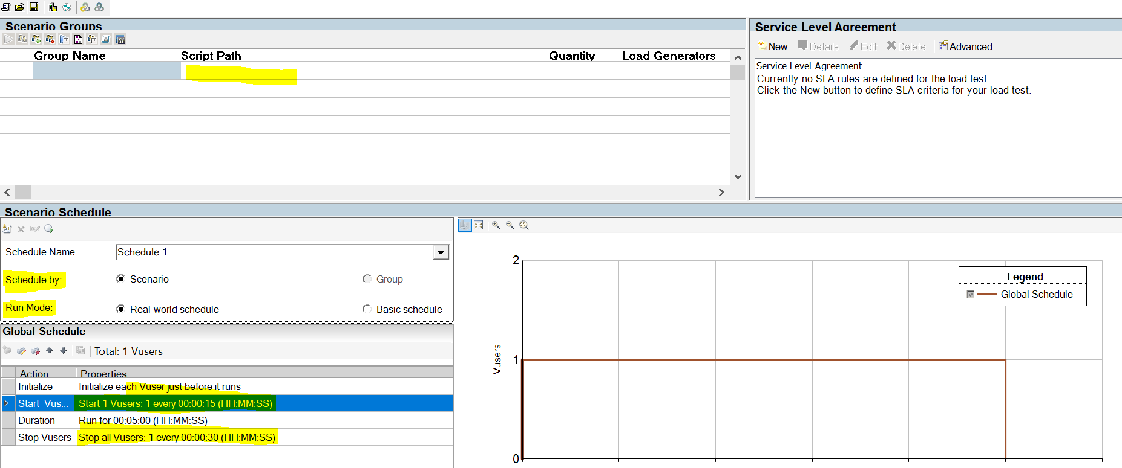

1. We can set Real word and Basic Schedule in run mode option

|  |  |
| --- | --- |
| **Real word schedule** | **Basic Schedule** |
| We can’t change Vusers load directly. | We can change Vusers load Directly. |
| Here we can increase the Vusers every time like after 5min duration 10 users. | Here we can’t increase the Vusers. |
| Here we can do stress testing, scalability Testing, spike testing. | Here we can do only load testing and Endurance Testing. |

1. Schedule by group and schedule by schedule option.

* **Schedule By Group:** If customer wants to run the scenarios consecutively then we go for Schedule by group.
* This can be used by Stress and Spike test

**Ex:** Each scenarios will create each group

Suppose if we have 15 scenarios , 15 groups are created

* Each group will have different scenario.

**Schedule By Scenario:** When customer wants to run scenarios simulteniously

Then we go for schedule By Scenario.

* All scenarios will have 1 group
* This can be used in Load and Endurance Test.

**In the Global schedule we can set ramp up and ramp down timings for Vusers**

**Ramp up:** Here we set the timings for Vusers login.

**Ramp down:** Here we can set timings for Vusers signoff.

**Load Test Sceanrio:-**

**Stress Test Scenario:-**

Here we go with Schedule by group and Real world schedule

Note:- In the schedule by group we Have to set the scenario for each Script

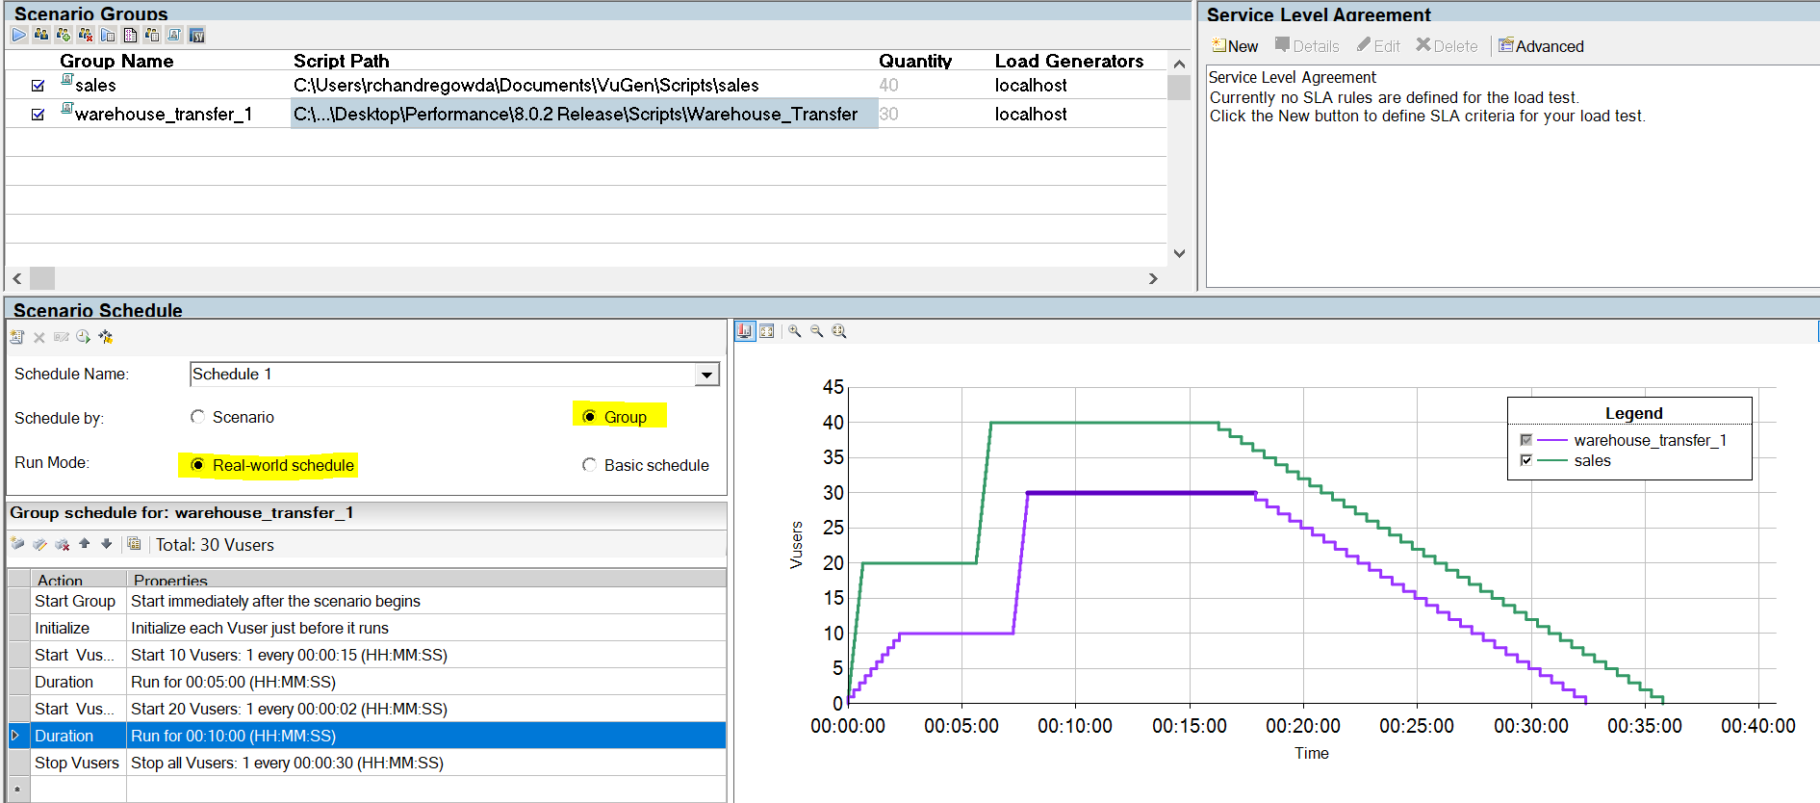

**Run-Time settings:**

1. **Pacing:**

Transaction per each user= No.of transaction per hour/No.of users

Time for each iteration= 3600/Transaction per each user

Pacing=Time for each iteration-(Response Time+ Think Time)

Response Time= Time taken to run 1 iteration in Vugen.

Think Time = Time you given between the transactions.

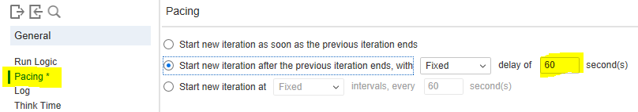

1. **Log setting**

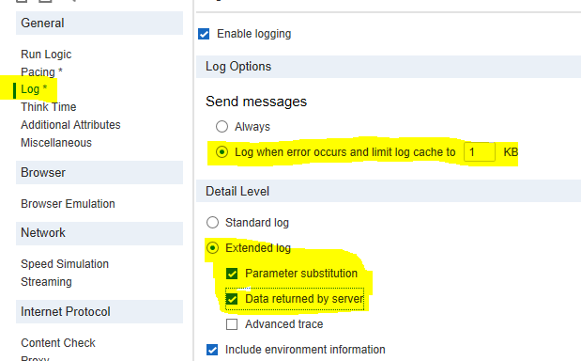

1. **Think Time:**

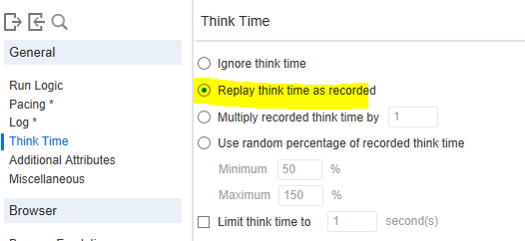

1. **Miscellaneous:**

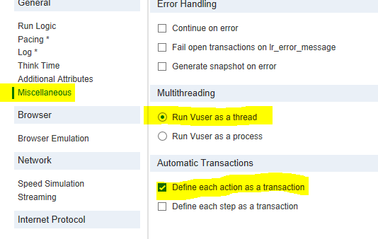

1. **Browser:** unselect simulate a new user on each iteration.

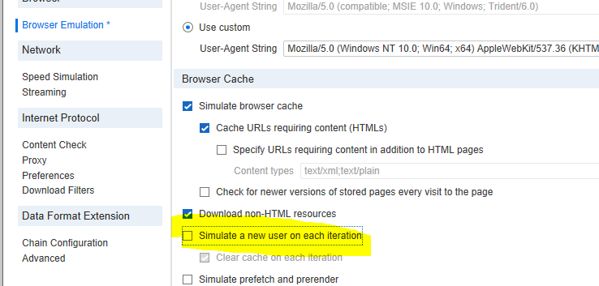

**Rest of options go with default settings**

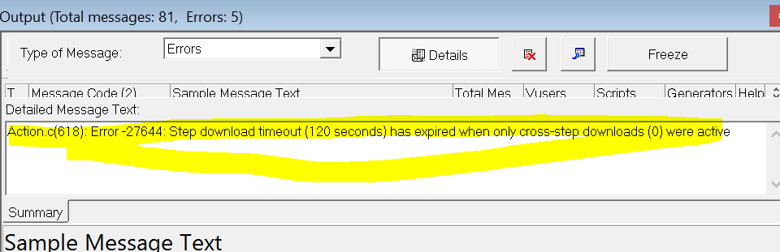

Resolution1: Go to Run Time settings🡪 Browser Emulation🡪Uncheck Download Non-html resource.

Resolution2: Run Time settings🡪Preferences🡪General🡪Increase step download Timeout to 999 or 360.

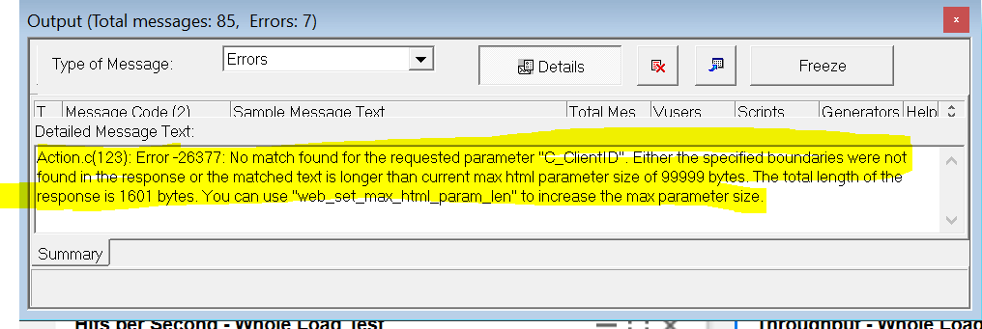

**Resolution:** Co-relation is not required if it is failing in every iteration , Suppose if it failing in few iteration then check with parameter.

1. If we got the below error

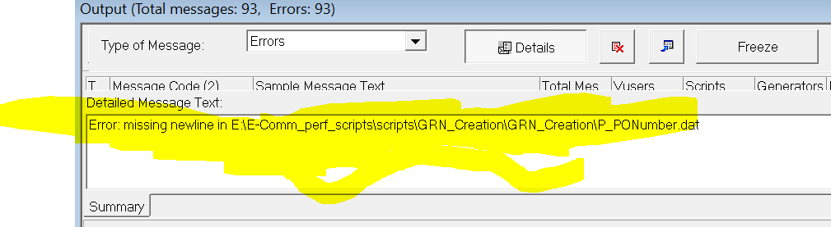

**Resolution:** Remove the space in last parameter and Hit enter save the parameter List.

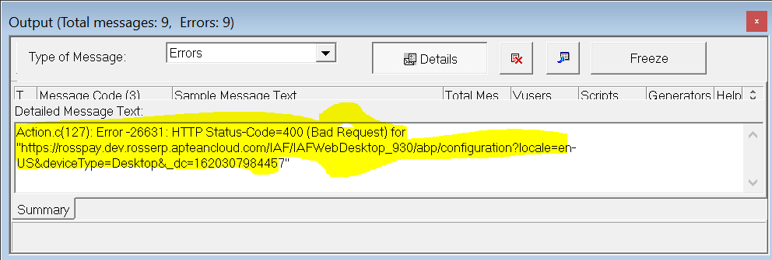

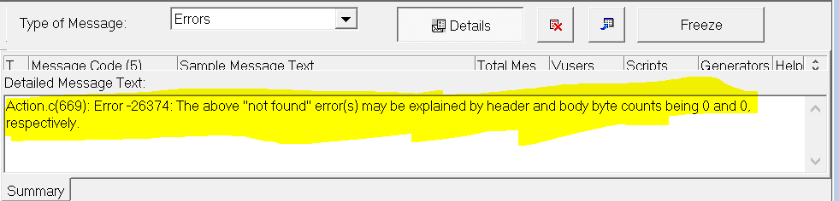

**How to monitor DB and App server in Azure potal**

1. Open the Azure portle.
2. Open VM’s.
3. Click on insights in monitoring.
4. Click on the performance tab.(If it is not enabled then you should enable).

**How to calculate Memory Utilization**

Utilization= Max-Min

%Utilization= (Utilization/Max)*100