**Performance Testing Steps:**

1. VuGen: Here we are doing the scripting part.
2. Controller: Here we do the execution.
3. Analysis: Here we analyze the results and Co-relate with customer req.

**How to do scripting in VuGen**

1. Create New script and solution.

File->New Script And solution.

1. Record the script just change url wrt release.

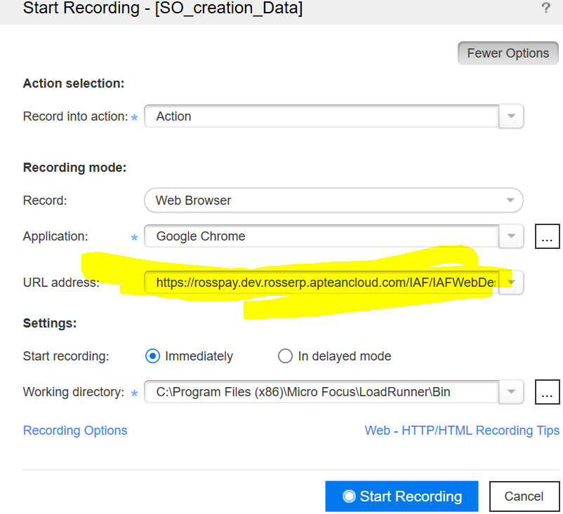

1. Record 2 times with same scenario and compare the scripts find out the dynamic values

Tools—Compare—Compare with external file.

Max Number snapshot-->web_set_max_html_param_len("value");

1. **Co-relate for that dynamic value**.

* Ctrl+F, search for the find all snapshot and open the 1st response Note down LB & RB.
* Then apply the Co-relation function.

Web_reg_save_param(“Name”,”Lb=”,”RB=”,”ORD=ALL”,LAST);

* Replay the script before that change the Runtime settings🡪Log🡪Extended log should be selected and select parameter substitution and data return by the server.
* Then check in the output the co-relation value got captured or not if it captured then replace that value with co-relation name.
* Cltr+H then put value and give the same variable name given in the co-relation.

1. Parameterize for the value you are passing

* Right click on the value in the script—>Replace with parameter🡪Create New parameter

1. Once all co-relation and parameterization done then Replay the script.
2. Then validate the errormessage in output

* Validate Number got created or not Like SO, PO And Transaction Number.

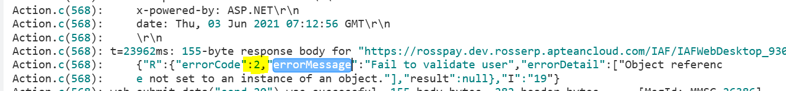

* If you see that error count has “0” then it working fine.
* If you see in the number then we need to validate that request whether we are getting error in the recording response if we are getting same error in both the replay and recording response then its fine.
* If we are getting different response in both recording and replay response then we need to identify the co-relation value then we have to follow co-relation steps.

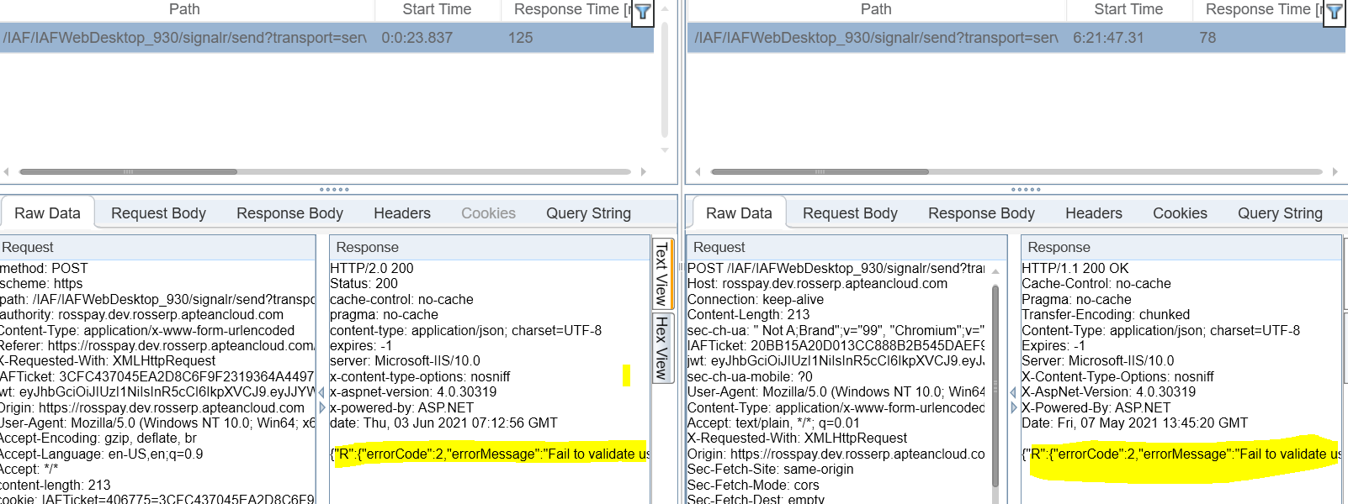

**File Operations:-**

long FileVarriable;    
char FileLocation[1024] = “C:\\Users\\VinayPrasad\\Desktop\\PT_Test.txt”;

Action()  
 {  
     
     FileVarriable = fopen (FileLocation,”w+”);  
     fprintf (FileVarriable, “%s \n”, lr_eval_string(“{PT_Param}”));   
     fclose (FileVarriable);  
       
    
     return 0;  
 }

**Note:**

**FileVarriable**– It is a variable which open file for reading/writing etc..

**FileLocation**– This variable keeps the file location.

**fprintf** function- sends formatted output to a stream.

**{PT_Param}**– This is parameter which is keeping the different values at each Iterations.

fopen (FileLocation,”**w+**“)- Here **w+ is the mode**, which instruct the data to follow action accordingly.

**“r”** –Opens a file for reading. The file must exist.  
**“w”** –Creates an empty file for writing. If a file with the same name already exists, its content is erased and the file is considered as a new empty file.  
**“a”** –Appends to a file. Writing operations, append data at the end of the file. The file is created if it does not exist.  
**“r+”** –Opens a file to update both reading and writing. The file must exist.  
**“w+”** –Creates an empty file for both reading and writing.  
**“a+”** –Opens a file for reading and **appending**.

**Common errors while doing scripting part:**

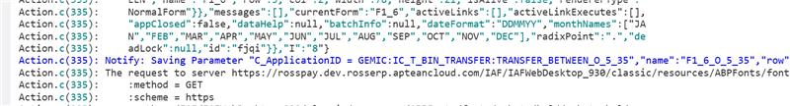

**Resolution:** In the Co-relation function add “ORD=All” argument and check in which number you are getting co-relation element then replace the number.

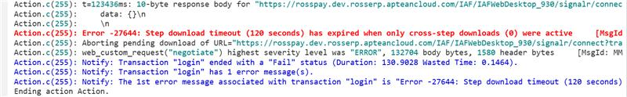

**Resolution:**

Go to Run-Time settings,  
  
Go to Internet Protocol -> Preferences and select the "Options" button,  
  
Change the "Step DownLoad Timeout (secs)" from the default value of 120 seconds to the desired value.

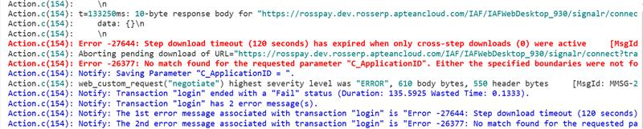

**Resolution:** Check for next response find out LB And RB.