Android app creation using excel

Hello,

Here I have created an app which is used to read data from the excel (xls) version and display it in the app screen.

Here I used Java in Android Studio for creating this app.

I have hosted the xls file in the github for the retrival of data.

You can see the project in this like given below:

<https://github.com/rakshithkalmadi/Excel2AndroidApp>

Here are the two sample images of it:

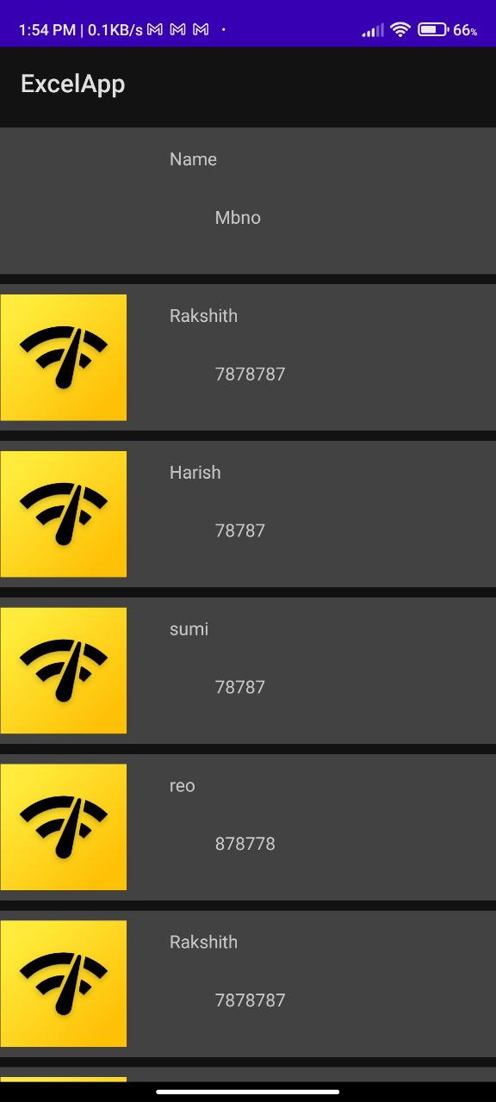 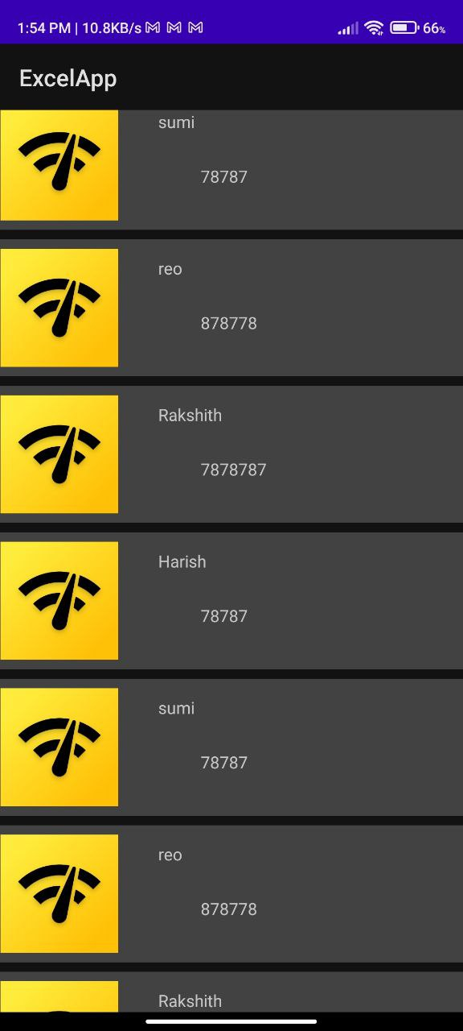

The picture of the excel file is given below:

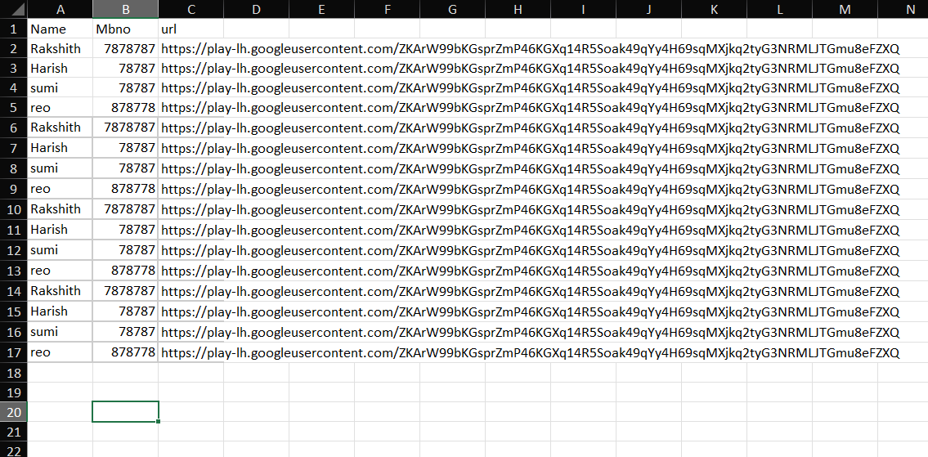

So, these data are displayed in the table.

It is the beginning stage of the app and to show that it works.

We can add many other details in the excel and show it in the app also.

Here if we give the link of the image then the image will be displayed otherwise it will not be displayed and the space will be left blank

This was created watching YouTube video and some blogs in the stack overflow and other blogs when encountered some errors.

There are some of the things to remember while creating this app:

It works fine only when you upload it to github or other hosting it will not work for google sheets or drive.

It works fine only for the xls older version of the excel and will not be compitable with the newer version of the excel it will give error soo search for xlsx to xls converter in online and use that excel file.

You have to add these three dependencies in the build (app):

implementation 'net.sourceforge.jexcelapi:jxl:2.6.12'  
implementation 'com.loopj.android:android-async-http:1.4.11'  
implementation 'com.squareup.picasso:picasso:2.8'

These are required to convert the excel and the Picasso is used to display the image.

And the async http is used to get the file.

Codes:

Adapter.java:

import android.content.Context;  
import android.util.Log;  
import android.view.LayoutInflater;  
import android.view.View;  
import android.view.ViewGroup;  
import android.widget.ImageView;  
import android.widget.TextView;  
  
import androidx.annotation.NonNull;  
import androidx.recyclerview.widget.RecyclerView;  
  
import com.squareup.picasso.Picasso;  
  
import java.util.List;  
  
public class Adapter extends RecyclerView.Adapter<Adapter.ViewHolder> {  
  
 LayoutInflater inflater;  
 List<String> titles,description,imageUrl;  
 public Adapter(Context context, List<String> titles, List<String> description, List<String> imageUrl){  
 this.inflater = LayoutInflater.*from*(context);  
 this.titles = titles;  
 this.description = description;  
 this.imageUrl = imageUrl;  
  
 Log.*d*("TAG","Adapter"+titles);  
  
  
 }  
 @NonNull  
 @Override  
 public ViewHolder onCreateViewHolder(@NonNull ViewGroup parent, int viewType) {  
 View view = inflater.inflate(R.layout.*custom_layout*, parent, false);  
 return new ViewHolder(view);  
 }  
  
 @Override  
 public void onBindViewHolder(@NonNull ViewHolder holder, int position) {  
 String title = titles.get(position);  
 String desc = description.get(position);  
 String img = imageUrl.get(position);  
  
 holder.title.setText(title);  
 holder.content.setText(desc);  
  
 Picasso.*get*().load(img).into(holder.listImg);  
  
 }  
  
 @Override  
 public int getItemCount() {  
 return titles.size();  
 }  
  
 public class ViewHolder extends RecyclerView.ViewHolder {  
 ImageView listImg;  
 TextView title,content;  
 public ViewHolder(@NonNull View itemView) {  
  
 super(itemView);  
 listImg = itemView.findViewById(R.id.*imageView*);  
 title = itemView.findViewById(R.id.*datatitle*);  
 content = itemView.findViewById(R.id.*datadescription*);  
 }  
 }  
}

MainActivity.java:

import androidx.appcompat.app.AppCompatActivity;  
import androidx.recyclerview.widget.LinearLayoutManager;  
import androidx.recyclerview.widget.RecyclerView;  
  
import android.os.Bundle;  
import android.util.Log;  
import android.view.View;  
import android.widget.ProgressBar;  
import android.widget.Toast;  
  
import com.loopj.android.http.AsyncHttpClient;  
import com.loopj.android.http.FileAsyncHttpResponseHandler;  
  
import java.io.File;  
import java.io.IOException;  
import java.util.ArrayList;  
import java.util.List;  
  
import cz.msebera.android.httpclient.Header;  
import jxl.Cell;  
import jxl.Sheet;  
import jxl.Workbook;  
import jxl.WorkbookSettings;  
import jxl.read.biff.BiffException;  
  
public class MainActivity extends AppCompatActivity {  
  
 RecyclerView recyclerView;  
 Adapter adapter;  
 AsyncHttpClient client;  
 Workbook workbook;  
 List<String> titles,description,imageUrl;  
// ProgressBar progressBar;  
  
 @Override  
 protected void onCreate(Bundle savedInstanceState) {  
 super.onCreate(savedInstanceState);  
 setContentView(R.layout.*activity_main*);  
  
 String url = "https://github.com/rakshithkalmadi/Excel2App/blob/master/exceldata.xls?raw=true";  
  
 recyclerView = findViewById(R.id.*listdata*);  
  
  
 titles = new ArrayList<>();  
 description = new ArrayList<>();  
 imageUrl = new ArrayList<>();  
  
  
  
  
 client = new AsyncHttpClient();  
 //progressBar.setVisibility(View.VISIBLE);  
 client.get(url, new FileAsyncHttpResponseHandler(this) {  
 @Override  
 public void onFailure(int statusCode, Header[] headers, Throwable throwable, File file) {  
 //progressBar.setVisibility(View.GONE);  
 Toast.*makeText*(MainActivity.this, "Failed to download", Toast.*LENGTH_SHORT*).show();  
 }  
  
 @Override  
 public void onSuccess(int statusCode, Header[] headers, File file) {  
 //progressBar.setVisibility(View.GONE);  
 Toast.*makeText*(MainActivity.this, "Download Successful", Toast.*LENGTH_SHORT*).show();  
  
 WorkbookSettings ws = new WorkbookSettings();  
 ws.setGCDisabled(true);  
  
 if(file != null){  
 try {  
 workbook = Workbook.*getWorkbook*(file);  
 Sheet sheet = workbook.getSheet(0);  
  
 for(int i = 0; i<sheet.getRows() ; i++){  
 Cell[] row = sheet.getRow(i);  
 titles.add(row[0].getContents());  
 description.add(row[1].getContents());  
 imageUrl.add(row[2].getContents());  
  
 }  
 showData();  
  
 Log.*d*("TAG", "Success "+ titles);  
 } catch (IOException e) {  
 e.printStackTrace();  
 } catch (BiffException e) {  
 e.printStackTrace();  
 }  
  
 }  
 }  
 });  
  
  
  
 }  
  
 private void showData() {  
 adapter = new Adapter(this,titles,description,imageUrl);  
 recyclerView.setLayoutManager(new LinearLayoutManager(this));  
 recyclerView.setAdapter(adapter);  
 }  
}

activity_main.xml:

<?xml version="1.0" encoding="utf-8"?>  
<androidx.constraintlayout.widget.ConstraintLayout xmlns:android="http://schemas.android.com/apk/res/android"  
 xmlns:app="http://schemas.android.com/apk/res-auto"  
 xmlns:tools="http://schemas.android.com/tools"  
 android:layout_width="match_parent"  
 android:layout_height="match_parent"  
 tools:context=".MainActivity">  
  
 <androidx.recyclerview.widget.RecyclerView  
 android:layout_width="0dp"  
 android:layout_height="0dp"  
 app:layout_constraintBottom_toBottomOf="parent"  
 app:layout_constraintEnd_toEndOf="parent"  
 app:layout_constraintStart_toStartOf="parent"  
 app:layout_constraintTop_toTopOf="parent"  
 android:id="@+id/listdata"/>  
  
 <ProgressBar  
 android:id="@+id/progressBar"  
 style="?android:attr/progressBarStyle"  
 android:layout_width="wrap_content"  
 android:layout_height="wrap_content"  
 android:visibility="invisible"  
 app:layout_constraintBottom_toBottomOf="@+id/listdata"  
 app:layout_constraintEnd_toEndOf="parent"  
 app:layout_constraintStart_toStartOf="@+id/listdata"  
 app:layout_constraintTop_toTopOf="@+id/listdata" />  
  
</androidx.constraintlayout.widget.ConstraintLayout>

Custom_layout.xml:

<?xml version="1.0" encoding="utf-8"?>  
<androidx.constraintlayout.widget.ConstraintLayout xmlns:android="http://schemas.android.com/apk/res/android"  
 xmlns:app="http://schemas.android.com/apk/res-auto"  
 xmlns:tools="http://schemas.android.com/tools"  
 android:layout_width="match_parent"  
 android:layout_height="wrap_content">  
  
  
 <androidx.cardview.widget.CardView  
 android:layout_width="409dp"  
 android:layout_height="wrap_content"  
 android:layout_marginStart="8dp"  
 android:layout_marginTop="8dp"  
 android:layout_marginEnd="8dp"  
 app:layout_constraintEnd_toEndOf="parent"  
 app:layout_constraintStart_toStartOf="parent"  
 app:layout_constraintTop_toTopOf="parent">  
  
 <androidx.constraintlayout.widget.ConstraintLayout  
 android:layout_width="match_parent"  
 android:layout_height="match_parent">  
  
 <ImageView  
 android:id="@+id/imageView"  
 android:layout_width="100dp"  
 android:layout_height="100dp"  
 android:layout_marginStart="8dp"  
 android:layout_marginTop="8dp"  
 android:layout_marginBottom="8dp"  
 app:layout_constraintBottom_toBottomOf="parent"  
 app:layout_constraintStart_toStartOf="parent"  
 app:layout_constraintTop_toTopOf="parent"  
 app:srcCompat="@drawable/ic_launcher_background" />  
  
 <TextView  
 android:id="@+id/datatitle"  
 android:layout_width="213dp"  
 android:layout_height="24dp"  
 android:text="TextView"  
  
 app:layout_constraintBottom_toBottomOf="parent"  
 app:layout_constraintEnd_toEndOf="parent"  
 app:layout_constraintHorizontal_bias="0.724"  
 app:layout_constraintStart_toStartOf="parent"  
 app:layout_constraintTop_toTopOf="parent"  
 app:layout_constraintVertical_bias="0.16" />  
  
 <TextView  
 android:id="@+id/datadescription"  
 android:layout_width="168dp"  
 android:layout_height="23dp"  
 android:text="TextView"  
 app:layout_constraintBottom_toBottomOf="parent"  
 app:layout_constraintEnd_toEndOf="parent"  
 app:layout_constraintHorizontal_bias="0.738"  
 app:layout_constraintStart_toStartOf="parent"  
 app:layout_constraintTop_toTopOf="parent"  
 app:layout_constraintVertical_bias="0.653" />  
  
 </androidx.constraintlayout.widget.ConstraintLayout>  
  
 </androidx.cardview.widget.CardView>  
</androidx.constraintlayout.widget.ConstraintLayout>

So these were all the codes you can copy and paste it also or go to the github link provided.

----------------------------------------------------------------------------------------------------------End of this report