LIFE LENS
Life Expectancy Machine Learning Capstone
Review 2 — Results, Visualisations and Evaluation
Prepared from the saved outputs in the Review 2 Jupyter notebook. Metrics below reflect the notebook outputs available at the time of report generation; plots are reproduced from those saved outputs.

1. Project overview
This project explores the WHO-style life-expectancy dataset using exploratory data analysis, preprocessing, PCA, regression, classification, hyperparameter tuning, cross-validation and clustering. The notebook uses separate regression and classification targets and applies train-only preprocessing to reduce data leakage.

2. Key results

Regression
- Best baseline regression model: Support Vector Regressor — R² = 0.9361, RMSE = 2.4422, MAE = 1.6222.
- Best tuned regression candidate remained the Support Vector Regressor at R² = 0.9361.
- Gradient Boosting tuning improved test R² from 0.8946 to 0.9090 (+0.0144). Random Forest tuning did not improve its reported R².
- Five-fold cross-validation for the SVR produced mean R² = 0.9263 (standard deviation = 0.0078).
- Regression PCA retained 14 components and 96.2375% of variance.

Classification
- Best Part-A classifier: K-Nearest Neighbors — accuracy = 0.9456, weighted F1 = 0.9454, ROC-AUC = 0.9661.
- Best Part-B standalone classifier: Bagging (Decision Tree) — accuracy = 0.9575, weighted F1 = 0.9577, ROC-AUC = 0.9867.
- Tuned Random Forest reached accuracy = 0.9524, weighted F1 = 0.9516 and ROC-AUC = 0.9829.
- The notebook's final selection rule chose Bagging (Decision Tree) by highest weighted F1, using ROC-AUC as a tie-breaker.
- Classification PCA retained 14 components and 96.4752% of variance.

Clustering
- The notebook compares K-Means with Agglomerative clustering using ward, complete and average linkage, with k = 3.
- Agglomerative complete linkage had the highest reported Silhouette Score (0.7157) and lowest Davies–Bouldin Index (0.6618).
- K-Means had a higher Calinski–Harabasz Index (638.96) than the other reported configurations.
- The K-Means cluster counts were 1,188, 1,730 and 20; this small third cluster warrants careful interpretation.
- The first two clustering PCA components explained 42.63% of variance.

3. Results tables

Regression model comparison
Model | R² | RMSE | MAE
Support Vector Regressor | 0.9361 | 2.4422 | 1.6222
Polynomial Regression (degree 2) | 0.9207 | 2.7209 | 2.0462
Gradient Boosting (tuned) | 0.9090 | 2.9148 | 2.1167
K-Nearest Neighbors Regressor | 0.9056 | 2.9683 | 2.1026
Random Forest Regressor | 0.9054 | 2.9728 | 2.1176
Gradient Boosting Regressor | 0.8946 | 3.1369 | 2.3203
Linear Regression | 0.8561 | 3.6658 | 2.7375
Decision Tree Regressor | 0.8325 | 3.9549 | 2.8553

Classification comparison highlights
Model | Accuracy | Weighted F1 | ROC-AUC | Track
Bagging (Decision Tree) | 0.9575 | 0.9577 | 0.9867 | Part B
Random Forest (tuned) | 0.9524 | 0.9516 | 0.9829 | Tuned
Random Forest | 0.9473 | 0.9458 | 0.9819 | Part B
K-Nearest Neighbors | 0.9456 | 0.9454 | 0.9661 | Part A
Support Vector Machine | 0.9456 | 0.9454 | 0.9728 | Part A
Gradient Boosting | 0.9354 | 0.9340 | 0.9803 | Part B

Clustering metrics
Configuration | Silhouette ↑ | Davies–Bouldin ↓ | Calinski–Harabasz ↑
Agglomerative — complete | 0.7157 | 0.6618 | 245.73
Agglomerative — average | 0.7110 | 0.6783 | 248.97
K-Means | 0.2412 | 1.4297 | 638.96
Agglomerative — ward | 0.2219 | 1.4506 | 584.36

4. Visual results gallery
The following 22 plots are extracted directly from saved notebook outputs. Titles are based on their notebook cell context; refer to the notebook for full plotting code and surrounding interpretation.

1. ============================================================
Source: notebook cell 7
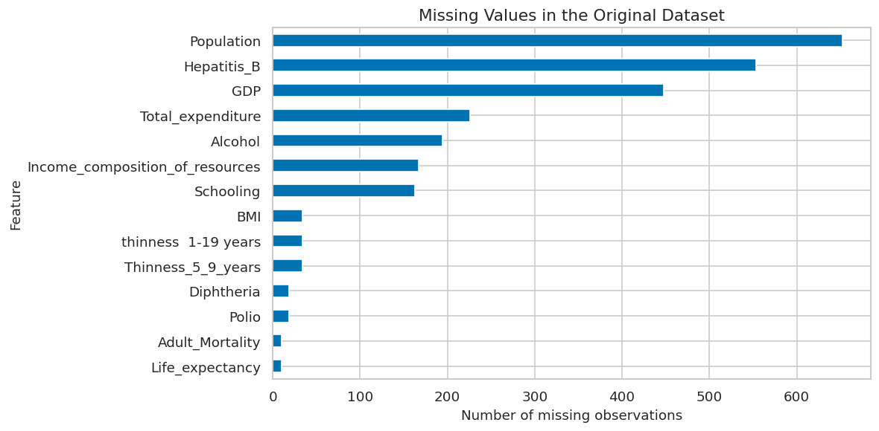

2. ============================================================
Source: notebook cell 9
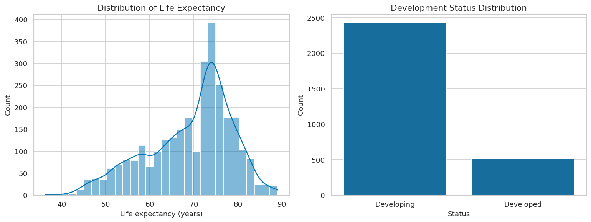

3. ============================================================
Source: notebook cell 12
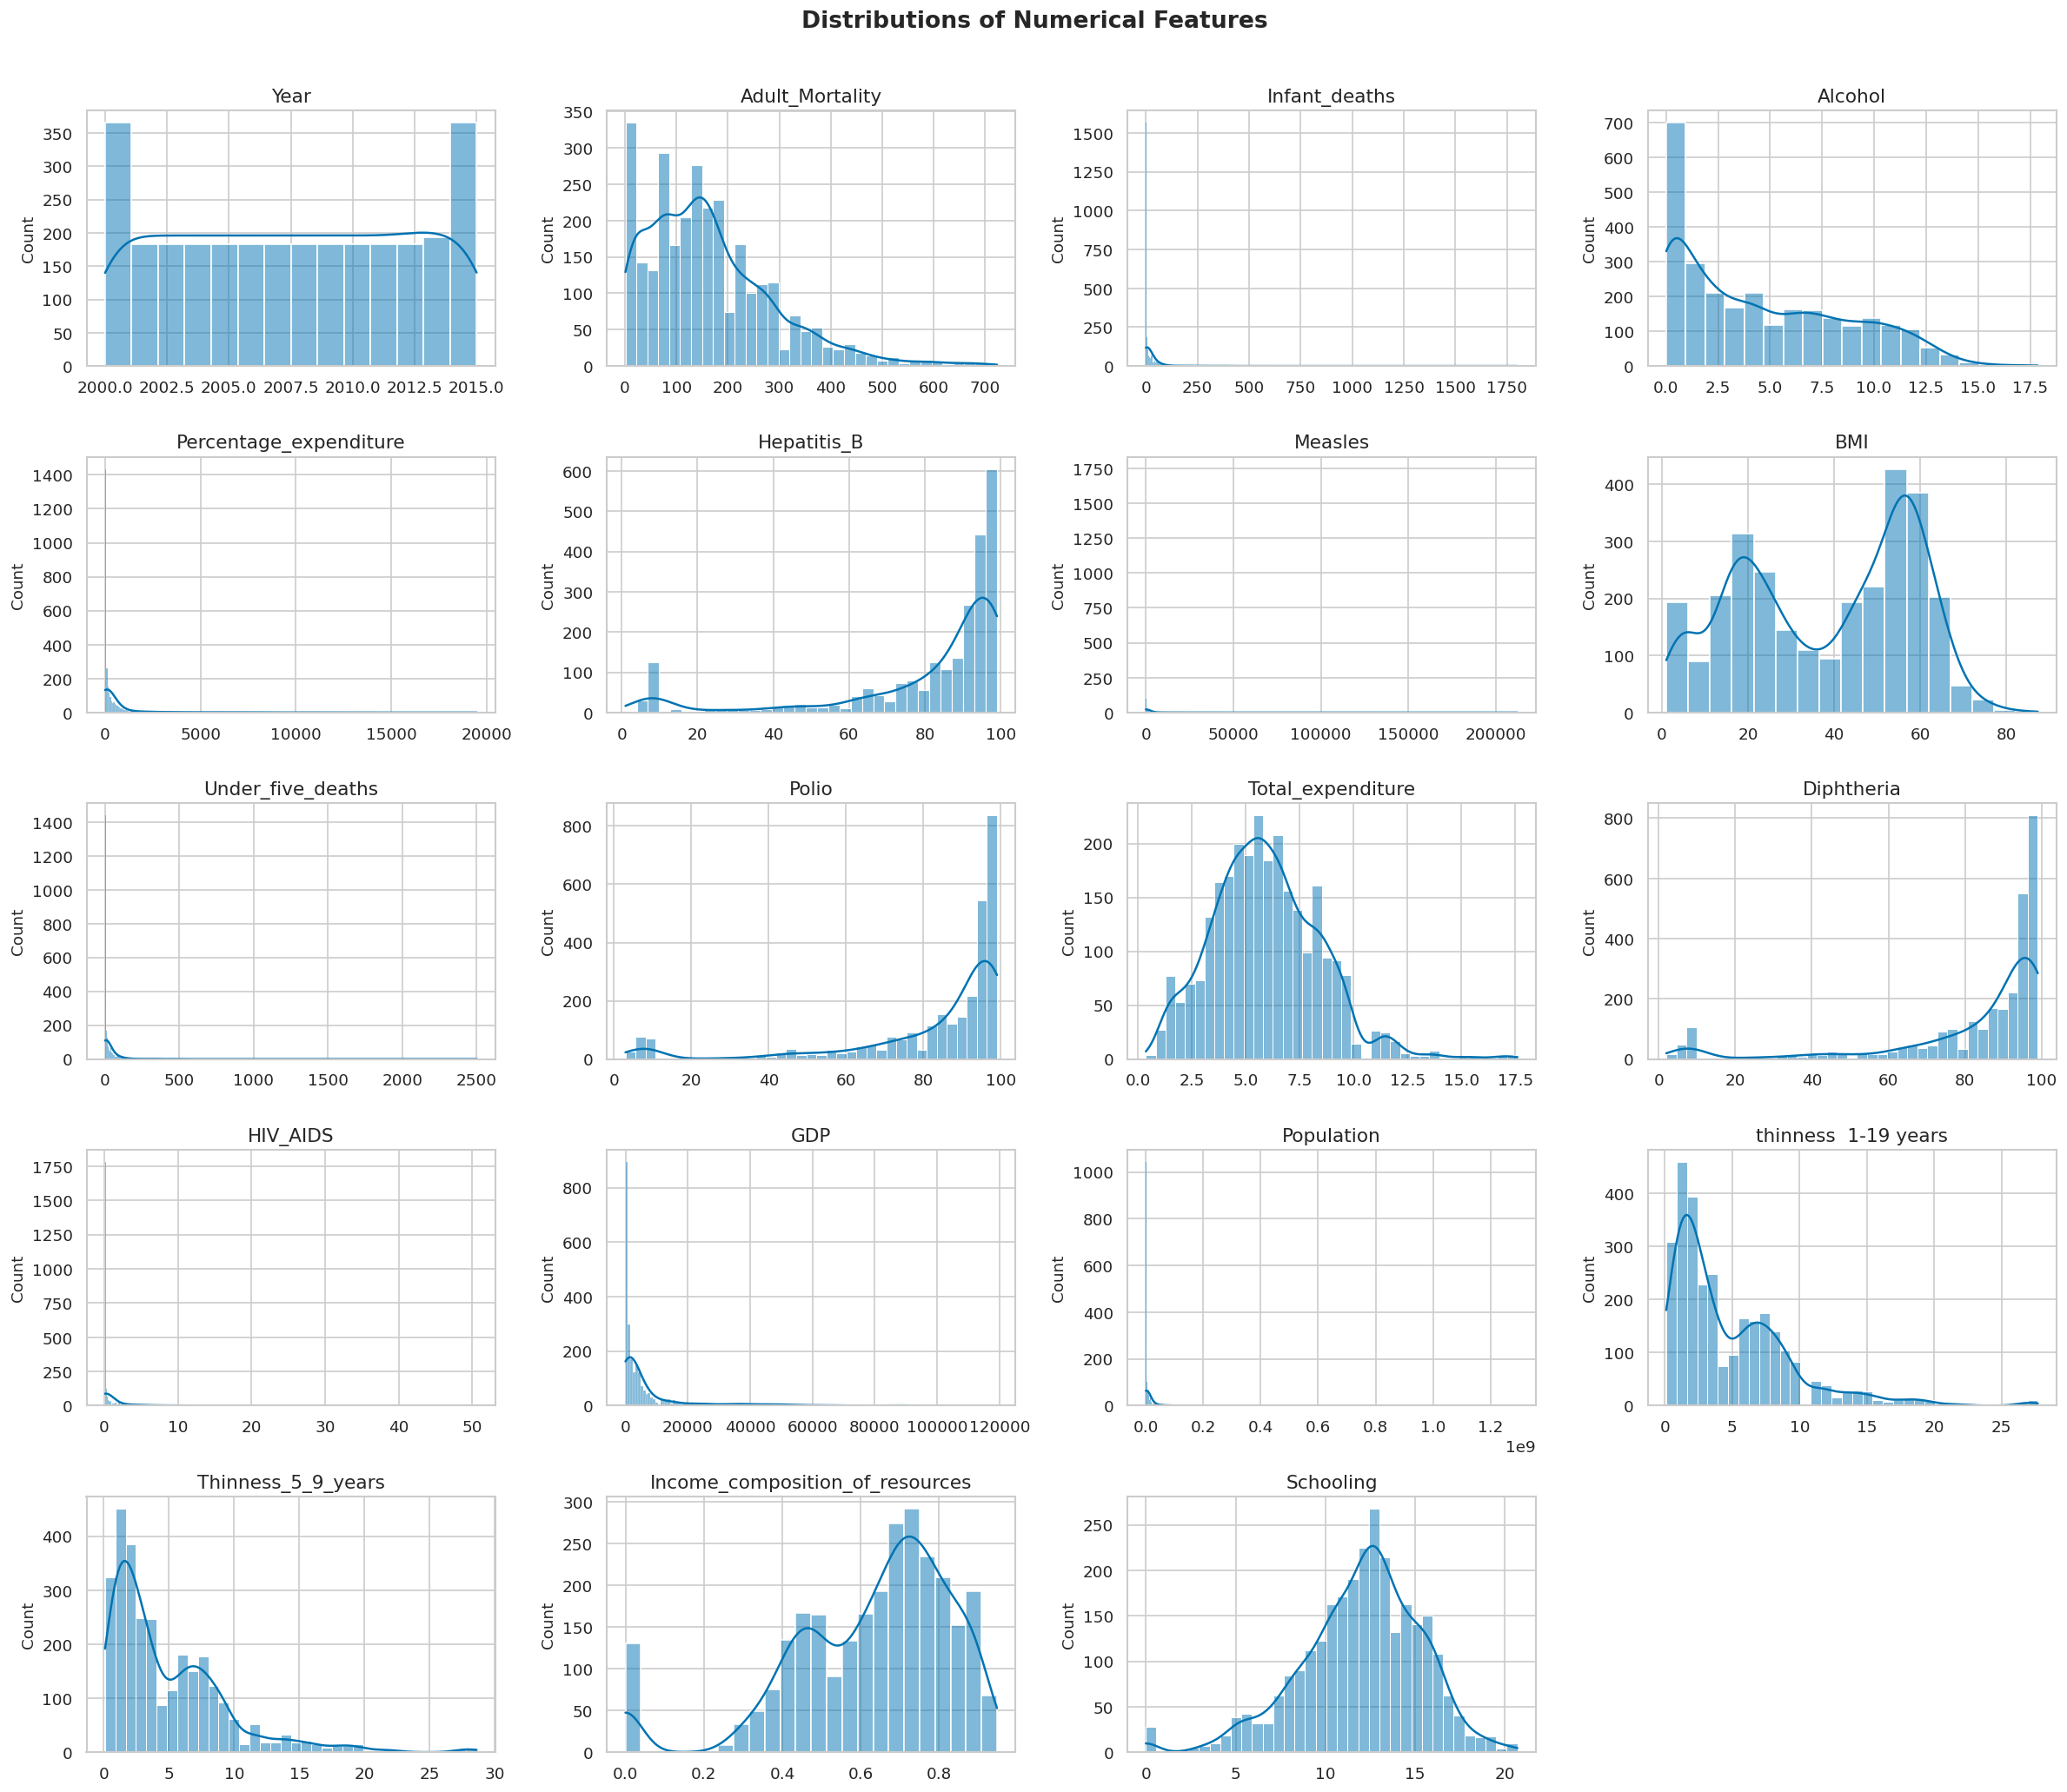

4. ============================================================
Source: notebook cell 13
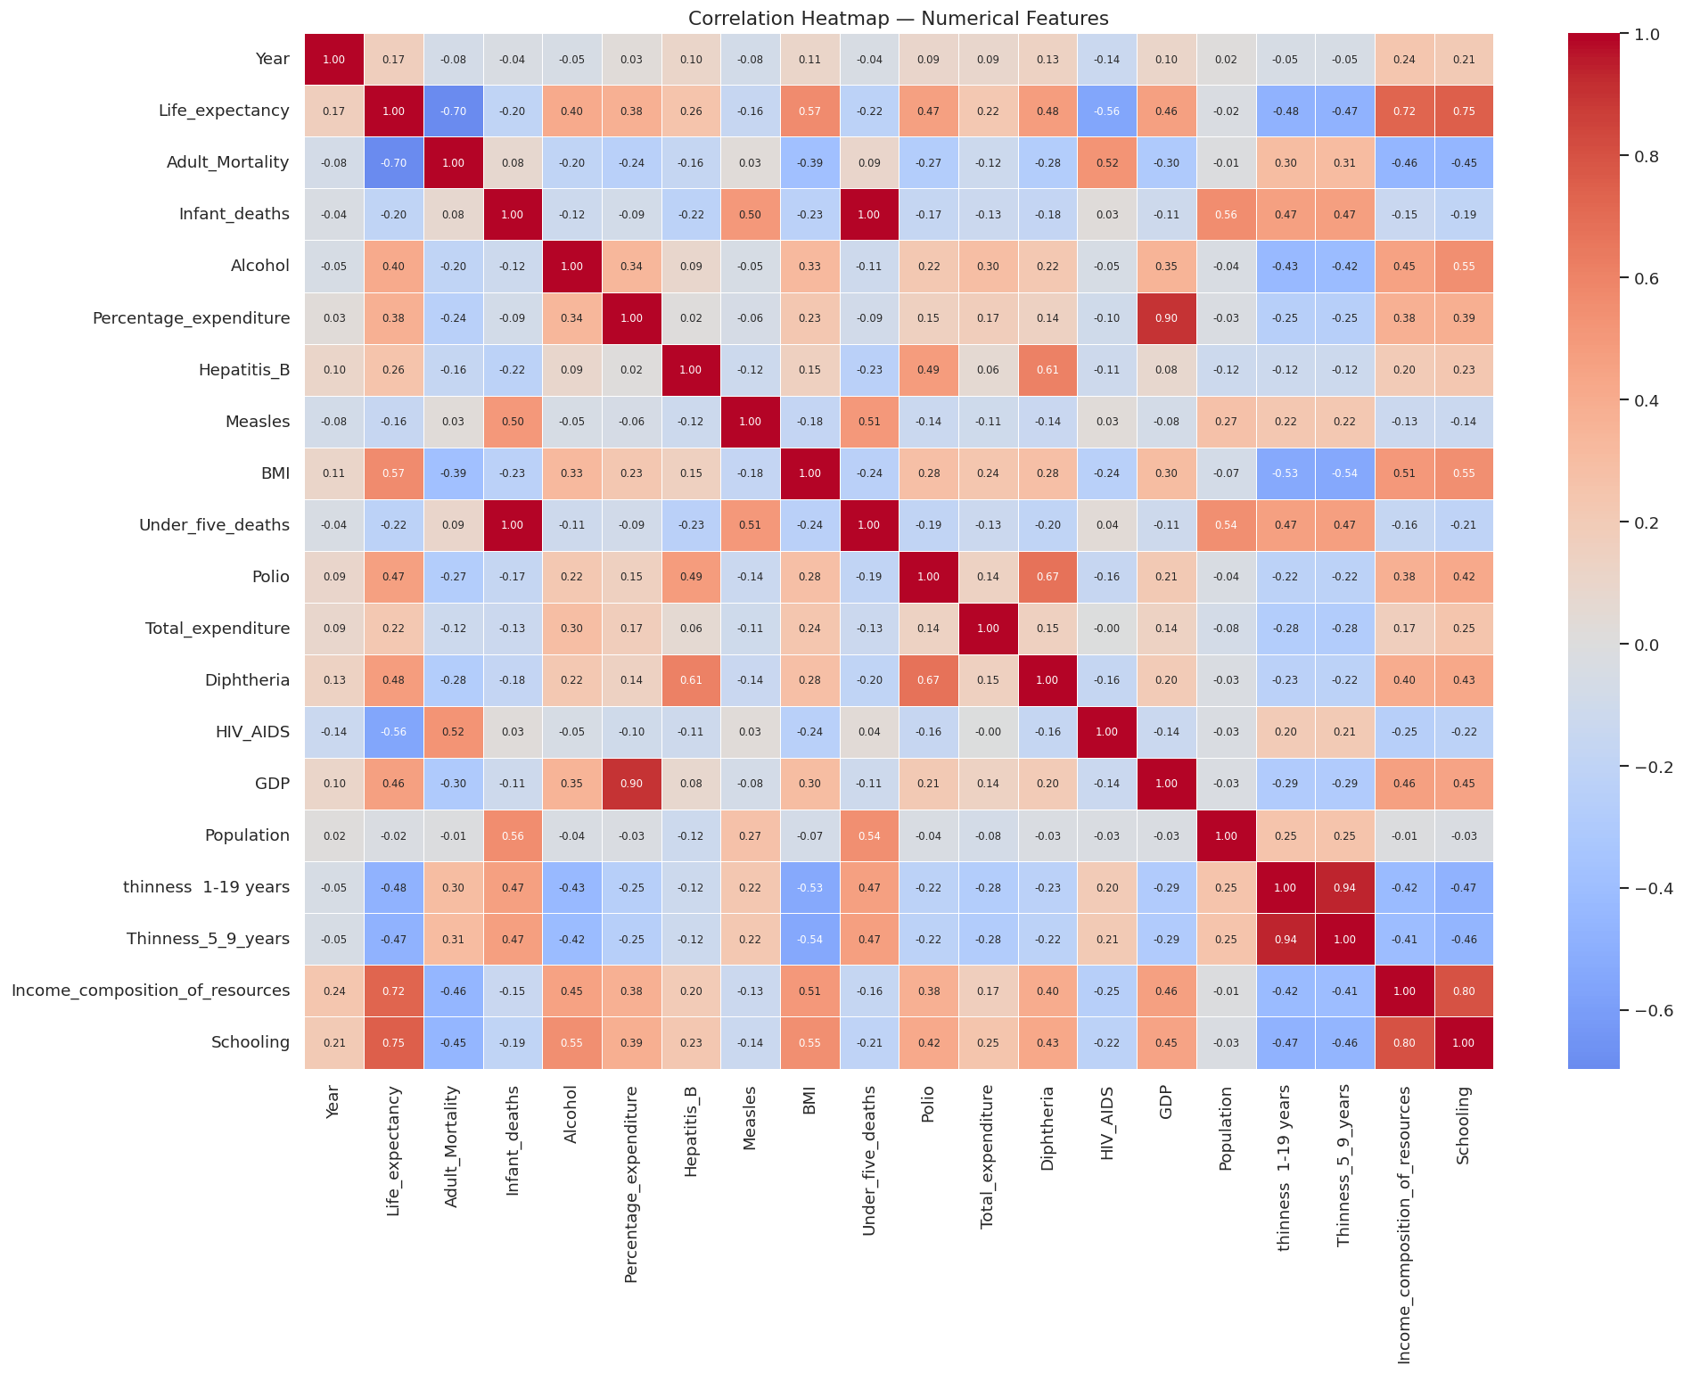

5. ============================================================
Source: notebook cell 14
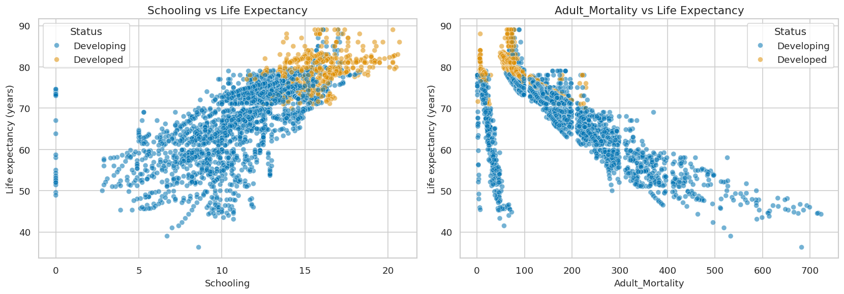

6. ============================================================
Source: notebook cell 26
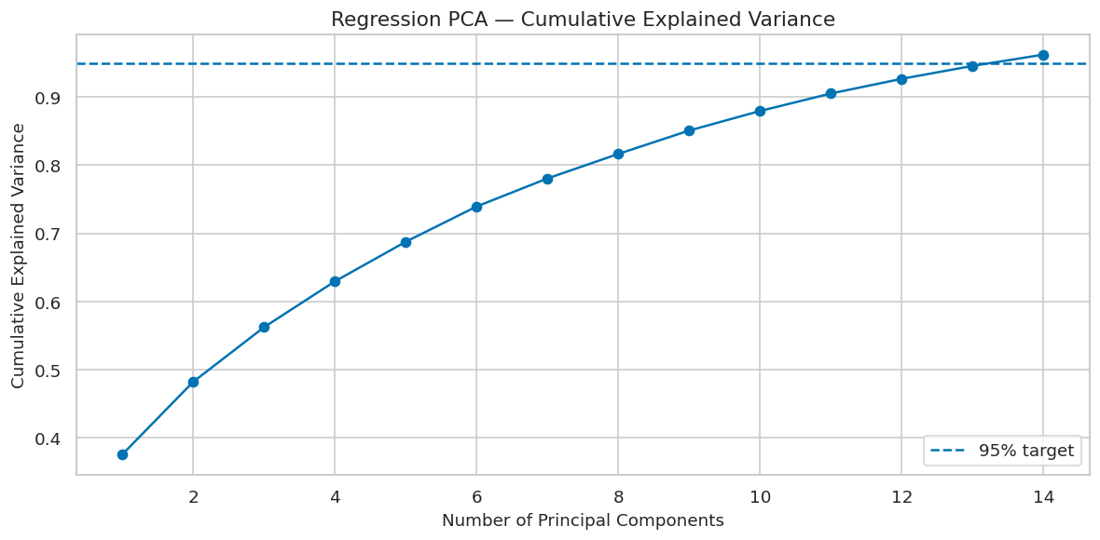

7. ============================================================
Source: notebook cell 26
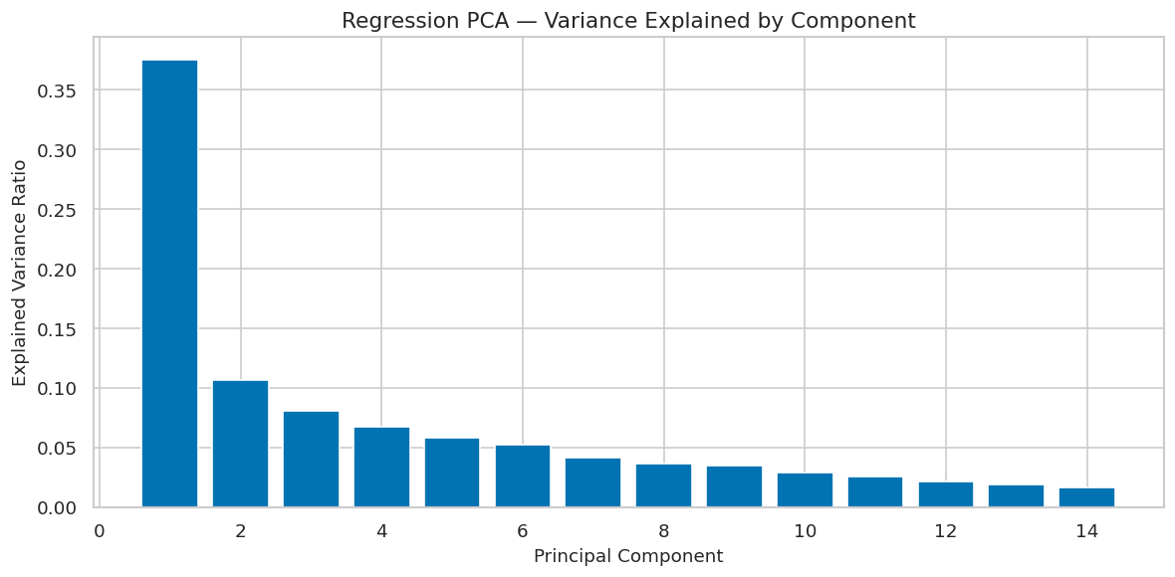

8. ============================================================
Source: notebook cell 27
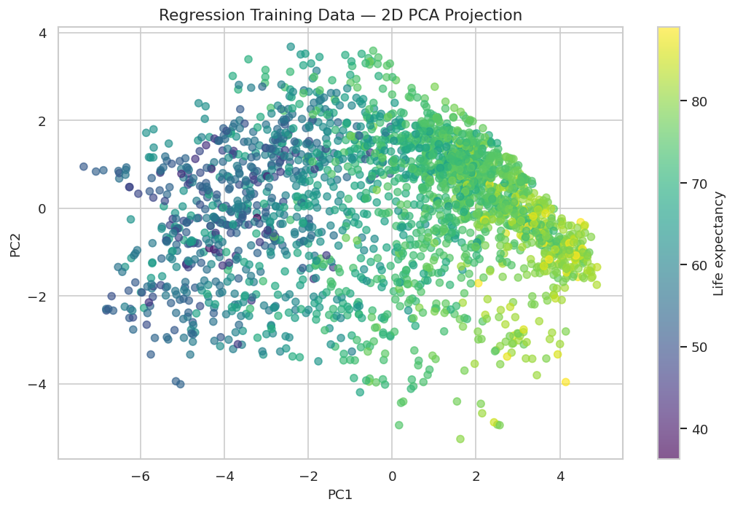

9. ============================================================
Source: notebook cell 28
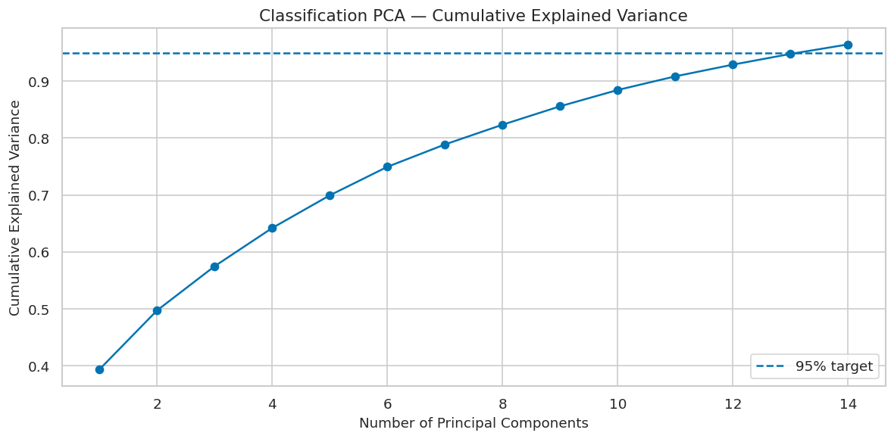

10. ============================================================
Source: notebook cell 28
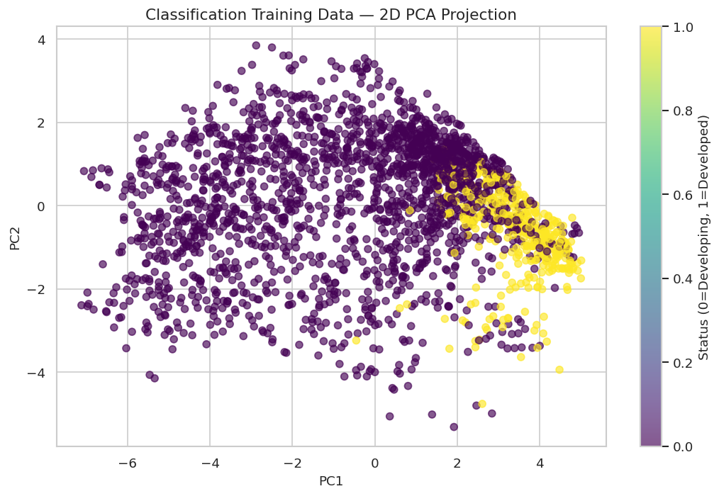

11. ============================================================
Source: notebook cell 34
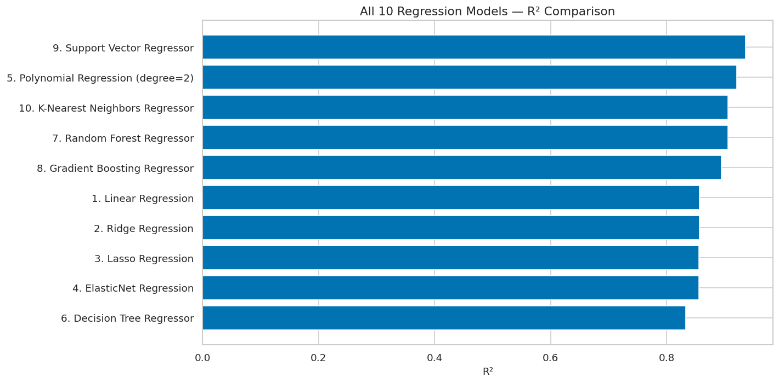

12. ============================================================
Source: notebook cell 46
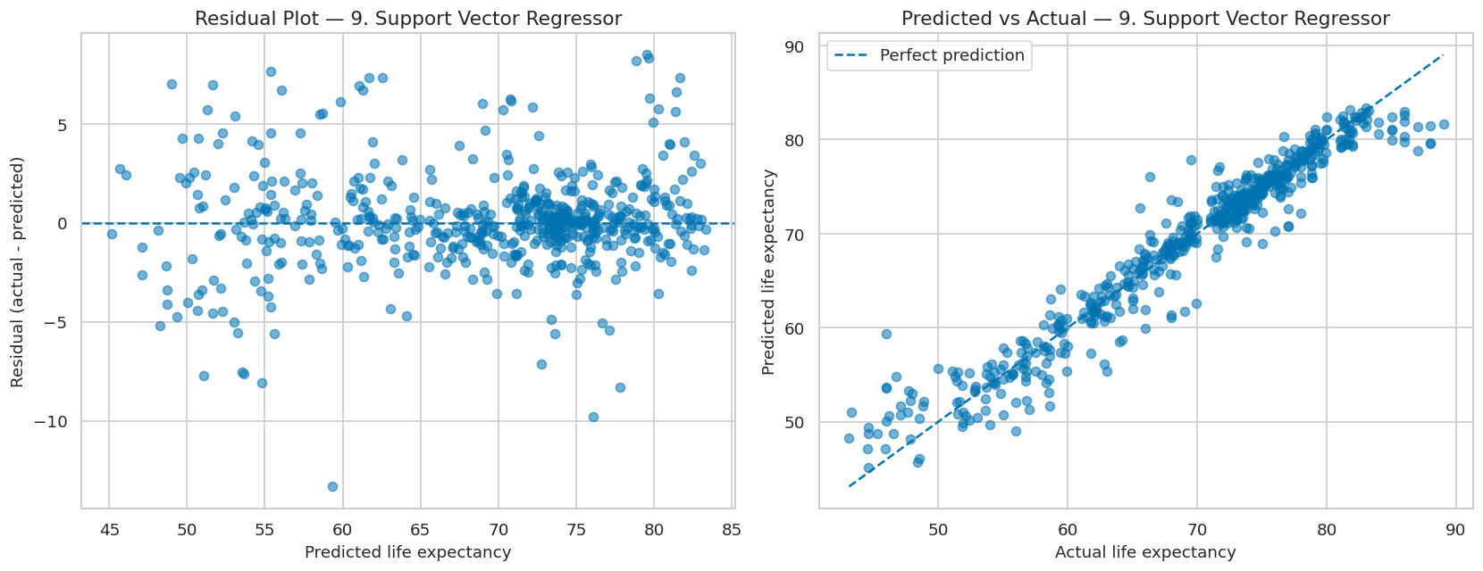

13. ============================================================
Source: notebook cell 47
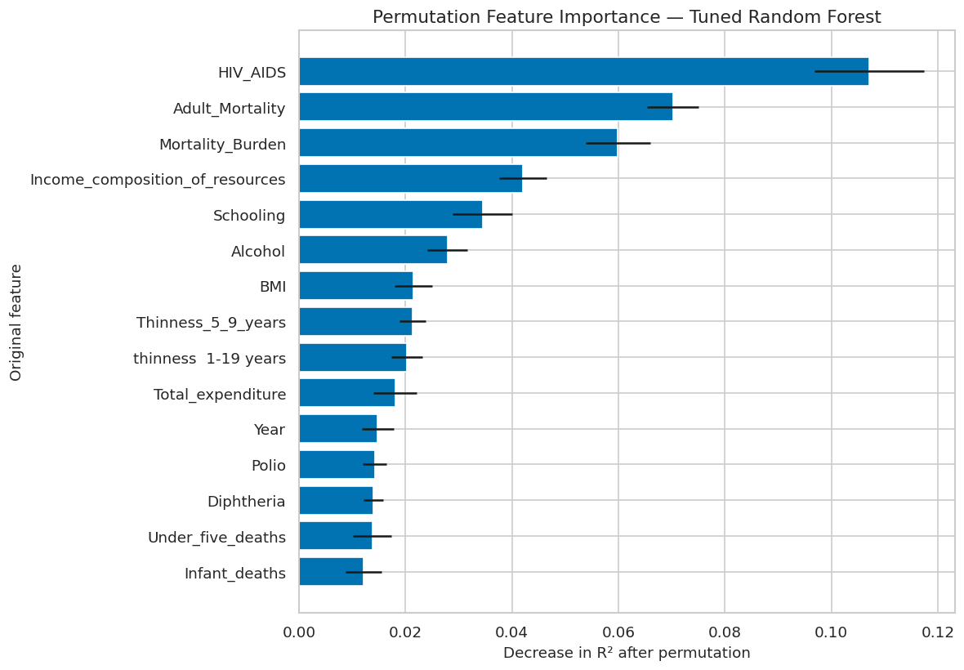

14. ============================================================
Source: notebook cell 53
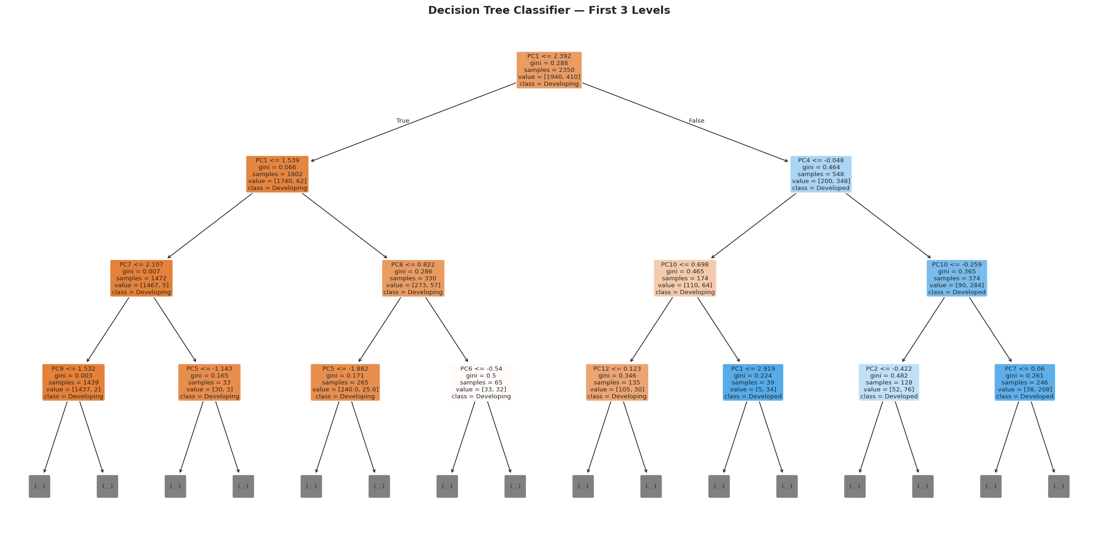

15. ============================================================
Source: notebook cell 55
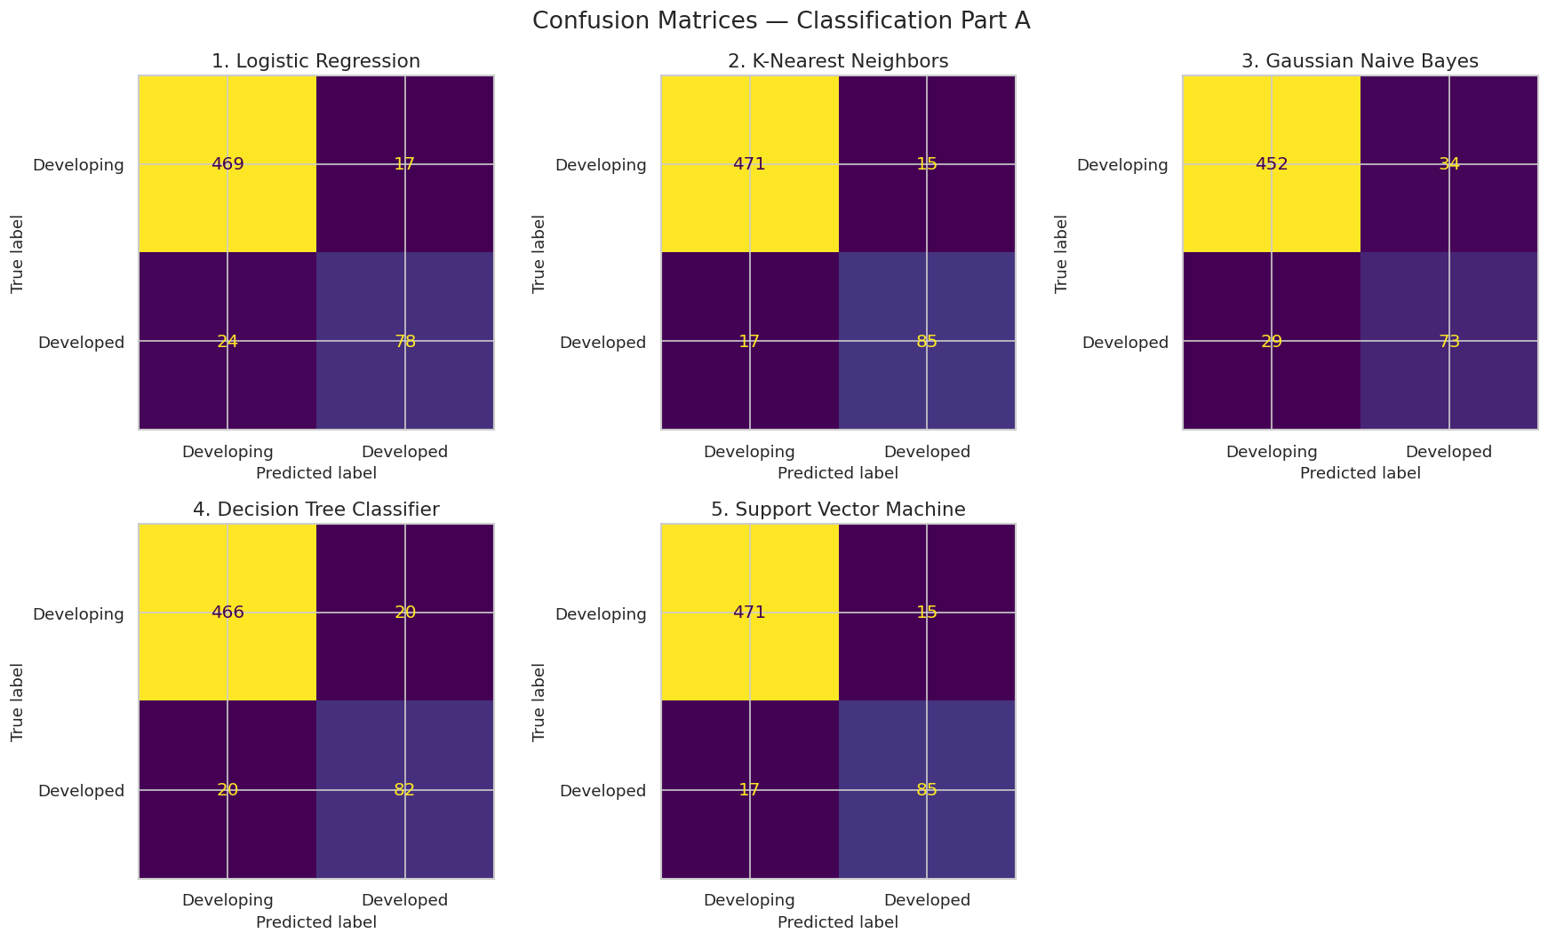

16. Review 2: Confusion matrices for the five Part-B classifiers
Source: notebook cell 63
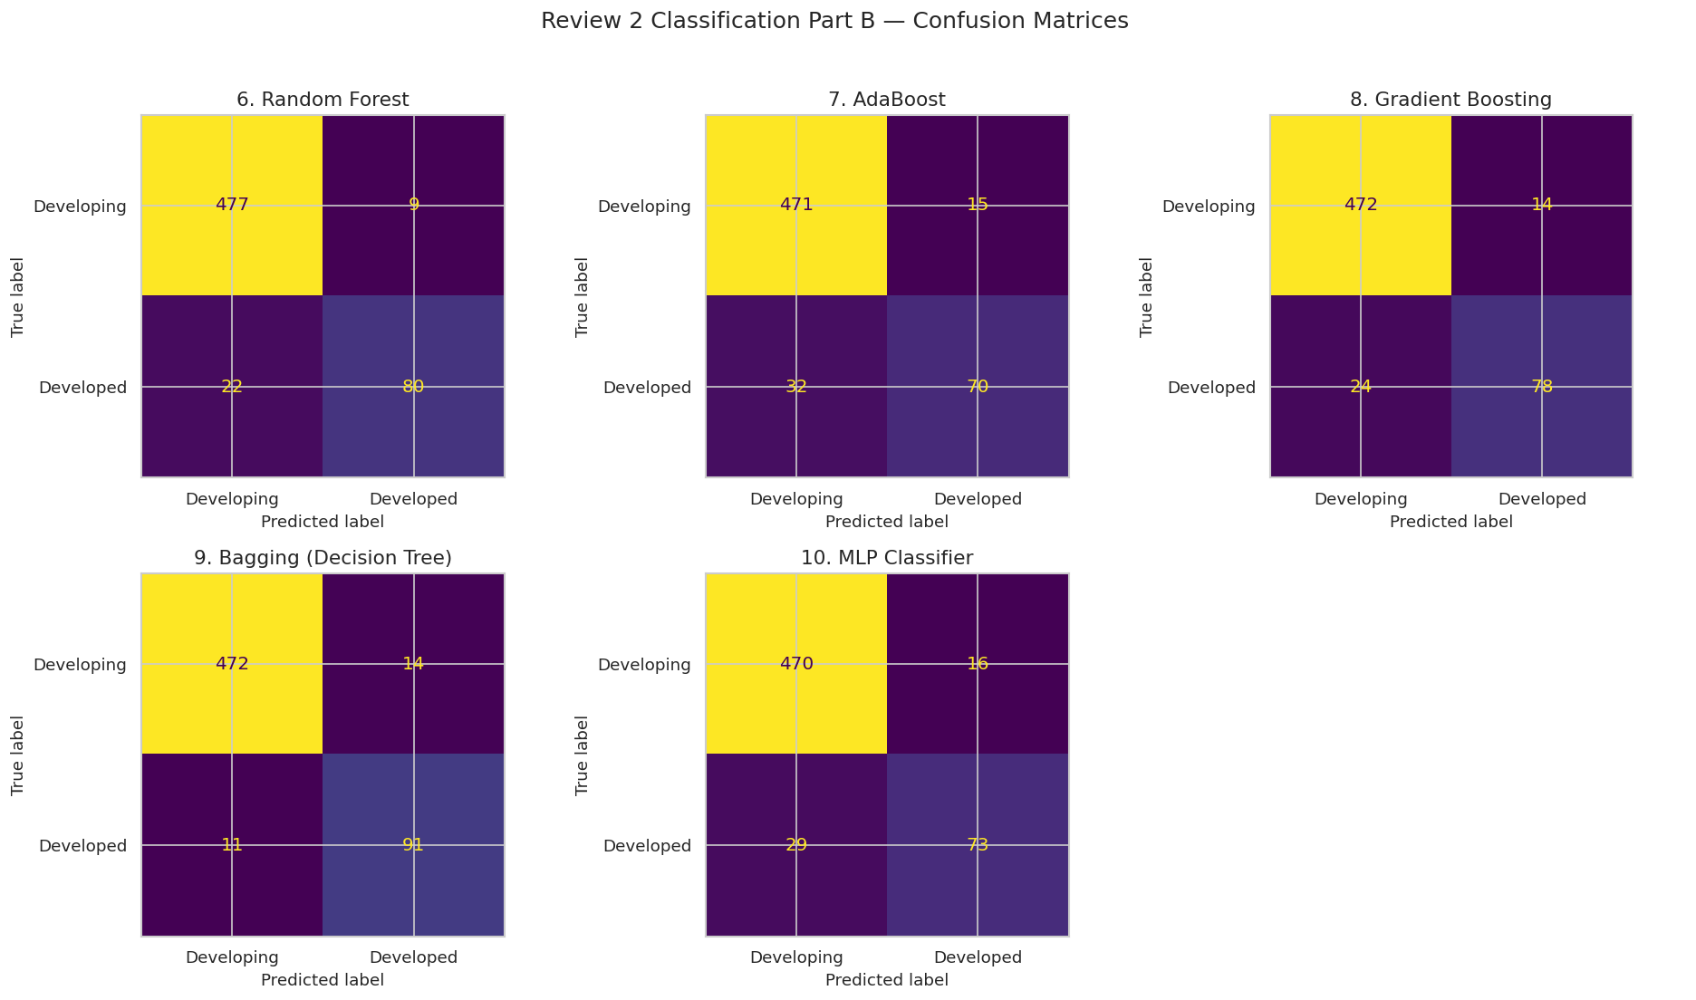

17. Review 2: ROC curves for the five Part-B classifiers
Source: notebook cell 64
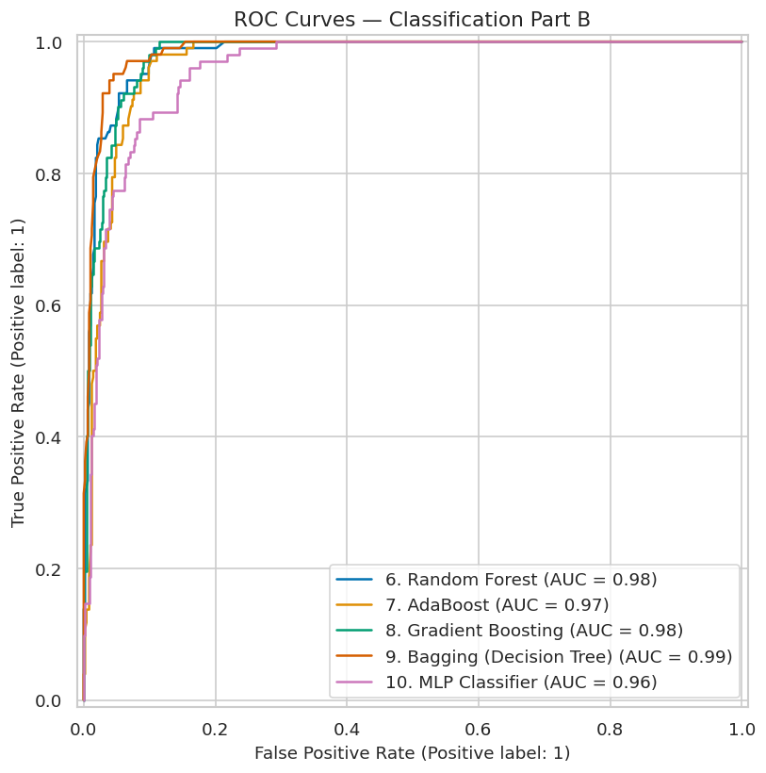

18. Compare all ten required models plus the tuned candidate and select by weighted F1
Source: notebook cell 67
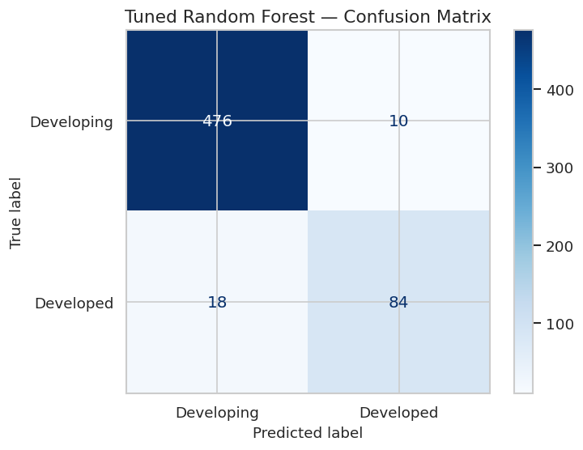

19. K-Means elbow curve: inertia against k
Source: notebook cell 70
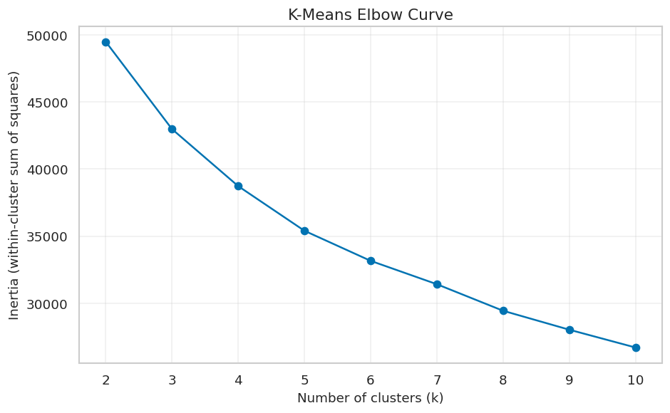

20. Dendrogram for hierarchical clustering (reproducible sample for readable display)
Source: notebook cell 72
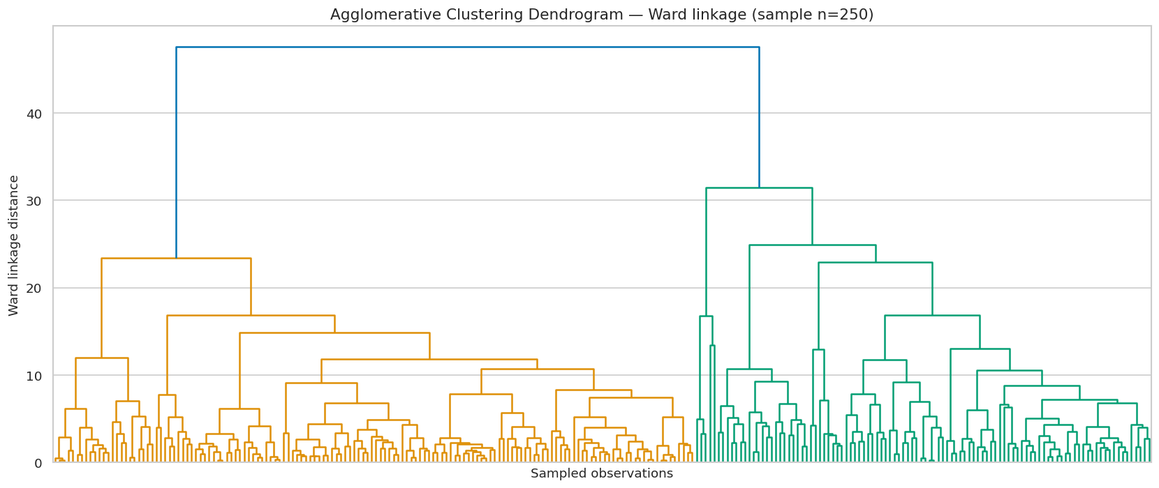

21. Mandatory PCA 2D visualisation for each clustering configuration
Source: notebook cell 74
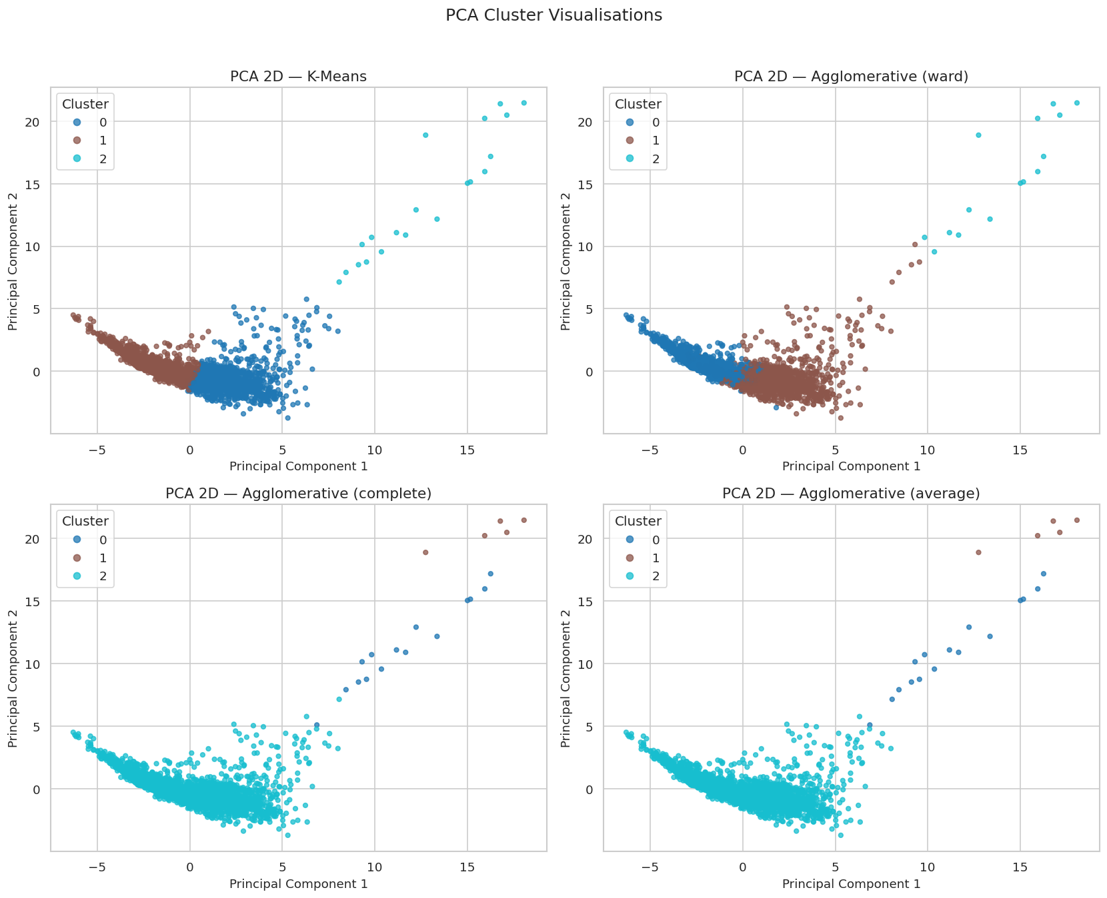

22. t-SNE visualisation for K-Means clusters (subsampled for reasonable runtime)
Source: notebook cell 75
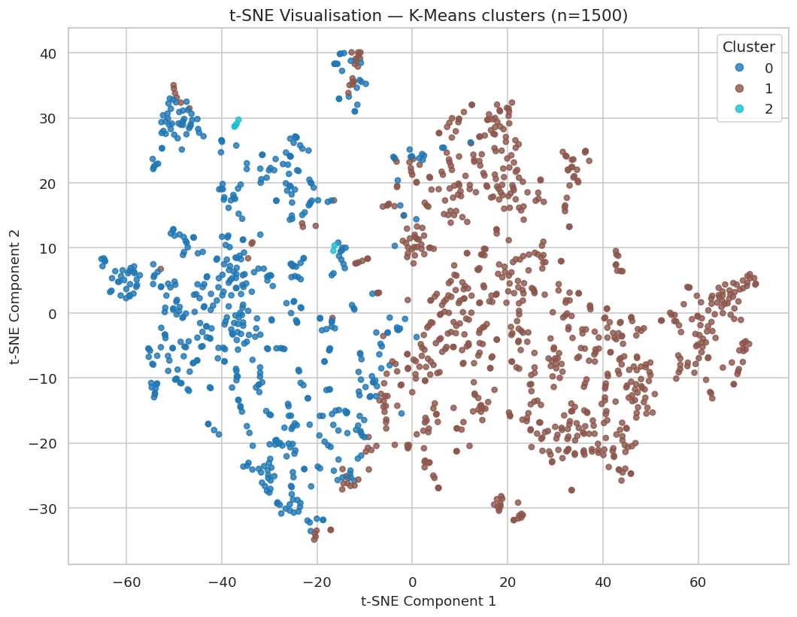

5. Notes and limitations
- This document is a presentation of saved notebook results, not a fresh rerun of the complete training workflow.
- Classification results are evaluated against the dataset's Status labels; class imbalance is visible in the reported supports and clustering counts.
- Clustering labels are unsupervised and should not be interpreted as ground-truth health categories without further analysis.
- The notebook reports a very small cluster for some configurations; investigate outliers, scaling and the selected cluster count before drawing substantive conclusions.
- Keep the dataset attribution/licence and any course-specific reporting requirements in the repository.

