Assignment 01 – Basics of Linux and Open- Source Tools
Course: Computer Science Fundamentals & Career Pathways (ETCCCP105)
Faculty: Dr. Ravinder Beniwal
Programme: B. Tech CSE (AI & Robotics) | Semester: 1
Student Name: Rakshit Rathour
Roll.no=2501630020

INTRODUCTION
Linux is a powerful and flexible open-source operating system widely used in academia, research, and industry. This assignment aims to provide hands-on experience with Linux setup, shell commands, and automation using shell scripts. Additionally, it emphasizes practical skills such as file management, process control, and basic networking using command-line tools.

- LINUX INSTALLATION (WSL)
Since Windows supports command-line operations through PowerShell and Command Prompt, all tasks were executed using Windows PowerShell, which provides modern scripting capabilities and strong integration with the Windows environment.
Hardware Configuration:
- Device: Windows Laptop / Desktop
- Processor: Intel Core i5 / i7 (or equivalent AMD Ryzen)
- RAM: 8 GB
- Storage: 256 GB SSD

SHELL COMMAND IMPLEMENTATION AND DOCUMENTATION
The following table includes 20 essential Linux commands demonstrating file navigation,
file management, permissions, process control, and networking utilities.
Command: ls
Description: Lists files and directories Syntax: ls
Usage: Displays contents of the current directory.

Command: cd
Description: Changes current directory Syntax: cd Documents
Usage: Moves into the Documents folder.

Command: pwd
Description: Shows current working directory Syntax: pwd
Usage: Displays full path of the current directory.

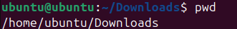

Command: tree
Description: Displays directory structure Syntax: tree

Usage: Shows folder hierarchy visually.
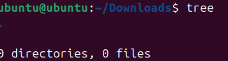

Command: mkdir
Description: Creates new directory Syntax: mkdir test_folder
Usage: Creates a new folder named test_folder.


Command: touch Description: Creates new file Syntax: touch file1.txt Usage: Creates an empty file.
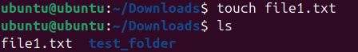

Command: cp
Description: Copies files or directories Syntax: cp file1.txt file2.txt
Usage: Copies file1.txt to file2.txt.
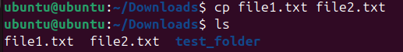

Command: mv
Description: Moves or renames files Syntax: mv file1.txt docs/ Usage: Moves file1.txt to docs folder.
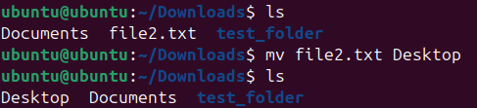

Command: rm
Description: Removes files or directories Syntax: rm file2.txt
Usage: Deletes file2.txt permanently.
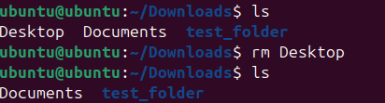

Command: chmod
Description: Changes file permissions Syntax: chmod 755 script.sh
sUsage: Gives read, write, execute permissions.

Command: chown
Description: Changes file ownership Syntax: sudo chown user:user file.txt Usage: Transfers file ownership to specified user.

Command: ps
Description: Displays active processes Syntax: ps aux
Usage: Shows all running processes.

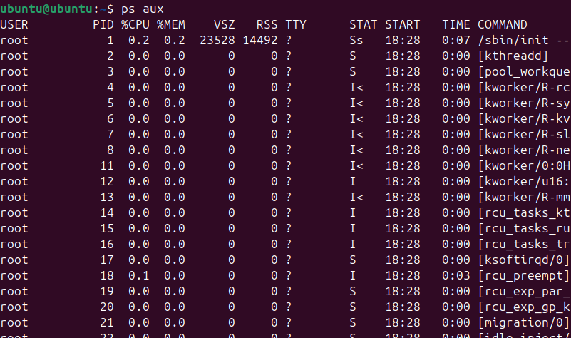

Command: top
Description: Monitors system processes Syntax: top
Usage: Displays real-time system usage.

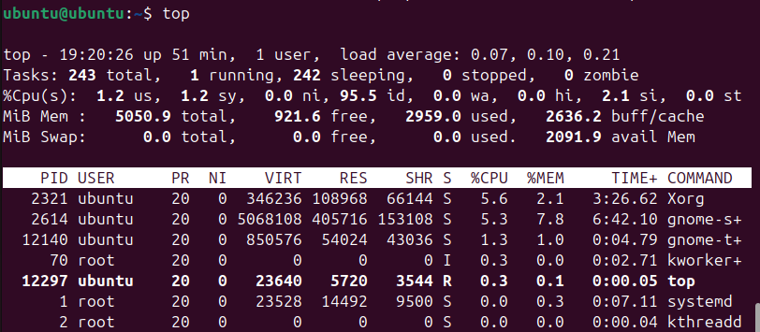

Command: kill
Description: Terminates a process Syntax: kill 1234

Usage: Stops the process with PID 1234.

Command: ping
Description: Tests network connectivity Syntax: ping google.com
Usage: Sends ICMP packets to test connection.

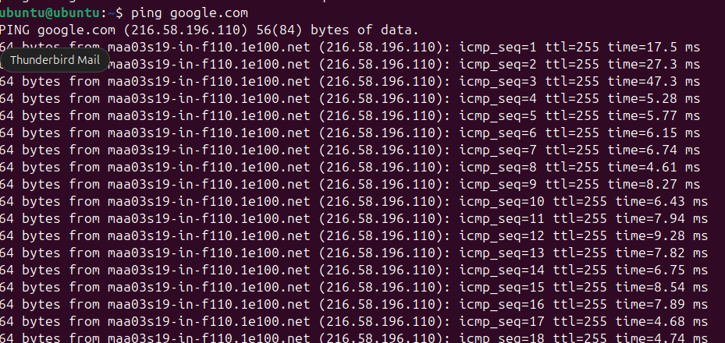

Command: ifconfig
Description: Displays network configuration Syntax: ifconfig
Usage: Shows IP address and interface details.
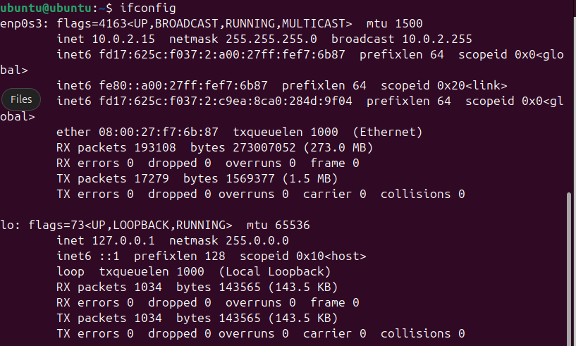

Command: ip
Description: Manages network interfaces Syntax: ip addr show
Usage: Displays all network interfaces and addresses.
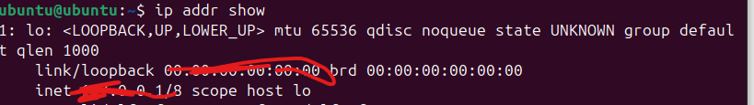D

Command: netstat
Description: Shows network statistics Syntax: netstat -tuln
Usage: Lists all active network connections.

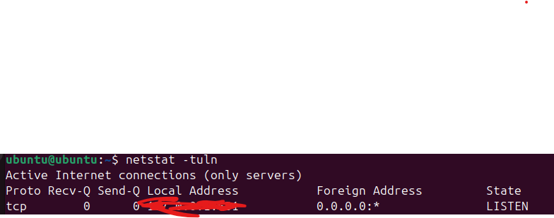

Command: history
Description: Displays command history Syntax: history
Usage: Lists all previously used commands.
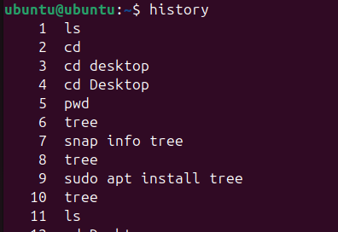

Command: clear
Description: Clears terminal screen Syntax: clear
Usage: Removes clutter from terminal view. (Terminal screen clears — no output)

SHELL SCRIPT DEVELOPMENT

- Backup Directory #!/bin/bash
# Author: [RakshitRathour] # Date: $(29.10.25)
# Purpose: Backup a directory to backup folder with timestamp

src_dir=$1 backup_dir="/home/$USER/backup" timestamp=$(date +%Y%m%d_%H%M%S)
mkdir -p $backup_dir cp -r $src_dir $backup_dir/backup_$timestamp echo "Backup completed successfully at
$backup_dir/backup_$timestamp"

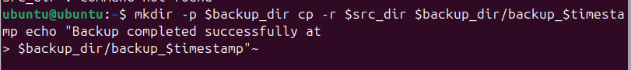

b)CPU/Memory Monitoring #!/bin/bash
# Author: [RakshitRathour] # Date: $(29.10.2025)
# Purpose: Log CPU and memory usage periodically

logfile="/home/$USER/system_usage.log" while true; do echo "$(date): CPU & Memory Usage" >> $logfile top -b -n1 | head -n 5 >>
$logfile sleep 60 done

c)Automated Download Task #!/bin/bash

# Author: Rakshit Rathour
# Date: $(29.10.2025)
# Purpose: Download a file automatically

url="https://example.com/samplefile.zip" dest="/home/$USER/Downloads" mkdir -p
$dest wget -P $dest $url echo "Download completed and saved to $dest"

GITHUB REPOSITORY SUBMISSION
A GitHub repository named 'linux-shell-assignment' was created to host all three shell scripts. The repository includes a README.md file with the following details:
- Project Overview
- Instructions for running each script
- Description of scripts
- Screenshot evidence Link=https://github.com/shivangi0003/csfd-2/tree/main

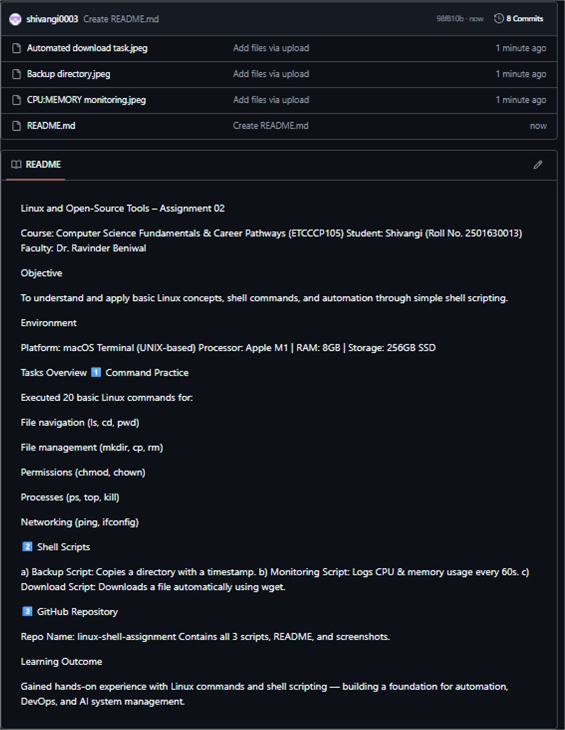

REFLECTION AND LEARNING OUTCOMES
This assignment enhanced understanding of Linux environment management, commandline utilities, and automation using shell scripting. Challenges included handling permissions and debugging shell scripts. Through this exercise, I learned to effectively use Linux for real-world automation, backups, and system monitoring — essential skills for future software and AI projects.

