21ECC301P - MICROPROCESSOR, MICROCONTROLLER AND INTERFACING TECHNIQUES

SEMESTER V
(2025-26 ODD)

LI-FI-BASED BRAKE FAILURE DETECTION SYSTEM
A PROJECT REPORT

Submitted by

JANANI.J [Reg No: RA2311004010203]
G.RAKSHITHA [Reg No: RA2311004010210]
JAISHA.J [Reg No: RA2311004010218]

Under the guidance of
DR. SHAYNA KUMARI
(Assistant Professor, Department of Electronics & Communication Engineering)


DEPARTMENT OF ELECTRONICS AND COMMUNICATION ENGINEERING
College of Engineering and Technology
SRM INSTITUTE OF SCIENCE AND TECHNOLOGY
- R.M. Nagar, Kattankulathur – 603203, Chengalpattu District
NOV 202


COLLEG COLLEGE OF ENGINEERING & TECHNOLOGY
SRM INSTITUTE OF SCIENCE & TECHNOLOGY
S.R.M. Nagar, Kattankulathur – 603203, Chengalpattu District

BONAFIDE CERTIFICATE

Certified that this project report titled “LIFI BASED BREAK ALERT SYSTEM” is the Bonafide work of “Janani.J [RA2311004010203], G.Rakshitha[RA2311004010210], Jaisha.J[RA2311004010218]”, who carried out the project work under my supervision, as a part of the course “Microprocessor, Microcontroller and Interfacing Techniques (21ECC301P)”, during the academic year 2025-26 (ODD) in the Department of ECE, SRM Institute of Science & Technology, Kattankulathur.

SIGNATURE SIGNATURE
Dr.Shayna Kumari Dr. Vivek Devendra Kachhatiya
SUPERVISOR COURSE IN CHARGE
Assistant Professor Assistant Professor
Dept. of Electronics and Dept. of Electronics and
Communication Engineering Communication Engineering

Date: Academic Advisor

(Dr. M.S Vasanthi)
DECLARATION

We hereby declare that the Project entitled “LI-FI-BASED BRAKE FAILURE DETECTION SYSTEM” to be submitted for the course “21ECC301P – Microprocessor, Microcontroller and Interfacing Techniques”, is our original work as a team

Place:
Date:

JANANI.J [RA2311004010203]

G.RAKSHITHA[RA2311004010210]

JAISHA.J [RA2311004010218]

ABSTRACT

This project demonstrates a simple Li-Fi(Light Fidelity) based brake failure detection system using light as the medium of communication. The transmitter section consists of one to five IR LED s (Infrared Light Emitting Diode) connected in forward bias, which emit infrared light signals. The receiver section uses an IR photodiode connected in reverse bias to detect the incoming light. The STM32 microcontroller reads the voltage from the photodiode through its analog input and displays the result on an OLED(Organic Light Emitting Diode) screen.
When light from the transmitter falls on the photodiode, the voltage drops and the corresponding ADC(Analog to Digital Converter) value decreases. If the ADC value goes below the set threshold (room light level), it indicates Brake Failure; otherwise, it displays Brake OK. The system was tested using different numbers of LEDs and photodiodes to measure the sensing distance. The circuit was found to detect the signal reliably up to 9 cm- 17cm. The project successfully proves that Li-Fi communication can be used for short-range, light-based brake failure indication systems.
Sustainable Development Goals Addressed
Goal 3 – Good Health and Well-being
Goal 9 – Industry, Innovation, and Infrastructure
Goal 11 – Sustainable Cities and Communities



ACKNOWLEDGEMENTS

We would like to express our deepest gratitude to the entire management of SRM Institute of Science and Technology for providing us with the necessary facilities for the completion of this project.
We wish to express our deep sense of gratitude and sincere thanks to our Professor and Head of the Department Dr. M. Sangeetha, for her encouragement, timely help, and advice offered to us. We wish to express our sincere thanks to our professor in-charge Dr. P. Aruna Priya, for her constant motivation.
We would like to express our deepest gratitude to our guide, Dr. Shayna Kumari
for her valuable guidance, consistent encouragement, personal caring, timely help and providing me with an excellent atmosphere for doing research. All through the work, in spite of her busy schedule, she has extended cheerful and cordial support to us for completing this research work.
We would like to express our sincere thanks to our faculty coordinators Dr. Vivek Devendra Kachhatiya and Dr. Sivakumar E for their time and suggestions for the implementation of this project.
We also extend our gratitude and thanks to all the teaching and non-teaching staff of the Electronics and Communication Engineering Department and to my parents and friends, who extended their kind cooperation using valuable suggestions and timely help during this project work.

Authors
J.Janani.
G.Rakshitha
Jaisha.J

TABLE OF CONTENTS
CHAPTER NO. | TITLE | PAGE NO.
 | ABSTRACT | iii
 | ACKNOWLEDGEMENT | iv
1 | INTRODUCTION | 9
1.1 | Background of the Topic
1.2 | Importance of Project
1.3 | Overview of the Report
2 | LITERATURE SURVEY | 10
2.1 | Literature Survey
2.2 | Discussion of Above Mentioned Literature
3 | SYSTEM DESCRIPTION AND METHODOLOGY | 12
3.1 | System Description
3.2 | Hardware Components
3.3 | Circuit
3.4 | Software and Explanation
3.5 | Step – by – Approach of Lifi Based Brake Alert System
3.6 | Summary
4 | RESULTS AND DISCUSSION | 20
4.1 | Overview
4.2 | Experimental Setup
4.3 | Observed Results
4.4 | Performance graph
4.5 | Summary
5 | CONCLUSION | 24
5.1 | Conclusion
5.2 | Future Improvements and Extensions
6 | REFERENCES | 25

LIST OF TABLES
Table 3.1 | Hardware Components
Table 3.2 | Software and Libraries used
Table 4.3 | Summary Table

LIST OF FIGURES
Figure 3.1 | Block Diagram of Project
Figure 3.2 | Transmitter Circuit
Figure 3.3 | Receiver Circuit
Figure 3.4 | Transmitter Code
Figure 3.4 | Receiver Code
Figure 4.1 | 2 Red LEDs used
Figure 4.2 | 1 White LED used
Figure 4.3 | 2 White LEDs used
Figure 4.4 | Number of LEDs vs ADC value

CHAPTER 1
INTRODUCTION

1.1 Background of the Topic
In recent years, the demand for vehicle safety and reliable communication systems has increased rapidly. Many road accidents occur due to brake failures or delayed fault detection. To reduce such risks, new technologies are being explored to enable faster and safer data transfer between vehicle systems. One promising technology is Li-Fi (Light Fidelity), which uses light instead of radio waves to transmit data. Li-Fi communication is fast, safe, and free from electromagnetic interference, making it suitable for automotive safety applications. This project applies Li-Fi principles to design a simple and effective brake failure detection system using infrared light.
1.2 Importance of the Project
This project demonstrates how Li-Fi technology can be used beyond data communication — in this case, for vehicle safety monitoring. The system detects brake failure using infrared light and provides a real-time indication on an OLED(Organic Light Emitting Diode) display. It is a low-cost, energy-efficient, and reliable approach to prevent accidents caused by sudden brake malfunction. The work also aligns with the UN Sustainable Development Goals:
- Goal 3: Good Health and Well-being
- Goal 9: Industry, Innovation, and Infrastructure
- Goal 11: Sustainable Cities and Communities
1.3 Overview of the Report
This report presents the concept, design, and implementation of the Li-Fi-based brake failure detection system. It explains the working principle of Li-Fi, details about the hardware components such as STM32 microcontroller, LEDs(Light Emitting Diode), and photodiodes, and the circuit connections. The report also includes the software implementation, testing results, and performance analysis. The system successfully detects light intensity changes up to a distance of about 17 cm, proving the feasibility of short-range optical sensing for vehicle safety applications.

CHAPTER 2
LITERATURE SURVEY
2.1 Literature Survey
1. What is Li-Fi?
Published in: Journal of Lightwave Technology (Volume 34, Issue 6, 15 March 2016)
Authors: Harald Haas, Liang Yin, Yunlu Wang, and Cheng Chen
Abstract:
This paper attempts to clarify the difference between visible light communication (VLC) and light-fidelity (Li-Fi). In particular, it shows how Li-Fi extends VLC by using light-emitting diodes (LEDs) to realize fully networked wireless systems. The study emphasizes how Li-Fi converts ordinary lighting systems into data transmitters (attocells), enabling high-speed, interference-free communication. This research provides the foundational concept for using light as a communication medium, which inspired the use of LEDs and photodiodes in the present project to transfer signals optically.
2. Li-Fi Based Communication System
Published in: International Journal of Scientific & Engineering Research (Volume 9, Issue 5, 2018)
Authors: A. Sharma and R. Patel
Abstract:
This study presents a simple Li-Fi system where an LED is used as a transmitter and a photodiode as a receiver. The research focuses on how changes in light intensity correspond to variations in the received voltage, which can be measured by a microcontroller. The authors highlight how light signals can be used for short-range data transfer and monitoring applications. This work directly relates to the present project, where similar principles are applied for detecting brake failure by observing the voltage change across a photodiode.
3. IR Sensor Applications in Safety Systems
Published in: International Journal of Innovative Research in Electrical, Electronics, Instrumentation and Control Engineering (Volume 7, Issue 2, 2019)
Authors: K. Meena and S. Aravind
Abstract:
This paper discusses the use of infrared sensors for proximity and safety detection systems. It describes how IR LEDs and photodiodes can be used to sense light reflection or interruption for identifying faults or obstacles. The authors demonstrate that such sensors can be effective in short-range safety systems with low power consumption. This work supports the present project’s idea of using IR light to sense changes caused by brake failure conditions.
4. Hybrid Li-Fi and Wi-Fi Networks: A Survey
Published in: IEEE Communications Surveys & Tutorials (Volume 23, Issue 2, Second Quarter 2021)
Authors: Xiping Wu, Mohammad Dehghani Soltani, Lai Zhou, Majid Safari, and Harald Haas
Abstract:
This survey introduces the concept of Hybrid Li-Fi and Wi-Fi Networks (HLWNets) to combine the high-speed, short-range capability of Li-Fi with the wide coverage of Wi-Fi. The paper reviews network architecture, illumination constraints, modulation schemes, and key performance parameters. It highlights that Li-Fi is most effective for secure and localized communication. The present project adopts these principles in a small-scale setup, using Li-Fi for localized signalling between an LED transmitter and photodiode receiver.
2.2 Discussion on above mentioned Literature
From the literature reviewed, it is clear that Li-Fi technology has proven potential for high-speed, interference-free communication using light. The pioneering work by Harald Haas et al. (2016) introduced Li-Fi as an efficient alternative to radio-based systems. A. Sharma and R. Patel (2018) demonstrated how LEDs and photodiodes can be used for short-range communication, while K. Meena and S. Aravind (2019) focused on using infrared light for safety detection. However, most previous studies concentrated on data transfer or distance measurement, not fault indication.
This analysis identified a gap — no simple implementation had combined Li-Fi principles with a fault-detection application such as brake failure indication. Hence, the present project was developed to fill this gap. It uses infrared LEDs and photodiodes to establish a light-based communication link, where the change in light intensity indicates a fault condition. The STM32 microcontroller processes the analog signal and displays the status (“Brake OK” or “Brake Failure”) on the OLED screen. Through this approach, the project demonstrates a practical, low-cost, and efficient way to apply Li-Fi technology for real-time safety monitoring.

CHAPTER 3
SYSTEM DESCRIPTION AND METHODOLOGY
3.1 System Description
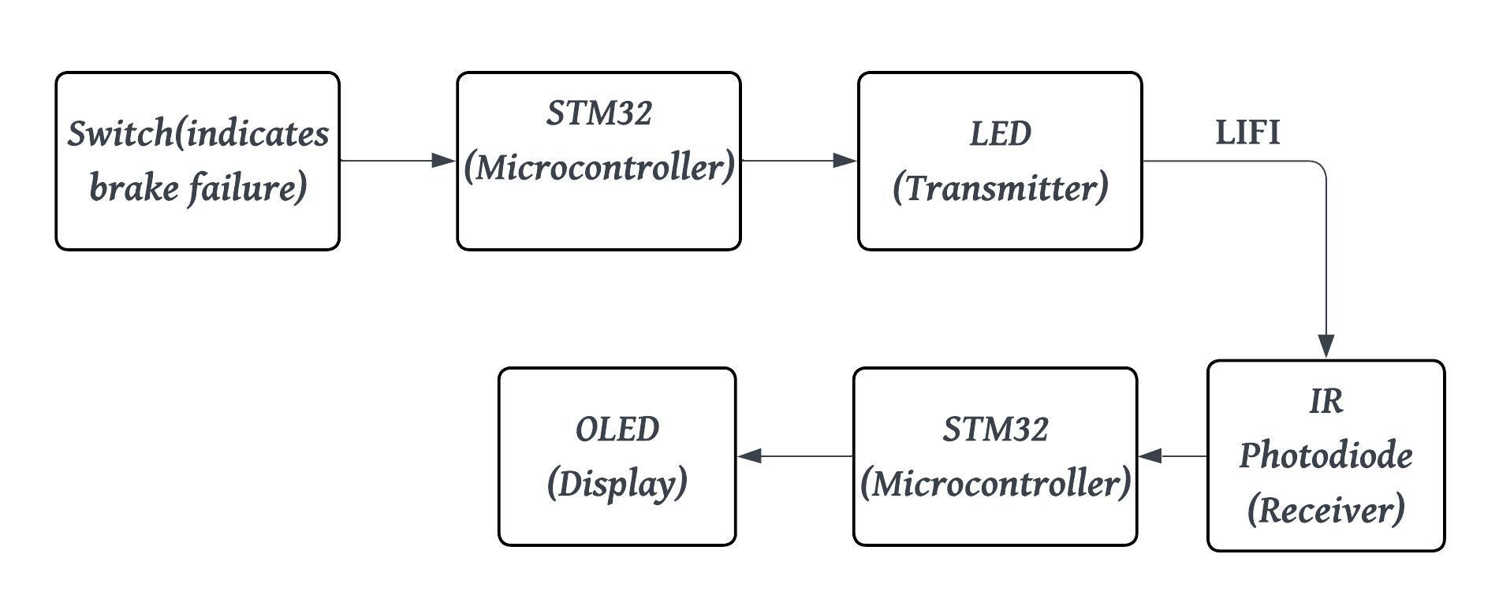
Figure 3.1 Block Diagram of Lifi Based Brake Alert System
Transmitter Unit
- The transmitter section includes a switch connected to one of the STM32’s digital input pins.
- When the button is pressed, it sends a HIGH logic signal to the microcontroller, which in turn drives one or more LEDs (Light Emitting Diode) through current-limiting resistors.
- These LEDs are connected in forward bias, and the light intensity increases whenever the button is pressed.
- Different colours (red and white) and numbers of LEDs (from 1 to 2) were used to test how the sensing distance changes with light power.
This section acts as the “brake signal sender” in the system.
Receiver Unit
- The receiver section consists of a photodiode connected in reverse bias along with a bias resistor.
- When light from the LED falls on the photodiode, it generates a small photocurrent.
- Because the photodiode is reverse-biased, this current flow causes a drop in voltage across the resistor.
- The voltage at this node is connected to an analog input pin (A1) of the STM32.
- The microcontroller continuously reads this analog voltage value using its ADC (Analog-to-Digital Converter) and compares it with a fixed threshold (set at 420 from calibration).
- If the measured value falls below this threshold, it indicates that the LED light has been detected and the system displays “Brake FAIL.” Otherwise, when the light is absent, the display shows “Brake OK.”
- The SSD1306 OLED (Organic Light Emitting Diode) display connected via the I²C interface shows both the real-time ADC value and the system status message (“Brake OK” or “Brake FAIL”).
- This helps visualize how the photodiode output changes as the LED moves closer or farther away.
- During testing, the ADC values were noted for various distances and LED counts, confirming that the detection range increases with the number of LEDs and is most effective up to approximately 9 cm.
3.2 Hardware Components
Table 3.1 Hardware Components
HARDWARE | PURPOSE
STM32F103C8T6 | Core controller, ADC + I²C
LEDs (Red/White) | Light transmitters
IR Photodiode | Light receiver
SSD1306 OLED (128×64) | Display for ADC & status
Resistors | 220 Ω (LED current limit), 10 kΩ (bias)
Switch | Simulates Brake Failure
Breadboard & Wires | Circuit connection
STlink and USB-to-Serial Adapter | Programming & debugging

3.3 Circuit
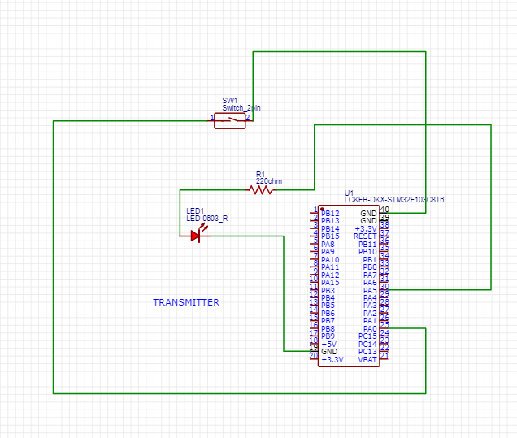
Figure 3.2 Transmitter Circuit
Transmitter:
- Switch connected to STM32 input (A0) with internal pulldown.
- Output pin (A5) drives 1–2 LEDs through 220 Ω resistors.
- LEDs are forward biased; pressing the button turns them ON.
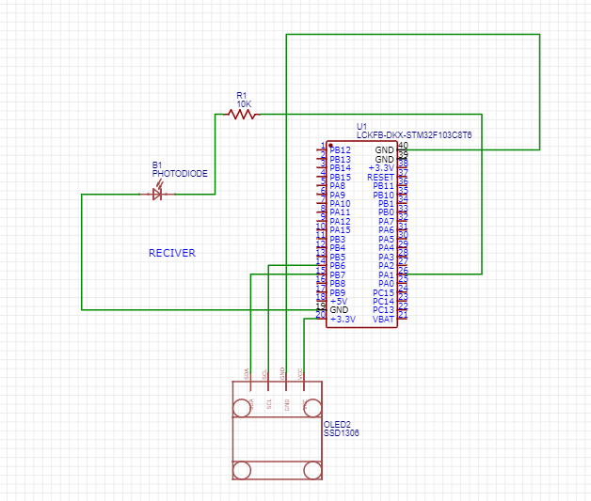
Figure 3.3 Receiver Circuit
Receiver:
- Photodiode anode connected to a 10 kΩ resistor that goes to +3.3 V.
- Cathode connected to GND.
- The junction between them (Node A) goes to STM32 analog pin A1.
- More light → higher photocurrent → lower voltage at Node A → ADC drops.
Display:
- SSD1306 OLED connected via I²C (SCL = PB6, SDA = PB7).
- 3.3 V supply to VCC, GND common.

3.4 Software Used and Code Explanation
Table 3.2 Software and Libraries Used
SOFTWARE | PURPOSE
Arduino IDE | Coding & uploading to STM32
Stm IDE and Stm Programmer | Board support package
Adafruit_GFX & SSD1306 libraries | For OLED
Wire library | For I2C

TRANSMITTER:
- When the button is pressed, the STM32 sends a HIGH output signal to the LED pin, causing the LED to emit light.
- This light acts as the transmission signal in the Li-Fi system.
- When the button is released, the LED turns OFF, stopping the light signal.
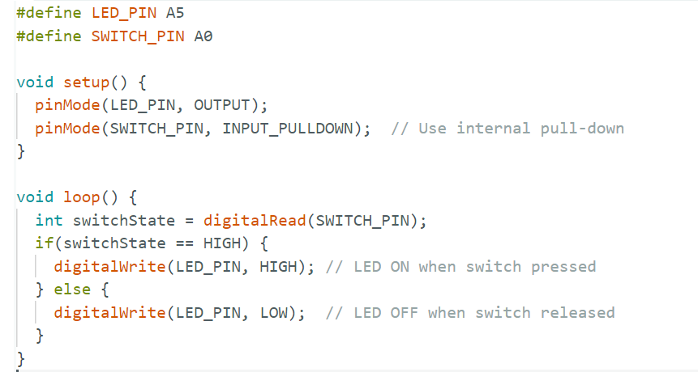
Figure 3.4 Transmitter Code

Pin Declaration:
- The program first defines two pins —
- A5 for the LED output and A0 for the push button input.
- The LED represents the transmitter, while the push button simulates the brake signal.
Setup Function:
- Inside the setup() function, the microcontroller pins are configured:
- A5 is set as an OUTPUT pin so that it can drive the LED.
- A0 is configured as an INPUT_PULLDOWN, which means the STM32 keeps the pin LOW (0 V) when the button is not pressed and reads HIGH (3.3 V) when the button is pressed.
Loop Function:
- The loop() function runs continuously and performs the main operation.
- It reads the state of the button using digitalRead(SWITCH_PIN).
- If the button is pressed (HIGH), the LED connected to A5 turns ON using digitalWrite(LED_PIN, HIGH).
- If the button is not pressed (LOW), the LED turns OFF using digitalWrite(LED_PIN, LOW).
RECEIVER:
- When the transmitter LED is ON, light falls on the photodiode, causing an increase in photocurrent.
- Since the photodiode is connected in reverse bias, this current reduces the voltage at the analog input, resulting in a lower ADC reading.
- The STM32 microcontroller compares this value to the set threshold to determine the brake status.
- If the reading drops below the threshold, the system identifies it as a Brake Failure and displays it on the OLED.

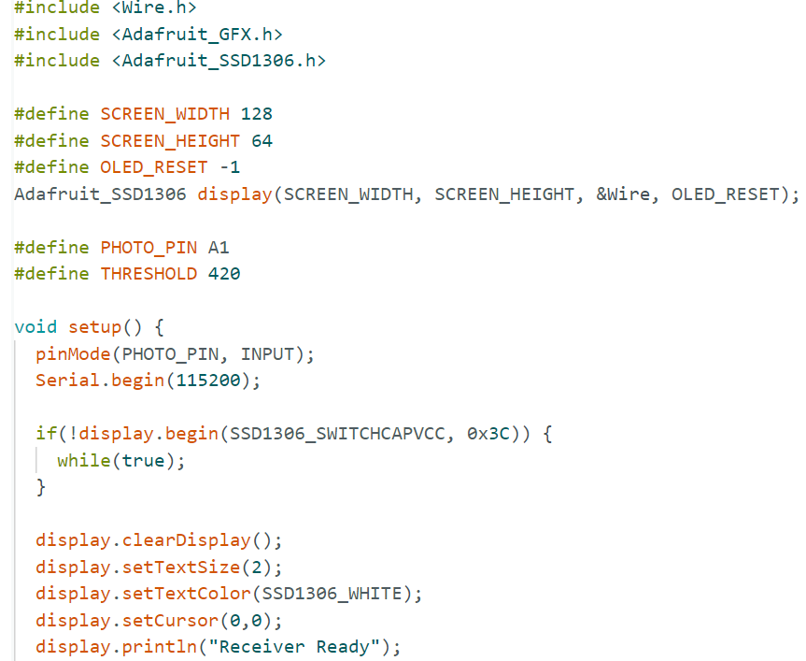
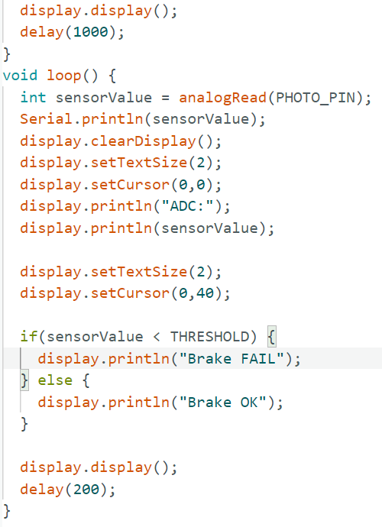
Figure 3.5 Receiver Code
Library Inclusion:
- The program starts by including three libraries:
- Wire.h is used for I²C communication between STM32 and the OLED display.
- Adafruit_GFX.h is used for provides basic graphics functions like text and shapes.
- Adafruit_SSD1306.h is used for specifically controls the SSD1306 OLED display module.
Display Configuration:
- The OLED display is initialized with a width of 128 pixels and height of 64 pixels.
- The display.begin() function sets up the display at I²C address 0x3C.
- If initialization fails, the program stops inside the infinite loop while(true).
Input Pin Setup:
- The photodiode output is connected to analog pin A1, which is configured as an input.
- The analog voltage at this pin corresponds to the intensity of light falling on the photodiode.
Threshold Definition:
- A threshold value of 420 is set based on experimental calibration.
- In normal room light, the ADC reading is around 465.
- When the LED light from the transmitter hits the photodiode, the ADC reading drops to around 360.
- The midpoint (420) is chosen as the decision level.
Main Loop:
The loop() function executes continuously and performs three main operations:
Analog Reading:
- The line analogRead(PHOTO_PIN) reads the photodiode voltage and stores it in sensorValue.
- The value is printed to the serial monitor for debugging.
Display Update:
The OLED screen is cleared and updated to show the current ADC reading.
Condition Check:
- If sensorValue < THRESHOLD, it means the photodiode detected LED light → Brake FAIL.
- Otherwise, it means no LED light is received → Brake OK.
- The result is displayed on the OLED screen in real time.
Delay:
A small delay of 200 milliseconds is added for stable display updates and smooth reading transitions.

3.5 Step-by-Step Approach of Lifi Based Brake Alert System
Concept Definition:
- Demonstrate Li-Fi-style light sensing for brake status indication using STM32.
Circuit Design:
- Button input controls LEDs; photodiode senses light; OLED shows results.
Hardware Assembly:
- Connected LEDs, photodiode, and OLED on breadboard. Verified biasing directions and voltages.
Code Development:
- Program 1: Button → LED ON/OFF.
- Program 2: ADC reading → OLED display with threshold comparison.
Calibration:
- Measured ADC values under room light and with LED ON to choose threshold (420).
Testing:
- Increased LED and Colour LED count (1–2) and measured maximum distance.
- Achieved stable detection up to ~17 cm .
Observation:
- More LEDs or IR photodiode → stronger signal and longer sensing distance.
- Ambient light slightly affects readings, but still within threshold margin.
3.6 Summary
This chapter detailed the design and realization of the Li-Fi-based brake indication system.
The transmitter turns LEDs ON when a button is pressed, and the receiver photodiode senses the light intensity, feeding an analog signal to the STM32.
The microcontroller evaluates this signal against a calibrated threshold and displays Brake OK or Brake FAIL on the OLED.
Through multiple LED and photodiode trials, the system achieved a reliable sensing range of about 17 cm, effectively demonstrating the principle of short-range light-base detection
CHAPTER 4
RESULTS AND DISCUSSION
4.1 Overview
The project aimed to implement a simple Li-Fi (Light Fidelity) system using the STM32 microcontroller as a receiver and LED light as a transmitter.
The objective was to analyse how the photodiode’s analog response i.e. ADC (Analog to Digital Converter) value changes with different light sources and intensities.
The received light intensity was measured through the STM32 ADC and displayed on an OLED (Organic Light Emitting Diode)screen, where lower ADC values indicated higher received light intensity.
4.2 Experimental Setup of Lifi – Based Brake Alert System
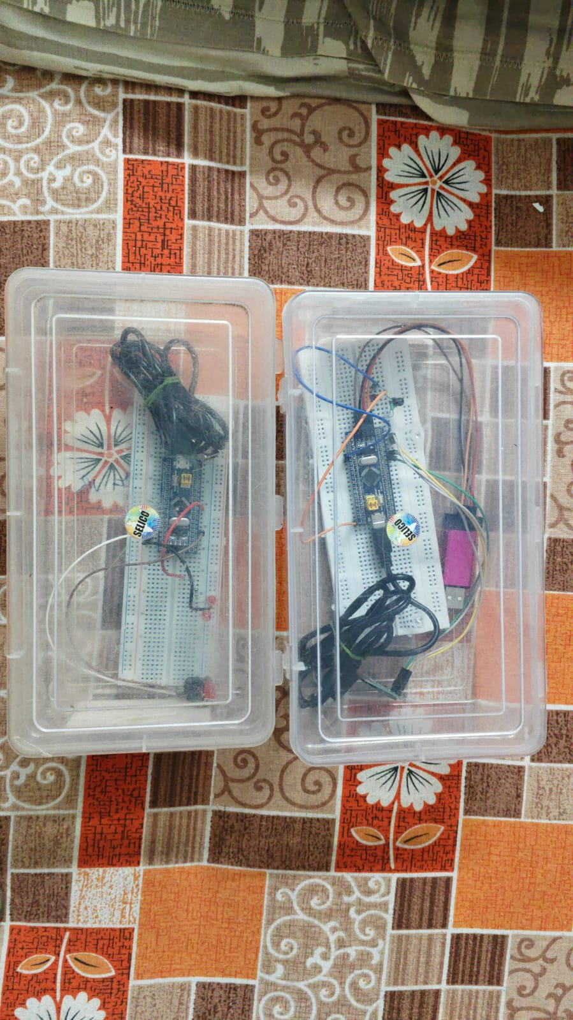
The setup consisted of:
- Transmitter section: one to three LEDs(Light Emitting Diode) which are red or white, connected through a switch and resistor.
- Receiver section: an IR photodiode connected in reverse bias with a resistor to form a light-sensitive voltage divider.
- OLED display interfaced with STM32 to show the live ADC values and system status (“Brake OK” or “Brake FAIL”).
The test was conducted under normal ambient light conditions. For each LED configuration, the ADC value and maximum detection distance (where change in ADC was still visible) were noted.

4.3 Observed Results
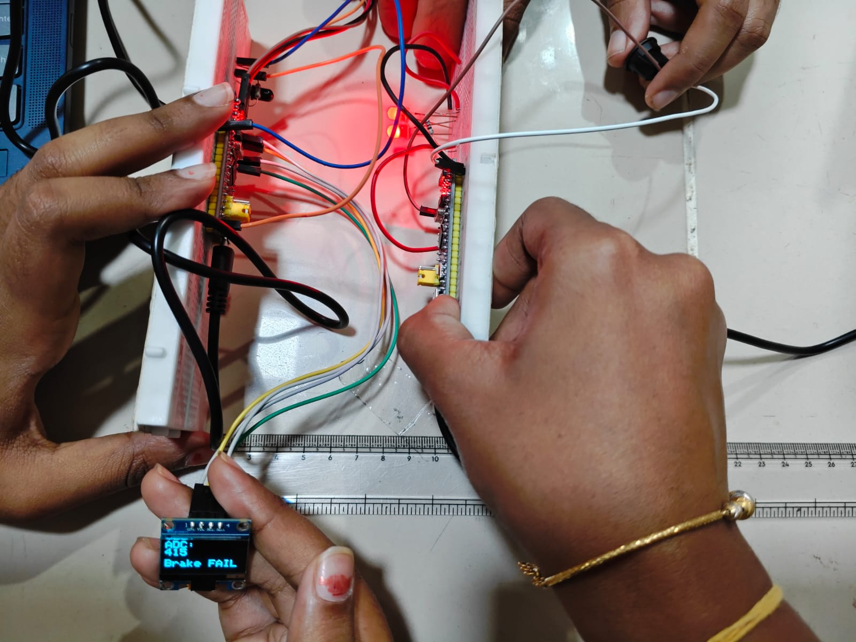
Figure 4.1 2 Red LEDs used

Observation:
The OLED display shows ADC = 415 with the message “Brake FAIL.”
The transmitter side has two red LEDs, and the receiver uses an IR photodiode.
Detection was possible only up to 10 cm.
Explanation:
- The IR photodiode mainly responds to infrared light (~850–950 nm).
- Red LEDs (~630 nm) emit light outside this sensitive range.
- Therefore, even though two LEDs are used, the photodiode receives very little usable light.
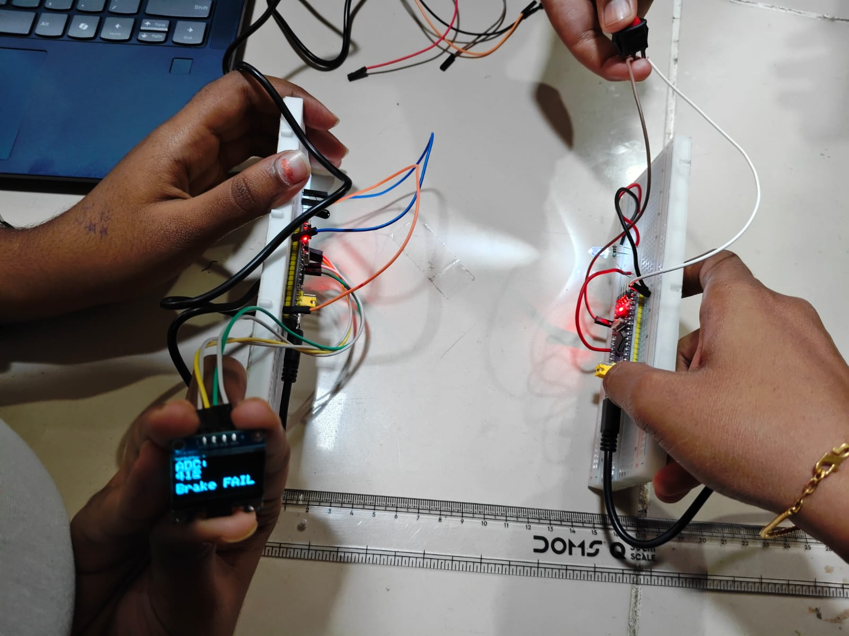
Figure 4.2 1 White LED used
Observation:
The OLED shows ADC = 412 and “Brake FAIL.”
Here, only one white LED is active, with a detection distance of 15 cm.
Explanation:
- A white LED emits broad-spectrum light, including visible and near-infrared components, which the IR photodiode can detect better.
- Even a single LED provides higher light intensity in the detectable wavelength range.
- The IR photodiode produces more photocurrent, slightly lowering the ADC value

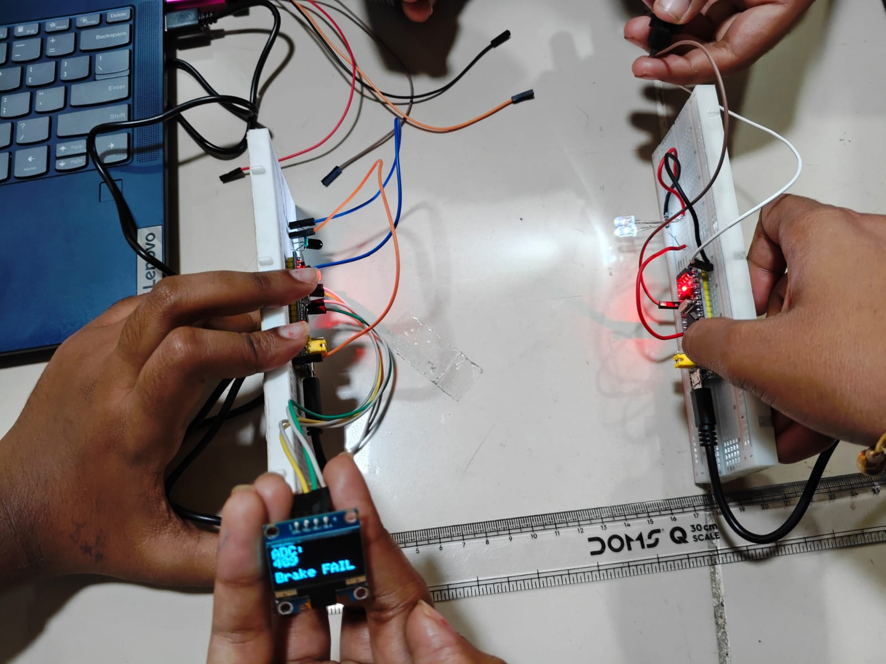
Figure 4.3 2 White LEDs used
Observation:
The OLED shows ADC = 409 and “Brake FAIL.”
The setup uses two white LEDs, with a clear detection range up to 17 cm — the best performance recorded.
Explanation:
- With two white LEDs, the overall light intensity doubles, and more IR-spectrum light reaches the photodiode.
- The resulting photocurrent increases, pulling the node voltage lower, giving a smaller ADC value.
Table 4.1 Summary Table
LED Type | Number of LEDs | ADC Value | Detection Distance
Red | 2 | 415 | 10 cm
White | 1 | 412 | 15 cm
White | 2 | 409 | 17 cm
With two red LEDs, the system detected light only up to about 10 cm, and the ADC value was 415, showing very little voltage drop.
The IR photodiode is primarily sensitive to infrared wavelengths (≈850 nm) and therefore responded poorly to red light (≈630 nm).
As a result, even multiple red LEDs produced only a weak photocurrent.
When switched to a white LED, the photodiode response improved markedly.
White LEDs emit a broad spectrum that includes visible and near-infrared components, which fall within the IR photodiode’s sensitivity range.
Consequently, the ADC value decreased to 412, indicating increased photocurrent and improved light detection up to 15 cm.
Using two white LEDs further increased the light intensity reaching the photodiode. This generated more photocurrent, reducing the output voltage and lowering the ADC reading to 409.The detection distance increased to 17 cm, demonstrating the correct relationship:
4.4 Performance Graph
The below graph has been plotted using MSExcel
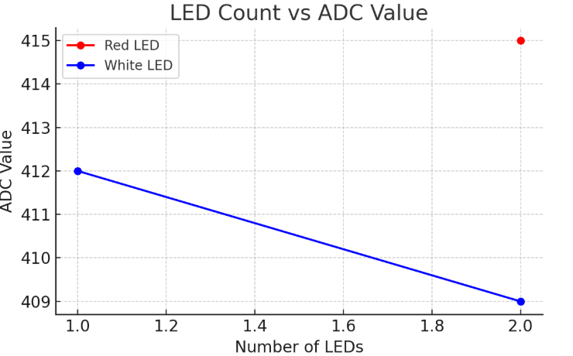
Figure 4.4 Number of LEDs vs ADC value
- X-axis: Number of LEDs
- Y-axis: ADC value
Plot both red LED and white LED results.
The downward slope for white LEDs shows better sensitivity and longer range.
4.5 Summary
The experimental results validate the working of a basic Li-Fi receiver circuit.
Switching from red to white LEDs improved system response due to the broader and more intense light spectrum of white LEDs, which matched the IR photodiode’s sensitivity.
The decreasing ADC trend confirms correct photodiode operation: as the incident light intensity increases, the ADC value decreases.
The system effectively demonstrates optical data reception capability within a short range (10–17 cm) and provides a visible status indication on the OLED.

CHAPTER 5
CONCLUSION
5.1 Conclusion
Project successfully demonstrated a simple Li-Fi (Light Fidelity) based brake indication system using STM32, LEDs (Light Emitting Diode), and a photodiode. The system proved that light can be used effectively for short-range communication and sensing.
When the transmitter LEDs were turned ON by pressing the button, the receiver photodiode detected the change in light intensity, and the STM32 displayed the corresponding “Brake OK” or “Brake FAIL” message on the OLED (Organic Light Emitting Diode) screen.
Through experimental testing, the system responded accurately within a distance of approximately 17 cm, with sensitivity improving as more LEDs were added.
The project achieved all its objectives: it demonstrated the principle of Li-Fi communication, successfully interfaced an OLED display, and developed a simple and reliable method for detecting brake status using light signals.
This small-scale prototype validates the potential of Li-Fi for real-time safety and control applications.
5.2 Future Improvements and Extensions
Although the system performed well for basic testing, several enhancements can be made to improve range, stability, and real-world performance:
- Increase the detection range by using higher-power IR LEDs or an op-amp-based transimpedance amplifier for the photodiode.
- Implement wireless data transfer by encoding signals on the light beam (for example, PWM-based communication).
- Integrate the system into a vehicle model, where the transmitter and receiver can communicate between two real modules (e.g., brake pedal and brake light).
- Use machine-learning or adaptive thresholding to automatically adjust to varying light conditions.
In conclusion, this project has shown that Li-Fi technology can be effectively used for short-range optical detection and signaling. The combination of STM32, LEDs, and photodiode created a simple yet innovative system for brake failure indication. With further enhancements, this work can be extended into more advanced optical communication and safety systems for vehicles or smart infrastructure.

REFERENCES
[1] H. Haas, Y. Liang, Y. Wang, and C. Chen, “What is LiFi?” Journal of Lightwave Technology, vol. 34, no. 6, pp. 1533–1544, Mar. 2016.
[2] E. Basar, M. Wen, R. Mesleh, M. Di Renzo, Y. Xiao, and H. Haas, “Index Modulation Techniques for Next-Generation Wireless Networks,” IEEE Access, vol. 5, pp. 16693–16746, 2017.
[3] M. Z. Chowdhury, M. S. Shahjalal, S. Ahmed, and Y. M. Jang, “6G Wireless Communication Systems: Applications, Requirements, Technologies, Challenges, and Research Directions,” IEEE Open Journal of the Communications Society, vol. 1, pp. 957–975, 2020.
[4] X. Wu, M. D. Soltani, L. Zhou, M. Safari, and H. Haas, “Hybrid LiFi and WiFi Networks: A Survey,” IEEE Communications Surveys & Tutorials, vol. 23, no. 2, pp. 1398–1420, 2021.
[5] I. Ara and B. Kelley, “Physical Layer Security for 6G: Toward Achieving Intelligent Native Security at Layer-1,” IEEE Access, vol. 12, pp. 12315–12330, 2024.
[6] N. Kumar, N. Lourenço, D. Terra, L. N. Alves, and R. L. Aguiar, “Visible Light Communication System for Automotive Applications,” IEEE Transactions on Intelligent Transportation Systems, vol. 16, no. 4, pp. 1730–1738, 2015.
[7] A. S. Abd El-Wahab, M. Abdallah, and H. S. Momtaz, “Design and Implementation of Li-Fi Communication System for Short-Range Data Transmission,” International Journal of Advanced Computer Science and Applications, vol. 10, no. 3, pp. 251–258, 2019.
[8] H. Le-Minh, D. O’Brien, G. Faulkner, L. Zeng, K. Lee, D. Jung, and Y. Oh, “High-Speed Visible Light Communications Using Multiple-Resonant Equalization,” IEEE Photonics Technology Letters, vol. 20, no. 14, pp. 1243–1245, 2008.

