Project Analysis Report
t2mpoc
Comprehensive analysis and documentation of Mule project configuration, flows, and resources
December 20, 2025 22:54:28 CST

Table of Contents

1. Project Information

1.1 Project Details
Property | Value
Project Name | t2mpoc
Version | 1.0.0
Project Path | C:\raks\apiguard\raksanalyzer\.\testdata\t2mpoc

1.2 POM Details
Path: pom.xml

1.2.1 Basic Information
Property | Value
Model Version | 4.0.0
Group ID | com.truist.eapi01
Artifact ID | t2mpoc
Version | 1.0.0
Packaging | mule-application
Name | t2mpoc-1.0.0-mule-application
Description | t2mpoc api is created for t2m related POCs.

1.2.2 Properties
Key | Value
mule.maven.plugin.version | 4.0.0
munit.version | 3.0.0
project.build.sourceEncoding | UTF-8
app.runtime | 4.4.0-20240219
project.reporting.outputEncoding | UTF-8
cicd.mule.version | 4.4.0

1.2.3 Plugins
GroupId | ArtifactId | Version
org.apache.maven.plugins | maven-clean-plugin | 3.0.0
org.mule.tools.maven | mule-maven-plugin | ${mule.maven.plugin.version}
com.mulesoft.munit.tools | munit-maven-plugin | 3.0.0

1.2.4 Dependencies
GroupId | ArtifactId | Version
com.enterprisemath | em-utils | 4.1.1
org.apache.poi | poi | 5.2.4
org.apache.poi | poi-ooxml | 5.2.4
org.apache.poi | poi-ooxml-schemas | 4.1.2
org.eclipse.jgit | org.eclipse.jgit | 6.8.0.202311291450-r
org.mule.connectors | mule-http-connector | 1.9.0
org.mule.connectors | mule-sockets-connector | 1.2.4
org.mule.connectors | mule-objectstore-connector | 1.2.2
org.mule.connectors | mule-file-connector | 1.5.2
org.mule.connectors | mule-email-connector | 1.7.2
org.mule.module | mule-java-module | 1.2.12
org.mule.modules | mule-xml-module | 1.4.2
org.mule.modules | mule-compression-module | 2.2.3
com.mulesoft.modules | mule-secure-configuration-property-module | 1.2.7
org.mule.connectors | mule-db-connector | 1.14.7
com.microsoft.sqlserver | mssql-jdbc | 12.6.0.jre8
org.antlr | antlr4-runtime | 4.9.3
com.mulesoft.connectors | mule-ibm-mq-connector | 1.6.23
com.ibm.mq | com.ibm.mq.allclient | 9.3.5.1
org.json | json | 20240205

1.3 Mule-artifact.json
Path: mule-artifact.json
{
"minMuleVersion": "4.4.0"
}

1.4 Release-info.json
Path: releaseinfo.json
{
"API CI Name": "YourAPIServiceName",
"Release Value": "YourReleaseValueHere",
"Release Number": "RLSEXXXXXXX",
"Project Name": "YourProjectNameHere",
"Implementation Date": "mm/dd/ccyy HH:MM - mm/dd/ccyy HH:MM",
"Project ID": "YourProjectIdHere",
"RFC": "YourServiceNowChangeRequestIdHere"
}

2. Flow Diagrams

2.1 Mule Project Flow Integration

2.1.1 AddException
Path: src\main\mule\apireviewexceptions.xml
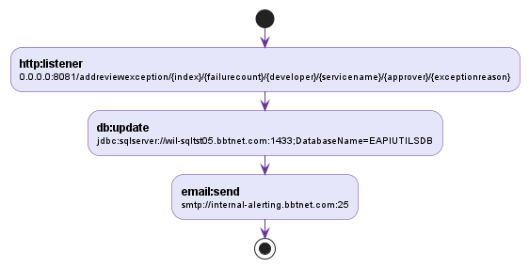

2.1.2 PLTFlow
Path: src\main\mule\PLT.xml
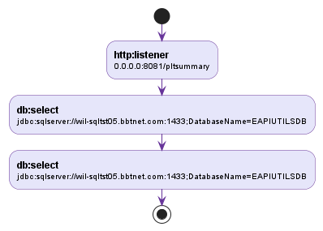

2.1.3 PLTFlow1
Path: src\main\mule\PLT.xml
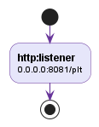

2.1.4 PLTFlow2
Path: src\main\mule\PLT.xml
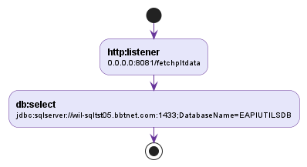

2.1.5 PLTFlow3
Path: src\main\mule\PLT.xml
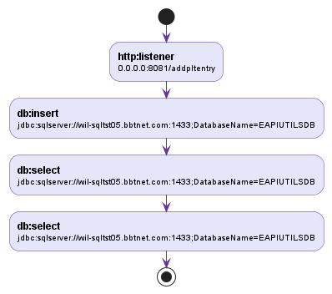

2.1.6 PLTFlow4
Path: src\main\mule\PLT.xml
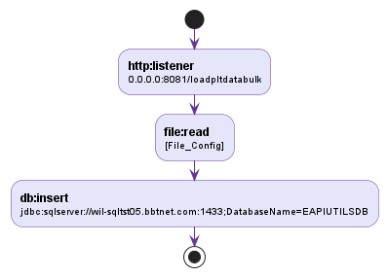

2.1.7 PLTFlow5
Path: src\main\mule\PLT.xml
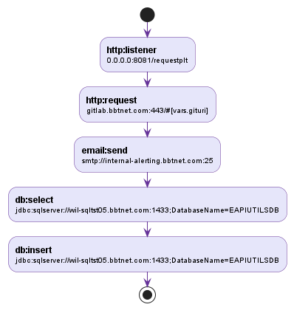

2.1.8 PLTFlow6
Path: src\main\mule\PLT.xml
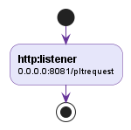

2.1.9 PLTFlow7
Path: src\main\mule\PLT.xml
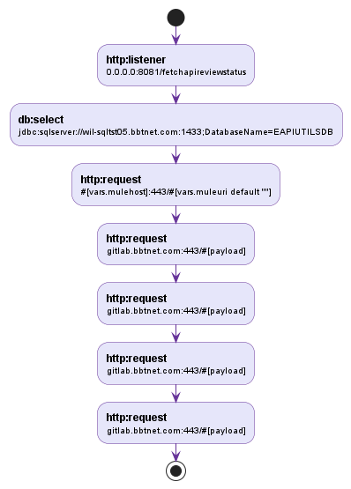

2.1.10 PLTLive
Path: src\main\mule\PLT.xml
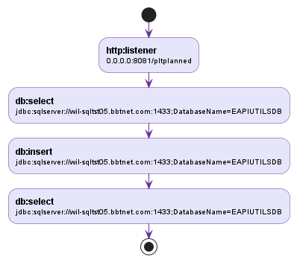

2.1.11 PLTLiveStart
Path: src\main\mule\PLT.xml
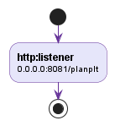

2.1.12 PLTUpdate
Path: src\main\mule\PLT.xml
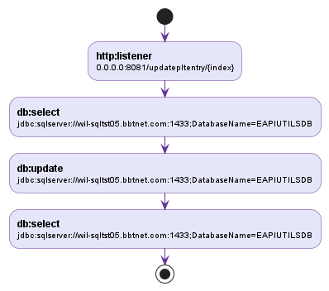

2.1.13 ReviewSummary
Path: src\main\mule\t2mdbexport.xml
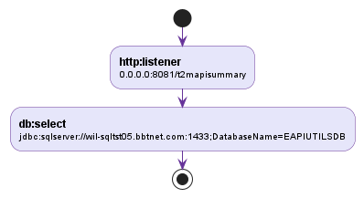

2.1.14 apireviewexceptionsFlow
Path: src\main\mule\apireviewexceptions.xml
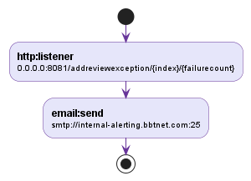

2.1.15 apireviewexceptionsFlow1
Path: src\main\mule\apireviewexceptions.xml
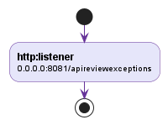

2.1.16 apireviewexceptionsFlow2
Path: src\main\mule\apireviewexceptions.xml
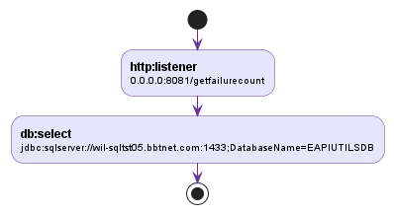

2.1.17 apireviewexceptionsFlow3
Path: src\main\mule\apireviewexceptions.xml
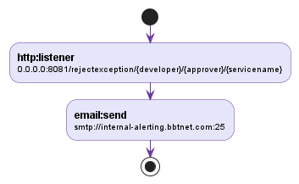

2.1.18 devtrackerreadFlow
Path: src\main\mule\devtrackerread.xml
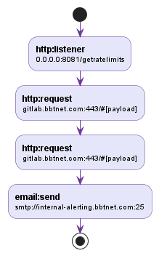

2.1.19 devtrackerreadFlow1
Path: src\main\mule\devtrackerread.xml
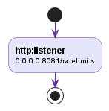

2.1.20 devtrackerreadFlow2
Path: src\main\mule\devtrackerread.xml
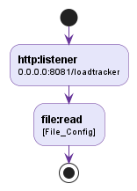

2.1.21 devtrackerreadFlow3
Path: src\main\mule\devtrackerread.xml
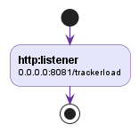

2.1.22 interceptcicscallsFlow
Path: src\main\mule\interceptcicscalls.xml
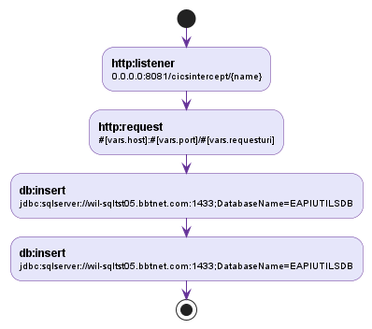

2.1.23 interceptcicscallsFlow1
Path: src\main\mule\interceptcicscalls.xml
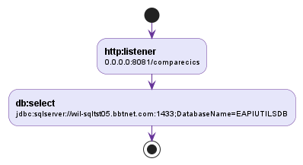

2.1.24 interceptcicscallsFlow2
Path: src\main\mule\interceptcicscalls.xml
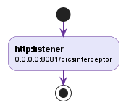

2.1.25 mulemqtriggerFlow
Path: src\main\mule\mulemqtrigger.xml
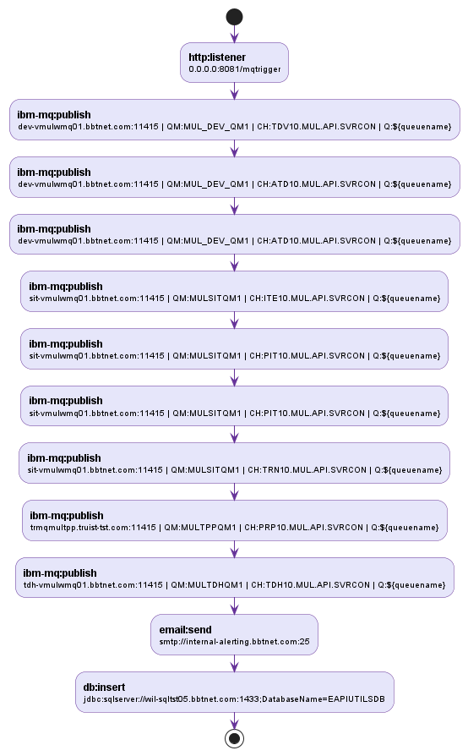

2.1.26 mulemqtriggerFlow1
Path: src\main\mule\mulemqtrigger.xml
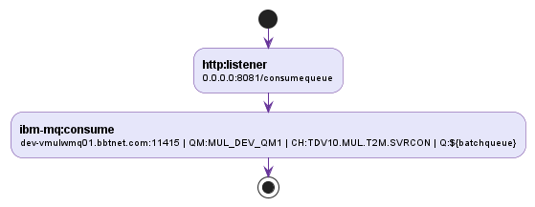

2.1.27 mulemqtriggerFlow2
Path: src\main\mule\mulemqtrigger.xml
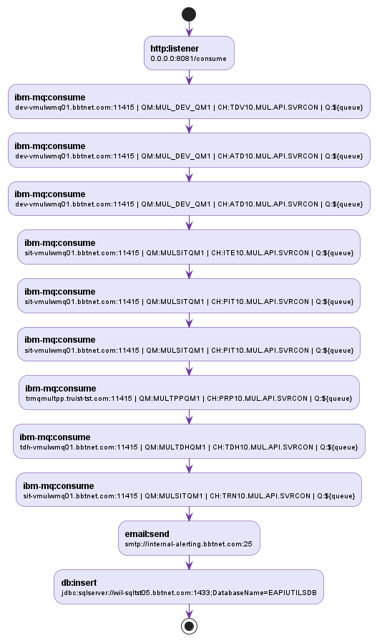

2.1.28 mulemqtriggerFlow3
Path: src\main\mule\mulemqtrigger.xml
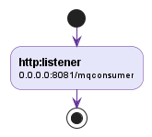

2.1.29 mulemqtriggerhome
Path: src\main\mule\mulemqtrigger.xml
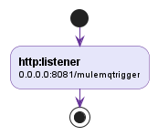

2.1.30 parentpomconversionFlow
Path: src\main\mule\parentpomconversion.xml
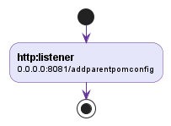

2.1.31 parentpomconversionFlow1
Path: src\main\mule\parentpomconversion.xml
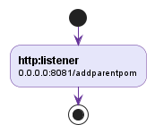

2.1.32 responsevalidatorFlow
Path: src\main\mule\responsevalidator.xml
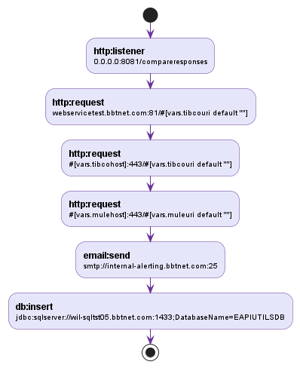

2.1.33 responsevalidatorFlow1
Path: src\main\mule\responsevalidator.xml
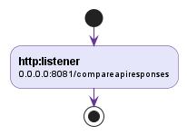

2.1.34 t2m_pocFlow
Path: src\main\mule\t2mpoc.xml
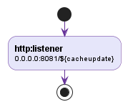

2.1.35 t2m_pocFlow1
Path: src\main\mule\t2mpoc.xml
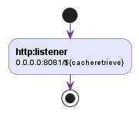

2.1.36 t2mdbexportFlow
Path: src\main\mule\t2mdbexport.xml
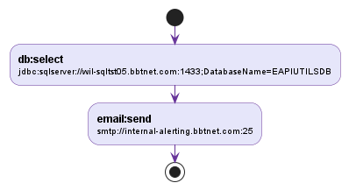

2.1.37 t2mdbexportFlow1
Path: src\main\mule\t2mdbexport.xml
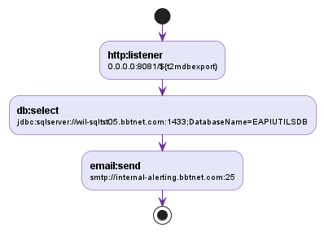

2.1.38 t2mdbexportFlow2
Path: src\main\mule\t2mdbexport.xml
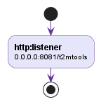

2.1.39 t2mpocFlow
Path: src\main\mule\t2mpoc.xml
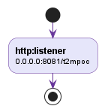

2.2 Mule Project Flow Diagram

2.2.1 AddException
Path: src\main\mule\apireviewexceptions.xml
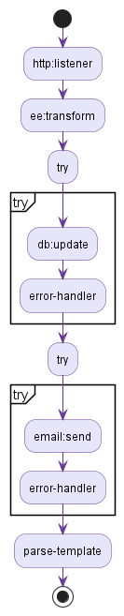

2.2.2 PLTFlow
Path: src\main\mule\PLT.xml
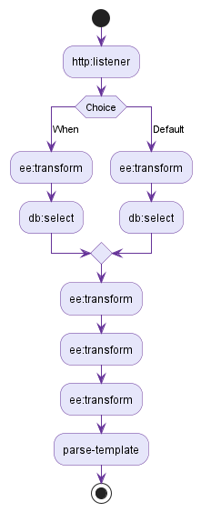

2.2.3 PLTFlow1
Path: src\main\mule\PLT.xml
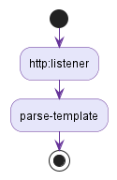

2.2.4 PLTFlow2
Path: src\main\mule\PLT.xml
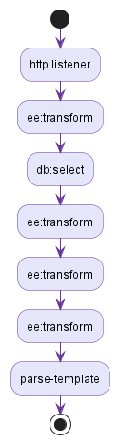

2.2.5 PLTFlow3
Path: src\main\mule\PLT.xml
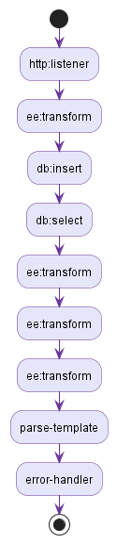

2.2.6 PLTFlow4
Path: src\main\mule\PLT.xml
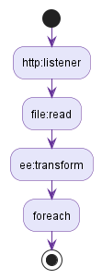

2.2.7 PLTFlow5
Path: src\main\mule\PLT.xml
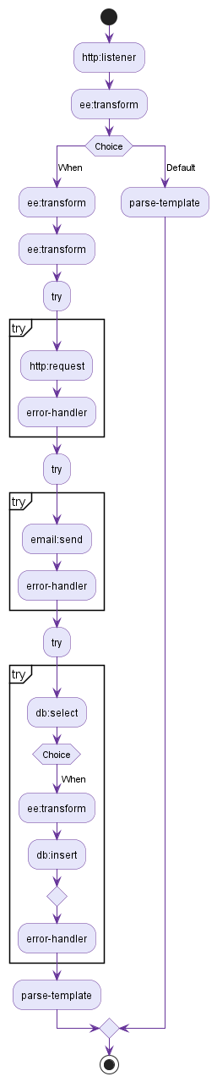

2.2.8 PLTFlow6
Path: src\main\mule\PLT.xml

2.2.9 PLTFlow7
Path: src\main\mule\PLT.xml

2.2.10 PLTLive
Path: src\main\mule\PLT.xml
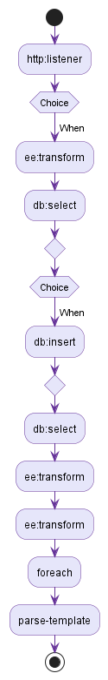

2.2.11 PLTLiveStart
Path: src\main\mule\PLT.xml

2.2.12 PLTUpdate
Path: src\main\mule\PLT.xml
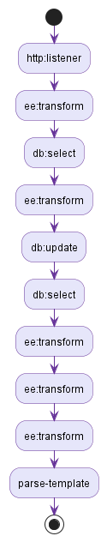

2.2.13 ReviewSummary
Path: src\main\mule\t2mdbexport.xml
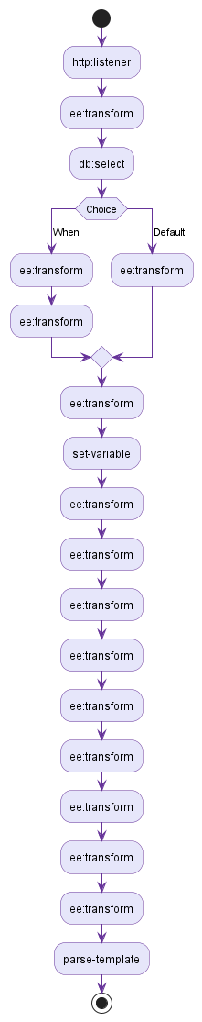

2.2.14 apireviewexceptionsFlow
Path: src\main\mule\apireviewexceptions.xml
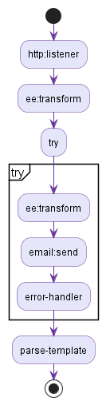

2.2.15 apireviewexceptionsFlow1
Path: src\main\mule\apireviewexceptions.xml

2.2.16 apireviewexceptionsFlow2
Path: src\main\mule\apireviewexceptions.xml
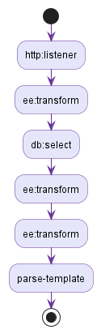

2.2.17 apireviewexceptionsFlow3
Path: src\main\mule\apireviewexceptions.xml
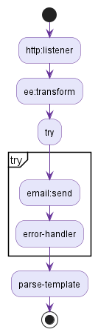

2.2.18 devtrackerreadFlow
Path: src\main\mule\devtrackerread.xml
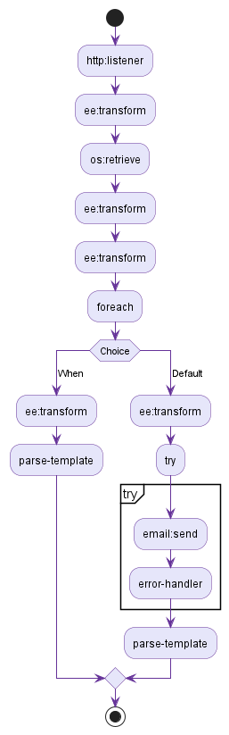

2.2.19 devtrackerreadFlow1
Path: src\main\mule\devtrackerread.xml

2.2.20 devtrackerreadFlow2
Path: src\main\mule\devtrackerread.xml
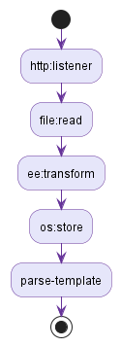

2.2.21 devtrackerreadFlow3
Path: src\main\mule\devtrackerread.xml

2.2.22 interceptcicscallsFlow
Path: src\main\mule\interceptcicscalls.xml
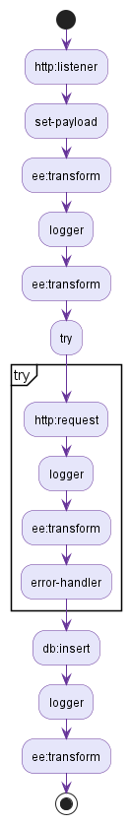

2.2.23 interceptcicscallsFlow1
Path: src\main\mule\interceptcicscalls.xml
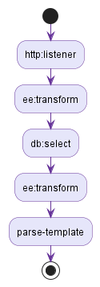

2.2.24 interceptcicscallsFlow2
Path: src\main\mule\interceptcicscalls.xml

2.2.25 mulemqtriggerFlow
Path: src\main\mule\mulemqtrigger.xml
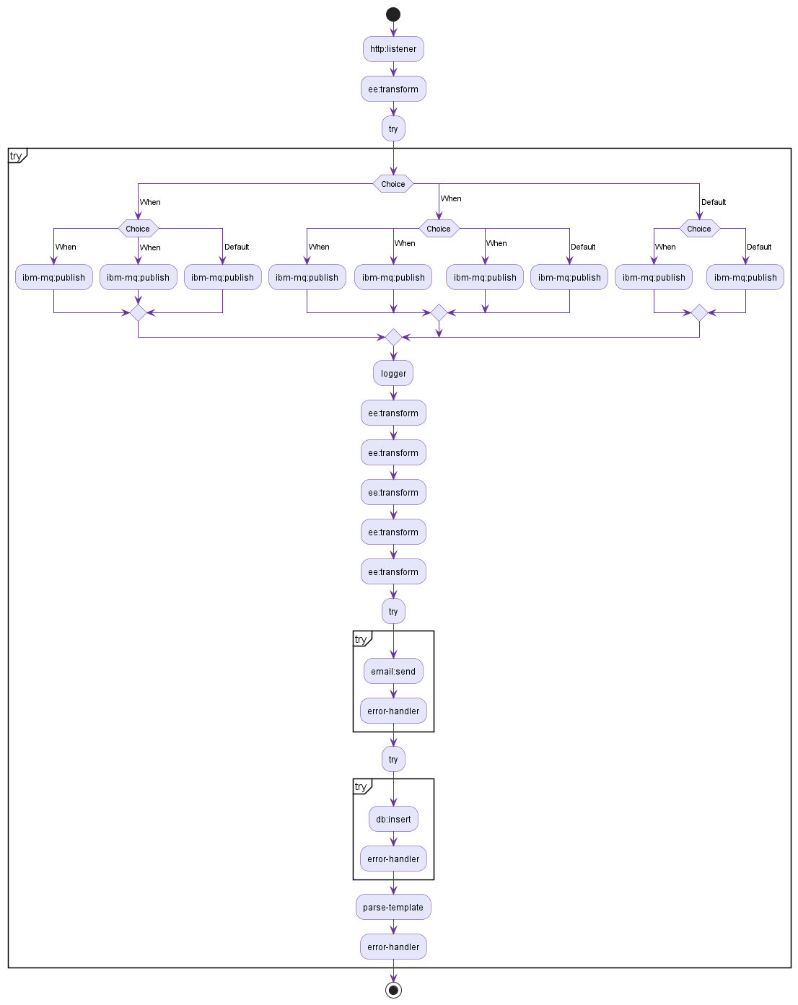

2.2.26 mulemqtriggerFlow1
Path: src\main\mule\mulemqtrigger.xml
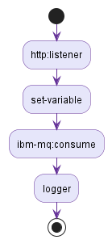

2.2.27 mulemqtriggerFlow2
Path: src\main\mule\mulemqtrigger.xml
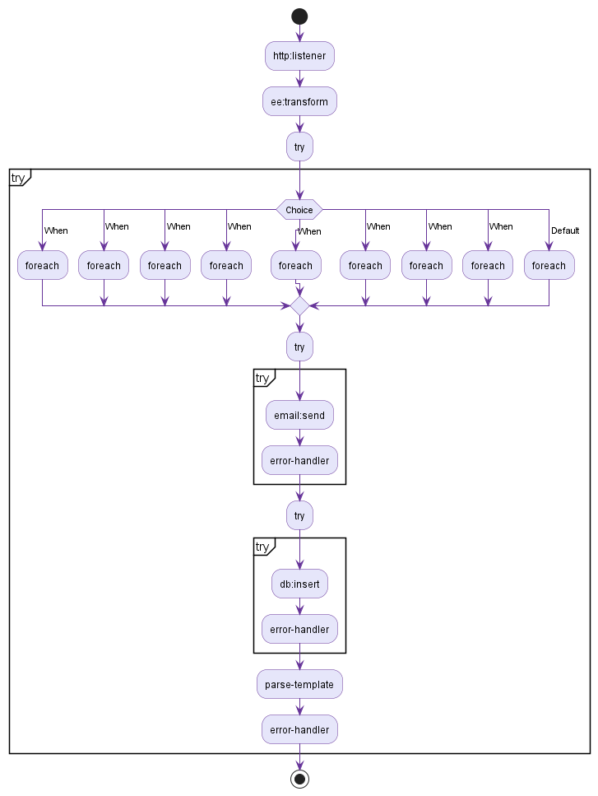

2.2.28 mulemqtriggerFlow3
Path: src\main\mule\mulemqtrigger.xml

2.2.29 mulemqtriggerhome
Path: src\main\mule\mulemqtrigger.xml

2.2.30 parentpomconversionFlow
Path: src\main\mule\parentpomconversion.xml
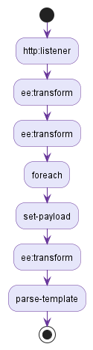

2.2.31 parentpomconversionFlow1
Path: src\main\mule\parentpomconversion.xml

2.2.32 responsevalidatorFlow
Path: src\main\mule\responsevalidator.xml
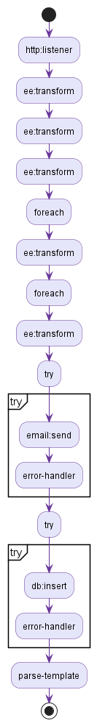

2.2.33 responsevalidatorFlow1
Path: src\main\mule\responsevalidator.xml

2.2.34 t2m_pocFlow
Path: src\main\mule\t2mpoc.xml
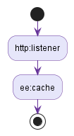

2.2.35 t2m_pocFlow1
Path: src\main\mule\t2mpoc.xml
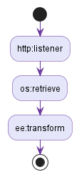

2.2.36 t2mdbexportFlow
Path: src\main\mule\t2mdbexport.xml
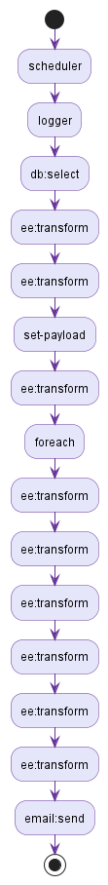

2.2.37 t2mdbexportFlow1
Path: src\main\mule\t2mdbexport.xml
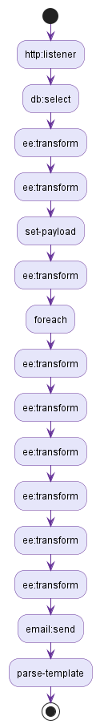

2.2.38 t2mdbexportFlow2
Path: src\main\mule\t2mdbexport.xml

2.2.39 t2mpocFlow
Path: src\main\mule\t2mpoc.xml
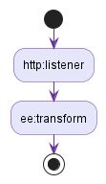

3. Global Configuration

3.1 mule-app.properties
Path: src\main\resources\mule-app.properties
Key | Value
keystore.path | eapi-mule-lastmile.truist-tst.com.jks
channel.trn | TRN10.MUL.API.SVRCON
liveConsumer.queuename | MUL.FN5SUBMIT.FRAUDNETFORATOAPI.PREP.L
qmanager.tdv | MUL_DEV_QM1
smtp.from | DL.API.T2M@truist.com
input.inquirylevel | 101,102,103,100,000,00 0,00ab0,000@,null, ,removetag
input.userids | A71595,A71 595,D34526,A7159500000000,000000000A71595,B12765,B12765#,null, ,removetag
input.channels | AD,BP,CSB,OLBWEB,OLB WEB,AR,OW,OM,BV,GH,MP,PV,NNC,CHANNEL,null, ,removetag
qmanager.tpp | MULTPPQM1
wmq.queuemanager2 | MUL_DEV_QM1
wmq.queuemanager3 | MUL_DEV_QM1
doTestConnectivity | False
input.statickeys | 1845192,1845195,201035013,1845200,1845212,35791287,000000051778527,184-5212,18452.12,63103818,6310 3818,6310ab3818,34287311,000000038081234,1337375,1174669,384899,1734152,1035079,9802055,1580961,1174631,2121607,1363479,2338997,7816684,1919249,2224265,162922,2065369,1131481,887250,389433,1903799,49629805,000000072149650,000000051778527,78527,null, ,removetag
input.applications | DDA,DA,ASD,DSA,DS A,DS#A, ,removetag
wmq.cps.numofconsumers | 4
input.customerids | 00004491623402066988,00004491623402568154,00004491623401502602,00004491623409665094,00004491623408382240,572267304,00000000057226730400000000000000000,00000000000000000000000000000000572267304,000000000572267304#,00000128000000390a,-0.5,00004491623404821933,00004491623409195181,00004491623408613410,00004491623409772246,00004491623404815377,0000449162340 436319,00004491623409223777,00004491623405348197,00004491623405336145,null, ,removetag
wmq.connectionNameList.prep | trmqmultpp.truist-tst.com(11415)
wmq.connectionNameList | dev-vmulwmq01.bbtnet.com(11415)
gui.apphome | ${mule.home}//apps//${app.name}//
qmanager.mne | MUL_DEV_QM1
wmq.host.drl | tdh-vmulwmq01.bbtnet.com
wmq.dlp.requestqueue | EAPI_MUL.ESP.SCHEDULE.ARCHIVEAPPDATAAPI.TRIGGER
input.codes | 01,08,80,ad,F5,T6,H7,123,12A,#, ,null,removetag
wmq.sessionCacheSize | 25
wmq.connectionNameList.ite | sit-vmulwmq01.bbtnet.com(11415)
qmanager.ibf | MULSITQM1
wmq.connectionNameList.drl | tdh-vmulwmq01.bbtnet.com(11415)
wmq.channel | TDV.TLS.CMAS.SVRCN
channel.mne | ATD10.MUL.API.SVRCON
cacheupdate | /cacheupdate
channel.pite | PIT10.MUL.API.SVRCON
email.subject | T2M Review Tool Report
email.cqc.body | Hello,<br/></br>Please find the review summary below.<br/></br>
email.cqc.signature | <br/><br/>Thanks & regards,<br />Mule API review tool<br /><br />*************************************************************************** <br/>This is an auto generated email, please do not reply to this email.
channel.ibf | PIT10.MUL.API.SVRCON
input.accountnumbers | 153211234567,2665544304,36104402555599,1470000863467,4147240000948099,4147241008461655,49629805,5422719530152416,5408009528211210,5408000500012056,5426579800051599,5408009528211210,4491611129302750,4491611302160918,5422769087016332,5408009528211210,2665544304,000000001033021050,000000001043052523,000000001033019986,7082052,7012510104884453,36104402555599,4147240000948099,0000000000000000000004341824804502626,4341824804502626,4147240000948099,4118031270571165,41180312 70571165,41180312ab70571165,4000000000536312,4000000000536487,4000000000503197,1483138314,1483107664,148310-7664,14831076.64,0000000000503197,FF0ECC3D7B7D9AC978553605EC04EE90D288DBDA0713290FBCCCFAF90A795D9B,4661890003334253,1470000863470,0000044300003032741,null, ,removetag
input.ssn | 00151739394,00151739395,00151-739395,001 517 3935,501-517-393,0151 739395,001517ab39395,00151739395#,0000000000151739394,1517393940000000000,400101121,39394,null, ,removetag
password.gitlab | zq7_xjB8dtG7WpxZ3U-1
wmq.cipherSuite | TLS_ECDHE_RSA_WITH_AES_256_GCM_SHA384
email.signature | <br/><br/>Thanks & regards,<br />T2M Review Tool<br /><br />*************************************************************************** <br/>This is an auto generated email, please do not reply to this email.
wmq.channel2 | TDV.TLS.CMAS.SVRCN
channel.tpp | PRP10.MUL.API.SVRCON
wmq.channel3 | TDV.TLS.CMAS.SVRCN
input.amounts | 0,0.0,0.00000,0000.000,0000,0.12000,12.012223324,01,10,1,1ab,1#,-0.5,-10,251.75,100000.6756,56753,4563,$3000,10000rs,null, ,removetag
wmq.reconnection.attempts | 1
wmq.queuemanager | MUL_DEV_QM1
smtp.port | 25
truststore.path | bbt-internal-certs.jks
input.dates | 10/11/23,10/12/2021,13/13/2020,13-13-2020,13:13:2020,13:13:2020 00:12:12,13/10/2020 00:12:12,13/10/2020 00:12:12 IST,1/1/2020,1/1,1/2020,2023,2023ab,20 23,20090301,200903,20090,2009,200,null, ,removetag
ks.alias | eapi-mule-mq-client-cert-np
ocphost | https://api-lms-sandbox.eapi01.truist-dev.com/t2mpoc-eapi01-sbx
wmq.host.prep | trmqmultpp.truist-tst.com
qmanager.atdv | MUL_DEV_QM1
apiId | 1234
channel.tdv | TDV10.MUL.API.SVRCON
ks.path | eapi-mule-mq-client-cert-np.jks
wmq.reconnection.frequency | 1000
input.banknums | 102,0102,104,0104,01 02,01ab02,null,31505,2000,2000000,1020000000000000,-123, ,removetag
input.cardnumbers | 4661890021183302,4661890021183305,4007000000027,4661890015731397,4307450030004294,00000002500,4700480030001415,004035370100066008,004130400800000025,4545070000000080,4393317108099412,4393319950043597,4393-3199-5004-3597,4393-31995004-3597,4661890021183503,466189002 1183302,46618900ab21183302,4007000000027,4661890021183302#,00000000000000004661890021183302,4661890021183302000000000000,890021183,4351420005029050,4661880067702990,4661880061152580,4661880053044639,4393316688084117,null, ,removetag
qmanager.drl | MULTDHQM1
wmq.host.sit | sit-vmulwmq01.bbtnet.com
wmq.host | dev-vmulwmq01.bbtnet.com
smtp.hostname | internal-alerting.bbtnet.com
qmanager.ite | MULSITQM1
input.names | AMWAY STES,JEROME DARD,JOHNY,DAVID,John2,Josh#,123 Fake Drive,Debostotra Jana,MACYS/GECCCC,Autaugaville,1661 Maple Ave,BANKAMERIC,CHESTER,FULTON,AL,GA,CA,MD,GB,GM,121 Single Fam Res, ,removetag
channel.ite | ITE10.MUL.API.SVRCON
email.body | Hello,<br/></br>Please find the attached review report and API level review summary below.<br/><br/>
keystore.alias | eapi-mule-lastmile.truist-tst.com
qmanager.pite | MULSITQM1
qmanager.trn | MULSITQM1
wmq.cps.timetolive | 4
channel.batch | TDV.MUL.BATCH.SVC
channel.drl | TDH10.MUL.API.SVRCON
wmq.port | 11415
input.inds | I,A,B,C,D,F,G,HI,JKL,123,#, ,null,removetag
ts.path | multls.mq.tst.truist.com.jks
cacheretrieve | /cacheretrieve
username.gitlab | D97029
t2mdbexport | /t2mdbexport
channel.atdv | ATD10.MUL.API.SVRCON

3.2 secure.properties
Path: src\main\resources\secure.properties
Key | Value
truststore.wmq.keypassword | ![o+HlBx0x2JOmjK8omjjxXsGv3AWCH/3Z43IUuuamldU=]
lastmile.keypassword | ![p/06LGgH1QUpvWg0I8NgXA==]
log.encryption.pwd | ![yKyjr1Tz45zVqlZTuB/8yQ==]
wmq.password | ![o+HlBx0x2JOmjK8omjjxXsGv3AWCH/3Z43IUuuamldU=]
wmq.userid | ![5Xt/10X/w5XUlHsF65nurg==]
truststore.password | ![o+HlBx0x2JOmjK8omjjxXsGv3AWCH/3Z43IUuuamldU=]

4. Connector Configurations

4.1 ATDV
Path: src\main\mule\mulemqtrigger.xml
Attribute Name | Attribute Value
doc:name | IBM MQ Config
doc:id | 3153ef30-94b4-445b-9543-b6cb870f836f
name | ATDV

4.1.1 ibm-mq:connection
Attribute Name | Attribute Value
tlsContext | Policy_TLS_Context
cipherSuite | ${wmq.cipherSuite}
username | ${secure::wmq.userid}

4.2 Batch
Path: src\main\mule\mulemqtrigger.xml
Attribute Name | Attribute Value
doc:name | IBM MQ Config
doc:id | 577dc52f-7414-46be-a487-04e6823c9fbb
name | Batch

4.2.1 ibm-mq:connection
Attribute Name | Attribute Value
cipherSuite | ${wmq.cipherSuite}
username | ${secure::wmq.userid}

4.3 DRL
Path: src\main\mule\mulemqtrigger.xml
Attribute Name | Attribute Value
doc:name | IBM MQ Config
doc:id | b461abf8-6483-4155-9d9f-3fee47553402
name | DRL

4.3.1 ibm-mq:connection
Attribute Name | Attribute Value
tlsContext | Policy_TLS_Context
cipherSuite | ${wmq.cipherSuite}
username | ${secure::wmq.userid}

4.4 Database-Connection
Path: src\main\mule\t2mdbexport.xml
Attribute Name | Attribute Value
doc:name | Database Config
doc:id | bcb2903b-9858-4cbd-8fa6-40fc4922c90d
name | Database-Connection

4.4.1 db:generic-connection
Attribute Name | Attribute Value
password | sql5678
driverClassName | com.microsoft.sqlserver.jdbc.SQLServerDriver
user | SV-MULEAPIUTILSDB
url | jdbc:sqlserver://wil-sqltst05.bbtnet.com:1433;DatabaseName=EAPIUTILSDB;encrypt=true;trustServerCertificate=true;

4.5 Email_SMTP
Path: src\main\mule\t2mdbexport.xml
Attribute Name | Attribute Value
doc:name | Email SMTP
doc:id | 1e458940-e8e1-4b89-919c-c6e227a8880c
name | Email_SMTP

4.5.1 email:smtp-connection
Attribute Name | Attribute Value
port | ${smtp.port}
readTimeout | 50
host | ${smtp.hostname}
writeTimeout | 50
connectionTimeout | 50

4.6 File_Config
Path: src\main\mule\interceptcicscalls.xml
Attribute Name | Attribute Value
doc:name | File Config
doc:id | 4920c81c-be8d-4078-96a2-eda06db0ad1c
name | File_Config

4.7 GetCredential
Path: src\main\mule\PLT.xml
Attribute Name | Attribute Value
doc:name | HTTP Request configuration
doc:id | b58e71dd-5a40-443b-865a-6ebb24d79a2a
name | GetCredential

4.7.1 http:request-connection
Attribute Name | Attribute Value
protocol | HTTPS
port | 443
host | gitlab.bbtnet.com
usePersistentConnections | false

4.8 HTTPRVMule
Path: src\main\mule\responsevalidator.xml
Attribute Name | Attribute Value
doc:name | HTTP Request configuration
doc:id | 88e84cb3-9d9f-4bd2-ba2e-b7a9cd0613d4
name | HTTPRVMule

4.8.1 http:request-connection
Attribute Name | Attribute Value
protocol | HTTPS
port | 443
host | #[vars.mulehost]
usePersistentConnections | false

4.9 HTTPResponseCompare
Path: src\main\mule\responsevalidator.xml
Attribute Name | Attribute Value
doc:name | HTTP Request configuration
doc:id | 7dc5c6c6-99b6-4900-82cb-d8ffe439b822
name | HTTPResponseCompare

4.9.1 http:request-connection
Attribute Name | Attribute Value
protocol | HTTPS
port | 443
host | #[vars.tibcohost]
usePersistentConnections | false
tlsContext | TLS_ContextRV

4.10 HTTP_Listener_config
Path: src\main\mule\t2mpoc.xml
Attribute Name | Attribute Value
doc:name | HTTP Listener config
doc:id | 1044a46a-98f5-442c-ad71-63fa76f4c8cc
name | HTTP_Listener_config

4.10.1 http:listener-connection
Attribute Name | Attribute Value
protocol | HTTPS
port | 8081
host | 0.0.0.0
usePersistentConnections | false
tlsContext | TLS_Context

4.11 HTTP_Request_configuration
Path: src\main\mule\interceptcicscalls.xml
Attribute Name | Attribute Value
doc:name | HTTP Request configuration
doc:id | faf5f8d4-ca88-4e87-b4b1-2fdfb21d434a
name | HTTP_Request_configuration

4.11.1 http:request-connection
Attribute Name | Attribute Value
port | #[vars.port]
host | #[vars.host]
usePersistentConnections | false

4.12 IBF
Path: src\main\mule\mulemqtrigger.xml
Attribute Name | Attribute Value
doc:name | IBM MQ Config
doc:id | e8ef495f-bb50-4b0b-9dd8-5254935513e1
name | IBF

4.12.1 ibm-mq:connection
Attribute Name | Attribute Value
tlsContext | Policy_TLS_Context
cipherSuite | ${wmq.cipherSuite}
username | ${secure::wmq.userid}

4.13 ITE
Path: src\main\mule\mulemqtrigger.xml
Attribute Name | Attribute Value
doc:name | IBM MQ Config
doc:id | dd787f93-17d1-4492-a3ff-e8fdd8dac3f4
name | ITE

4.13.1 ibm-mq:connection
Attribute Name | Attribute Value
tlsContext | Policy_TLS_Context
cipherSuite | ${wmq.cipherSuite}
username | ${secure::wmq.userid}

4.14 MNE
Path: src\main\mule\mulemqtrigger.xml
Attribute Name | Attribute Value
doc:name | IBM MQ Config
doc:id | aa6b25a8-24d1-4374-a877-f2d68756a0e8
name | MNE

4.14.1 ibm-mq:connection
Attribute Name | Attribute Value
tlsContext | Policy_TLS_Context
cipherSuite | ${wmq.cipherSuite}
username | ${secure::wmq.userid}

4.15 ObjectStore_Config
Path: src\main\mule\t2mpoc.xml
Attribute Name | Attribute Value
doc:name | ObjectStore Config
doc:id | d5b9e4e4-cb13-41da-a74c-3d119578f8b4
name | ObjectStore_Config

4.16 PITE
Path: src\main\mule\mulemqtrigger.xml
Attribute Name | Attribute Value
doc:name | IBM MQ Config
doc:id | 3dd02435-4aeb-4b42-88fa-9e46956b74a6
name | PITE

4.16.1 ibm-mq:connection
Attribute Name | Attribute Value
tlsContext | Policy_TLS_Context
cipherSuite | ${wmq.cipherSuite}
username | ${secure::wmq.userid}

4.17 PLTChecklistupload
Path: src\main\mule\PLT.xml
Attribute Name | Attribute Value
doc:name | HTTP Request configuration
doc:id | a966099a-33ee-4651-b235-f820de2ceffb
name | PLTChecklistupload

4.17.1 http:request-connection
Attribute Name | Attribute Value
protocol | HTTPS
port | 443
host | gitlab.bbtnet.com
usePersistentConnections | false

4.18 Policy_TLS_Context
Path: src\main\mule\mulemqtrigger.xml
Attribute Name | Attribute Value
doc:name | TLS Context
doc:id | 8ced47e2-cc3c-4440-9cc8-ab577160313d
name | Policy_TLS_Context

4.18.1 tls:trust-store
Attribute Name | Attribute Value
path | ${ts.path}
password | ${secure::wmq.password}
type | jks

4.18.2 tls:key-store
Attribute Name | Attribute Value
path | ${ks.path}
password | ${secure::truststore.wmq.keypassword}
keyPassword | ${secure::truststore.wmq.keypassword}
alias | ${ks.alias}
type | jks

4.19 Secure_Properties_Config
Path: src\main\mule\t2mpoc.xml
Attribute Name | Attribute Value
doc:name | Secure Properties Config
doc:id | e84cf3e7-33b7-4b84-ac9f-106d67796258
file | secure.properties
name | Secure_Properties_Config
key | ${secure.key}

4.20 TDV
Path: src\main\mule\mulemqtrigger.xml
Attribute Name | Attribute Value
doc:name | IBM MQ Config
doc:id | 8c032524-9324-4e54-8c4b-9fabb92cd01f
name | TDV

4.20.1 ibm-mq:connection
Attribute Name | Attribute Value
tlsContext | Policy_TLS_Context
cipherSuite | ${wmq.cipherSuite}
username | ${secure::wmq.userid}

4.21 TLS_Context
Path: src\main\mule\t2mpoc.xml
Attribute Name | Attribute Value
doc:name | TLS Context
doc:id | b530699e-cf2c-4bc9-a07d-6ace5b7d40f0
name | TLS_Context

4.21.1 tls:key-store
Attribute Name | Attribute Value
path | ${keystore.path}
password | ${secure::lastmile.keypassword}
keyPassword | ${secure::lastmile.keypassword}
alias | ${keystore.alias}
type | jks

4.22 TLS_ContextRV
Path: src\main\mule\responsevalidator.xml
Attribute Name | Attribute Value
doc:name | TLS Context
doc:id | ffd24f90-22c9-47ae-9e73-a5f2e8b5aeeb
name | TLS_ContextRV

4.22.1 tls:trust-store
Attribute Name | Attribute Value
path | ${truststore.path}
password | ${secure::truststore.password}
type | jks

4.23 TPP
Path: src\main\mule\mulemqtrigger.xml
Attribute Name | Attribute Value
doc:name | IBM MQ Config
doc:id | 7ea9137c-fa1a-4865-a7a8-140c55b2fcf0
name | TPP

4.23.1 ibm-mq:connection
Attribute Name | Attribute Value
tlsContext | Policy_TLS_Context
cipherSuite | ${wmq.cipherSuite}
username | ${secure::wmq.userid}

4.24 TRN
Path: src\main\mule\mulemqtrigger.xml
Attribute Name | Attribute Value
doc:name | IBM MQ Config
doc:id | f9b56120-b8d9-409e-a5db-2061c09a94b1
name | TRN

4.24.1 ibm-mq:connection
Attribute Name | Attribute Value
tlsContext | Policy_TLS_Context
cipherSuite | ${wmq.cipherSuite}
username | ${secure::wmq.userid}

4.25 api-gateway:autodiscovery
Path: src\main\mule\t2mpoc.xml
Attribute Name | Attribute Value
doc:name | API Autodiscovery
doc:id | bec42e52-341a-4a11-95db-fa894f8ff968
ignoreBasePath | true
apiId | ${apiId}
flowRef | t2mpocFlow

4.26 bbtnetconnection
Path: src\main\mule\responsevalidator.xml
Attribute Name | Attribute Value
doc:name | HTTP Request configuration
doc:id | 58c8bfac-61bd-4090-b5a1-9cd951ceb860
name | bbtnetconnection

4.26.1 http:request-connection
Attribute Name | Attribute Value
port | 81
host | webservicetest.bbtnet.com
usePersistentConnections | false

5. Mule Flows

5.1 apireviewexceptionsFlow
Path: src\main\mule\apireviewexceptions.xml

5.1.1 http:listener
Attribute Name | Attribute Value
doc:name | Listener
path | /addreviewexception/{index}/{failurecount}
config-ref | HTTP_Listener_config

5.1.2 ee:transform
Attribute Name | Attribute Value
doc:name | Transform Message

5.1.3 try
Attribute Name | Attribute Value
doc:name | Try1

5.1.4 parse-template
Attribute Name | Attribute Value
doc:name | Parse Template
location | web\exceptionresponse.html

5.2 AddException
Path: src\main\mule\apireviewexceptions.xml

5.2.1 http:listener
Attribute Name | Attribute Value
doc:name | Listener
path | /addreviewexception/{index}/{failurecount}/{developer}/{servicename}/{approver}/{exceptionreason}
config-ref | HTTP_Listener_config

5.2.2 ee:transform
Attribute Name | Attribute Value
doc:name | Transform Message

5.2.3 try
Attribute Name | Attribute Value
doc:name | Try

5.2.4 try
Attribute Name | Attribute Value
doc:name | Try1

5.2.5 parse-template
Attribute Name | Attribute Value
doc:name | Parse Template
location | web\exceptionapproved.html

5.3 apireviewexceptionsFlow1
Path: src\main\mule\apireviewexceptions.xml

5.3.1 http:listener
Attribute Name | Attribute Value
doc:name | Listener
path | /apireviewexceptions
config-ref | HTTP_Listener_config

5.3.2 parse-template
Attribute Name | Attribute Value
doc:name | Parse Template
location | web\reviewexceptions.html

5.4 apireviewexceptionsFlow3
Path: src\main\mule\apireviewexceptions.xml

5.4.1 http:listener
Attribute Name | Attribute Value
doc:name | Listener
path | /rejectexception/{developer}/{approver}/{servicename}
config-ref | HTTP_Listener_config

5.4.2 ee:transform
Attribute Name | Attribute Value
doc:name | Transform Message

5.4.3 try
Attribute Name | Attribute Value
doc:name | Try

5.4.4 parse-template
Attribute Name | Attribute Value
doc:name | Parse Template
location | web\exceptionrejected.html

5.5 apireviewexceptionsFlow2
Path: src\main\mule\apireviewexceptions.xml

5.5.1 http:listener
Attribute Name | Attribute Value
doc:name | Listener
path | /getfailurecount
config-ref | HTTP_Listener_config

5.5.2 ee:transform
Attribute Name | Attribute Value
doc:name | Transform Message

5.5.3 db:select
Attribute Name | Attribute Value
doc:name | Select
config-ref | Database-Connection

5.5.4 ee:transform
Attribute Name | Attribute Value
doc:name | Transform Message

5.5.5 ee:transform
Attribute Name | Attribute Value
doc:name | Transform Message

5.5.6 parse-template
Attribute Name | Attribute Value
doc:name | Parse Template
location | web\fetchfailures.html

5.6 devtrackerreadFlow
Path: src\main\mule\devtrackerread.xml

5.6.1 http:listener
Attribute Name | Attribute Value
doc:name | Listener
path | /getratelimits
config-ref | HTTP_Listener_config

5.6.2 ee:transform
Attribute Name | Attribute Value
doc:name | Transform Message

5.6.3 os:retrieve
Attribute Name | Attribute Value
doc:name | Retrieve
objectStore | Object_store
key | Development

5.6.4 ee:transform
Attribute Name | Attribute Value
doc:name | Transform Message

5.6.5 ee:transform
Attribute Name | Attribute Value
doc:name | Transform Message

5.6.6 foreach
Attribute Name | Attribute Value
doc:name | For Each
collection | #[vars.apiname default []]

5.6.7 choice
Attribute Name | Attribute Value
doc:name | Choice

5.7 devtrackerreadFlow1
Path: src\main\mule\devtrackerread.xml

5.7.1 http:listener
Attribute Name | Attribute Value
doc:name | Listener
path | /ratelimits
config-ref | HTTP_Listener_config

5.7.2 parse-template
Attribute Name | Attribute Value
doc:name | Parse Template
location | web\getratelimits.html

5.8 devtrackerreadFlow2
Path: src\main\mule\devtrackerread.xml

5.8.1 http:listener
Attribute Name | Attribute Value
doc:name | Listener
path | /loadtracker
config-ref | HTTP_Listener_config

5.8.2 file:read
Attribute Name | Attribute Value
doc:name | Read
path | #[p('gui.apphome') ++ "T2M Wave0 Development Tracker.xlsx"]
outputMimeType | application/xlsx
config-ref | File_Config

5.8.3 ee:transform
Attribute Name | Attribute Value
doc:name | Transform Message

5.8.4 os:store
Attribute Name | Attribute Value
doc:name | Store
objectStore | Object_store
failOnNullValue | false
key | Development

5.8.5 parse-template
Attribute Name | Attribute Value
doc:name | Parse Template
location | web\devtrackerloaded.html

5.9 devtrackerreadFlow3
Path: src\main\mule\devtrackerread.xml

5.9.1 http:listener
Attribute Name | Attribute Value
doc:name | Listener
path | /trackerload
config-ref | HTTP_Listener_config

5.9.2 parse-template
Attribute Name | Attribute Value
doc:name | Parse Template
location | web\trackerload.html

5.10 interceptcicscallsFlow
Path: src\main\mule\interceptcicscalls.xml

5.10.1 http:listener
Attribute Name | Attribute Value
doc:name | Listener
path | /cicsintercept/{name}
config-ref | HTTP_Listener_config

5.10.2 set-payload
Attribute Name | Attribute Value
doc:name | Set Payload
mimeType | text/plain
value | #[payload]

5.10.3 ee:transform
Attribute Name | Attribute Value
doc:name | Transform Message

5.10.4 logger
Attribute Name | Attribute Value
doc:name | Logger
level | INFO
message | #[%dw 2.0  output text/plain  ---  (vars.configuration default 'N/A') ++ (vars.postdata default "") ++ (vars.authorization default "")]

5.10.5 ee:transform
Attribute Name | Attribute Value
doc:name | Transform Message

5.10.6 try
Attribute Name | Attribute Value
doc:name | Try

5.10.7 db:insert
Attribute Name | Attribute Value
doc:name | Insert
config-ref | Database-Connection

5.10.8 logger
Attribute Name | Attribute Value
doc:name | Logger
level | INFO
message | #[%dw 2.0  output application/json  ---  {  APP_NAME : vars.apptype default "",  SERVICE_NAME : vars.service default "",  OPERATION_NAME : vars.operation default "",  HOST : vars.host default "",  PORT : vars.port default "",  PROGRAM_ID : vars.program default "",  REQUEST_URI : vars.requesturi default "",  RECEIVED_URI : vars.configuration default "",  POST_DATA : vars.postdata default "",  CREDENTIAL_RECEIVED : vars.authorization default "",  TXN_TIMESTAMP : (now() >> "America/New_York") as String {format: "y-MM-dd HH:m:s"},  STATUS_CODE : attributes.statusCode ,  STATUS_DESC : attributes.reasonPhrase default "",  STACK_TRACE : (write(attributes,'application/json') ) default "",  RESPONSE_PAYLOAD : vars.responsepayload default "",  RESERVE1 : vars.correlationid default "",  CORRELATION_ID : vars.tibcocorrelationid default ""  }]

5.10.9 ee:transform
Attribute Name | Attribute Value
doc:name | Transform Message

5.11 interceptcicscallsFlow1
Path: src\main\mule\interceptcicscalls.xml

5.11.1 http:listener
Attribute Name | Attribute Value
doc:name | Listener
path | /comparecics
config-ref | HTTP_Listener_config

5.11.2 ee:transform
Attribute Name | Attribute Value
doc:name | Transform Message

5.11.3 db:select
Attribute Name | Attribute Value
doc:name | Select
config-ref | Database-Connection

5.11.4 ee:transform
Attribute Name | Attribute Value
doc:name | Transform Message

5.11.5 parse-template
Attribute Name | Attribute Value
doc:name | Parse Template

5.12 interceptcicscallsFlow2
Path: src\main\mule\interceptcicscalls.xml

5.12.1 http:listener
Attribute Name | Attribute Value
doc:name | Listener
path | /cicsinterceptor
config-ref | HTTP_Listener_config

5.12.2 parse-template
Attribute Name | Attribute Value
doc:name | Parse Template

5.13 mulemqtriggerFlow
Path: src\main\mule\mulemqtrigger.xml

5.13.1 http:listener
Attribute Name | Attribute Value
doc:name | Listener
path | /mqtrigger
config-ref | HTTP_Listener_config

5.13.2 ee:transform
Attribute Name | Attribute Value
doc:name | Transform Message

5.13.3 try
Attribute Name | Attribute Value
doc:name | Try

5.14 mulemqtriggerhome
Path: src\main\mule\mulemqtrigger.xml

5.14.1 http:listener
Attribute Name | Attribute Value
doc:name | Listener
path | /mulemqtrigger
config-ref | HTTP_Listener_config

5.14.2 parse-template
Attribute Name | Attribute Value
doc:name | Parse Template
location | web\mulemqtrigger.html

5.15 mulemqtriggerFlow1
Path: src\main\mule\mulemqtrigger.xml

5.15.1 http:listener
Attribute Name | Attribute Value
doc:name | Listener
path | /consumequeue
config-ref | HTTP_Listener_config

5.15.2 set-variable
Attribute Name | Attribute Value
doc:name | Set Variable
variableName | batchqueue
value | MUL.ESP.WIREDAILYREPORTAPI.TDV.L

5.15.3 ibm-mq:consume
Attribute Name | Attribute Value
doc:name | Consume
config-ref | Batch
ackMode | IMMEDIATE
destination | #[vars.batchqueue default ""]

5.15.4 logger
Attribute Name | Attribute Value
doc:name | Logger
level | INFO
message | #[payload ++" has been received over " ++ (vars.batchqueue default "")]

5.16 mulemqtriggerFlow2
Path: src\main\mule\mulemqtrigger.xml

5.16.1 http:listener
Attribute Name | Attribute Value
doc:name | Listener
path | /consume
config-ref | HTTP_Listener_config

5.16.2 ee:transform
Attribute Name | Attribute Value
doc:name | Transform Message

5.16.3 try
Attribute Name | Attribute Value
doc:name | Try

5.17 mulemqtriggerFlow3
Path: src\main\mule\mulemqtrigger.xml

5.17.1 http:listener
Attribute Name | Attribute Value
doc:name | Listener
path | /mqconsumer
config-ref | HTTP_Listener_config

5.17.2 parse-template
Attribute Name | Attribute Value
doc:name | Parse Template
location | web\mqconsumer.html

5.18 parentpomconversionFlow
Path: src\main\mule\parentpomconversion.xml

5.18.1 http:listener
Attribute Name | Attribute Value
doc:name | Listener
path | /addparentpomconfig
config-ref | HTTP_Listener_config

5.18.2 ee:transform
Attribute Name | Attribute Value
doc:name | Transform Message

5.18.3 ee:transform
Attribute Name | Attribute Value
doc:name | Transform Message

5.18.4 foreach
Attribute Name | Attribute Value
doc:name | For Each
collection | #[vars.dependencycontent default []]

5.18.5 set-payload
Attribute Name | Attribute Value
doc:name | Set Payload
mimeType | application/xml
value | #[%dw 2.0  ---  (vars.contentbeforeproperties default "") ++ (vars.propertycontent default "") ++ (vars.contentbeforedependencies default "") ++ "<dependencies>" ++ (vars.updateddependencycontent default "") ++ "</dependencies>" ++ (vars.contentafterdependencies default "")]

5.18.6 ee:transform
Attribute Name | Attribute Value
doc:name | Transform Message

5.18.7 parse-template
Attribute Name | Attribute Value
doc:name | Parse Template
location | web\parentpomresponse.html

5.19 parentpomconversionFlow1
Path: src\main\mule\parentpomconversion.xml

5.19.1 http:listener
Attribute Name | Attribute Value
doc:name | Listener
path | /addparentpom
config-ref | HTTP_Listener_config

5.19.2 parse-template
Attribute Name | Attribute Value
doc:name | Parse Template
location | web\addparentpom.html

5.20 PLTFlow
Path: src\main\mule\PLT.xml

5.20.1 http:listener
Attribute Name | Attribute Value
doc:name | Listener
path | /pltsummary
config-ref | HTTP_Listener_config

5.20.2 choice
Attribute Name | Attribute Value
doc:name | Choice

5.20.3 ee:transform
Attribute Name | Attribute Value
doc:name | Transform Message

5.20.4 ee:transform
Attribute Name | Attribute Value
doc:name | Transform Message

5.20.5 ee:transform
Attribute Name | Attribute Value
doc:name | Transform Message

5.20.6 parse-template
Attribute Name | Attribute Value
doc:name | Parse Template
location | web\pltsummary.html

5.21 PLTUpdate
Path: src\main\mule\PLT.xml

5.21.1 http:listener
Attribute Name | Attribute Value
doc:name | Listener
path | /updatepltentry/{index}
config-ref | HTTP_Listener_config

5.21.2 ee:transform
Attribute Name | Attribute Value
doc:name | Transform Message

5.21.3 db:select
Attribute Name | Attribute Value
doc:name | Select
config-ref | Database-Connection

5.21.4 ee:transform
Attribute Name | Attribute Value
doc:name | Transform Message

5.21.5 db:update
Attribute Name | Attribute Value
doc:name | Update
config-ref | Database-Connection

5.21.6 db:select
Attribute Name | Attribute Value
doc:name | Select
config-ref | Database-Connection

5.21.7 ee:transform
Attribute Name | Attribute Value
doc:name | Transform Message1

5.21.8 ee:transform
Attribute Name | Attribute Value
doc:name | Transform Message2

5.21.9 ee:transform
Attribute Name | Attribute Value
doc:name | Transform Message3

5.21.10 parse-template
Attribute Name | Attribute Value
doc:name | Parse Template
location | web\existingpltentries.html

5.22 PLTFlow2
Path: src\main\mule\PLT.xml

5.22.1 http:listener
Attribute Name | Attribute Value
doc:name | Listener
path | /fetchpltdata
config-ref | HTTP_Listener_config

5.22.2 ee:transform
Attribute Name | Attribute Value
doc:name | Transform Message

5.22.3 db:select
Attribute Name | Attribute Value
doc:name | Select
config-ref | Database-Connection

5.22.4 ee:transform
Attribute Name | Attribute Value
doc:name | Transform Message1

5.22.5 ee:transform
Attribute Name | Attribute Value
doc:name | Transform Message2

5.22.6 ee:transform
Attribute Name | Attribute Value
doc:name | Transform Message3

5.22.7 parse-template
Attribute Name | Attribute Value
doc:name | Parse Template
location | web\existingpltentries.html

5.23 PLTFlow1
Path: src\main\mule\PLT.xml

5.23.1 http:listener
Attribute Name | Attribute Value
doc:name | Listener
path | /plt
config-ref | HTTP_Listener_config

5.23.2 parse-template
Attribute Name | Attribute Value
doc:name | Parse Template
location | web\fetchpltdata.html

5.24 PLTFlow3
Path: src\main\mule\PLT.xml

5.24.1 http:listener
Attribute Name | Attribute Value
doc:name | Listener
path | /addpltentry
config-ref | HTTP_Listener_config

5.24.2 ee:transform
Attribute Name | Attribute Value
doc:name | Transform Message

5.24.3 db:insert
Attribute Name | Attribute Value
doc:name | Insert
config-ref | Database-Connection

5.24.4 db:select
Attribute Name | Attribute Value
doc:name | Select
config-ref | Database-Connection

5.24.5 ee:transform
Attribute Name | Attribute Value
doc:name | Transform Message1

5.24.6 ee:transform
Attribute Name | Attribute Value
doc:name | Transform Message2

5.24.7 ee:transform
Attribute Name | Attribute Value
doc:name | Transform Message3

5.24.8 parse-template
Attribute Name | Attribute Value
doc:name | Parse Template
location | web\existingpltentries.html

5.24.9 error-handler

5.25 PLTFlow4
Path: src\main\mule\PLT.xml

5.25.1 http:listener
Attribute Name | Attribute Value
doc:name | Listener
path | /loadpltdatabulk
config-ref | HTTP_Listener_config

5.25.2 file:read
Attribute Name | Attribute Value
doc:name | Read
path | C:\data\PLT\Wave 7 & 8\Wave 7 and 8 PLT.xlsx
outputMimeType | application/xlsx
config-ref | File_Config

5.25.3 ee:transform
Attribute Name | Attribute Value
doc:name | Transform Message

5.25.4 foreach
Attribute Name | Attribute Value
doc:name | For Each

5.26 PLTFlow5
Path: src\main\mule\PLT.xml

5.26.1 http:listener
Attribute Name | Attribute Value
doc:name | Listener
path | /requestplt
config-ref | HTTP_Listener_config

5.26.2 ee:transform
Attribute Name | Attribute Value
doc:name | Transform Message

5.26.3 choice
Attribute Name | Attribute Value
doc:name | Choice

5.27 PLTFlow6
Path: src\main\mule\PLT.xml

5.27.1 http:listener
Attribute Name | Attribute Value
doc:name | Listener
path | /pltrequest
config-ref | HTTP_Listener_config

5.27.2 parse-template
Attribute Name | Attribute Value
doc:name | Parse Template
location | web\requestpltstart.html

5.28 PLTFlow7
Path: src\main\mule\PLT.xml

5.28.1 http:listener
Attribute Name | Attribute Value
doc:name | Listener
path | /fetchapireviewstatus
config-ref | HTTP_Listener_config

5.28.2 ee:transform
Attribute Name | Attribute Value
doc:name | Transform Message

5.28.3 db:select
Attribute Name | Attribute Value
doc:name | Select
config-ref | Database-Connection

5.28.4 ee:transform
Attribute Name | Attribute Value
doc:name | Transform Message

5.28.5 try
Attribute Name | Attribute Value
doc:name | Try

5.28.6 ee:transform
Attribute Name | Attribute Value
doc:name | Transform Message

5.28.7 try
Attribute Name | Attribute Value
doc:name | Try

5.28.8 try
Attribute Name | Attribute Value
doc:name | Try

5.28.9 ee:transform
Attribute Name | Attribute Value
doc:name | Transform Message

5.28.10 ee:transform
Attribute Name | Attribute Value
doc:name | Transform Message1

5.28.11 http:request
Attribute Name | Attribute Value
doc:name | request
path | #[payload]
method | GET
config-ref | GetCredential

5.28.12 ee:transform
Attribute Name | Attribute Value
doc:name | Transform Message2

5.28.13 ee:transform
Attribute Name | Attribute Value
doc:name | Transform Message3

5.28.14 http:request
Attribute Name | Attribute Value
doc:name | Request
path | #[payload]
method | GET
config-ref | GetCredential

5.28.15 ee:transform
Attribute Name | Attribute Value
doc:name | Transform Message

5.28.16 parse-template
Attribute Name | Attribute Value
doc:name | Parse Template
location | web\apipltvalidation.html

5.29 PLTLive
Path: src\main\mule\PLT.xml

5.29.1 http:listener
Attribute Name | Attribute Value
doc:name | Listener
path | /pltplanned
config-ref | HTTP_Listener_config

5.29.2 choice
Attribute Name | Attribute Value
doc:name | Choice

5.29.3 choice
Attribute Name | Attribute Value
doc:name | Choice

5.29.4 db:select
Attribute Name | Attribute Value
doc:name | Select
config-ref | Database-Connection

5.29.5 ee:transform
Attribute Name | Attribute Value
doc:name | Transform Message

5.29.6 ee:transform
Attribute Name | Attribute Value
doc:name | Transform Message

5.29.7 foreach
Attribute Name | Attribute Value
doc:name | For Each
collection | #[payload]

5.29.8 parse-template
Attribute Name | Attribute Value
doc:name | Parse Template
location | web\ongoingplt.html

5.30 PLTLiveStart
Path: src\main\mule\PLT.xml

5.30.1 http:listener
Attribute Name | Attribute Value
doc:name | Listener
path | /planplt
config-ref | HTTP_Listener_config

5.30.2 parse-template
Attribute Name | Attribute Value
doc:name | Parse Template
location | web\pltplanning.html

5.31 responsevalidatorFlow
Path: src\main\mule\responsevalidator.xml

5.31.1 http:listener
Attribute Name | Attribute Value
doc:name | Listener
path | /compareresponses
config-ref | HTTP_Listener_config

5.31.2 ee:transform
Attribute Name | Attribute Value
doc:name | Transform Message

5.31.3 ee:transform
Attribute Name | Attribute Value
doc:name | Transform Message

5.31.4 ee:transform
Attribute Name | Attribute Value
doc:name | Transform Message

5.31.5 foreach
Attribute Name | Attribute Value
doc:name | For Each
collection | #[payload default []]

5.31.6 ee:transform
Attribute Name | Attribute Value
doc:name | Transform Message

5.31.7 foreach
Attribute Name | Attribute Value
doc:name | For Each
collection | #[payload default []]

5.31.8 ee:transform
Attribute Name | Attribute Value
doc:name | Transform Message

5.31.9 try
Attribute Name | Attribute Value
doc:name | Try

5.31.10 try
Attribute Name | Attribute Value
doc:name | Try1

5.31.11 parse-template
Attribute Name | Attribute Value
doc:name | Parse Template
location | web\compareapiresponses.html

5.32 responsevalidatorFlow1
Path: src\main\mule\responsevalidator.xml

5.32.1 http:listener
Attribute Name | Attribute Value
doc:name | Listener
path | /compareapiresponses
config-ref | HTTP_Listener_config

5.32.2 parse-template
Attribute Name | Attribute Value
doc:name | Parse Template
location | web\compareresponseshome.html

5.33 t2mdbexportFlow
Path: src\main\mule\t2mdbexport.xml

5.33.1 scheduler
Attribute Name | Attribute Value
doc:name | Scheduler

5.33.2 logger
Attribute Name | Attribute Value
doc:name | Logger
level | INFO
message | Daily review report has been triggered

5.33.3 db:select
Attribute Name | Attribute Value
doc:name | Select
config-ref | Database-Connection

5.33.4 ee:transform
Attribute Name | Attribute Value
doc:name | Transform Message

5.33.5 ee:transform
Attribute Name | Attribute Value
doc:name | Transform Message1

5.33.6 set-payload
Attribute Name | Attribute Value
doc:name | Set Payload
value | #[payload]

5.33.7 ee:transform
Attribute Name | Attribute Value
doc:name | Transform Message2

5.33.8 foreach
Attribute Name | Attribute Value
doc:name | For Each
collection | #[vars.dbresponse default []]

5.33.9 ee:transform
Attribute Name | Attribute Value
doc:name | Transform Message3

5.33.10 ee:transform
Attribute Name | Attribute Value
doc:name | Transform Message4

5.33.11 ee:transform
Attribute Name | Attribute Value
doc:name | Transform Message5

5.33.12 ee:transform
Attribute Name | Attribute Value
doc:name | Transform Message6

5.33.13 ee:transform
Attribute Name | Attribute Value
doc:name | Transform Message7

5.33.14 ee:transform
Attribute Name | Attribute Value
doc:name | Transform Message8

5.33.15 email:send
Attribute Name | Attribute Value
doc:name | Send
config-ref | Email_SMTP
subject | #["T2M Review Tool Report - Daily"]
fromAddress | ${smtp.from}

5.34 t2mdbexportFlow1
Path: src\main\mule\t2mdbexport.xml

5.34.1 http:listener
Attribute Name | Attribute Value
doc:name | Listener
path | ${t2mdbexport}
config-ref | HTTP_Listener_config

5.34.2 db:select
Attribute Name | Attribute Value
doc:name | Select
config-ref | Database-Connection

5.34.3 ee:transform
Attribute Name | Attribute Value
doc:name | Transform Message

5.34.4 ee:transform
Attribute Name | Attribute Value
doc:name | Transform Message1

5.34.5 set-payload
Attribute Name | Attribute Value
doc:name | Set Payload
value | #[payload]

5.34.6 ee:transform
Attribute Name | Attribute Value
doc:name | Transform Message2

5.34.7 foreach
Attribute Name | Attribute Value
doc:name | For Each
collection | #[vars.dbresponse default []]

5.34.8 ee:transform
Attribute Name | Attribute Value
doc:name | Transform Message3

5.34.9 ee:transform
Attribute Name | Attribute Value
doc:name | Transform Message4

5.34.10 ee:transform
Attribute Name | Attribute Value
doc:name | Transform Message5

5.34.11 ee:transform
Attribute Name | Attribute Value
doc:name | Transform Message6

5.34.12 ee:transform
Attribute Name | Attribute Value
doc:name | Transform Message7

5.34.13 ee:transform
Attribute Name | Attribute Value
doc:name | Transform Message8

5.34.14 email:send
Attribute Name | Attribute Value
doc:name | Send
config-ref | Email_SMTP
subject | #["T2M Review Tool Report - Daily"]
fromAddress | ${smtp.from}

5.34.15 parse-template
Attribute Name | Attribute Value
doc:name | Parse Template
location | web\t2mdailyreviewreport.html

5.35 ReviewSummary
Path: src\main\mule\t2mdbexport.xml

5.35.1 http:listener
Attribute Name | Attribute Value
doc:name | Listener
path | /t2mapisummary
config-ref | HTTP_Listener_config

5.35.2 ee:transform
Attribute Name | Attribute Value
doc:name | Transform Message

5.35.3 db:select
Attribute Name | Attribute Value
doc:name | Select
config-ref | Database-Connection

5.35.4 choice
Attribute Name | Attribute Value
doc:name | Choice

5.35.5 ee:transform
Attribute Name | Attribute Value
doc:name | Transform Message

5.35.6 set-variable
Attribute Name | Attribute Value
doc:name | Set Variable
variableName | apireviewsummary
value | #[%dw 2.0  output text/plain  ---  vars.mapdata.mapdata joinBy("\n")]

5.35.7 ee:transform
Attribute Name | Attribute Value
doc:name | Transform Message

5.35.8 ee:transform
Attribute Name | Attribute Value
doc:name | Transform Message

5.35.9 ee:transform
Attribute Name | Attribute Value
doc:name | Transform Message

5.35.10 ee:transform
Attribute Name | Attribute Value
doc:name | Transform Message

5.35.11 ee:transform
Attribute Name | Attribute Value
doc:name | Transform Message

5.35.12 ee:transform
Attribute Name | Attribute Value
doc:name | Transform Message

5.35.13 ee:transform
Attribute Name | Attribute Value
doc:name | Transform Message

5.35.14 ee:transform
Attribute Name | Attribute Value
doc:name | Transform Message

5.35.15 ee:transform
Attribute Name | Attribute Value
doc:name | Transform Message

5.35.16 parse-template
Attribute Name | Attribute Value
doc:name | Parse Template
location | web\apireviewsummary.html

5.36 t2mdbexportFlow2
Path: src\main\mule\t2mdbexport.xml

5.36.1 http:listener
Attribute Name | Attribute Value
doc:name | Listener
path | /t2mtools
config-ref | HTTP_Listener_config

5.36.2 parse-template
Attribute Name | Attribute Value
doc:name | Parse Template
location | web\t2mtools.html

5.37 t2m_pocFlow
Path: src\main\mule\t2mpoc.xml

5.37.1 http:listener
Attribute Name | Attribute Value
doc:name | Listener
path | ${cacheupdate}
config-ref | HTTP_Listener_config

5.37.2 ee:cache
Attribute Name | Attribute Value
doc:name | Cache
cachingStrategy-ref | Caching_Strategy

5.38 t2m_pocFlow1
Path: src\main\mule\t2mpoc.xml

5.38.1 http:listener
Attribute Name | Attribute Value
doc:name | Listener
path | ${cacheretrieve}
config-ref | HTTP_Listener_config

5.38.2 os:retrieve
Attribute Name | Attribute Value
doc:name | Retrieve
objectStore | Object_store
key | cachevalue

5.38.3 ee:transform
Attribute Name | Attribute Value
doc:name | Transform Message

5.39 t2mpocFlow
Path: src\main\mule\t2mpoc.xml

5.39.1 http:listener
Attribute Name | Attribute Value
doc:name | Listener
path | /t2mpoc
config-ref | HTTP_Listener_config

5.39.2 ee:transform
Attribute Name | Attribute Value
doc:name | Transform Message

6. Mule Sub-flows

7. Mule DataWeave Files

8. Other Resources
File Name | Relative Path
PLT Request error.html | src\main\resources\web\PLT Request error.html
PLT.xml | src\main\mule\PLT.xml
README.md | README.md
T2M Wave0 Development Tracker.xlsx | src\main\resources\T2M Wave0 Development Tracker.xlsx
addparentpom.html | src\main\resources\web\addparentpom.html
apipltvalidation.html | src\main\resources\web\apipltvalidation.html
apiratelimitdata.html | src\main\resources\web\apiratelimitdata.html
apireviewexceptions.xml | src\main\mule\apireviewexceptions.xml
apireviewsummary.html | src\main\resources\web\apireviewsummary.html
bbt-internal-certs.jks | src\main\resources\bbt-internal-certs.jks
compareapiresponses.html | src\main\resources\web\compareapiresponses.html
compareresponseshome.html | src\main\resources\web\compareresponseshome.html
devtrackerloaded.html | src\main\resources\web\devtrackerloaded.html
devtrackerread.xml | src\main\mule\devtrackerread.xml
duplicatepltentries.html | src\main\resources\web\duplicatepltentries.html
eapi-mule-lastmile.truist-tst.com.jks | src\main\resources\eapi-mule-lastmile.truist-tst.com.jks
eapi-mule-mq-client-cert-np.jks | src\main\resources\eapi-mule-mq-client-cert-np.jks
errorresponse.html | src\main\resources\web\errorresponse.html
exceptionapproved.html | src\main\resources\web\exceptionapproved.html
exceptionrejected.html | src\main\resources\web\exceptionrejected.html
exceptionresponse.html | src\main\resources\web\exceptionresponse.html
existingpltentries.html | src\main\resources\web\existingpltentries.html
fetchfailures.html | src\main\resources\web\fetchfailures.html
fetchpltdata.html | src\main\resources\web\fetchpltdata.html
getratelimits.html | src\main\resources\web\getratelimits.html
home.md | exchange-docs\home.md
interceptcicscalls.xml | src\main\mule\interceptcicscalls.xml
log4j2-test.xml | src\test\resources\log4j2-test.xml
log4j2.xml | src\main\resources\log4j2.xml
mqconsumeerror.html | src\main\resources\web\mqconsumeerror.html
mqconsumer.html | src\main\resources\web\mqconsumer.html
mqconsumesuccess.html | src\main\resources\web\mqconsumesuccess.html
mulemqtrigger.html | src\main\resources\web\mulemqtrigger.html
mulemqtrigger.xml | src\main\mule\mulemqtrigger.xml
multls.mq.tst.truist.com.jks | src\main\resources\multls.mq.tst.truist.com.jks
ongoingplt.html | src\main\resources\web\ongoingplt.html
parentpomconversion.xml | src\main\mule\parentpomconversion.xml
parentpomresponse.html | src\main\resources\web\parentpomresponse.html
pltplanning.html | src\main\resources\web\pltplanning.html
pltrequestsubmitted.html | src\main\resources\web\pltrequestsubmitted.html
pltsummary.html | src\main\resources\web\pltsummary.html
ratelimitexportsent.html | src\main\resources\web\ratelimitexportsent.html
requestplt.html | src\main\resources\web\requestplt.html
requestpltstart.html | src\main\resources\web\requestpltstart.html
responsevalidator.xml | src\main\mule\responsevalidator.xml
reviewexceptions.html | src\main\resources\web\reviewexceptions.html
t2mdailyreviewreport.html | src\main\resources\web\t2mdailyreviewreport.html
t2mdbexport.xml | src\main\mule\t2mdbexport.xml
t2mpoc.xml | src\main\mule\t2mpoc.xml
t2mtools.html | src\main\resources\web\t2mtools.html
trackerload.html | src\main\resources\web\trackerload.html
triggerresponse.html | src\main\resources\web\triggerresponse.html

9. References
References section is placeholder for any reference details team requires. It can have team playbook reference details or any other information for project.

