Project Analysis Report
testmule1
Comprehensive analysis and documentation of Mule project configuration, flows, and resources
December 20, 2025 22:54:59 CST

Table of Contents

1. Project Information

1.1 Project Details
Property | Value
Project Name | testmule1
Version | 1.0.0-SNAPSHOT
Project Path | C:\raks\apiguard\raksanalyzer\.\testdata\testmule1

1.2 POM Details
Path: pom.xml

1.2.1 Basic Information
Property | Value
Model Version | 4.0.0
Group ID | com.mycompany
Artifact ID | testmule1
Version | 1.0.0-SNAPSHOT
Packaging | mule-application
Name | testmule1

1.2.2 Properties
Key | Value
mule.maven.plugin.version | 4.6.1
project.build.sourceEncoding | UTF-8
app.runtime | 4.9.11
project.reporting.outputEncoding | UTF-8

1.2.3 Plugins
GroupId | ArtifactId | Version
org.apache.maven.plugins | maven-clean-plugin | 3.2.0
org.mule.tools.maven | mule-maven-plugin | ${mule.maven.plugin.version}

1.2.4 Dependencies
GroupId | ArtifactId | Version
org.mule.connectors | mule-http-connector | 1.11.0
org.mule.connectors | mule-sockets-connector | 1.2.7
org.mule.connectors | mule-email-connector | 1.7.6

1.3 Mule-artifact.json
Path: mule-artifact.json
{
"minMuleVersion": "4.9.0",
"javaSpecificationVersions": [
"17"
]
}

2. Flow Diagrams

2.1 Mule Project Flow Integration

2.1.1 testmule1Flow
Path: src\main\mule\testmule1.xml
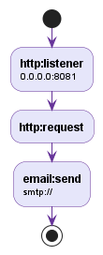

2.1.2 testmule1Flow1
Path: src\main\mule\testmule1.xml


2.2 Mule Project Flow Diagram

2.2.1 testmule1Flow
Path: src\main\mule\testmule1.xml
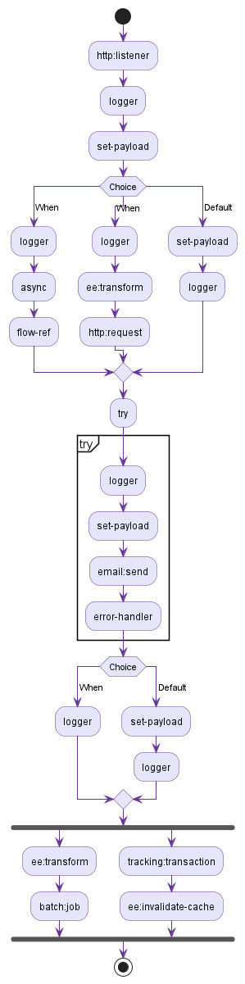

2.2.2 testmule1Flow1
Path: src\main\mule\testmule1.xml
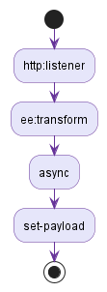

3. Global Configuration

4. Connector Configurations

4.1 Email_SMTP
Path: src\main\mule\testmule1.xml
Attribute Name | Attribute Value
doc:name | Email SMTP
doc:id | acfd95b4-d4ea-4472-8a6d-a4fbb09e8cbd
name | Email_SMTP

4.1.1 email:smtp-connection

4.2 HTTP_Listener_config
Path: src\main\mule\testmule1.xml
Attribute Name | Attribute Value
doc:name | HTTP Listener config
doc:id | 3e43eccd-04fe-42c7-ae91-c8f6e78f367e
name | HTTP_Listener_config

4.2.1 http:listener-connection
Attribute Name | Attribute Value
port | 8081
host | 0.0.0.0

4.3 HTTP_Request_config
Path: src\main\mule\testmule1.xml
Attribute Name | Attribute Value
doc:name | HTTP Request config
doc:id | b550bc32-648d-403b-9f22-2f852e0e0e23
name | HTTP_Request_config

5. Mule Flows

5.1 testmule1Flow
Path: src\main\mule\testmule1.xml

5.1.1 http:listener
Attribute Name | Attribute Value
doc:name | Listener
config-ref | HTTP_Listener_config

5.1.2 logger
Attribute Name | Attribute Value
doc:name | Logger
level | INFO

5.1.3 set-payload
Attribute Name | Attribute Value
doc:name | Set Payload
value | #[payload]

5.1.4 choice
Attribute Name | Attribute Value
doc:name | Choice

5.1.5 try
Attribute Name | Attribute Value
doc:name | Try

5.1.6 choice
Attribute Name | Attribute Value
doc:name | Choice

5.1.7 scatter-gather
Attribute Name | Attribute Value
doc:name | Scatter-Gather

5.2 testmule1Flow1
Path: src\main\mule\testmule1.xml

5.2.1 http:listener
Attribute Name | Attribute Value
doc:name | Listener

5.2.2 ee:transform
Attribute Name | Attribute Value
doc:name | Transform Message

5.2.3 async
Attribute Name | Attribute Value
doc:name | Async

5.2.4 set-payload
Attribute Name | Attribute Value
doc:name | Set Payload
value | #[payload]

6. Mule Sub-flows

7. Mule DataWeave Files

8. Other Resources
File Name | Relative Path
application-types.xml | src\main\resources\application-types.xml
home.md | exchange-docs\home.md
log4j2-test.xml | src\test\resources\log4j2-test.xml
log4j2.xml | src\main\resources\log4j2.xml
testmule1.xml | src\main\mule\testmule1.xml

9. References
References section is placeholder for any reference details team requires. It can have team playbook reference details or any other information for project.

