Tibco2MulesoftAccelerator_ReferenceDocument

Guide to Tibco2MulesoftAccelerator
Version 1.0

Revision History

Version | Dated On | Author | Changes / Description
1.0 | Jan 2020 | IBM COE Team | Draft Version

Table of Contents
1. Introduction 3
2. Features 3
3. Prerequisite 3
3.1. Sample Checklist for code review 3
4. Accelerator Output 3
4.1. Project Inventory Report 4
4.1.1. Sample Project Inventory Report 4
4.1.2. Project inventory report file details 4
4.2. Code Analyzer Report 5
4.2.1. Sample Code Analyzer Report 5
4.2.2. Code analyzer report file details 5
4.3. Validation Checklist Report 6
4.3.1. Sample Validation Checklist Report 6
4.3.2. Validation checklist report file details 6
4.4. Converted Code in Mulesoft 7
4.4.1. Process1 8
4.4.2. Process2 9
4.4.3. Process3 10
4.4.4. Process4 11
4.4.5. Process5_Checklist 12
4.4.6. ErrorHandler 13

Introduction
This document is created to explain the usage of Tibco2Mulesoft Accelerator. The accelerator is used to convert Tibco BW project code to Mulesoft code. This accelerator also creates report to analyze the Tibco code along with the checklist for the code deviations.

Features

- It can migrate 5.x code to Mule 3.x. It can be tweaked to upgrade it into Mule 4.x too.
- More than one Tibco BW project folders can be migrated in one shot. it can in-fact convert the full Tibco BW code repository in minutes.
- It created reports to have complete details of migration for all the projects even at process, activity and other component level.
- Password can be decrypted while migration.
- Developer related checklist is also supported for automated code review.

Prerequisite
To use Tibco2Mulesoft accelerator following are the prerequisites.
Sr.# | Item Detail | Remark
1 | Tibco BW 5.x Code | One or more Tibco BW project code/s
2 | Validation Checklist | The checklist format and detail can be found in the below sample attachment. The items in the checklist can be configured as per any specific requirement to get it flagged for any code deviations by developers.
3 | Mulesoft Project Template* | Predefined Mulesoft project temple and based on that accelerator will convert the code.

Sample Checklist for code review

Accelerator Output

Sr.# | Item Detail | Remark
1 | Project Inventory Report | This report details all the Tibco BW project code/s which all are converted by accelerator. It contains status (success or Error) for all the projects and correspondingly time taken to convert from Tibco to Mule.
2 | Code Analyzer Report | It contains followings:  - List of processes (Inventory)  - Complexity based on number of activities, sub-processes  - Services by list of adapters  - Services by list of sub-processes  - Services by list of activities  - Identify list of services to be re-tested  - Guidance to Developer (Highlight things such as Java code, Render XML, custom logic, concatenation, XPATH etc.)
3 | Validation Checklist Report | All the deviations in the code against input validation checklist file. It also contains the severity of the checklists along with suggestion to follow.
4 | Converted Code in Mulesoft | Mulesoft 3.x project code folder for every Tibco BW 5.x project folder.

Project Inventory Report
This report contains all the project folder details for both Tibco and Mulesoft along with the migration status and time taken while code conversion.

Sample Project Inventory Report

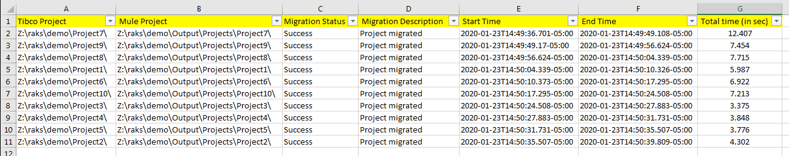

Project inventory report file details

Sr.# | Item Detail | Remark
1 | Tibco Project | Tibco BW project location
2 | Mule Project | Mulesoft project location where accelerator created it.
3 | Migration Status | Status for the migration of the project (Success or Error)
4 | Migration Description | Description of the migration.
5 | Start Time | When the corresponding Tibco code started converting by the accelerator.
6 | End Time | When the corresponding Tibco code completed converting by the accelerator.
7 | Total time (in sec) | Total time taken to convert the code in Mulesoft by the accelerator.

Code Analyzer Report
This report contains all the processes, GV files, schemas, wsdls, jar, aliases, archives, connections, and any possible artifacts available in the Tibco BW project code. It contains all the corresponding activity, process, artifacts level analysis in details. It also provides whether any specific component is migrated into Mule or not. We can also know which processes are starter types, whether any subprocess is spawned while invocation etc.

Sample Code Analyzer Report

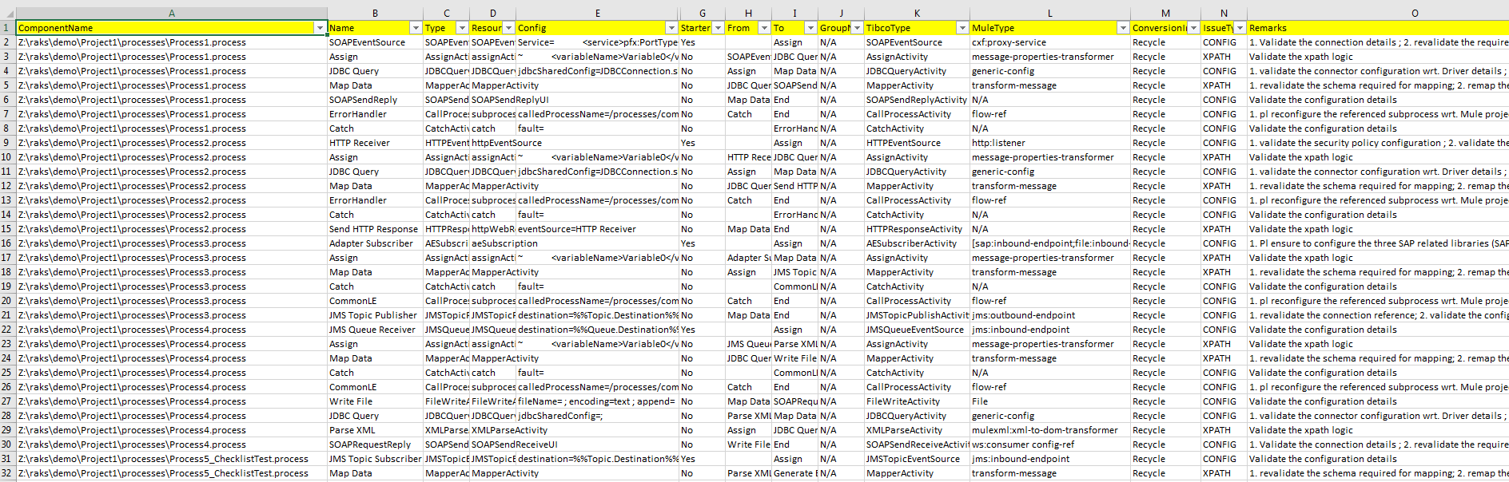

Code analyzer report file details

Sr.# | Item Detail | Remark
1 | ComponentName | Tibco code component type like process, activity, schema, wsdl, global variable etc.
2 | Name | Name of component
3 | Type | Technical Tibco type of component
4 | ResourceType | Technical Tibco resource type of component
5 | Config | Partial extracted config details for components.
6 | InputBinding | Partial extracted input binding details for components.
7 | Starter | Whether the process is of starter type.
8 | From | Where from the component is connected (in transition). In other word, which activity precedes the component.
9 | To | Where to the component is connected (in transition). In other word, which activity is the next activity after the component.
10 | GroupName | Whether any group activity is available in the process for the component.
11 | TibcoType | Same information as column 3 (Type)
12 | MuleType | Corresponding Mulesoft component mapping if applicable.
13 | ConversionImpl | Whether conversion is implemented in accelerator for the component.
14 | IssueType | After migration by the accelerator what kind of possible issues needs to focus on for the component.
15 | Remarks | Suggestion regarding the migration of the component.

Validation Checklist Report

This report is created after considering the input checklist over which Tibco code is required to review. These checklist items could be standard, or any specific checklist based on requirements.

Sample Validation Checklist Report

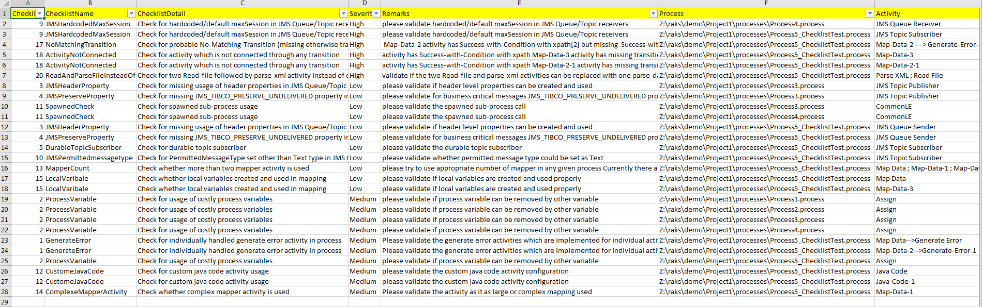

Validation checklist report file details

Sr.# | Item Detail | Remark
1 | ChecklistNumber | Checklist item id in the given validation checklist input file
2 | ChecklistName | Name of checklist item
3 | ChecklistDetail | Detail description of the checklist item
4 | Severity | Severity of the checklist item
5 | Remarks | Further explanation of the checklist validated in the code
6 | Process | Tibco process name in which the checklist item is flagged.
7 | Activity | Tibco activity name for which the checklist item is flagged.

Converted Code in Mulesoft

The accelerator also creates complete Mulesoft 3.x Anypoint studio project folders for every Tibco 5.x BW project code.

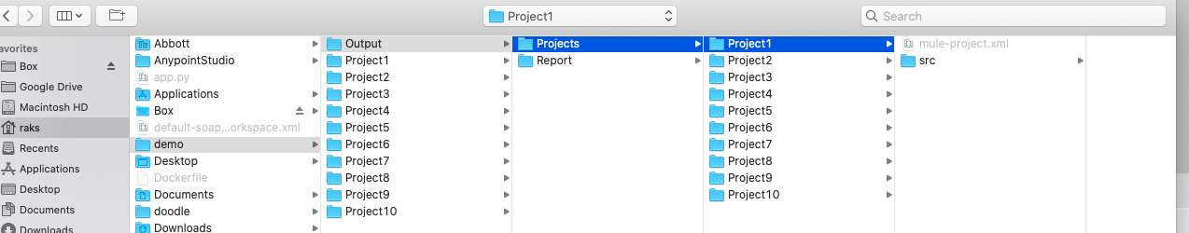

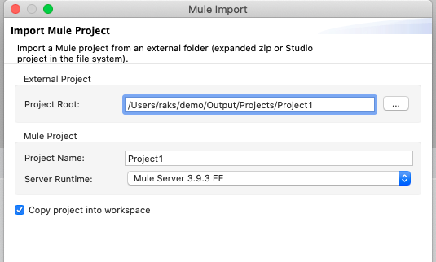

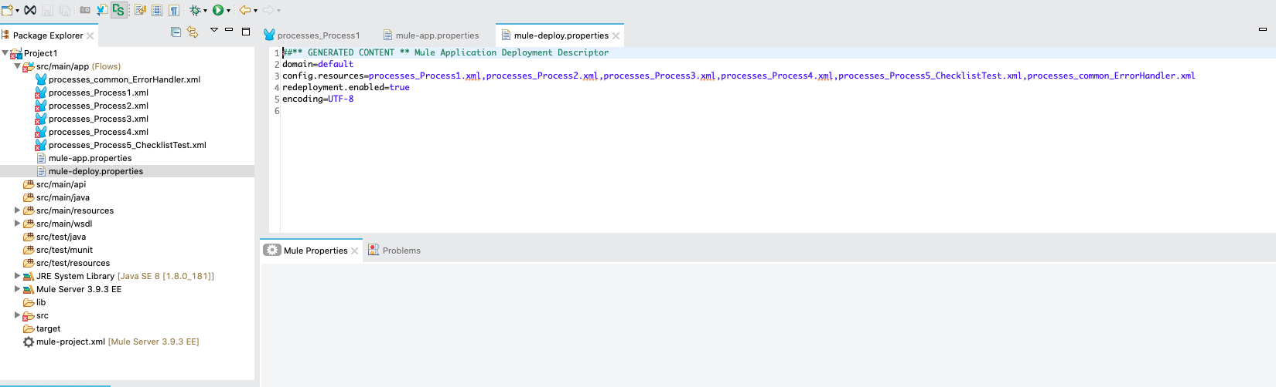

Process1

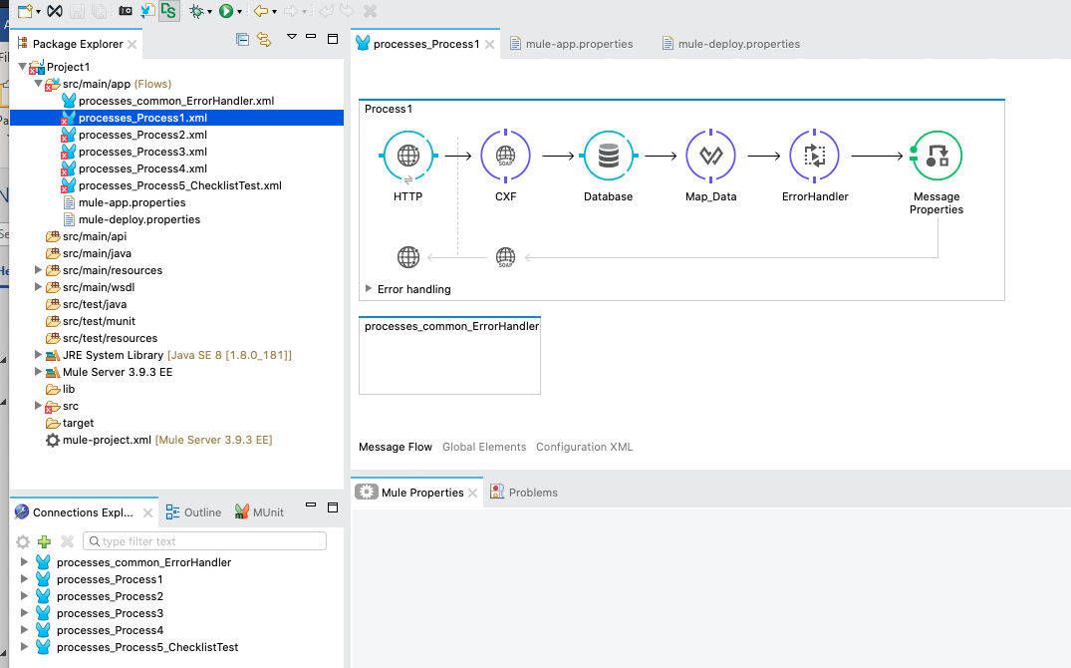

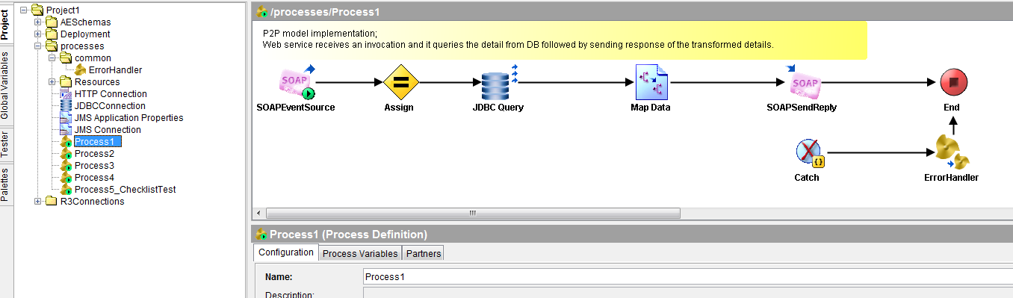

Process2

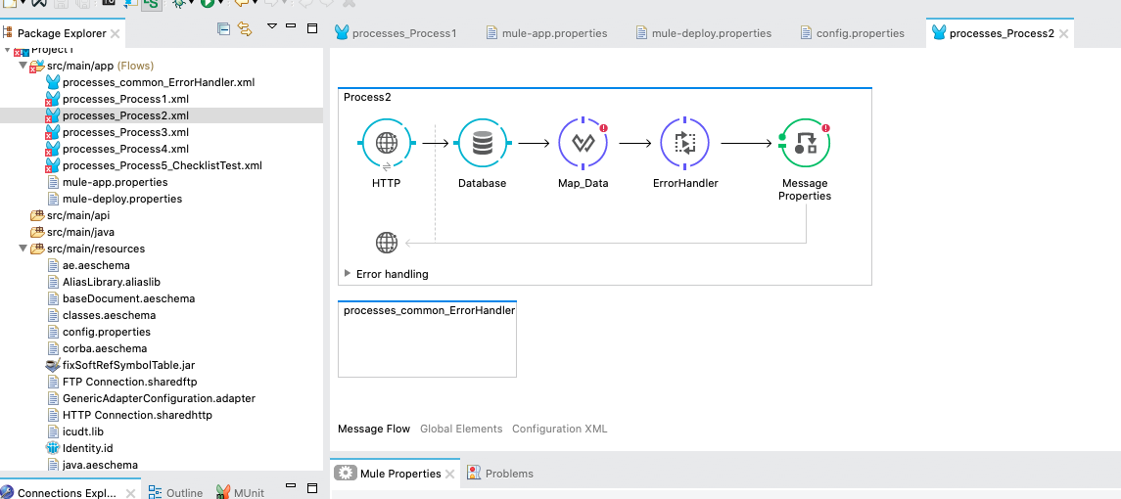

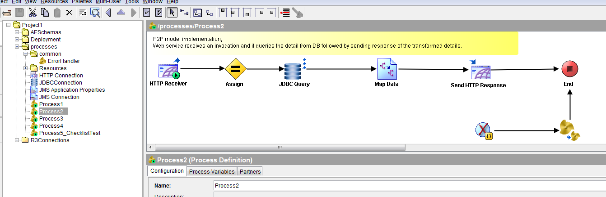

Process3

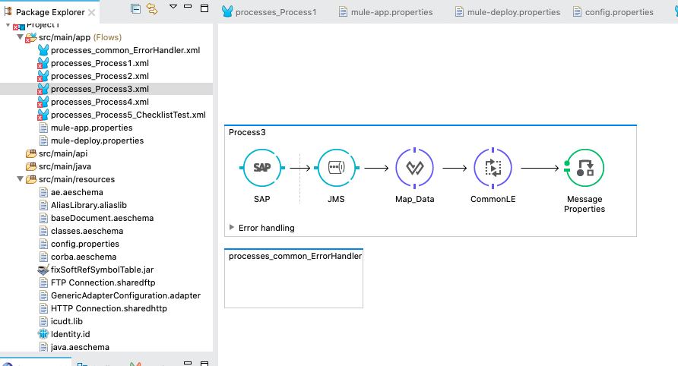

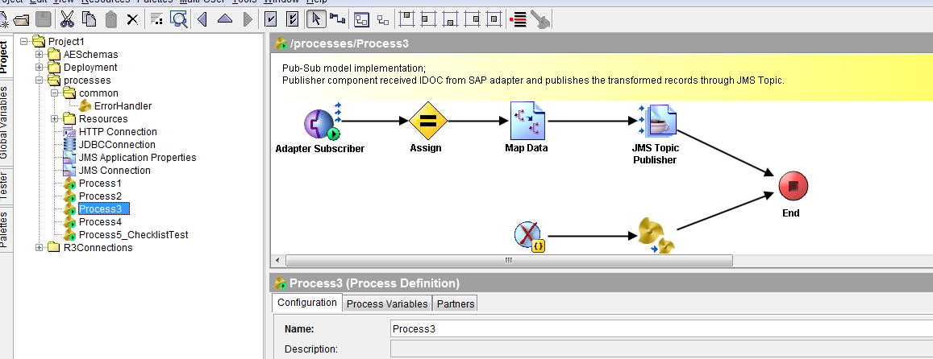

Process4

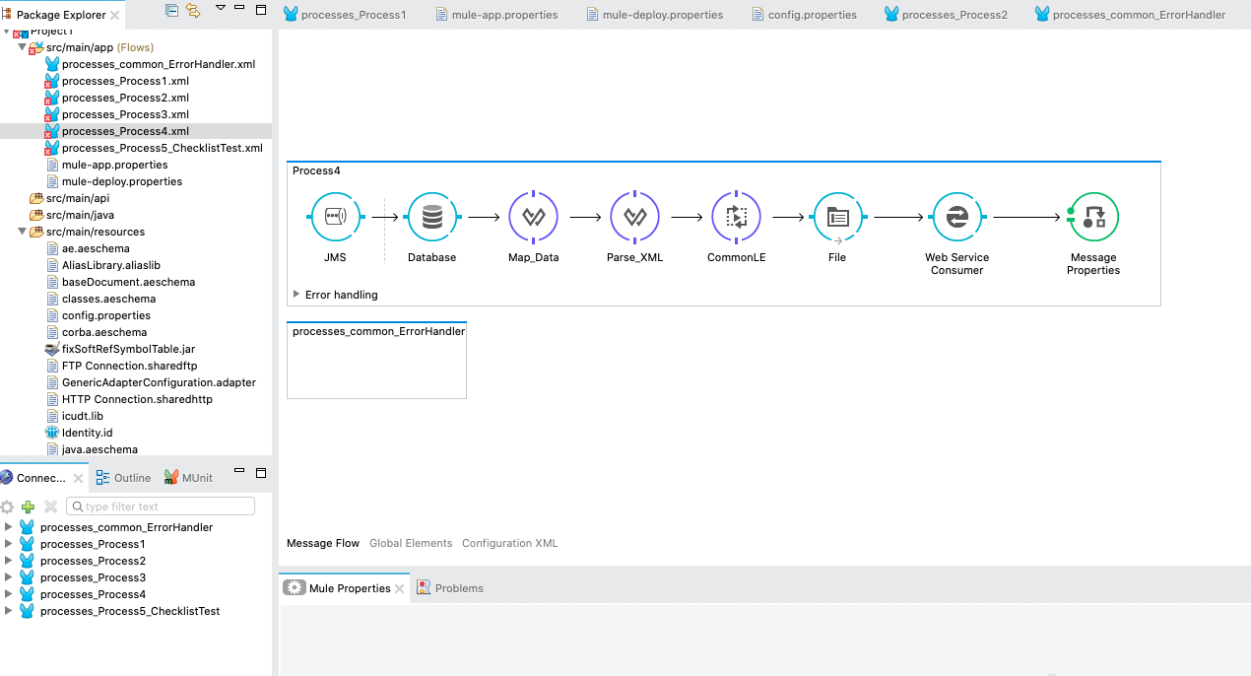

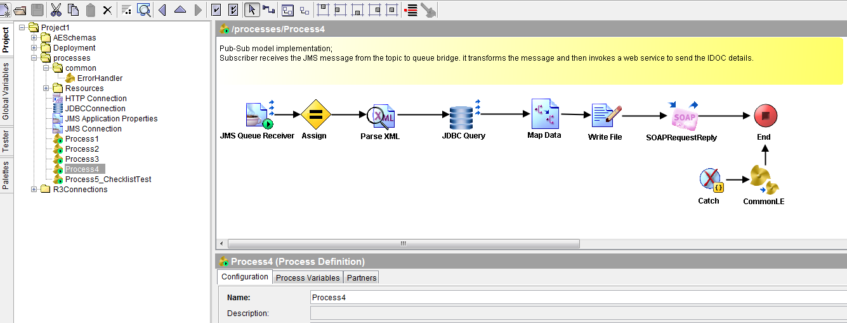

Process5_Checklist

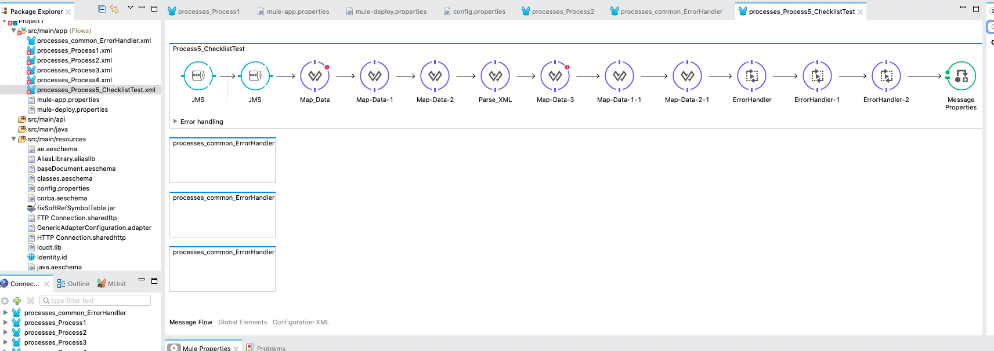

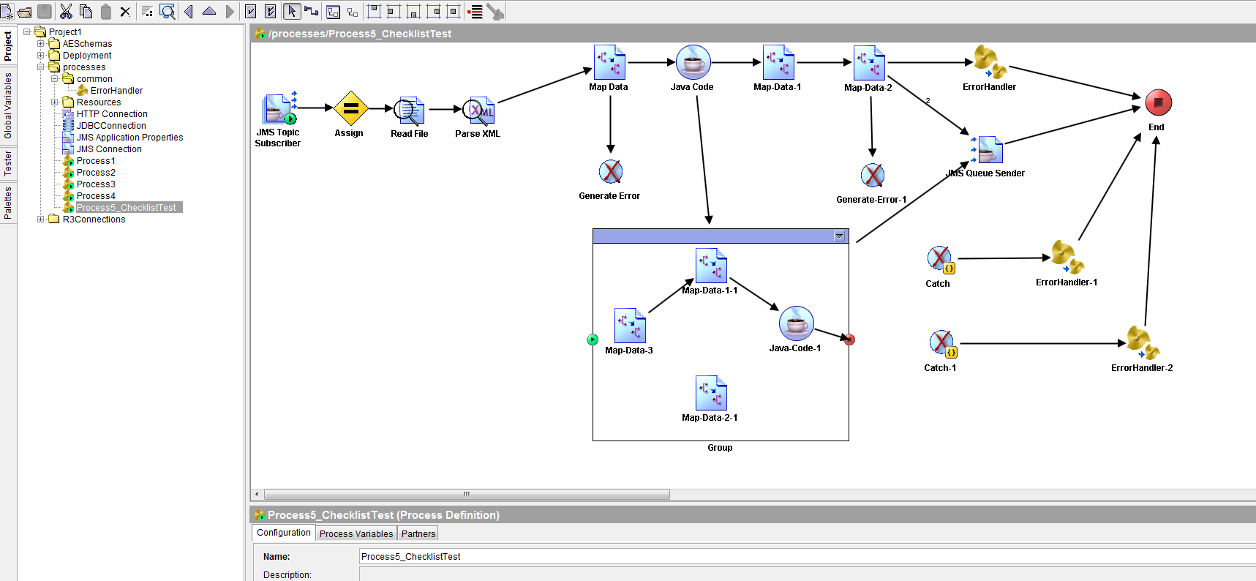

ErrorHandler

