Project Analysis Report
apiguardwrapper
Comprehensive analysis and documentation of Mule project configuration, flows, and resources
December 25, 2025 21:06:44 CST

Table of Contents

1. Project Information

1.1 Project Details
Property | Value
Project Name | apiguardwrapper
Version | 1.0.0
Project Path | C:\raks\apiguard\apiguardwrapper

1.2 POM Details
Path: pom.xml

1.2.1 Basic Information
Property | Value
Model Version | 4.0.0
Group ID | com.raks.apiguard
Artifact ID | apiguardwrapper
Version | 1.0.0
Packaging | mule-application
Name | apiguardwrapper

1.2.2 Properties
Key | Value
mule.maven.plugin.version | 4.5.3
maven.compiler.target | 17
maven.compiler.source | 17
project.build.sourceEncoding | UTF-8
app.runtime | 4.9.1
project.reporting.outputEncoding | UTF-8

1.2.3 Plugins
GroupId | ArtifactId | Version
org.apache.maven.plugins | maven-clean-plugin | 3.0.0
org.mule.tools.maven | mule-maven-plugin | ${mule.maven.plugin.version}

1.2.4 Dependencies
GroupId | ArtifactId | Version
org.mule.connectors | mule-http-connector | 1.9.2
org.mule.connectors | mule-sockets-connector | 1.2.2
org.mule.connectors | mule-file-connector | 1.5.2
org.mule.connectors | mule-email-connector | 1.7.3
org.mule.connectors | mule-objectstore-connector | 1.2.4
org.mule.module | mule-java-module | 2.0.0
org.mule.modules | mule-compression-module | 2.2.3
com.mulesoft.modules | mule-secure-configuration-property-module | 1.2.6
org.jsoup | jsoup | 1.17.2
com.raks | raksanalyzer | 1.0.0
com.raks | muleguard | 1.0.0

1.3 Mule-artifact.json
Path: mule-artifact.json
{
"minMuleVersion": "4.9.1",
"javaSpecificationVersions": [
"17"
],
"classLoaderModelLoaderDescriptor": {
"id": "mule",
"attributes": {
"exportedPackages": [
"javax.activation",
"com.raks.muleguard.wrapper"
]
}
}
}

2. Flow Diagrams

2.1 Mule Project Flow Integration

2.1.1 cleanup-workspace-flow
Path: src\main\mule\muleguard-wrapper.xml
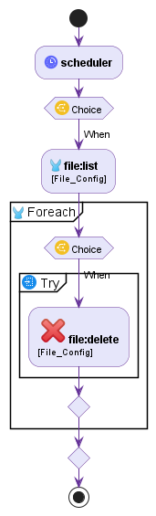

2.1.2 common-send-registration-notification-flow
Path: src\main\mule\apiguard-common.xml
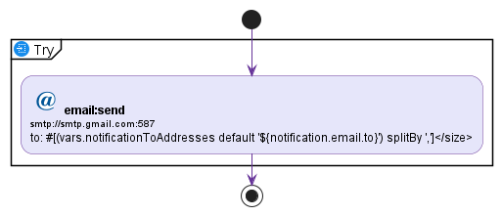

2.1.3 common-static-resource-flow
Path: src\main\mule\apiguard-common.xml
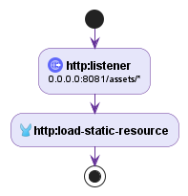

2.1.4 create-anonymous-session-subflow
Path: src\main\mule\muleguard-wrapper.xml
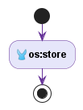

2.1.5 main-landing-page-flow
Path: src\main\mule\muleguard-wrapper.xml
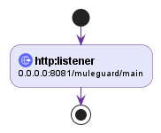

2.1.6 main-page-flow
Path: src\main\mule\apiguard-portal.xml
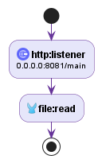

2.1.7 muleguard-root-flow
Path: src\main\mule\muleguard-wrapper.xml
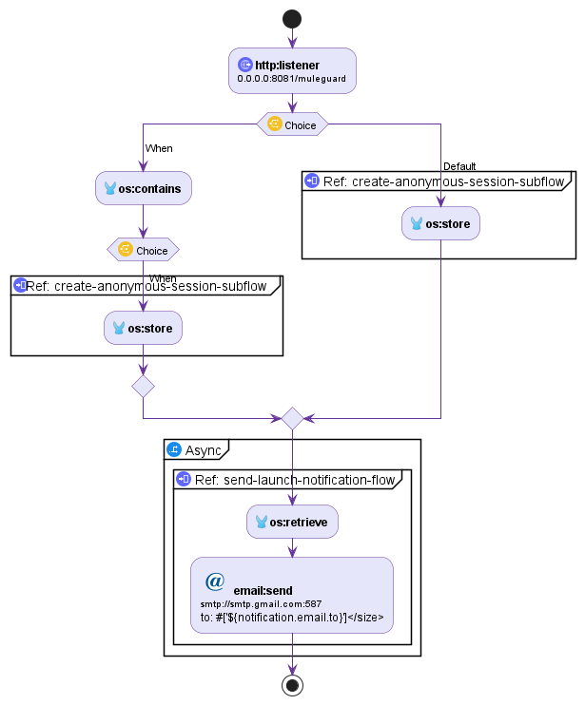

2.1.8 raks-create-anonymous-session-subflow
Path: src\main\mule\raksanalyzer-wrapper.xml

2.1.9 raks-send-launch-notification-flow
Path: src\main\mule\raksanalyzer-wrapper.xml
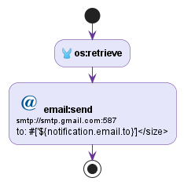

2.1.10 raksanalyzer-api-flow
Path: src\main\mule\raksanalyzer-wrapper.xml
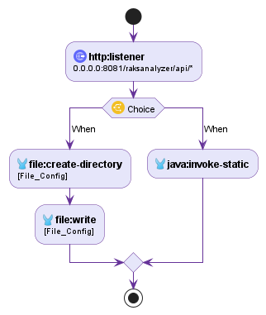

2.1.11 raksanalyzer-root-flow
Path: src\main\mule\raksanalyzer-wrapper.xml
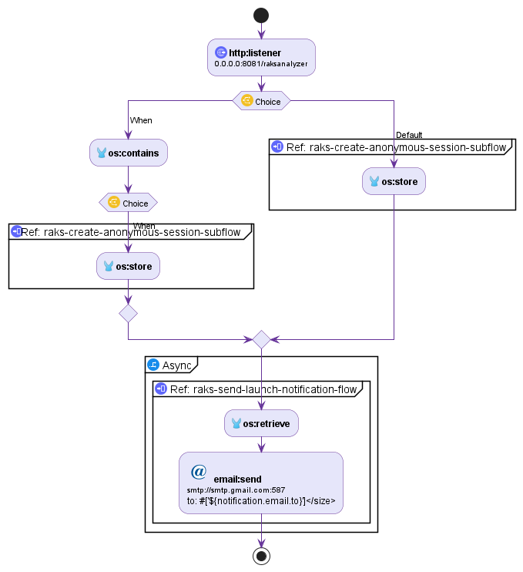

2.1.12 raksanalyzer-ui-flow
Path: src\main\mule\raksanalyzer-wrapper.xml
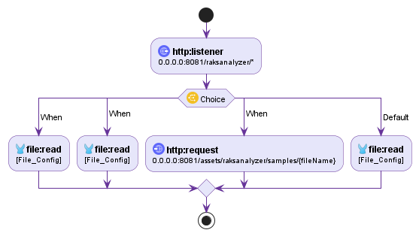

2.1.13 registration-page-flow
Path: src\main\mule\apiguard-portal.xml
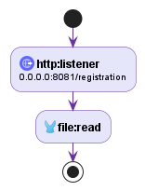

2.1.14 registration-success-flow
Path: src\main\mule\apiguard-portal.xml
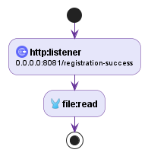

2.1.15 root-redirect-flow
Path: src\main\mule\apiguard-portal.xml
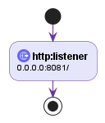

2.1.16 send-launch-notification-flow
Path: src\main\mule\muleguard-wrapper.xml

2.1.17 send-registration-notification-flow
Path: src\main\mule\muleguard-wrapper.xml
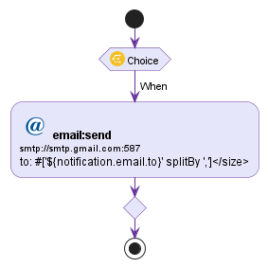

2.1.18 send-usage-notification-flow
Path: src\main\mule\muleguard-wrapper.xml
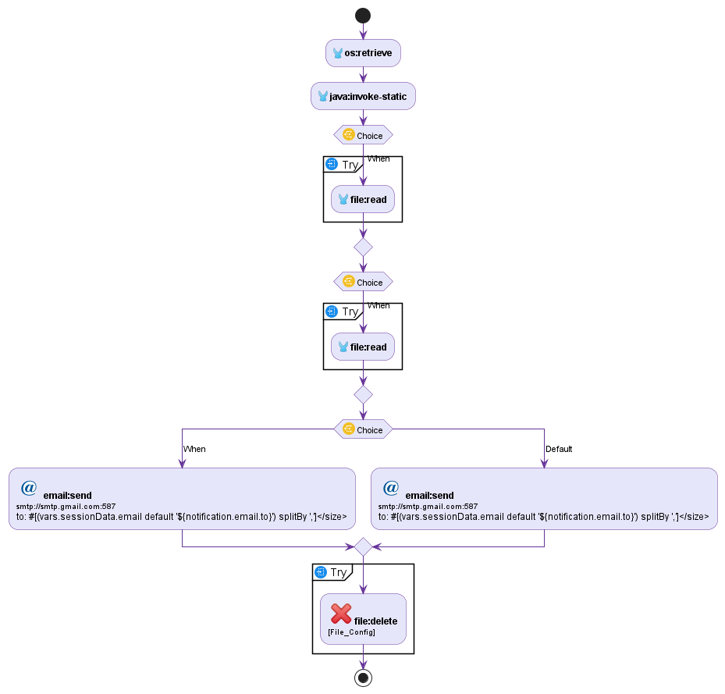

2.1.19 serve-report-flow
Path: src\main\mule\muleguard-wrapper.xml
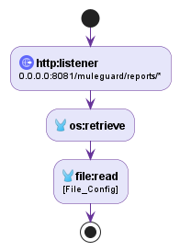

2.1.20 session-validation-flow
Path: src\main\mule\muleguard-wrapper.xml
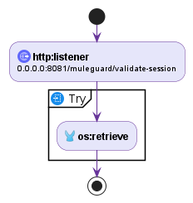

2.1.21 static-resource-flow
Path: src\main\mule\muleguard-wrapper.xml
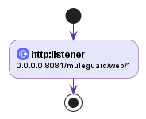

2.1.22 static-resources-flow
Path: src\main\mule\apiguard-portal.xml
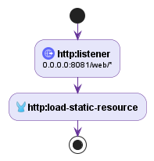

2.1.23 user-registration-flow
Path: src\main\mule\apiguard-portal.xml
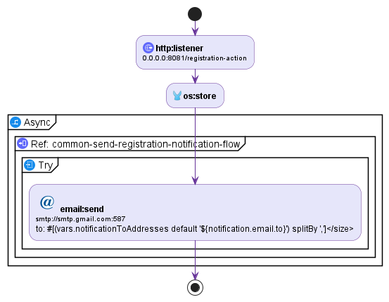

2.1.24 validation-trigger-flow
Path: src\main\mule\muleguard-wrapper.xml
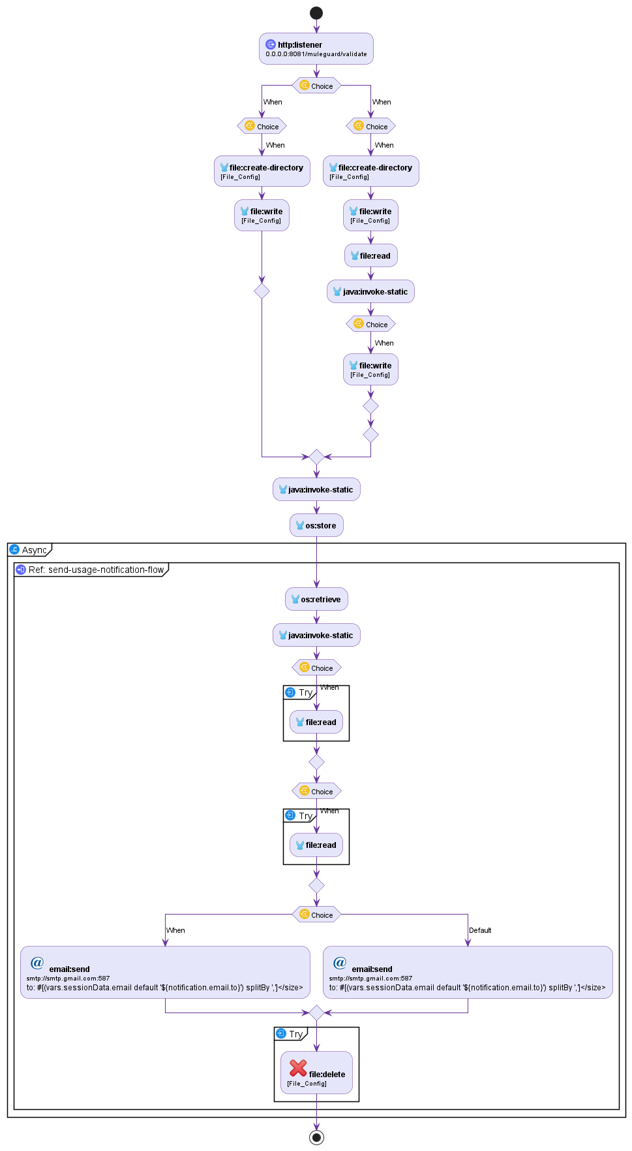

2.2 Mule Project Flow Diagram

2.2.1 cleanup-workspace-flow
Path: src\main\mule\muleguard-wrapper.xml
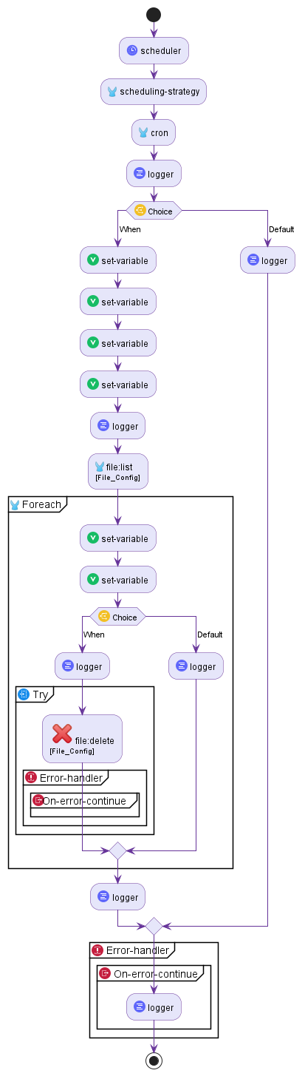

2.2.2 common-send-registration-notification-flow
Path: src\main\mule\apiguard-common.xml
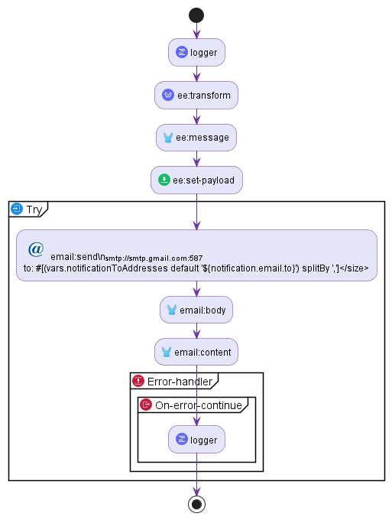

2.2.3 common-static-resource-flow
Path: src\main\mule\apiguard-common.xml
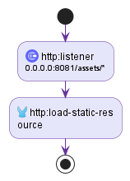

2.2.4 create-anonymous-session-subflow
Path: src\main\mule\muleguard-wrapper.xml
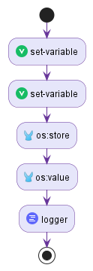

2.2.5 main-landing-page-flow
Path: src\main\mule\muleguard-wrapper.xml
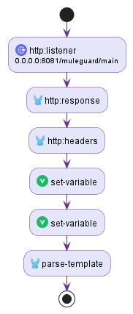

2.2.6 main-page-flow
Path: src\main\mule\apiguard-portal.xml
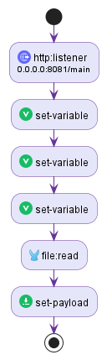

2.2.7 muleguard-root-flow
Path: src\main\mule\muleguard-wrapper.xml
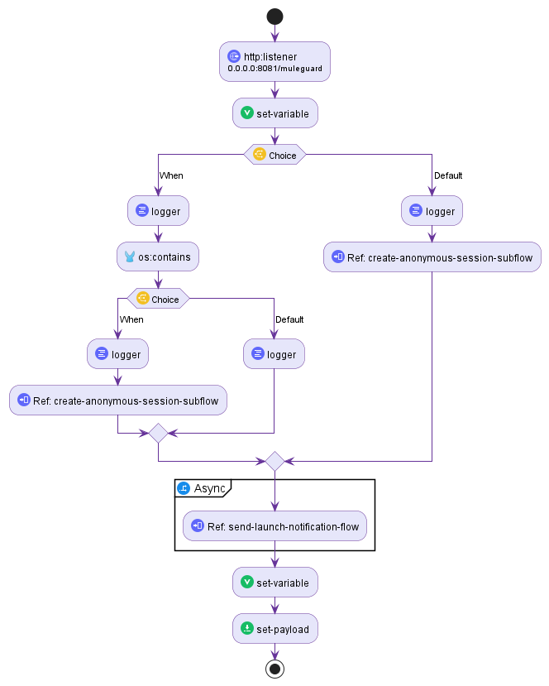

2.2.8 raks-create-anonymous-session-subflow
Path: src\main\mule\raksanalyzer-wrapper.xml

2.2.9 raks-send-launch-notification-flow
Path: src\main\mule\raksanalyzer-wrapper.xml
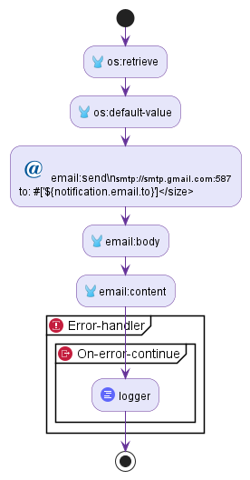

2.2.10 raksanalyzer-api-flow
Path: src\main\mule\raksanalyzer-wrapper.xml
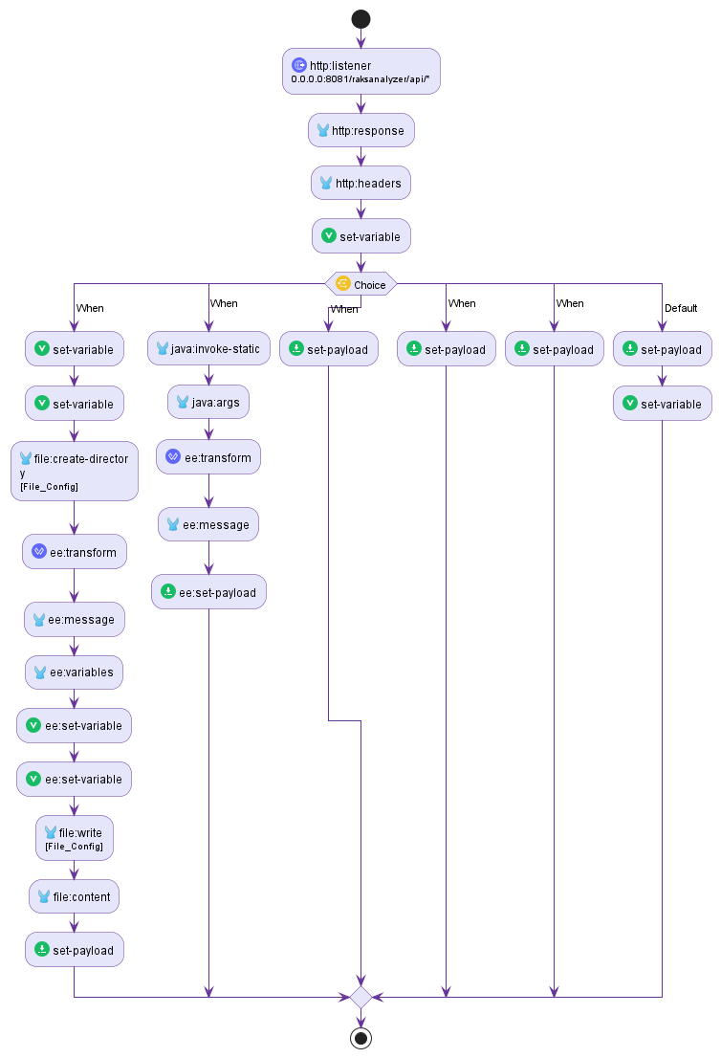

2.2.11 raksanalyzer-root-flow
Path: src\main\mule\raksanalyzer-wrapper.xml
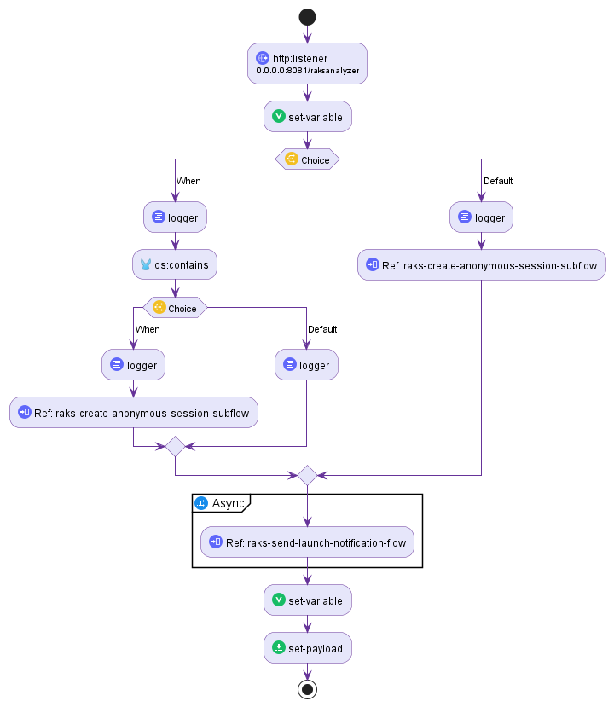

2.2.12 raksanalyzer-ui-flow
Path: src\main\mule\raksanalyzer-wrapper.xml
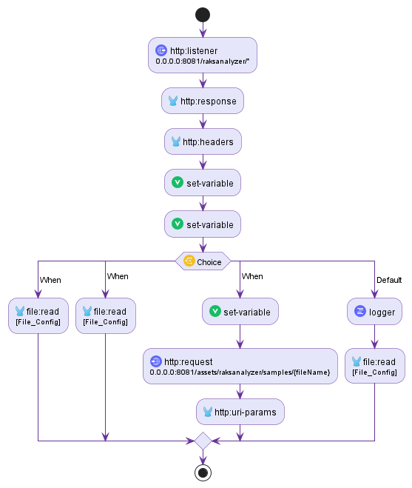

2.2.13 registration-page-flow
Path: src\main\mule\apiguard-portal.xml
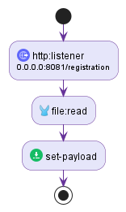

2.2.14 registration-success-flow
Path: src\main\mule\apiguard-portal.xml
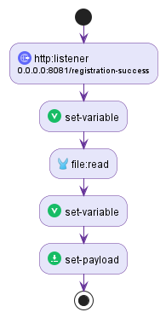

2.2.15 root-redirect-flow
Path: src\main\mule\apiguard-portal.xml
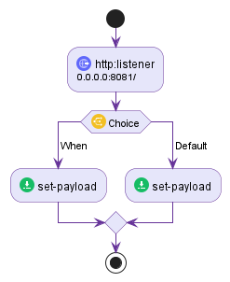

2.2.16 send-launch-notification-flow
Path: src\main\mule\muleguard-wrapper.xml

2.2.17 send-registration-notification-flow
Path: src\main\mule\muleguard-wrapper.xml
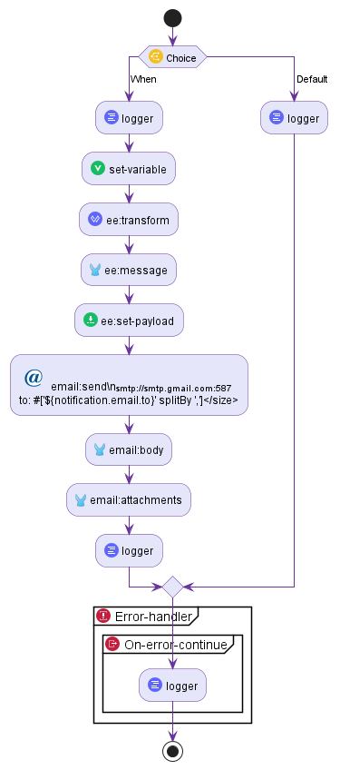

2.2.18 send-usage-notification-flow
Path: src\main\mule\muleguard-wrapper.xml
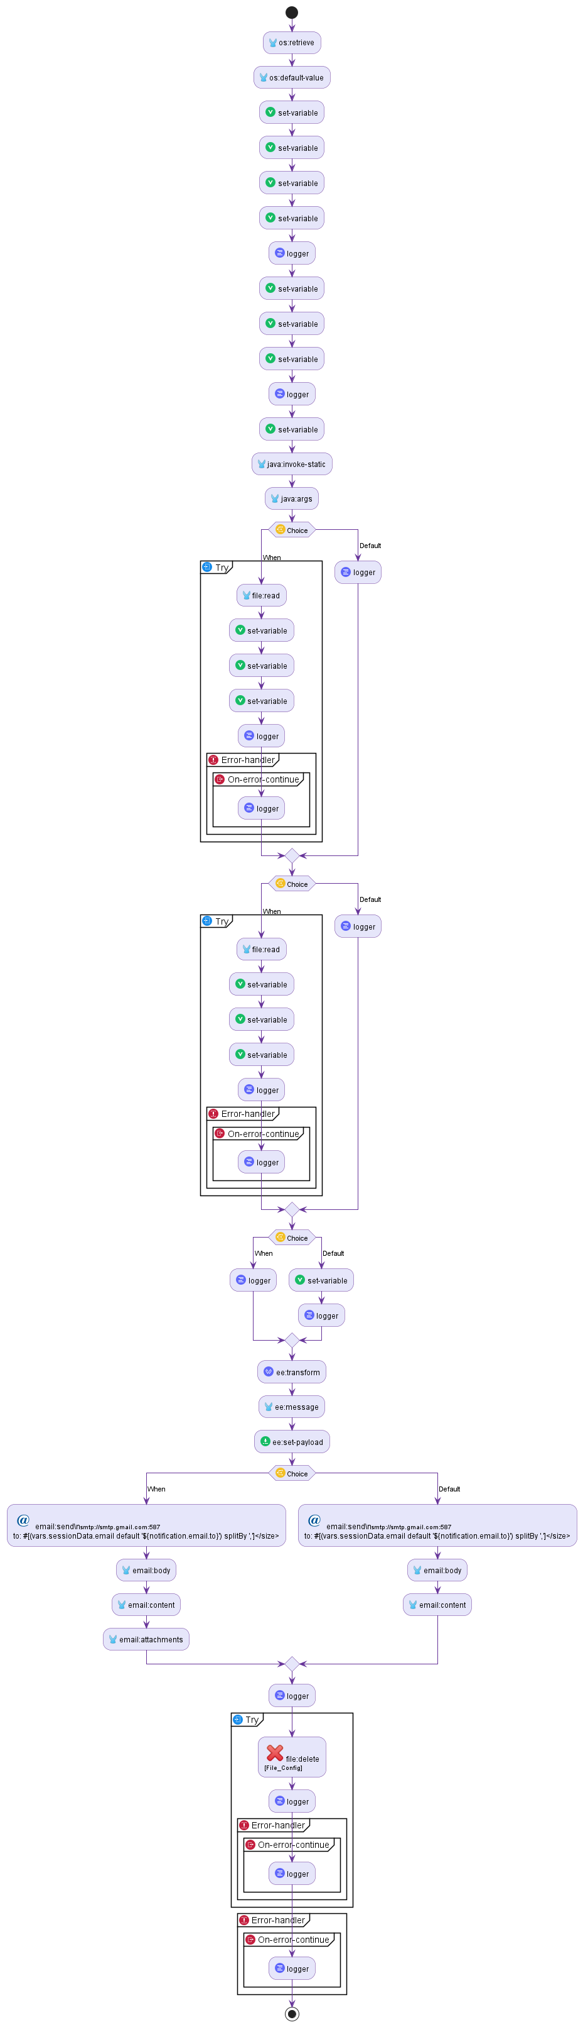

2.2.19 serve-report-flow
Path: src\main\mule\muleguard-wrapper.xml
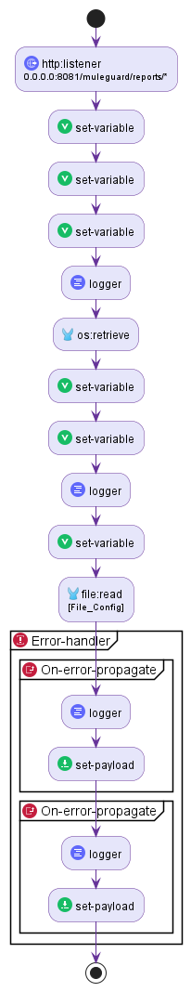

2.2.20 session-validation-flow
Path: src\main\mule\muleguard-wrapper.xml
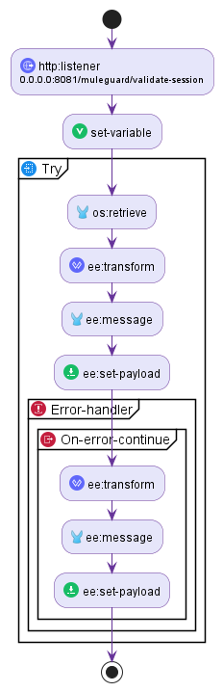

2.2.21 static-resource-flow
Path: src\main\mule\muleguard-wrapper.xml
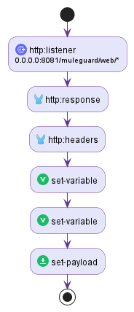

2.2.22 static-resources-flow
Path: src\main\mule\apiguard-portal.xml
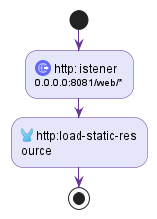

2.2.23 user-registration-flow
Path: src\main\mule\apiguard-portal.xml
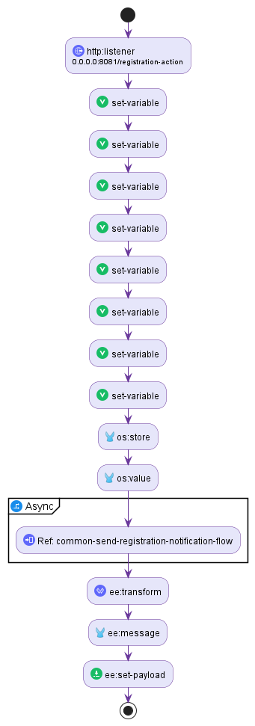

2.2.24 validation-trigger-flow
Path: src\main\mule\muleguard-wrapper.xml
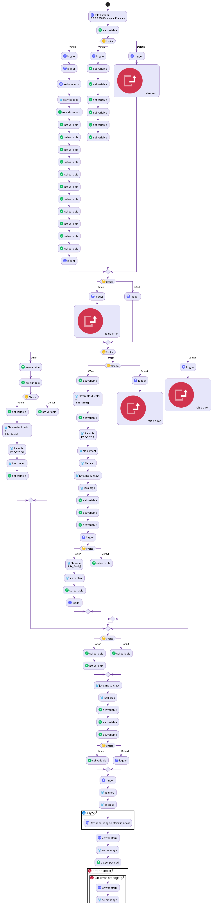

3. Global Configuration

3.1 mule-app.properties
Path: src\main\resources\mule-app.properties
Key | Value
registration.field.3.name | company
report.timestamp.format | yyyyMMdd-HHmmss
workspace.cleanup.retention.days | 1
notification.attach.localproject.enabled | true
registration.page.title | ApiGuard Portal - Registration
http.listener.host | 0.0.0.0
registration.success.page.header | ApiGuard Portal
registration.field.1.placeholder | Enter your full name
registration.field.2.placeholder | your.email@company.com
workspace.cleanup.enabled | true
notification.attach.localproject.default | false
http.listener.staticResourcesPath | /web/*
registration.field.3.required | false
registration.enabled | true
notification.email.username | rakkuma8@gmail.com
zip.extraction.ignore.folders | target,bin,build,.git,.idea,.vscode,node_modules,muleguard-reports
email.header.background | #f9f4ff
notification.email.password | fjuqjxckvosjummv
workspace.cleanup.schedule | 0 0 2 * * ?
portal.page.header | ApiGuard Portal
tool.1.url | /apiguard/muleguard
muleguard.work.dir | ${mule.home}/apps/apiguardwrapper/working
http.listener.port | 8081
report.timestamp.enabled | true
registration.page.footer | &copy; 2018 RAKS - Enterprise API Solution Suite - ApiGuard
registration.success.message | Registration Successful!
registration.field.3.placeholder | Your organization (optional)
registration.field.1.label | Name
muleguard.workspace.dir | ${mule.home}/apps/apiguardwrapper/workspace
registration.field.1.name | name
notification.email.host | smtp.gmail.com
registration.page.subtitle | Please provide your details to continue.
notification.email.from | apiguard-noreply@raks.com
registration.field.2.required | true
http.listener.startPath | /
notification.attach.reports.default | true
tool.3.name | TibcoGuard
registration.success.redirect.text | Redirecting to portal in a few seconds...
notification.attach.reports.enabled | true
http.listener.basePath | /apiguard
raksanalyzer.work.dir | ${mule.home}/apps/apiguardwrapper/working/raks
notification.email.to | raksjnu@gmail.com
session.timeout.minutes | 30
tool.3.url | #
registration.button.text | Open ApiGuard Portal
registration.field.2.type | email
notification.registration.email.enabled | true
notification.email.port | 587
tool.4.description | Compare API Responses
notification.max.attachment.size.mb | 10
registration.field.2.label | Email
tool.1.description | Mule Code Review & Validation Suite
registration.success.redirect.delay | 5000
muleguard.input.local.enabled | true
tool.3.description | Tibco Code Analysis
portal.page.footer | &copy; 2018 RAKS - Enterprise API Solution Suite - ApiGuard
registration.field.1.required | true
tool.2.name | RaksAnalyzer
notification.registration.email.to | raksjnu@gmail.com
tool.2.description | Automated Documentation & Analysis
registration.page.header | ApiGuard Portal
tool.2.url | /apiguard/raksanalyzer
portal.templates.dir | ${mule.home}/apps/apiguardwrapper/templates
notification.registration.email.from | apiguard-noreply@raks.com
notification.email.subject | MuleGuard Tool Used by {name} ({emailId})
registration.success.page.footer | &copy; 2018 RAKS - Enterprise API Solution Suite - ApiGuard
app.name | ApiGuard Portal
tool.4.name | API Comparison
notification.attach.zipproject.default | false
registration.required | false
registration.field.1.type | text
tool.1.name | MuleGuard
portal.web.dir | ${mule.home}/apps/apiguardwrapper/web
registration.field.2.name | email
registration.success.page.title | ApiGuard Portal - Registration Successful
email.header.color | #663399
muleguard.web.templates.path | web/muleguard
muleguard.reports.dir.name
registration.button.processing | Please wait...
registration.field.3.type | text
encryption.key | rakspassphrase
email.footer.background | #f9f4ff
email.footer.color | #663399
tool.4.url | #
app.organization | RAKS
email.footer.text | &copy; 2018 RAKS - Enterprise API Solution Suite - ApiGuard
portal.page.subtitle | Select a tool from the catalog below to launch it in a new tab.
registration.field.3.label | Company
portal.page.title | ApiGuard Portal
notification.registration.email.subject | ${app.name} Registration - {name} ({email}) - {company}
notification.attach.zipproject.enabled | true
raksanalyzer.web.dir | ${mule.home}/apps/apiguardwrapper/web/raksanalyzer

4. Connector Configurations

4.1 Email_SMTP
Path: src\main\mule\apiguard-common.xml
Attribute Name | Attribute Value
doc:name | Email SMTP
name | Email_SMTP

4.1.1 email:smtp-connection
Attribute Name | Attribute Value
password | fjuqjxckvosjummv
port | 587
host | smtp.gmail.com
user | rakkuma8@gmail.com

4.1.1.1 email:properties

4.1.1.1.1 email:property
Attribute Name | Attribute Value
value | true
key | mail.smtp.starttls.enable

4.2 File_Config
Path: src\main\mule\apiguard-common.xml
Attribute Name | Attribute Value
doc:name | File Config
name | File_Config

4.3 HTTP_Listener_config
Path: src\main\mule\apiguard-common.xml
Attribute Name | Attribute Value
doc:name | HTTP Listener config
basePath | /apiguard
name | HTTP_Listener_config

4.3.1 http:listener-connection
Attribute Name | Attribute Value
port | 8081
host | 0.0.0.0

4.4 ObjectStore_Config
Path: src\main\mule\apiguard-common.xml
Attribute Name | Attribute Value
name | ObjectStore_Config

4.5 Self_HTTP_Request_Config
Path: src\main\mule\apiguard-common.xml
Attribute Name | Attribute Value
doc:name | Self HTTP Request configuration
name | Self_HTTP_Request_Config

4.5.1 http:request-connection
Attribute Name | Attribute Value
port | 8081
host | 0.0.0.0

5. Mule Flows

5.1 common-send-registration-notification-flow
Path: src\main\mule\apiguard-common.xml

5.1.1 logger
Attribute Name | Attribute Value
level | INFO
message | Sending registration notification email (Common Flow)

5.1.2 ee:transform
Attribute Name | Attribute Value
doc:name | Prepare Reg Email Body

5.1.2.1 ee:message

5.1.2.1.1 ee:set-payload
Attribute Name | Attribute Value
<![CDATA[#[...]]]> | %dw 2.0  output text/html  ---  "<html>  <body style='font-family: Arial, sans-serif;'>  <div style='background-color: #f8f9fa; padding: 20px;'>  <h2 style='color: #663399;'>👤 New User Registration</h2>  <div style='background-color: white; padding: 20px; border-radius: 5px; border-left: 5px solid #663399;'>  <p><strong>Name:</strong> " ++ vars.userName ++ "</p>  <p><strong>Email:</strong> " ++ vars.userEmail ++ "</p>  <p><strong>Company:</strong> " ++ vars.userCompany ++ "</p>  <p><strong>Tool:</strong> " ++ (vars.currentTool default 'ApiGuard Portal') ++ "</p>  <p><strong>Time:</strong> " ++ now() ++ "</p>  </div>  <p style='color: #666; font-size: 12px; margin-top: 20px;'>ApiGuard Notification System</p>  </div>  </body>  </html>"

5.1.3 try
Attribute Name | Attribute Value
doc:name | Try Send Email

5.1.3.1 email:send
Attribute Name | Attribute Value
doc:name | Send Registration Email
config-ref | Email_SMTP
subject | ApiGuard Registration: #[vars.userName]
fromAddress | ${notification.email.from}
toAddresses | #[(vars.notificationToAddresses default '${notification.email.to}') splitBy ',']

5.1.3.1.1 email:body
Attribute Name | Attribute Value
contentType | text/html

5.1.3.1.1.1 email:content
Attribute Name | Attribute Value
<![CDATA[#[...]]]> | payload

5.1.3.2 error-handler

5.1.3.2.1 on-error-continue
Attribute Name | Attribute Value
doc:name | On Error Continue
logException | true
enableNotifications | true

5.1.3.2.1.1 logger
Attribute Name | Attribute Value
doc:name | Log Email Error
level | ERROR
message | Failed to send registration email: #[error.description]

5.2 common-static-resource-flow
Path: src\main\mule\apiguard-common.xml

5.2.1 http:listener
Attribute Name | Attribute Value
path | /assets/*
config-ref | HTTP_Listener_config
allowedMethods | GET

5.2.2 http:load-static-resource
Attribute Name | Attribute Value
resourceBasePath | ${app.home}/web/assets/

5.3 root-redirect-flow
Path: src\main\mule\apiguard-portal.xml

5.3.1 http:listener
Attribute Name | Attribute Value
doc:name | Listener
path | ${http.listener.startPath}
config-ref | HTTP_Listener_config

5.3.2 choice

5.3.2.1 when
Attribute Name | Attribute Value
expression | #['${registration.enabled}' == 'true']

5.3.2.1.1 set-payload
Attribute Name | Attribute Value
mimeType | text/html
value | #['<html><head><meta http-equiv="refresh" content="0;url=/apiguard/registration"></head><body>Redirecting...</body></html>']

5.3.2.2 otherwise

5.3.2.2.1 set-payload
Attribute Name | Attribute Value
mimeType | text/html
value | #['<html><head><meta http-equiv="refresh" content="0;url=/apiguard/main"></head><body>Redirecting...</body></html>']

5.4 registration-page-flow
Path: src\main\mule\apiguard-portal.xml

5.4.1 http:listener
Attribute Name | Attribute Value
doc:name | Listener
path | /registration
config-ref | HTTP_Listener_config

5.4.2 file:read
Attribute Name | Attribute Value
doc:name | Read registration template
path | ${mule.home}/apps/apiguardwrapper/templates/registration.template.html

5.4.3 set-payload
Attribute Name | Attribute Value
doc:name | Replace placeholders
mimeType | text/html
value | #[%dw 2.0  output text/plain  ---  payload replace '{{registration.page.title}}' with p('registration.page.title') replace '{{registration.page.header}}' with p('registration.page.header') replace '{{registration.page.subtitle}}' with p('registration.page.subtitle') replace '{{registration.button.text}}' with p('registration.button.text') replace '{{registration.button.processing}}' with p('registration.button.processing') replace '{{registration.field.1.name}}' with p('registration.field.1.name') replace '{{registration.field.1.label}}' with p('registration.field.1.label') replace '{{registration.field.1.type}}' with p('registration.field.1.type') replace '{{registration.field.1.required}}' with p('registration.field.1.required') replace '{{registration.field.1.placeholder}}' with p('registration.field.1.placeholder') replace '{{registration.field.2.name}}' with p('registration.field.2.name') replace '{{registration.field.2.label}}' with p('registration.field.2.label') replace '{{registration.field.2.type}}' with p('registration.field.2.type') replace '{{registration.field.2.required}}' with p('registration.field.2.required') replace '{{registration.field.2.placeholder}}' with p('registration.field.2.placeholder') replace '{{registration.field.3.name}}' with p('registration.field.3.name') replace '{{registration.field.3.label}}' with p('registration.field.3.label') replace '{{registration.field.3.type}}' with p('registration.field.3.type') replace '{{registration.field.3.required}}' with p('registration.field.3.required') replace '{{registration.field.3.placeholder}}' with p('registration.field.3.placeholder') replace '{{registration.page.footer}}' with p('registration.page.footer')]

5.5 main-page-flow
Path: src\main\mule\apiguard-portal.xml

5.5.1 http:listener
Attribute Name | Attribute Value
doc:name | Listener
path | /main
config-ref | HTTP_Listener_config

5.5.2 set-variable
Attribute Name | Attribute Value
variableName | sessionId
value | #[attributes.queryParams.session default '']

5.5.3 set-variable
Attribute Name | Attribute Value
variableName | tool1Url
value | #[p('tool.1.url') ++ (if (vars.sessionId != '') '?session=' ++ vars.sessionId else '')]

5.5.4 set-variable
Attribute Name | Attribute Value
variableName | tool2Url
value | #[p('tool.2.url') ++ (if (vars.sessionId != '') '?session=' ++ vars.sessionId else '')]

5.5.5 file:read
Attribute Name | Attribute Value
doc:name | Read portal template
path | ${portal.templates.dir}/index.template.html

5.5.6 set-payload
Attribute Name | Attribute Value
doc:name | Replace placeholders
mimeType | text/html
value | #[%dw 2.0  output text/plain  ---  payload replace '{{portal.page.title}}' with p('portal.page.title') replace '{{portal.page.header}}' with p('portal.page.header') replace '{{portal.page.subtitle}}' with p('portal.page.subtitle') replace '{{portal.page.footer}}' with p('portal.page.footer') replace '{{tool.1.name}}' with p('tool.1.name') replace '{{tool.1.description}}' with p('tool.1.description') replace '{{tool.1.url}}' with vars.tool1Url replace '{{tool.2.name}}' with p('tool.2.name') replace '{{tool.2.description}}' with p('tool.2.description') replace '{{tool.2.url}}' with vars.tool2Url replace '{{tool.3.name}}' with p('tool.3.name') replace '{{tool.3.description}}' with p('tool.3.description') replace '{{tool.3.url}}' with p('tool.3.url') replace '{{tool.4.name}}' with p('tool.4.name') replace '{{tool.4.description}}' with p('tool.4.description') replace '{{tool.4.url}}' with p('tool.4.url')]

5.6 user-registration-flow
Path: src\main\mule\apiguard-portal.xml

5.6.1 http:listener
Attribute Name | Attribute Value
path | /registration-action
config-ref | HTTP_Listener_config
allowedMethods | POST

5.6.2 set-variable
Attribute Name | Attribute Value
variableName | userName
value | #[payload.name]

5.6.3 set-variable
Attribute Name | Attribute Value
variableName | userEmail
value | #[payload.email]

5.6.4 set-variable
Attribute Name | Attribute Value
variableName | userCompany
value | #[payload.company default 'N/A']

5.6.5 set-variable
Attribute Name | Attribute Value
variableName | userIpAddress
value | #[attributes.headers['x-forwarded-for'] default attributes.remoteAddress]

5.6.6 set-variable
Attribute Name | Attribute Value
variableName | userAgent
value | #[attributes.headers['user-agent']]

5.6.7 set-variable
Attribute Name | Attribute Value
variableName | sessionStartTime
value | #[now()]

5.6.8 set-variable
Attribute Name | Attribute Value
variableName | currentTool
value | Portal Registration

5.6.9 set-variable
Attribute Name | Attribute Value
variableName | sessionId
value | #[uuid()]

5.6.10 os:store
Attribute Name | Attribute Value
objectStore | User_Session_Store
key | #[vars.sessionId]

5.6.10.1 os:value
Attribute Name | Attribute Value
<![CDATA[#[...]]]> | output application/java --- {  name: vars.userName,  email: vars.userEmail,  company: vars.userCompany,  ipAddress: vars.userIpAddress,  userAgent: vars.userAgent,  startTime: vars.sessionStartTime  }

5.6.11 async

5.6.11.1 flow-ref
Attribute Name | Attribute Value
name | common-send-registration-notification-flow

5.6.12 ee:transform

5.6.12.1 ee:message

5.6.12.1.1 ee:set-payload
Attribute Name | Attribute Value
<![CDATA[#[...]]]> | %dw 2.0  output application/json indent=false  ---  {status: "success", message: "Registration successful", redirectUrl: "/apiguard/registration-success?session=" ++ vars.sessionId}

5.7 registration-success-flow
Path: src\main\mule\apiguard-portal.xml

5.7.1 http:listener
Attribute Name | Attribute Value
path | /registration-success
config-ref | HTTP_Listener_config
allowedMethods | GET

5.7.2 set-variable
Attribute Name | Attribute Value
variableName | sessionId
value | #[attributes.queryParams.session default '']

5.7.3 file:read
Attribute Name | Attribute Value
doc:name | Read success template
path | ${portal.templates.dir}/registration-success.template.html

5.7.4 set-variable
Attribute Name | Attribute Value
variableName | redirectLink
value | #['/apiguard/main' ++ (if (vars.sessionId != '') '?session=' ++ vars.sessionId else '')]

5.7.5 set-payload
Attribute Name | Attribute Value
doc:name | Replace placeholders
mimeType | text/html
value | #[%dw 2.0  output text/plain  ---  payload replace '{{registration.success.page.title}}' with p('registration.success.page.title') replace '{{registration.success.page.header}}' with p('registration.success.page.header') replace '{{registration.success.message}}' with p('registration.success.message') replace '{{registration.success.redirect.text}}' with p('registration.success.redirect.text') replace '{{registration.success.redirect.delay}}' with p('registration.success.redirect.delay') replace '{{registration.button.text}}' with p('registration.button.text') replace '{{registration.success.page.footer}}' with p('registration.success.page.footer') replace '{{registration.success.redirect.link}}' with vars.redirectLink]

5.8 static-resources-flow
Path: src\main\mule\apiguard-portal.xml

5.8.1 http:listener
Attribute Name | Attribute Value
doc:name | Listener
path | ${http.listener.staticResourcesPath}
config-ref | HTTP_Listener_config

5.8.2 http:load-static-resource
Attribute Name | Attribute Value
doc:name | Load static resource
resourceBasePath | ${app.home}/web/

5.9 muleguard-root-flow
Path: src\main\mule\muleguard-wrapper.xml

5.9.1 http:listener
Attribute Name | Attribute Value
path | /muleguard
config-ref | HTTP_Listener_config
allowedMethods | GET

5.9.2 set-variable
Attribute Name | Attribute Value
variableName | sessionId
value | #[attributes.queryParams.session]

5.9.3 choice

5.9.3.1 when
Attribute Name | Attribute Value
expression | #[vars.sessionId != null]

5.9.3.1.1 logger
Attribute Name | Attribute Value
level | INFO
message | #['Existing session detected: ' ++ vars.sessionId]

5.9.3.1.2 os:contains
Attribute Name | Attribute Value
objectStore | User_Session_Store
key | #[vars.sessionId]
target | sessionExists

5.9.3.1.3 choice

5.9.3.1.3.1 when
Attribute Name | Attribute Value
expression | #[!vars.sessionExists]

5.9.3.1.3.1.1 logger
Attribute Name | Attribute Value
level | WARN
message | Session ID provided but not found in store. Creating new anonymous session.

5.9.3.1.3.1.2 flow-ref
Attribute Name | Attribute Value
name | create-anonymous-session-subflow

5.9.3.1.3.2 otherwise

5.9.3.1.3.2.1 logger
Attribute Name | Attribute Value
level | DEBUG
message | Session valid.

5.9.3.2 otherwise

5.9.3.2.1 logger
Attribute Name | Attribute Value
level | INFO
message | No session provided. Creating anonymous session.

5.9.3.2.2 flow-ref
Attribute Name | Attribute Value
name | create-anonymous-session-subflow

5.9.4 async

5.9.4.1 flow-ref
Attribute Name | Attribute Value
name | send-launch-notification-flow

5.9.5 set-variable
Attribute Name | Attribute Value
variableName | redirectLocation
value | #['/apiguard/muleguard/main?session=' ++ vars.sessionId]

5.9.6 set-payload
Attribute Name | Attribute Value
mimeType | text/html
value | #['<html><head><meta http-equiv="refresh" content="0;url=' ++ vars.redirectLocation ++ '"></head><body>Redirecting...</body></html>']

5.10 send-launch-notification-flow
Path: src\main\mule\muleguard-wrapper.xml

5.10.1 os:retrieve
Attribute Name | Attribute Value
objectStore | User_Session_Store
key | #[vars.sessionId]
target | sessionData

5.10.1.1 os:default-value
Attribute Name | Attribute Value
<![CDATA[#[...]]]> | {  name: 'Unknown',  email: '${notification.email.to}',  company: 'N/A'  }

5.10.2 email:send
Attribute Name | Attribute Value
config-ref | Email_SMTP
subject | #['${notification.email.subject}' replace '{name}' with vars.sessionData.name replace '{emailId}' with vars.sessionData.email ++ ' - Launched MuleGuard']
fromAddress | ${notification.email.from}
toAddresses | #['${notification.email.to}']

5.10.2.1 email:body
Attribute Name | Attribute Value
contentType | text/html

5.10.2.1.1 email:content
Attribute Name | Attribute Value
<![CDATA[#[...]]]> | output text/plain --- "User " ++ vars.sessionData.name ++ " (" ++ vars.sessionData.email ++ ") from " ++ vars.sessionData.company ++ " launched MuleGuard."

5.10.3 error-handler

5.10.3.1 on-error-continue

5.10.3.1.1 logger
Attribute Name | Attribute Value
level | WARN
message | Failed to send launch notification

5.11 main-landing-page-flow
Path: src\main\mule\muleguard-wrapper.xml

5.11.1 http:listener
Attribute Name | Attribute Value
path | /muleguard/main
config-ref | HTTP_Listener_config
allowedMethods | GET

5.11.1.1 http:response

5.11.1.1.1 http:headers
Attribute Name | Attribute Value
<![CDATA[#[...]]]> | #[{  "Content-Type": "text/html; charset=UTF-8"  }]

5.11.2 set-variable
Attribute Name | Attribute Value
variableName | localInputEnabled
value | ${muleguard.input.local.enabled}

5.11.3 set-variable
Attribute Name | Attribute Value
variableName | registrationRequired
value | ${registration.required}

5.11.4 parse-template
Attribute Name | Attribute Value
location | ${muleguard.web.templates.path}/index.html

5.12 static-resource-flow
Path: src\main\mule\muleguard-wrapper.xml

5.12.1 http:listener
Attribute Name | Attribute Value
path | /muleguard/web/*
config-ref | HTTP_Listener_config
allowedMethods | GET

5.12.1.1 http:response

5.12.1.1.1 http:headers
Attribute Name | Attribute Value
<![CDATA[#[...]]]> | output application/java  ---  {  "Content-Type": vars.mimeType default "application/octet-stream"  }

5.12.2 set-variable
Attribute Name | Attribute Value
variableName | resourcePath
value | #[attributes.relativePath replace '/muleguard/web/' with '']

5.12.3 set-variable
Attribute Name | Attribute Value
variableName | mimeType
value | #[ if (vars.resourcePath endsWith '.html') 'text/html; charset=UTF-8' else if (vars.resourcePath endsWith '.css') 'text/css; charset=UTF-8' else if (vars.resourcePath endsWith '.js') 'application/javascript; charset=UTF-8' else if (vars.resourcePath endsWith '.svg') 'image/svg+xml' else if (vars.resourcePath endsWith '.png') 'image/png' else if (vars.resourcePath endsWith '.jpg') 'image/jpeg' else if (vars.resourcePath endsWith '.json') 'application/json; charset=UTF-8' else 'application/octet-stream' ]

5.12.4 set-payload
Attribute Name | Attribute Value
value | #[readUrl('classpath://web/muleguard/' ++ vars.resourcePath, 'application/octet-stream')]

5.13 session-validation-flow
Path: src\main\mule\muleguard-wrapper.xml

5.13.1 http:listener
Attribute Name | Attribute Value
path | /muleguard/validate-session
config-ref | HTTP_Listener_config
allowedMethods | GET

5.13.2 set-variable
Attribute Name | Attribute Value
variableName | sessionId
value | #[attributes.queryParams.session]

5.13.3 try

5.13.3.1 os:retrieve
Attribute Name | Attribute Value
objectStore | User_Session_Store
key | #[vars.sessionId]

5.13.3.2 ee:transform

5.13.3.2.1 ee:message

5.13.3.2.1.1 ee:set-payload
Attribute Name | Attribute Value
<![CDATA[#[...]]]> | %dw 2.0  output application/json  ---  {valid: true, sessionId: vars.sessionId}

5.13.3.3 error-handler

5.13.3.3.1 on-error-continue
Attribute Name | Attribute Value
type | OS:KEY_NOT_FOUND

5.13.3.3.1.1 ee:transform

5.13.3.3.1.1.1 ee:message

5.13.3.3.1.1.1.1 ee:set-payload
Attribute Name | Attribute Value
<![CDATA[#[...]]]> | %dw 2.0  output application/json  ---  {valid: false, message: "Session expired or not found"}

5.14 validation-trigger-flow
Path: src\main\mule\muleguard-wrapper.xml

5.14.1 http:listener
Attribute Name | Attribute Value
path | /muleguard/validate
config-ref | HTTP_Listener_config
allowedMethods | POST

5.14.2 set-variable
Attribute Name | Attribute Value
variableName | contentType
value | #[attributes.headers['content-type'] default 'unknown']

5.14.3 choice

5.14.3.1 when
Attribute Name | Attribute Value
expression | #[vars.contentType contains 'multipart/form-data']

5.14.3.1.1 logger
Attribute Name | Attribute Value
level | INFO
message | Processing multipart/form-data request

5.14.3.1.2 logger
Attribute Name | Attribute Value
level | INFO
message | #['Available multipart parts: ' ++ (payload.parts pluck $$ joinBy ', ')]

5.14.3.1.3 ee:transform

5.14.3.1.3.1 ee:message

5.14.3.1.3.1.1 ee:set-payload
Attribute Name | Attribute Value
<![CDATA[#[...]]]> | %dw 2.0  output application/java  ---  {  userSessionId: payload.parts.session.content default null,  validationMode: payload.parts.mode.content default null,  pathContent: payload.parts.path.content default null,  zipFileContent: payload.parts.zipFile.content default null,  zipFilename: payload.parts.zipFile.headers['Content-Disposition'].filename default "Uploaded ZIP File",  customRulesContent: payload.parts.customRules.content default null,  attachReports: payload.parts.attachReports.content default null,  attachInput: payload.parts.attachInput.content default null,  attachProject: payload.parts.attachProject.content default null  }

5.14.3.1.4 set-variable
Attribute Name | Attribute Value
variableName | userSessionId
value | #[trim(payload.userSessionId default '')]

5.14.3.1.5 set-variable
Attribute Name | Attribute Value
variableName | validationMode
value | #[trim(payload.validationMode default '')]

5.14.3.1.6 set-variable
Attribute Name | Attribute Value
variableName | pathContent
value | #[trim(payload.pathContent default '')]

5.14.3.1.7 set-variable
Attribute Name | Attribute Value
variableName | zipFileContent
value | #[payload.zipFileContent]

5.14.3.1.8 set-variable
Attribute Name | Attribute Value
variableName | zipFilename
value | #[payload.zipFilename]

5.14.3.1.9 set-variable
Attribute Name | Attribute Value
variableName | customRulesContent
value | #[payload.customRulesContent]

5.14.3.1.10 set-variable
Attribute Name | Attribute Value
variableName | baseUrl
value | #[(attributes.headers['x-forwarded-proto'] default 'http') ++ '://' ++ (attributes.headers['x-forwarded-host'] default attributes.headers.host)]

5.14.3.1.11 set-variable
Attribute Name | Attribute Value
variableName | isMultipart
value | #[true]

5.14.3.1.12 set-variable
Attribute Name | Attribute Value
variableName | userWantsReportAttachment
value | #[trim(payload.attachReports default 'false')]

5.14.3.1.13 set-variable
Attribute Name | Attribute Value
variableName | userWantsInputAttachment
value | #[trim(payload.attachInput default 'false')]

5.14.3.1.14 set-variable
Attribute Name | Attribute Value
variableName | userWantsProjectAttachment
value | #[trim(payload.attachProject default 'false')]

5.14.3.1.15 logger
Attribute Name | Attribute Value
level | INFO
message | #['Extracted - sessionId: ' ++ (vars.userSessionId default 'null') ++ ', mode: ' ++ (vars.validationMode default 'null') ++ ', path: ' ++ (vars.pathContent default 'N/A') ++ ', zipFile: ' ++ (vars.zipFileContent != null) ++ ', customRules: ' ++ (vars.customRulesContent != null) ++ ', Attach[Report=' ++ vars.userWantsReportAttachment ++ ', Input=' ++ vars.userWantsInputAttachment ++ ', LocalProject=' ++ vars.userWantsProjectAttachment ++ ']']

5.14.3.2 when
Attribute Name | Attribute Value
expression | #[vars.contentType contains 'application/json']

5.14.3.2.1 logger
Attribute Name | Attribute Value
level | INFO
message | Processing application/json request

5.14.3.2.2 set-variable
Attribute Name | Attribute Value
variableName | userSessionId
value | #[payload.session default null]

5.14.3.2.3 set-variable
Attribute Name | Attribute Value
variableName | validationMode
value | #[payload.mode default null]

5.14.3.2.4 set-variable
Attribute Name | Attribute Value
variableName | pathContent
value | #[payload.path default null]

5.14.3.2.5 set-variable
Attribute Name | Attribute Value
variableName | zipFileContent
value | #[null]

5.14.3.2.6 set-variable
Attribute Name | Attribute Value
variableName | customRulesContent
value | #[null]

5.14.3.2.7 set-variable
Attribute Name | Attribute Value
variableName | isMultipart
value | #[false]

5.14.3.3 otherwise

5.14.3.3.1 logger
Attribute Name | Attribute Value
level | ERROR
message | #['Unsupported content type: ' ++ vars.contentType]

5.14.3.3.2 raise-error
Attribute Name | Attribute Value
description | Unsupported content type
type | MULEGUARD:UNSUPPORTED_CONTENT_TYPE

5.14.4 choice

5.14.4.1 when
Attribute Name | Attribute Value
expression | #[vars.userSessionId == null or vars.validationMode == null]

5.14.4.1.1 logger
Attribute Name | Attribute Value
level | ERROR
message | #['Missing required fields - userSessionId: ' ++ (vars.userSessionId != null) ++ ', validationMode: ' ++ (vars.validationMode != null)]

5.14.4.1.2 raise-error
Attribute Name | Attribute Value
description | Missing required fields: session and/or mode
type | MULEGUARD:MISSING_REQUIRED_FIELDS

5.14.4.2 otherwise

5.14.4.2.1 logger
Attribute Name | Attribute Value
level | DEBUG
message | Required fields present, proceeding with validation

5.14.5 choice

5.14.5.1 when
Attribute Name | Attribute Value
expression | #[trim(vars.validationMode as String) == 'local']

5.14.5.1.1 set-variable
Attribute Name | Attribute Value
variableName | projectPath
value | #[vars.pathContent]

5.14.5.1.2 set-variable
Attribute Name | Attribute Value
variableName | displayPath
value | #[vars.pathContent]

5.14.5.1.3 choice

5.14.5.1.3.1 when
Attribute Name | Attribute Value
expression | #[vars.customRulesContent != null]

5.14.5.1.3.1.1 set-variable
Attribute Name | Attribute Value
variableName | tempWorkspaceDir
value | #['${muleguard.workspace.dir}' ++ '/' ++ uuid()]

5.14.5.1.3.1.2 file:create-directory
Attribute Name | Attribute Value
directoryPath | #[vars.tempWorkspaceDir]
config-ref | File_Config

5.14.5.1.3.1.3 file:write
Attribute Name | Attribute Value
mode | OVERWRITE
path | #[vars.tempWorkspaceDir ++ '/rules.yaml']
config-ref | File_Config

5.14.5.1.3.1.3.1 file:content
Attribute Name | Attribute Value
<![CDATA[#[...]]]> | #[vars.customRulesContent]

5.14.5.1.3.1.4 set-variable
Attribute Name | Attribute Value
variableName | customRulesPath
value | #[vars.tempWorkspaceDir ++ '/rules.yaml']

5.14.5.1.3.2 otherwise

5.14.5.1.3.2.1 set-variable
Attribute Name | Attribute Value
variableName | customRulesPath
value | #[null]

5.14.5.2 when
Attribute Name | Attribute Value
expression | #[trim(vars.validationMode as String) == 'zip']

5.14.5.2.1 choice

5.14.5.2.1.1 when
Attribute Name | Attribute Value
expression | #[vars.isMultipart and vars.zipFileContent != null]

5.14.5.2.1.1.1 set-variable
Attribute Name | Attribute Value
variableName | workingDir
value | #['${muleguard.work.dir}' ++ '/' ++ vars.userSessionId]

5.14.5.2.1.1.2 file:create-directory
Attribute Name | Attribute Value
directoryPath | #[vars.workingDir]
config-ref | File_Config

5.14.5.2.1.1.3 set-variable
Attribute Name | Attribute Value
variableName | zipFilePath
value | #[vars.workingDir ++ '/input.zip']

5.14.5.2.1.1.4 file:write
Attribute Name | Attribute Value
path | #[vars.zipFilePath]
config-ref | File_Config

5.14.5.2.1.1.4.1 file:content
Attribute Name | Attribute Value
<![CDATA[#[...]]]> | #[vars.zipFileContent]

5.14.5.2.1.1.5 file:read
Attribute Name | Attribute Value
path | #[vars.zipFilePath]
target | savedZipContent

5.14.5.2.1.1.6 java:invoke-static
Attribute Name | Attribute Value
method | extractZip(java.io.InputStream, String)
class | com.raks.muleguard.wrapper.ZipExtractor

5.14.5.2.1.1.6.1 java:args
Attribute Name | Attribute Value
<![CDATA[#[...]]]> | #[{  arg0: vars.savedZipContent,  arg1: vars.workingDir ++ '/extracted'  }]

5.14.5.2.1.1.7 set-variable
Attribute Name | Attribute Value
variableName | extractedPath
value | #[payload]

5.14.5.2.1.1.8 set-variable
Attribute Name | Attribute Value
variableName | projectPath
value | #[vars.extractedPath]

5.14.5.2.1.1.9 set-variable
Attribute Name | Attribute Value
variableName | displayPath
value | #[vars.zipFilename]

5.14.5.2.1.1.10 logger
Attribute Name | Attribute Value
level | INFO
message | #['ZIP extracted to: ' ++ vars.projectPath]

5.14.5.2.1.1.11 choice

5.14.5.2.1.1.11.1 when
Attribute Name | Attribute Value
expression | #[vars.customRulesContent != null]

5.14.5.2.1.1.11.2 otherwise

5.14.5.2.1.2 otherwise

5.14.5.2.1.2.1 logger
Attribute Name | Attribute Value
level | ERROR
message | ZIP mode requires multipart/form-data with a ZIP file

5.14.5.2.1.2.2 raise-error
Attribute Name | Attribute Value
description | ZIP upload mode requires multipart/form-data content type with a ZIP file
type | MULEGUARD:ZIP_REQUIRES_MULTIPART

5.14.5.3 otherwise

5.14.5.3.1 logger
Attribute Name | Attribute Value
level | ERROR
message | #['Invalid validation mode: ' ++ vars.validationMode]

5.14.5.3.2 raise-error
Attribute Name | Attribute Value
description | #['Invalid validation mode: ' ++ vars.validationMode ++ '. Must be local or zip']
type | MULEGUARD:INVALID_MODE

5.14.6 choice

5.14.6.1 when
Attribute Name | Attribute Value
expression | #['${report.timestamp.enabled}' == 'true']

5.14.6.1.1 set-variable
Attribute Name | Attribute Value
variableName | reportTimestamp
value | #[now() as String {format: '${report.timestamp.format}'}]

5.14.6.1.2 set-variable
Attribute Name | Attribute Value
variableName | reportDirName
value | #['muleguard-reports-' ++ vars.reportTimestamp]

5.14.6.2 otherwise

5.14.6.2.1 set-variable
Attribute Name | Attribute Value
variableName | reportDirName
value | muleguard-reports

5.14.7 java:invoke-static
Attribute Name | Attribute Value
method | validate(String, String, String, String)
class | com.raks.muleguard.wrapper.MuleGuardInvoker

5.14.7.1 java:args
Attribute Name | Attribute Value
<![CDATA[#[...]]]> | #[{  arg0: vars.projectPath,  arg1: vars.customRulesPath,  arg2: vars.displayPath,  arg3: vars.reportDirName  }]

5.14.8 set-variable
Attribute Name | Attribute Value
variableName | validationResults
value | #[payload]

5.14.9 set-variable
Attribute Name | Attribute Value
variableName | reportPath
value | #[vars.projectPath ++ '/' ++ vars.reportDirName ++ '/CONSOLIDATED-REPORT.html']

5.14.10 set-variable
Attribute Name | Attribute Value
variableName | reportsFolderPath
value | #[vars.projectPath ++ '/' ++ vars.reportDirName]

5.14.11 choice

5.14.11.1 when
Attribute Name | Attribute Value
expression | #[vars.validationMode == 'zip' and vars.zipWorkspace != null]

5.14.11.1.1 set-variable
Attribute Name | Attribute Value
variableName | zipFilePath
value | #[vars.zipWorkspace ++ '/input.zip']

5.14.11.2 otherwise

5.14.11.2.1 logger
Attribute Name | Attribute Value
level | DEBUG
message | Not using zip mode or zip workspace not set, skipping input zip path assignment

5.14.12 logger
Attribute Name | Attribute Value
level | INFO
message | #['DEBUG: Attachment Prefs - Report: ' ++ (vars.userWantsReportAttachment default 'null') ++ ', Input: ' ++ (vars.userWantsInputAttachment default 'null') ++ ', Project: ' ++ (vars.userWantsProjectAttachment default 'null')]

5.14.13 os:store
Attribute Name | Attribute Value
objectStore | Report_Path_Store
key | #[vars.userSessionId]

5.14.13.1 os:value
Attribute Name | Attribute Value
<![CDATA[#[...]]]> | #[vars.projectPath ++ '||' ++ vars.reportDirName]

5.14.14 async

5.14.14.1 flow-ref
Attribute Name | Attribute Value
name | send-usage-notification-flow

5.14.15 ee:transform

5.14.15.1 ee:message

5.14.15.1.1 ee:set-payload
Attribute Name | Attribute Value
<![CDATA[#[...]]]> | %dw 2.0  output application/json indent=false  ---  {  status: "success",  sessionId: vars.validationSessionId default vars.userSessionId,  mode: vars.validationMode,  reportsPath: vars.projectPath ++ "/" ++ vars.reportDirName,  customRules: vars.customRulesPath != null,  baseUrl: vars.baseUrl  }

5.14.16 error-handler

5.14.16.1 on-error-propagate
Attribute Name | Attribute Value
type | MULEGUARD:UNSUPPORTED_CONTENT_TYPE

5.14.16.1.1 ee:transform

5.14.16.1.1.1 ee:message

5.14.16.1.1.1.1 ee:set-payload
Attribute Name | Attribute Value
<![CDATA[#[...]]]> | %dw 2.0  output application/json indent=false  ---  {status: "error", message: "Unsupported content type. Use multipart/form-data or application/json"}

5.14.16.2 on-error-propagate
Attribute Name | Attribute Value
type | ANY

5.14.16.2.1 logger
Attribute Name | Attribute Value
level | ERROR
message | #['Validation flow error: ' ++ error.description]

5.14.16.2.2 ee:transform

5.14.16.2.2.1 ee:message

5.14.16.2.2.1.1 ee:set-payload
Attribute Name | Attribute Value
<![CDATA[#[...]]]> | %dw 2.0  output application/json indent=false  ---  {status: "error", message: error.description default "An error occurred during validation"}

5.15 send-usage-notification-flow
Path: src\main\mule\muleguard-wrapper.xml

5.15.1 os:retrieve
Attribute Name | Attribute Value
objectStore | User_Session_Store
key | #[vars.userSessionId]

5.15.1.1 os:default-value
Attribute Name | Attribute Value
<![CDATA[#[...]]]> | {  name: 'Anonymous User',  email: 'unknown@unknown.com',  company: 'N/A',  ipAddress: 'N/A',  userAgent: 'N/A',  startTime: now(),  validationRun: false  }

5.15.2 set-variable
Attribute Name | Attribute Value
variableName | sessionData
value | #[payload]

5.15.3 set-variable
Attribute Name | Attribute Value
variableName | shouldAttachReports
value | #[ '${notification.attach.reports.enabled}' == 'true' and ((vars.userWantsReportAttachment default '${notification.attach.reports.default}') == 'true') ]

5.15.4 set-variable
Attribute Name | Attribute Value
variableName | shouldAttachInput
value | #[ '${notification.attach.zipproject.enabled}' == 'true' and vars.validationMode == 'zip' and ((vars.userWantsInputAttachment default '${notification.attach.zipproject.default}') == 'true') ]

5.15.5 set-variable
Attribute Name | Attribute Value
variableName | shouldAttachProject
value | #[ '${notification.attach.localproject.enabled}' == 'true' and vars.validationMode == 'local' and ((vars.userWantsProjectAttachment default '${notification.attach.localproject.default}') == 'true') ]

5.15.6 logger
Attribute Name | Attribute Value
level | INFO
message | #['DEBUG: Attach Decision - Reports: ' ++ vars.shouldAttachReports ++ ', Input: ' ++ vars.shouldAttachInput ++ ' (Path: ' ++ (vars.zipFilePath default 'None') ++ '), Project: ' ++ vars.shouldAttachProject]

5.15.7 set-variable
Attribute Name | Attribute Value
variableName | emailAttachments
value | #[{ 'logo.png': readUrl('classpath://web/logo.png', 'application/octet-stream') }]

5.15.8 set-variable
Attribute Name | Attribute Value
variableName | totalAttachmentSize
value | #[0]

5.15.9 set-variable
Attribute Name | Attribute Value
variableName | tempAttachments
value | #[[]]

5.15.10 logger
Attribute Name | Attribute Value
level | INFO
message | Reports available at web interface (compression skipped)

5.15.11 set-variable
Attribute Name | Attribute Value
variableName | reportsZipPath
value | #[vars.validationResults.reportsPath ++ '.zip']

5.15.12 java:invoke-static
Attribute Name | Attribute Value
doc:name | Zip Reports
method | zipDirectory(java.lang.String,java.lang.String)
class | com.raks.muleguard.wrapper.ZipExtractor
target | zipResult

5.15.12.1 java:args
Attribute Name | Attribute Value
<![CDATA[#[...]]]> | {  arg0: vars.validationResults.reportsPath,  arg1: vars.reportsZipPath  }

5.15.13 choice

5.15.13.1 when
Attribute Name | Attribute Value
expression | #[vars.shouldAttachReports]

5.15.13.1.1 try

5.15.13.1.1.1 file:read
Attribute Name | Attribute Value
path | #[vars.reportsZipPath]
target | reportsZipContent

5.15.13.1.1.2 set-variable
Attribute Name | Attribute Value
variableName | reportsZipSize
value | #[output application/java --- sizeOf(vars.reportsZipContent)]

5.15.13.1.1.3 set-variable
Attribute Name | Attribute Value
variableName | totalAttachmentSize
value | #[output application/java --- vars.totalAttachmentSize + vars.reportsZipSize]

5.15.13.1.1.4 set-variable
Attribute Name | Attribute Value
variableName | emailAttachments
value | #[output application/java --- vars.emailAttachments ++ { (vars.reportDirName ++ '.zip'): vars.reportsZipContent }]

5.15.13.1.1.5 logger
Attribute Name | Attribute Value
level | INFO
message | #['Attached reports ZIP (' ++ vars.reportsZipSize ++ ' bytes)']

5.15.13.1.1.6 error-handler

5.15.13.1.1.6.1 on-error-continue

5.15.13.1.1.6.1.1 logger
Attribute Name | Attribute Value
level | WARN
message | #['Failed to attach reports ZIP: ' ++ error.description]

5.15.13.2 otherwise

5.15.13.2.1 logger
Attribute Name | Attribute Value
level | DEBUG
message | Report attachment not requested or disabled, skipping attachment

5.15.14 choice

5.15.14.1 when
Attribute Name | Attribute Value
expression | #[vars.shouldAttachInput and vars.zipFilePath != null]

5.15.14.1.1 try

5.15.14.1.1.1 file:read
Attribute Name | Attribute Value
path | #[vars.zipFilePath]
target | inputZipContent

5.15.14.1.1.2 set-variable
Attribute Name | Attribute Value
variableName | inputZipSize
value | #[output application/java --- sizeOf(vars.inputZipContent)]

5.15.14.1.1.3 set-variable
Attribute Name | Attribute Value
variableName | totalAttachmentSize
value | #[output application/java --- vars.totalAttachmentSize + vars.inputZipSize]

5.15.14.1.1.4 set-variable
Attribute Name | Attribute Value
variableName | emailAttachments
value | #[output application/java --- vars.emailAttachments ++ { 'input-project.zip': vars.inputZipContent }]

5.15.14.1.1.5 logger
Attribute Name | Attribute Value
level | INFO
message | #['Attached input ZIP (' ++ vars.inputZipSize ++ ' bytes)']

5.15.14.1.1.6 error-handler

5.15.14.1.1.6.1 on-error-continue

5.15.14.1.1.6.1.1 logger
Attribute Name | Attribute Value
level | WARN
message | #['Failed to attach input ZIP: ' ++ error.description]

5.15.14.2 otherwise

5.15.14.2.1 logger
Attribute Name | Attribute Value
level | DEBUG
message | Input ZIP attachment not requested or disabled, skipping attachment

5.15.15 choice

5.15.15.1 when
Attribute Name | Attribute Value
expression | #[vars.totalAttachmentSize < ('${notification.max.attachment.size.mb}' as Number * 1048576)]

5.15.15.1.1 logger
Attribute Name | Attribute Value
level | INFO
message | #['Attaching ' ++ sizeOf(vars.emailAttachments) ++ ' file(s) (total: ' ++ vars.totalAttachmentSize ++ ' bytes)']

5.15.15.2 otherwise

5.15.15.2.1 set-variable
Attribute Name | Attribute Value
variableName | emailAttachments
value | #[{}]

5.15.15.2.2 logger
Attribute Name | Attribute Value
level | WARN
message | #['Total attachments exceed size limit (' ++ vars.totalAttachmentSize ++ ' bytes), skipping all attachments']

5.15.16 ee:transform

5.15.16.1 ee:message

5.15.16.1.1 ee:set-payload
Attribute Name | Attribute Value
<![CDATA[#[...]]]> | %dw 2.0  output text/plain  ---  "<html>  <head>  <style>  body { font-family: Arial, sans-serif; margin: 0; padding: 0; background: #f5f5f5; }  .container { max-width: 700px; margin: 20px auto; background: white; }  .header { background: #663399; color: white; padding: 25px; text-align: center; }  .section { margin: 0; padding: 20px; border-bottom: 1px solid #e0e0e0; }  .label { font-weight: bold; color: #663399; width: 180px; display: inline-block; }  table { border-collapse: collapse; width: 100%; margin-top: 10px; }  td { padding: 10px 5px; border-bottom: 1px solid #f0f0f0; }  .highlight { background: #f9f4ff; padding: 15px; border-radius: 5px; margin: 10px 0; }  .link { color: #0078d4; text-decoration: none; font-weight: bold; }  .footer { background: #f9f9f9; padding: 15px; text-align: center; font-size: 12px; color: #666; }  .stats-grid { display: table; width: 100%; margin-top: 15px; }  .stat-box { display: table-cell; padding: 15px; text-align: center; border-right: 1px solid #e0e0e0; }  .stat-box:last-child { border-right: none; }  .stat-number { font-size: 24px; font-weight: bold; color: #663399; display: block; }  .stat-label { font-size: 12px; color: #666; margin-top: 5px; }  </style>  </head>  <body>  <div class='container'>  <div class='header'>  <img src='cid:logo.png' alt='MuleGuard' style='height: 50px; display: block; margin: 0 auto 10px auto;'/>  <h2 style='margin: 0;'>🛡️ MuleGuard Validation Report</h2>  </div>  <div class='section'>  <h3 style='color: #663399; margin-top: 0;'>👤 User Information</h3>  <table>  <tr><td class='label'>Name:</td><td>" ++ vars.sessionData.name ++ "</td></tr>  <tr><td class='label'>Email:</td><td>" ++ vars.sessionData.email ++ "</td></tr>  <tr><td class='label'>Company:</td><td>" ++ vars.sessionData.company ++ "</td></tr>  <tr><td class='label'>IP Address:</td><td>" ++ vars.sessionData.ipAddress ++ "</td></tr>  </table>  </div>  <div class='section'>  <h3 style='color: #663399; margin-top: 0;'>📦 Validation Details</h3>  <table>  <tr><td class='label'>Mode:</td><td><strong>" ++ upper(vars.validationMode) ++ "</strong></td></tr>  <tr><td class='label'>Session ID:</td><td><code>" ++ vars.userSessionId ++ "</code></td></tr>  <tr><td class='label'>Project Path:</td><td>" ++ vars.displayPath ++ "</td></tr>  <tr><td class='label'>Custom Rules:</td><td>" ++ (if (vars.customRulesPath != null) "Yes" else "No") ++ "</td></tr>  <tr><td class='label'>Timestamp:</td><td>" ++ now() as String {format: "yyyy-MM-dd HH:mm:ss"} ++ "</td></tr>  </table>  </div>  <div class='section'>  <h3 style='color: #663399; margin-top: 0;'>📊 Results Summary</h3>  <div class='highlight'>  <table style='width: 100%; border-collapse: collapse;'>  <tr>  <td class='label' style='width: 40%; padding: 8px; border-bottom: 1px solid #ddd;'>Overall Status:</td>  <td style='padding: 8px; border-bottom: 1px solid #ddd;'><strong style='font-size: 18px; color: " ++ (if (vars.validationResults.status == "PASS") "#28a745" else if (vars.validationResults.status == "FAIL") "#dc3545" else "#ffc107") ++ ";'>" ++ vars.validationResults.status ++ "</strong></td>  </tr>  <tr>  <td class='label' style='padding: 8px; border-bottom: 1px solid #ddd;'>Rules Passed:</td>  <td style='padding: 8px; border-bottom: 1px solid #ddd;'><strong style='color: #28a745;'>" ++ (sizeOf(vars.validationResults.passed default []) as String) ++ "</strong></td>  </tr>  <tr>  <td class='label' style='padding: 8px; border-bottom: 1px solid #ddd;'>Rules Failed:</td>  <td style='padding: 8px; border-bottom: 1px solid #ddd;'><strong style='color: " ++ (if (sizeOf(vars.validationResults.failed default []) > 0) "#dc3545" else "#28a745") ++ ";'>" ++ (sizeOf(vars.validationResults.failed default []) as String) ++ "</strong></td>  </tr>  <tr>  <td class='label' style='padding: 8px;'>Rules Skipped:</td>  <td style='padding: 8px;'><strong style='color: #ffc107;'>" ++ (sizeOf(vars.validationResults.skipped default []) as String) ++ "</strong></td>  </tr>  </table>  <p style='margin: 15px 0 0 0; color: #666; font-size: 13px;'>📊 <em>View the consolidated report for detailed API-level pass/fail counts, rule violations, and compliance scores.</em></p>  </div>  </div>  <div class='section'>  <h3 style='color: #663399; margin-top: 0;'>📎 Attachments</h3>  <p>" ++ (if (sizeOf(vars.emailAttachments default {}) > 0)  '✅ Please check the report details in attachment of the email.'  else if (vars.attachmentSkippedMessage != null)  '⚠️ ' ++ vars.attachmentSkippedMessage  else  '❌ No attachments (reports available via web interface)') ++ "</p>  </div>  " ++  "<div class='section'>  <h3 style='color: #663399; margin-top: 0;'>🔗 View Full Report Online</h3>  <div class='highlight'>  <p style='margin: 0;'>Click the link below to view the complete validation report:</p>  <p style='margin: 10px 0 0 0;'><a href='" ++ vars.baseUrl ++ "/muleguard/reports/" ++ vars.userSessionId ++ "/CONSOLIDATED-REPORT.html' class='link'>📊 View Consolidated Report</a></p>  <p style='font-size: 11px; color: #999; margin-top: 8px;'>⏱️ <em>Note: This link will remain active for the duration of your session. Reports are automatically cleaned up after session expiry.</em></p>  </div>  </div>"  ++ "  <div class='footer'>  <p style='margin: 0;'>This is an automated notification from MuleGuard</p>  <p style='margin: 5px 0 0 0;'>© 2025 RAKS - MuleSoft Application Validation Tool</p>  </div>  </div>  </body>  </html>"

5.15.17 choice

5.15.17.1 when
Attribute Name | Attribute Value
expression | #[sizeOf(vars.emailAttachments) > 0]

5.15.17.1.1 email:send
Attribute Name | Attribute Value
config-ref | Email_SMTP
subject | #['${notification.email.subject}' replace '{name}' with vars.sessionData.name replace '{emailId}' with vars.sessionData.email]
ccAddresses | #['${notification.email.to}' splitBy ',']
fromAddress | ${notification.email.from}
toAddresses | #[(vars.sessionData.email default '${notification.email.to}') splitBy ',']

5.15.17.1.1.1 email:body
Attribute Name | Attribute Value
contentType | text/html

5.15.17.1.1.1.1 email:content
Attribute Name | Attribute Value
<![CDATA[#[...]]]> | #[payload]

5.15.17.1.1.2 email:attachments
Attribute Name | Attribute Value
<![CDATA[#[...]]]> | #[vars.emailAttachments]

5.15.17.2 otherwise

5.15.17.2.1 email:send
Attribute Name | Attribute Value
config-ref | Email_SMTP
subject | #['${notification.email.subject}' replace '{name}' with vars.sessionData.name replace '{emailId}' with vars.sessionData.email]
ccAddresses | #['${notification.email.to}' splitBy ',']
fromAddress | ${notification.email.from}
toAddresses | #[(vars.sessionData.email default '${notification.email.to}') splitBy ',']

5.15.17.2.1.1 email:body
Attribute Name | Attribute Value
contentType | text/html

5.15.17.2.1.1.1 email:content
Attribute Name | Attribute Value
<![CDATA[#[...]]]> | #[payload]

5.15.18 logger
Attribute Name | Attribute Value
level | INFO
message | Usage notification email sent successfully

5.15.19 try

5.15.19.1 file:delete
Attribute Name | Attribute Value
path | #[vars.reportsZipPath]
config-ref | File_Config

5.15.19.2 logger
Attribute Name | Attribute Value
level | DEBUG
message | Temporary reports ZIP deleted

5.15.19.3 error-handler

5.15.19.3.1 on-error-continue

5.15.19.3.1.1 logger
Attribute Name | Attribute Value
level | DEBUG
message | Reports ZIP cleanup skipped (not found)

5.15.20 error-handler

5.15.20.1 on-error-continue

5.15.20.1.1 logger
Attribute Name | Attribute Value
level | ERROR
message | Failed to send usage notification email

5.16 serve-report-flow
Path: src\main\mule\muleguard-wrapper.xml

5.16.1 http:listener
Attribute Name | Attribute Value
path | /muleguard/reports/*
config-ref | HTTP_Listener_config
allowedMethods | GET

5.16.2 set-variable
Attribute Name | Attribute Value
variableName | pathParts
value | #[attributes.requestPath splitBy '/' filter ($ != '')]

5.16.3 set-variable
Attribute Name | Attribute Value
variableName | sessionId
value | #[vars.pathParts[2]]

5.16.4 set-variable
Attribute Name | Attribute Value
variableName | requestedPath
value | #[vars.pathParts[3 to -1] joinBy '/']

5.16.5 logger
Attribute Name | Attribute Value
level | INFO
message | #['Serving report - sessionId: ' ++ vars.sessionId ++ ', file: ' ++ vars.requestedPath]

5.16.6 os:retrieve
Attribute Name | Attribute Value
objectStore | Report_Path_Store
key | #[vars.sessionId]
target | reportPathString

5.16.7 set-variable
Attribute Name | Attribute Value
variableName | pathParts
value | #[vars.reportPathString splitBy '||']

5.16.8 set-variable
Attribute Name | Attribute Value
variableName | fullPath
value | #[vars.pathParts[0] ++ '/' ++ vars.pathParts[1] ++ '/' ++ vars.requestedPath]

5.16.9 logger
Attribute Name | Attribute Value
level | INFO
message | #['Serving report file: ' ++ vars.fullPath]

5.16.10 set-variable
Attribute Name | Attribute Value
variableName | contentType
value | #[ if (vars.requestedPath endsWith '.html') 'text/html; charset=UTF-8' else if (vars.requestedPath endsWith '.css') 'text/css; charset=UTF-8' else if (vars.requestedPath endsWith '.js') 'application/javascript; charset=UTF-8' else if (vars.requestedPath endsWith '.png') 'image/png' else if ((vars.requestedPath endsWith '.jpg') or (vars.requestedPath endsWith '.jpeg')) 'image/jpeg' else if (vars.requestedPath endsWith '.svg') 'image/svg+xml' else if (vars.requestedPath endsWith '.gif') 'image/gif' else if (vars.requestedPath endsWith '.json') 'application/json' else 'application/octet-stream' ]

5.16.11 file:read
Attribute Name | Attribute Value
path | #[vars.fullPath]
outputMimeType | #[vars.contentType]
config-ref | File_Config

5.16.12 error-handler

5.16.12.1 on-error-propagate
Attribute Name | Attribute Value
type | FILE:FILE_NOT_FOUND

5.16.12.1.1 logger
Attribute Name | Attribute Value
level | WARN
message | #['Report file not found: ' ++ vars.fullPath]

5.16.12.1.2 set-payload
Attribute Name | Attribute Value
mimeType | application/json
value | {"error": "Report file not found"}

5.16.12.2 on-error-propagate
Attribute Name | Attribute Value
type | ANY

5.16.12.2.1 logger
Attribute Name | Attribute Value
level | ERROR
message | #['Error serving report: ' ++ error.description]

5.16.12.2.2 set-payload
Attribute Name | Attribute Value
mimeType | application/json
value | {"error": "Error serving report"}

5.17 cleanup-workspace-flow
Path: src\main\mule\muleguard-wrapper.xml

5.17.1 scheduler

5.17.1.1 scheduling-strategy

5.17.1.1.1 cron
Attribute Name | Attribute Value
expression | ${workspace.cleanup.schedule}

5.17.2 logger
Attribute Name | Attribute Value
level | INFO
message | Starting workspace cleanup...

5.17.3 choice

5.17.3.1 when
Attribute Name | Attribute Value
expression | #['${workspace.cleanup.enabled}' == 'true']

5.17.3.1.1 set-variable
Attribute Name | Attribute Value
variableName | workspaceDir
value | #[mule.home ++ '/apps/muleguardwrapper/workspace']

5.17.3.1.2 set-variable
Attribute Name | Attribute Value
variableName | retentionDays
value | #['${workspace.cleanup.retention.days}' as Number]

5.17.3.1.3 set-variable
Attribute Name | Attribute Value
variableName | retentionHours
value | #[vars.retentionDays * 24]

5.17.3.1.4 set-variable
Attribute Name | Attribute Value
variableName | cutoffTime
value | #[now() - (vars.retentionHours as Number) * |PT1H|]

5.17.3.1.5 logger
Attribute Name | Attribute Value
level | INFO
message | #['Cleaning up workspace directories older than ' ++ vars.retentionDays ++ ' days']

5.17.3.1.6 file:list
Attribute Name | Attribute Value
directoryPath | #[vars.workspaceDir]
config-ref | File_Config

5.17.3.1.7 foreach

5.17.3.1.7.1 set-variable
Attribute Name | Attribute Value
variableName | dirPath
value | #[vars.workspaceDir ++ '/' ++ payload.attributes.fileName]

5.17.3.1.7.2 set-variable
Attribute Name | Attribute Value
variableName | dirModified
value | #[payload.attributes.lastModifiedTime]

5.17.3.1.7.3 choice

5.17.3.1.7.3.1 when
Attribute Name | Attribute Value
expression | #[vars.dirModified < vars.cutoffTime]

5.17.3.1.7.3.1.1 logger
Attribute Name | Attribute Value
level | INFO
message | #['Deleting old workspace: ' ++ payload.attributes.fileName]

5.17.3.1.7.3.1.2 try

5.17.3.1.7.3.2 otherwise

5.17.3.1.7.3.2.1 logger
Attribute Name | Attribute Value
level | DEBUG
message | #['Workspace directory is recent: ' ++ payload.attributes.fileName ++ ', skipping cleanup']

5.17.3.1.8 logger
Attribute Name | Attribute Value
level | INFO
message | Workspace cleanup completed

5.17.3.2 otherwise

5.17.3.2.1 logger
Attribute Name | Attribute Value
level | INFO
message | Workspace cleanup is disabled

5.17.4 error-handler

5.17.4.1 on-error-continue

5.17.4.1.1 logger
Attribute Name | Attribute Value
level | ERROR
message | #['Workspace cleanup failed: ' ++ error.description]

5.18 send-registration-notification-flow
Path: src\main\mule\muleguard-wrapper.xml

5.18.1 choice

5.18.1.1 when
Attribute Name | Attribute Value
expression | #['${notification.registration.email.enabled}' == 'true']

5.18.1.1.1 logger
Attribute Name | Attribute Value
level | INFO
message | Sending registration notification email...

5.18.1.1.2 set-variable
Attribute Name | Attribute Value
variableName | registrationEmailAttachments
value | #[{ 'logo.png': readUrl('classpath://web/logo.png', 'application/octet-stream') }]

5.18.1.1.3 ee:transform

5.18.1.1.3.1 ee:message

5.18.1.1.3.1.1 ee:set-payload
Attribute Name | Attribute Value
<![CDATA[#[...]]]> | %dw 2.0  output text/plain  ---  "<html>  <head>  <style>  body { font-family: Arial, sans-serif; margin: 0; padding: 0; background: #f5f5f5; }  .container { max-width: 600px; margin: 20px auto; background: white; border-radius: 8px; overflow: hidden; box-shadow: 0 4px 6px rgba(0,0,0,0.1); }  .header { background: #663399; color: white; padding: 25px; text-align: center; }  .section { padding: 25px; border-bottom: 1px solid #e0e0e0; }  .label { font-weight: bold; color: #663399; width: 140px; display: inline-block; }  table { border-collapse: collapse; width: 100%; }  td { padding: 12px 5px; border-bottom: 1px solid #f0f0f0; }  tr:last-child td { border-bottom: none; }  .footer { background: #f9f9f9; padding: 15px; text-align: center; font-size: 12px; color: #666; }  </style>  </head>  <body>  <div class='container'>  <div class='header'>  <img src='cid:logo.png' alt='MuleGuard' style='height: 50px; display: block; margin: 0 auto 10px auto;'/>  <h2 style='margin: 0;'>New User Registration</h2>  </div>  <div class='section'>  <p>A new user has registered to use the MuleGuard application.</p>  <table>  <tr><td class='label'>Name:</td><td>" ++ vars.userName ++ "</td></tr>  <tr><td class='label'>Email:</td><td>" ++ vars.userEmail ++ "</td></tr>  <tr><td class='label'>Company:</td><td>" ++ vars.userCompany ++ "</td></tr>  <tr><td class='label'>IP Address:</td><td>" ++ vars.userIpAddress ++ "</td></tr>  <tr><td class='label'>Session Start:</td><td>" ++ vars.sessionStartTime ++ "</td></tr>  </table>  </div>  <div class='footer'>  <p style='margin: 0;'>MuleGuard Notification System</p>  </div>  </div>  </body>  </html>"

5.18.1.1.4 email:send
Attribute Name | Attribute Value
config-ref | Email_SMTP
subject | #['MuleGuard Tool Registered by ' ++ vars.userName ++ ' : ' ++ vars.userEmail ++ (if (vars.userCompany != null and vars.userCompany != 'N/A' and vars.userCompany != '') ' - ' ++ vars.userCompany else '')]
fromAddress | ${notification.email.from}
toAddresses | #['${notification.email.to}' splitBy ',']

5.18.1.1.4.1 email:body
Attribute Name | Attribute Value
contentType | text/html

5.18.1.1.4.2 email:attachments
Attribute Name | Attribute Value
<![CDATA[#[...]]]> | #[vars.registrationEmailAttachments]

5.18.1.1.5 logger
Attribute Name | Attribute Value
level | INFO
message | Registration notification sent.

5.18.1.2 otherwise

5.18.1.2.1 logger
Attribute Name | Attribute Value
level | DEBUG
message | Registration email disabled.

5.18.2 error-handler

5.18.2.1 on-error-continue

5.18.2.1.1 logger
Attribute Name | Attribute Value
level | WARN
message | #['Failed to send registration email: ' ++ error.description]

5.19 raksanalyzer-root-flow
Path: src\main\mule\raksanalyzer-wrapper.xml

5.19.1 http:listener
Attribute Name | Attribute Value
path | /raksanalyzer
config-ref | HTTP_Listener_config
allowedMethods | GET

5.19.2 set-variable
Attribute Name | Attribute Value
variableName | sessionId
value | #[attributes.queryParams.session]

5.19.3 choice

5.19.3.1 when
Attribute Name | Attribute Value
expression | #[vars.sessionId != null]

5.19.3.1.1 logger
Attribute Name | Attribute Value
level | INFO
message | #['Existing session detected: ' ++ vars.sessionId]

5.19.3.1.2 os:contains
Attribute Name | Attribute Value
objectStore | User_Session_Store
key | #[vars.sessionId]
target | sessionExists

5.19.3.1.3 choice

5.19.3.1.3.1 when
Attribute Name | Attribute Value
expression | #[!vars.sessionExists]

5.19.3.1.3.1.1 logger
Attribute Name | Attribute Value
level | WARN
message | Session ID provided but not found in store. Creating new anonymous session.

5.19.3.1.3.1.2 flow-ref
Attribute Name | Attribute Value
name | raks-create-anonymous-session-subflow

5.19.3.1.3.2 otherwise

5.19.3.1.3.2.1 logger
Attribute Name | Attribute Value
level | DEBUG
message | Session valid.

5.19.3.2 otherwise

5.19.3.2.1 logger
Attribute Name | Attribute Value
level | INFO
message | No session provided. Creating anonymous session.

5.19.3.2.2 flow-ref
Attribute Name | Attribute Value
name | raks-create-anonymous-session-subflow

5.19.4 async

5.19.4.1 flow-ref
Attribute Name | Attribute Value
name | raks-send-launch-notification-flow

5.19.5 set-variable
Attribute Name | Attribute Value
variableName | redirectLocation
value | #['/apiguard/raksanalyzer/index.html?session=' ++ vars.sessionId]

5.19.6 set-payload
Attribute Name | Attribute Value
mimeType | text/html
value | #['<html><head><meta http-equiv="refresh" content="0;url=' ++ vars.redirectLocation ++ '"></head><body>Redirecting...</body></html>']

5.20 raks-send-launch-notification-flow
Path: src\main\mule\raksanalyzer-wrapper.xml

5.20.1 os:retrieve
Attribute Name | Attribute Value
objectStore | User_Session_Store
key | #[vars.sessionId]
target | sessionData

5.20.1.1 os:default-value
Attribute Name | Attribute Value
<![CDATA[#[...]]]> | {  name: 'Unknown',  email: '${notification.email.to}',  company: 'N/A'  }

5.20.2 email:send
Attribute Name | Attribute Value
config-ref | Email_SMTP
subject | #['${notification.email.subject}' replace '{name}' with vars.sessionData.name replace '{emailId}' with vars.sessionData.email ++ ' - Launched RaksAnalyzer']
fromAddress | ${notification.email.from}
toAddresses | #['${notification.email.to}']

5.20.2.1 email:body
Attribute Name | Attribute Value
contentType | text/html

5.20.2.1.1 email:content
Attribute Name | Attribute Value
<![CDATA[#[...]]]> | output text/plain --- "User " ++ vars.sessionData.name ++ " (" ++ vars.sessionData.email ++ ") from " ++ vars.sessionData.company ++ " launched RaksAnalyzer."

5.20.3 error-handler

5.20.3.1 on-error-continue

5.20.3.1.1 logger
Attribute Name | Attribute Value
level | WARN
message | Failed to send launch notification

5.21 raksanalyzer-ui-flow
Path: src\main\mule\raksanalyzer-wrapper.xml

5.21.1 http:listener
Attribute Name | Attribute Value
doc:name | Listener
path | /raksanalyzer/*
config-ref | HTTP_Listener_config

5.21.1.1 http:response

5.21.1.1.1 http:headers
Attribute Name | Attribute Value
<![CDATA[#[...]]]> | {  "Content-Type": vars.mimeType default "text/html",  "Cache-Control": "public, max-age=3600"  }

5.21.2 set-variable
Attribute Name | Attribute Value
doc:name | Extract Path
variableName | resourcePath
value | #[attributes.relativePath replace '/raksanalyzer/' with '']

5.21.3 set-variable
Attribute Name | Attribute Value
variableName | mimeType
value | #[ if (vars.resourcePath endsWith '.css') 'text/css' else if (vars.resourcePath endsWith '.js') 'application/javascript' else if (vars.resourcePath endsWith '.png') 'image/png' else if (vars.resourcePath endsWith '.svg') 'image/svg+xml' else if (vars.resourcePath endsWith '.jpg') 'image/jpeg' else 'text/html' ]

5.21.4 choice
Attribute Name | Attribute Value
doc:name | Route UI vs API

5.21.4.1 when
Attribute Name | Attribute Value
expression | #[vars.resourcePath == '' or vars.resourcePath == 'index' or vars.resourcePath == 'index.html']

5.21.4.1.1 file:read
Attribute Name | Attribute Value
doc:name | Read Raks Index
path | ${raksanalyzer.web.dir}/index.html
config-ref | File_Config

5.21.4.2 when
Attribute Name | Attribute Value
expression | #[vars.resourcePath == 'guide' or vars.resourcePath == 'guide.html']

5.21.4.2.1 file:read
Attribute Name | Attribute Value
doc:name | Read Raks Guide
path | ${raksanalyzer.web.dir}/guide.html
config-ref | File_Config

5.21.4.3 when
Attribute Name | Attribute Value
expression | #[vars.resourcePath startsWith 'api/samples']

5.21.4.3.1 set-variable
Attribute Name | Attribute Value
variableName | fileName
value | #[vars.resourcePath replace 'api/samples/' with '']

5.21.4.3.2 http:request
Attribute Name | Attribute Value
doc:name | Proxy to resource or simple read
path | /assets/raksanalyzer/samples/{fileName}
method | GET
config-ref | Self_HTTP_Request_Config

5.21.4.3.2.1 http:uri-params
Attribute Name | Attribute Value
<![CDATA[#[...]]]> | { fileName: vars.fileName }

5.21.4.4 otherwise

5.21.4.4.1 logger
Attribute Name | Attribute Value
level | INFO
message | #['Reading static asset: ' ++ vars.resourcePath ++ ' from ' ++ p('raksanalyzer.web.dir') ++ '/' ++ vars.resourcePath]

5.21.4.4.2 file:read
Attribute Name | Attribute Value
doc:name | Read Asset
path | #[p('raksanalyzer.web.dir') ++ '/' ++ vars.resourcePath]
config-ref | File_Config

5.22 raksanalyzer-api-flow
Path: src\main\mule\raksanalyzer-wrapper.xml

5.22.1 http:listener
Attribute Name | Attribute Value
doc:name | Listener
path | /raksanalyzer/api/*
config-ref | HTTP_Listener_config
allowedMethods | GET, POST

5.22.1.1 http:response
Attribute Name | Attribute Value
statusCode | #[vars.httpStatus default 200]

5.22.1.1.1 http:headers
Attribute Name | Attribute Value
<![CDATA[#[...]]]> | {"Content-Type": "application/json"}

5.22.2 set-variable
Attribute Name | Attribute Value
variableName | apiPath
value | #[attributes.relativePath replace '/raksanalyzer/api/' with '']

5.22.3 choice

5.22.3.1 when
Attribute Name | Attribute Value
expression | #[vars.apiPath startsWith 'upload/']

5.22.3.1.1 set-variable
Attribute Name | Attribute Value
variableName | uploadId
value | #[uuid()]

5.22.3.1.2 set-variable
Attribute Name | Attribute Value
variableName | workingDir
value | #[p('raksanalyzer.work.dir') ++ '/' ++ vars.uploadId]

5.22.3.1.3 file:create-directory
Attribute Name | Attribute Value
directoryPath | #[vars.workingDir]
config-ref | File_Config

5.22.3.1.4 ee:transform
Attribute Name | Attribute Value
doc:name | Extract Multipart Data

5.22.3.1.4.1 ee:message

5.22.3.1.4.2 ee:variables

5.22.3.1.4.2.1 ee:set-variable
Attribute Name | Attribute Value
variableName | inputPart
<![CDATA[#[...]]]> | %dw 2.0  output application/java  ---  payload.parts.file.content

5.22.3.1.4.2.2 ee:set-variable
Attribute Name | Attribute Value
variableName | inputFilename
<![CDATA[#[...]]]> | %dw 2.0  output application/java  ---  payload.parts.file.headers['Content-Disposition'].filename

5.22.3.1.5 file:write
Attribute Name | Attribute Value
path | #[vars.workingDir ++ '/' ++ vars.inputFilename]
config-ref | File_Config

5.22.3.1.5.1 file:content
Attribute Name | Attribute Value
<![CDATA[#[...]]]> | #[vars.inputPart]

5.22.3.1.6 set-payload
Attribute Name | Attribute Value
mimeType | application/json
value | #[output application/json --- { 'success': true, 'tempPath': (vars.workingDir ++ '/' ++ vars.inputFilename) replace '\\' with '/', 'uploadId': vars.uploadId }]

5.22.3.2 when
Attribute Name | Attribute Value
expression | #[vars.apiPath == 'analyze' and attributes.method == 'POST']

5.22.3.2.1 java:invoke-static
Attribute Name | Attribute Value
doc:name | Invoke RaksAnalyzer
method | analyze(java.lang.String,java.lang.String,java.lang.String)
class | com.raks.muleguard.wrapper.RaksAnalyzerInvoker

5.22.3.2.1.1 java:args
Attribute Name | Attribute Value
<![CDATA[#[...]]]> | {  arg0: payload.inputPath,  arg1: payload.configFilePath,  arg2: "reports"  }

5.22.3.2.2 ee:transform
Attribute Name | Attribute Value
doc:name | Transform Result

5.22.3.2.2.1 ee:message

5.22.3.2.2.1.1 ee:set-payload
Attribute Name | Attribute Value
<![CDATA[#[...]]]> | %dw 2.0  output application/json  ---  payload

5.22.3.3 when
Attribute Name | Attribute Value
expression | #[vars.apiPath == 'config/framework']

5.22.3.3.1 set-payload
Attribute Name | Attribute Value
mimeType | application/json
value | {"defaultProjectPath": "C:/raks/workspace"}

5.22.3.4 when
Attribute Name | Attribute Value
expression | #[vars.apiPath == 'config/environments']

5.22.3.4.1 set-payload
Attribute Name | Attribute Value
mimeType | application/json
value | [{"code":"DEV","displayName":"Development"},{"code":"QA","displayName":"QA"}]

5.22.3.5 when
Attribute Name | Attribute Value
expression | #[vars.apiPath == 'config/ui-labels']

5.22.3.5.1 set-payload
Attribute Name | Attribute Value
mimeType | application/json
value | {"ui.app.title":"RaksAnalyzer"}

5.22.3.6 otherwise

5.22.3.6.1 set-payload
Attribute Name | Attribute Value
mimeType | application/json
value | {"status": "error", "message": "Endpoint not found"}

5.22.3.6.2 set-variable
Attribute Name | Attribute Value
variableName | httpStatus
value | 404

6. Mule Sub-flows

6.1 create-anonymous-session-subflow
Path: src\main\mule\muleguard-wrapper.xml

6.1.1 set-variable
Attribute Name | Attribute Value
variableName | sessionId
value | #[uuid()]

6.1.2 set-variable
Attribute Name | Attribute Value
variableName | sessionStartTime
value | #[now()]

6.1.3 os:store
Attribute Name | Attribute Value
objectStore | User_Session_Store
key | #[vars.sessionId]

6.1.4 os:value
Attribute Name | Attribute Value
<![CDATA[#[...]]]> | output application/java --- {  name: 'Anonymous User',  email: '${notification.email.to}',  company: 'N/A',  ipAddress: attributes.headers['x-forwarded-for'] default attributes.remoteAddress,  userAgent: attributes.headers['user-agent'],  startTime: vars.sessionStartTime,  validationRun: false  }

6.1.5 logger
Attribute Name | Attribute Value
level | INFO
message | #['Created anonymous session: ' ++ vars.sessionId]

6.2 raks-create-anonymous-session-subflow
Path: src\main\mule\raksanalyzer-wrapper.xml

6.2.1 set-variable
Attribute Name | Attribute Value
variableName | sessionId
value | #[uuid()]

6.2.2 set-variable
Attribute Name | Attribute Value
variableName | sessionStartTime
value | #[now()]

6.2.3 os:store
Attribute Name | Attribute Value
objectStore | User_Session_Store
key | #[vars.sessionId]

6.2.4 os:value
Attribute Name | Attribute Value
<![CDATA[#[...]]]> | output application/java --- {  name: 'Anonymous User',  email: '${notification.email.to}',  company: 'N/A',  ipAddress: attributes.headers['x-forwarded-for'] default attributes.remoteAddress,  userAgent: attributes.headers['user-agent'],  startTime: vars.sessionStartTime,  validationRun: false  }

6.2.5 logger
Attribute Name | Attribute Value
level | INFO
message | #['Created anonymous session: ' ++ vars.sessionId]

7. Mule DataWeave Files

8. Other Resources
File Name | Relative Path
MuleGuardInvoker.java | src\main\java\com\raks\muleguard\wrapper\MuleGuardInvoker.java
RaksAnalyzerInvoker.java | src\main\java\com\raks\muleguard\wrapper\RaksAnalyzerInvoker.java
ZipExtractor.java | src\main\java\com\raks\muleguard\wrapper\ZipExtractor.java
apiguard-common.xml | src\main\mule\apiguard-common.xml
apiguard-portal.xml | src\main\mule\apiguard-portal.xml
apiguardwrapper_20251225_205648.xlsx | reports\apiguardwrapper_20251225_205648.xlsx
apiguardwrapper_20251225_210153.xlsx | reports\apiguardwrapper_20251225_210153.xlsx
apiguardwrapper_20251225_210607.xlsx | reports\apiguardwrapper_20251225_210607.xlsx
apiguardwrapper_Analysis_Document_20251225_205648.docx | reports\apiguardwrapper_Analysis_Document_20251225_205648.docx
apiguardwrapper_Analysis_Document_20251225_205648.pdf | reports\apiguardwrapper_Analysis_Document_20251225_205648.pdf
apiguardwrapper_Analysis_Document_20251225_210153.docx | reports\apiguardwrapper_Analysis_Document_20251225_210153.docx
apiguardwrapper_Analysis_Document_20251225_210153.pdf | reports\apiguardwrapper_Analysis_Document_20251225_210153.pdf
apiguardwrapper_Analysis_Document_20251225_210607.docx | reports\apiguardwrapper_Analysis_Document_20251225_210607.docx
apiguardwrapper_Analysis_Document_20251225_210607.pdf | reports\apiguardwrapper_Analysis_Document_20251225_210607.pdf
app.js | src\main\resources\web\raksanalyzer\app.js
build-apiguardwrapper-withmuleguard-raksanalyzer.bat | build-apiguardwrapper-withmuleguard-raksanalyzer.bat
build-apiguardwrapper-withmuleguard-raksanalyzer.sh | build-apiguardwrapper-withmuleguard-raksanalyzer.sh
build-apiguardwrapper.bat | build-apiguardwrapper.bat
build-apiguardwrapper.sh | build-apiguardwrapper.sh
checklist.html | src\main\resources\web\muleguard\checklist.html
clean-redeploy-apiguardwrapper.bat | clean-redeploy-apiguardwrapper.bat
clean-redeploy-apiguardwrapper.sh | clean-redeploy-apiguardwrapper.sh
deploy-apiguardwrapper.bat | deploy-apiguardwrapper.bat
deploy-apiguardwrapper.sh | deploy-apiguardwrapper.sh
guide.html | src\main\resources\web\raksanalyzer\guide.html
help.html | src\main\resources\web\muleguard\help.html
home.md | exchange-docs\home.md
index.html | src\main\resources\web\muleguard\index.html
index.html | src\main\resources\web\raksanalyzer\index.html
index.template.html | src\main\resources\templates\index.template.html
logo.png | src\main\resources\web\assets\images\logo.png
logo.png | src\main\resources\web\muleguard\logo.png
logo.png | src\main\resources\web\logo.png
logo.svg | src\main\resources\web\assets\images\logo.svg
logo.svg | src\main\resources\web\muleguard\logo.svg
logo.svg | src\main\resources\web\raksanalyzer\assets\images\logo.svg
logo.svg | src\main\resources\web\logo.svg
muleapp1.zip | src\main\resources\web\muleguard\muleapp1.zip
muleguard-wrapper.xml | src\main\mule\muleguard-wrapper.xml
muleguard.jar | lib\muleguard.jar
raks-theme.css | src\main\resources\web\assets\css\raks-theme.css
raks-theme.css | src\main\resources\web\raksanalyzer\assets\css\raks-theme.css
raks-theme.css | src\main\resources\web\raks-theme.css
raksanalyzer-wrapper.xml | src\main\mule\raksanalyzer-wrapper.xml
raksanalyzer.jar | lib\raksanalyzer.jar
registration-success.template.html | src\main\resources\templates\registration-success.template.html
registration.template.html | src\main\resources\templates\registration.template.html
rule_guide.html | src\main\resources\web\muleguard\rule_guide.html
sample-rules.yaml | src\main\resources\web\muleguard\sample-rules.yaml
styles.css | src\main\resources\web\raksanalyzer\styles.css
welcome.html | src\main\resources\web\muleguard\welcome.html

9. References
References section is placeholder for any reference details team requires. It can have team playbook reference details or any other information for project.

• MuleSoft Documentation
• MuleSoft Anypoint Platform
• MuleSoft Knowledge Base

