Introduction:
Muleguard is a static analysis tool for MuleSoft applications specifically built to validate the Mulesoft Runtime Upgrade. It validates Mule apps against a defined set of rules, covering Maven configurations (pom.xml), Mule runtime manifests (mule-artifact.json), XML configurations, DataWeave scripts, and environment-specific property files to enforce coding standards, security best practices, and migration readiness.

Dashboard:
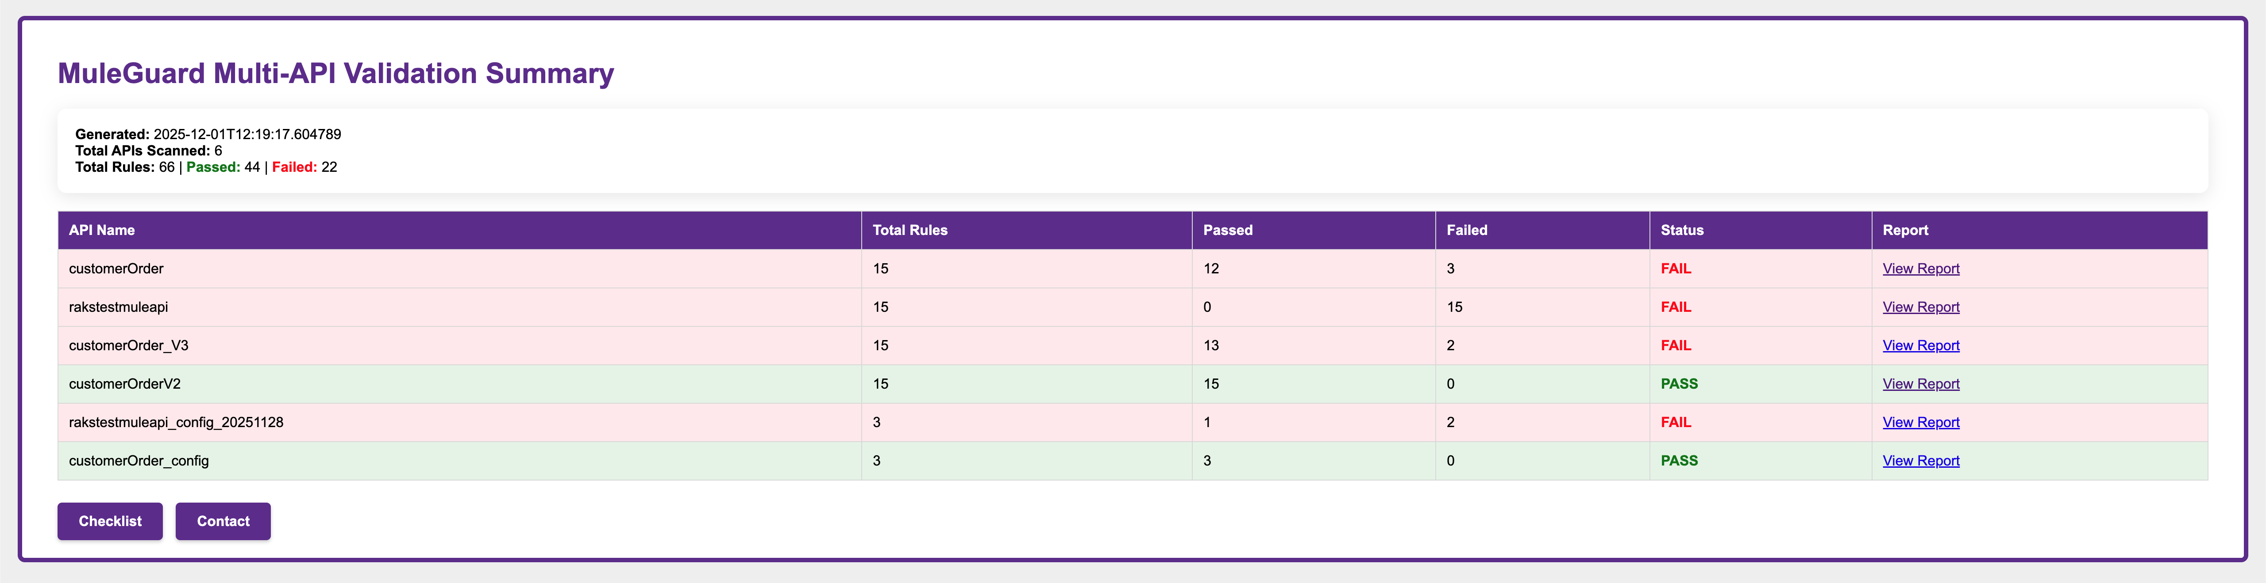

Individual API Report- PASS:
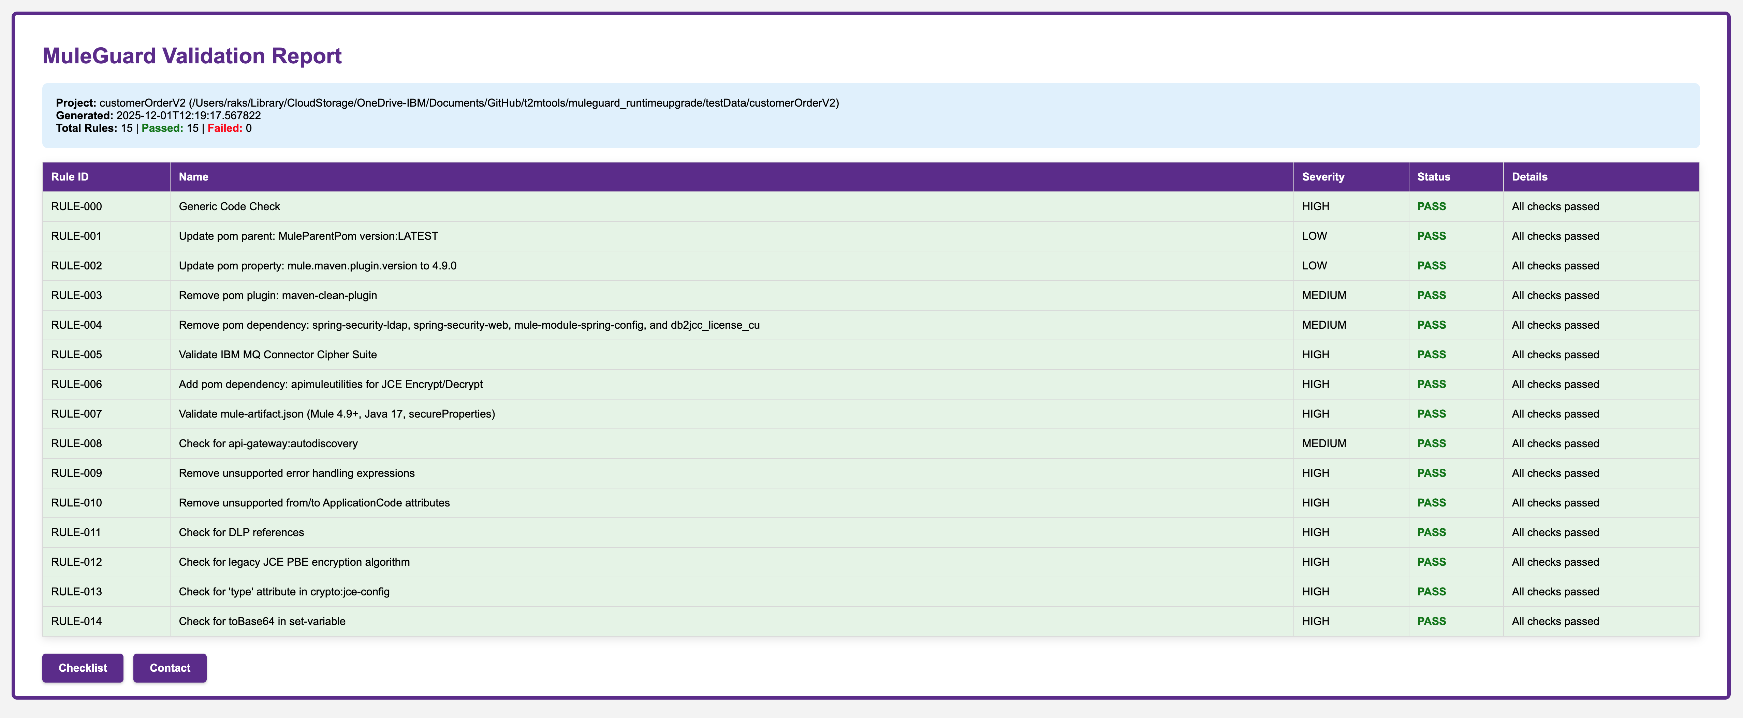

Individual API Report- FAIL:
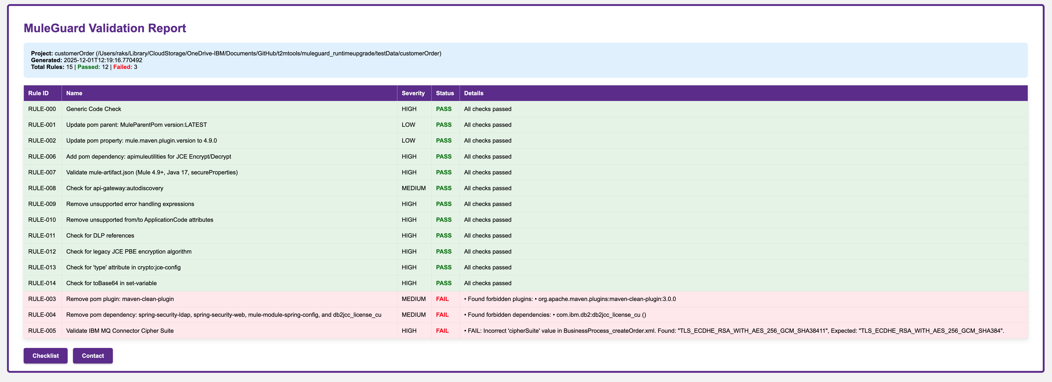

Individual API CONFIG Report- PASS:
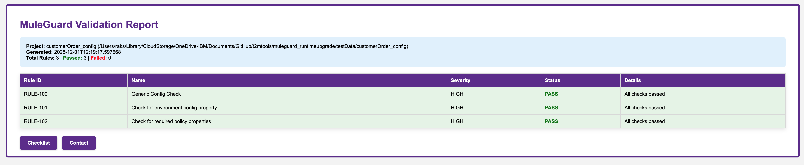

Individual API CONFIG Report- FAIL:
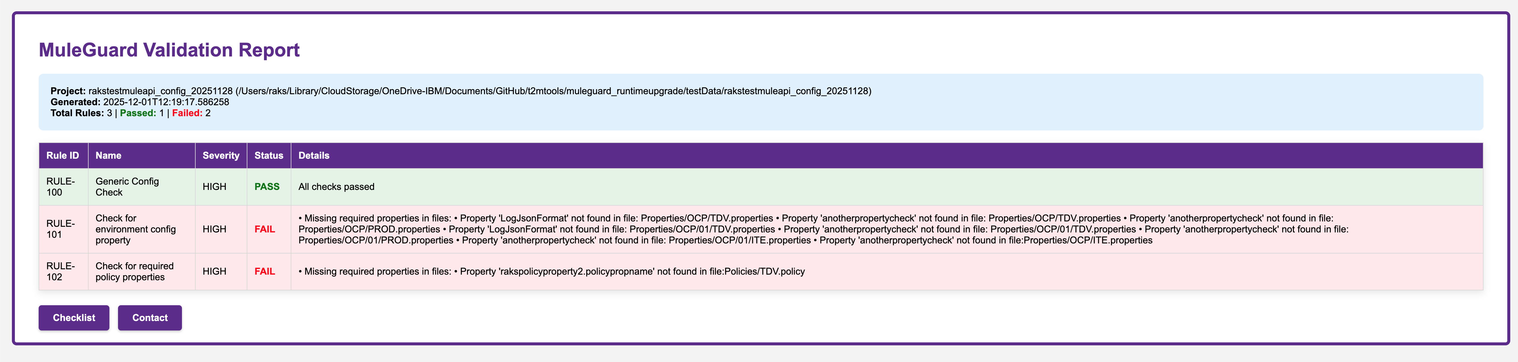

Here is a breakdown of its core capabilities:

Project Structure and Configuration Validation:

POM Analysis (pom.xml):

It can inspect and enforce standards on pom.xml files, including:
- Verifying the parent POM (RULE-001).
- Checking for specific Maven properties and their values (RULE-002).
- Ensuring required dependencies are added (RULE-006) and that obsolete ones are removed (RULE-004).
- Flagging deprecated Maven plugins (RULE-003).

Mule Application Manifest (mule-artifact.json):

It validates the application's manifest to ensure it meets runtime requirements, such as minimum Mule version, Java version, and the use of secure properties (RULE-007).

Mule Configuration XML Analysis:
- XPath-Based Checks: It uses XPath to query Mule configuration files (*.xml) to find or validate specific elements and attributes. This is used to:
- Ensure critical elements like <api-gateway:autodiscovery> are present (RULE-008).
- Verify connector configurations, such as checking the cipher suite for the IBM MQ connector (RULE-005).

Attribute and Content Validation: The tool can scan for and flag:
- Unsupported attributes in specific XML elements, like fromApplicationCode in a custom logging module (RULE-010).
- Forbidden tokens within certain elements, such as toBase64 inside a set-variable component (RULE-014).

Code and Expression Scanning:
- Legacy Code Detection: It scans Mule XML and DataWeave (.dwl) files to find and report the use of:
  - Legacy error handling expressions (e.g., error.errorType) that are no longer supported (RULE-009).
  - Generic forbidden tokens, like a misspelled secure property prefix (seceure:) (RULE-000).
- Security and Best Practices: It enforces security best practices by checking for:
  - Legacy JCE encryption algorithms (RULE-012).
  - Missing security attributes in cryptography configurations (RULE-013).

Environment-Specific Configuration Rules:
- Configuration Projects: The tool can differentiate between regular Mule applications and "configuration" projects (based on a folder name pattern i.e. “<<APIName>>_config”).
- Property File Validation: For these config projects, it can scan property files (.properties, .policy) across multiple environments (SBX, ATDV, PROD, etc.) to ensure that required properties like LogJsonFormat or specific policy settings are present (RULE-101, RULE-102).

Reporting:
- It can generate reports in Excel & HTML formats. It generates HTML reports for both a summary view and individual Mule APP details.

Rules and Checklist Mapping:
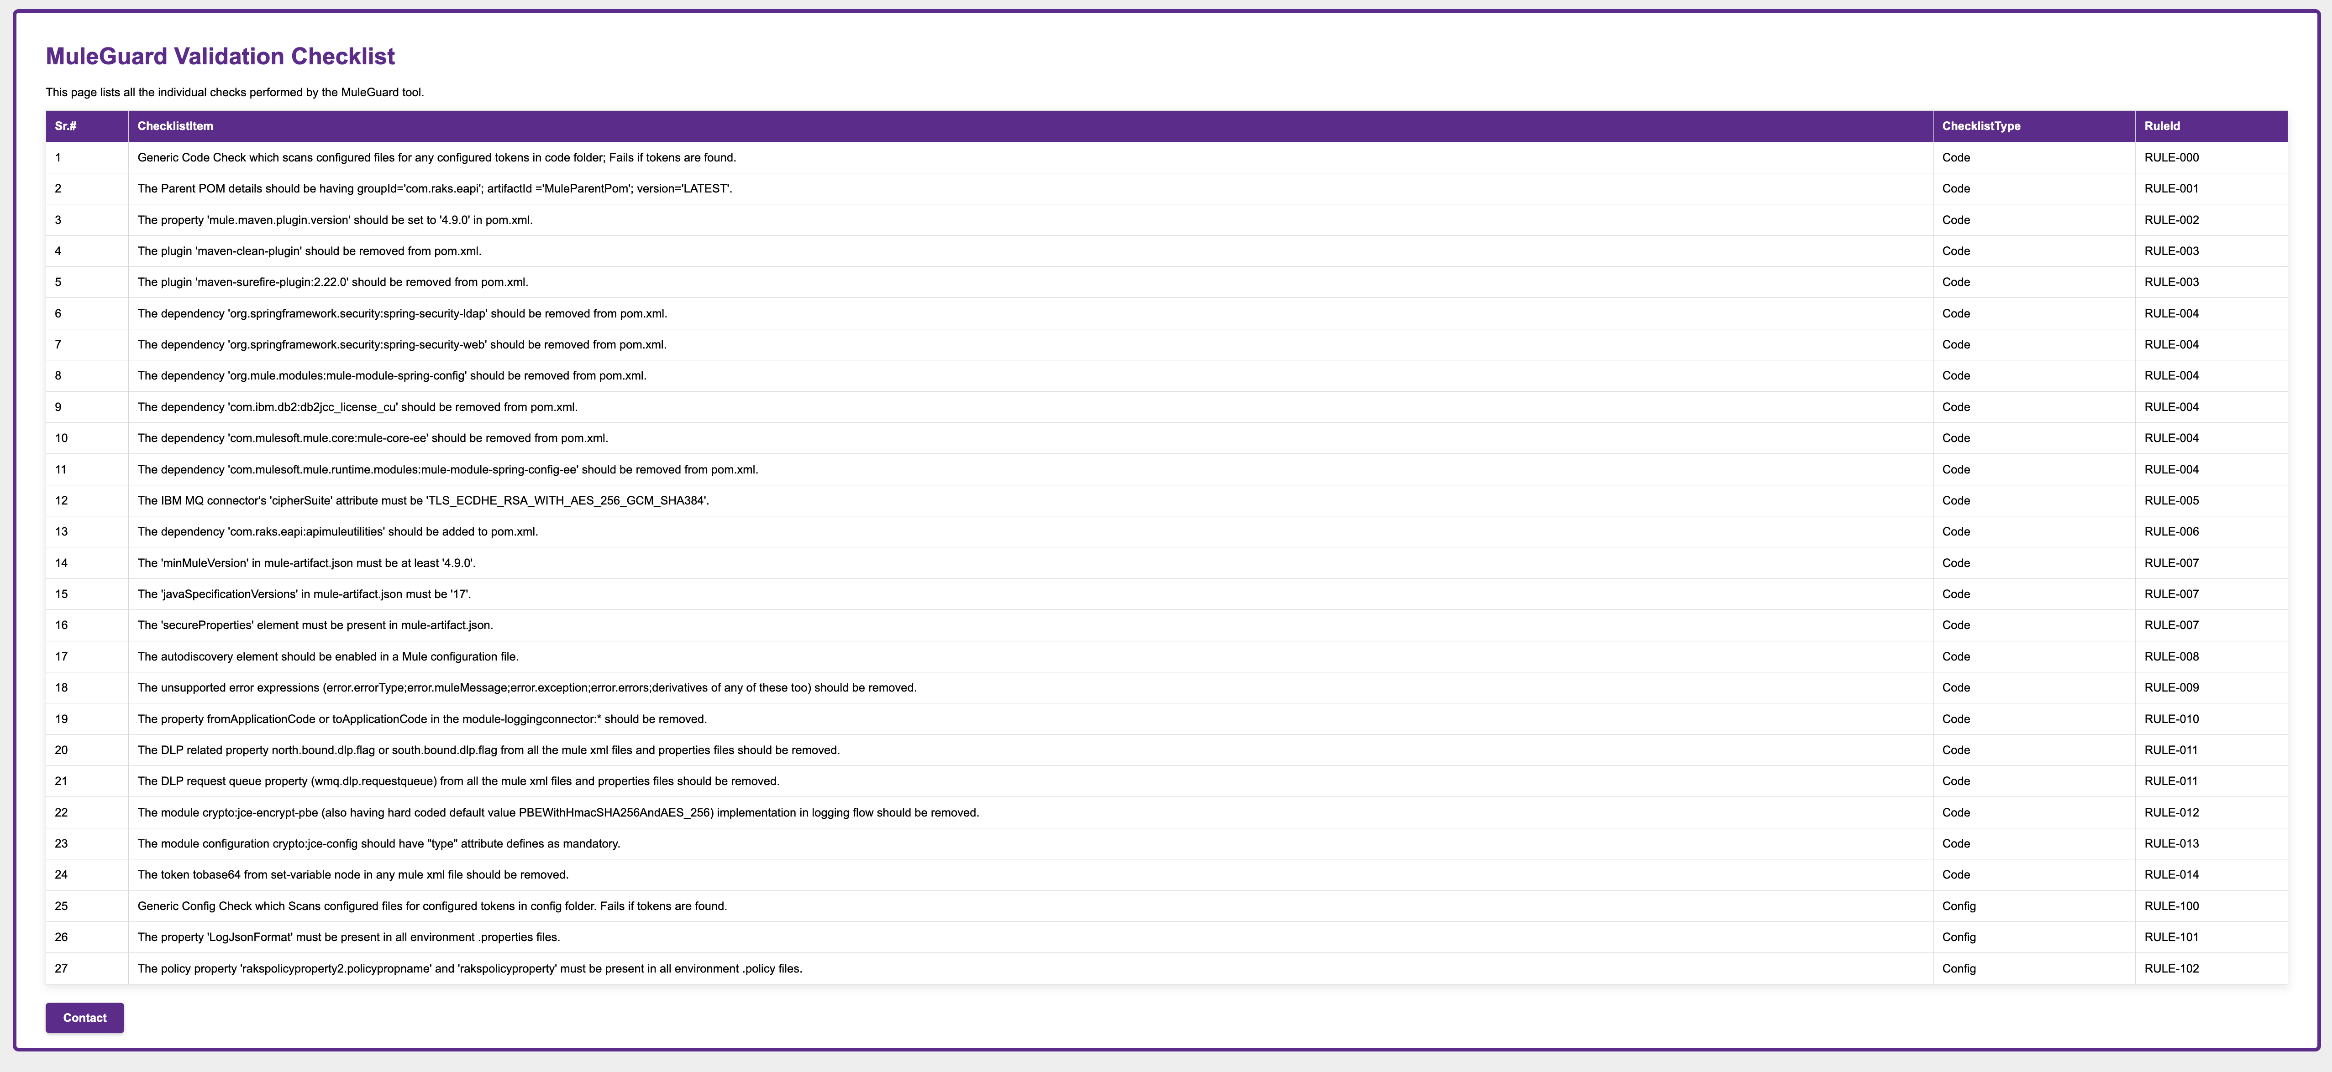

SR# | ChecklistItem | Type | RuleId
1 | Generic Code Check which scans configured files for any configured tokens in code folder; Fails if tokens are found. | Code | RULE-000
2 | The Parent POM details should be having groupId='com.raks.eapi'; artifactId ='MuleParentPom'; version='LATEST'. | Code | RULE-001
3 | The property 'mule.maven.plugin.version' should be set to '4.9.0' in pom.xml. | Code | RULE-002
4 | The plugin 'maven-clean-plugin' should be removed from pom.xml. | Code | RULE-003
5 | The plugin 'maven-surefire-plugin:2.22.0' should be removed from pom.xml. | Code | RULE-003
6 | The dependency 'org.springframework.security:spring-security-ldap' should be removed from pom.xml. | Code | RULE-004
7 | The dependency 'org.springframework.security:spring-security-web' should be removed from pom.xml. | Code | RULE-004
8 | The dependency 'org.mule.modules:mule-module-spring-config' should be removed from pom.xml. | Code | RULE-004
9 | The dependency 'com.ibm.db2:db2jcc_license_cu' should be removed from pom.xml. | Code | RULE-004
10 | The dependency 'com.mulesoft.mule.core:mule-core-ee' should be removed from pom.xml. | Code | RULE-004
11 | The dependency 'com.mulesoft.mule.runtime.modules:mule-module-spring-config-ee' should be removed from pom.xml. | Code | RULE-004
12 | The IBM MQ connector's 'cipherSuite' attribute must be 'TLS_ECDHE_RSA_WITH_AES_256_GCM_SHA384'. | Code | RULE-005
13 | The dependency 'com.raks.eapi:apimuleutilities' should be added to pom.xml. | Code | RULE-006
14 | The 'minMuleVersion' in mule-artifact.json must be at least '4.9.0'. | Code | RULE-007
15 | The 'javaSpecificationVersions' in mule-artifact.json must be '17'. | Code | RULE-007
16 | The 'secureProperties' element must be present in mule-artifact.json. | Code | RULE-007
17 | The autodiscovery element should be enabled in a Mule configuration file. | Code | RULE-008
18 | The unsupported error expressions (error.errorType;error.muleMessage;error.exception;error.errors;derivatives of any of these too) should be removed. | Code | RULE-009
19 | The property fromApplicationCode or toApplicationCode in the module-loggingconnector:* should be removed. | Code | RULE-010
20 | The DLP related property north.bound.dlp.flag or south.bound.dlp.flag from all the mule xml files and properties files should be removed. | Code | RULE-011
21 | The DLP request queue property (wmq.dlp.requestqueue) from all the mule xml files and properties files should be removed. | Code | RULE-011
22 | The module crypto:jce-encrypt-pbe (also having hard coded default value PBEWithHmacSHA256AndAES_256) implementation in logging flow should be removed. | Code | RULE-012
23 | The module configuration crypto:jce-config should have "type" attribute defines as mandatory. | Code | RULE-013
24 | The token tobase64 from set-variable node in any mule xml file should be removed. | Code | RULE-014
25 | Generic Config Check which Scans configured files for configured tokens in config folder. Fails if tokens are found. | Config | RULE-100
26 | The property 'LogJsonFormat' must be present in all environment .properties files. | Config | RULE-101
27 | The policy property 'rakspolicyproperty2.policypropname' and 'rakspolicyproperty' must be present in all environment .policy files. | Config | RULE-102

Next Steps:
Truist Customization & Onboarding: Update the tool configurations with exact property name and values etc. as per Truist requirements. Once tool is updated then bring the tool into Truist network.

