2016 Beijing

ICDIC

Group 6 Submission

July 23 2016

Oskar Niburski
Ai Nakada
Joao
Nadeer
Jia

IDCIC 2016

TABLE OF CONTENTS

Page #

1.0 GENERAL INFORMATION
1.1 System Overview
1.2 Project References
1.3 Authorized Use Permission
1.4 Points of Contact
1.4.1 Information
1.5 Organization of the Manual
2.0 SYSTEM SUMMARY
2.1 System Configuration
2.2 Data Flows 2-3
3.0 GETTING STARTED
3.1 Logging On
3.2 System Menu
3.2.1 Changing the views
3.4 Exit System
4.0 Calculator View 4-1
4.1 Operand Buttons (Addition, Subtraction, Division, Multiplication) 4-1
4.2 Sin and Cos Buttons 4-3
4.3 Factorial, PI, Decimal Point, X and Negate Buttons 4-4
4.4 SAVE, UNDO, Clear, TEST, Graph and INFO Buttons 4-8
5.0 Graph View 5-1
5.1 Save button 5-1

1.0 GENERAL INFORMATION

GENERAL INFORMATION

1.1 Abstract

We have proposed a possible solution to power loss in a twin airplane. Our solution represents a reasonable enhancement to current solutions, and aims to become feasible.

1.2 Definitions

This report uses numerous definations and concepts. Below are a few explained:
- blue line: speed at which a double engine twin plane needs to act as a single engine plane to climb
- assymetric thrust: assymetric power condition when the nete centre of trhust is displaced from the centre to one of the lateral wings.
- Twin engine: Two engine airfract under a certain wait class.
- Minimum control speed on the ground: minmum air speed at which aircraft is directionally controllable during acceleration along the runway with one engine inoperative.
- Airborne minimum control speed: Minimum airspeed at which directional control can be maintained during a crtical engine failed with the possibility of windmilling
- Vy: Optimal climb rate speed with single operating engine in twin engine plane

1.2 Background
If there is one constant humanity has always fought with, it is a human’s inability to control chaos and the uncertainty of nature. With fire, we forged torches but caused arson in the process. With homes and industry we created comfort and ease, but at the same time large amounts of pollution. And this inevitability of our want to control nature leading to unelectuable outcomes is no different than in aircraft.

It is almost unbelievable that we can now fly, and the history of aviation speaks to the greatness of men. And yet still, our human ingenuity poses itself a problem, that our systems are not foolproof, and people die in the process while we try to control nature.

Within the recent few years alone, there are multiple examples. One only needs to look at the 2016 Sunbird crash, the EgyptAir Flight 181 accident, or any of the other various crashes to see that aviation still is far from perfect. And these reoccurring accidents speak to the importance of aviation safety in modern times.

1.3 Problem Statement

As such, the problem we are aiming to understand and explore is aviation safety. More specifically, we are looking at propose a solution for the twin enginer Bombardier q400, a common commercial passenger plane and determine a solution for when there is a power loss in one of the engines. We will also only be concerned with in-flight safety, but will speak about take off and landing as well.

1.4 Current Solutions

Currently there are a multitude of various solutions, ranging from plane design, to wingspan, to arieal techniques, as well as automation systems. However, to analyze our proposed solution effectively, I will compare automation systems and pilot trained ariel techniques.

Pilot Techniques
When a light twin enginer plane experience engine malfunction, often the other engine is used to get the pilot and passengers to the neariest airfield. When the engine does fail, there is an intial effect of yawing. This is because the thrust line )please refer to the thrust definitions above) becomes asymmetrious. The size of this yawing depends on the engrine trhust and centre of gravity of the plane. As the plane becomes to yaw, it is further enhanced by an ever growing drag force.

Afterwards, the yawing becomes too intense and becomes a roll force. The roll force is intiayed on the failed enginer side, resuling in an increase in drag, and a decrease in lift. Of course, this is very damaging to the planes aerodynamics (as is any chaotic motion). According to Skybrary, a loss of 50% of available power results in as much as 80% loss in performance.

To counteract this yawing while flting, genrally pilots to various actions. The simplest action invovlescountering the opposite side of the engine failure. Therefore if the right engine suffered a failure, the pilot would use the full left rudder input and slow down the left engine. This would cause the plane to tilt against the assymetric thrust. Generally speaking, you are to counter approximately 5 degrees toward the live engine.
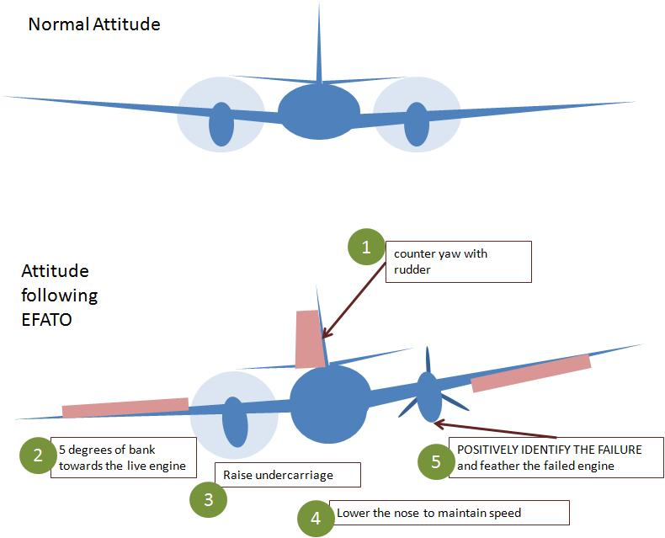
Figure 1. A pilot’s techniques to counter engine failure

During takeoff, a series of lifting the flaps and retracting them as well as making approrioate operating enginers are necessary. Furthermore, adjustments need to be made in airspeed as one needs to keep at the airspeed now appropriate for a single engine climb.

Often in moments like this, during engine loss, the pilot takes over from any autonoms system. Therefore it is important to look at autonomous systems, and see their basic overviews.

Authonomis flight systems, or autopilot as it is commonly known, flies planes counteracting basic stimuli on the plane. A great overview can be seen in the airspace.net. From a basic view, pilots provide the parameters to the automated flight system. This automated system then adjusted itself according to these predesigned paramters.

However, with the advent of many autonomos flying systems, from drones to trucks to lawn mowers, one must wonder if the same cannot be applied to the world of flight, and especially in terms of engine failure.

1.5 Constraints

The system source code is going to be public on GitHub and it will be accessible by anyone who seek calculator with new features. The developer team authorizes copy and usage of the application.

1.6 Assumptions

Following is the point of organizational contact (POC) that may be needed by the document user for informational and troubleshooting purposes.
Email Contact: zarifi@my.yorku.ca
Department: York University, Lassonde School of Engineering, Department of Electrical Engineering and Computer Science (EECS)

1.7 Stakeholders

The first section of the user manual is about an introduction of the calculator application and the following sections explain about different views and functionality of the system.

1.8 Introduction to Solution

The first section of the user manual is about an introduction of the calculator application and the following sections explain about different views and functionality of the system.

2.0 SOLUTION EXPLORATION

SOLUTION EXPLORATION

2.1 Alternate solutions
The following is the user interface of the calculator, figures 1 to 3. It consists of three views, Calculator view in figure 1, Graph view in figure 2 and Favorites view in figure 3. These views interact with each other through main panel. The input of the calculator is user input via keyboard and the output can be views in the text field of the calculator view.

Figure 1: User Interface of the Calculator (Calculator View)

Figure 2: Graph view of the Calculator

Figure 3: Favorites view

2.2 Solution - Problem
User enters the number by typing it in the input field and press Enter button, then the value would be stored in the history and after user presses the desired operand (+, -, *, /...) the result of the expression will be stored in the Calculated Value field. You can see the addition of 5+6 in figure 4. So first number 5 and 6 is pushed and then Enter button is pressed and finally + button is pressed to calculate the result. The data is entered in postfix form and is displayed in infix form.

2.2 Solution - Features
User enters the number by typing it in the input field and press Enter button, then the value would be stored in the history and after user presses the desired operand (+, -, *, /...) the result of the expression will be stored in the Calculated Value field. You can see the addition of 5+6 in figure 4. So first number 5 and 6 is pushed and then Enter button is pressed and finally + button is pressed to calculate the result. The data is entered in postfix form and is displayed in infix form.

2.2 Solution - Approximations
User enters the number by typing it in the input field and press Enter button, then the value would be stored in the history and after user presses the desired operand (+, -, *, /...) the result of the expression will be stored in the Calculated Value field. You can see the addition of 5+6 in figure 4. So first number 5 and 6 is pushed and then Enter button is pressed and finally + button is pressed to calculate the result. The data is entered in postfix form and is displayed in infix form.

2.3 Solution - Justications
User enters the number by typing it in the input field and press Enter button, then the value would be stored in the history and after user presses the desired operand (+, -, *, /...) the result of the expression will be stored in the Calculated Value field. You can see the addition of 5+6 in figure 4. So first number 5 and 6 is pushed and then Enter button is pressed and finally + button is pressed to calculate the result. The data is entered in postfix form and is displayed in infix form.

2.4 Solution - Fiscal
User enters the number by typing it in the input field and press Enter button, then the value would be stored in the history and after user presses the desired operand (+, -, *, /...) the result of the expression will be stored in the Calculated Value field. You can see the addition of 5+6 in figure 4. So first number 5 and 6 is pushed and then Enter button is pressed and finally + button is pressed to calculate the result. The data is entered in postfix form and is displayed in infix form.

2.5 Solution - Future
User enters the number by typing it in the input field and press Enter button, then the value would be stored in the history and after user presses the desired operand (+, -, *, /...) the result of the expression will be stored in the Calculated Value field. You can see the addition of 5+6 in figure 4. So first number 5 and 6 is pushed and then Enter button is pressed and finally + button is pressed to calculate the result. The data is entered in postfix form and is displayed in infix form.

Figure 4: 5+6 operation in the calculator

http://planes.axlegeeks.com/l/301/Bombardier-Q400
http://www.skybrary.aero/index.php/Engine_Failure_After_TakeOff_-_Light_Twin_Engine_Aircraft
http://www.faa.gov/regulations_policies/handbooks_manuals/ aircraft/airplane_handbook/media/faa-h-8083-3a-3of7.pdf
http://theairspace.net/technology-2/how-does-autopilot-work/

