New Learner Academy.

**Project details:**

As “admin” user

Will be able access academy portal and

Will be able create teacher,classroom,subject and students.

Will be able to see subject and teacher details for a class

Will be able to map classroom,teacher and subject

Will be able map student to a calss.

**Concepts Used:**

|  |  |  |
| --- | --- | --- |
| JDBC connectivity | Used to query DB and check if user entered correct username and password | "admin" user details stored in table "user_details" of schema "academy" |
| Servlets(Concepts used: Servlet doPost,doGet,redirection,Deployment descriptor,DB Connectivity) | AdminLogin | Method:get Logic to verify admin username and password is correct |
| ClassRoomServlet | Method:post Logic to create ClassRoom entity |
| MapServlet | Method:post Logic to map classroom,teacher and subject |
| StudentServlet | Method:post Logic to create Student entity |
| SubjectServlet | Method:post Logic to create Subject entity |
| TeacherServlet | Method:post Logic to create Teacher entity |
| ClassDetails | Method:get Logic to get the teacher and subject details for a given class |
| Class | ClassRoom | ManytoMany Relation ship with student and Subject |
| Student | ManytoMany Relation ship with classes and Teacher |
| Subject | ManytoMany Relation ship with Student and ClassRoom |
| DB tables(concepts used:Hibernate entity mapping,ManyToMany relationship) All the tables created usign Hibernate mapping | ClassRooms | To store ClassRoom details |
| Teachers | To store Teacher details |
| Subjects | To store Subejct Details |
| classrooms_teachers | To map classrooms and teachers |
| subjects_teachers | To map subjects and teachers |
| classrooms_subjects | To map classrooms and subjects |
| HTML | Classroom | Calls ClassRoomServlet |
| details | Calls ClassDetails |
| login | Calls AdminLogin servlet |
| mainpage | Main page after login |
| mapid | Calls MapServlet |
| studentform | Calls StudentServlet |
| subjectform | Calls SubjectServlet |
| teacher | Calls TeacherServlet |
| other java concepts | List: To get the list of Classroom ,tacher and subject details |  |
| Try/Catch exception handling |  |
| setters/getters method |  |

**GitHub Link:**

**Admin login**

Admin login checks username and password from DB.

* When wrong username and password supplied.

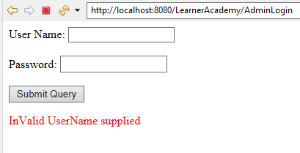

* Successful login.

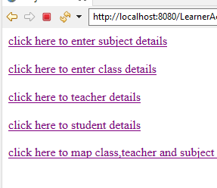

**Enter Subject Details.**

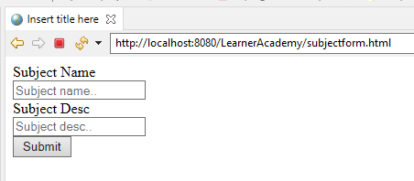

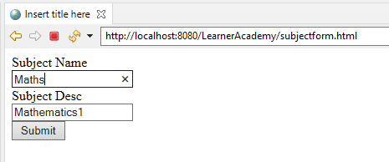

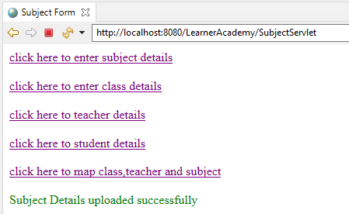

In DB record inserted into.

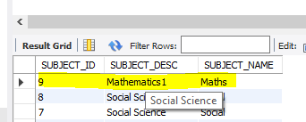

**Class Details.**

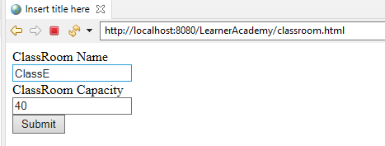

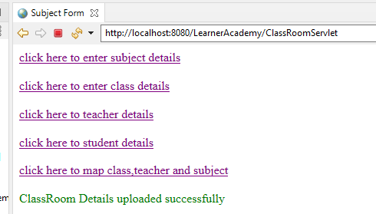

In DB ClassRoom details entered.

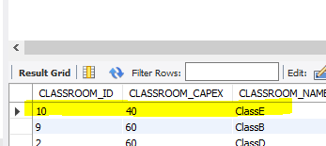

**Teacher Details**

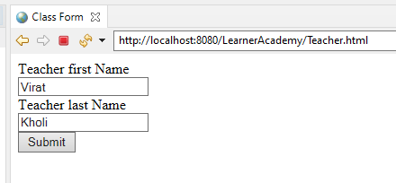

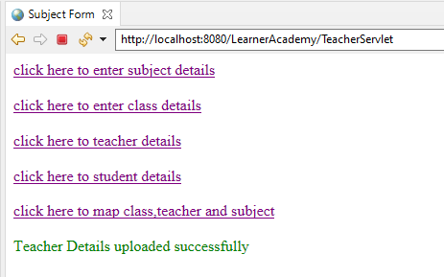

In DB teachers table.

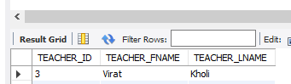

**Student Details.**

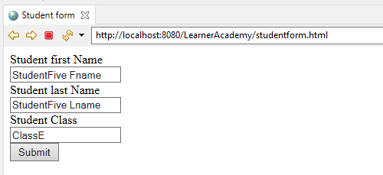

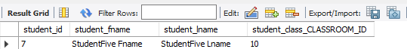

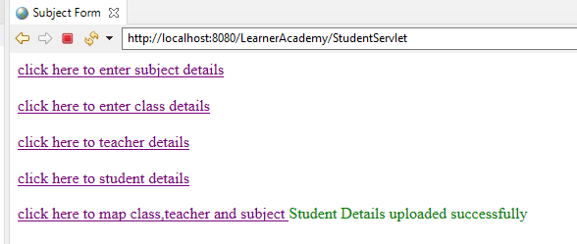

**When for a student non existing class assigned .**

Here ClassG doesn’t exist.

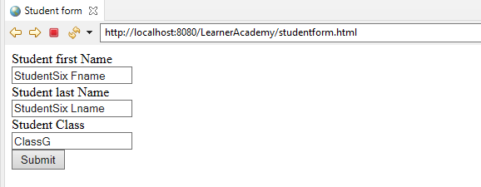

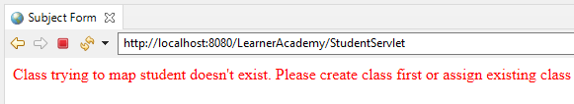

**Mapping Class,Teacher and Subject using each entity ID.**

When less than 2 ID is entered.

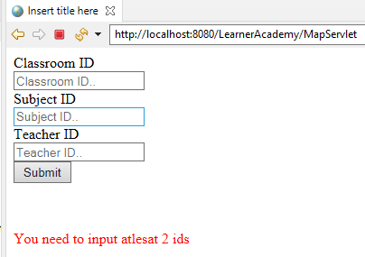

IF any entity is not present then

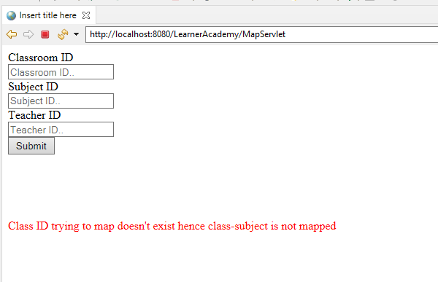

**Trying to establish below mapping**

**ClassRoom|Teashcer**

|  |  |  |
| --- | --- | --- |
| **ClassRooom** | **Teacher** | **Subject** |
| ClassE(10) | Virat Kholi(3) | Mathematics(9) |
| ClassE(10) | Ajay Devgan(2) | Social(8) |
| ClassF(11) | Ajay Devgan(2) | Social(8) |
| ClassF(11) | Virat Kholi(3) | Mathematics(9) |

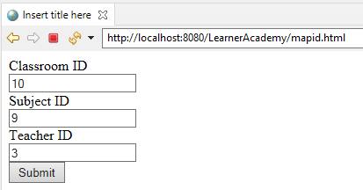

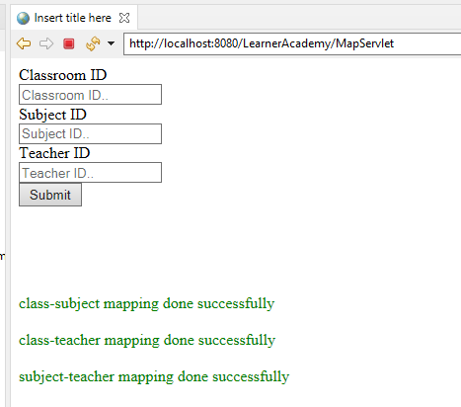

Classrooms_teacher table

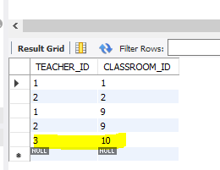

ClassRoom_subject table

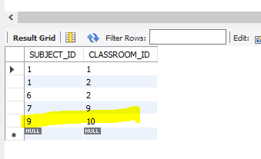

Teacher_subject table

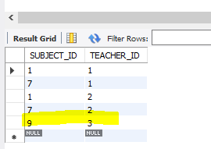

**To check the Class, Teacher and Subject details for given class**

Enter class name.

