**New Learner Academy.**

Author: Rakshith Shetty Date: 19/08/2021

Ph:+91 9742553322

Email: rshetty89@gmail.com

**First Page**

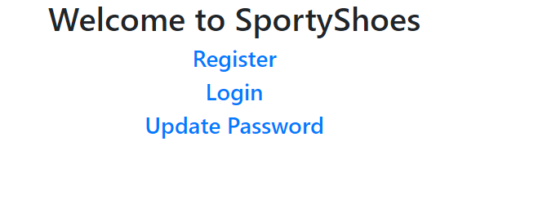

Signig up for admin.

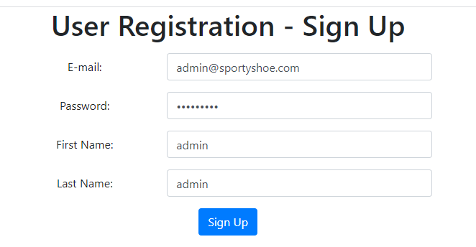

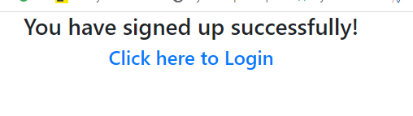



Update password.

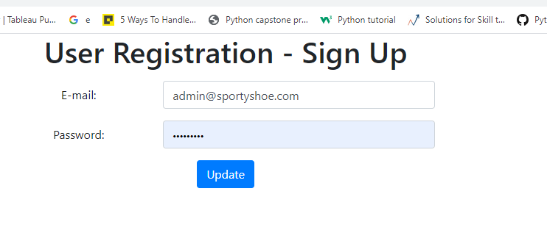

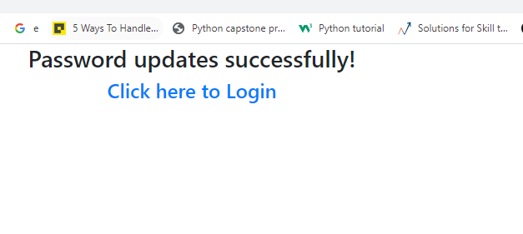

Login with updated pasword.

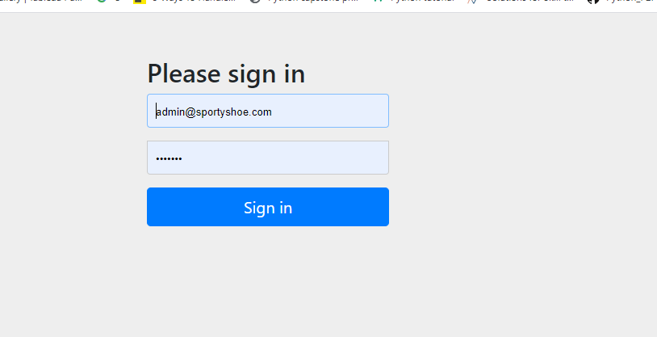



**Creating Categories via Postman**

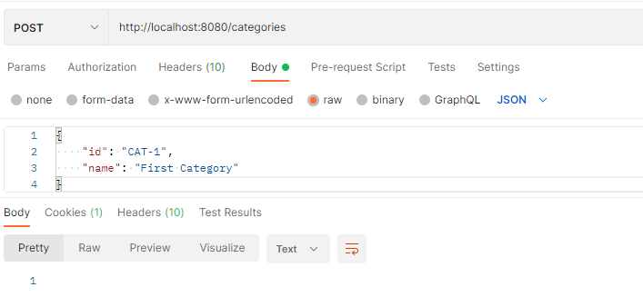

**Browse category.**

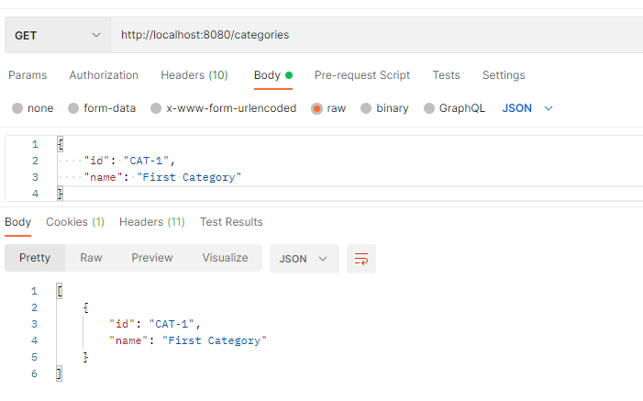

**Update category now.**

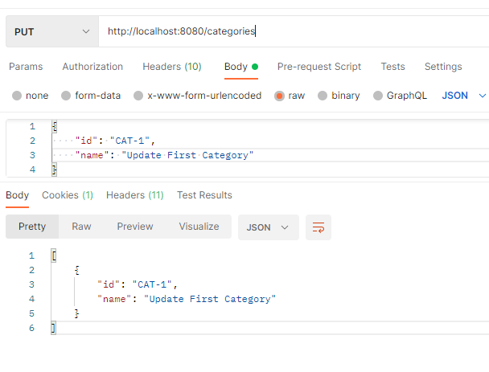

**Update category.**

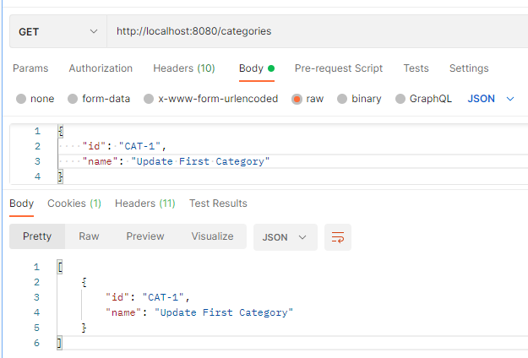

**Creating procut this has OnetoOne mapping with Category.**

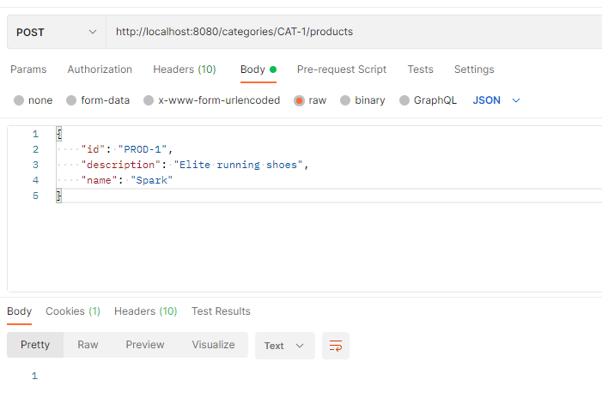

**Get product and we could see that category details also fetched.**

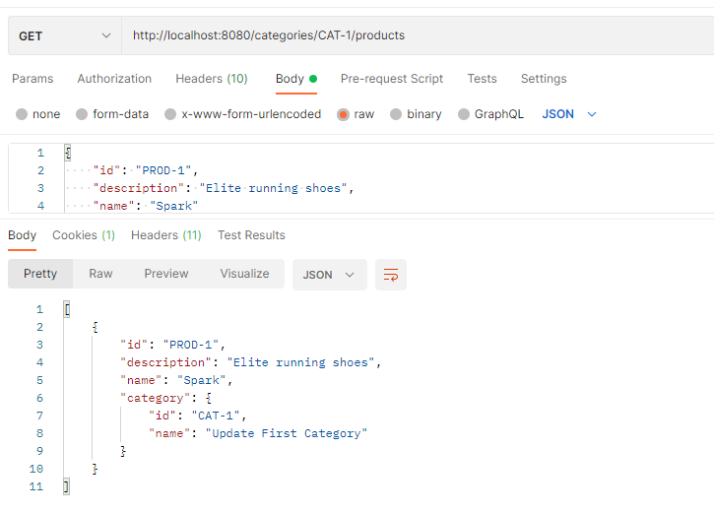

**Get list of signed up users.**

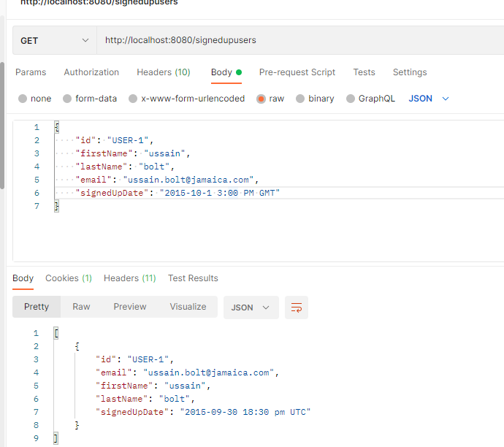

**Now search the user based on userid(user-1).**

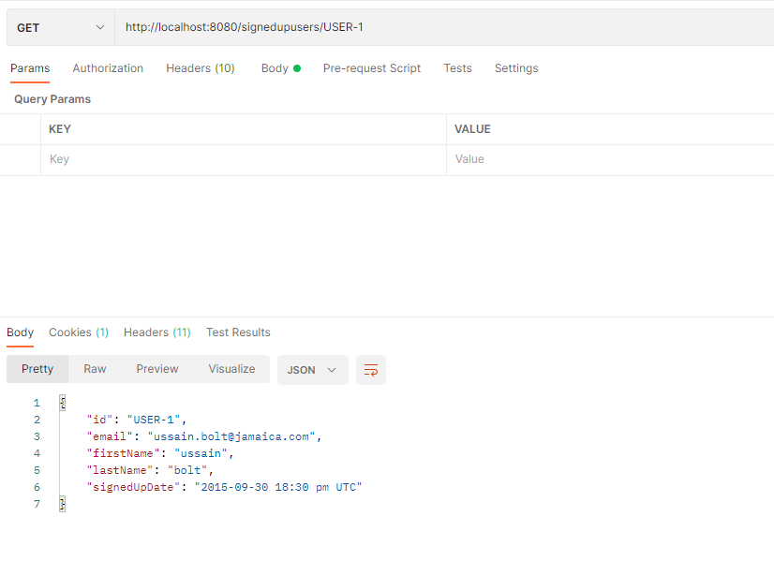

**Search using First name.This is firstname “Like”**

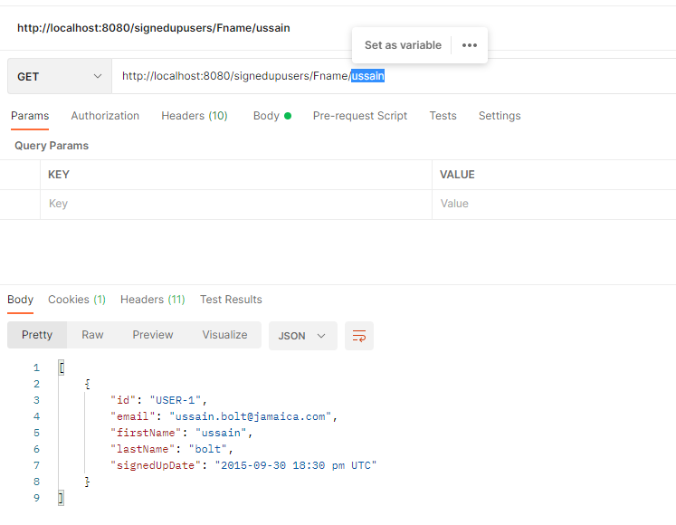

**When non existing Fname is searched no result.**

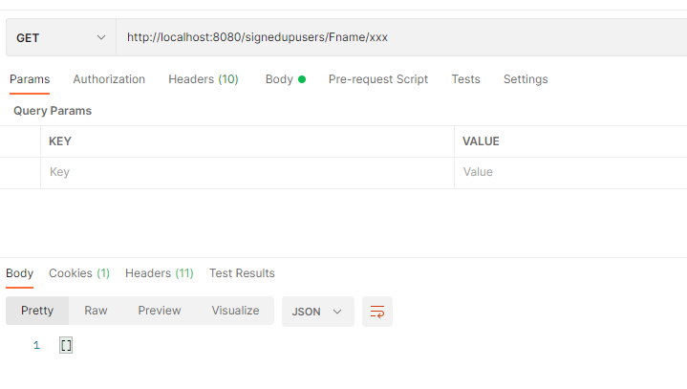

**Create purchase instance.**

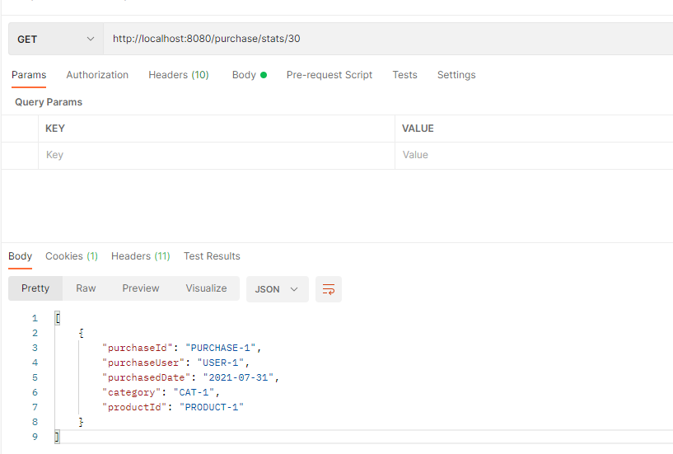

**Get Purchase reports(there are 3)**

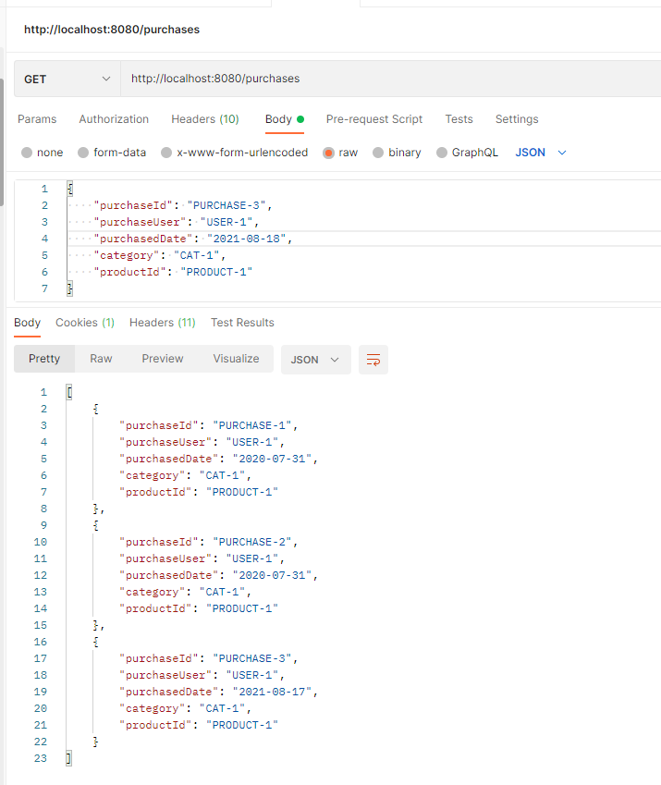

**Get purchase report in last 7 days so from above screen shot only the purchase id with “PURCHASE-3” should be returned.**

**Other two purchased on year “2020” and they are not appearing in the list.**

