SOC L1 Incident Detection & Incident Response Lab
1. Project Overview
This project simulates a real-world Security Operations Centre (SOC) Level 1 investigation involving a suspected compromise of an employee workstation.
The objective is to investigate suspicious activity, identify Indicators of Compromise (IOCs), reconstruct the attack timeline, assess the impact, and document an appropriate incident response.
The investigation will be performed using a controlled virtual lab consisting of a Kali Linux analyst machine and a Windows endpoint representing an employee workstation.

2. Organisation Background
Organisation: Apex Financial Services
Apex Financial Services is a medium-sized financial services organisation that provides online financial and advisory services to customers.
The organisation operates a hybrid IT environment consisting of Windows workstations, internal servers, cloud services, and network infrastructure.
Employees use Windows-based workstations to access internal applications, email, file shares, and business systems.
The organisation has a small Security Operations Centre responsible for monitoring security events and responding to suspected incidents.

3. SOC Environment
The SOC team operates a three-level incident response structure:
- SOC L1 Analyst: Alert monitoring, initial triage, investigation, evidence collection and escalation.
- SOC L2 Analyst: Advanced investigation, threat hunting and containment support.
- Incident Response / Security Team: Incident containment, eradication, recovery and post-incident activities.
As part of this scenario, I will act as the SOC L1 Analyst responsible for the initial investigation.

4. Incident Scenario
At approximately 10:15 AM, the SOC monitoring system generates an alert associated with an employee workstation.
The alert indicates that the workstation has experienced multiple failed authentication attempts followed by a successful login.
Shortly after the successful authentication, suspicious PowerShell activity is observed on the same endpoint.
The SOC monitoring system also identifies an unusual process execution and an outbound network connection from the workstation.
The activity does not match the employee's normal behaviour and is therefore escalated to the SOC L1 analyst for investigation.

- Victim Endpoint — Windows 10-Lab
The Windows 10-Lab virtual machine will be used as the simulated employee workstation/victim endpoint in the SOC investigation. The VM is configured with 6,144 MB of RAM, 4 virtual processors, and a 50 GB virtual hard disk. The current network adapter is configured for NAT; this configuration will be modified later to place the endpoint on the isolated SOC laboratory network.
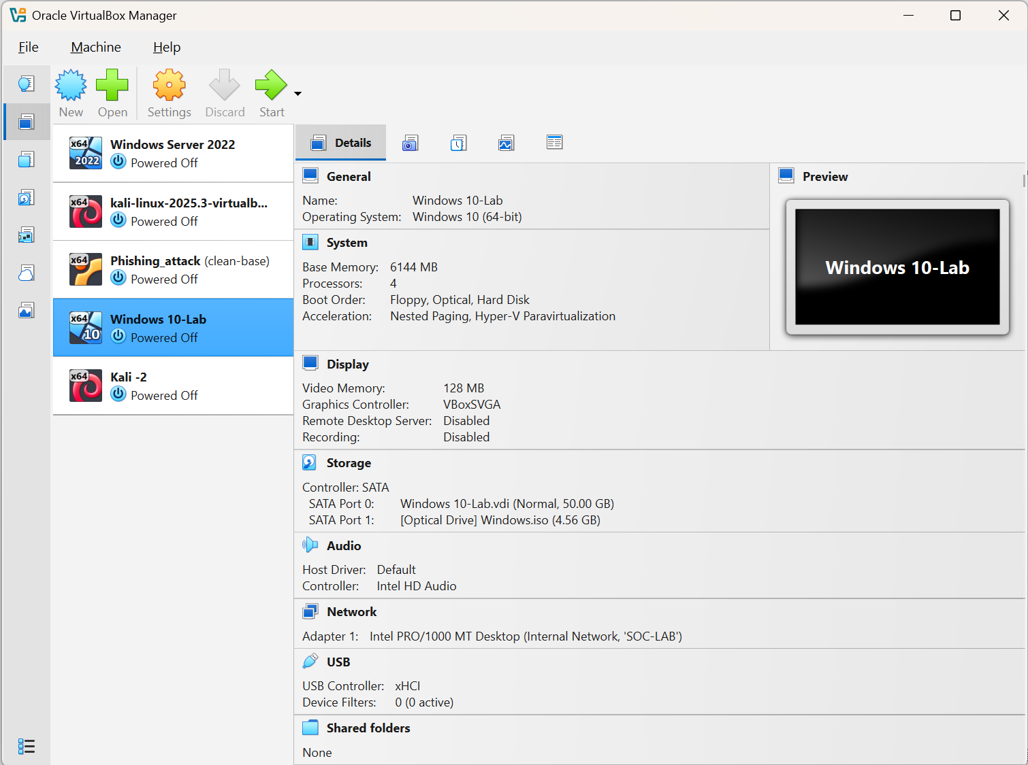
- Analyst Workstation — Kali Linux
The Kali Linux virtual machine will function as the SOC analyst workstation. It is configured with 4 GB (4,096 MB) of RAM, 2 virtual processors and an 80.09 GB virtual hard disk. The VM was initially configured with a NAT network adapter, which is being replaced with the isolated VirtualBox Host-only network as part of the laboratory setup. 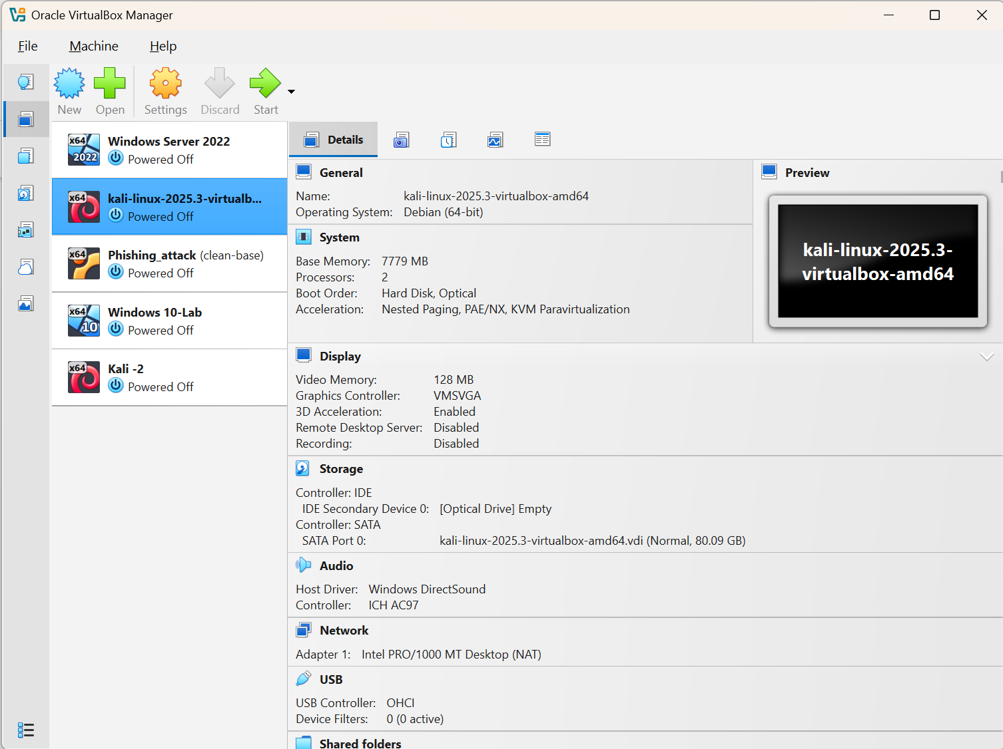
- Kali Linux Resource Allocation:
To maintain adequate resources for the host operating system while running the SOC laboratory, the Kali Linux VM was allocated 4 GB of RAM and 2 virtual processors. This allocation provides sufficient resources for security analysis tools while maintaining a balanced resource allocation across the laboratory environment.
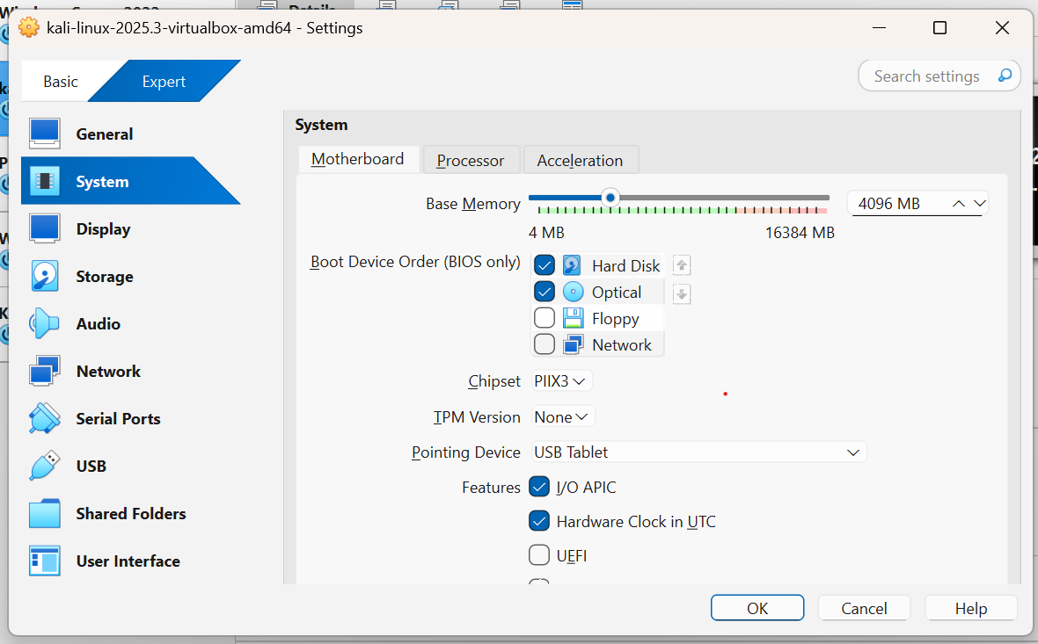
- Windows Victim Resource Allocation:
The Windows 10 victim endpoint was allocated 6 GB of RAM and 4 virtual processors. This provides sufficient resources for Windows, Sysmon and the endpoint telemetry required for the investigation while preserving sufficient system resources for the host operating system.
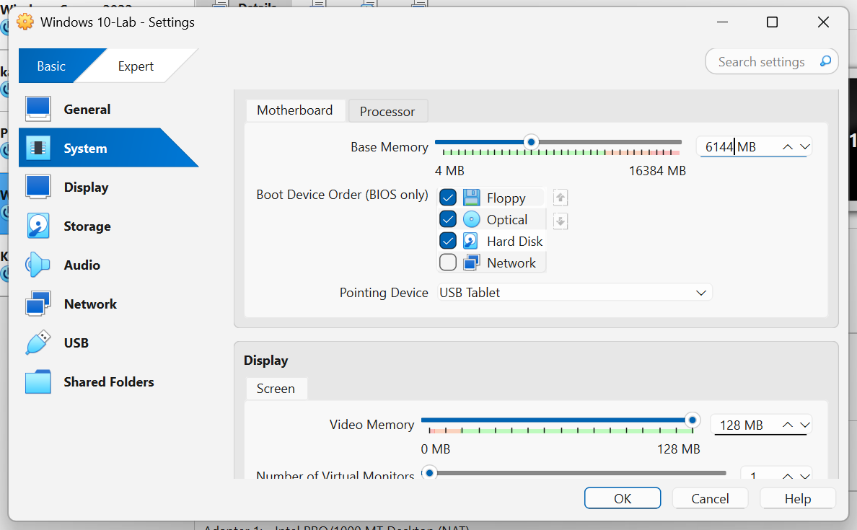

5. Initial Alert
The initial alert received by the SOC analyst contains the following information:
Alert Name: Suspicious Authentication and PowerShell Activity
Severity: Medium
Affected Host: Windows 10-Lab
User Account: Raktabh
Initial Detection Time: 10:15 AM
Alert Description:
Multiple failed authentication attempts were detected against the employee account, followed by a successful authentication. Shortly after authentication, PowerShell executed a suspicious command on the endpoint.
The SOC analyst must determine whether this activity represents a genuine security incident or a legitimate administrative/user action.

6. Suspicious Activity
During the investigation, the SOC analyst may identify the following activities:
Authentication Activity
Multiple failed authentication attempts are recorded against the employee account.
This is followed by a successful authentication from the affected workstation.
The analyst must determine:
- Number of failed attempts
- Time between attempts
- Source of authentication attempts
- Successful login time
- Whether the login behaviour is normal
- Whether credential compromise is possible

PowerShell Activity
Shortly after the successful authentication, PowerShell is executed on the workstation.
The analyst must investigate:
- Which user launched PowerShell
- Parent process
- Command-line arguments
- Execution time
- Whether encoded or obfuscated commands were used
- Whether the activity resembles legitimate administration
- Whether the command attempted to download or execute another file

Process Activity
The workstation subsequently shows unusual process creation activity.
The analyst must investigate:
- Process name
- Parent process
- Process ID
- Command line
- Execution time
- User account
- Whether the process is expected
- Whether the process indicates malicious execution

Network Activity
The workstation establishes an outbound connection to an external IP address that is not normally associated with the organisation.
The analyst must investigate:
- Destination IP address
- Destination port
- Protocol
- Connection time
- Source process
- Whether the destination is suspicious
- Whether the connection could represent command-and-control activity

7. Investigation Objective
The primary objective of the SOC L1 investigation is to determine:
- What happened?
- When did the activity begin?
- Which user account was involved?
- Which endpoint was affected?
- How was the suspicious activity initiated?
- What processes were executed?
- What network connections were established?
- What Indicators of Compromise can be identified?
- Was the endpoint compromised?
- What is the potential impact?
- What containment actions should be recommended?
- Should the incident be escalated to SOC L2 / Incident Response?

- 7.1 Initial Network Configuration
The Windows 10-Lab and Kali Linux virtual machines were initially configured to use NAT networking. NAT provides network connectivity to the guest operating system through the host system. For the SOC laboratory, this configuration was reviewed and replaced with an isolated Host-only network. 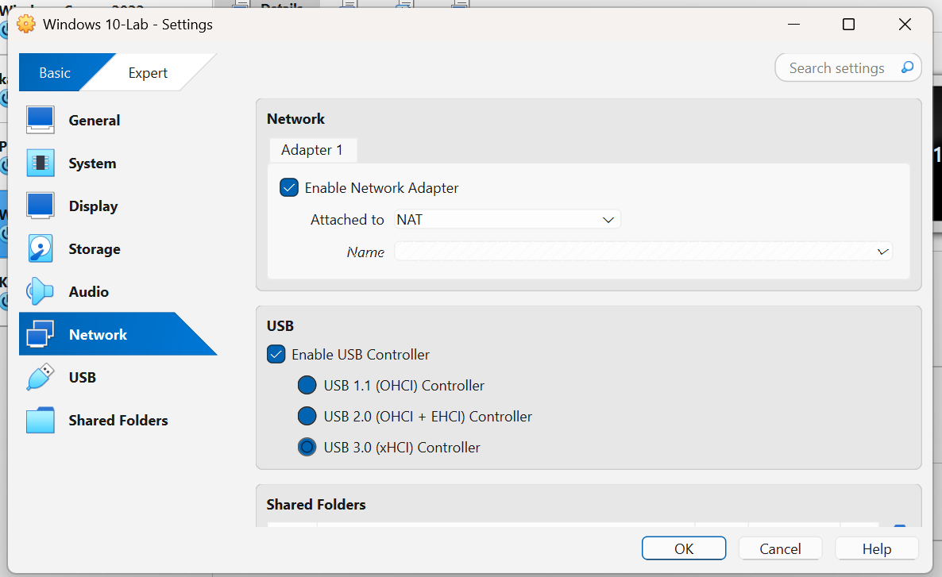

- 7.2 Isolated SOC Laboratory Network
A VirtualBox Host-only network was selected to provide an isolated communication environment for the SOC laboratory. The Windows 10-Lab victim endpoint and Kali Linux analyst workstation were both configured to use the VirtualBox Host-Only Ethernet Adapter.
The Host-only configuration allows the laboratory virtual machines to communicate with each other and with the host system while keeping the laboratory traffic separate from the physical network. The configuration also allows the analyst workstation to interact with the simulated victim endpoint without placing the intentionally generated security activity directly onto the production or home network.
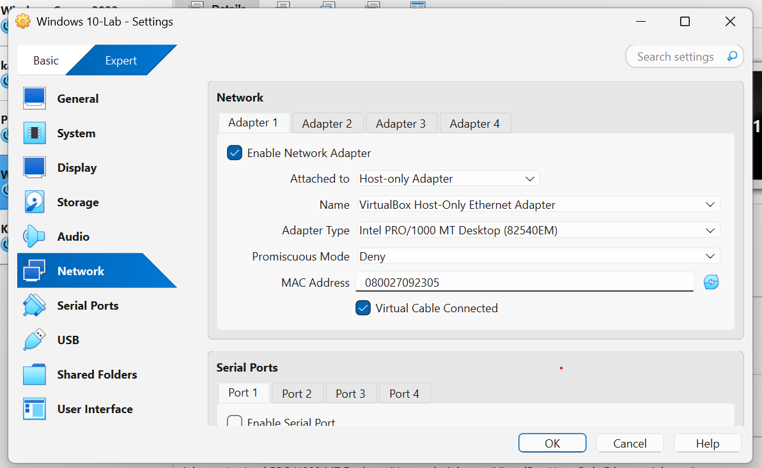
- 7.3 Windows Network Configuration
The Windows 10-Lab VM was configured with Adapter 1 enabled and attached to the VirtualBox Host-Only Ethernet Adapter. The adapter uses the Intel PRO/1000 MT Desktop (82540EM) virtual network interface, with Promiscuous Mode set to Deny and the virtual cable enabled.
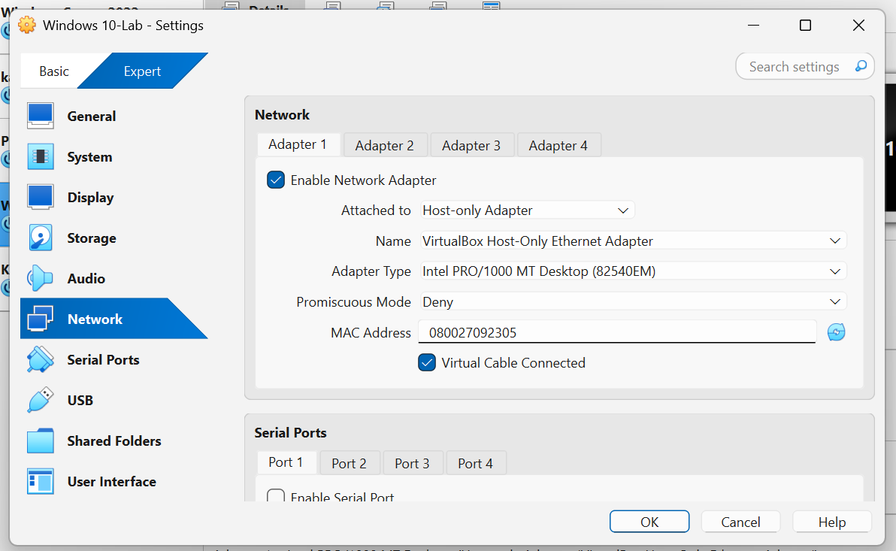

- 7.4 Kali Network Configuration
The Kali Linux analyst workstation was configured with Adapter 1 enabled and attached to the same VirtualBox Host-Only Ethernet Adapter. Using the same host-only interface allows Kali and the Windows victim endpoint to communicate within the isolated SOC laboratory network.
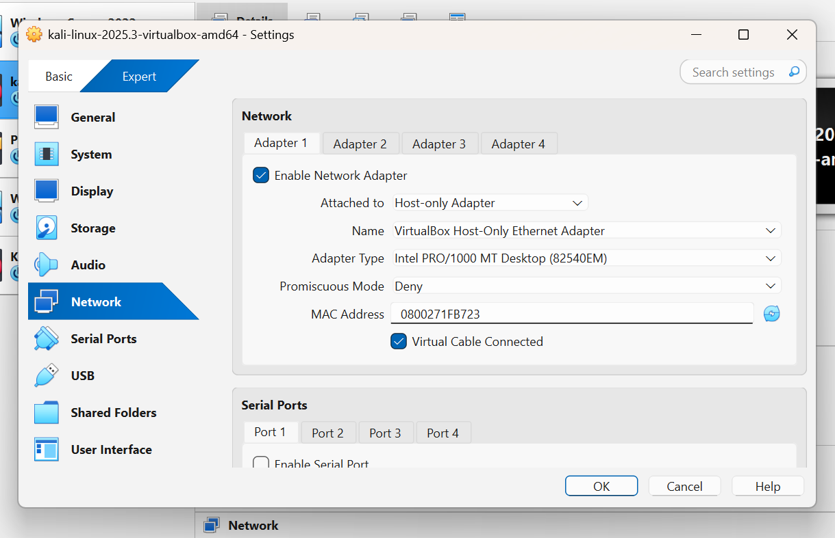
- 7.5 Kali Linux IP Configuration
The Kali Linux analyst workstation was started and its network configuration was verified using the ip addr command. The primary laboratory network interface, eth0, was active and assigned the IPv4 address 192.168.56.102/24. The /24 prefix corresponds to the 192.168.56.0/24 network. No default gateway was configured on the interface, which is consistent with the isolated Host-only laboratory design.
This confirms that the Kali Linux workstation is successfully connected to the VirtualBox Host-only network and is ready to communicate with other systems connected to the same laboratory network.
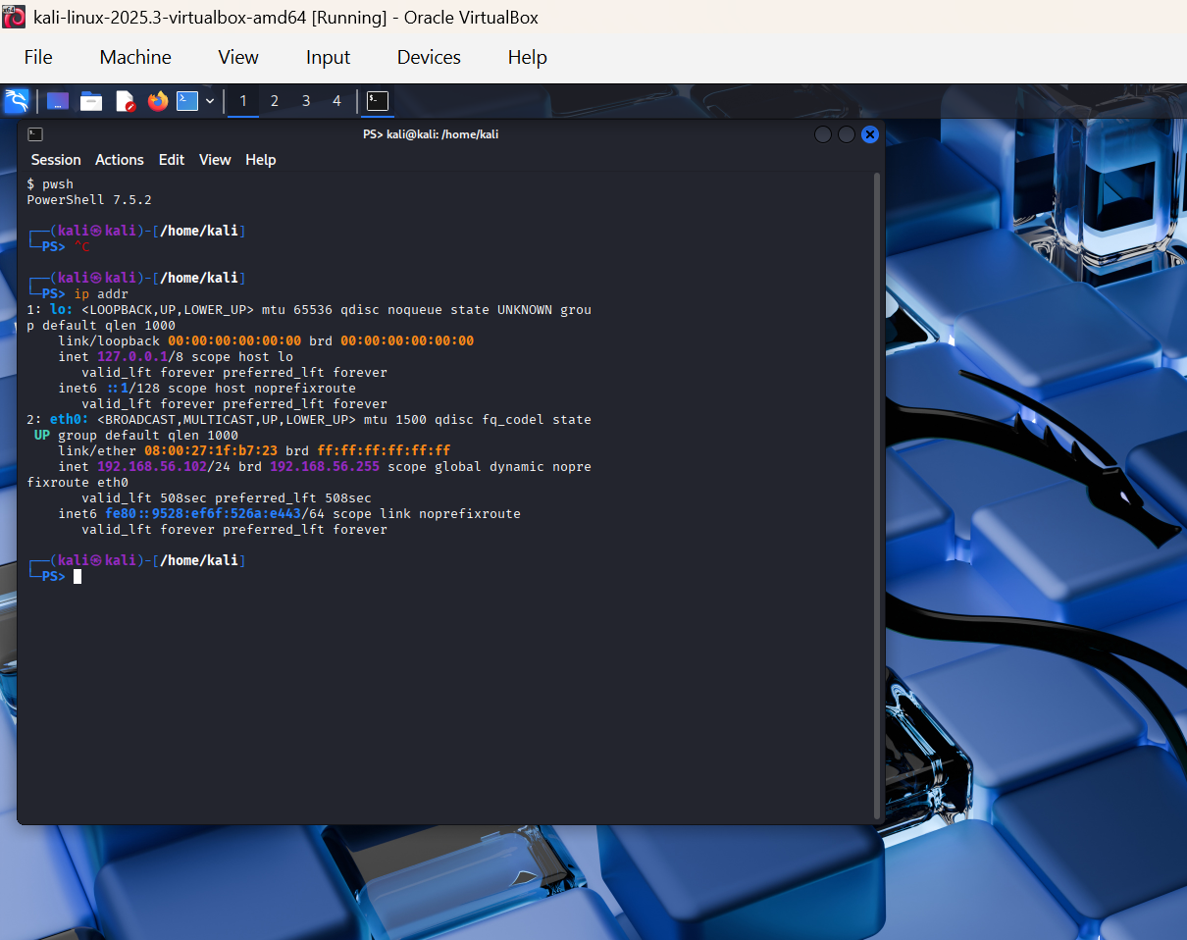
Figure 13: Kali Linux IP configuration on the isolated Host-only network

System | Role | Interface | IPv4 Address | Subnet
Kali Linux 2025.3 | SOC Analyst | eth0 | 192.168.56.102/24 | 192.168.56.0/24
Windows 10-Lab | Victim Endpoint | Ethernet | 192.168.56.101/24 | 192.168.56.0/24

- 7.6 Windows 10-Lab IP Configuration
The Windows 10-Lab victim endpoint was started and its network configuration was verified using the ipconfig command. The Ethernet interface was assigned the IPv4 address 192.168.56.101 with a subnet mask of 255.255.255.0 (/24). No default gateway was configured.
The Windows endpoint and Kali analyst workstation are therefore located on the same 192.168.56.0/24 Host-only network. The absence of a default gateway maintains the isolation of the laboratory network from external networks.
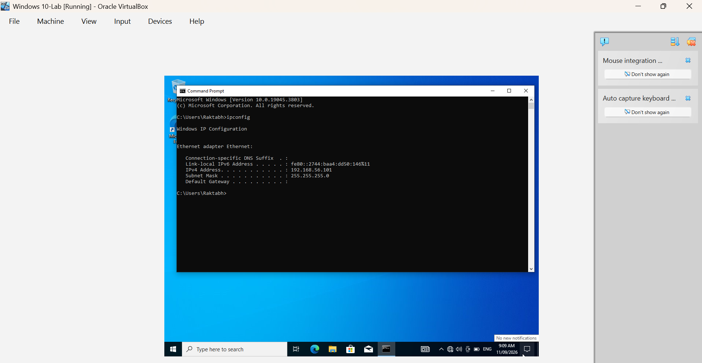
Figure 14: Windows 10-Lab IP configuration on the isolated Host-only network
- 7.7 Windows-to-Kali Connectivity Test
Connectivity between the Windows 10-Lab victim endpoint and the Kali Linux analyst workstation was tested using ICMP echo requests. From the Windows endpoint, the Kali Linux address 192.168.56.102 was successfully reached with 0% packet loss. This confirms that both virtual machines can communicate across the configured Host-only laboratory network.
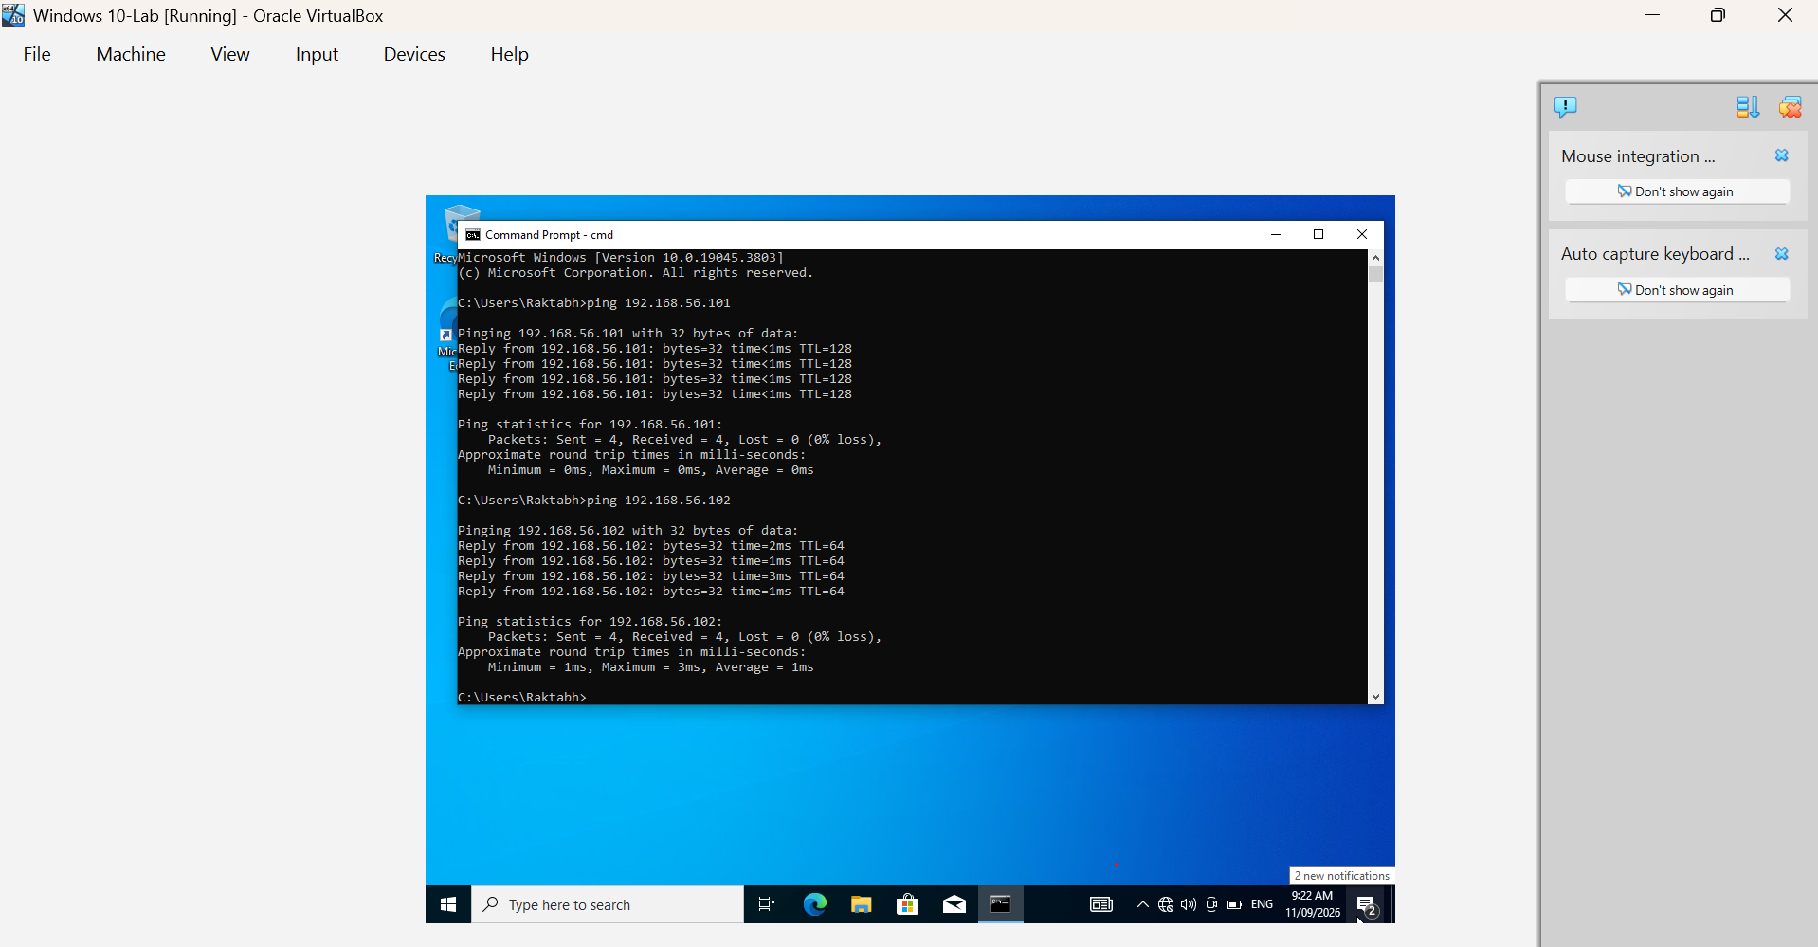
Figure 15: Successful ICMP connectivity test from Windows 10-Lab to Kali Linux

- 7.8 Kali-to-Windows Connectivity Test
A reverse connectivity test was performed from the Kali Linux analyst workstation to the Windows 10-Lab victim endpoint using ICMP. Kali Linux successfully reached the Windows endpoint at 192.168.56.101, with 4 packets transmitted, 4 packets received and 0% packet loss. This confirms bidirectional connectivity between the analyst and victim systems across the isolated Host-only laboratory network.
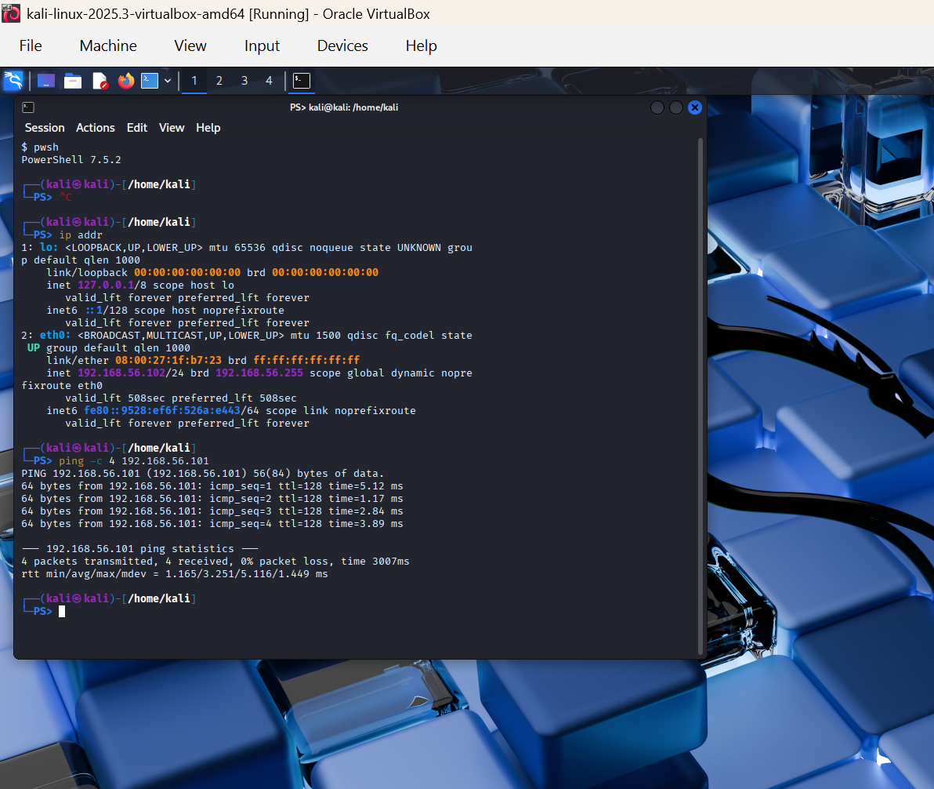
Figure 16: Successful ICMP connectivity test from Kali Linux to Windows 10-Lab

8. Investigation Methodology
The investigation will follow a standard SOC incident-handling process:
Phase 1 — Alert Triage
The analyst reviews the initial alert and determines its relevance and severity.
Phase 2 — Evidence Collection
Relevant Windows Event Logs, Sysmon events, PowerShell logs and network information are collected.
Phase 3 — Investigation
The analyst correlates authentication, process, PowerShell and network events to determine what occurred.
Phase 4 — IOC Identification
Potential Indicators of Compromise are documented, including:
- IP addresses
- Domains
- File names
- File hashes
- Processes
- User accounts
- Commands
- Registry locations
- Other suspicious artefacts
Phase 5 — Timeline Reconstruction
The analyst creates a chronological timeline of the incident.
Phase 6 — Impact Assessment
The analyst determines the potential scope and impact of the incident.
Phase 7 — Containment Recommendation
Appropriate containment actions are recommended based on the findings.
Phase 8 — Escalation
If the investigation confirms or strongly indicates malicious activity, the incident is escalated to the appropriate security team.
Phase 9 — Incident Documentation
The investigation findings are documented in a formal incident report.
- 8.1 Windows Hostname Baseline
The Windows 10-Lab endpoint was accessed using an elevated Administrator Command Prompt. The hostname command was executed to identify the system hostname. The endpoint was identified as DESKTOP-DBE0IR. This hostname will be used to identify the victim endpoint throughout the subsequent security investigation and event analysis. 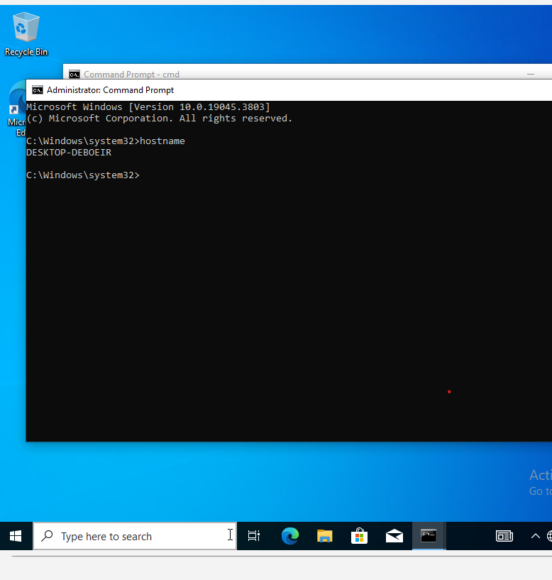
Figure 17: Windows 10-Lab hostname baseline
- 8.2 Windows User Account Baseline
The whoami command was executed from an elevated Administrator Command Prompt to identify the account currently associated with the Windows 10-Lab endpoint. The result confirms that the investigation is being performed using the configured local Windows user account. Establishing the active user account provides baseline context for subsequently analysing process creation, authentication activity and other security events generated during the investigation.
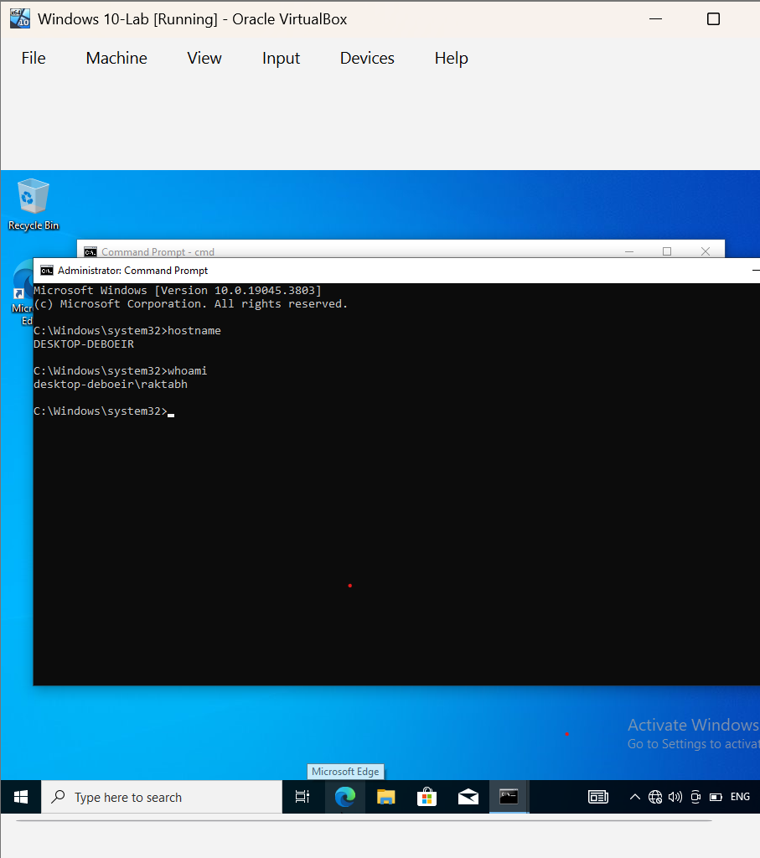

- 8.3 Windows System Information Baseline
The systeminfo command was executed to establish the operating-system and hardware baseline of the Windows 10-Lab endpoint. The system is running Microsoft Windows 10 Pro, build 19045, on an x64-based VirtualBox system. The virtual machine is allocated 6144 MB of physical memory. This baseline provides system context for subsequent endpoint monitoring, event collection and incident-response activities.
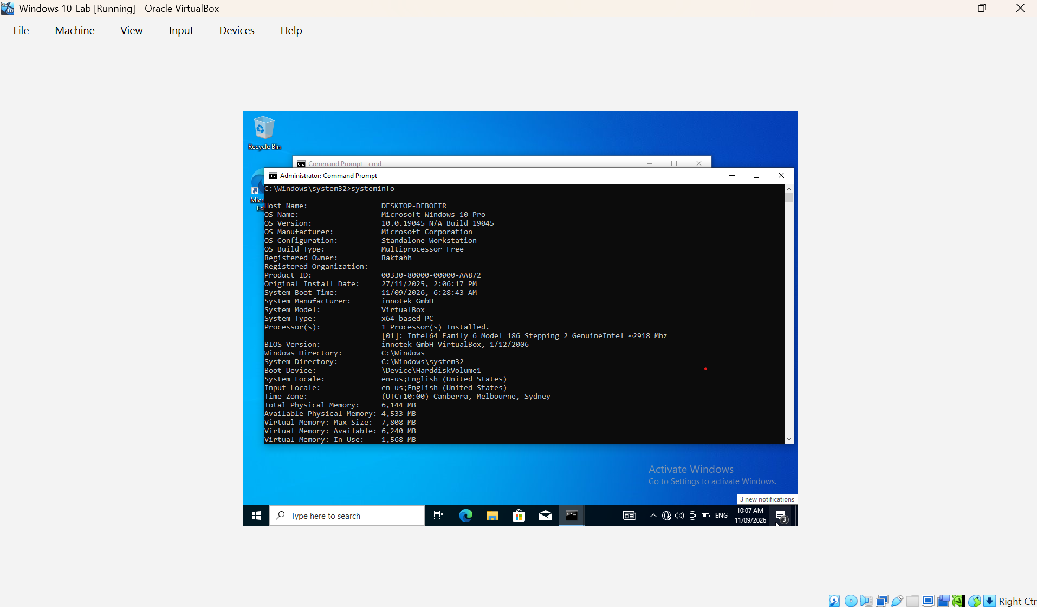
Figure 19: Windows 10-Lab system information baseline

- 8.4 Windows Core Event Log Verification
The Windows 10-Lab endpoint was verified to contain the three primary Windows Event Logs required for the SOC investigation: Application, Security, and System. These logs provide the baseline event sources required for monitoring system activity, authentication events, application activity, and security-related events during the incident investigation.
The following command was used to verify the availability of the core logs:
wevtutil el | findstr /i /x "Application Security System"
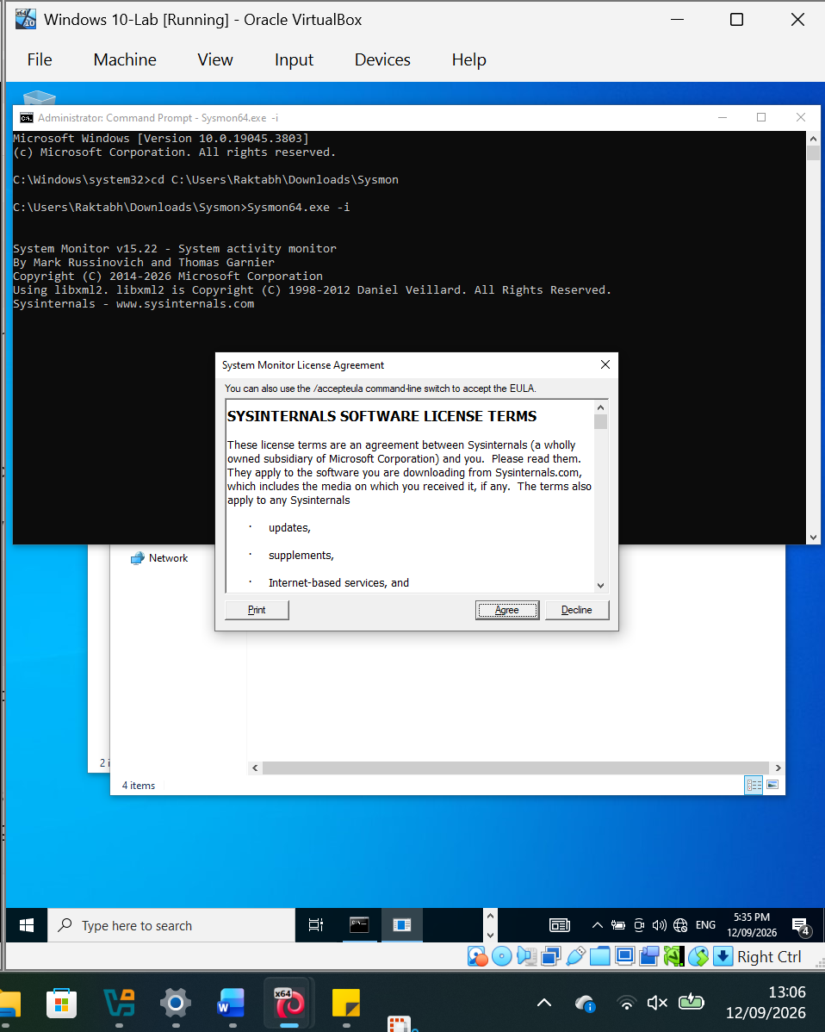
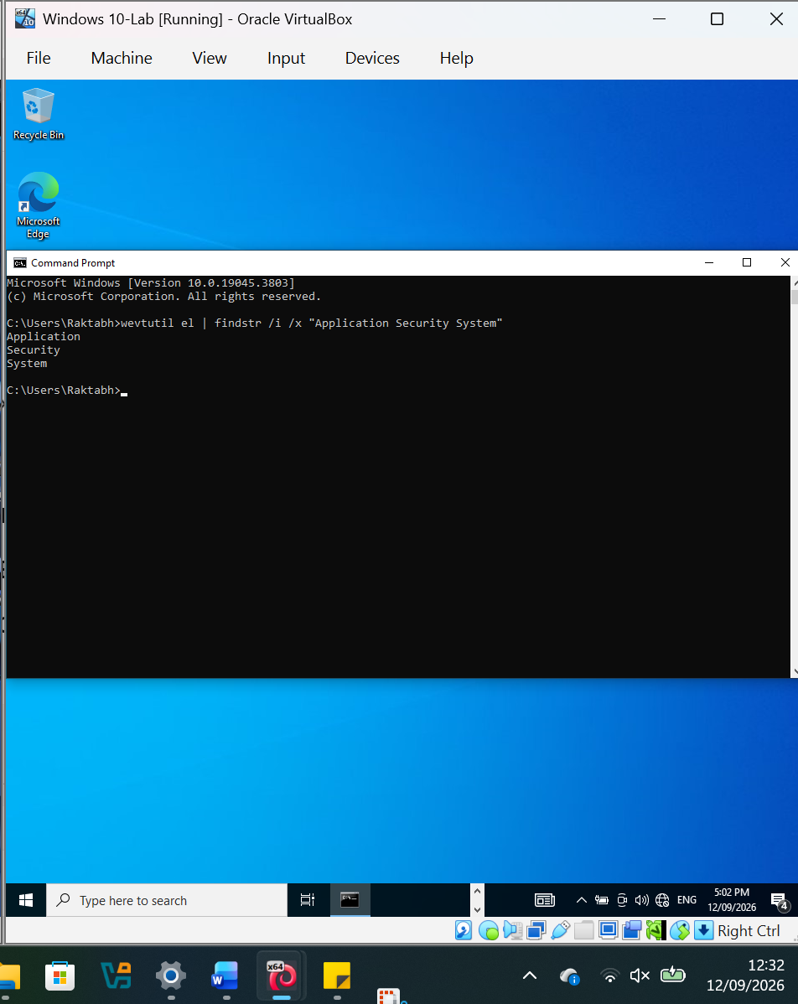

9. Expected Investigation Evidence
The laboratory will generate and analyse evidence from multiple sources.
Windows Event Logs
The investigation will examine relevant Windows security events, including:
- Successful logons
- Failed logons
- Process creation
- Account activity
- Privilege-related events
Sysmon
Sysmon will provide enhanced endpoint telemetry, including:
- Process creation
- Network connections
- File creation
- Process relationships
- Hash information
PowerShell Logs
PowerShell activity will be examined to identify potentially malicious commands and execution behaviour.
Network Evidence
Network traffic may be examined using Wireshark and other network-analysis tools.
- 9.1 Sysmon Installation
Microsoft Sysinternals System Monitor (Sysmon) version 15.22 was installed on the Windows 10-Lab endpoint to provide enhanced endpoint telemetry for the SOC investigation. Sysmon was installed using the 64-bit executable from an elevated Administrator Command Prompt.
The installation completed successfully. The installation output confirmed that the Sysmon64 executable and SysmonDrv driver were installed and started successfully.
Installation command:
cd C:\Users\Raktabh\Downloads\Sysmon
Sysmon64.exe -i
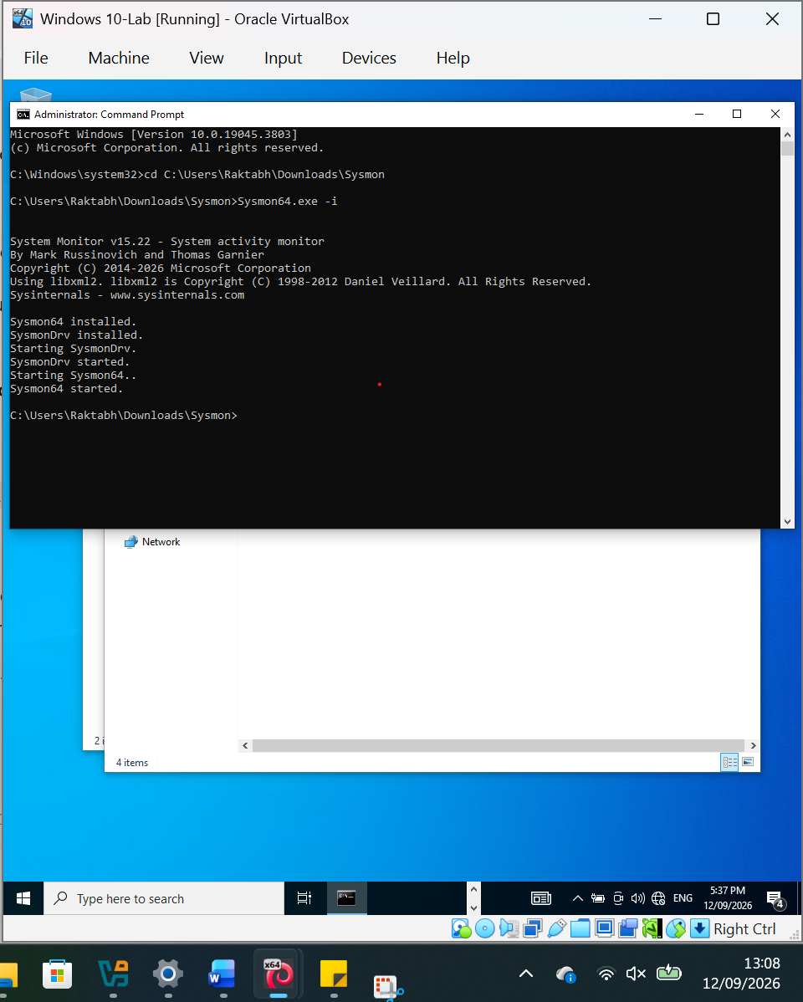

- 9.2 Sysmon Service Verification
Following installation, the Sysmon service was verified using the Windows Service Control utility. The service status confirmed that Sysmon64 was registered and in a RUNNING state, demonstrating that the endpoint telemetry service was operational.
Verification command:
sc query Sysmon64
The resulting service state was:
STATE: 4 RUNNING
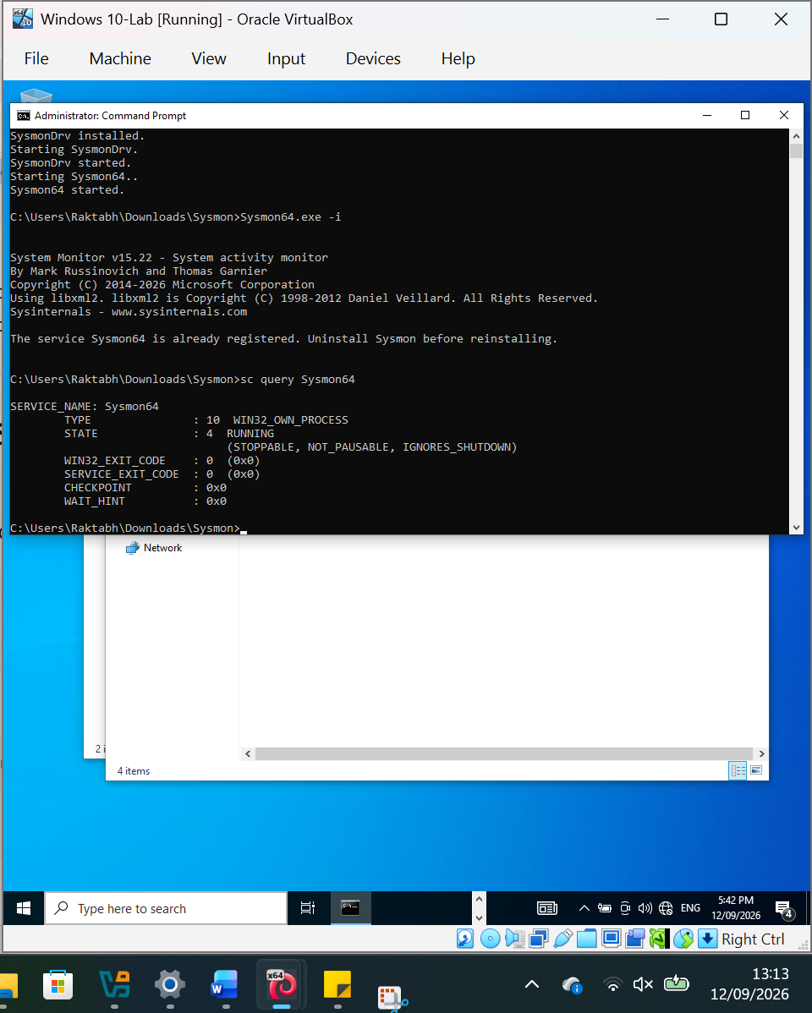

- 9.3 Sysmon Event Log Channel Verification
The Windows event log configuration was queried to verify the presence of the Sysmon operational event channel. The following command was executed:
wevtutil el | findstr /i "Sysmon"
The command returned:
Microsoft-Windows-Sysmon/Operational
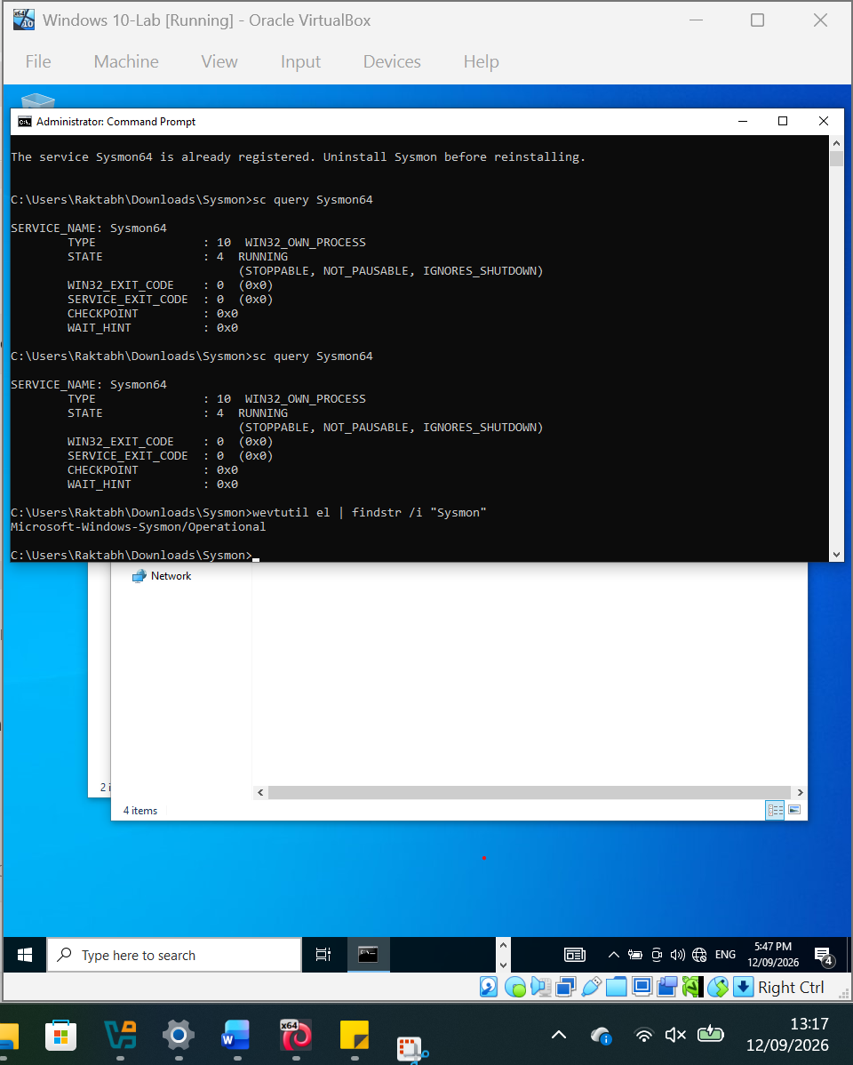

- 9.4 Sysmon Telemetry Verification
The Sysmon operational event channel was queried to confirm that endpoint telemetry was being actively generated. The following command was used to retrieve the five most recent events:
wevtutil qe "Microsoft-Windows-Sysmon/Operational" /c:5 /rd:true /f:text
The query successfully returned multiple Sysmon events. The captured telemetry included Event ID 5 (Process Terminated) events generated by the Windows endpoint. The events included timestamps, process identifiers, process GUIDs, executable image paths, user context, and computer information.
The observed events confirmed that Sysmon was actively collecting process-level telemetry on the Windows 10-Lab endpoint.
Evidence: Screenshot 26 – Sysmon Recent Events
Microsoft identifies Event ID 5 as the Sysmon Process Terminated event, while Event ID 1 records process creation with detailed process and command-line information.
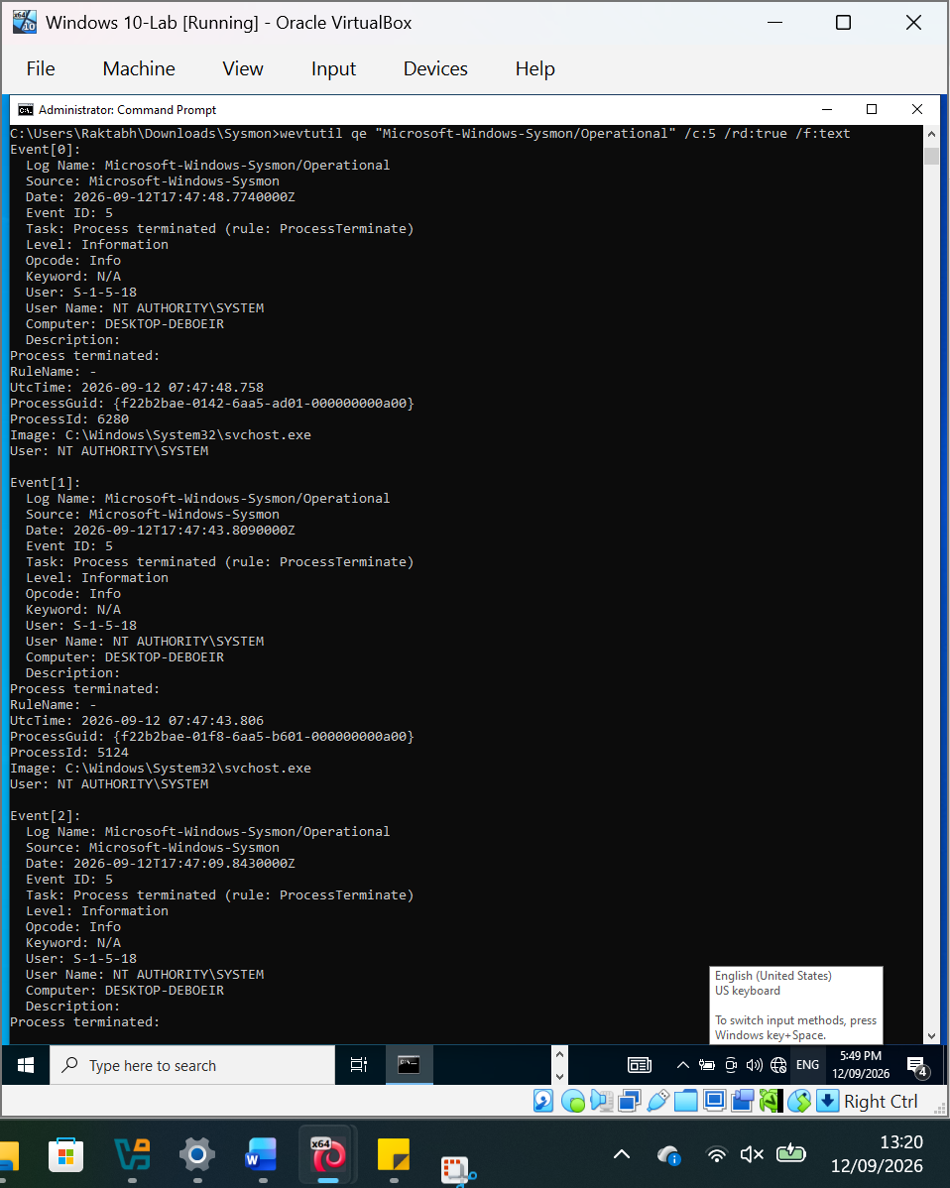

- 9.5 Sysmon Process Creation Telemetry Verification
Text:
Sysmon Event ID 1 (Process Create) telemetry was verified on the Windows 10-Lab endpoint. The query returned process creation events containing process identifiers, executable image paths, command-line information, parent process information, user context, integrity level and cryptographic hashes.
Example telemetry included smartscreen.exe launched with the command line C:\Windows\System32\smartscreen.exe -Embedding, with svchost.exe identified as the parent process. This confirms that Sysmon is capturing the process execution context required for SOC investigation and process-based incident analysis.
Command used:
wevtutil qe "Microsoft-Windows-Sysmon/Operational" /q:"*[System[(EventID=1)]]" /c:5 /rd:true /f:text
Result:
Sysmon Event ID 1 (Process C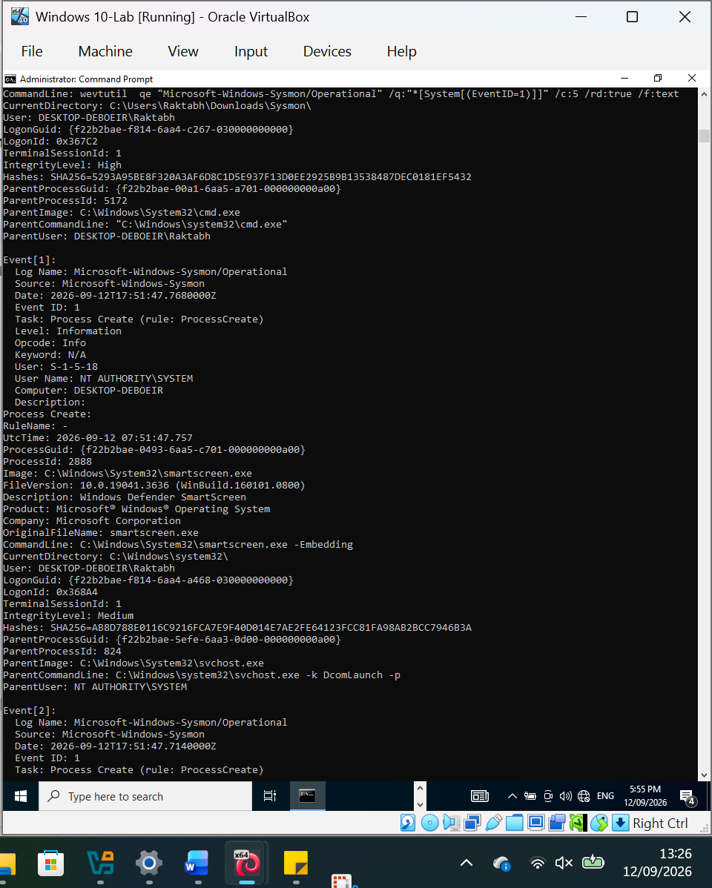reate) events successfully retrieved.

- 9.5 Network Telemetry Test
A controlled network connection was generated from the Windows 10-Lab endpoint to the Kali Linux analyst workstation using HTTP. The Windows endpoint successfully accessed the Kali-hosted Python HTTP server at 192.168.56.102:8000, returning HTTP Status Code 200 (OK). This confirmed that network connectivity between the laboratory endpoints was functioning correctly and provided controlled network activity for validating Sysmon network telemetry.
Command:
powershell -Command "Invoke-WebRequest http://192.168.56.102:8000 -UseBasicParsing"
Result: HTTP 200 OK
Evidence: Screenshot 28 – Windows-to-Kali HTTP Connection
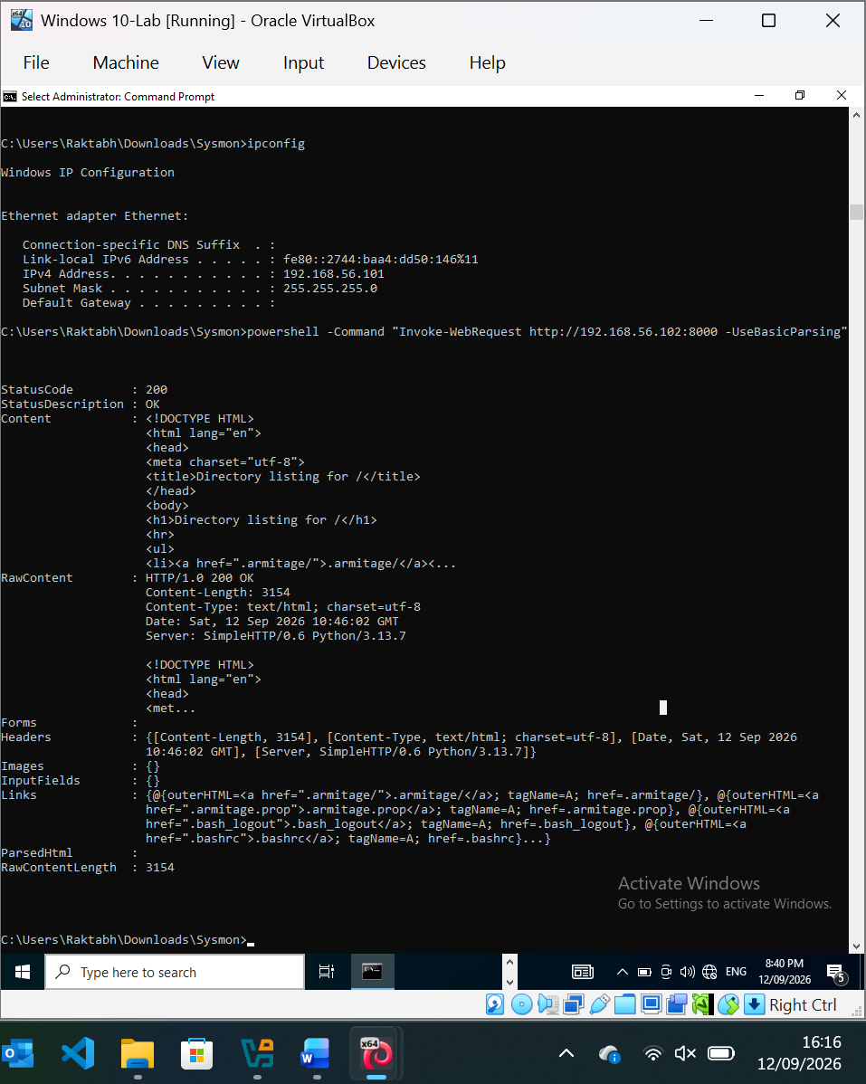
A controlled HTTP connection was generated from the Windows 10-Lab endpoint to the Kali Linux analyst workstation after enabling Sysmon network connection monitoring. The Windows endpoint successfully accessed the Kali-hosted Python HTTP server at 192.168.56.102:8000, returning HTTP Status Code 200 (OK). This confirmed that network connectivity was functioning correctly and generated controlled network activity for validating Sysmon Event ID 3 network connection telemetry.
Command:
powershell -Command "Invoke-WebRequest http://192.168.56.102:8000 -UseBasicParsing"
Result: HTTP 200 OK
Evidence: Screenshot 32 – Windows-to-Kali HTTP Connection (Sysmon Enabled)
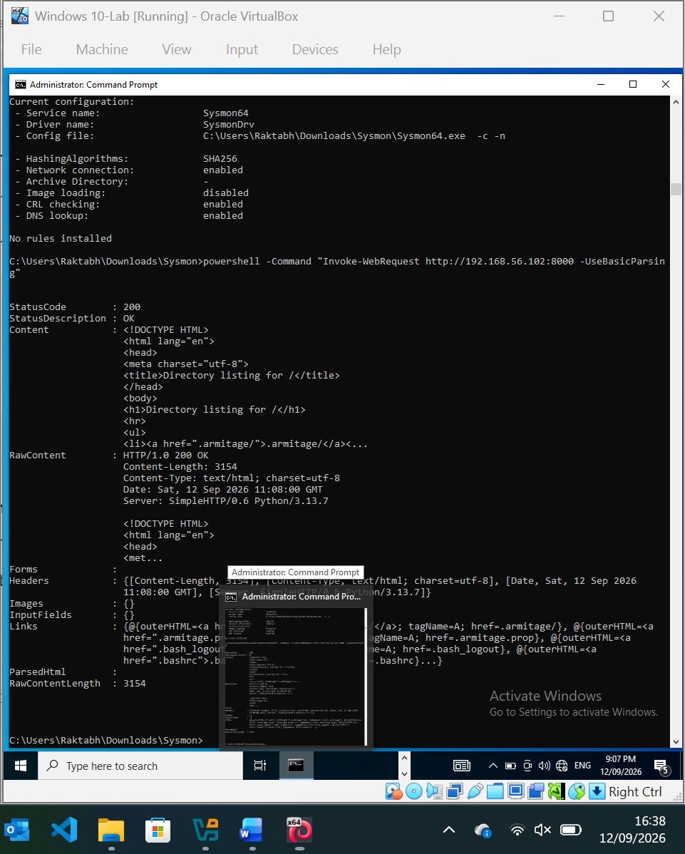
Sysmon Network Monitoring Enabled.png
Sysmon Custom Configuration Applied
A custom Sysmon configuration was successfully validated and applied to the Windows 10-Lab endpoint. The configuration enables telemetry for process creation, network connections, and file creation events using Sysmon Event Filtering. SHA256 hashing was also configured to support subsequent investigation and evidence correlation.
Sysmon Custom Configuration Successfully Applied
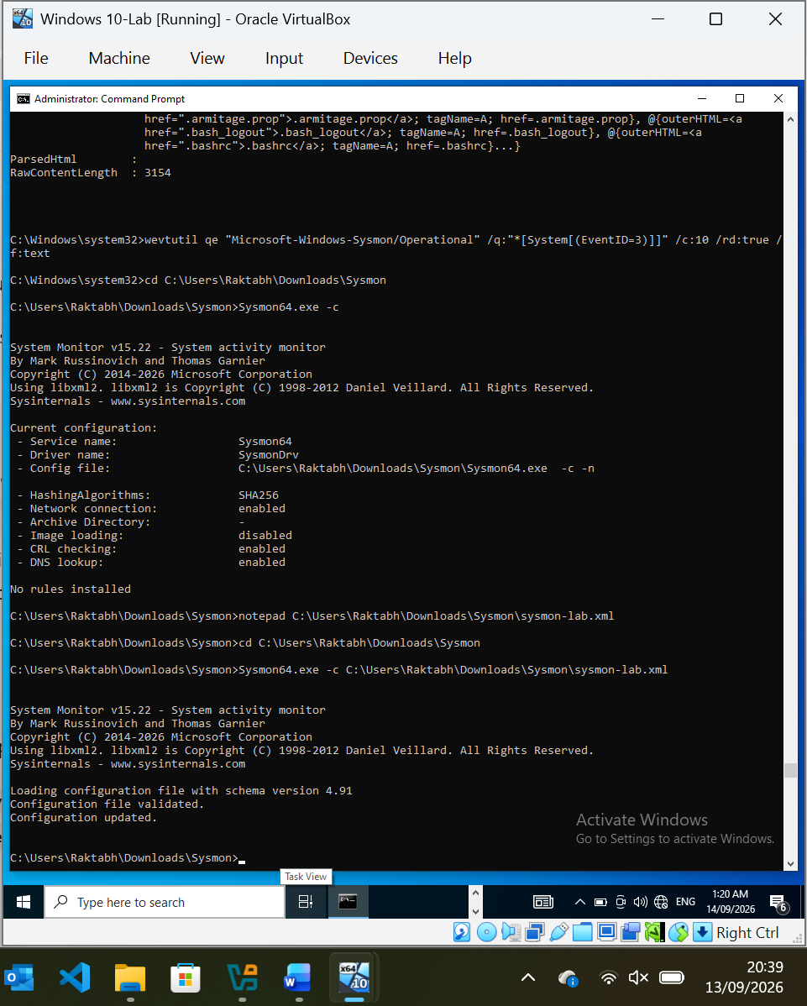
Sysmon-Lab-Configuration-Applied.png
Note:
Configuration File: sysmon-lab.xml
Schema Version: 4.91
ProcessCreate: Enabled
NetworkConnect: Enabled
FileCreate: Enabled
Hash Algorithm: SHA256
Configuration Status: Successfully Applied
Sysmon Configuration Persistence Verified
Following a restart of the Windows 10-Lab endpoint, the active Sysmon configuration was verified successfully. The configuration persisted across the reboot and showed network connection monitoring enabled, with ProcessCreate, NetworkConnect, and FileCreate event filtering rules installed. SHA256 hashing remained enabled. This confirms that the Sysmon telemetry configuration is active and persistent.
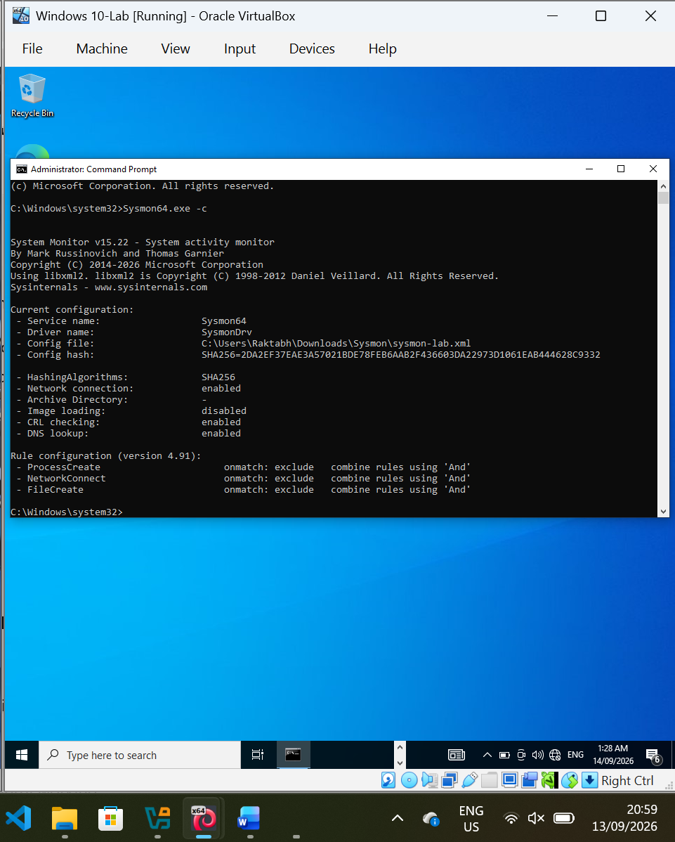
Sysmon-Active-Rules-Verified.png
Note:
Post-Reboot Verification: PASSED
Network Connection Monitoring: Enabled
ProcessCreate: Enabled
NetworkConnect: Enabled
FileCreate: Enabled
Hash Algorithm: SHA256
Rules Installed: Yes
Persistence Across Reboot: VERIFIED

10. Analyst Deliverables
At the conclusion of the investigation, the SOC L1 analyst will produce:
1. Incident Timeline
A chronological record of relevant events.
2. IOC List
A structured list of identified Indicators of Compromise.
3. Investigation Notes
Detailed evidence and analysis supporting the investigation.
4. Incident Classification
The incident will be classified based on the investigation findings.
Possible classifications include:
- False Positive
- Benign / Expected Activity
- Suspicious Activity
- Confirmed Security Incident
5. Incident Severity
The analyst will assign an appropriate severity based on:
- Evidence of compromise
- Affected endpoint
- User account involved
- Potential attacker access
- Data exposure
- Persistence
- Lateral movement
- Business impact
6. Recommended Actions
The report will contain recommended containment, eradication and recovery actions.
7. Final Incident Report
A professional SOC incident report will summarise the investigation, findings, evidence, IOCs, timeline, impact and recommended response.
- 10.1 PowerShell Script Block Logging
PowerShell Script Block Logging was enabled on the Windows 10-Lab endpoint to provide visibility into PowerShell commands and script content executed during the SOC investigation. This telemetry will support investigation of the simulated suspicious PowerShell activity.
Configuration command:
reg add "HKLM\SOFTWARE\Policies\Microsoft\Windows\PowerShell\ScriptBlockLogging" /v EnableScriptBlockLogging /t REG_DWORD /d 1 /f
Result: The operation completed successfully.
Evidence: Screenshot 35 – PowerShell Script Block Logging Enabled
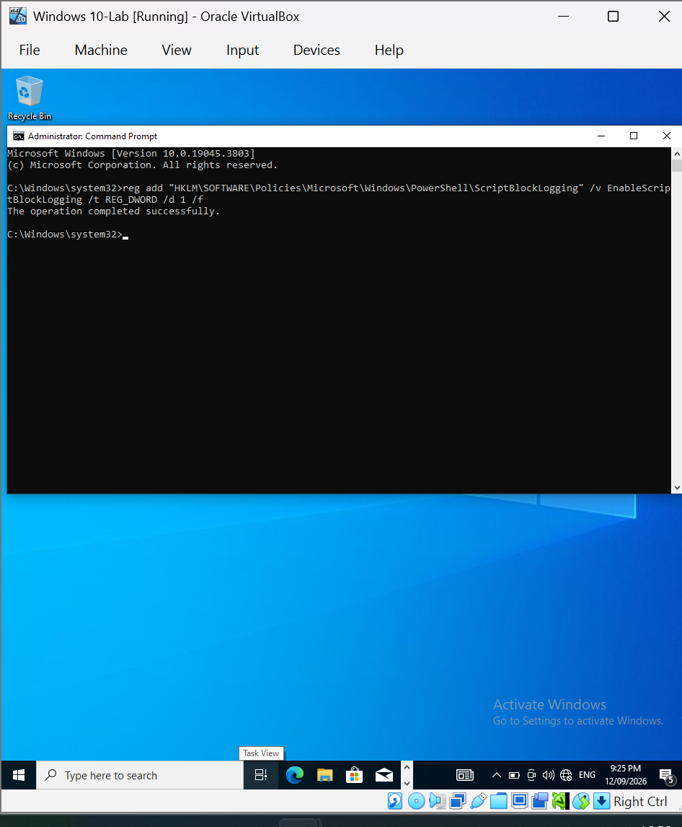
PowerShell ScriptBlock Logging Enabled.png
- 10.2 PowerShell Script Block Logging Verification, add:
PowerShell Script Block Logging was successfully validated through the Windows PowerShell Operational event log. Event ID 4104 was observed, confirming that PowerShell script block telemetry is being generated on the endpoint. The captured event included PowerShell script content and a ScriptBlock ID.
Verification command:
powershell -Command "Get-WinEvent -LogName 'Microsoft-Windows-PowerShell/Operational' -FilterXPath '*[System[(EventID=4104)]]' -MaxEvents 10 | Format-List TimeCreated,Id,Message"
Result: Event ID 4104 observed.
Evidence: Screenshot 37 – PowerShell Event 4104 Script Block
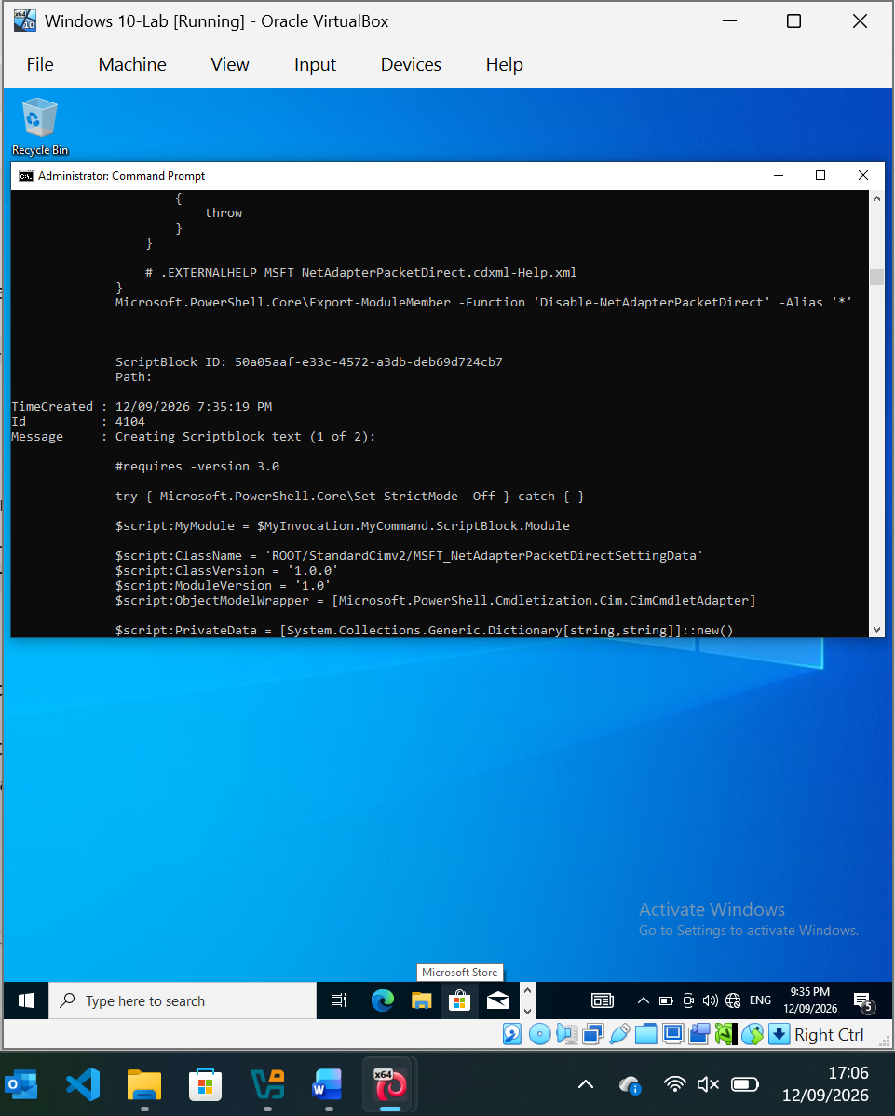
PowerShell Event 4104 ScriptBlock.png
A controlled PowerShell test command was executed to validate Script Block Logging. Windows generated PowerShell Event ID 4104 containing the exact test command Write-Output 'SOC-Lab-PowerShell-Test'. A unique ScriptBlock ID was also recorded, confirming that PowerShell script content can be captured and correlated during the SOC investigation.
Test command:
powershell -Command "Write-Output 'SOC-Lab-PowerShell-Test'"
Observed event:
Event ID: 4104
ScriptBlock: Write-Output 'SOC-Lab-PowerShell-Test'
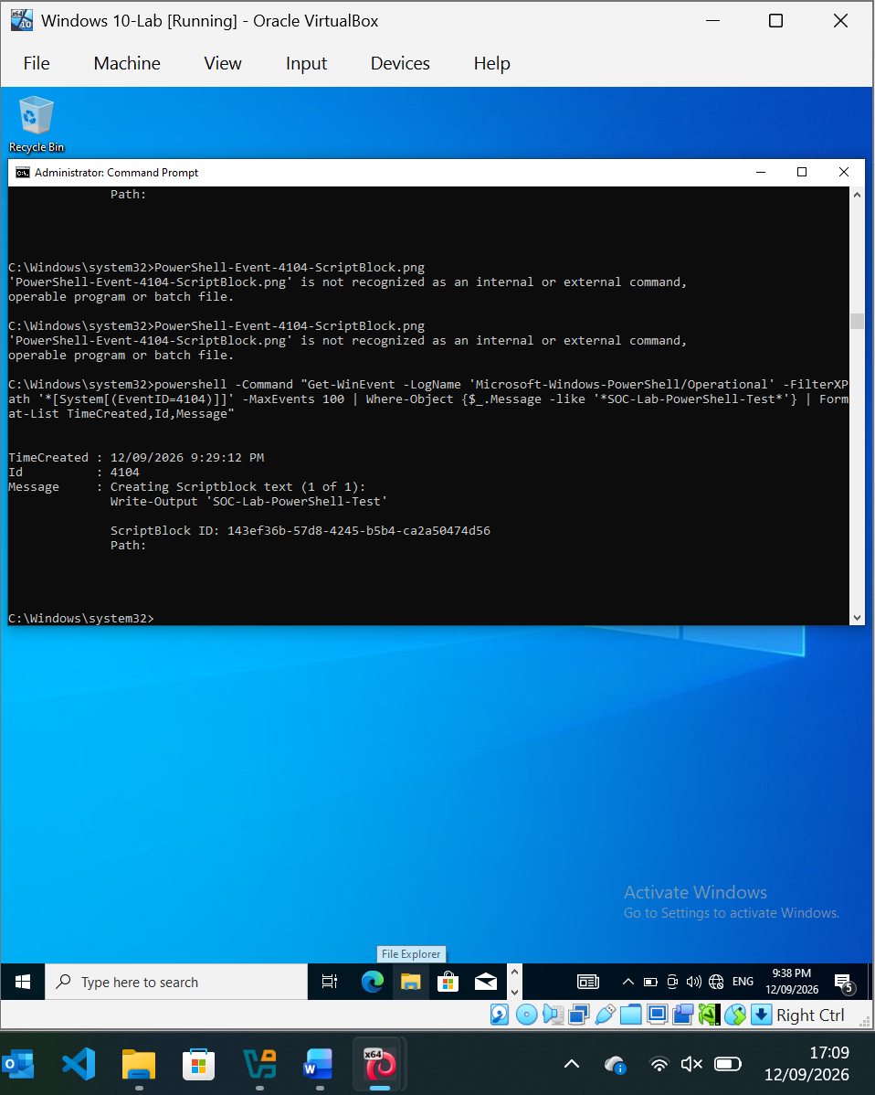
PowerShell Test Event 4104.png

11. Lab Architecture
The investigation will be conducted within an isolated virtual environment.
Analyst Machine
Operating System: Kali Linux
The analyst machine will be used for:
- Network analysis
- Investigation
- Reconnaissance
- Log analysis
- Evidence analysis
Victim Machine
Operating System: Windows 10/11
The Windows machine will represent the compromised employee workstation.
It will generate:
- Windows Security Events
- Sysmon Events
- PowerShell Events
- Process Activity
- Network Activity
The virtual machines will communicate through an isolated laboratory network.

- The Windows audit policy for the Logon subcategory was checked before configuring the authentication monitoring stage. The endpoint was already configured to audit both successful and failed logon events. No additional audit policy modification was required.
Command:
auditpol /get /subcategory:"Logon"
Result:
Logon Success and Failure

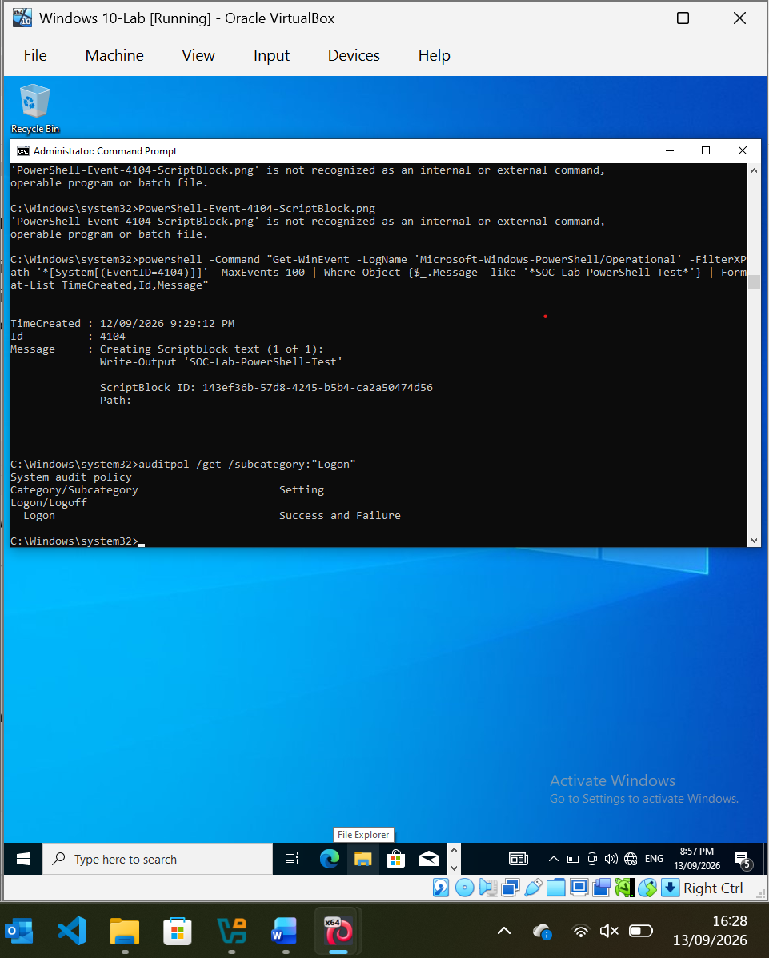
Windows Logon Audit Policy Baseline.png

11.2 Windows Authentication Event Verification :
The Windows Security event log was queried for successful and failed authentication events. The endpoint returned Event ID 4624 records, confirming that successful logon events are being captured by Windows Security Auditing. No Event ID 4625 failed-logon events were observed in the returned baseline events. Controlled failed authentication activity will be generated during the incident simulation.

Command:
wevtutil qe Security /q:"*[System[(EventID=4624 or EventID=4625)]]" /c:10 /rd:true /f:text
Observed: Event ID 4624 – Successful logon

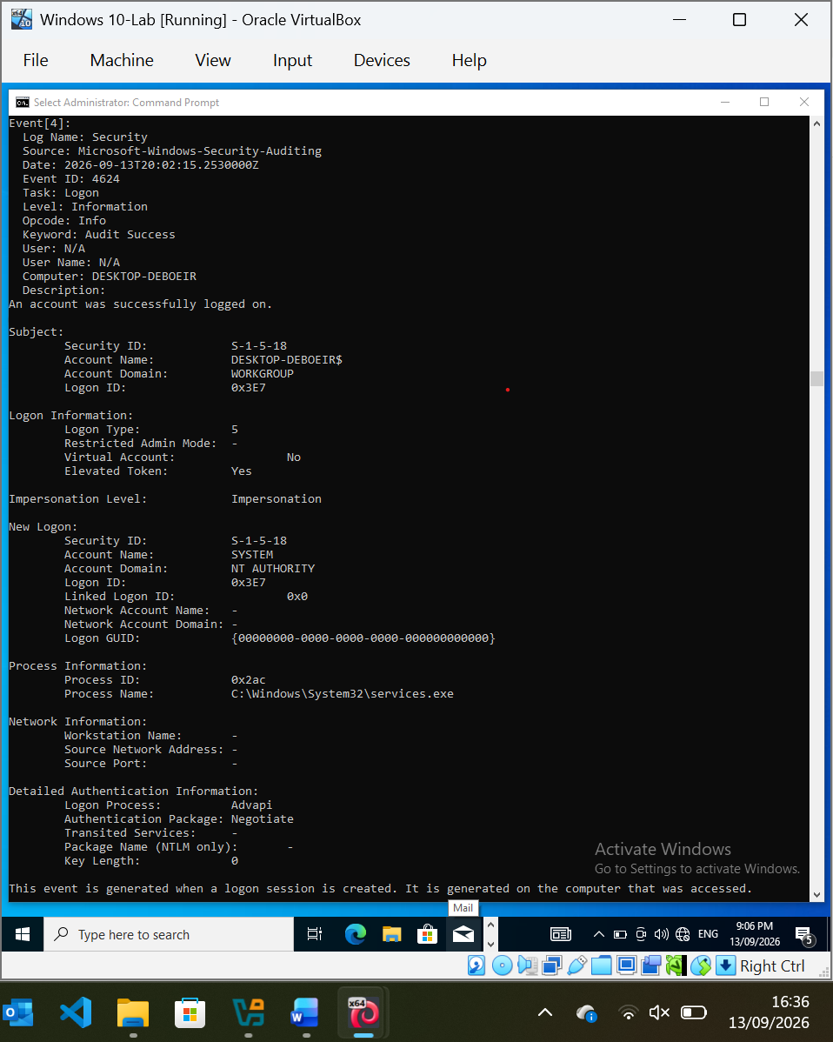
Windows Authentication Events Baseline.png
Note:
The initial controlled runas authentication test did not generate Windows Security Event ID 4625. The test was therefore not used as the failed-logon evidence for the incident simulation.
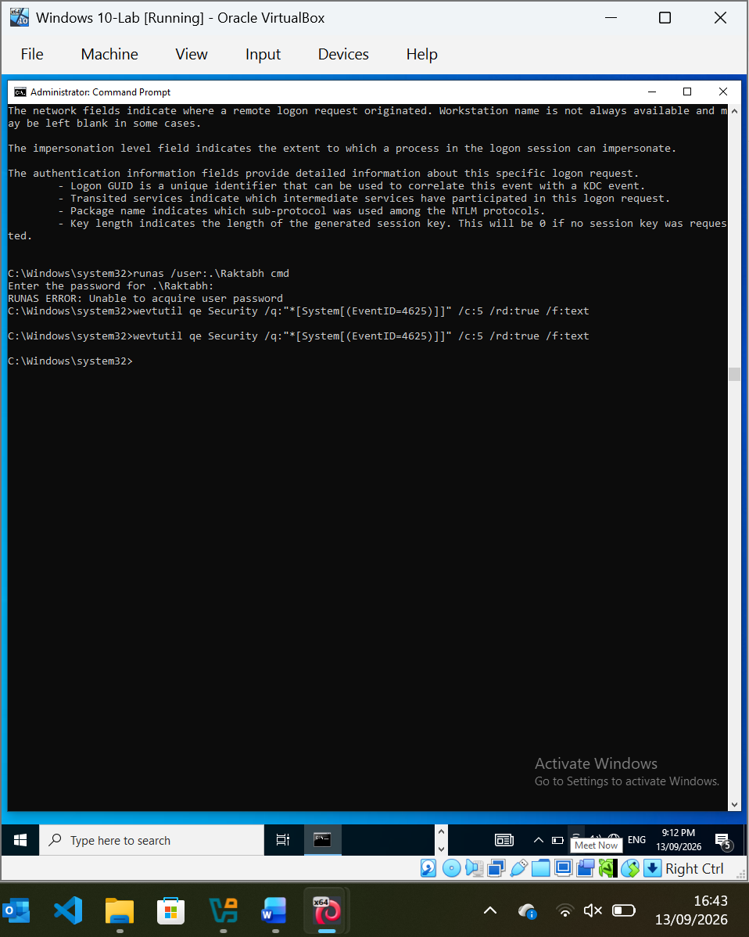
Failed Logon Test-No 4625.png
11.2 Windows Authentication Event Verification, add:
A controlled failed authentication attempt was generated against the Windows 10-Lab endpoint using an intentionally incorrect password. Windows Security Auditing recorded Event ID 4625, confirming that failed authentication activity is being captured successfully. The event identified the affected account as Raktabh, with Logon Type 3 and the failure reason recorded as an unknown username or incorrect password. The event used NTLM authentication and recorded the source network address as 192.168.56.101.
Observed Event:
Event ID: 4625
Account Name: Raktabh
Logon Type: 3
Failure Reason: Unknown user name or bad password
Status: 0xC000006D
Sub Status: 0xC000006A
Source Network Address: 192.168.56.101
Authentication Package: NTLM

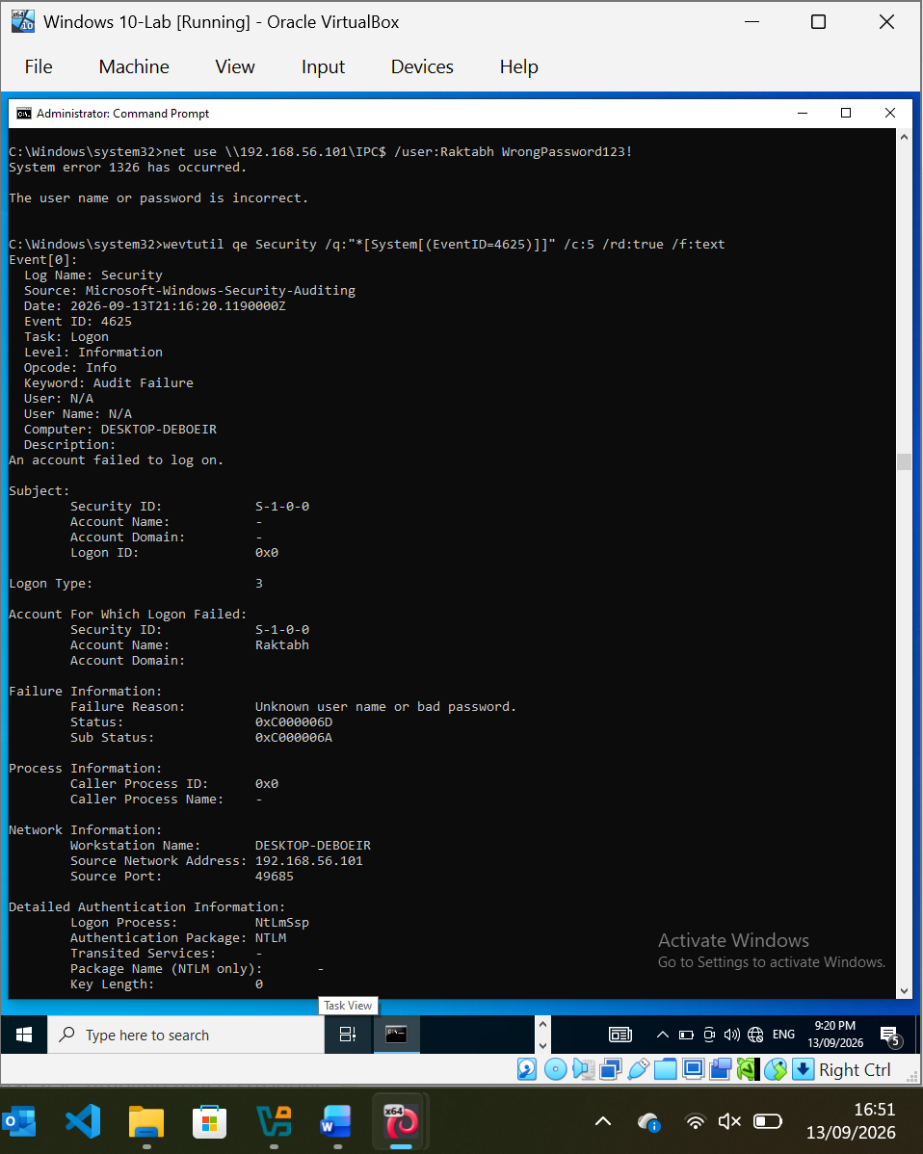
Windows_Failed_Logon_Event_4625.png

NOTE
Record:
Failed authentication telemetry: VERIFIED
Event ID: 4625
Logon Type: 3
Account: Raktabh
Authentication: NTLM

11.3 Controlled Successful Authentication Test, add:
A controlled successful authentication was performed against the Windows 10-Lab endpoint using the local Raktabh account. The SMB IPC$ connection completed successfully, confirming that successful network authentication can be generated and subsequently captured by Windows Security Auditing.
Command:
net use \\192.168.56.101\IPC$ /user:Raktabh *
Result:
The command completed successfully.
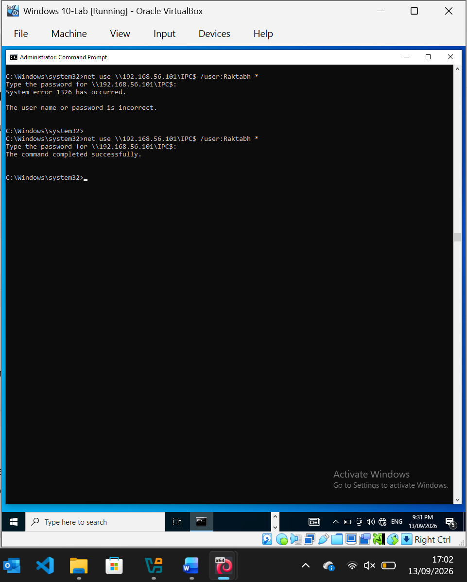
Controlled-Successful-Logon-Test.png
Successful authentication
- Event ID: 4624
- Account: Raktabh
- Logon Type: 3 (Network)
- Source IP: 192.168.56.101
- Authentication Package: NTLM
- Result: Successful
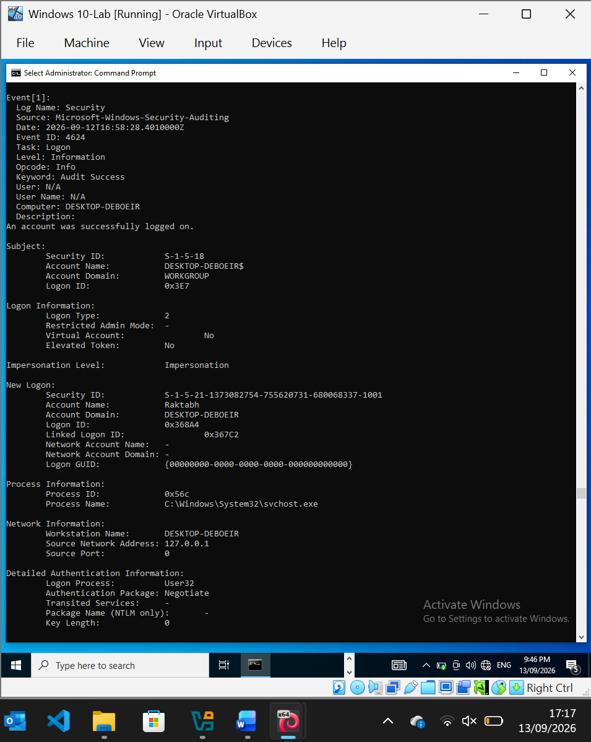
Windows-Successful-Logon-Event-4624.png

NOTE
Record:
Event ID: 4104
Log: Microsoft-Windows-PowerShell/Operational
User: DESKTOP-DBE0EIR\Raktabh
Test activity: SOC-Lab-PowerShell-Test
Result: Successfully captured by Script Block Logging
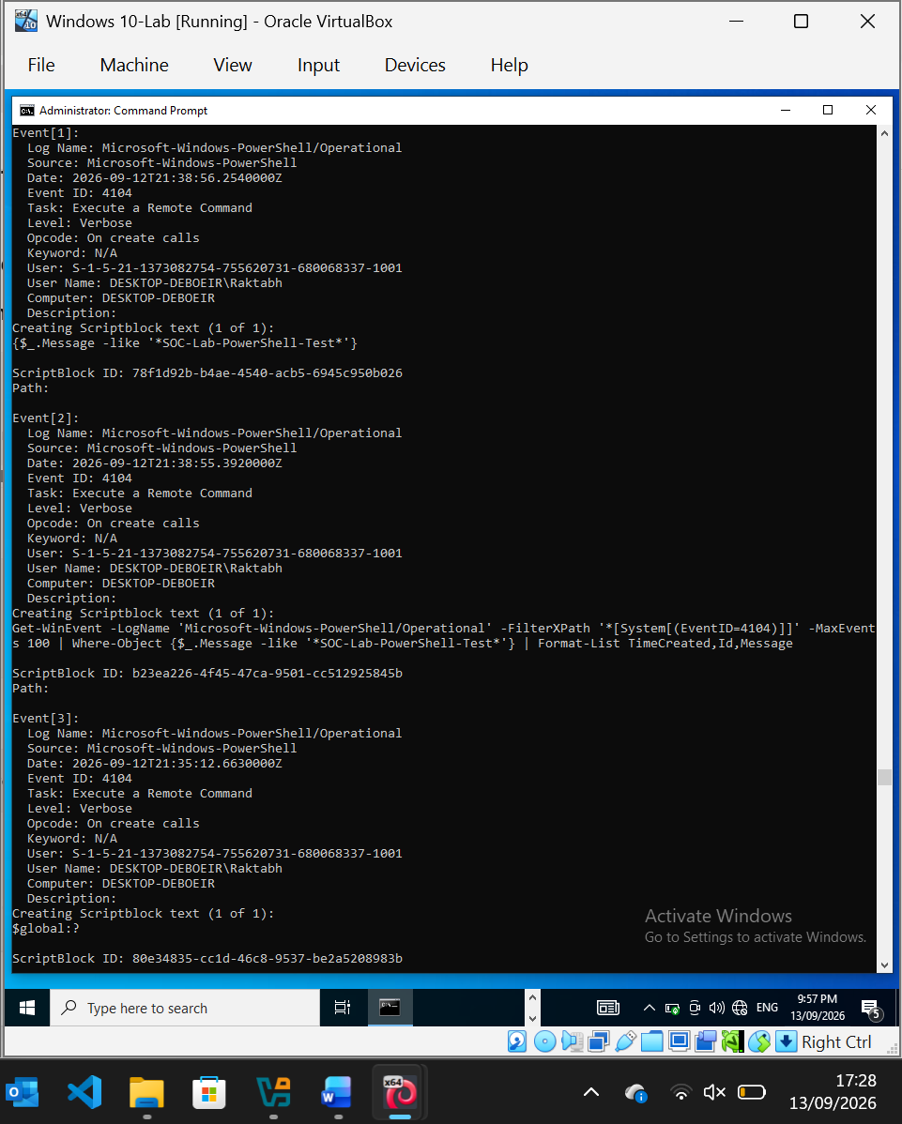
PowerShell-ScriptBlock-Event-4104.png

Under your PowerShell Logging section, add:
PowerShell Script Block Logging Verification
PowerShell Script Block Logging was enabled on the Windows 10-Lab endpoint and verified using Event ID 4104. A controlled PowerShell test generated a Script Block event containing the test activity, confirming that PowerShell execution content can be captured for SOC investigation and forensic analysis.
Incident Simulation / Suspicious PowerShell Activity section:
Controlled PowerShell Activity Simulation
A controlled PowerShell activity was generated on the Windows 10-Lab endpoint to simulate suspicious PowerShell execution within the SOC investigation scenario. The activity was intentionally benign and consisted of a test output statement and process enumeration using Get-Process. The activity was designed to generate observable PowerShell telemetry without executing malicious code.

NOTE
Record:
Activity: Controlled PowerShell simulation
Command: Write-Output + Get-Process
Purpose: Generate benign PowerShell telemetry for SOC investigation
Result: Successfully executed
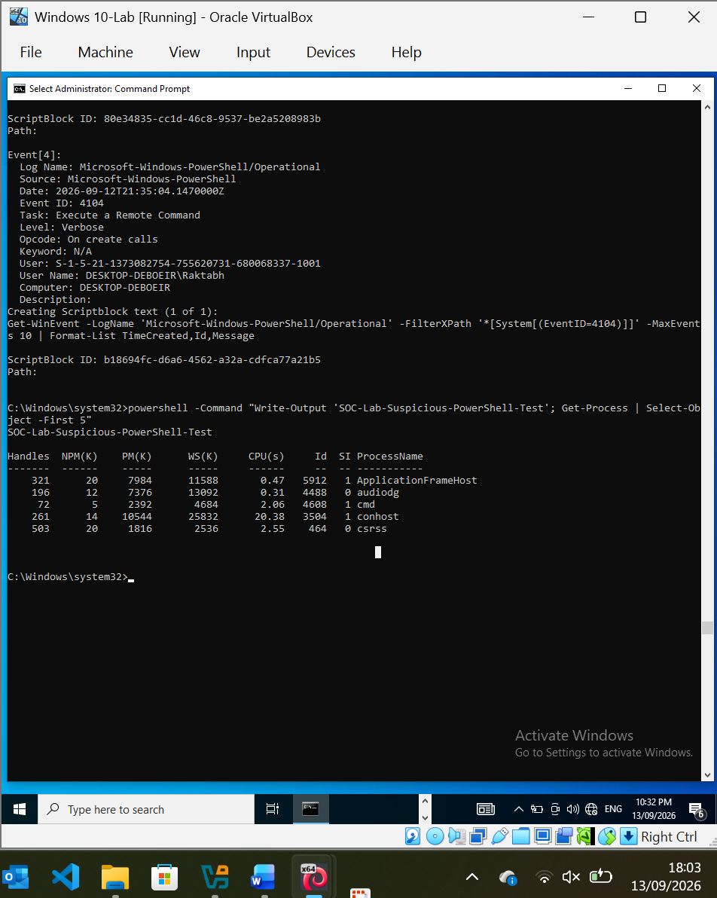
Simulated-PowerShell-Activity.png

12. Security Objective
The purpose of this laboratory is to demonstrate practical SOC L1 capabilities rather than simply demonstrating individual security tools.
The project will demonstrate the ability to:
- Monitor security events
- Perform alert triage
- Analyse Windows logs
- Investigate authentication activity
- Analyse PowerShell execution
- Investigate process activity
- Analyse network connections
- Identify IOCs
- Correlate multiple sources of evidence
- Reconstruct an incident timeline
- Assess incident severity
- Recommend containment
- Escalate incidents appropriately
- Produce professional incident documentation

- 12.1 Incident Simulation – Failed Authentication Activity
Paste:
Controlled Failed Authentication from Analyst Workstation
A controlled failed authentication attempt was initiated from the Kali analyst workstation against the Windows 10-Lab endpoint using an intentionally incorrect password. The Windows Security log recorded Event ID 4625, confirming that the failed network authentication originated from the Kali workstation at IP address 192.168.56.102. The attempted account was Raktabh, with Logon Type 3 indicating a network logon attempt. The authentication failure was attributed to an unknown username or incorrect password and was processed using NTLM authentication.
NOTE:
Incident Evidence
Source IP: 192.168.56.102
Source Host: KALI
Target Host: DESKTOP-DBE0EIR
Account: Raktabh
Event ID: 4625
Logon Type: 3 – Network
Authentication: NTLM
Result: Failed authentication
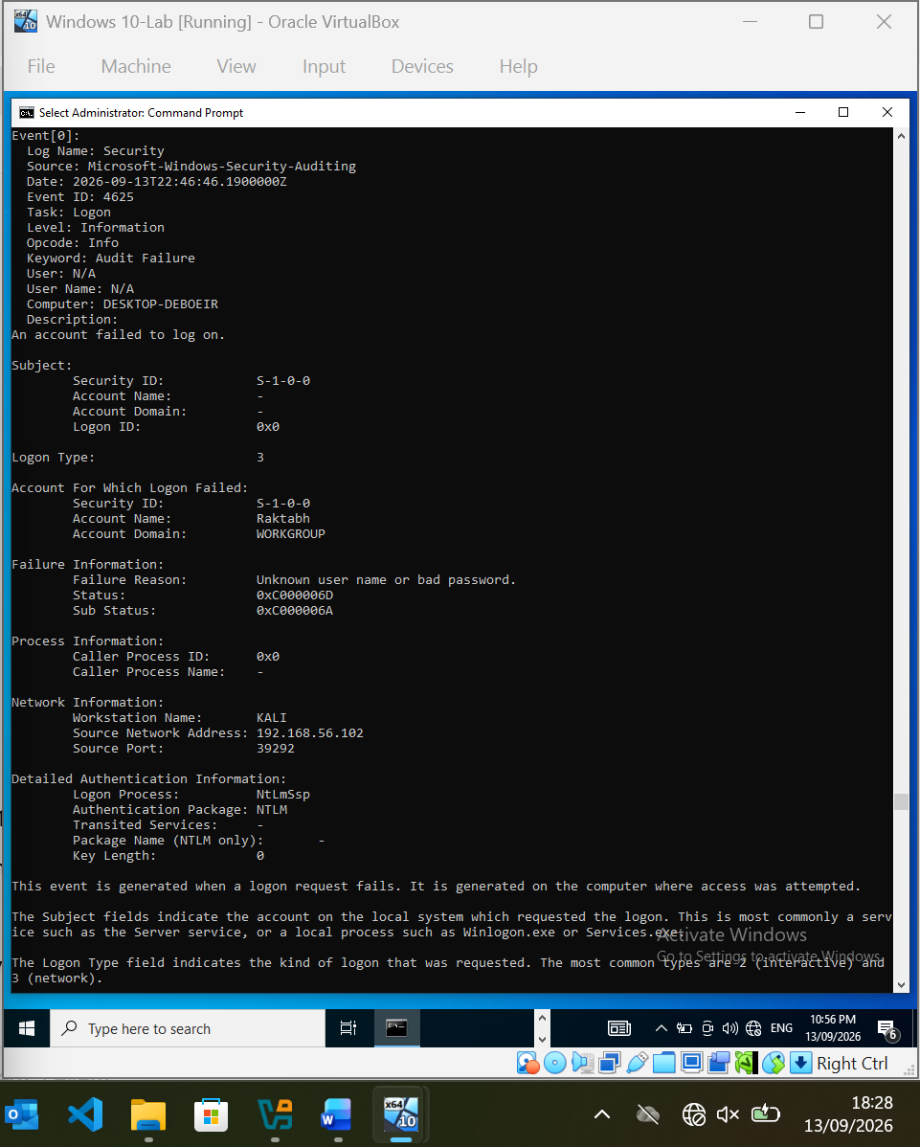
Kali-to-Windows-Failed-Logon-4625.png

12.2 Successful Authentication Following Failed Attempt:
Controlled Successful Authentication from Analyst Workstation
Following the controlled failed authentication activity, a successful network authentication was performed from the Kali analyst workstation to the Windows 10-Lab endpoint using the valid credentials for the Raktabh account. Windows Security Auditing recorded Event ID 4624, confirming a successful network logon. The event identified KALI as the originating workstation with source IP address 192.168.56.102. The authentication used Logon Type 3 and the NTLM authentication package. The successful authentication following the preceding failed attempt provides a controlled example of an authentication sequence requiring further investigation by a SOC analyst.
Successful Authentication Following Failed Attempt.png

Kali-to-Windows Successful Logon Event 4624
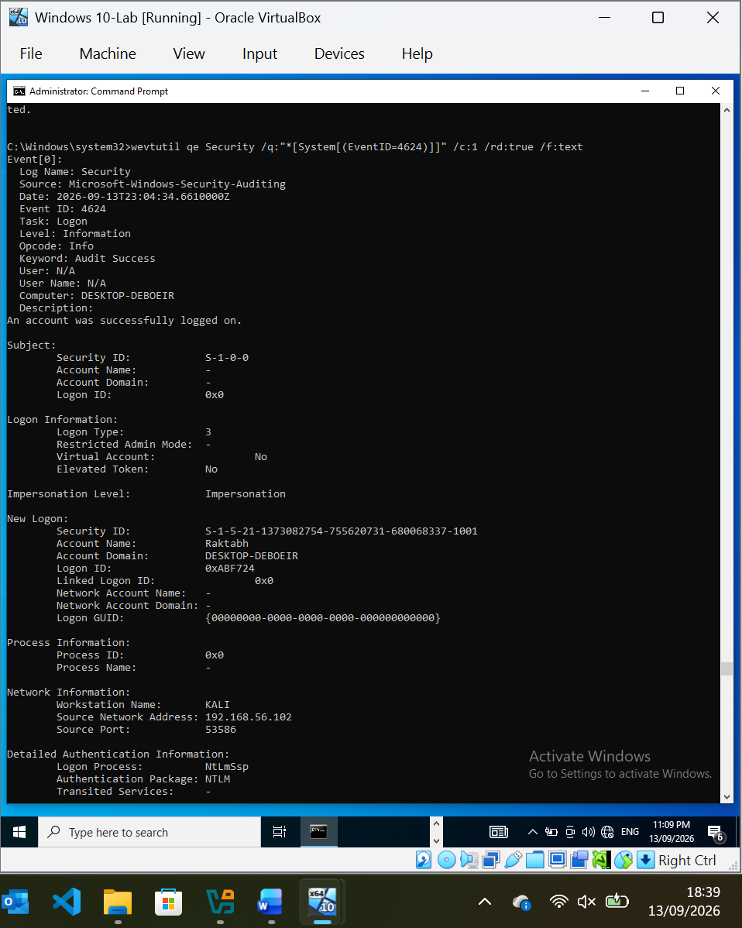
Kali-to-Windows-Successful-Logon-Event-4624.png
Incident Evidence
Source Host: KALI
Source IP: 192.168.56.102
Target Host: DESKTOP-DBE0EIR
Account: Raktabh
Event ID: 4624
Logon Type: 3 – Network
Authentication: NTLM
Result: Successful authentication
12.3 Suspicious PowerShell Activity
Controlled PowerShell Execution
Following the successful authentication activity, a controlled PowerShell command was executed on the Windows 10-Lab endpoint using powershell.exe with the -NoProfile and -ExecutionPolicy Bypass parameters. The command itself was benign and produced a controlled test output. PowerShell Script Block Logging successfully recorded the activity as Event ID 4104, providing visibility into the executed script content. This demonstrates how a SOC analyst can use PowerShell logging to investigate potentially suspicious command execution following an authentication event.
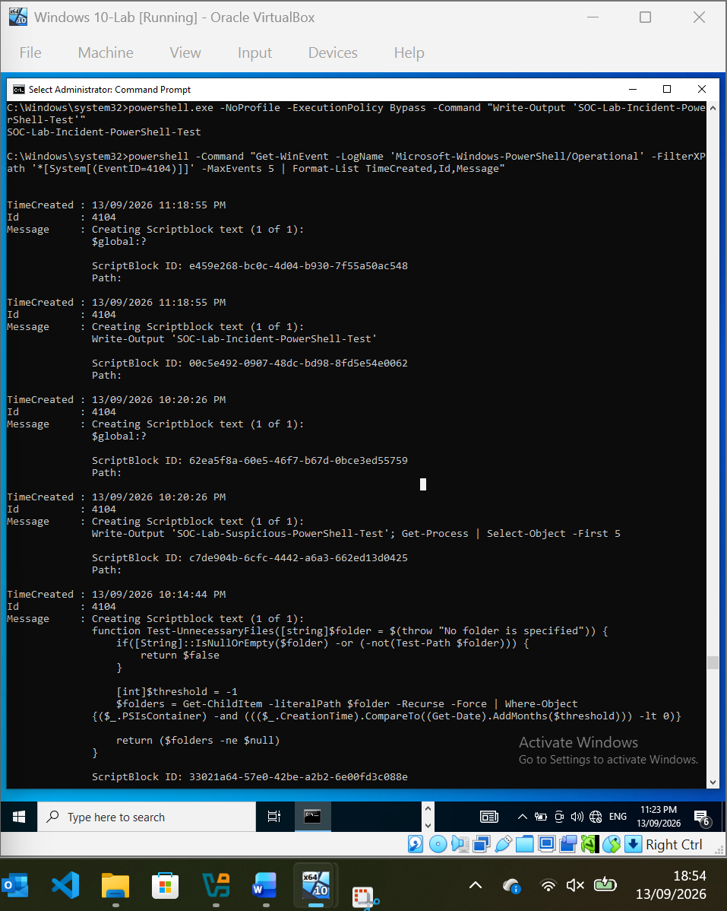
PowerShell-Script-Block-Event-4104.png
Incident Evidence
Event ID: 4104
Timestamp: 13/09/2026 11:18:55 PM
Activity: PowerShell Script Block
Command: Write-Output 'SOC-Lab-Incident-PowerShell-Test'
Logging Status: VERIFIED
Script Block ID: 00c5e492-0907-48dc-bd98-8fd5e54e0062
12.4 PowerShell Process Creation – Sysmon Event ID 1
Paste:
Sysmon Process Creation Evidence
Sysmon recorded the creation of the PowerShell process as Event ID 1 (Process Create). The event identified powershell.exe as the executed process and captured the complete command line, including the -NoProfile and -ExecutionPolicy Bypass parameters used during the controlled test. The process was executed under the DESKTOP-DBE0EIR\Raktabh account with a High integrity level. Sysmon also recorded the parent process as cmd.exe, allowing the process execution chain to be reconstructed. This telemetry provides additional context for correlating the PowerShell Script Block Logging event with the underlying process execution.
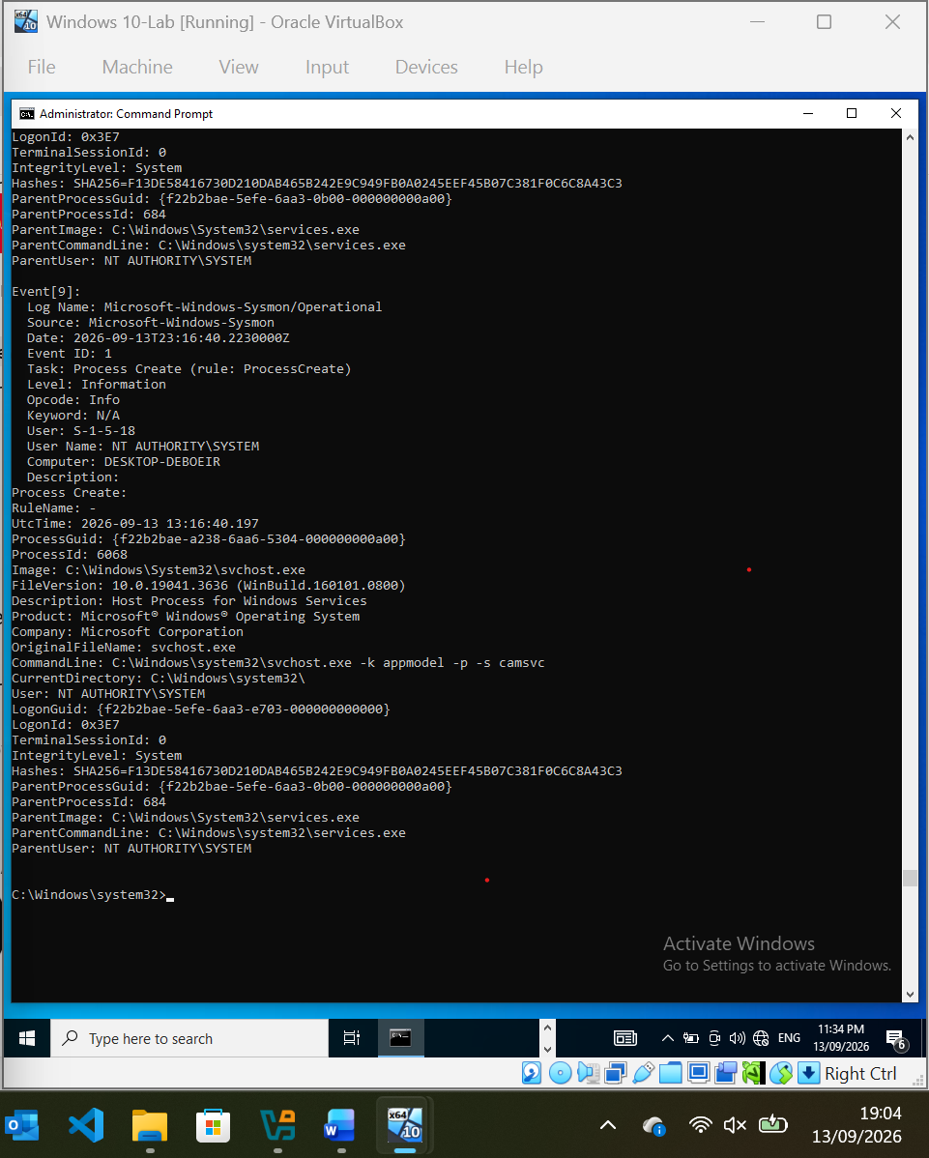
Sysmon-PowerShell-Process-Creation-Event-ID-1.png
Process Evidence
Event ID: 1 – Process Create
Process: powershell.exe
Process ID: 5608
User: DESKTOP-DBE0EIR\Raktabh
Integrity Level: High
Parent Process: cmd.exe
Parent Process ID: 4608
Command Line: powershell.exe -NoProfile -ExecutionPolicy Bypass -Command "Write-Output 'SOC-Lab-Incident-PowerShell-Test'"
SHA256: Captured by Sysmon
Result: Process creation telemetry VERIFIED
12.5 Controlled Network Activity
Controlled Network Listener
A Python HTTP server was started on the Kali analyst workstation and bound to the isolated lab interface at 192.168.56.102 on TCP port 8000. The listener was used to generate controlled network traffic between the Kali analyst workstation and the Windows 10-Lab endpoint. This activity was performed within the isolated Host-only lab network for the purpose of validating network telemetry and investigating the corresponding Sysmon network connection event.
Kali HTTP Listener on Port 8000
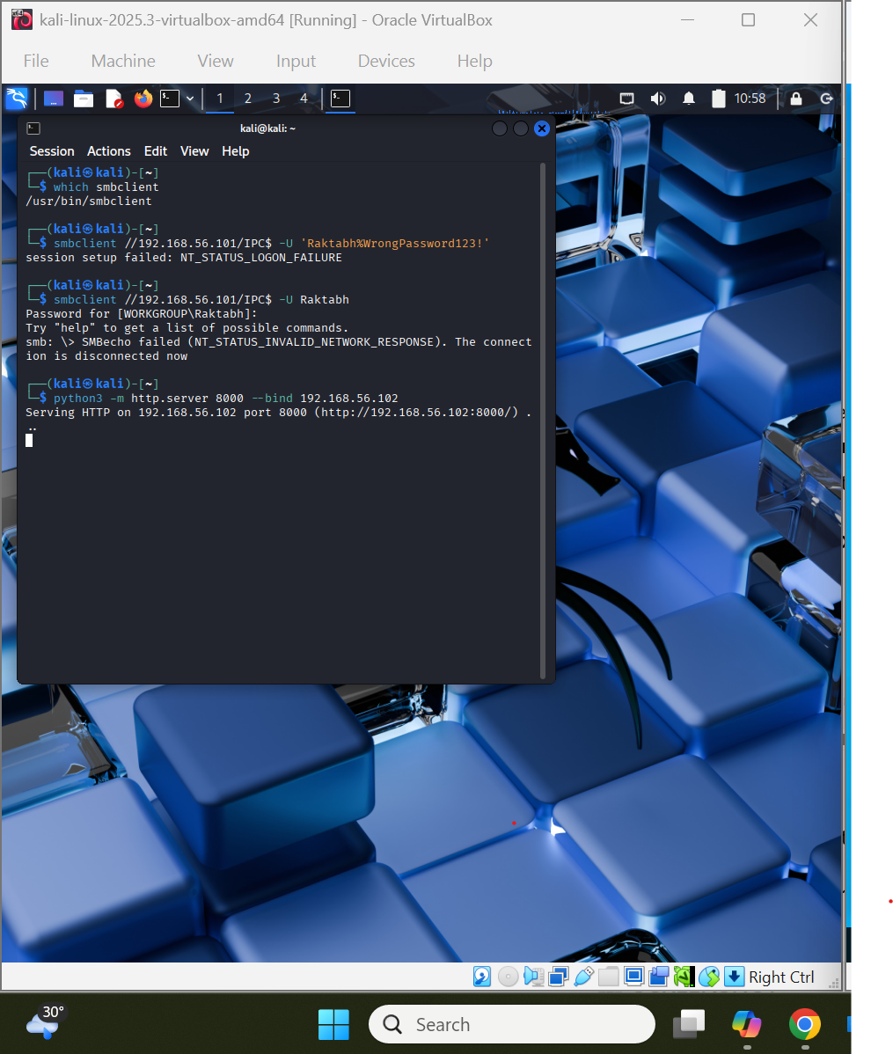
Kali-HTTP-Listener.png
NOTE
Source Host: KALI
Source IP: 192.168.56.102
Destination Port: 8000
Protocol: HTTP/TCP
Purpose: Controlled network telemetry generation

12.6 Sysmon Network Connection Evidence
Use this exact wording:
Sysmon Event ID 3 – Network Connection
Sysmon successfully recorded the controlled network connection generated during the HTTP telemetry validation as Event ID 3. The event identified powershell.exe as the originating process running under the DESKTOP-DBE0EIR\Raktabh account. The connection used TCP from source IP address 192.168.56.101 and source port 49674 to the Kali analyst workstation at destination IP address 192.168.56.102 on TCP port 8000. The event recorded Initiated: true, confirming that the Windows endpoint initiated the connection. This demonstrates successful collection of network connection telemetry through the configured Sysmon NetworkConnect rule.
Sysmon Event ID 3 Network Connection Evidence
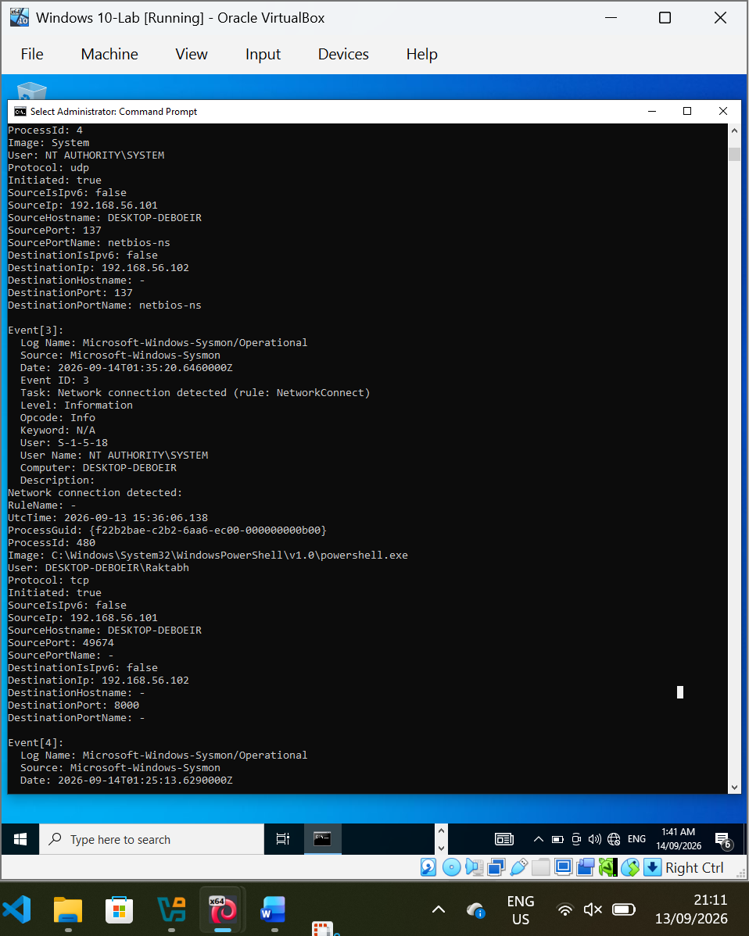
Sysmon-NetworkConnect-Event3.png

NOTE:
Event ID: 3 – Network Connection
Rule: NetworkConnect
Process: powershell.exe
User: DESKTOP-DBE0EIR\Raktabh
Protocol: TCP
Source IP: 192.168.56.101
Source Port: 49674
Destination IP: 192.168.56.102
Destination Port: 8000
Initiated: True
Telemetry Status: VERIFIED

13. Final Outcome
The completed laboratory will simulate the lifecycle of a security incident from the initial SOC alert through investigation, evidence collection, IOC identification, timeline reconstruction, impact assessment, containment recommendations and final reporting.
The completed project will serve as a practical demonstration of SOC L1 and Incident Response capabilities and will be documented for inclusion in a professional cybersecurity portfolio.

- 13.1 Correlated Incident Timeline
- The collected security telemetry was correlated across Windows Security Auditing, PowerShell Script Block Logging and Sysmon to reconstruct the sequence of activity observed during the controlled incident simulation. The evidence demonstrates a progression from failed authentication attempts to successful network authentication, followed by PowerShell execution, process creation and an outbound network connection.

The primary events identified during the investigation were:
  - Failed Authentication – Event ID 4625
A failed network authentication attempt originated from the Kali analyst workstation (192.168.56.102) against the Windows 10-Lab endpoint. The attempted account was Raktabh and the event recorded Logon Type 3 using NTLM authentication.
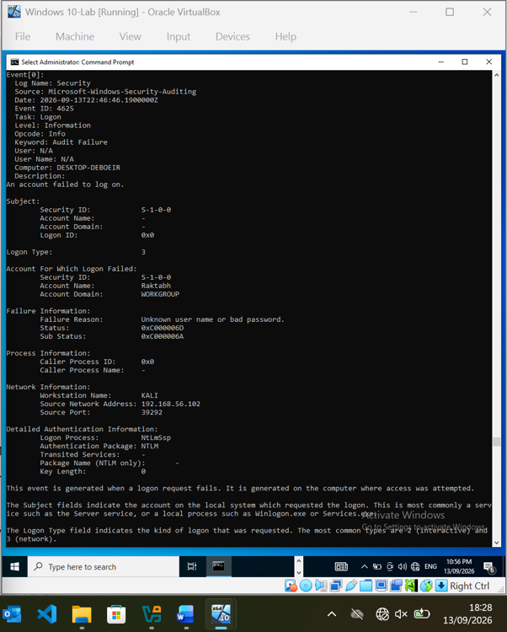Kali-to-Windows-Failed-Logon-4625.png
2. Successful Authentication – Event ID 4624
A subsequent successful network authentication originated from the same Kali workstation (192.168.56.102) against the Windows endpoint. The event recorded Logon Type 3 and NTLM authentication for the Raktabh account.
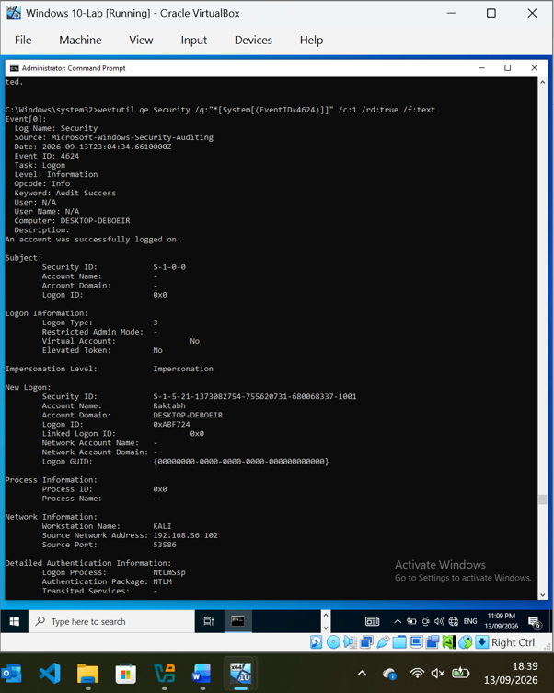
Kali-to-Windows-Successful-Logon-Event-4624.png
3. PowerShell Script Block – Event ID 4104
PowerShell Script Block Logging recorded execution of the controlled command Write-Output 'SOC-Lab-Incident-PowerShell-Test'.
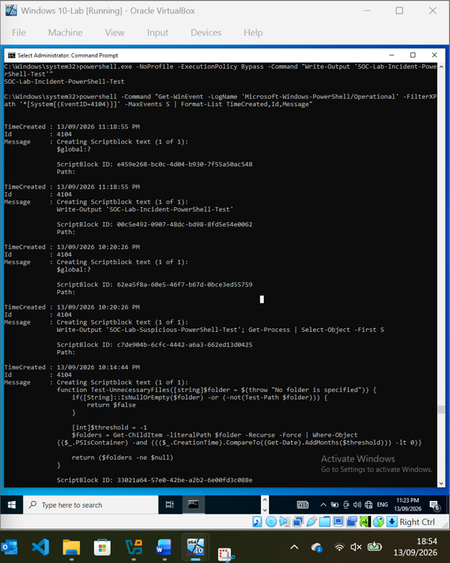
PowerShell-Script-Block-Event-4104.png
4. Process Creation – Sysmon Event ID 1
Sysmon recorded creation of powershell.exe under the DESKTOP-DBE0EIR\Raktabh account. The event captured the command line, parent process (cmd.exe), process ID and SHA256 hash.
Sysmon-PowerShell-Process-Creation-Event-ID-1.png
5. Network Connection – Sysmon Event ID 3
Sysmon recorded a TCP connection initiated by powershell.exe from 192.168.56.101:49674 to the Kali workstation at 192.168.56.102:8000. The connection was generated as a controlled HTTP telemetry test.
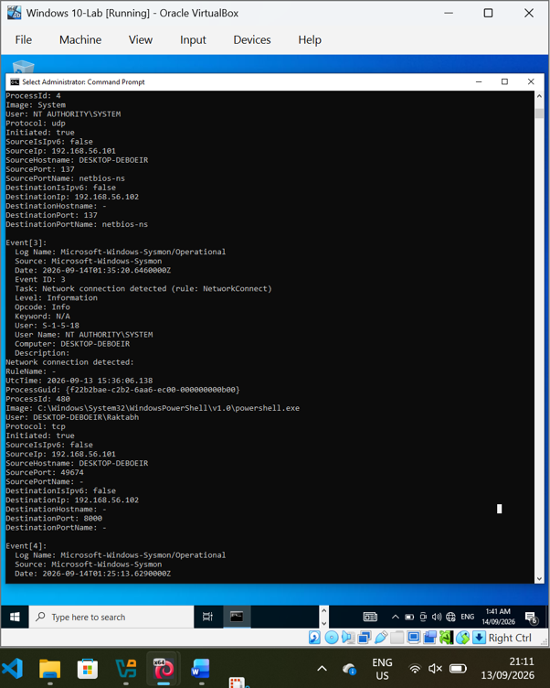
Sysmon-NetworkConnect-Event3.png

13.2 Indicator of Compromise (IOC) Identification
The investigation identified several technical indicators associated with the controlled incident simulation. These indicators were correlated across Windows Security Auditing, PowerShell Script Block Logging and Sysmon. Because the activity was intentionally generated within an isolated laboratory environment, the identified IP addresses and test commands should be treated as lab-generated investigation indicators rather than confirmed malicious IOCs.
The following indicators were identified during the investigation:
1. Source IP Address – 192.168.56.102
The Kali analyst workstation was identified as the source of the controlled failed and successful authentication activity. The same address represents the analyst workstation within the isolated SOC laboratory.
2. Target IP Address – 192.168.56.101
The Windows 10-Lab endpoint was identified as the target of the authentication activity and the source of the subsequent controlled PowerShell network connection.
3. User Account – Raktabh
The Raktabh account was involved in both the failed Event ID 4625 and successful Event ID 4624 network authentication events.
4. Process – powershell.exe
Sysmon Event ID 1 identified powershell.exe as the process created during the controlled PowerShell activity.
5. PowerShell Command
The command Write-Output 'SOC-Lab-Incident-PowerShell-Test' was recorded by PowerShell Script Block Logging as Event ID 4104.
6. Network Destination – 192.168.56.102:8000
Sysmon Event ID 3 recorded a TCP connection from the Windows endpoint to the Kali HTTP listener on port 8000.
7. Authentication Events
Event ID 4625 and Event ID 4624 provide correlated evidence of failed followed by successful network authentication.
8. Cryptographic Hash
Sysmon captured a SHA256 hash for the PowerShell process. The hash should be retained as supporting evidence for process identification and future comparison.

Indicator | Value | Evidence Source | Assessment
Source IP | 192.168.56.102 | Windows Security 4625/4624 | Lab-generated
Target IP | 192.168.56.101 | Windows/Sysmon | Lab endpoint
User Account | Raktabh | 4625/4624 | Investigative indicator
Process | powershell.exe | Sysmon Event 1 | Suspicious-looking activity, controlled test
Command | Write-Output 'SOC-Lab-Incident-PowerShell-Test' | PowerShell 4104 | Benign controlled command
Destination | 192.168.56.102:8000 | Sysmon Event 3 | Controlled HTTP traffic
Authentication | 4625 → 4624 | Windows Security | Failed → successful sequence
SHA256 | Captured by Sysmon | Sysmon Event 1 | Supporting process evidence

13.3 Incident Classification
Classification: Suspicious Activity – Controlled Security Simulation
The investigation identified a sequence of activity that would warrant investigation in a real production environment. The sequence included a failed network authentication attempt (Event ID 4625), followed by a successful network authentication (Event ID 4624), PowerShell execution recorded by Event ID 4104, PowerShell process creation recorded by Sysmon Event ID 1, and a subsequent outbound network connection recorded by Sysmon Event ID 3.
From a SOC L1 perspective, this activity would initially be considered suspicious because the combination of authentication anomalies, PowerShell execution and network communication could indicate potential compromise.
However, the activity was intentionally generated as part of this controlled SOC laboratory. The PowerShell command was benign, the network connection was directed to the Kali analyst workstation within the isolated Host-only network, and no evidence of actual malicious payload execution, persistence, data exfiltration or confirmed compromise was identified.
Therefore, the final classification for this laboratory investigation is Suspicious Activity – Controlled Security Simulation, rather than a confirmed security incident. The classification demonstrates the importance of validating and correlating multiple sources of telemetry before declaring an incident confirmed.
Classification: Suspicious Activity – Controlled Security Simulation
Confidence: High
Compromise Confirmed: No
Malicious Payload Confirmed: No
Persistence Identified: No
Data Exfiltration Identified: No
Lateral Movement Identified: No
Lab Environment: Isolated Host-only Network

13.4 Incident Severity Assessment
Severity: Medium
The simulated activity is assessed as Medium severity from a SOC L1 monitoring perspective. The correlated sequence of failed authentication, successful authentication, PowerShell execution and subsequent network communication represents activity that would require investigation and escalation in a production environment.
The severity is not classified as High or Critical because the investigation did not identify confirmed malicious payload execution, persistence, data exfiltration, lateral movement or confirmed compromise. The activity was intentionally generated within an isolated Host-only laboratory environment.
The Medium severity classification reflects the potential security significance of the observed activity while recognising the controlled nature of the simulation and the absence of confirmed business or system impact.

Severity: Medium
Compromise Confirmed: No
Business Impact: None identified
Production Impact: None
Escalation Required: Yes – for investigation in a real SOC environment

13.5 Impact Assessment
The investigation identified no confirmed operational, financial or data impact within the controlled laboratory environment. The observed authentication events, PowerShell execution and network communication were intentionally generated for SOC detection and investigation testing.
The simulated activity did not result in confirmed system compromise, data loss, data exfiltration, persistence or lateral movement. The network communication was limited to the isolated Host-only network between the Windows endpoint and Kali analyst workstation.
From a production SOC perspective, the observed sequence would nevertheless require investigation because similar activity could indicate credential misuse, unauthorised access or execution of potentially malicious PowerShell commands.
Impact Assessment: No confirmed impact
System Compromise: Not identified
Data Loss: Not identified
Data Exfiltration: Not identified
Business Impact: None identified
Lab Network Impact: Limited to isolated Host-only network

13.6 Containment Recommendations
Based on the investigation findings, no emergency containment action was required within the laboratory because the activity was intentionally generated in an isolated Host-only environment. However, the following containment actions would be appropriate if equivalent activity were identified on a production endpoint:
- Validate the affected account and determine whether the authentication activity was authorised.
- Review the source endpoint associated with the failed and successful authentication attempts.
- Investigate PowerShell activity and validate the executed command against the user's expected activity.
- Review associated network connections to determine whether the destination is authorised and whether additional suspicious communication occurred.
- Isolate the affected endpoint if malicious execution or confirmed compromise is identified.
- Reset or temporarily disable compromised credentials where unauthorised authentication is confirmed.
- Preserve relevant security and Sysmon logs for further investigation and evidence collection.
These recommendations demonstrate a SOC L1 containment approach while avoiding unnecessary disruption when the available evidence does not establish confirmed compromise.
13.7 Escalation Decision
The activity identified during the investigation would warrant escalation to a higher-level security analyst or incident response team in a production environment.
The escalation decision is based on the correlation of multiple security telemetry sources, including failed authentication (Event ID 4625), successful authentication (Event ID 4624), PowerShell Script Block Logging (Event ID 4104), Sysmon process creation (Event ID 1), and Sysmon network connection telemetry (Event ID 3).
Although the activity was confirmed to be intentionally generated within the controlled laboratory environment, the same sequence observed on a production endpoint could indicate unauthorised access or malicious execution and would therefore require additional investigation.
Escalation Decision: Escalate for further investigation in a production environment
Lab Escalation Required: No
Reason: Correlated authentication, PowerShell, process and network telemetry
Final Determination: No confirmed compromise

13.8 Investigation Conclusion / Final Findings
The SOC L1 investigation successfully identified, collected and correlated security telemetry generated during a controlled incident simulation.
The investigation established a sequence consisting of a failed network authentication attempt (Event ID 4625), a successful network authentication (Event ID 4624), PowerShell Script Block activity (Event ID 4104), PowerShell process creation recorded by Sysmon Event ID 1, and network communication recorded by Sysmon Event ID 3.
Correlation of these events demonstrated how multiple telemetry sources can be used to reconstruct an incident timeline and identify potentially suspicious behaviour.
The investigation did not identify confirmed malicious payload execution, persistence, lateral movement, data exfiltration, data loss or system compromise. The activity was intentionally generated within the isolated Host-only laboratory network.
The final determination is therefore Suspicious Activity – Controlled Security Simulation, with Medium severity and no confirmed compromise.
The investigation demonstrates the SOC L1 workflow of event validation, evidence collection, timeline reconstruction, IOC identification, incident classification, severity assessment, impact assessment and escalation decision-making.
Final Classification: Suspicious Activity – Controlled Security Simulation
Severity: Medium
Compromise: Not confirmed
Impact: None identified
Escalation: Recommended for further investigation in production
Investigation Status: Closed – Controlled Laboratory Exercise

