Version 87.0.4280.141 (Official Build) (64-bit)

Get help with Chrome

========================

<!-- https://mvnrepository.com/artifact/io.cucumber/cucumber-java -->

<dependency>

<groupId>io.cucumber</groupId>

<artifactId>cucumber-java</artifactId>

<version>6.9.0</version>

</dependency>

<!-- https://mvnrepository.com/artifact/io.cucumber/cucumber-testng -->

<dependency>

<groupId>io.cucumber</groupId>

<artifactId>cucumber-testng</artifactId>

<version>6.9.0</version>

</dependency>

<!-- https://mvnrepository.com/artifact/org.testng/testng -->

<dependency>

<groupId>org.testng</groupId>

<artifactId>testng</artifactId>

<version>7.1.0</version>

<scope>test</scope>

</dependency>

<!-- https://mvnrepository.com/artifact/org.seleniumhq.selenium/selenium-java -->

<dependency>

<groupId>org.seleniumhq.selenium</groupId>

<artifactId>selenium-java</artifactId>

<version>3.141.59</version>

</dependency>

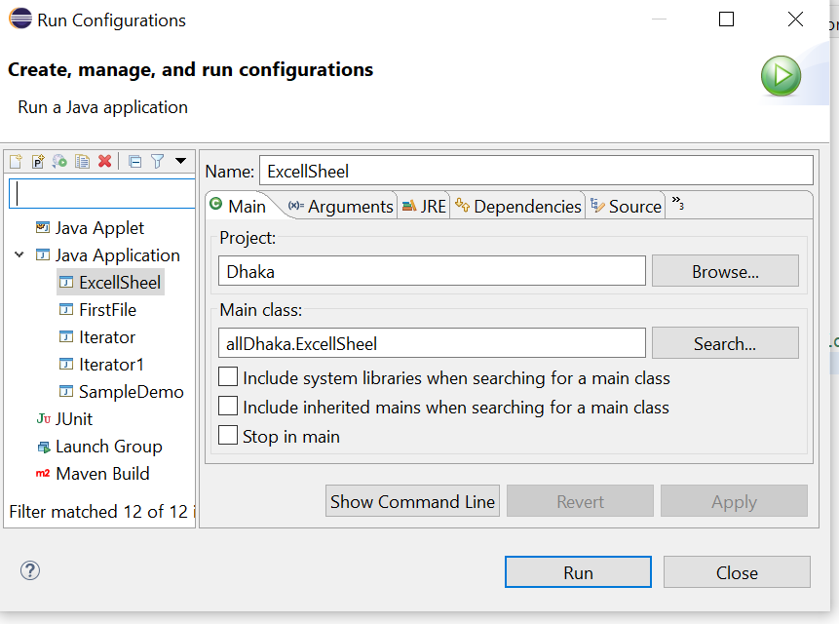

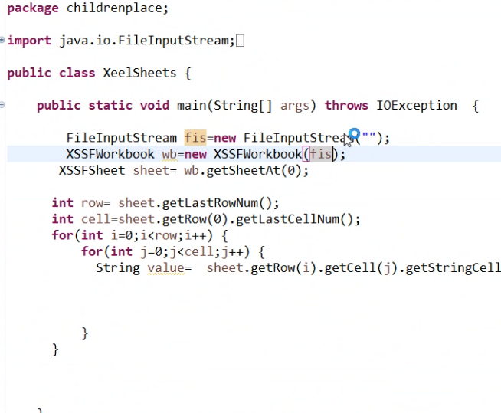

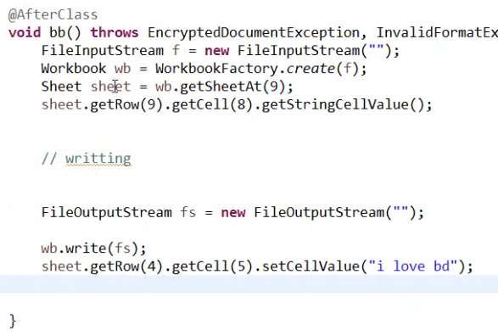

<!-- https://mvnrepository.com/artifact/org.seleniumhq.selenium/selenium-java -->

**Java Selenium**

<dependency>

<groupId>org.seleniumhq.selenium</groupId>

<artifactId>selenium-java</artifactId>

<version>3.141.59</version>

</dependency>

<!-- https://mvnrepository.com/artifact/org.testng/testng -->

**testng**

<dependency>

<groupId>org.testng</groupId>

<artifactId>testng</artifactId>

<version>6.14.3</version>

<scope>test</scope>

</dependency>

<!-- https://mvnrepository.com/artifact/org.apache.logging.log4j/log4j-core -->

**log4j-core**

<dependency>

<groupId>org.apache.logging.log4j</groupId>

<artifactId>log4j-core</artifactId>

<version>2.12.1</version>

</dependency>

<!-- https://mvnrepository.com/artifact/org.apache.logging.log4j/log4j-api -->

**log4j-api**

<dependency>

<groupId>org.apache.logging.log4j</groupId>

<artifactId>log4j-api</artifactId>

<version>2.12.1</version>

</dependency>

**poi-ooxml**

<!-- https://mvnrepository.com/artifact/org.apache.poi/poi-ooxml -->

<dependency>

<groupId>org.apache.poi</groupId>

<artifactId>poi-ooxml</artifactId>

<version>3.17</version>

</dependency>

**poi**

<!-- https://mvnrepository.com/artifact/org.apache.poi/poi -->

<dependency>

<groupId>org.apache.poi</groupId>

<artifactId>poi</artifactId>

<version>3.17</version>

</dependency>

**maven-surefire-plugin and** maven-compiler-plugin

<build>

<plugins>

<plugin>

<groupId>org.apache.maven.plugins</groupId>

<artifactId>maven-surefire-plugin</artifactId>

<version>3.0.0-M5</version>

</plugin>

<plugin>

<groupId>org.apache.maven.plugins</groupId>

<artifactId>maven-compiler-plugin</artifactId>

<version>3.8.1</version>

</plugin>

</plugins>

</build>

**maven-surefire-plugin and** maven-compiler-plugin

<build>

<plugins>

<plugin>

<groupId>org.apache.maven.plugins</groupId>

<artifactId>maven-surefire-plugin</artifactId>

<version>3.0.0-M5</version>

</plugin>

<plugin>

<groupId>org.apache.maven.plugins</groupId>

<artifactId>maven-compiler-plugin</artifactId>

<version>3.8.1</version>

</plugin>

</plugins>

</build>

For ChromeDriver

<https://sites.google.com/a/chromium.org/chromedriver/downloads>

Dependencies for BDD Cucumber Framework

1. ***cucumber-core***
2. ***cucumber-java***
3. ***cucumber-junit***
4. ***cucumber-jvm-deps***
5. ***cucumber-reporting***
6. ***gherkin***

Cucumber Dependencies

<properties>

<project.build.sourceEncoding>UTF-8</project.build.sourceEncoding>

<java.version>1.8</java.version>

<junit.version>4.13.1</junit.version>

<cucumber.version>6.9.1</cucumber.version>

<maven.compiler.version>3.8.1</maven.compiler.version>

<maven.surefire.version>2.22.2</maven.surefire.version>

</properties>

<dependencies>

<dependency>

<groupId>io.cucumber</groupId>

<artifactId>cucumber-java</artifactId>

<version>${cucumber.version}</version>

<scope>test</scope>

</dependency>

<dependency>

<groupId>io.cucumber</groupId>

<artifactId>cucumber-junit</artifactId>

<version>${cucumber.version}</version>

<scope>test</scope>

</dependency>

<dependency>

<groupId>junit</groupId>

<artifactId>junit</artifactId>

<version>${junit.version}</version>

<scope>test</scope>

</dependency>

</dependencies>

<build>

<plugins>

<plugin>

<groupId>org.apache.maven.plugins</groupId>

<artifactId>maven-compiler-plugin</artifactId>

<version>${maven.compiler.version}</version>

<configuration>

<encoding>UTF-8</encoding>

<source>${java.version}</source>

<target>${java.version}</target>

</configuration>

</plugin>

<plugin>

<groupId>org.apache.maven.plugins</groupId>

<artifactId>maven-surefire-plugin</artifactId>

<version>${maven.surefire.version}</version>

</plugin>

</plugins>

</build>

Cuccumber Dependencies----

1. Cucumber Core
2. Cucumber -html
3. Cobertura code coverage
4. Cucumber -TestNG
5. Cucumber-Java
6. Cucumber-jvm-deps
7. Cucumber- reporting
8. Hamcrest-core
9. Gherkin

10)Junit

11) Selenium Java

<dependencies>

<!-- https://mvnrepository.com/artifact/io.cucumber/cucumber-core -->

<dependency>

<groupId>io.cucumber</groupId>

<artifactId>cucumber-core</artifactId>

<version>6.9.0</version>

</dependency>

<!-- https://mvnrepository.com/artifact/info.cukes/cucumber-java -->

<!-- https://mvnrepository.com/artifact/io.cucumber/cucumber-jvm-deps -->

<dependency>

<groupId>io.cucumber</groupId>

<artifactId>cucumber-jvm-deps</artifactId>

<version>1.0.6</version>

<scope>provided</scope>

</dependency>

<!-- https://mvnrepository.com/artifact/net.masterthought/cucumber-reporting -->

<dependency>

<groupId>net.masterthought</groupId>

<artifactId>cucumber-reporting</artifactId>

<version>5.3.1</version>

</dependency>

<!-- https://mvnrepository.com/artifact/org.hamcrest/hamcrest-core -->

<dependency>

<groupId>org.hamcrest</groupId>

<artifactId>hamcrest-core</artifactId>

<version>2.2</version>

<scope>test</scope>

</dependency>

<!-- https://mvnrepository.com/artifact/io.cucumber/gherkin -->

<dependency>

<groupId>io.cucumber</groupId>

<artifactId>gherkin</artifactId>

<version>15.0.2</version>

</dependency>

<!-- https://mvnrepository.com/artifact/io.cucumber/cucumber-html -->

<dependency>

<groupId>io.cucumber</groupId>

<artifactId>cucumber-html</artifactId>

<version>0.2.7</version>

</dependency>

<!-- https://mvnrepository.com/artifact/org.seleniumhq.selenium/selenium-java -->

<dependency>

<groupId>org.seleniumhq.selenium</groupId>

<artifactId>selenium-java</artifactId>

<version>3.141.59</version>

</dependency>

<!-- https://mvnrepository.com/artifact/io.cucumber/cucumber-testng -->

<dependency>

<groupId>io.cucumber</groupId>

<artifactId>cucumber-testng</artifactId>

<version>6.9.0</version>

</dependency>

</dependencies>

Murcury Tours

Xpath –

1) //input[@name="userName"]

<dependency>

<groupId>org.testng</groupId>

<artifactId>testng</artifactId>

<version>${testng.version}</version>

<scope>test</scope>

</dependency>

<dependency>

<groupId>org.seleniumhq.selenium</groupId>

<artifactId>selenium-java</artifactId>

<version>${selenium.version}</version>

</dependency>

<!-- https://mvnrepository.com/artifact/io.cucumber/cucumber-core -->

<dependency>

<groupId>io.cucumber</groupId>

<artifactId>cucumber-core</artifactId>

<version>4.5.0</version>

</dependency>

<!-- https://mvnrepository.com/artifact/io.cucumber/cucumber-java -->

<dependency>

<groupId>io.cucumber</groupId>

<artifactId>cucumber-java</artifactId>

<version>4.5.0</version>

</dependency>

<!-- https://mvnrepository.com/artifact/io.cucumber/cucumber-java8 -->

<dependency>

<groupId>io.cucumber</groupId>

<artifactId>cucumber-java8</artifactId>

<version>4.5.0</version>

</dependency>

<!-- https://mvnrepository.com/artifact/io.cucumber/cucumber-testng -->

<dependency>

<groupId>io.cucumber</groupId>

<artifactId>cucumber-testng</artifactId>

<version>4.5.0</version>

</dependency>