Name – Raktim Gautam Goswami

Roll No. - EE17BTECH11051

Disclaimer – The program was taking too long to execute (maybe becuase of the dataset I choose). So I plotted the graphs for 5 epochs only.

The graphs between efficiency and epochs are as follows -

1. SGD-

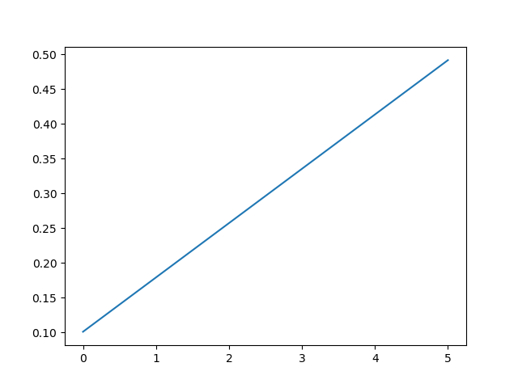Though this looks like a linear graph, it is actually not exactly linear. The same is the case with the other graphs as well. This can be seen by printing the efficiency values.

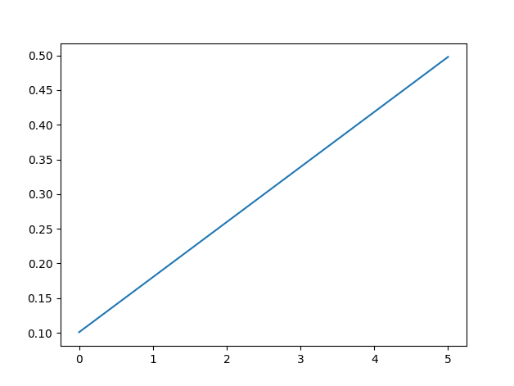2. Momentum

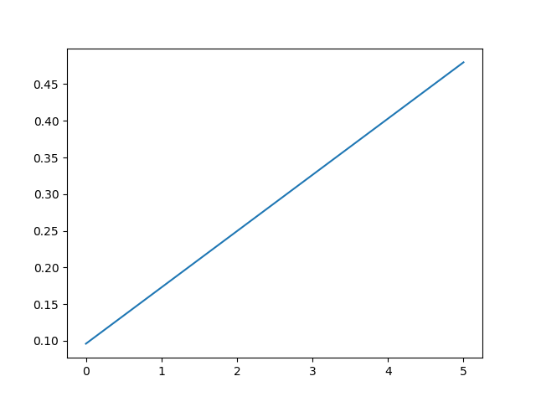3. Adaptive gradient -

4. Nesterov momentum-

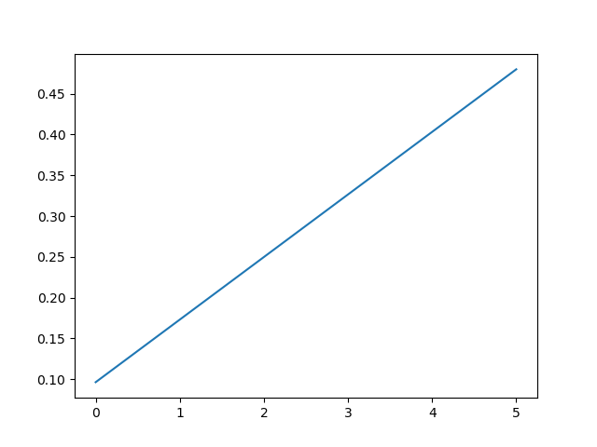

5. RMS Prop -

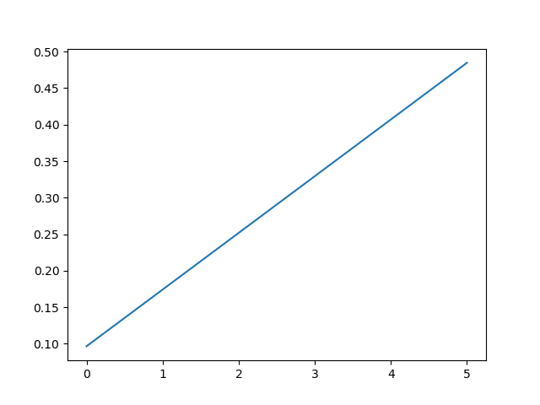

6. Adam -

