RESUME Of
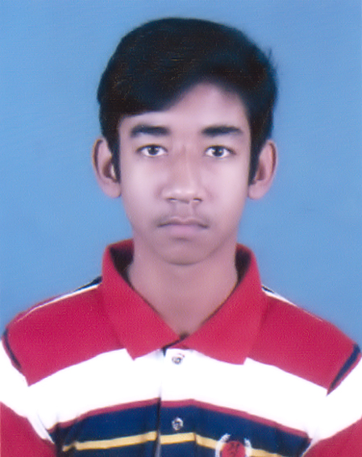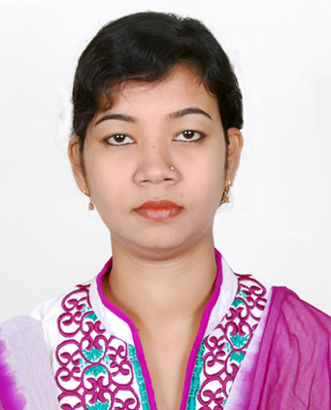
Sudipto Laskar

Cell: +880130-3644935
E-mail: avilashlasker01@gmail.com

Mailing Address

Sudipto Laskar
Holding no- 519/3, 2nd floor,
Dhorompur, Kazla
Rajshahi-6204.

Career Objective

Looking for a desirable opportunity in up growing private sector where I can utilize my skill and work with potentiality, integrity and show my stamina in particular sector; besides, I will have the scope to do something innovative for the benefit of the organization as well as mankind and the society from which I will be able to enhance my knowledge and efficiency to face the challenges in future.

Academic Qualification

Secondary School Certificate

Institution | Rajshahi University School, Rajshahi
Department | Business Studies
Obtained GPA | A (CGPA-4.06 on a scale of 5.00)
Year of Passing | 2017
Board | Rajshahi

Higher Secondary Certificate

Institution | Rajshahi University School, Rajshahi
Department | Business Studies
Obtained GPA | A (CGPA-4.58 on a scale of 5.00)
Year of Passing | 2020
Board | Rajshahi

Computer Knowledge

Hardware | Assemble and maintenance PC
Software | Windows Operation System, MS Office, Adobe Photoshop & Illustrator, Internet Browsing Software, Data recovery Software, Antivirus Software etc.
Networking | Internet Browsing, e-mail, uploading & downloading documents & others.

Computer Training Course:

Institute | Course Outline
Bangladesh Small and Cottage Industries Corporation (BSCIC), Rajshahi | Computer Office Application and Internet Browsing.
Bangladesh Small and Cottage Industries Corporation (BSCIC), Rajshahi | Computer Graphic Design.

Language Proficiency

- Good command over English and Bengali, both oral and written.
- Able to oral communication in Hindi.

Biographic Information

Name : Sudipto Laskar
Father’s Name : Late Arobinda Kumar Laskar
Mother’s Name : Chaina Laskar
Permanents Address : Holding no: - 519/3, Avilash Palace, Vill: - Dharampur,
P.O:- Binodpur Bazar, P.S: Motihar, Dist: -Rajshahi
Date of Birth : 23th March, 2002
Nationality : Bangladeshi
Religion : Hinduism
Sex : Male
Marital Status : Unmarried
National ID No. : 811034002302
Blood Group : AB (+) Positives

References

02. Susanta Kumar Sarkar
Deputy Secretary
Ministry of Expatriates Welfare and Overseas
Employment
Probashi Kollayn Bhaban,
Eskaton Garden Road, Dhaka.
Mobile: 01741-494776

01. Md. Ziaul Hasan Khan
Trainer, Computer Graphic Design, Skill
Development
Training Center, BSCIC, Sopura, Rajshahi
Phone: +8801746027708
Email: mdziaulhasan@gmail.com

Declaration

I, the undersigned declare that the information specified in this Resume is true to the best of my belief and knowledge and correctly describe my experience and myself.

Date: ………. (Sudipto Laskar)

