With Open Hands

A Handbook on Open Relationships



@nti-Copyright 1995-96.
All materials are in the public domain.
Please copy, distribute, translate and change as you like.
Giving us credit is nice, but not necessary.

Thanx
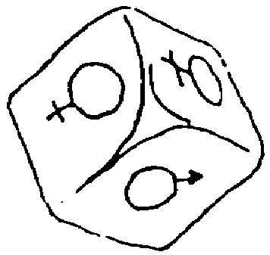
This work will never be finished, but there are number of people who have helped make it happen so far, especially Adela, @nissa, Chuck, Erikk, Helmi, JanH, Sigrid, Susan, Tobias and Ulla. To Lu and Veronika & Erikk for translating (into German and Czech). Ben and Erikk have slaved over the DTP and scanner to make it pretty. To the KUD DTP folx for great hardware and kind patience. Also thanx to Amanda, Nick, and Helmi for contributing the grafix. Many images were stolen from Paramour Magazine see the credits and subscription info which appears on the inside back cover.

History
There is a fitting story - this Fingerbook was a love letter. Once upon a time Ulla and i were honeymooning and she said “i do not mind you having other lovers, but it is not what i want for myself.” Then Chuck came along and he and Ulla seduced each other. A short time later Ulla said “This is complicated help me to avoid the mistakes you have already made.” So i wrote this long letter which some others read and suggested it become a handbook. And after many edits, long conversations and few fights it has become what you see before you.

Dedication
This handbook is dedicated to all those who are at least willing to try something different, however difficult it seemed to be.

What is an Open Relationship?
An open relationship is when two lovers* do not limit each other in having other lovers. There are many other words used to describe this (f.e. multiple relations, non-monogamy, polyfidelity, omnigomy). I chose „open relationship” here because it sounds nicer and you can have an open relationship with just two, providing you are open for more - so in a way it is a step before these other names.
The other way of defining an open relationship is by what it is not. A closed relationship (a monogomous agreement) means at the very least, neither of the lovers will have other sex partners. Often in monogamy there are more restrictions on new intimacy. Having ”affairs” or secret other lovers is NOT open relationships.
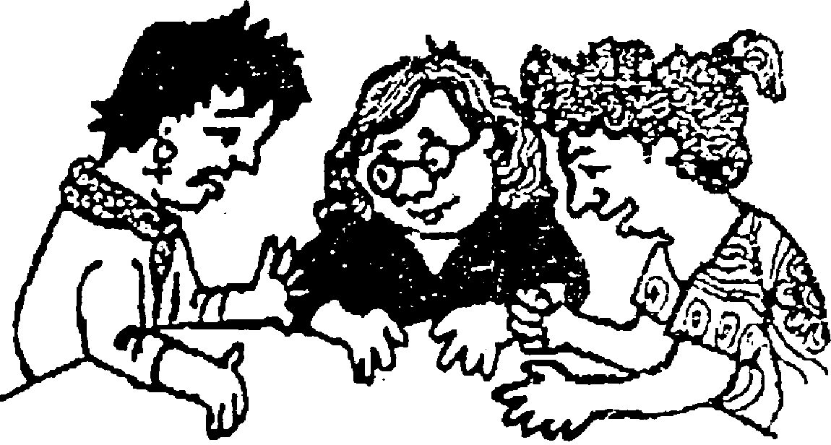
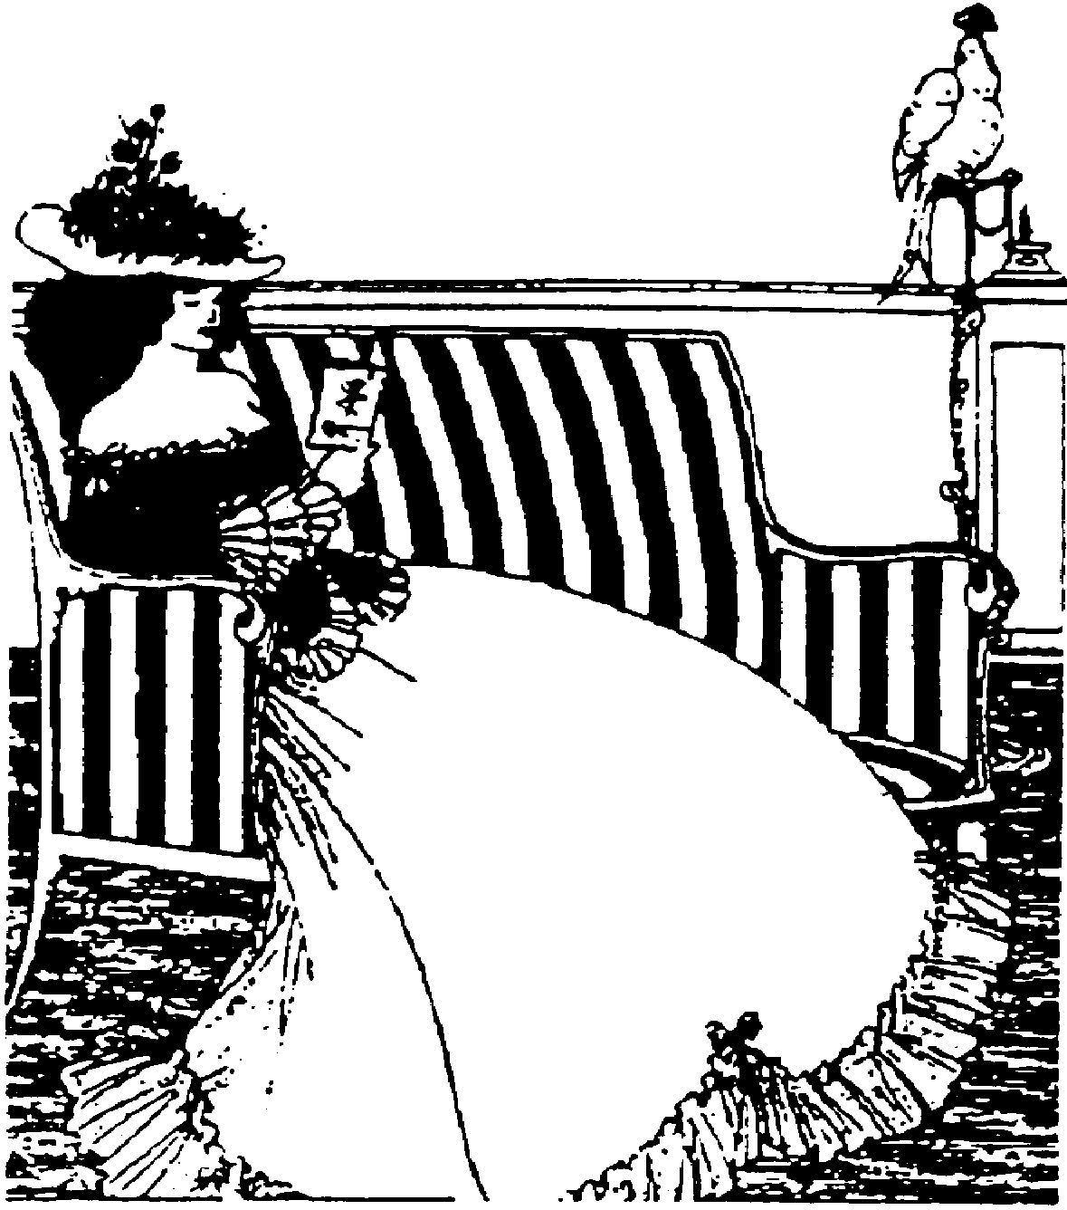

Why this Handbook?
This book was not written to convince people that open relations are the right thing for them (tho some reasons appear later) Instead, it is written as a guide for people who are in open relationships, are considering them, or are just curious about how they might work.
Because there are almost no role models for successful open relationships, a friend of mine used to say „we are beginners playing by the advanced rules“. This handbook is an attempt to help all of us beginners.

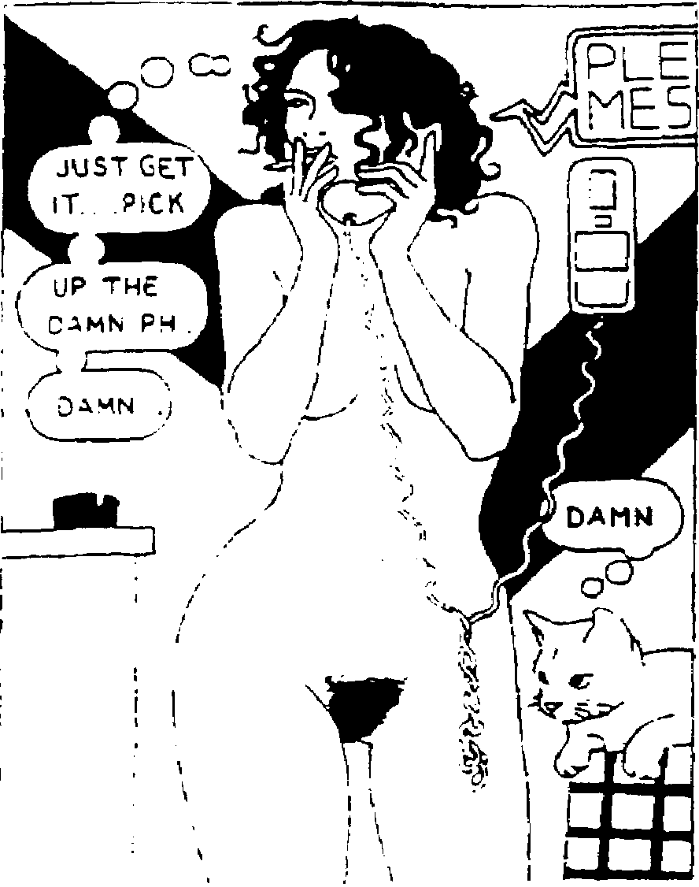

After reading this Fingerbook, Kim asked “Where is the Love?”. I am sure people can fall in love without my advice. This work is about how to take care of each other and work thru difficult emotions and situations.
It is a guide which shows a path. There are lots of other relationship paths, but even if the advice here is useless for your particular relationship, the issues brought up are nearly universal (jealousy, privacy vs honesty, switching problems, honeymoons, etc.). Hopefully, this handbook will be useful at showing trouble areas even if it can’t offer perfect advice for your exact situation.
Open relationships are almost always more complex than closed ones. There are more personalities involved and for open relation- ships to work you have to deal with difficult emotions which frequently can be played down or ignored in a monogamous contract.

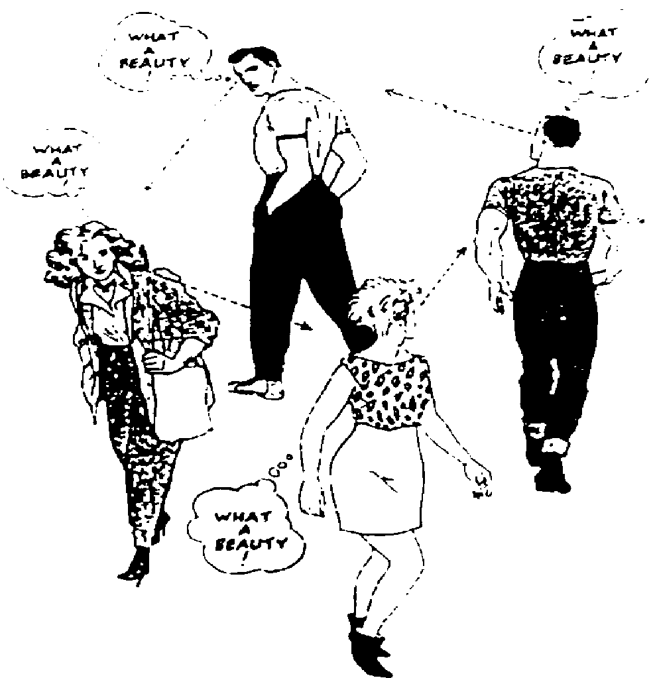
This handbook assumes that at least the shared lover/s (this means any lover one involved in more than one relationship) honestly want to maintain their relationships. Much of the bad name that open relationsips get comes from people who are basically monogamous but find a new and “better” lover while they are already involved. They claim to be trying multiple relationships, but really what they are trying to do is let the old relationship end slowly. Then after a while, when things begin to fall apart, they say “Oh well, multiple relationships do not work“, and often people agree. Nothing will work emotionally if you enter it in bad faith. Open relationships are more work than simple pairs; some people find it effort well spent.
This handbook comes from my experience and a tremendous number of mistakes, plus advice from others who are dedicated to this lifestyle. This guide is written mostly because so little of practical value is written on the topic. It is also my hope to demystify open relationships a bit - they are possible, difficult, but possible.

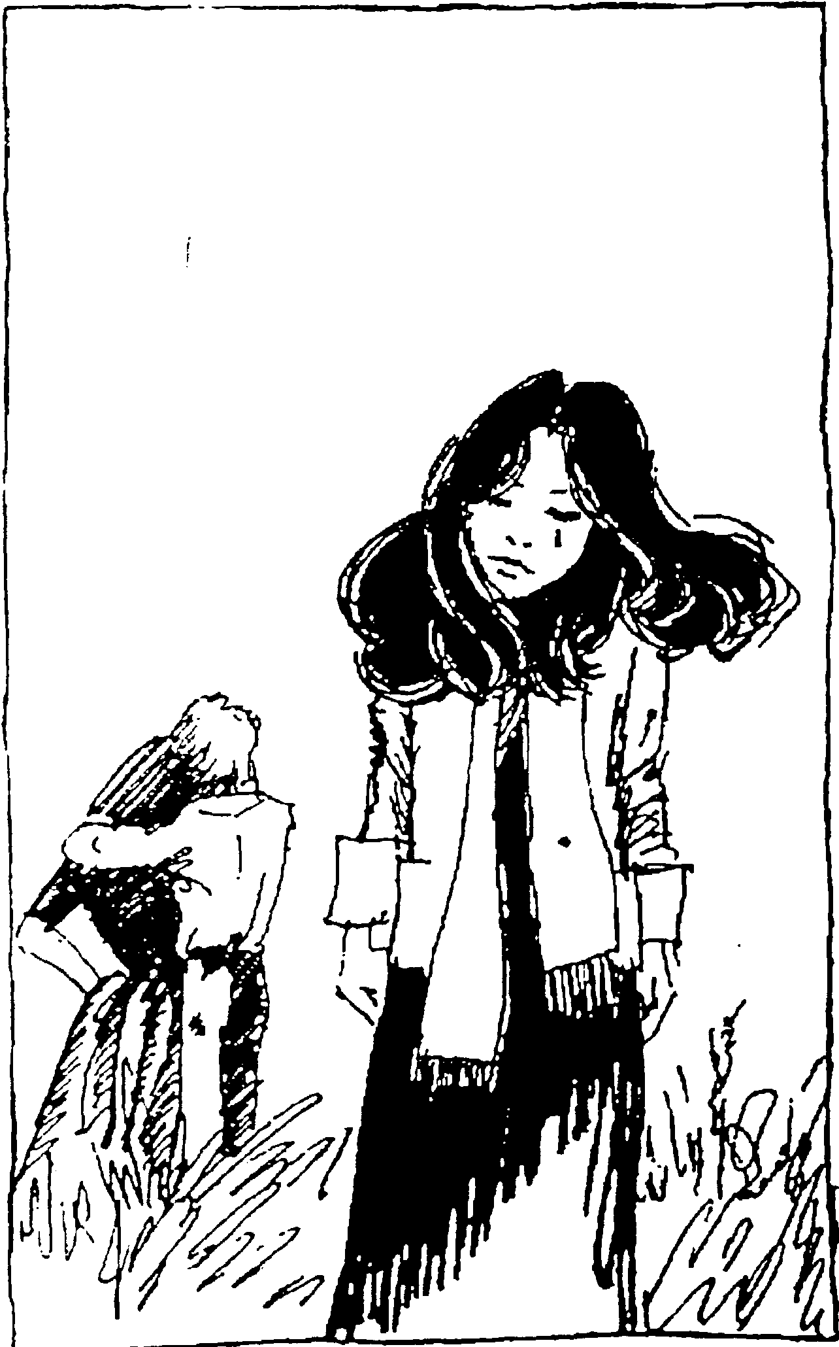
Jealousy
Almost everyone is jealous. How could your lover be attracted to someone else? Aren’t you enough? How can your lover hurt you by being disloyal to you?
Open relationships are an agreement to communicate about these kinds of feelings. If you can’t talk over how you feel about the other relationships, you don’t have a chance. That does not mean open relationships only work if you completely escape jealousy - not at all.
If you have jealous feelings, you need to build bridges around them. You have to work with the lover you share on how you need to be taken care of. For example, lovers living together: “Get him to send you love letters at work, so i don’t have to see them.“ Or “don’t tell me how wonderful he is in bed when you know i’m not feeling so secure about our sex.“
But you also should not demand complete isolation from the other relationship for a few reasons. First, it is not possible - you will get the other lover on the phone occasionally; their schedule will affect the lover you share; you may find yourself at the same party or event together.
But more importantly, it won’t work for you - if you ask never to hear any information about the other romance, it will grow more threatening in your mind - whenever you don’t know where the shared lover is you will assume he or she is with the other lover. By “locking yourself out,” you make it impossible to support your shared lover when things are difficult in the other relationship (this is a potential advantage of a balanced long-term open relation-ship), and finally, if you block out the lover, you will never get a chance to move through your jealousy.
So the bridges over jealousy cannot just be walls which block out your view of the other relationship. You need to balance the limits to what you can hear and see with honest communication between you and your lover. The primary burden falls on shared lovers in helping find „safe“ things to communicate to lovers working on jealousy. For example, it is probably easier to talk about a nice cafe conversation with your other lover than about a wild night of lovemaking.
You can take care of a lover who might be jealous by highlighting the differences (both positive and negative) about the other lover. If your jealous lover has no interest in art, but the other lover does, you might explain that you and the other lover fill this need (art) for each other.
Similarly, you can complain (if it is true) that your other lover does not share the interest in politics that the two of you have in common. The task for the shared lover is to keep clear in the mind of both partners why both relationships make sense and do not compete.

Transending jealousy: It is something of a debate whether jealousy is something you acquire from your culture or if it is a „genetic“ thing. What i am certain of is that it is something you can move through if you want to work on it.
The theory is simple: you want your lover to be happy; they are happy when they are with the other lover; this should make you happy. It rarely works that easily - at least not at first.
The single most important thing you can do to transcend jealousy is to be secure in yourself - to be confident about yourself, feel strong in your relationship, and understand each other, what you give each other and why you make sense together. This does not mean you have to have exact words or perfect descriptions for all these things - some will be undescribable feelings (for example, “that magic we feel dancing naked in the rain“ or “that special afternoon in the canoe“). Once you are secure in your relationship, jealousy is less like to take root.
But when it does take hold, try to connect to what works about your romance, both for yourself and your lover. Find the strengths of your intimacy and play to those strengths (for example, if your best times together have been playing, go to a fun spot that makes it easy - if intellectual talking is your bond, find that controversial topic you never discussed before).
Escaping jealousy is a process; take it a bit at a time. When you are feeling strong in yourself and your relationship, ask your lover to tell you something about the other lover. One of the best things you can do to melt jealousy is actually meet the other lover (this is discussed later). Jealous imagination can make them a perfect opponent; if you meet them, they return to real-life size.
The ultimate test of overcoming jealousy is to watch your lover enjoying the other lover and feeling good about it inside. This can be an incredibly liberating experience. It is not necessary for a working open relationship; some people will never get there and do not need to. For others, it is a desirable goal.



Privacy vs. Honesty

Even if all those involved in an open relationship have transcended their jealous feelings, it is not desirable or useful to share everything about the relationships with all involved. Relationships have their confidences, secrets, special private moments, inside jokes, and more.
Trying to manage privacy while being open is one of the hardest balances of a working open relationship. You come back from a fantastic evening with one lover; how much do you tell the other? You’re exhausted from hours of partying with one and the other wants to go out dancing or make love; what do you say?
The second question is easy: you say you‘re tired and explain as much of why as you think your partner can hear.
The first question is trickier - it depends on how strong you are feeling in the relationship and if your other lover can share the good news in a way which works.
When you are asked a direct question - “How was it last night?“, then the asking intimate takes some responsibility for hearing the truth. Judge how much detail you go into by what you know about them, and by their expression when you start to tell more.
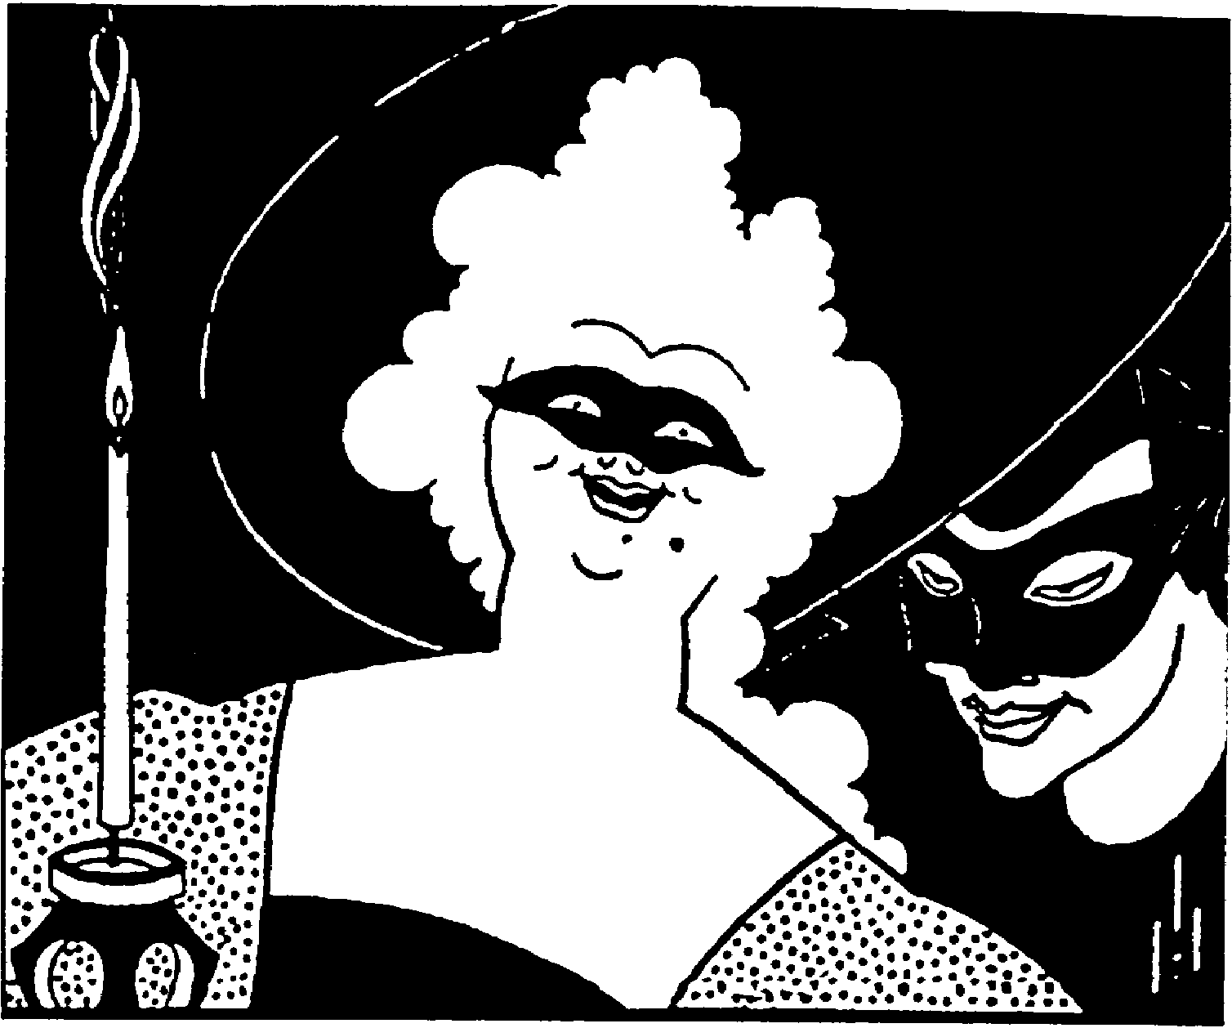
This does not answer the question of how you know what to keep secret. Ideally, the rule would be that you would keep secrets just as you do with friends. Sadly, it seems many change their keeping-secrets rules with lovers; many sworn to secrecy feel it is okay to share the hot news with their lovers. I can give no commands here, only suggest that unless you are asked a direct question, it’s beeter to be too private than too loose, because then you won’t betray people‘s trust.

Don't Kiss and Tell
Something which may be uncomfortable in beginning a new relationsip is revealing the news that you are already involved with someone else. The answer to the question, “when should i tell someone new that i have another romance?“ is “As soon as possible“. If your having another relationship makes a new one with this person difficult or impossible, the fair thing to do is to bring it up early. It can potentially save you both a lot of time and pain. This is triply true for folks who are married - if you really want to make someone angry, then emotionally fool them for a couple of “dates“ before mentioning that you are married!
If you are just looking for a hot night, you can leave the truth to the morning. If you want an open relationship, don’t kiss and tell.

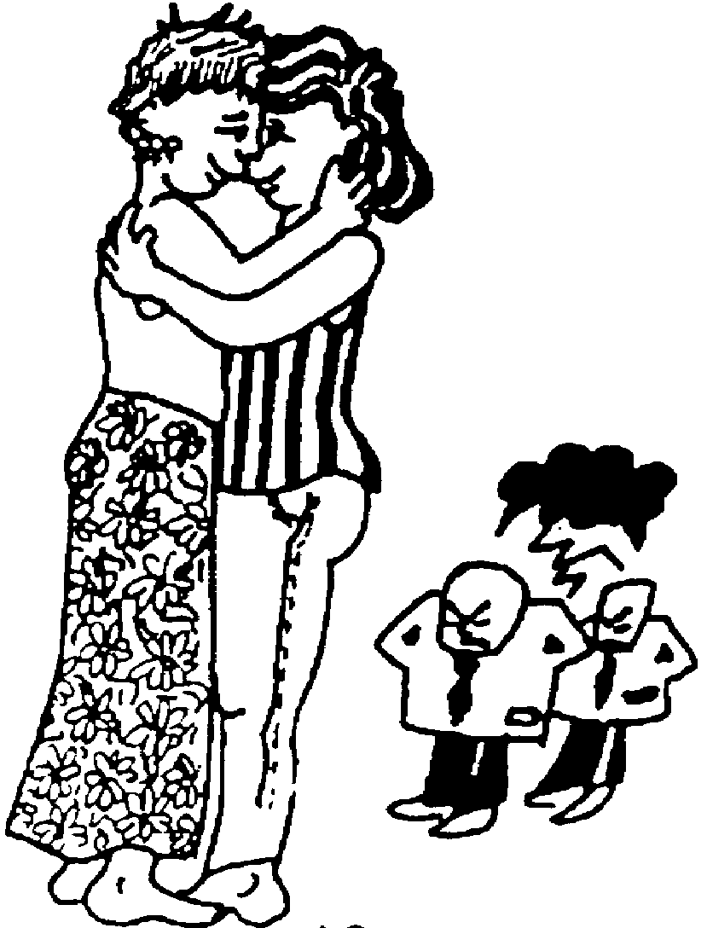

Switching and Crossover Effect
Switching, when you go from being with one lover to being with another, may require some management. The easiest way to switch is to put something else in-between - do some work, read a book, call a friend, visit a neigbouring country. If switching is hard for you, don’t do it more than needed (for example, don’t phone one lover immediately after you have spoken to the other; if you are spending a day with one lover, but they have to leave for lunch, don’t schedule lunch with the other lover).
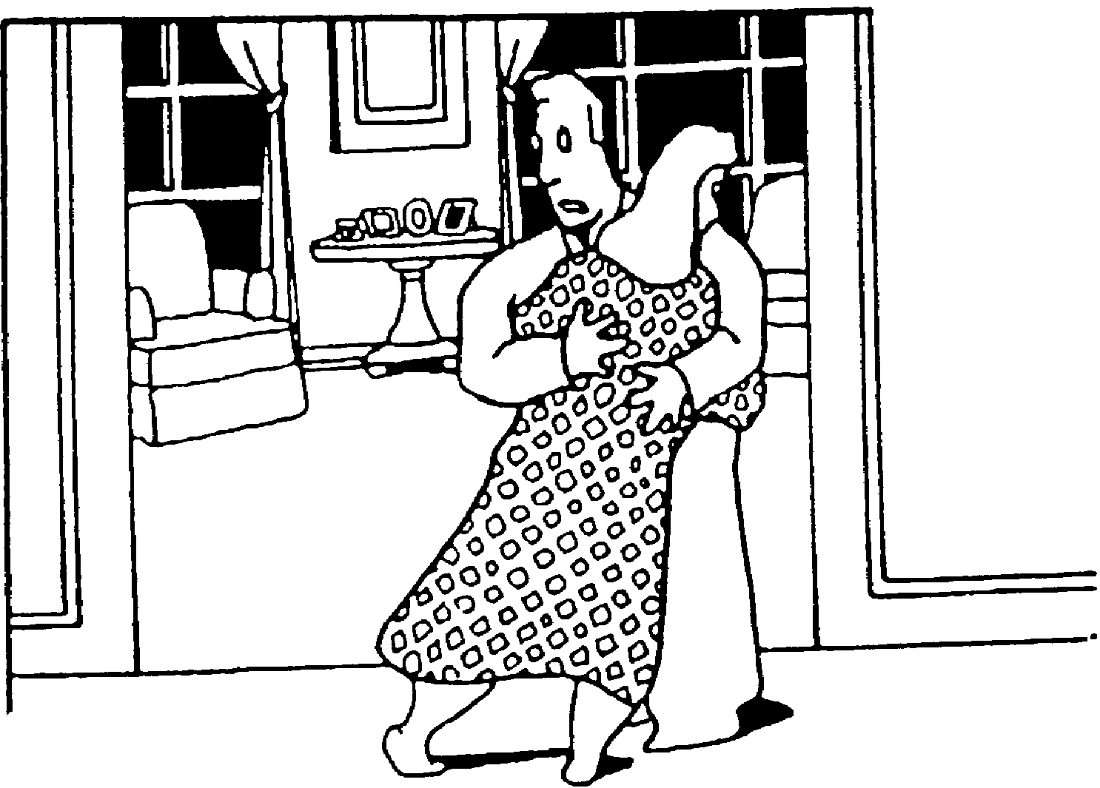
Switching can also be a problem for the lovers between whom one is switching. It can be hard to meet a lover after they have spent time with the other especially if they are in an extreme place because of it. When your situation with one lover affects another lover (f.e. you are depressed and angry when you meet your lover after having been with the other), this is the crossover effect. Many people believe that different relationships (especially if they are in different places), are independent. This is a myth.
In most things, most people don’t hesitate to ask a lover for support; ideally it should be no different asking for help around your other relationship - but this ideal often escapes us. There are two likely problem scenarios. First, if your lover is not very happy about your other lover - they may too quickly suggest you abandon the other relationship: the simplifying solution. Alternatively, if the trouble in one relationship goes on for long, it may damage the other by being a constant burden to it. If these are likely problems, you would do better to seek counsel from a friend or less involved person.
But one lover can potentially be your best counsellor about the other, for a couple of reasons. First they may be the easiest person for you to talk with. They already know you well and because they know you, they may be able to see what part of the problem in the other relationship is your responsibility (which may be hidden to you). This may help you unlock your problem with your other partner.
If you are in an open relationship, you need to accept a certain amount of crossover effect and as with almost everything, the better you communicate what you can handle and desire to your lover, the more success you are likely to have.




Not a Contest
„Which lover is more important to you?“, i’ve been asked. Because open relationships are unusual, people ask these kinds of questions to try to understand them. You probably would not seriously think of answering the question „which of your closest friends is more important?“ Most people chose multiple relation- ships because they find different desirable things in each of their lovers, in general it does not make much sense to compare them character by character - though some of this is unavoidable.
One lover will always be more interesting, fun, better sexually, more artistic, more political, better looking, more grounded, more intelligent, more spiritual, have more attention for you or what ever - but it is very unlikely that one lover will have all these traits (and whatever else is desirable to you), over the other.
But one of the things which is especially important in open relationships is making lovers know why they are special, why they are unique in your life. Especially people new to open relationships need to know that they are not just one of a group - but that their relationship is important and why.

Counting and „Managing“
People occasionally ask me „How many lovers do you have?“ i often answer with the phrase „How many friends do you have?“ Some people get annoyed by getting a question as an answer. The rest usually reply „I don’t count,“ to which i say „Neither do i“.
Which is actually true, i am tired of trying to decide if a non-sexual romance counts, or if the lovely Bebop, who was a close friend for over a decade before we became sexually involved should count - our relationship is basically unchanged.

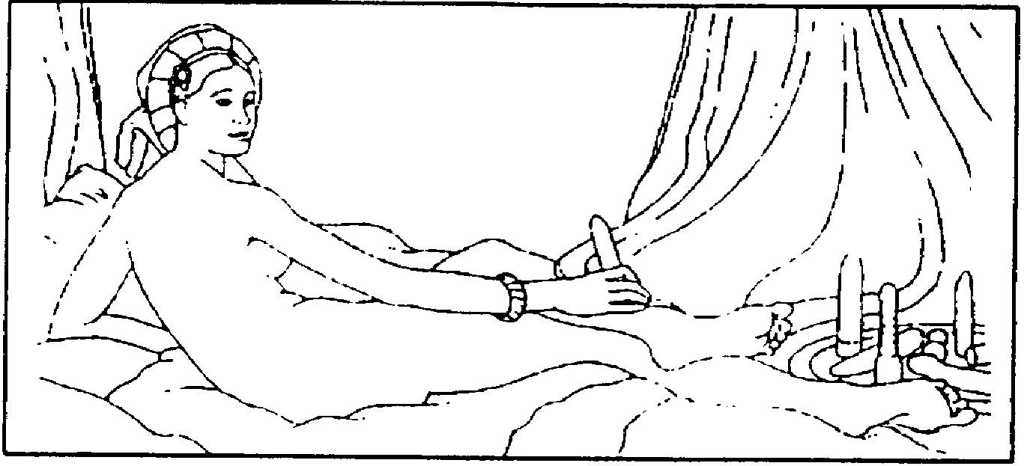
Which is not to say that sex does not change relationships. It almost always does; Bebop is an exception (and exceptional). But it does not have to. In an ideal world/community, you could develop intense friendships, experiment with sex and if you did not like it go back to the friendship. In the real world, this almost never happens. Sex brings expecations (and new definitions, now you are „lovers“ and not just seeing each other). There is often no going back.
And besides trouble deciding “who counts,” i find this counting only gets used against me. Rarely do people say „it’s great that you are open to being close with this many people“, instead i often hear „you can only be having superficial relationshps then“ - again a ruling no one would ever apply to close friendships.

People used to ask „How do you have time for all these romances?“, to which i replied „i don’t watch TV“ (which is true, but a bit beside the point). You make time for what is important to you. I do political work and spend a lot of time „managing“ romances. If this sounds unromantic, you need to see it as the same thing ever busy person does (tho generally balancing one romance with many other things).

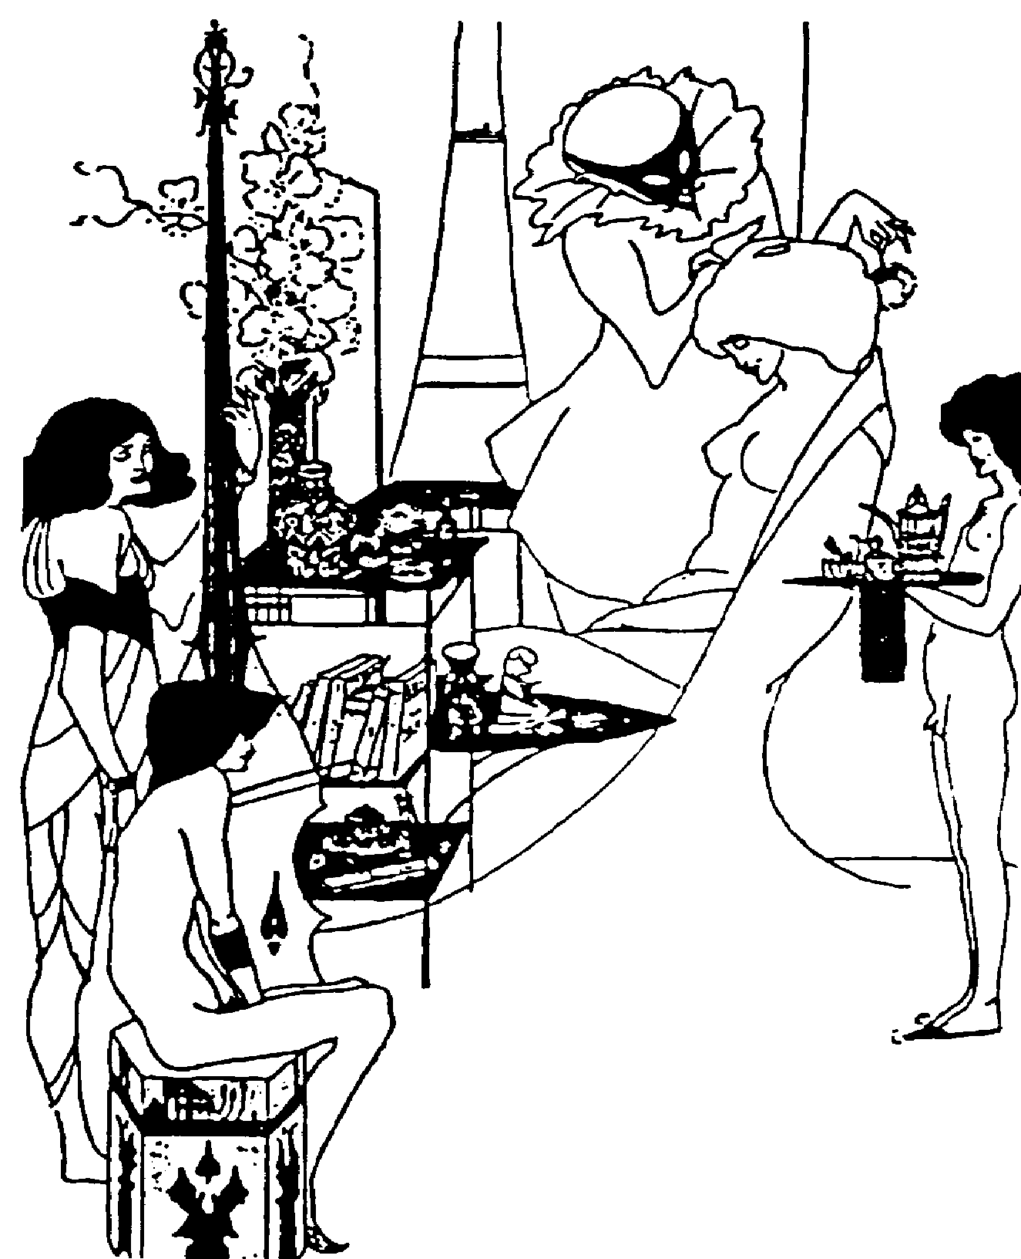

[Editor’s note: I would strongly disagree with Paxus. Counting is real, number of lovers are real - decide for yourself how to count, you’re smart enough. Counting is real because managing is real and, in most people’s world, not easy - just like with friends, time spent with one lover is not always spent with the other (though it can be). And not everybody has or can have Pax’s freedom - though he will argue this, I would argue back, point- ing to the 90% of people around me not living in his kind of world. - Erikk]



Primary Relationships
Many people have primary relationships; commonly it is the lover who you live with, but this is not necessary the case. So what is a primary relationship?
Most people would say a primary relationship is the „most important one“ or the one in which you spend the largest amount of time. But the first means ranking and rating - and the second could easily not be true if you, for example worked with a secondary relationship or lived far away from your primary one. Primary relationships often share property or have long-term plans together, but neither of these is necessary or sufficient condition.
Unfortunately, the best definition which we have come up with so far is: A primary relationship is the one which you take care of when you cannot reach a decision about how to take care of all your relationships.
This is a negative definition, but it works and in a way it defines the „primary“ nature of the relationship. When there is trouble and you can’t all agree, you take care of the primary love first.
Ideally, the primary relationship was been formed with the understanding that the relationship is still open to new other relationships, but this is often not the case. We’ll look at the easier first case first.
Suppose your partner in a primary relationship is spending time with someone else. You started out knowing this day would come; you were open to new romances, and did not think about it much during your own honeymoon (see “space for honeymoons”), but now this feels like a lot of time.
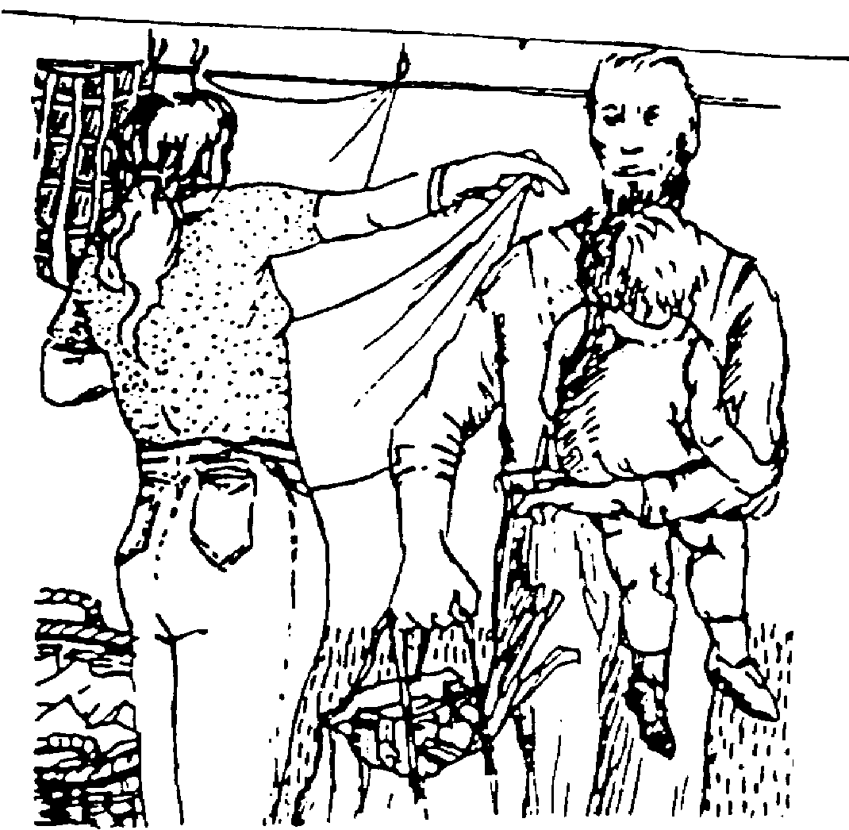
The tools for dealing with jealousy and other issues have already been discussed; what is special about primary relationships is the power - and respons-ibility - contained in the denifition.
You could say, „i really need you to take care of me and not see this person for a while until our relationship feels more secure“ and because yours is the primary relationship, your partner would probably attempt this. You need to be aware of this power - and use as little as possible in a primary relationship.
The reasons are clear and simple: If you abuse this power, placing lots of restrictions on the other relationships, you will strain and may break your own. But there is also a higher reason -keeping the spirit of open relationships. You are trying to give your partner as much freedom as possible. You should take care of yourself, but fundamentally, you want the partner coming to you from her or his desire, rather than your need.

Monogamous relationships which try to „open up“ are a common special case. You are changing your agreement (which may have never been precisely formed) this almost certainly means a long and possibly difficult discussion about why your relationship is changing. The unshared lover will likely feel threatened and if the shared lover really wants everything to work, it is time to cancel the rest of your busy life and get this part right. Seriously consider bringing in a trusted shared friend in as a mediator (at least at the start ofthe discussion). Ideally, go to somplace unusual (and beautiful?) with no distractins to try to work this out. Come back with clear definitions and norms (see pages 32-33) and hopefully a renewed sense of commitment and feeling of attraction to your long term relationship.

Kids

[ This section is Jan Haverkamp’s idea; he will write it with Adela - Ulla says she has nothing to say about it, but in fact she has a lot to say about it and hopefully will edit it]

Gays

[Another section to be added - if you or someone you know could write about how gay open relationships differ from the straight culture, please contact the address on the back cover]


Free Love vs. Open Relationships
Free love is different from open relationships in my mind. Free love means being attracted to someone and feeling free to have sex with them. It also means feeling free to move on. Open relationships mean more commitment, working on difficult feelings when they come up, commiting to supporting one lover’s feelings about another. People practicing free love have a different expectation: “we will come together, we will have our wonderful moments and if it happens again, great; if not, that is okay also.”


Space for Honeymoons
Many people in the first few open relations seem to forget that relationships have lives, which usually start with a fairly intense honeymoon period. During this period the honeymooners have stars in their eyes. They see all the wonderful things about the new partner; they have not yet run into the problems or character traits which will disturb them later. This is a very difficult time for an “old” relationship, for several reasons. First, the “old” lover will likely feel threatened - because there is always some comparison in relationships, the old lover is simply less wonderful than the new one (you don’t see the new one very clearly yet). Second, the old lover may show some less attractive sides - anger, complaint. Finally, the honeymooners will have a very natural desire to spend a bunch of time togethe - right when the old relationship is in need of support.
But honeymoons are not forever. And if you are the old lover, you have to take the long view. You will have to ride out the honeymoon and see where things settle out in the end. And if you can avoid getting crazily jealous, the shared lover will hopefully remember why they are in an open relationship and will stay better in touch with their strong feelings for you.

If it is possible, honeymoons may be a good time for the old lover to start something new. Anything from a long-delayed project to a new hobby can work. There is a temptation to pick up another lover, in order to „get even“, or maybe to feel taken care of - generally this does not work very well. New lovers are not usually easy to find, and bad choices can be emotionally expensive. Better to spend more time with a close friend.
The shared lover in a honeymoon situation faces a difficult challenge. A careful mix of supporting the old lover, while enjoying the new one is the best choice. To do this, if you have a busy life, drop something you do. Skip more classes, spend less time with other friends, put the project on hold, take vacation or sick days off work. Treat the relationships like living things that deserve time. Create time not only for the honeymoon, but also so you do not lose touch with the earlier lover.

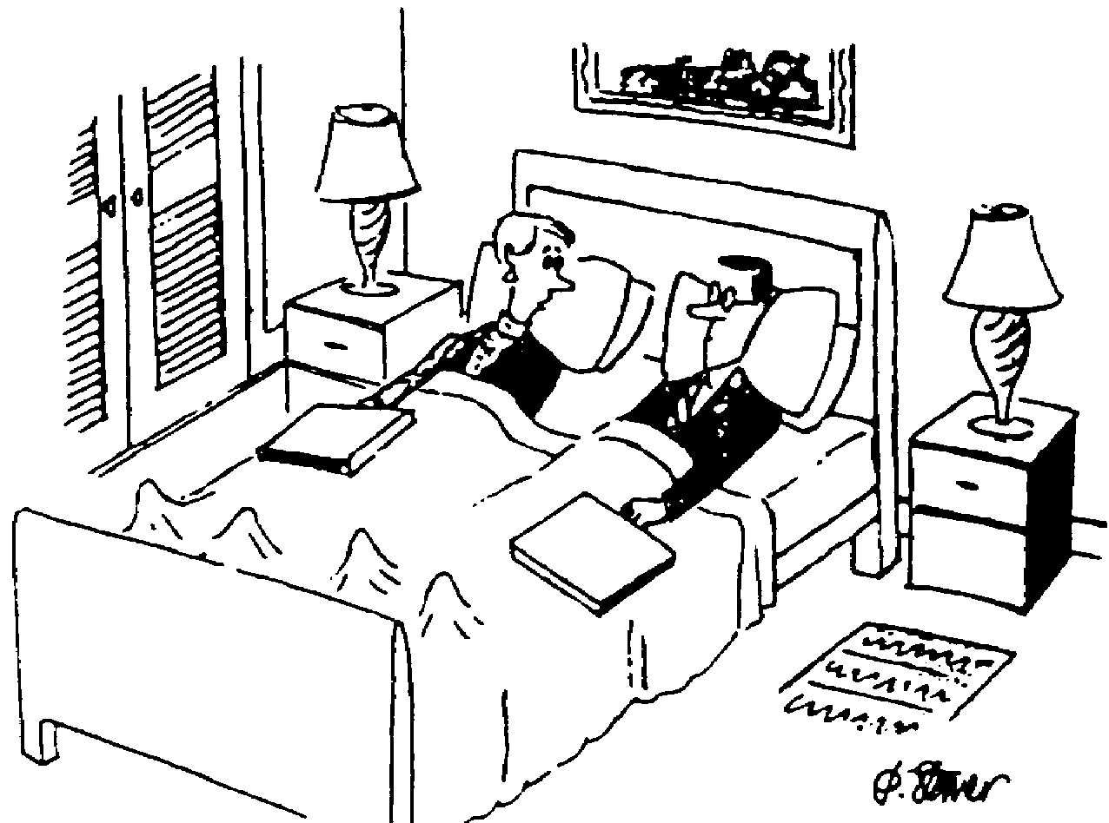

Mistakes
The classic fear is calling one lover by the other’s name while you are in the middle of a passionate moment. In fact, it does not happen much; people remember who they are with, and lovers feel different from each other - physically, and in many other ways. But mistakes do happen. Roll with them, laugh at them, make fun of them - but don’t get stuck in them.
I had a lover who was telling a story once, when she was a bit drunk. I was the main character in the story, which was not familiar to me. As it continued, i realized she was mistaking me for her other lover - i just let the story go on, though i could not help the growing smile on my face. When her mistake finally became obvious to everyone, she turned bright red. The people listening were stunned and looked for a crisis, but it had become fairly comic and in the end, we all just laughed.
You are not choosing lovers because they are perfect. You certainly are not.


Safe Sex
If you thought you had an excuse to forget „politically correct“ safe sex before you went into open relationships, you have no excuse now. Even if you are not very sexually active, the mathematics of open relationships are not on your side - nor your partner’s. Open relationships are partly about taking care of each other; safe sex is physically taking care of each other. The danger is less AIDS (obviously dangerous, but relatively difficult to give someone) than other sexually transmitted diseasess. If you do not know what is safe, teach each other and if you are unsure make a commitment to go and find out.
Sexual agreements and restrictions on types of risky sexual behavior in other relationships is one of the more sensitive and difficult things to agree on in open relationships (especially if there is a primary relationship involved). The tools are the same as always: be honest, forecast problems, discuss them before they are in front of you. One of the things to do in your discussions is to try switching places with your partner in discussing the issue - make sure that your arrangements are fair from every direction. Otherwise you will build resentment.


Meeting Each Other – Introducting Lovers
If the partners can handle it, one of the best things you can do in open relationships is to introduce the various lovers to each other. There is many opinions on how to do this, but i think the best way is to keep the shared lover out of the first meeting. It is also wise for the two meetign for the first time to arrange the meeting themselves, without the shared lovers assistance.
Why meet each other? For me, one of the most interesting pluses of this has been that frequently, even though they may be very different from each other, they like each other. Second, it demystifies the „other“ lover - when you meet someone, you can see that they are human, not tremendously more wonderful than you, certainly not the threat your imagination was trying to make them. One of topics of conversation will almost certainly be the shared lover. There there will be some likely comic moments, usually mockingly critical of the shared lover.
Third, by creating some type of relationship between the non-shared lovers, it will be possible for them to communicate without the bridge of the shared lover - who is frequently in the difficult position of carrying messages s/he does not wish to. This also ensures some trust. The stories will come directly from their sources, not through the shared lover’s filter.
Finally, it just makes sense: these people have significant ties to the same person; they should know each other, They don’t have to be great friends and may choose to see each other rarely - but a bit of knowledge is better than fear in mystery.
One thing to avoid is “ganging up” on the shared lover when you return from this first meeting. There are quite likely things which need to be explained, but the wrong way to start is by saying “You lied to us and we are both furious with you” - recognize that this is difficult thing for everyone including the shared lover, do not avoid the issues brought up, but at least begin by assuming there is another side to the story.

Flexible Agreements
Keeping open relationships means letting in the possibility of new romances. This needs some trust and can be helped by making agreements. But some agreements which seem like good ideas are mistakes. The most common mistake (i’ve made it a few times) is to promise to tell your old lover before you get involved with a new lover. It is a nice idea, but sometimes it just does not work out that way. In particular, you don’t want to have to stop an unexpected, wonderful romantic evening because you did not forecast it to your old lover.
One replacement is flexible agreements. These need your common sense, but can be more useful than rules (see below). One flexible agreement you can make is to try to inform your lover about possible new romances. It should be flexible because it can drive your lover crazy to hear all of the possible intimacies you might have, especially if you have an active romantic imagination.
But flexible agreements go much farther than simply this one example. They have to do with communicating, describing what is likely to happen and what you need to happen. „I’m going out with my friends tonight, i’ll be back around midnight“ (forget open relationships for a moment) - Is 1:00 AM about midnight, what about 3:00 AM?
The problem with many relationships is that people make hard commitments to what they desire (or frequently, what they think the other desires) rather than what is comfortable or even possible. „I’m going out, don’t wait up“ is hard to say. Is it hard to hear? Sometimes it is - but frequently, these flexible options are available and we don’t take them - creating trouble when we walk in exhausted at 5:00 AM.
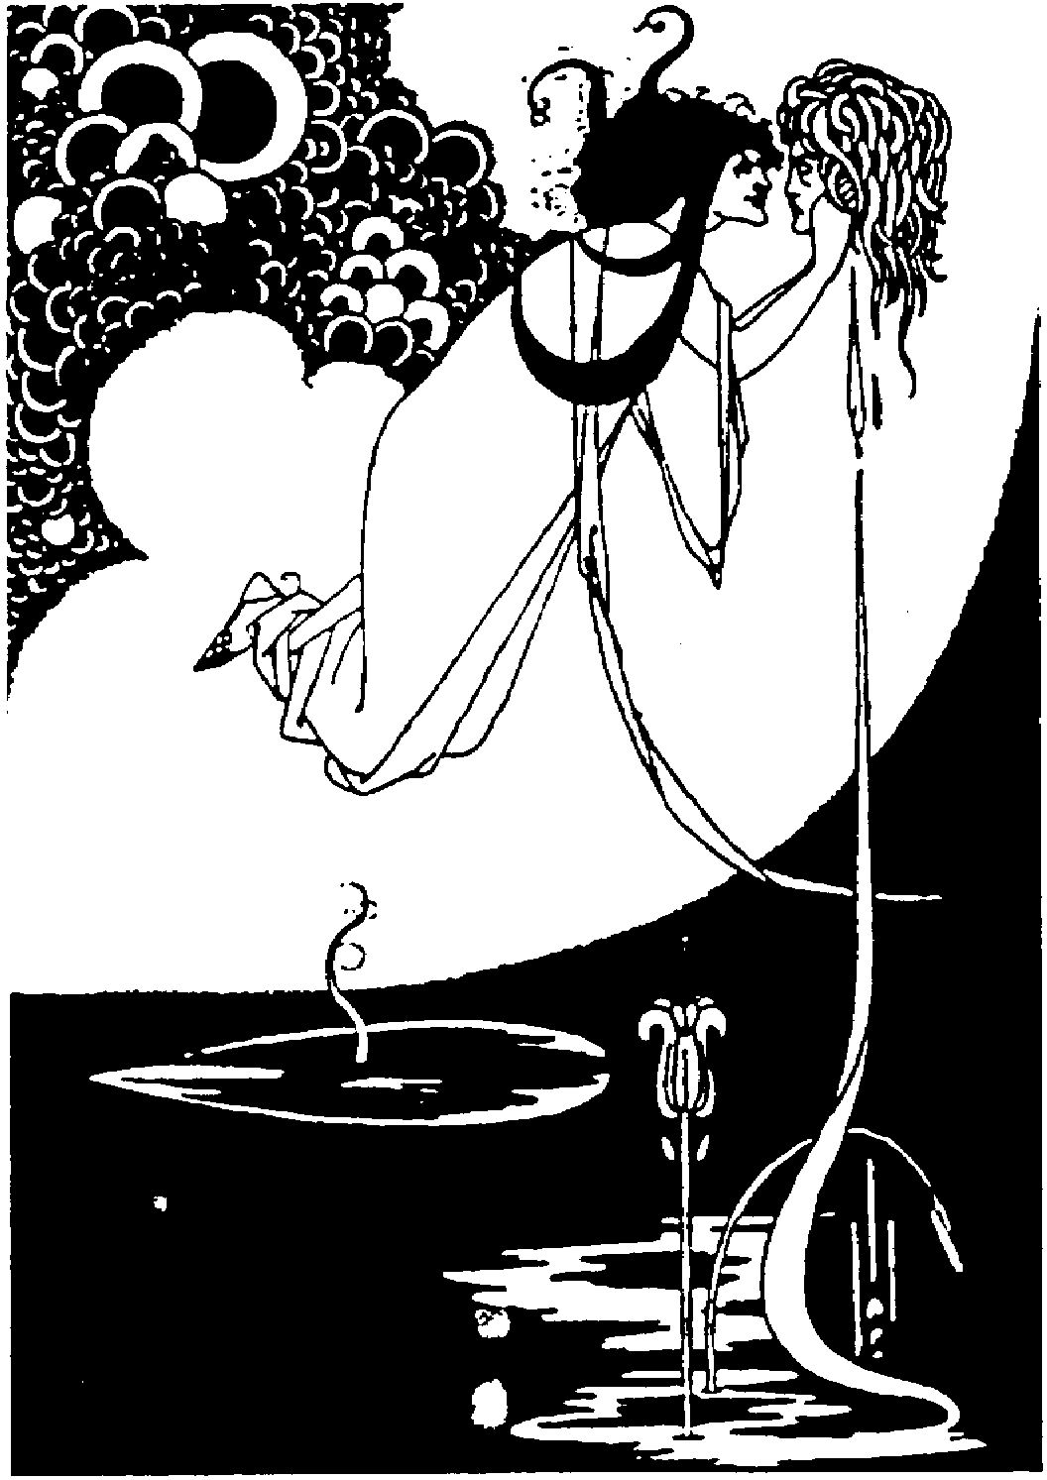
You can also see agreements as „rules“ or „norms“ - an interesting division for discussing politics, etc., as well. Rules, like laws, always happen or there is some punishment. Norms happen almost all the time, but when they don’t, it is not a crisis. It is just an exception. The more you can live with norms instead of rules, the more durable your open relationship will be. Norms are in essense flexible agreements.



Uncooperative Partners
It sometimes happens that one lover just does not want deal with any of the aspects of the other relationships, does not want to get the other lover on the phone, does not want to hear that lover’s name and has absolutely no interest in meating with them. This is an unstable situation, not unmanagable, but damaging.
The shared lovers options are severly limited here and they must watch their own feelings. If the new relationship becomes very important OR complex it may not be emotionally or ethically possible just to split your life and pretend this undiscussed relationship does nto exist. The “process perfect” approach is not simply to walk away. Instead try to give the uncooperative partner options (they will likely be hard ones like “open up some or i will have to go”), but if you can do this in good faith it is certainly better than abandonment.


Breaking up – Open Relationships End Too
Monogamy is simple. You are in love with someone for a while and someone comes into your life who appears more wonderful, you either break up the old relationship and start the new one, or you push away the new possibility (holding hidden resentments?) and hold onto what you have.
In a open relationship,you have another option, but - what if after facing six months of jealous or unworkable feelings you find you do not want to be in the old relationship anymore? Well, the old relationship will likely fall apart - but before it does, you should try to be clear about why. It is not enough to simply say "new is more wonderful than old, so i'll dump the old". This means falling into the monogamy trap. It assumes there is no balance possible - sometimes there isn't, but part of the commitment of open relationships is that you will try to stay in touch with those things which attracted you to the old relationship in the beginning.
You should try to celibrate your magic, find the "us". Sometimes it is possible to move apart and stay friends or sex partners occassionally, sometimes you need to move onto something different. But try to avoid the monogamy blindness, where you flee from your broken relationship, blaming the other and ignoring your responsibility or the changes you (or your partner) may have gone thru which make the relationship make less or no sense.
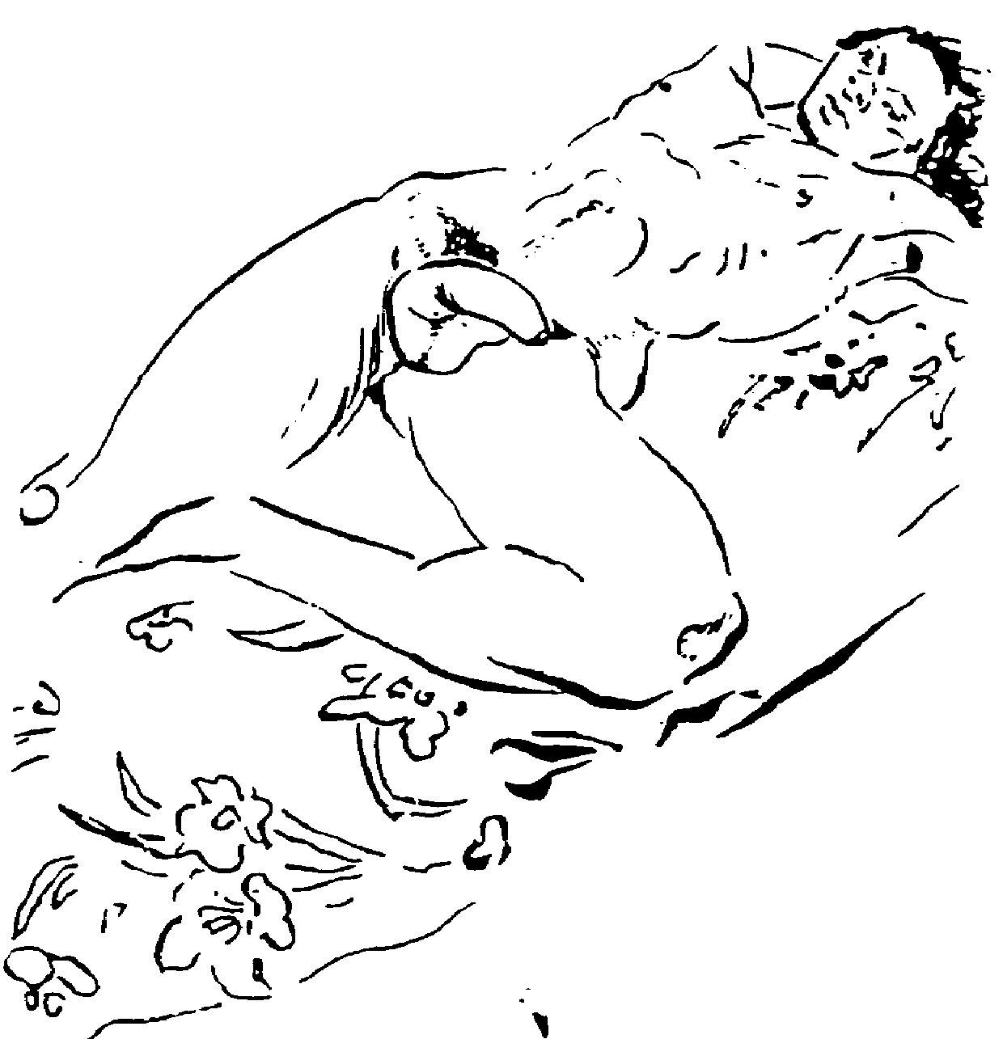
"Don't leave one lover for another." This is a key norm for open relationships. One of your basic responsibilities in open relationships to find the sense in each relationship based on itself, not the others.


Why Open Relations?
If it’s all this work, why bother with open relationships? In part it challenges part of our socialization: society’s standard is monogamy, a possessive contract which implies love is scarce, like CD players or hair driers, and once you’ve got it, you better grab it and hold it, because you don’t want to be without it. I think we can be more creative than this about our feelings.
The philosophy behind open relationships is, fundamentally, that we who are interested in them are complex folks. It is unlikely that any single person will fill all our needs/desires. If more than one intimate will be filling these needs and desires, it makes some sense to judge the rightness of sex for these relationships independently from other relationships.
So I believe the line society draws between having sex with someone you care about and not having sex with them is somewhat silly. Some meaningless relationships are sexual, some powerful intimacies are without physical contact. The former would be called „lovers“ and the later „friends“ in our common language - i find this more than stupid.

The idea behind open relationships is that each relationship is free to determine the best way to communicate. If it includes sex, that's fine. Because we have not escaped our socialization, we have to work with our lovers in order to accept other sex partners. But it is useful work, in helping us to understand our desires and insecure feelings and if we succeed, we set our lovers free, to come back to us out of true desire.
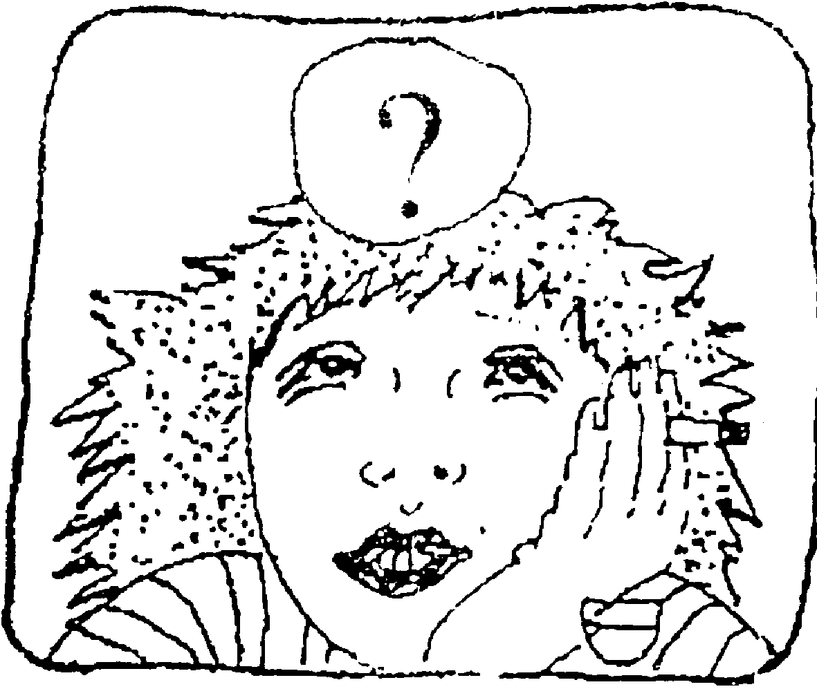

Getting There

At the point when you are able to overcome your jealous feelings, when you can be happy that your lover is enjoying being with someone else - there is a tremendous liberation which occurs. You stop holding tight, and love with open hands - this makes you much more attractive to your lovers, who will feel both free and secure. This starts a positive cycle - you feel better about yourself, and make lovers and friends happier too.

The Gift
In a secure open relationship, the gifts of having another lover become possible. A lover who was having trouble relaxing sexually was able to “break free“ through a partner who was more sexually experienced than me, and somewhat suddenly i found myself with a more passionate and expressive intimate. One of the most magical moments of my life was watching two of my lovers become lovers - very rare, very precious.

Grafix Credits
The following grafix came from Paramour Magazine

Artist Paramour, Volume, Issue, Page
Richard Dunn (cartoon) Vol 1, Iss 1, p25
Richard Dunn (cartoon) Vol 1, Iss 2, p24
Erica Chappuis (artwork) Vol 2, iss 3, p10
Richard Dunn (cartoon) Vol 1, Iss 2, p30
Auguste Haboush (drawing) Vol 1, Iss 4, p29
Andrew Savard (drawing) Vol 1, Iss 1, p3

You should subscribe RIGHT NOW at:
Paramour Magazine, PO Box 949, Cambridge Mass 02140-0008, USA (phone 1-617-449-0069), US$18 for 4 issues per year in USA, US$24 in Europe
The rest of the grafix were stolen from many places including advertisements - if they do not like it, they can sue us.


Fingerbooks explain big ideas using tiny pages and great pictures. Fingerbooks are @nticopyrighted - Change and distribute as you like.

* this handbook uses the word „lover” in the original sense: someone who is in love with someone else, who has a deep feeling of caring for their partner. The common use of the word „lover” these days means „sex partner” (for example, „They became lovers last night”). Even with this attempt to reclaim the word, i think our society is stuck with the „lover = sex partner” definition (in English at least, other languages have different problems). Sometimes i try to use „intimate” as a step beyond simple friendship while leaving the question of sex out of the description.

