2a) Creating a VM and adding Storage, Memory, and Network to a VM

Aim:
To create a vm and adding storage ,memory and network to a Vm in the
oracle virtual box

Steps:
- Open Oracle VM VirtualBox Manager and Click the "New" button
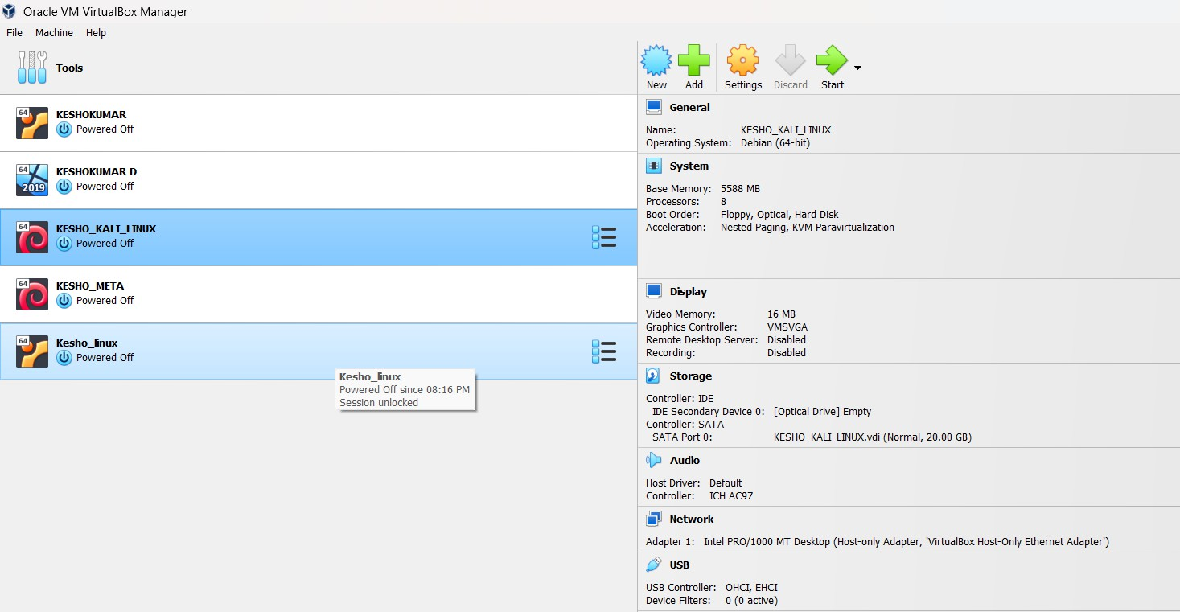
- Fill the name: (vigna169)Type: LinuxVersion: Ubuntu (64-bit) or your chosen OS and Click Next
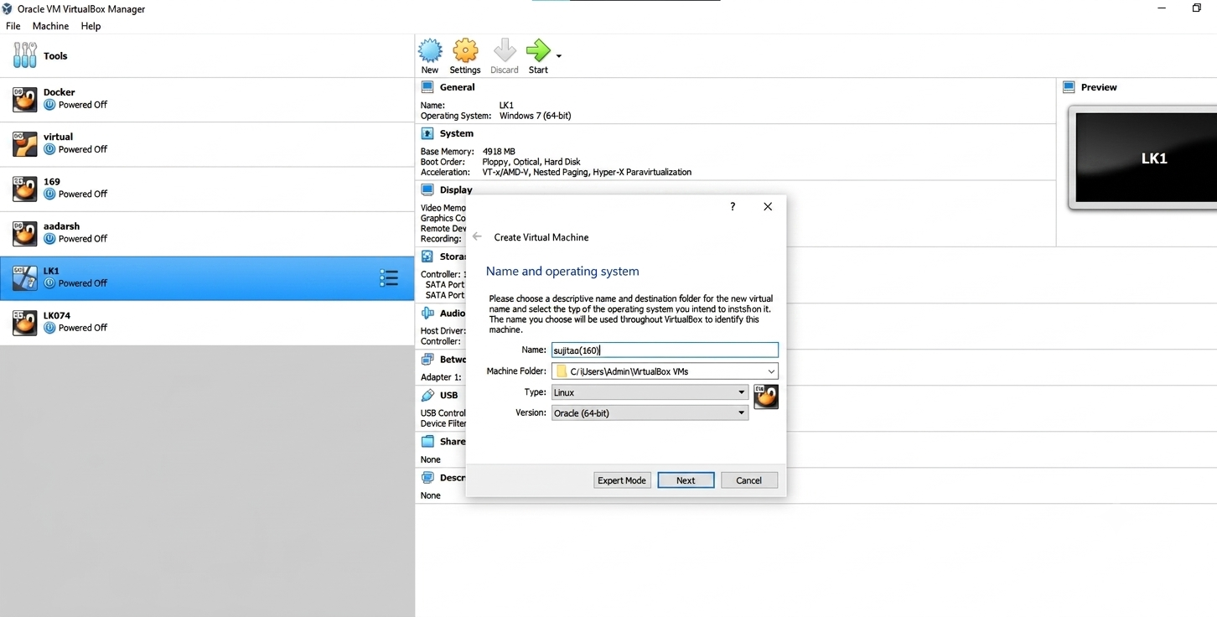

- Allocate Memory (RAM) .Set the memory size 4gb has been set below Don’t exceed 50% of your physical system RAMClick Next
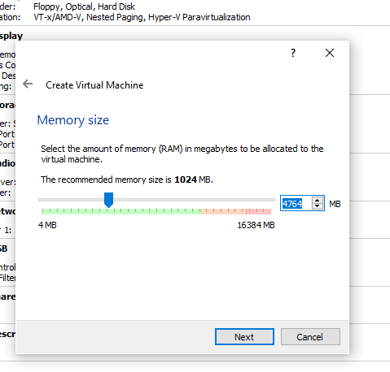

- Click use an existing virtual hard disk. Click NextDynamically allocated → Click NextSet disk size (e.g., 20 GB)Click Create
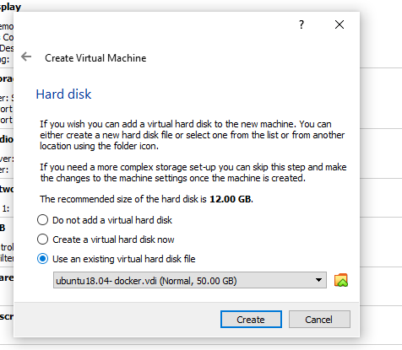

- Configure Network AdapterGo to Settings → NetworkEnsure Adapter 1 is:EnabledAttached to:Bridged Adapter (for internet + LAN access), orHost-Only Adapter (for communication with host only)Click OK Then new vm has been created
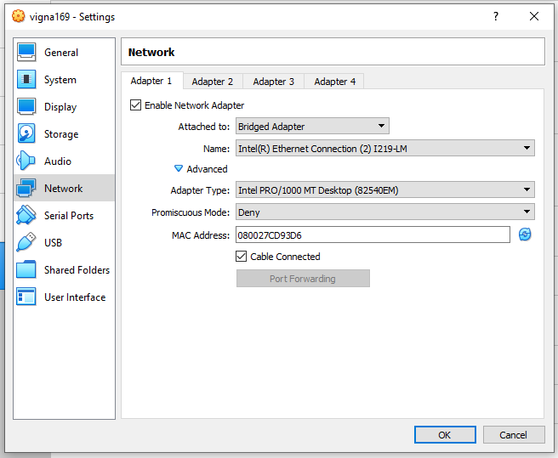

Execution of java program to test the execution time between vm (Ubunttu) and host(Windows)
- To find the sum of digits between 1 to max of long datatype Code:
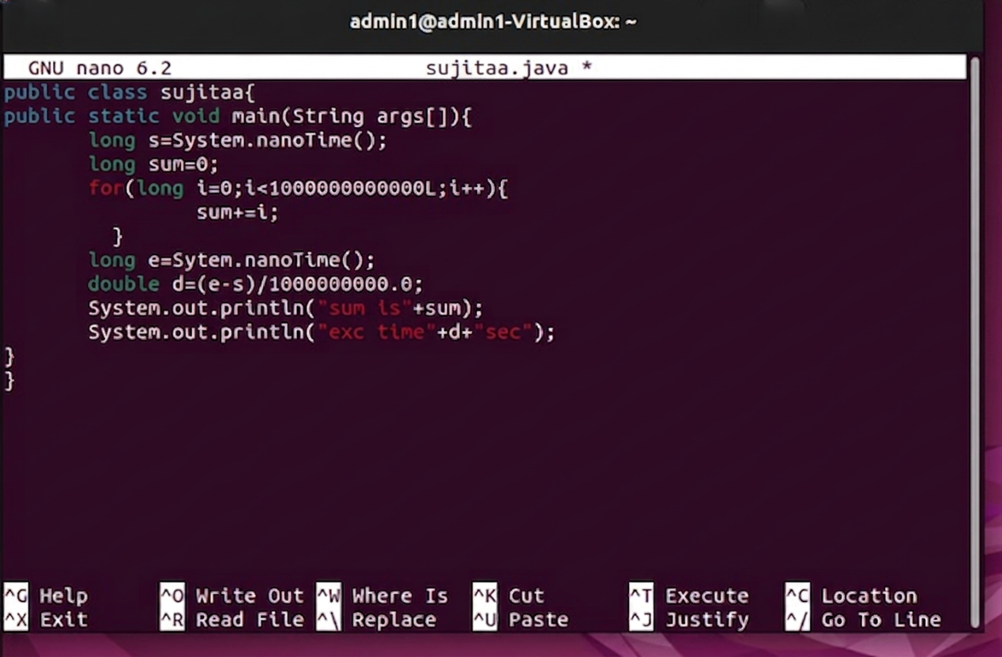

Execution time in Linux

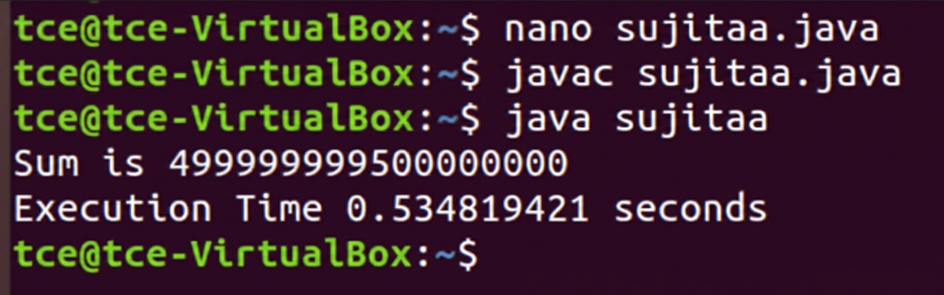

Execution time in Windows
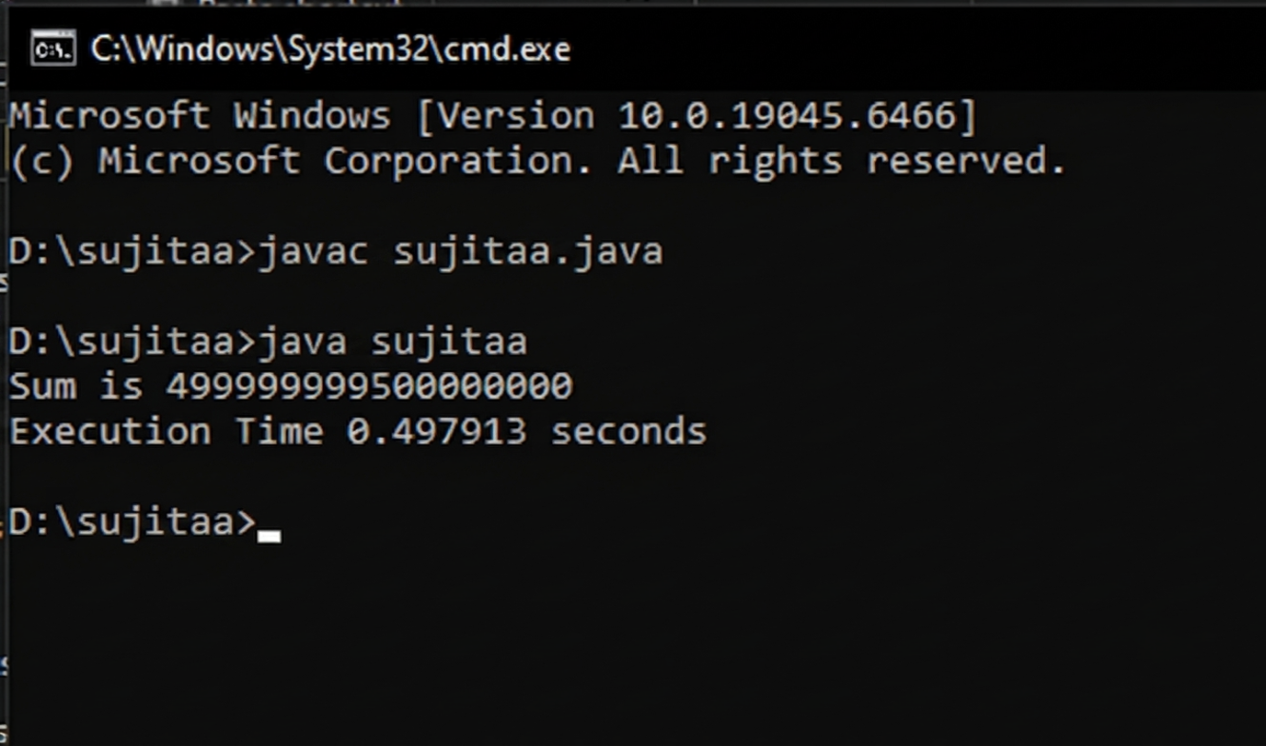
From the above the execution time in linux is 0.35 s where the time taken by the windows is 0.32 this clearly tells that the windows host is faster than the linux vm

RESULT:
Thus the Creation of VM and adding Storage, Memory, and Network to a VM has been created successfully and output has been verified

2b) VM-VM ping, VM-Native Ping
Aim:
To check the victim or target is alive between vm -vm and vm-native using the ping command .

Steps: Before Ping Commands
- Both VMs are powered ON.
- Both VMs are connected to the same network (Host-Only Adapter).
- Each VM has a valid IP address.
- Firewall is disabled or ICMP is allowed.

Find IP Addresses

In Ubuntu and Kali Linux
Open the Terminal and type:
ip a
Ubuntu (sujitaa) IP Address: 192.168.56.104
Kali Linux (sujitaa-160) IP Address: 192.168.56.103

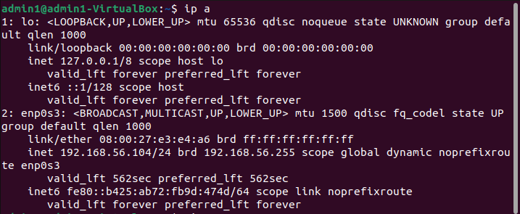
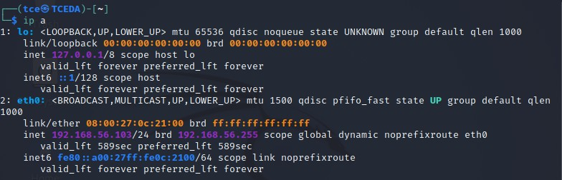

In Windows Host
Open Command Prompt and type: ipconfig
Find the IP address of the VirtualBox Host-Only Ethernet Adapter.
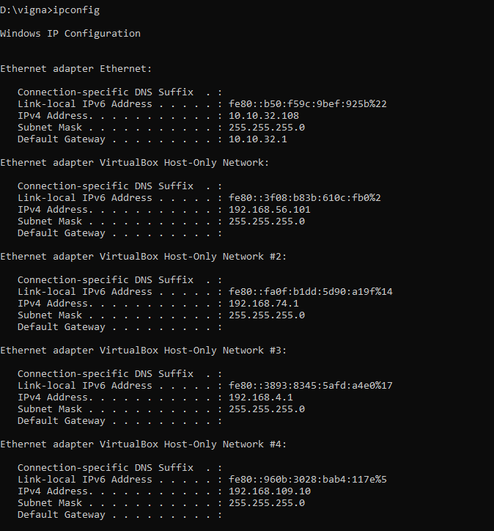

Network Configuration

To enable VM-to-VM and VM-to-Host communication in VirtualBox:
  - Open Oracle VM VirtualBox.
  - Select sujitaa (Ubuntu) → Settings → Network.
  - Enable Adapter 1.
  - Set Attached to: Host-Only Adapter.
  - Repeat the same steps for sujitaa-160 (Kali Linux).
  - Start both VMs.

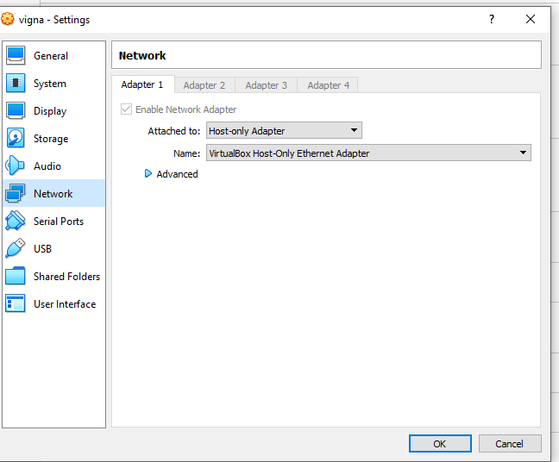
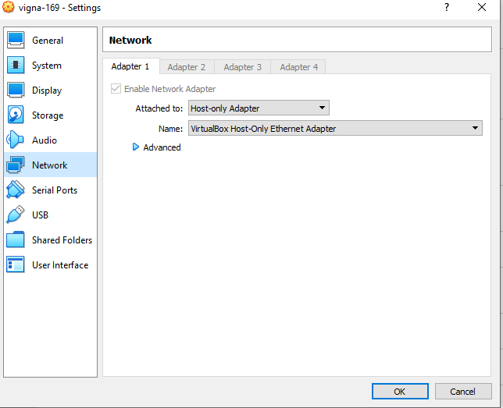

2) VM – VM
The experiment was performed using Ubuntu (sujitaa) and Kali Linux (sujitaa-160). Ping in Ubuntu
- To check whether Kali Linux is alive: ping 192.168.56.103

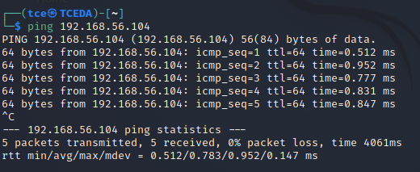
Ping in Kali Linux

- To check whether Ubuntu is alive: ping 192.168.56.104

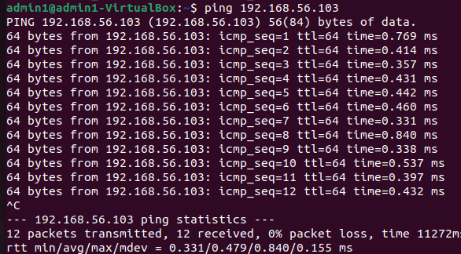
Ping in Ubuntu

Result
Thus, the victim or target system was successfully checked between VM–VM and VM–Native using the ping command. The communication between Ubuntu, Kali Linux, and the Windows Host was verified successfully, and the output was obtained successfully.

