**Introduction**

Good morning, everyone. Thank you all for taking the time to join today's meeting.

We are delighted to welcome our distinguished guests from AWS.

Before we dive into the discussion and turn **it over to our AWS team**

**I would like to lay out:**

Why we are here, who is here, key objectives from today’s meeting and some few guidelines on the scope of today's meeting with AWS

**Why we are here:**

WF in general and CIB in particular is in the building mode (from modernize infrastructure, product offering, meet regulation requirements risk, trading, pricing,): However, what slows everyone is the data mess because  data is central to everything we do.

This has prompted us to seek out and identify solutions that can revolutionize our approach to data management. In this quest, AWS has emerged as a potential collaborator with a proven track record of assisting large financial institutions in navigating similar challenges effectively.  
**The first two use cases that are relevant to CIB: JPMC Athena (more on compute calculation side) and JPMC Data Fusion (market data side)** -🡪

**Our main objectives for today's meeting are twofold**: to learn from AWS's experiences through the exploration of use cases and to delve into a specific use case that is relevant to our CIB

**Who is here:**

Today, we have a diverse group of stakeholders from across WF CIB. Joining us are stakeholders and their delegates from the CIB Markets business, our CIB Data Management organization, and our Technology teams. Each of you plays a crucial role in assessing and evaluating the capabilities that AWS solutions might bring to our firm.

**Few guidelines and expectations:**

**With that, I’d like to welcome our guests from AWS, who will be walking us through their capabiliti**es, particularly in the context of financial services. After the presentation, we’ll open the floor for questions and discussions

**With that, I’d like to turn it over to our AWS representatives to introduce** themselves and share their vision for how they can help us modernize and optimize our data architecture."

**Instructions during meeting**

**Post-Meeting Queries**: Should you have additional questions that we couldn’t cover today due to time constraints or because they were out of scope, please send them to me via email.

I will compile them and coordinate with AWS for the responses, or arrange a suitable follow-up discussion.

**Specificity in Questions**: Please ensure that your questions are directly related to the topics being discussed.

If you have queries that fall outside the immediate scope of today's topics, jot them down, and we can address them internally and set up a follow-up session with AWS.

To ensure our discussions remain focused and productive, I'd like to set a few guidelines on the scope of today's meeting with AWS

To ensure our meeting with AWS is as productive and efficient as possible, let’s adhere to the following guidelines regarding the scope and conduct of our discussion today:

**Stick to the Agenda**: Our agenda has been carefully curated to address specific challenges and opportunities with AWS solutions. Please keep all discussions aligned with the agenda topics to ensure all critical points are covered.

**Relevant Questions Only**: Questions should be directly related to the topics at hand. This will help us delve deeper into each subject and make the most of the expertise AWS brings to the table. If you have broader or unrelated questions, please hold them for a more appropriate setting or send them to me afterwards.

**Conclusion**

**As we conclude our productive sessions with the AWS team, I'd like to express our sincere appreciation for the insights and expertise shared toda**y.

The depth of expertise presented today has been invaluable, and it gives us much to consider as we evaluate our next steps.

**Next Steps – Reflect and Evaluate**: While today’s sessions have been highly informative and promising, it is important for us at WF to convene with our internal teams to discuss the insights gained from today's meeting and outline the next steps

**Maintaining Open Channels**: Moving forward, we will keep the lines of communication open with AWS. This will enable us to clarify any further details and address additional questions as our internal discussions progress.

it is just the beginning of a thoughtful deliberation process. We look forward to delving deeper into these possibilities and assessing our path forward.

Thank you to everyone involved for a productive session.

**PoC**

**AWS outlines:**

"Can you outline how AWS typically approaches proof of concept projects with potential banking clients where you don't have account with?

**Cost and Resource Allocation:**

What are the expected costs associated with conducting a PoC with AWS? What resources, if any, would be required from our side?

**Customization and Relevance:**

How customized can a PoC be to address specific challenges or use cases relevant to our bank

What is your approach to customizing cloud solutions to fit the unique needs of each banking client

**Assuming the PoC is successfu**l, what does the transition from PoC to full implementation look like

**How does AWS handle data security and regulatory** compliance during the PoC?

These questions aim to secure a clear framework for engaging in a PoC with AWS,

**allowing your C-suite to make informed decisions based on preliminary results rather than commitments based solely on conceptual promise**s.

**Some notes**

Good morning , everyone. Thank you all for taking the time to join today's meeting.

Good morning , everyone. We are delighted to welcome our distinguished guests from AWS.

Thank you all for being here, and I look forward to a beautiful discussion.

As we navigate the evolving landscape of financial markets, the role of data has become paramout.

data, as you know, data is central to everything we do, from real-time trading decisions to risk modeling and regulatory reporting. However, we've faced persistent challenges around data silos, scalability, and governance.

Our bank, like many others in the industry, has been observing the data solutions offered by AWS to some of our peers, including JPMorgan with their Athena platform and Fusion Data

We’ve been particularly impressed by how AWS has supported some of our peers like JP Morgan, with solutions such as Athena and the Fusion Data platform

Our goal is to understand the specific ways in which AWS can help us overcome our data bottlenecks and create a more agile and robust market data environment, similar to what we've seen at other leading institutions.

**With that, I’d like to welcome our guests from AWS, who will be walking us through their capabiliti**es, particularly in the context of financial services. After the presentation, we’ll open the floor for questions and discussions on how we can tailor AWS solutions to meet our unique needs.Thank you again, and with that, I’ll hand it over to our AWS team."

Given our focus on improving the scalability, flexibility, and integration of our data systems, we are interested in hearing more from AWS about how their technologies could support our objectives. In particular, we’re keen to explore how AWS might help us implement advanced solutions like Data Mesh architectures

**Before we dive into the discussion**, I would like to lay out a few key objectives for today’s meeting:

**With that, I’d like to turn it over to our AWS representatives to introduce** themselves and share their vision for how they can help us modernize and optimize our data architecture."

#############################

Before we dive into the discussion

give a pitch that lays out

* 1. an overview of why we are here: in our transformation journey at JPMC, we find ourselves stumbling with data mess. In exploring potential solutions, we have observed that AWS has helped/supported/worked with large financial institutions that had similar challenges.,
* 2. who is here: From JPMC, we have all stakeholders and their delegates from CIB Markets business , CIB Data management organization, and from Technology who will be involved in assessing and evaluating AWS solutions capabilities.
* 3. main objectives from today's meeting: Learn: explore use cases; , hear about one relevant use to CIB.
* 4. some expectation: Due to lack of time and since agenda

**Today, we have a diverse group of stakeholders from across JPMorgan Chase. Joining us are representatives and their delegates from the CIB Markets business, our CIB Data Management organization, and our Technology teams. Each of you plays a crucial role in assessing and evaluating the capabilities that AWS solutions might bring to our firm.**

**Our main objectives for today are twofold**: first, to learn from AWS’s experiences through the exploration of use cases that are directly applicable to our needs, particularly within the CIB. We aim to understand how AWS has enabled similar institutions to overcome their data challenges, which will give us insights into possible solutions for our own scenarios.

**Given our tight schedule today and the packed agenda, our expectation is to focus primarily on the most relevant discussions that can lead to actionable insight**s.

We look forward to a detailed presentation from AWS, highlighting specific solutions that have been successful, and engaging in a robust Q&A session.

This will help ensure that we cover the critical elements that can inform our decision-making process moving forward.

As we advance on our transformation journey here at JPMorgan Chase, we find ourselves facing significant challenges related to the complexity of our data environment. Our encounter with what we term as the 'data mess' has prompted us to seek out and identify solutions that can revolutionize our approach to data management. In this quest, AWS has emerged as a potential collaborator with a proven track record of assisting large financial institutions in navigating similar challenges effectively.

Today, we are joined by an esteemed group of stakeholders from across our organization. We welcome members and their delegates from the CIB Markets business, the CIB Data Management organization, and our Technology teams. Your insights and expertise are invaluable as we assess and evaluate the capabilities of AWS’s solutions in addressing our specific needs.

Our main objectives for today's meeting are twofold: **to learn from AWS's experiences through the exploration of use cases and to delve into a specific use case that is relevant to our Corporate & Investment Bank.** This focused approach will allow us to gain a deeper understanding of the potential applications of AWS technologies within our own frameworks.

Given the constraints of our schedule today and the broad scope of our discussion, **please note that today's session is designed to be strategic rather than technical**. We aim to lay the groundwork for further technical deep dives in future interactions.

What is your approach to customizing cloud solutions to fit the unique needs of each banking client

What were some of the primary obstacles faced by these banks during their digital transformation, and how did AWS assist in overcoming them?

Can you describe a scenario where AWS helped a bank navigate a complex regulatory landscape during a technology rollout

Everything that we do are built on solid data foundations.

This is where the complexity is, and this is where the hard work is. And building a solid data foundation for your company is the first step in deriving value and insights from your data

Unfortunately, sometimes this can be challenging, because you have to break down the silos that exist in your organization.

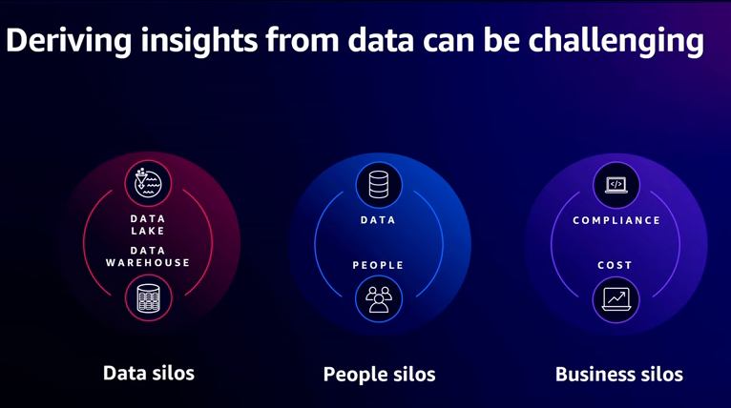

You may need to break down the data silos where your data lives across disparate databases, data warehouses, data lakes, and even third-party systems

You may need to break down people silos by making the data and analytics self-service, so it's easily accessible to everyone inside your organization, including your less technical people in your organization

you may need to break down business barriers that prevent cross-account across organization data sharing due to compliance issues or cost attribution.

To overcome these challenges, companies of all shapes and sizes are building decentralized, end-to-end data strategies that

* let **data producers** with domain expertise build and share curated data products across their organization.
  + In addition, data producers are responsible for their own infrastructure and for meeting business-defined SLAs around data timeliness and data quality.

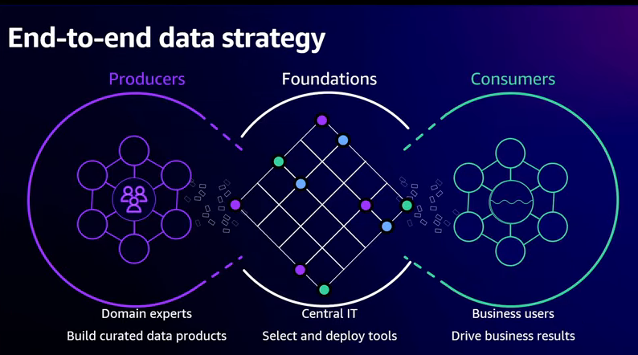

* **Data Consumers:** These curated data products are then utilized by data consumers who understand business priorities and use these data products to drive business results.
* **all the sharing has to be governed** in order to ensure that organizations comply with applicable regulations.

To implement this strategy, customers often use a multi-account architecture on AWS. Data producers use separate accounts to isolate data products from each other

**To facilitate the sharing of these data products** across the organization, **the foundation's team typically provides discovery tools, like a business data catalog**, tools for performance management,

and they are responsible for defining the governance, auditing, and compliance requirements for the entire organization.

**Then consumers can now discover and subscribe to these data assets**

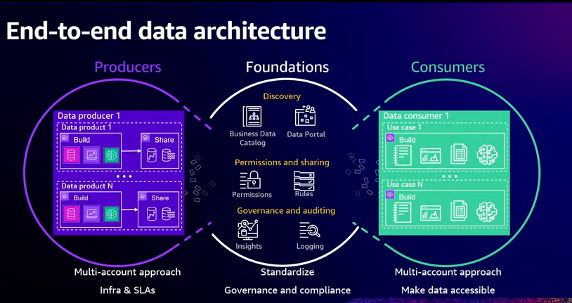

**To help you build your end-to-end data strateg**y, AWS **offers a comprehensive set of purpose-built services for a variety of use case**s, optimized for cost and performanc

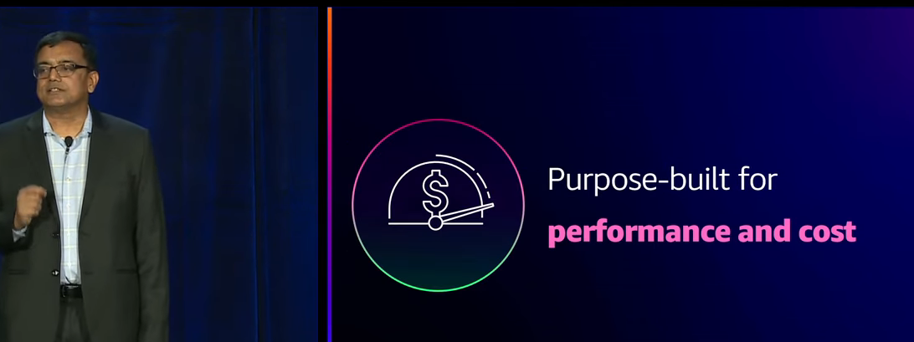

* And many of our services support multiple deployment options, so you can get started quickly by using a serverless option
* or you can optimize the cost performance of your workloads by running on pre-provision compute, Kubernetes,spot instances, or reserved instances

**One size does not fit all.**

, a database is not appropriate for every use case, just like a data warehouse is not appropriate for every use case, just like even a data lake is not appropriate for every use case.

i**t's common for customers to start with one service or an architectural approach**,

and then as they understand their workload and the usage patterns for that particular application, to switch to another service or another architectural approach, becau**se it is better suited for the task.**

For example, **they may start off with a relational database, because they understand it**, and they can get started with it quickly, but then, switch to a non-relational key value store, because it is a better fit for their use case and allows them to really fine tune the cost performance

**AWS provides a comprehensive set of services to help them store and utilize data,** to help them integrate the data across their organization, so they have visibility into their entire business and customers and to help them govern their data assets, so they can comply with their regulatory obligations.

Multi-account AWS structure to segregate