I still don't get how CMO sequential work in Covid(march 2020) vs now in terms of prepayment and duration changes

**ChatGPT said:**

Great question—and it’s a key concept for understanding **why CMOs (Collateralized Mortgage Obligations)** had such **large PnL impacts in March 2020** vs. today.

Let’s walk through this step by step, using **sequential CMOs** as the example structure.

**1. Quick Refresher: What is a Sequential CMO?**

A **sequential-pay CMO** is structured so that:

* **Tranche A** receives all principal payments **first**
* Then **Tranche B** begins receiving principal
* Then **Tranche C**, and so on...

**Prepayments from borrowers (early mortgage payoffs)** speed up how fast tranches are paid down.

**2. What Happened in March 2020? (COVID Shock)**

**a) Prepayments Dried Up**

* In March 2020, market panic and rate volatility **froze mortgage refinancing**.
* People didn’t refinance or move due to uncertainty and lockdowns.
* **Result:** Prepayments **slowed down dramatically.**

**b) Duration Extended**

* When prepayments slow, **Tranche A lives longer than expected** → all other tranches are **delayed**.
* This is called **extension risk**.
* **Sequential tranches like B and C had their expected maturity extended significantly.**

**c) Price Impact**

* Investors who expected short maturities suddenly held **longer-duration, riskier bonds**.
* Rising credit spreads and collapsing liquidity made prices fall sharply.
* Delta-Gamma models couldn’t capture this extension effect properly → **PnL losses were larger than modeled**.

**3. What’s Happening Now (2024–2025)?**

**a) Prepayments Are Picking Up Again**

* Rates have come down from highs, and housing activity is more stable.
* Homeowners are refinancing or moving again.
* **Result:** Prepayments are returning to normal or slightly elevated.

**b) Duration is Shortening Again**

* Tranche A is receiving principal **faster**, and Tranches B/C are now moving toward repayment as expected.
* **Extension risk is decreasing**, and durations are **shorter and more predictable.**

**c) Price Impact**

* Because cash flows are more stable and predictable, the **market prices these tranches with lower convexity and more confidence**.
* SVaR models are currently **less stressed**, and PnL swings are more in line with expectations.

**4. Key Differences: March 2020 vs. Now (in Summary)**

| **Factor** | **March 2020 (COVID)** | **Now (2024–2025)** |
| --- | --- | --- |
| **Prepayments** | Dried up (due to fear & lockdowns) | Recovering / Normalizing |
| **Extension Risk** | High – durations extended | Lower – durations more predictable |
| **Tranche Duration** | Much longer than expected | Shortening with resumed cash flows |
| **Price Behavior** | Sharp drops due to duration surprise | More stable, aligned with rate movement |
| **SVaR PnL Volatility** | Exaggerated by model breakdown | Lower, models perform better |

**Takeaway:**

In March 2020, **prepayment slowdown** and **duration extension** caused sequential CMO tranches to **"lock in risk"** unexpectedly. Today, with normalized prepayments, the structure behaves more predictably, and **SVaR and PnL impacts are more aligned with model expectations**.

Would you like a diagram to visualize the sequential CMO payoff and how it shifts in these two scenarios?

Yes please. Next i want you to explain how when the model starts to estimate faster payments, the duration got shorter, how that would lead the model to predict large cmo shifts in Covid.

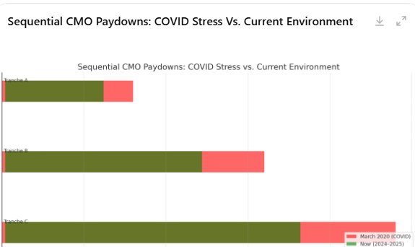

The chart above illustrates how **sequential CMO tranches (A, B, C)** experienced **delayed repayments in March 2020 (COVID stress)** compared to **shorter, more normal paydowns today**:

* In **March 2020**, prepayments dried up → **Tranche A's payoff slowed**, delaying Tranche B and C significantly (longer durations).
* In **2024–2025**, prepayments are healthier → Tranches are repaid **faster and more predictably**.

**Now to Your Question: How Faster Prepayment Estimates Caused Large Model-Based CMO Shifts in 2020**

This may seem counterintuitive, but here’s the logic step-by-step:

**1. The Model Reacts to Macro Changes (e.g., Fed Rate Cuts)**

When rates dropped sharply in March 2020, the model (e.g., Intex/COE) **initially interpreted this as a signal** that prepayments would rise (people refinance cheaper loans).

**2. Faster Prepayments → Shorter Duration**

The model assumed that mortgage borrowers would start **prepaying faster** → meaning CMO tranches would **get their principal back sooner** → so **duration would drop**.

**3. Duration Drop Triggers Price Reactions in the Model**

If the model expects a **shorter cashflow horizon**, it:

* Adjusts projected **duration** and **convexity**.
* Updates price sensitivities (delta/gamma).
* Projects that CMO prices should move **more** per unit of spread change (i.e., more convex behavior).

**4. Reality Didn’t Match the Model: Prepayments Collapsed**

But in the real world:

* **COVID lockdowns froze mortgage activity**.
* Despite lower rates, **no one was refinancing**.
* So prepayments **didn’t actually increase**—they dropped.

**5. Mismatch Between Model & Reality = Large PnL Moves**

* The model assumed **short duration** → made risk factor shocks behave like they were hitting a short bond.
* In reality, the bonds behaved like **longer-duration assets** → more sensitive to spread/rate changes.
* This mismatch caused **large mark-to-market PnL swings**, especially for:
  + Tranche B and C (exposed to both timing risk and structural convexity).
  + SVaR shocks calibrated to **model-based shifts**, not actual observed behavior.

**Key Insight:**

**It wasn’t just the model estimating faster prepayments — it was the model being wrong about them**, causing **large misalignments in duration and convexity**, which amplified the PnL impact when stress VaR scenarios hit.

Would you like a follow-up chart to show how model-estimated vs. actual prepayment paths diverged during 2020