Hello, everyone. It's a pleasure to be here.

Fusion by JP Morgan is a managed data service designed for institutional investors, such as asset owners and asset managers. Like everyone else, we are very focused on leveraging analytics and AI to both reduce their costs and improve their returns.

Technologies like AWS are evolving at an incredible pace, unlocking really powerful analytics and AI for end investors,

but **what slows everybody down is the data**

**Data, by default, tends to be dirty. It's very personal to the organization. It's poorly structured, difficult to understand, and normally takes an army of people to fix**.

**If we think about data within an organization, it's typically buried inside databases** in a multitude of tables. **It first needs to be extracted and converted into datasets in order to make it useful.**

**Once it's in datasets, that data needs to be easy to discover and easy to access programmatically**. Following that, rather than every consumer having to deal with a normalization problem when they get access to the data, it is preferable, through shift left, that the data is normalized on the way in, whether it comes to structure or identifiers, so users can benefit from that.

**Ideally, that data should then be integrated, linked, and modeled, so the data can be joined with minimal effort**.

**On top of that, you really need data management and data quality capabilities, so users can opine on individual data points and make amendments with the appropriate controls**. The combination of the entire solution, whether it's access, discovery, normalization, linkage, and management, creates a virtual data lifecycle.

 we are relentlessly focused on solving this entire problem, so the client can really benefit from clean, ready-to-use data, delivered directly into the technology of their choice

**With this, clients can deliver their business results in a matter of days and weeks** instead of months and years. Moving forward, what is our approach?

**Our approach is to source all the data from all kinds of vendors, like S&P**, we just heard from Sally, and service providers, like JPMorgan, across the entire range.

**It could be reference data, pricing, positions, transactions, company financials**, benchmarks, you name it. **All of the data flows through Fusion data mesh, and then immediately becomes accessible through rest APIs**,

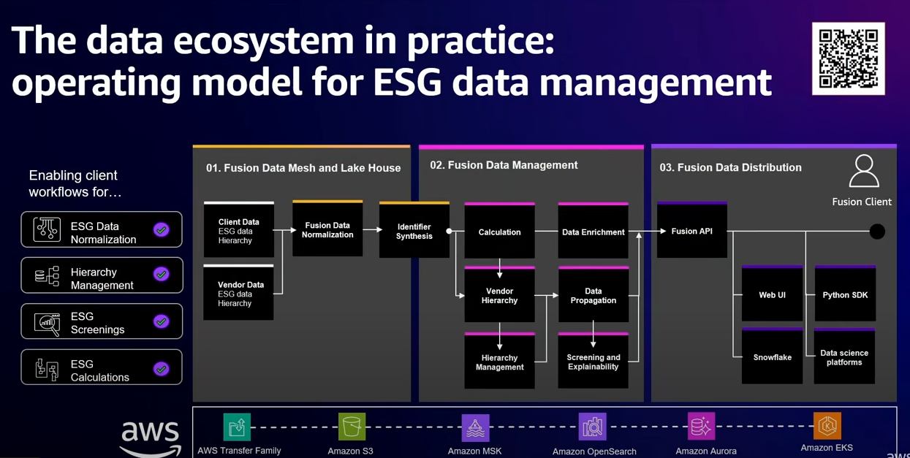

Let's look at an example where Fusion is being leveraged to use a really complex problem, which is around ESG data management. For an institutional investor, they would typically need to connect to lots of data sources to bring the data in to their system and then deal with all the idiosyncrasies, because data across providers is inherently different, with gaps and different identifiers.

Fusion takes the responsibility of connecting to these providers and sources, bringing the data in, doing that normalization, so all the data looks identical. Fusion then allows people to go in and express their opinions. They can go and change hierarchies, do different data propagation, make data overrides to make the data their own and customize to the way they think about it.

This data is completely normalized, so investors can save up to 90% of their time that they would typically spend on the data wrangling process. In addition to that, investors can apply their own opinions.

They can go in and express their opinion. That opinion then flows to the right person to approve, and once approved, that then becomes the official source with the client's opinions recorded. Then we solve a really hard problem. In order to query data, very often, users have to be familiar with thousands of tables with the primary keys and the foreign keys, figuring out how to join the data.

With Fusion, we take that all away from them. They can just come in here, express their intent in terms of what data they want to receive and what attributes they want to get. Then regardless of the source, we pull all the data in and deliver it to their destination. In this case, with this screen, they can actually describe their own data propagation rules.

Because we've done the normalization in advance, it's very simple to just set up that calculation, and it just works, and that data runs every day.

It's preserved with full lineage, so people can trace that back all the way to understand how it was manufactured

Using this process, we effectively achieve three things. We give the client a fully managed data service, where we combine the technology, the onboarding of data, the data management, the data modeling within our warehouse across all the data an investor can care about, and this really helps them accelerate and solve the data problem, enabling them to go with analytics.

They get greater choice. They only pick the services they want to really accelerate their specific data and analytical outcomes. They get speed, because rather than go and solve the problem in months and years, they can do it in days and weeks, and they get trust

First, as you know, it's elastic, and it's reliable, which means we can scale up and down, both in the short term and the long term for what's required. It's got a diverse product set with a lot of very new innovations.

That allows us to test things out for market fit before we really double down and invest on them.

We get expert guidance along the way. In addition, their network of partners allows us to really adopt strategic partners really quickly and onboard them fast

As we went on the Fusion journey with AWS, they really helped us in a few key areas that allow us to be successful. The first: the infrastructure was ideal, because we were able to go to market with our first launch in just a couple of months of work by the development teams. They allow us, through their SaaS experts in AWS SaaS Factory to be able to benefit from a lot of that knowledge that we can leverage.

Their architecture solutions teams helped us to architect and design a use case for a very complex financial data solution, and that guides us in how we've really built out the solution, and their day-to-day on-the-ground expertise really makes sure we can tune the products to give our users

#######################  
so just to calibrate us that's really about driving our products through true customer centricity driving agile ways of working through our teams

to give you a little bit of uh background the markets business in in JPMorgan is focused on providing largely corporate and institutional investors the marketplace to trade Financial products like Equity stocks FX um currencies Commodities

in terms of the business itself you know we were sort of number one

we're focused on today is on on Athena which is the Strategic trade management risk management and pricing system for for the markets business in in JPMorgan so as a result it is one of the most critical applications and platforms

it is one of the most critical applications and platforms that we have to sort of focus on

some of the numbers on this on this slide indicate the complexity that we're

dealing with

any changes that we want to make in this environment **is highly complex** because it impacts not just the developers that are working on this platform it impacts the business outcomes and it impacts the way that we serve our clients so

we're constantly evaluating we recognize that change is constant and that we want to sort of pivot to the Future and so we've listed out some of the challenges that we think we have and what we think will make us go faster

Cloud but more importantly making sure that we're doing it safely and securely and that our Focus hasn't been lift and shift  we're really trying to do this in a transformational way and so in ways that takes us a little bit more time

we are just about to I think start to really make some significant momentum or have some significant momentum there in our Cloud Journey

we are early in the journey we have migrated already about 15 of our overall workload and we'll get to about 20 this year um but we are hoping to start really making the greatest amount of progress

so we've been spending a lot of time not just in migrating to public

Cloud but more importantly making sure that we're doing it safely and securely and that our Focus hasn't been lift and shift we're really trying to do this in a transformational way and so in ways that takes us a little bit more time

so all of our new technology though is all being built you know containerized we want to be able to Port it very easily take advantage of the best cloud offering

again early but we are just about to I think start to really make some significant momentum or have some significant momentum there in our Cloud Journey

at's very data driven will be very data rich and our ability to do that really well will be defined by our ability to look at data and get those you know help provide true insights that help them