how to accelerate modernize data solution

should I build data platform from scratch

build your own data solution issues

<https://www.datadynamicsinc.com/blog-considering-cloud-migration-here-are-6-strategies-to-choose-from/>

<https://sandeeptol.medium.com/an-approach-to-cloud-transformation-and-cloud-migration-635550949249>

An organization’s chosen strategy directly affects the amount of work involved in migration

. Since the world has been experiencing a sudden movement towards digitalization, it’s no surprise that [90 percent](https://www.forbes.com/sites/bernardmarr/2018/05/21/how-much-data-do-we-create-every-day-the-mind-blowing-stats-everyone-should-read/?sh=4cccfc4b60ba) of the data in the world has been generated just in the last two years.

Steven Orban of Amazon Web Services in 2016, the five original strategies – Rehost, Refactor, Revise, Rebuild and Replace – were revived and adapted, adding a sixth.

* **Rehost (lift and shift).**

Lift-and-shifting, or rehosting, makes use of infrastructure-as-a-service (IaaS). Data and applications can be redeployed to the cloud server as needed. For organizations not familiar with [cloud technologies](https://www.statista.com/statistics/871513/worldwide-data-created/), it is an easy process. For example, despite not implementing any cloud optimizations, GE Oil & Gas found that it could rehost its applications and save roughly 30% of costs.

**Ideal for:** Legacy migrations, teams with limited cloud skills.

**Pros:** Lower risk of breaking applications, faster and easier migration.

**Cons:** Applications might be less efficient in using cloud resources and more challenging to scale up and down.

* **Replatforming**

Through re-platforming, apps can be configured to be more compatible with the cloud environment without changing their core architecture.

Replatforming requires a deeper insight into an application or virtual machine to be migrated than Rehosting but does not require the complexity and effort of Rearchitecting.

**Ideal for:**App developers commonly use this approach to change the way apps interact with databases to run on managed platforms like Google CloudSQL or Amazon RDS.

**Pros:**Using re-platforming, applications can benefit from cloud capabilities such as auto-scaling, managed storage and data processing services, and infrastructure as code (IaC). Cost-effective as it does not require significant investments

**Cons:**The scope of the work can grow, and changes must be made aggressively.To run the system in the cloud, some level of automation that provides some level of flexibility is required.

* **Refactor**

Refactoring, or a re-architecture, is the process of looking at existing applications and leveraging cloud-native features and services from the coding or architecture perspectives.   This strategy can also be the most worthwhile if you have a good product-market fit despite being expensive. For example, enterprises can leverage Azure SQL Database Managed Instances and Azure Container Service through refactoring when using public clouds such as Microsoft Azure. Additionally, enterprises can help re-architect, refactor, and rebuild their Azure apps using Azure App Service, Azure Functions, and Logic Apps.

**Ideal for:** Applications that are business-critical and sensitive, where disruption of ongoing functions is a concern, but where it is necessary to improve or modernize the infrastructure.

**Pros:** It’s quick and easy but allows you to upgrade your infrastructure by integrating DevOps automation and switching to container deployment.

**Cons:** The application cannot be split into microservices, which can provide significant efficiencies in the cloud

* **Retire**

A business needs to identify assets and services that can be retired to focus on widely used services and provide immediate value.

**Ideal for:** In cases where the application’s capabilities are redundant or no longer needed, it makes sense to disable it.

**Pros:** An opportunity to eliminate obsolete applications from your portfolio. Save money and other factors associated with outdated applications.

* **Retain:**

Migration may not be feasible for all applications, platforms, or data. It’s not uncommon for organizations that consider migrating to the public cloud to realize that they’re better suited for hybrid cloud deployment, as some of their existing architectures are still valuable in-house.

**Ideal for:**   When organizations deploy hybrid clouds, retaining is often used to maintain business continuity throughout long-term migrations. Heavily invested in on-premises applications, the legacy app is not compatible with the cloud and works well on-prem.

**Pros:**Revisits complex apps later

* **Repurchase:**

An organization may decide to switch to another product, ending current licensing and repurposing services on a new platform. Typically, moving to SaaS (Software as a Service) is the solution. Essentially, it involves changing your licensing agreement with the cloud provider; you stop the on-premises license and take on a new one with the cloud provider.

**Ideal for:**You are replacing software for standard functions like finance, accounting, CRM, human resource management, ERP, email, content management systems, etc. Legacy applications that are not compatible with cloud services.

**Pros:**Cloud-based apps are now more efficient, and app storage and maintenance costs can be reduced.

**Cons:**When repurchasing, you might face training staff and vendor lock-in challenges. Cloud-based platforms are less customizable and offer less control.

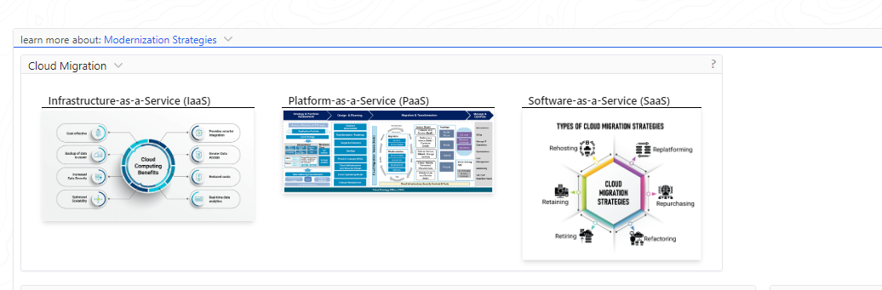

<https://medium.com/the-modern-scientist/data-ingestion-part-2-tool-selection-strategy-07c6ca7aeddb>

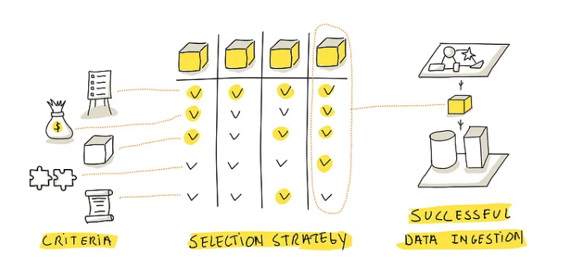

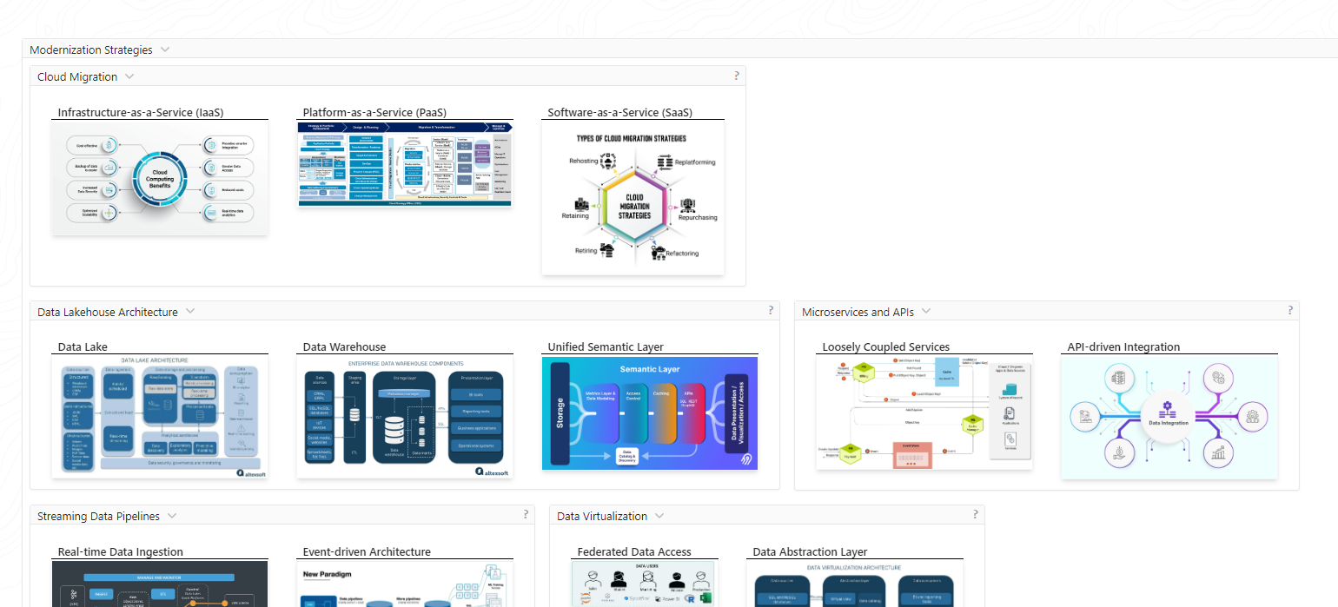

<https://blogs.oracle.com/analytics/post/increase-data-literacy-and-accelerate-self-service-analytics-with-data-catalog>

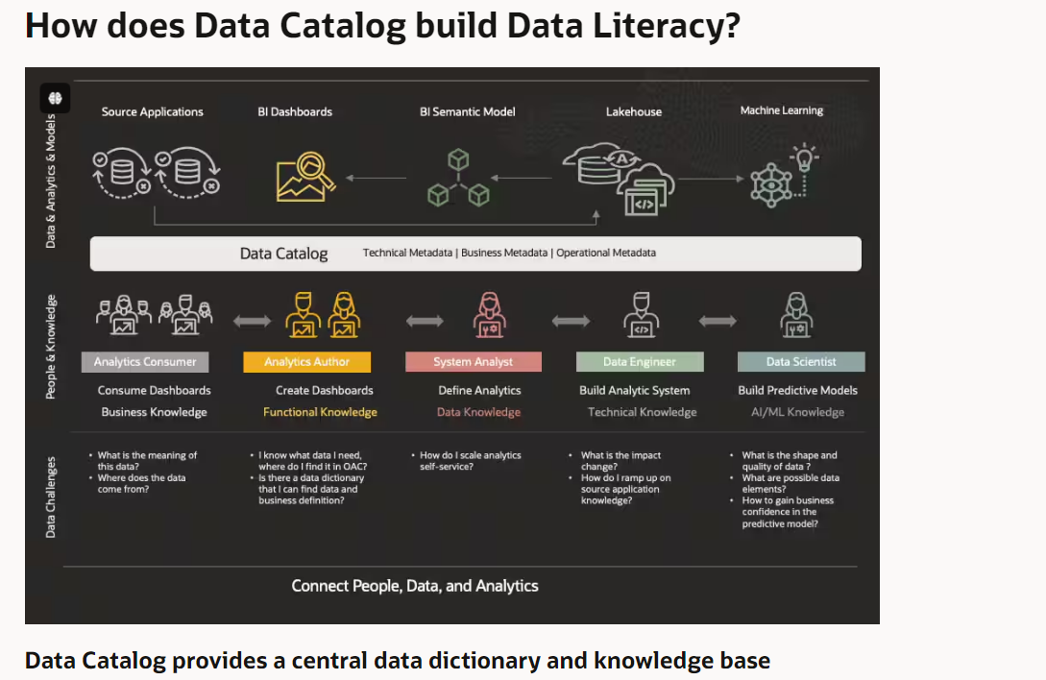

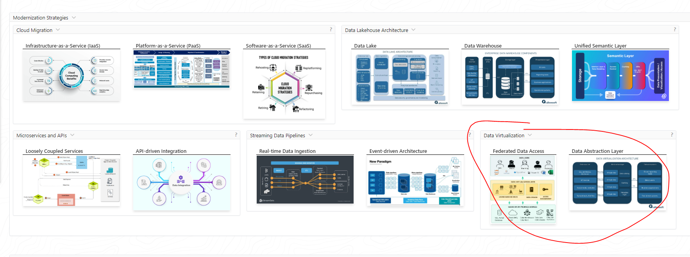

Building a data platform from scratch can present several challenges, but there are ways to accelerate and modernize the data solution: One key issue to consider is whether to build a data platform from scratch or leverage existing cloud-based data solutions. Building from scratch offers more customization but requires significant time and resources, while cloud-based solutions provide faster deployment and scalability. To accelerate the modernization of a data solution, organizations can explore low-code/no-code platforms, pre-built data connectors, and automated data pipeline tools. These can help streamline the development process and reduce the need for extensive custom coding.

Modernize Legacy Systems

Modernizing legacy systems involves updating or replacing outdated technology, software, and infrastructure to improve functionality, efficiency, and compatibility with newer systems. This process helps organizations adapt to changing business needs, take advantage of modern capabilities, and reduce the risks associated with relying on aging, unsupported legacy technologies.

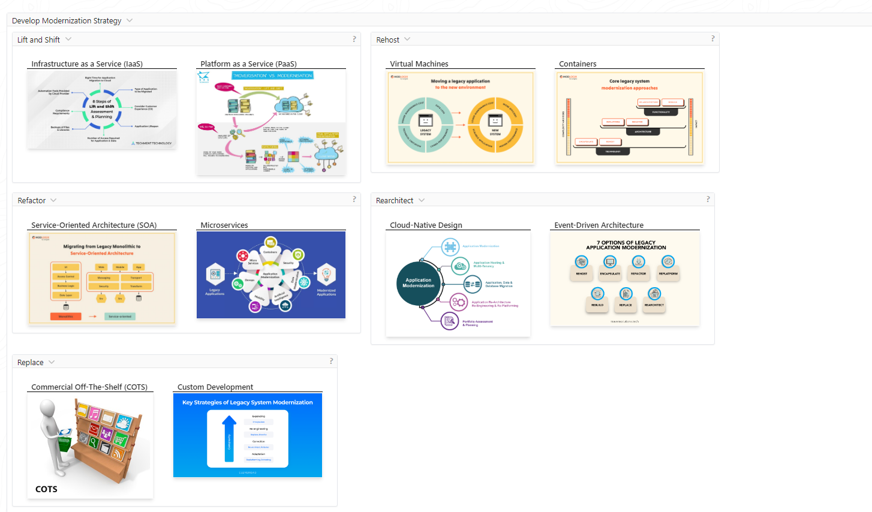

Modernize Legacy Systems

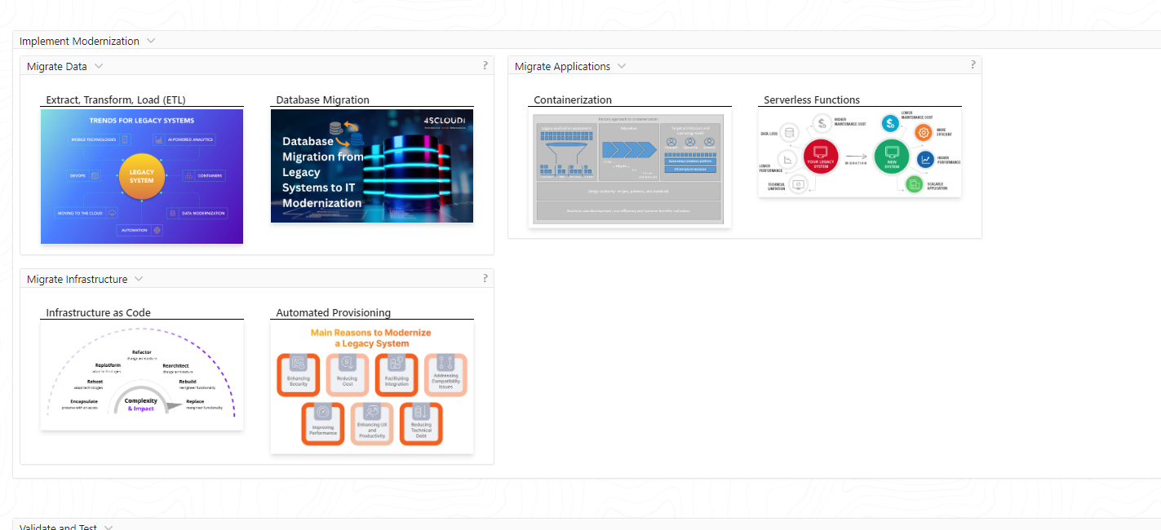

Historical Time Series Data System Problems: Legacy market data systems often struggle to efficiently manage and store large volumes of historical time series data. This can lead to performance issues and challenges in accessing and analyzing past market information. Modernizing Legacy Market Data Systems: To address the challenges of legacy market data systems, organizations are working to modernize their infrastructure. This typically involves migrating to more scalable, cloud-based platforms that can handle growing data volumes and provide faster access to historical information. Market Data System Migration Challenges: Migrating market data systems to modern platforms presents various challenges, such as data mapping, system integration, and ensuring seamless continuity of market data delivery during the transition. Careful planning and execution are crucial to minimize disruptions.

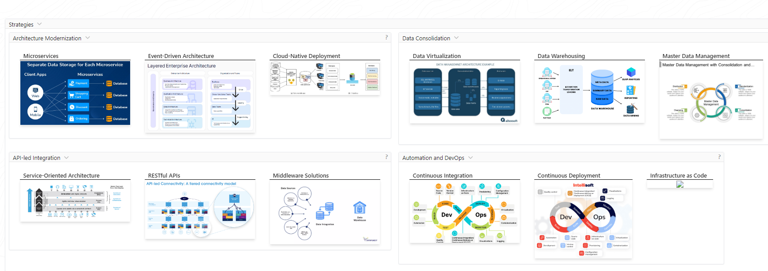

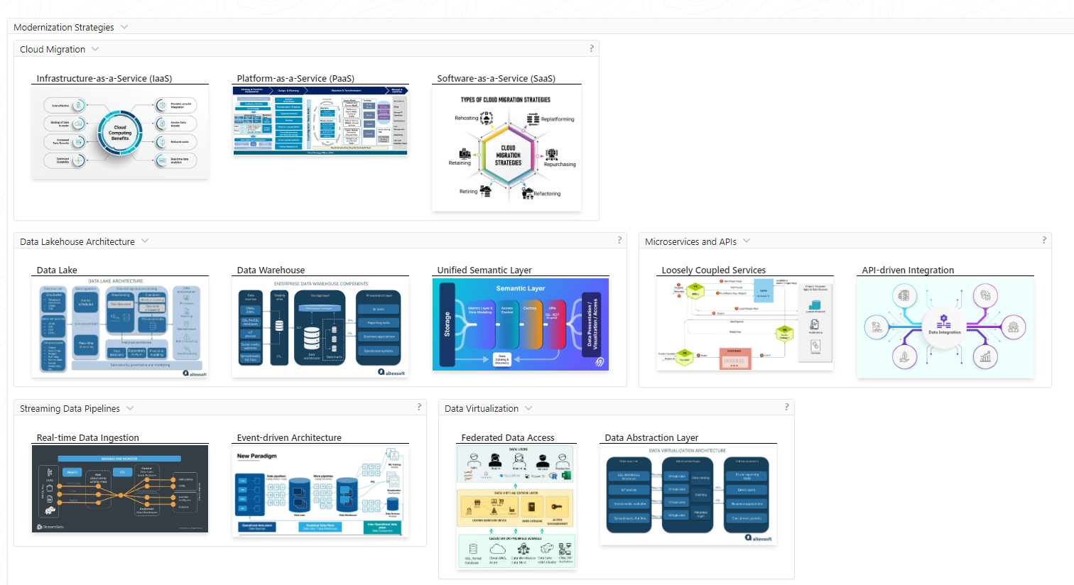

**4) JPMorgan leverages Big Data Analytics to give a clear perspective of Credit Market Data**

There are huge amounts of credit market data. Visualizing and understanding the massive amounts of credit data using traditional techniques like charts, tables and document repositories is difficult as it does not give a clear perspective. It does not help the bank to be responsive to potential investment opportunities.

Earlier, JPMorgan customers could get a perspective of the bond market report by reading text reports or viewing tables with statistical information but with the ever increasing volume of data, it was difficult to provide JPMorgan customers with clear insights on market [trends](https://www.projectpro.io/article/emerging-big-data-trends-for-2017/331). To provide valuable and intuitive services to customers JPMorgan leverages big data analytics through its “CreditMap” application that’s uses Datawatch platform to provide customers with accurate and faster real-time managed analytics. The new Datawatch analytics platform helps customers view and analyse information by using colour, size and proximity according to their needs with an easy to use interface.

JPMorgan won the Euromoney award for “Best Online Fixed Income Research” using the “CreditMap” solution as it successfully bridged the gap between providing informative research and valuable analytics to its customers.

“Datawatch has greatly enhanced our user’s ability to visualize the credit markets and utilize analytics- it is an important contributing factor to us winning the Euromoney Award.”-said Lee McGinty, Head of European Portfolio at JPMorgan.

Get confident to build end-to-end projects

<https://www.jpmorgan.com/markets/dataquery>

<https://markets.jpmorgan.com/data-and-analytics/data-solutions#data-query>

DataQuery

Drive your investment insights using J.P. Morgan’s data marketplace with over 50 million time series accessible on the web, desktop, excel, batch and modern APIs.

PricingDirect

Access independent, intra-day valuations and analytics services for over 1.5 million securities.

Instrument Analytics

Harness the power of J.P. Morgan’s proprietary models and powerful calculation engines to derive your own analytics.

Risk as a Service

The power of J.P. Morgan’s proprietary quantitative analytics, derived market data and real-time risk management technology, seamlessly delivered to your desktop.

Risk Analytics

Gain scale and efficiency as your business grows with robust reporting solutions that extend across a number of regulatory regimes.

