# Logging Into AWS (SSO)

In order to follow AWS best practices, we are using separate AWS accounts for our newer applications. We have a different way of authenticating to these instances which you can follow here!

* [Authenticating to the console](#LoggingIntoAWS(SSO)-Authenticatingtothe)
* [Command Line/Session Credentials Setup](#LoggingIntoAWS(SSO)-CommandLine/Session)
  + [Prerequisites](#LoggingIntoAWS(SSO)-Prerequisites)
  + [Initial setup](#LoggingIntoAWS(SSO)-Initialsetup)
  + [Switching accounts](#LoggingIntoAWS(SSO)-Switchingaccounts)
  + [Connecting to multiple accounts in one CLI session](#LoggingIntoAWS(SSO)-Connectingtomultipl)
* [Manually configuring AWS credentials from SSO](#LoggingIntoAWS(SSO)-Manuallyconfiguring)
* [Application configuration for SSO](#LoggingIntoAWS(SSO)-Applicationconfigur)

Official AWS documentation: <https://docs.aws.amazon.com/cli/latest/userguide/cli-configure-sso.html>

If you log into AWS using the old portal to our main AWS account, we encourage you to try this new way. We will be disabling access directly through the legacy AWS portal in the near future.

## Authenticating to the console

The URL for the single-sign on is https://d-90676f2e34.awsapps.com/start#/. It is highly recommended that you bookmark this page.

Your user name should be of the format flastname@ds.moxehealth.com – **this is the same user name and password you use to authenticate to Okta and/or your client OpenVPN**.

If this is your first time logging in, you will be asked to set up a Multi-Factor Authentication device. This code will be separate from the code you use for Okta/VPN.

This brings you to a page that will show you all AWS accounts you have access to:

1. Click on the cube for **AWS Account**
2. Click on the AWS account you wish to access
3. You should have one or more roles you can assume in that account. Next to the role you wish to select, click on **Management console**.
4. You are then able to access AWS normally.

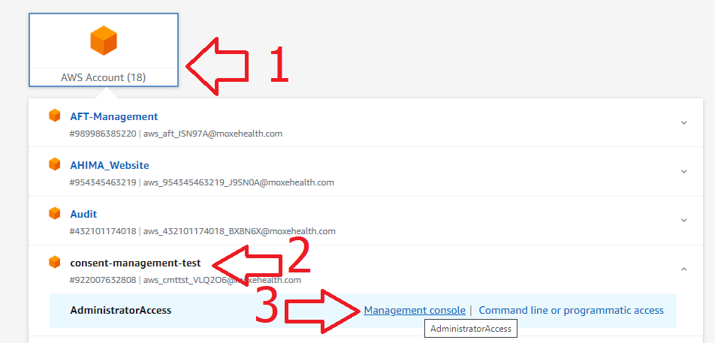

Note that if you wish to switch accounts, just browse back to your SSO link and repeat this process with a different account. **You can only be authenticated to one account in the browser at a time.**

The account names usually match the application, but there are some notable exceptions (which you might not have access to):

* **Moxe Health Prod**: our original AWS account where many of our original applications run from.
* **Shared Services**: An account for smaller Kubernetes workloads

If you only want to log into the AWS Console, you’re done!

The section below is for Engineering/Support/Implementation who may need command line access or SDK access.

## Command Line/Session Credentials Setup

AWS has a tool to facilitate multi-account access that works differently than our legacy AWSCLISetup.py.

### Prerequisites

* Download AWSCLI v2: <https://docs.aws.amazon.com/cli/latest/userguide/install-cliv2.html>
* If you are migrating off of using AWSCLISetup.py:
  + Browse to your AWS credentials folder (cd ~/.aws)
  + Rename the files config and credentials with an extension, like .bak , to deactivate them.

### Initial setup

Open terminal session and execute the following:

aws configure sso

If prompted for a SSO start URL, enter https://d-90676f2e34.awsapps.com/start#/  
For SSO Region just hit <enter> for SSO session name and ignore warning. After the first time running this, these values should be cached as the default and replace the [None] below, so you should just have to hit <enter> :

SSO session name (Recommended):

←[1mWARNING: Configuring using legacy format (e.g. without an SSO session).

Consider re-running "configure sso" command and providing a session name.

SSO start URL [None]: https://d-90676f2e34.awsapps.com/start#/

SSO Region [None]: us-east-1

This will open a browser window. If this is your first time logging in you may have to enter a code from your CLI window into the browser.

This authentication workflow is the exact same workflow as the **Authenticating to the Console** above (and if you logged in recently you shouldn’t have to re-authenticate).

After doing so, you should click **Allow** in the **Authorize request** window:

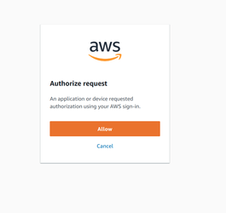

You will then get a list of AWS accounts available to you. Select the AWS account you wish to use. In addition you may be able to choose which role to use – you can use the arrow keys to select. Example below:

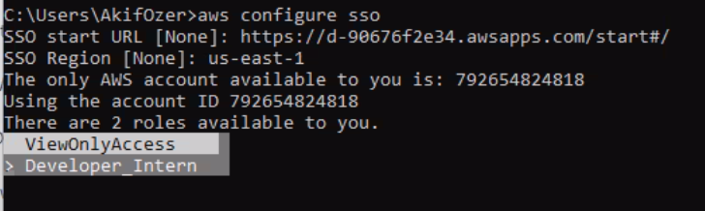

Enter the following to complete the setup **(note: the** CLI profile name **will need to be changed to** default, **so don’t just hit enter through all the options here)**:

CLI default client Region [None]: us-east-1

CLI default output format [None]: json

CLI profile name [Developer_Intern-792654824818]: default

Your credentials expire after 12 hours. Each day you will need to authenticate by running:

aws sso login

### Switching accounts

If you would like to switch which AWS account you want to use, you can run aws configure sso again, which should run quickly if you’re still authenticated. Select the different account. For the CLI defaults the only thing you’ll likely need to type in is CLI profile name set to default.

### Connecting to multiple accounts in one CLI session

In the two steps above, we set the CLI profile name to default - that means if we run a command without specifying --profile it will use your default credentials.

If you want to be able to run commands between two separate accounts, you can specify the CLI profile name to something else – for example, if you’re working in the shared services account but want to also be authenticated to Moxe Health Prod:

* Run aws configure sso, select Moxe Health Prod as the account, set the CLI profile name as default
* Run aws configure sso, select Shared Services as the account, set the CLI profile name as ssa
* If you’re running a AWSCLI command against the Shared Services account, add that as the profile. Example: aws s3 ls --profile ssa

## Manually configuring AWS credentials from SSO

If you are running an application that is unable to utilize AWS SSO from CLI as configured above, you can manually configure AWS credentials in the ~/.aws/credentials file by downloading them from the AWS portal, and copying from the "Command line or programmatic access" Option 2 into the credentials file. Note that these credentials expire after a certain time so you'll have to update them when necessary.



## Application configuration for SSO

Please make sure to follow instructions for AWS SSO, Your App, & You