Project Title: **Sneaky Shoes E-Commerce**

Group Name: **UNT-DEV**

Team Members List:

* RAHEEM ALI
* GIRISH VARDHAN GAVIREDDY
* SAI KIRAN REDDY SOMA
* LETHASWI THOKALA
* PRATHYUSHA REDDY PIPPIRADA
* LIKHITHA REDDY SAMA
* SAI VENKATARAMA INNAMURI

**Phase 1:** (Deadline: 20-Mar-2023)

In this phase Our team plan to do majority of the front-end Development.

This includes the prioritize functionalities as follows:

|  |  |  |
| --- | --- | --- |
| S.no | Feature | Page |
| 1. | User Login/Logout | P1 |
| 2. | Search box | P2 |
| 3. | Buy option and product Design (Front-end Only) | P3 |

**LOGIN FOR USERS**

If a user is already a member of our community i.e., registered their account with us, all they have to do is Sign-in and enjoy our website.

* Sign in option: When users sign in to an e-commerce website, they can create their own personalized profiles that store their preferences, order history, and payment information. This will make the shopping experience more amazing and user friendly to their needs.

By requesting a valid email address and password from users during user sign-in, the sneaky shoes e-commerce website is given an additional layer of protection. This helps in preventing unwanted access to sensitive data, including payment information.

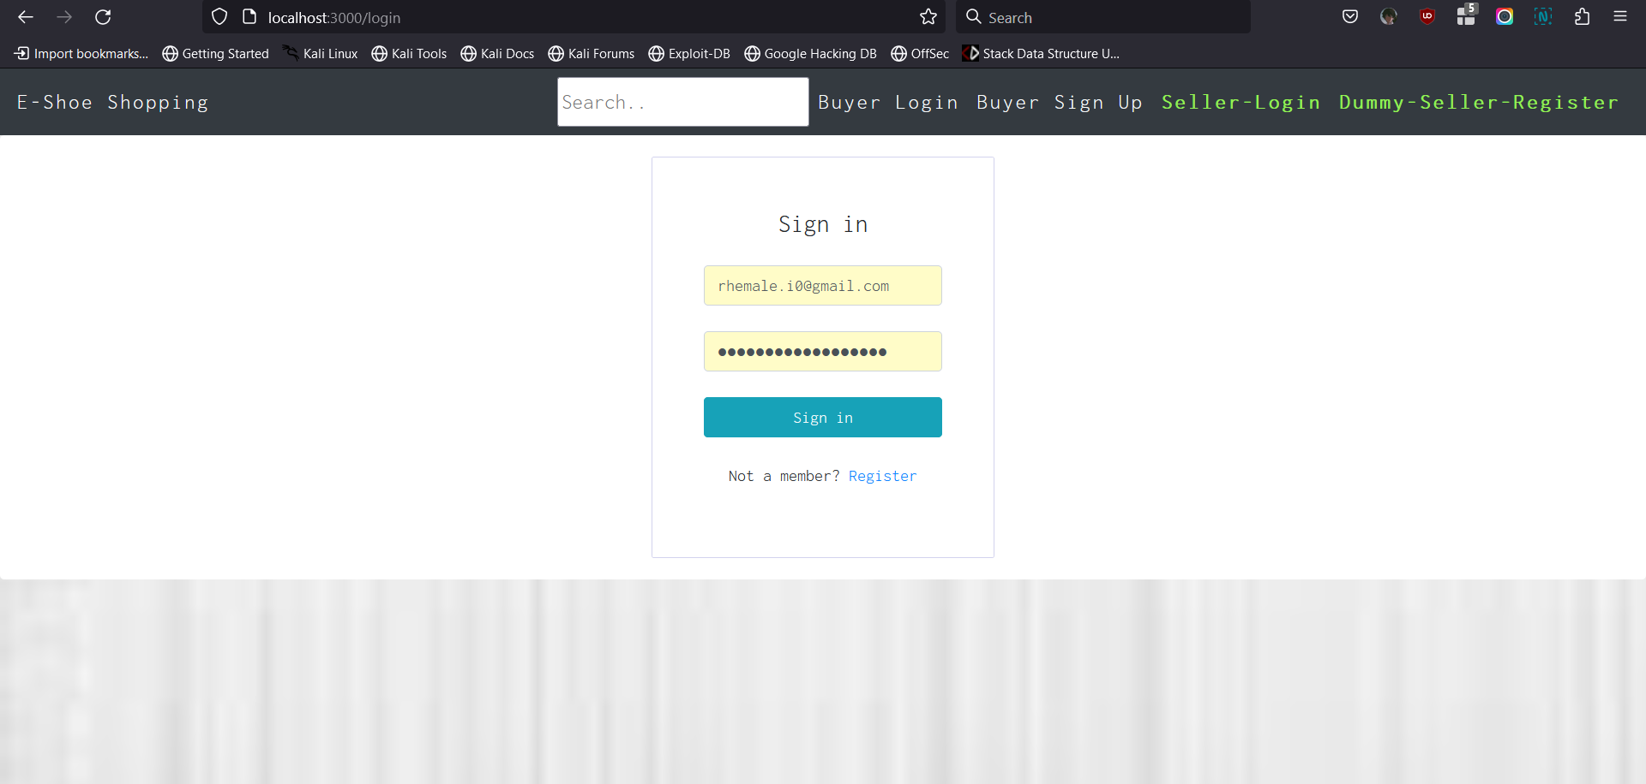

If the user is not register with our website. They need to first to register with us and then sign in in order to use our website.

* User Registration: In order to sign in First user must register with us. In order to register with us, A user need to enter 4 Important things i.e.
  + Name
  + Email- ID
  + New Password
  + Password match

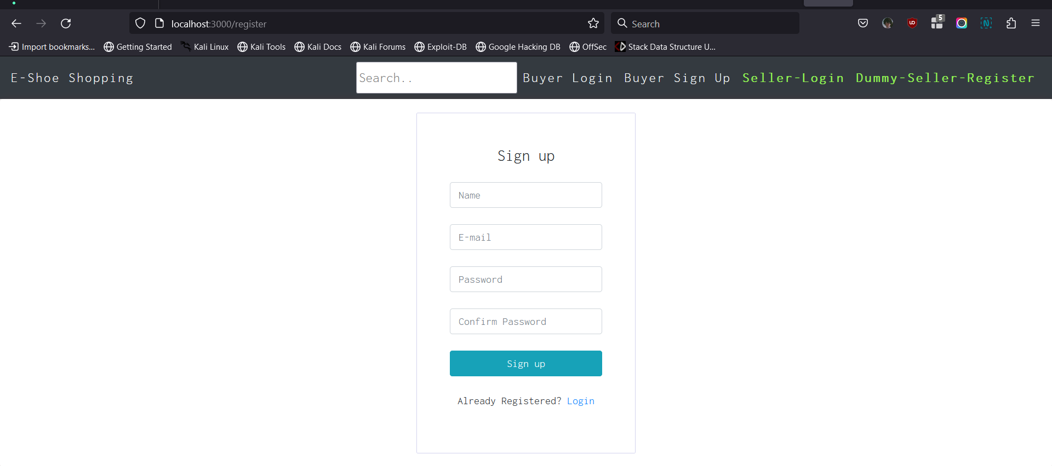

The below figure represents the actual working of user account when the whole website is developed.

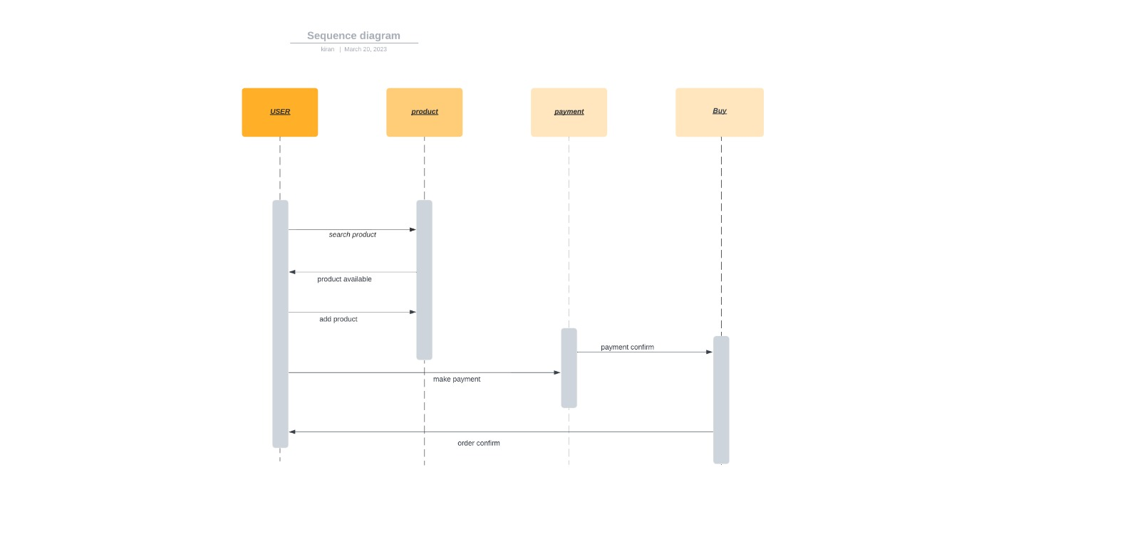

**LOGIN FOR SELLERS (ADMIN)**

If a Seller (Admin) is already a member of our community i.e., registered their account with us, all they have to do is Sign-in and sell their products.

* To sign in the seller just need to enter their credentials with username and password.

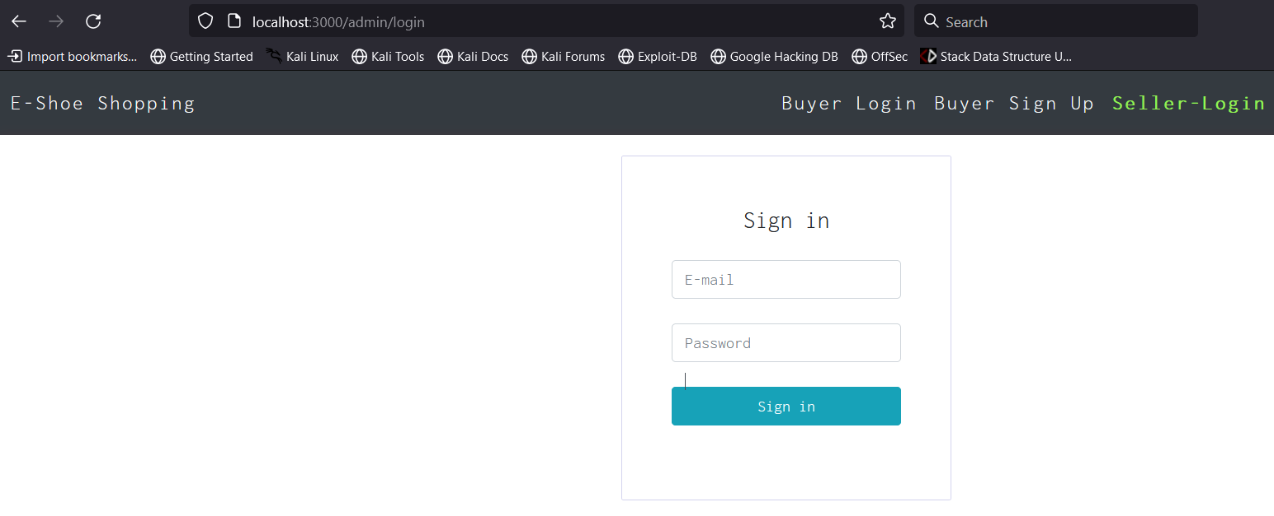

* Register for Seller: In order to sell products online a seller must register an account with us. And after successful login a seller can sell their product on our website.

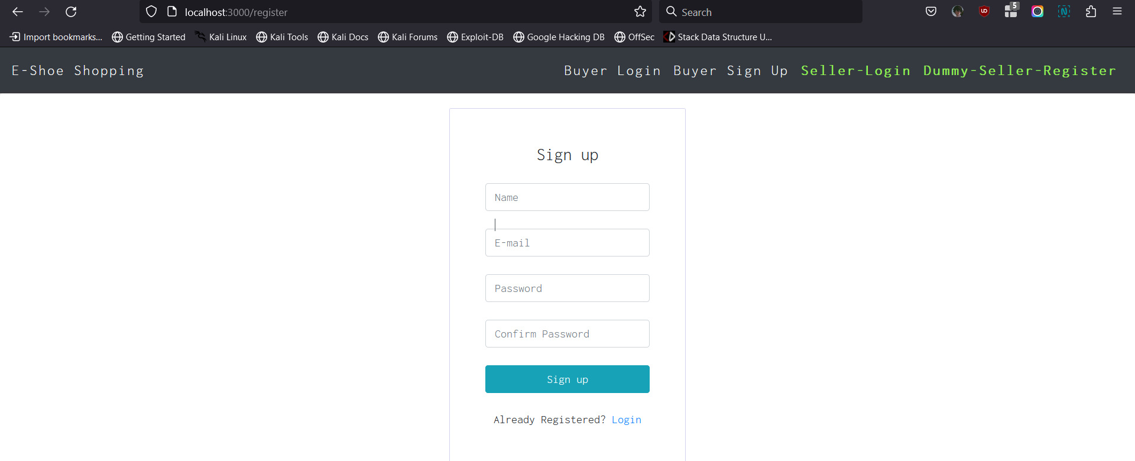

The below figure represents the UML diagram for the admin user.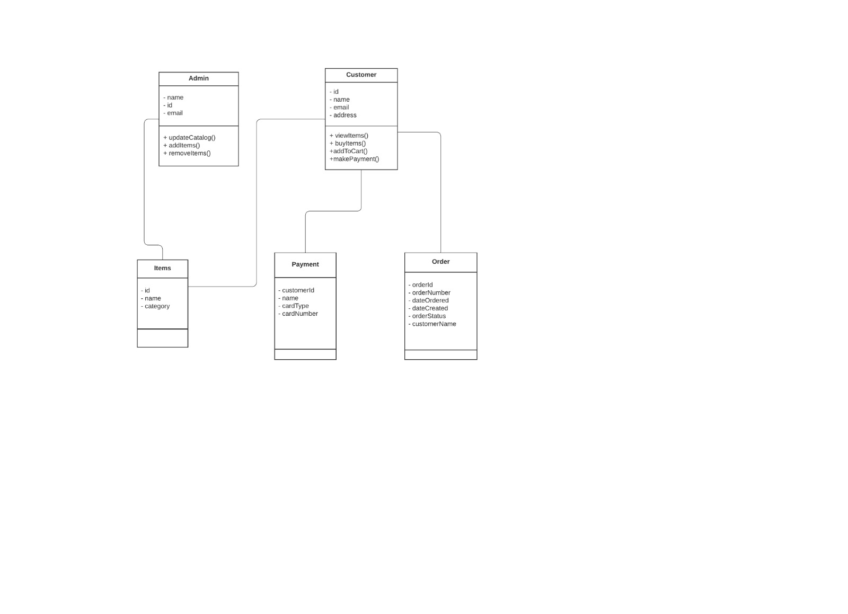

**PRODUCT (SHOE) DESIGN:**

In selling, getting the right amount of exposure to the offer is crucial. The way that clients view products is heavily influenced by the images.

In the Sneaky shoes’ website, proper presentation is extremely important. The potential buyer is not able to see the real product. Therefore, photos play a decisive role.

Advantages phrases are vital in marketing. It is used not only in texts. Moreover, graphics will draw attention to the advantages that a buyer will receive from a certain product. And therefore, it is critical to draw attention to those aspects of the thing that will be crucial for its intended usage in the future.

There are 4 important things that our Product should describe.

1. Product Title

2. Product Description

3. Price in USD

4. Images of the product.

**//** The below figure is the code snippet for creating a product.

|  |
| --- |
| const product = new Product({  title: title,  description: description,  price: price,  imageUrl: imageUrl,  }); |

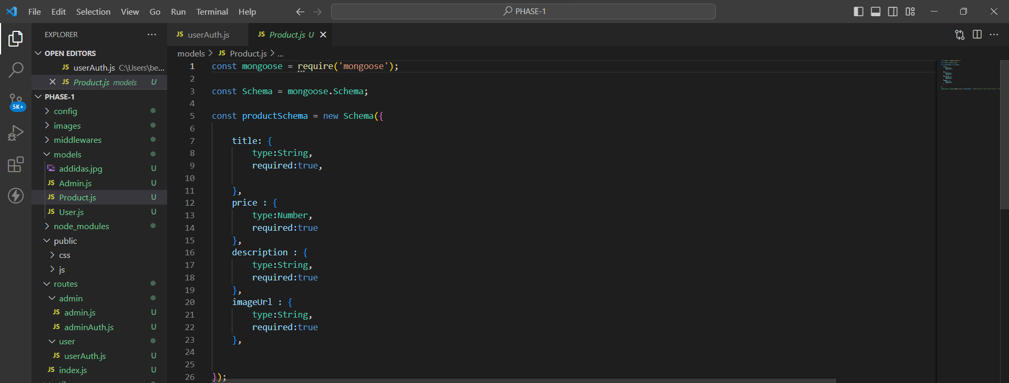

The below figure shows how the admin user account works on our website.

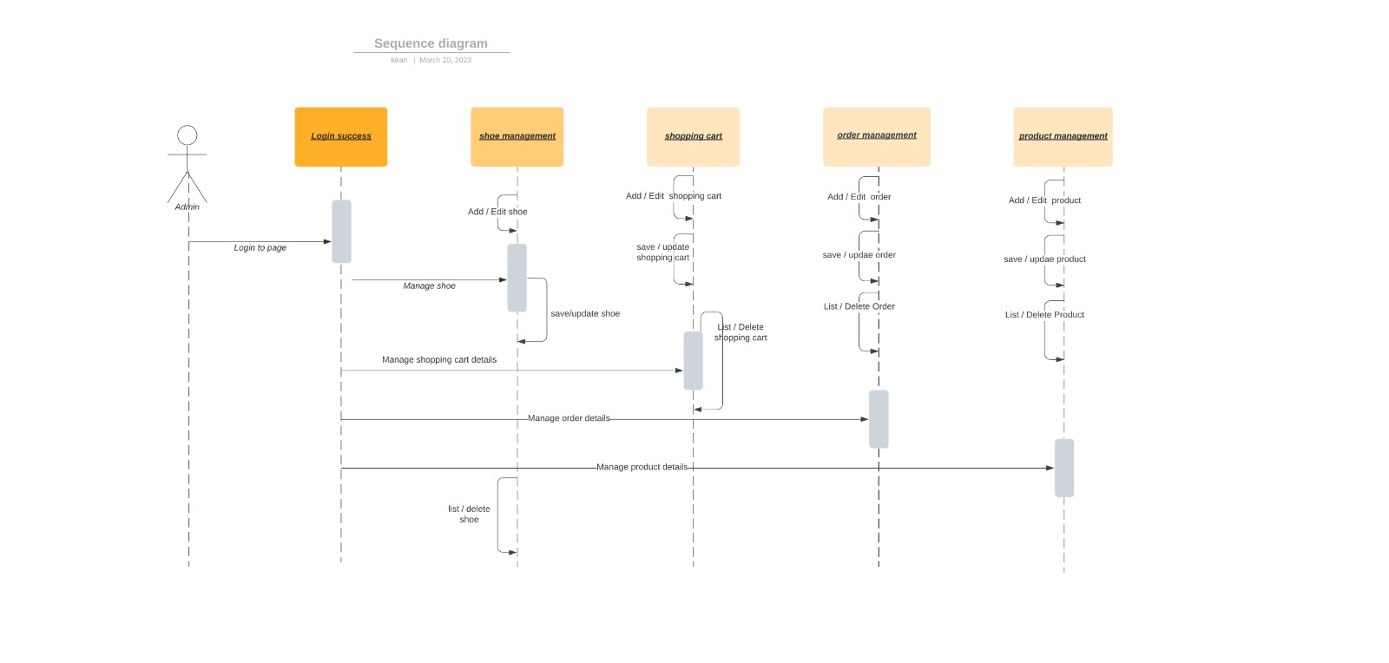

**Search Box for Product Search:**

This Search Box helps user to search shoes on the website. We wanted this feature in our phase one because, with this search box we have to create the front-end of the product list where user can see all the product list on a website which are available. So, This simple feature helps to connect multiple Routes at the backend.

Since We have to connect it with the products, and the developing products and it order is in phase2. We just wrote code of this feature. With the implementation of add to card and other feature. This feature must run successful as it depends on the product list.

He is the code snippet for the search box below:

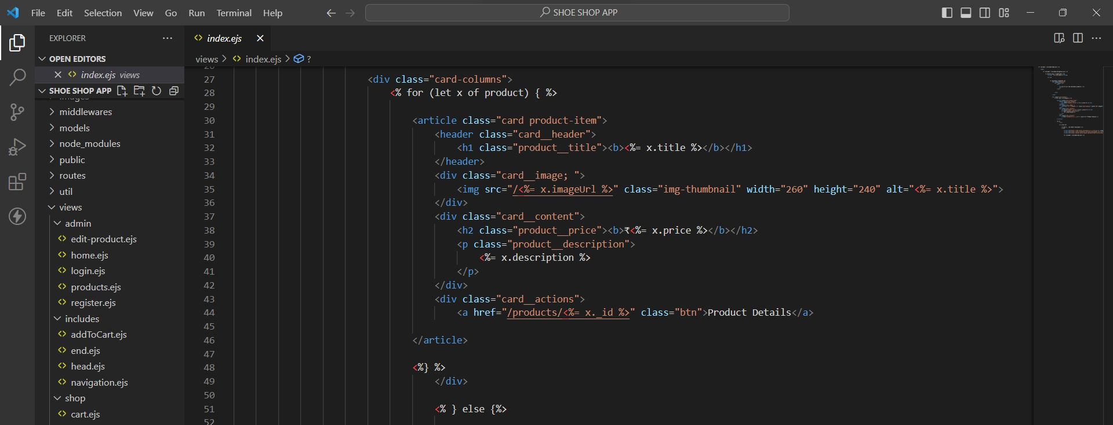

**User Manual**

1. From GitHub Repository (https://github.com/ralei0/UNT-Dev), click on Clone
2. Copy the clone URL
3. In Terminal (Mac) or command line (Windows git bash), move to local directory
4. Use the **git clone** command **along with the copied URL.**
5. After cloning, in Terminal type: “**npm install**”.
6. The finally run script: “**node app.js”** .
7. Open the browser and in type: “localhost:3000”

**Compilation Instructions**

To run the application the machine must have two essential things i.e.

* 1. A web Brower
  2. Node.js
  3. An editor preferred VS Code and a terminal.

Use Case Diagram :-

**Report Member Contribution**

|  |  |
| --- | --- |
| Team Member’s Name | Contribution |
| RAHEEM ALI | Build Embedded JavaScript Template for Sign in and Registration and JS script for app.js file |
| GIRISH VARDHAN GAVIREDDY | Build Schema for the Product & Users using JS. |
| SAI KIRAN REDDY SOMA | Build JS files for User Authentication for admin and users. |
| LETHASWI THOKALA | Made Routes using JS for Product and users and helped building delivery. |
| PRATHYUSHA REDDY PIPPIRADA | Check if the user is valid then redirect to home and CSS of the website. |
| LIKHITHA REDDY SAMA | Help building middleware for the website and delivery 3. |
| SAI VENKATARAMA INNAMURI | Admin schema for username and password in model’s module. |