2026-3-16
Update content:
- Add tutors and subject object in prisma model
- Add tutors and subject fake apis(I must add the empty routes, so the others can develop based on it.)
- Update the apis contents.
- At first, my branch named stage2_tutors_fake_apis, then change to stage2_backend for meeting the regular naming rules.
- I completely finished 3 tutor apis and 2 subject apis.
Commits:
First merge
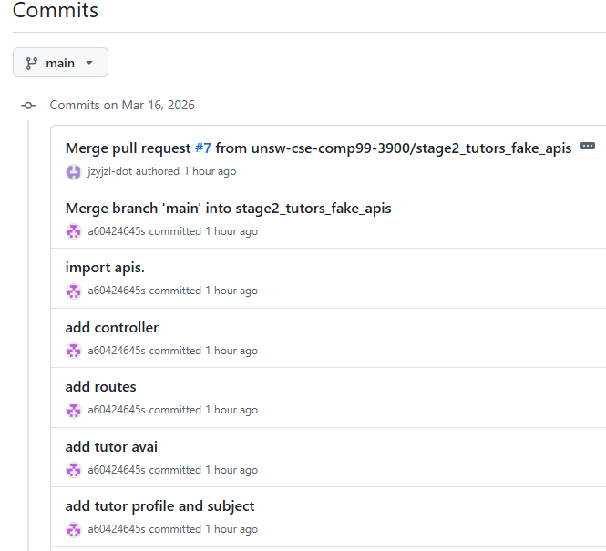

Second merge:
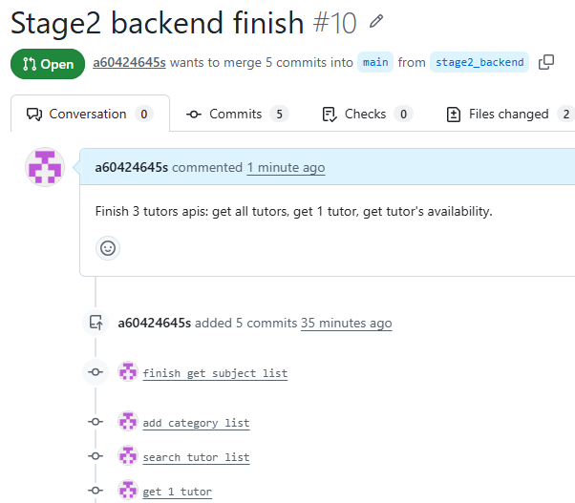

2026-3-15
Branch: tutors_api_empty
Update Content:
A mock interface for "tutors" was created, but no functional implementation was carried out. The current interface is the conventional CRUD (Create, Read, Update, Delete).
Branch: feature-tutor-route
Update Content:
A mock interface for "tutors" was created, but no functional implementation was carried out. The current interface is the conventional CRUD (Create, Read, Update, Delete). There are a total of 5 interfaces, all of which are based on the "tutor" resource.

Current call path is:
App.js -> router/tutors.js -> apis

The following are the added interfaces (VSCode can automatically generate comments based on the code I have completed).
GET /api/v1/tutors
GET /api/v1/tutors/:id
GET /api/v1/tutors/:id/availability
GET/api/v1/tutors/me/profilePUT /api/v1/tutors/me/application
PUT /api/v1/tutors/me/profile
PUT /api/v1/tutors/me/availability
POST /api/v1/tutors/me/subjects
DELETE /api/v1/tutors/me/subjects/:subjectId

Commits:
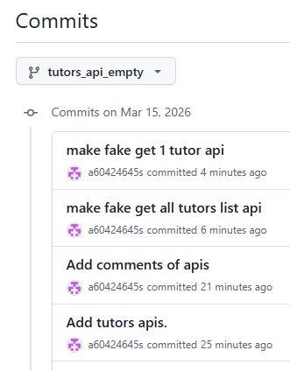

2026-3-14
Sort out the functions to be completed and compile a list of all the tutor-related APIs.

