Science Curiosity Study 1 Data

# Demographics

N $​_{total}$ = 541: N $​_{con}$ = 226, N $​_{lib}$ = 265, N $​_{mod}$ = 50

**N $​_{final}$ = 491**

* **Political ideology:** 46.03% conservative, 53.97% liberal
* **Age:** Mean $​_{age}$ = 43.23 (range: 21-78)
* **Gender:** 41.77% women, 47.87% men, 0.37% non-binary folks, 0.74% preferred not to answer
* **Race:** 75.05% White, 5.36% Black, 2.59% Hispanic, 5.91% Asian

# Descriptives

## Summary

Mean

SE

Min

Max

Median

SciCuriosity

24.73

0.26

9

44

25

RPM

5.64

0.07

1

10

6

ConArctic

-1.43

0.06

-3

3

-2

ConTemp

-1.69

0.05

-3

3

-2

LibOzone

-0.26

0.06

-3

3

-1

LibAir

-0.82

0.07

-3

3

-1

ConFillIce

-2.10

0.05

-3

3

-2

FillBacteria

-0.27

0.06

-3

3

0

FillQuake

0.31

0.02

0

1

0

## Correlations

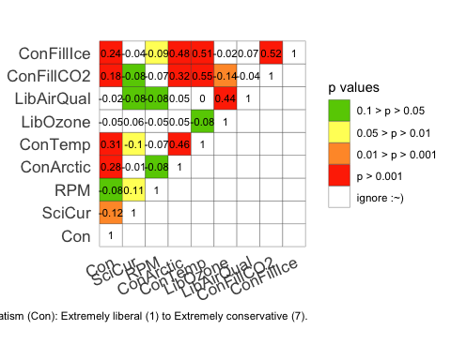

## Science curiosity and RPM

**Grouped by ideology**

Conservative

Liberal

Mean

SE

Min

Max

Mean

SE

Min

Max

SciCuriosity

24.12

0.38

9

43

25.25

0.35

9

44

RPM

5.55

0.10

1

10

5.71

0.10

1

10

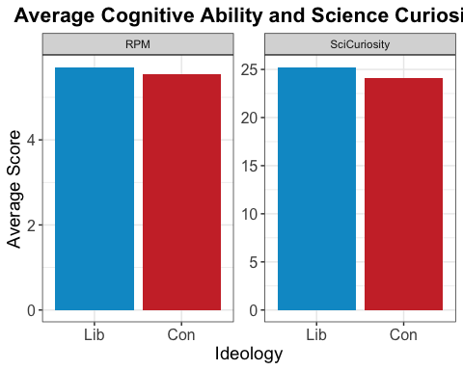

## Motivated reasoning items

**Grouped by ideology**

Conservative

Liberal

Mean

SE

Min

Max

Mean

SE

Min

Max

ConArctic

-1.07

0.09

-3

3

-1.73

0.07

-3

3

ConTemp

-1.37

0.08

-3

3

-1.97

0.06

-3

2

LibOzone

-0.32

0.09

-3

3

-0.21

0.09

-3

3

LibAir

-0.85

0.10

-3

3

-0.81

0.10

-3

3

ConFillIce

-1.83

0.09

-3

3

-2.33

0.06

-3

3

FillBacteria

-0.16

0.08

-3

3

-0.35

0.08

-3

3

FillQuake

0.29

0.03

0

1

0.33

0.03

0

1

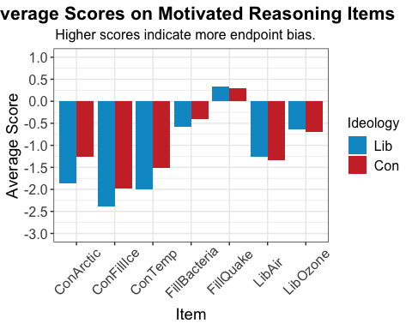

# “3-way int.” means

Conservative

Liberal

SciCur

RPM

Con1_M

Con1_SE

Con2_M

Con2_SE

Lib1_M

Lib1_SE

Lib2_M

Lib2_SE

Con

High

High

-1.05

0.18

-1.38

0.17

-0.14

0.16

-0.92

0.19

Con

High

Low

-1.00

0.22

-1.31

0.19

-0.33

0.24

-0.98

0.24

Con

Low

High

-1.05

0.15

-1.23

0.14

-0.52

0.14

-0.80

0.18

Con

Low

Low

-1.19

0.18

-1.58

0.16

-0.28

0.22

-0.68

0.23

Lib

High

High

-1.85

0.11

-2.14

0.09

-0.27

0.14

-0.92

0.17

Lib

High

Low

-1.45

0.20

-2.00

0.10

-0.02

0.20

-0.62

0.24

Lib

Low

High

-1.88

0.12

-2.15

0.10

-0.08

0.21

-0.75

0.20

Lib

Low

Low

-1.71

0.17

-1.53

0.16

-0.40

0.17

-0.87

0.19

Note:

* M = mean, SE = standard error * Item names: Con1 = arctic sea ice, Con2 = global temperature index, Lib1 = ozone layer hole, Lib2 = US air quality

# Conservative #1: Arctic

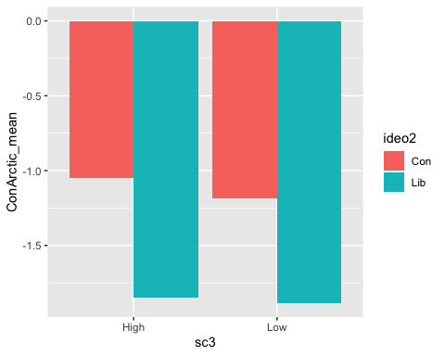

arcmod1 <- lm(ConArctic ~ 1, data = dfd2_lc)  
summary(arcmod1)

##   
## Call:  
## lm(formula = ConArctic ~ 1, data = dfd2_lc)  
##   
## Residuals:  
## Min 1Q Median 3Q Max   
## -1.5723 -0.5723 -0.5723 0.4277 4.4277   
##   
## Coefficients:  
## Estimate Std. Error t value Pr(>|t|)   
## (Intercept) -1.42770 0.05952 -23.99 <2e-16 ***  
## ---  
## Signif. codes: 0 '***' 0.001 '**' 0.01 '*' 0.05 '.' 0.1 ' ' 1  
##   
## Residual standard error: 1.319 on 490 degrees of freedom

arcmod2 <- lm(ConArctic ~ rav_scoredz, data = dfd2_lc)  
summary(arcmod2)

##   
## Call:  
## lm(formula = ConArctic ~ rav_scoredz, data = dfd2_lc)  
##   
## Residuals:  
## Min 1Q Median 3Q Max   
## -1.8764 -0.6798 -0.4831 0.4513 4.3858   
##   
## Coefficients:  
## Estimate Std. Error t value Pr(>|t|)   
## (Intercept) -1.42549 0.05940 -23.997 <2e-16 ***  
## rav_scoredz -0.10473 0.05993 -1.748 0.0811 .   
## ---  
## Signif. codes: 0 '***' 0.001 '**' 0.01 '*' 0.05 '.' 0.1 ' ' 1  
##   
## Residual standard error: 1.316 on 489 degrees of freedom  
## Multiple R-squared: 0.006207, Adjusted R-squared: 0.004175   
## F-statistic: 3.054 on 1 and 489 DF, p-value: 0.08115

anova(arcmod1, arcmod2)

## Analysis of Variance Table  
##   
## Model 1: ConArctic ~ 1  
## Model 2: ConArctic ~ rav_scoredz  
## Res.Df RSS Df Sum of Sq F Pr(>F)   
## 1 490 852.18   
## 2 489 846.89 1 5.2899 3.0544 0.08115 .  
## ---  
## Signif. codes: 0 '***' 0.001 '**' 0.01 '*' 0.05 '.' 0.1 ' ' 1

arcmod3 <- lm(ConArctic ~ sc_scoredz + rav_scoredz, data = dfd2_lc)  
summary(arcmod3)

##   
## Call:  
## lm(formula = ConArctic ~ sc_scoredz + rav_scoredz, data = dfd2_lc)  
##   
## Residuals:  
## Min 1Q Median 3Q Max   
## -1.8788 -0.6782 -0.4836 0.4514 4.3839   
##   
## Coefficients:  
## Estimate Std. Error t value Pr(>|t|)   
## (Intercept) -1.425486 0.059466 -23.972 <2e-16 ***  
## sc_scoredz -0.002092 0.061643 -0.034 0.9729   
## rav_scoredz -0.104508 0.060348 -1.732 0.0839 .   
## ---  
## Signif. codes: 0 '***' 0.001 '**' 0.01 '*' 0.05 '.' 0.1 ' ' 1  
##   
## Residual standard error: 1.317 on 488 degrees of freedom  
## Multiple R-squared: 0.00621, Adjusted R-squared: 0.002137   
## F-statistic: 1.525 on 2 and 488 DF, p-value: 0.2187

anova(arcmod1, arcmod3)

## Analysis of Variance Table  
##   
## Model 1: ConArctic ~ 1  
## Model 2: ConArctic ~ sc_scoredz + rav_scoredz  
## Res.Df RSS Df Sum of Sq F Pr(>F)  
## 1 490 852.18   
## 2 488 846.89 2 5.2919 1.5247 0.2187

arcmod4 <- lm(ConArctic ~ ArcticCong + sc_scoredz + rav_scoredz, data = dfd2_lc)  
summary(arcmod4)

##   
## Call:  
## lm(formula = ConArctic ~ ArcticCong + sc_scoredz + rav_scoredz,   
## data = dfd2_lc)  
##   
## Residuals:  
## Min 1Q Median 3Q Max   
## -2.1985 -0.9416 -0.2329 0.6405 4.5164   
##   
## Coefficients:  
## Estimate Std. Error t value Pr(>|t|)   
## (Intercept) -1.72874 0.07874 -21.954 < 2e-16 ***  
## ArcticCong 0.65778 0.11632 5.655 2.66e-08 ***  
## sc_scoredz 0.02956 0.06004 0.492 0.623   
## rav_scoredz -0.09122 0.05857 -1.558 0.120   
## ---  
## Signif. codes: 0 '***' 0.001 '**' 0.01 '*' 0.05 '.' 0.1 ' ' 1  
##   
## Residual standard error: 1.277 on 487 degrees of freedom  
## Multiple R-squared: 0.06745, Adjusted R-squared: 0.0617   
## F-statistic: 11.74 on 3 and 487 DF, p-value: 1.942e-07

anova(arcmod1, arcmod4)

## Analysis of Variance Table  
##   
## Model 1: ConArctic ~ 1  
## Model 2: ConArctic ~ ArcticCong + sc_scoredz + rav_scoredz  
## Res.Df RSS Df Sum of Sq F Pr(>F)   
## 1 490 852.18   
## 2 487 794.71 3 57.476 11.741 1.942e-07 ***  
## ---  
## Signif. codes: 0 '***' 0.001 '**' 0.01 '*' 0.05 '.' 0.1 ' ' 1

# Conservative #2: Temp

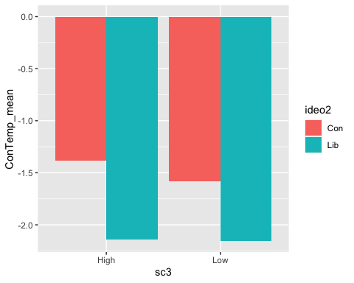

tempmod1 <- lm(ConTemp ~ 1, data = dfd2_lc)  
summary(tempmod1)

##   
## Call:  
## lm(formula = ConTemp ~ 1, data = dfd2_lc)  
##   
## Residuals:  
## Min 1Q Median 3Q Max   
## -1.3055 -0.3055 -0.3055 0.6945 4.6945   
##   
## Coefficients:  
## Estimate Std. Error t value Pr(>|t|)   
## (Intercept) -1.69450 0.05126 -33.06 <2e-16 ***  
## ---  
## Signif. codes: 0 '***' 0.001 '**' 0.01 '*' 0.05 '.' 0.1 ' ' 1  
##   
## Residual standard error: 1.136 on 490 degrees of freedom

tempmod2 <- lm(ConTemp ~ rav_scoredz, data = dfd2_lc)  
summary(tempmod2)

##   
## Call:  
## lm(formula = ConTemp ~ rav_scoredz, data = dfd2_lc)  
##   
## Residuals:  
## Min 1Q Median 3Q Max   
## -1.5464 -0.4425 -0.2868 0.6613 4.6094   
##   
## Coefficients:  
## Estimate Std. Error t value Pr(>|t|)   
## (Intercept) -1.69276 0.05119 -33.069 <2e-16 ***  
## rav_scoredz -0.08296 0.05164 -1.607 0.109   
## ---  
## Signif. codes: 0 '***' 0.001 '**' 0.01 '*' 0.05 '.' 0.1 ' ' 1  
##   
## Residual standard error: 1.134 on 489 degrees of freedom  
## Multiple R-squared: 0.00525, Adjusted R-squared: 0.003216   
## F-statistic: 2.581 on 1 and 489 DF, p-value: 0.1088

anova(tempmod1, tempmod2)

## Analysis of Variance Table  
##   
## Model 1: ConTemp ~ 1  
## Model 2: ConTemp ~ rav_scoredz  
## Res.Df RSS Df Sum of Sq F Pr(>F)  
## 1 490 632.18   
## 2 489 628.86 1 3.3192 2.581 0.1088

tempmod3 <- lm(ConTemp ~ sc_scoredz + rav_scoredz, data = dfd2_lc)  
summary(tempmod3)

##   
## Call:  
## lm(formula = ConTemp ~ sc_scoredz + rav_scoredz, data = dfd2_lc)  
##   
## Residuals:  
## Min 1Q Median 3Q Max   
## -1.6735 -0.4882 -0.2660 0.6194 4.6819   
##   
## Coefficients:  
## Estimate Std. Error t value Pr(>|t|)   
## (Intercept) -1.69229 0.05102 -33.172 <2e-16 ***  
## sc_scoredz -0.11015 0.05288 -2.083 0.0378 *   
## rav_scoredz -0.07119 0.05177 -1.375 0.1698   
## ---  
## Signif. codes: 0 '***' 0.001 '**' 0.01 '*' 0.05 '.' 0.1 ' ' 1  
##   
## Residual standard error: 1.13 on 488 degrees of freedom  
## Multiple R-squared: 0.01402, Adjusted R-squared: 0.009974   
## F-statistic: 3.468 on 2 and 488 DF, p-value: 0.03194

anova(tempmod1, tempmod3)

## Analysis of Variance Table  
##   
## Model 1: ConTemp ~ 1  
## Model 2: ConTemp ~ sc_scoredz + rav_scoredz  
## Res.Df RSS Df Sum of Sq F Pr(>F)   
## 1 490 632.18   
## 2 488 623.32 2 8.8601 3.4683 0.03194 *  
## ---  
## Signif. codes: 0 '***' 0.001 '**' 0.01 '*' 0.05 '.' 0.1 ' ' 1

tempmod4 <- lm(ConTemp ~ TempCong + sc_scoredz + rav_scoredz, data = dfd2_lc)  
summary(tempmod4)

##   
## Call:  
## lm(formula = ConTemp ~ TempCong + sc_scoredz + rav_scoredz, data = dfd2_lc)  
##   
## Residuals:  
## Min 1Q Median 3Q Max   
## -1.9102 -0.7079 -0.0741 0.4027 4.3675   
##   
## Coefficients:  
## Estimate Std. Error t value Pr(>|t|)   
## (Intercept) -1.95804 0.06746 -29.025 < 2e-16 ***  
## TempCong 0.57643 0.09965 5.785 1.3e-08 ***  
## sc_scoredz -0.08241 0.05143 -1.602 0.110   
## rav_scoredz -0.05954 0.05017 -1.187 0.236   
## ---  
## Signif. codes: 0 '***' 0.001 '**' 0.01 '*' 0.05 '.' 0.1 ' ' 1  
##   
## Residual standard error: 1.094 on 487 degrees of freedom  
## Multiple R-squared: 0.07741, Adjusted R-squared: 0.07172   
## F-statistic: 13.62 on 3 and 487 DF, p-value: 1.517e-08

anova(tempmod3, tempmod4)

## Analysis of Variance Table  
##   
## Model 1: ConTemp ~ sc_scoredz + rav_scoredz  
## Model 2: ConTemp ~ TempCong + sc_scoredz + rav_scoredz  
## Res.Df RSS Df Sum of Sq F Pr(>F)   
## 1 488 623.32   
## 2 487 583.24 1 40.075 33.462 1.301e-08 ***  
## ---  
## Signif. codes: 0 '***' 0.001 '**' 0.01 '*' 0.05 '.' 0.1 ' ' 1

# Liberal #1: Ozone

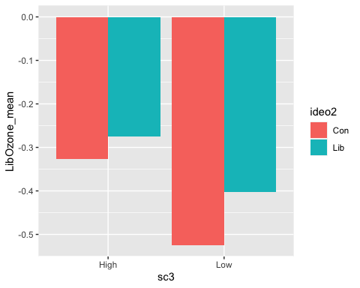

ozmod1 <- lm(LibOzone ~ 1, data = dfd2_lc)  
summary(ozmod1)

##   
## Call:  
## lm(formula = LibOzone ~ 1, data = dfd2_lc)  
##   
## Residuals:  
## Min 1Q Median 3Q Max   
## -2.7413 -0.7413 -0.7413 1.2587 3.2587   
##   
## Coefficients:  
## Estimate Std. Error t value Pr(>|t|)   
## (Intercept) -0.25866 0.06383 -4.052 5.89e-05 ***  
## ---  
## Signif. codes: 0 '***' 0.001 '**' 0.01 '*' 0.05 '.' 0.1 ' ' 1  
##   
## Residual standard error: 1.414 on 490 degrees of freedom

ozmod2 <- lm(LibOzone ~ rav_scoredz, data = dfd2_lc)  
summary(ozmod2)

##   
## Call:  
## lm(formula = LibOzone ~ rav_scoredz, data = dfd2_lc)  
##   
## Residuals:  
## Min 1Q Median 3Q Max   
## -2.8974 -0.7688 -0.6401 1.2312 3.3599   
##   
## Coefficients:  
## Estimate Std. Error t value Pr(>|t|)   
## (Intercept) -0.25721 0.06383 -4.029 6.48e-05 ***  
## rav_scoredz -0.06850 0.06439 -1.064 0.288   
## ---  
## Signif. codes: 0 '***' 0.001 '**' 0.01 '*' 0.05 '.' 0.1 ' ' 1  
##   
## Residual standard error: 1.414 on 489 degrees of freedom  
## Multiple R-squared: 0.002309, Adjusted R-squared: 0.0002684   
## F-statistic: 1.132 on 1 and 489 DF, p-value: 0.288

anova(ozmod1, ozmod2)

## Analysis of Variance Table  
##   
## Model 1: LibOzone ~ 1  
## Model 2: LibOzone ~ rav_scoredz  
## Res.Df RSS Df Sum of Sq F Pr(>F)  
## 1 490 980.15   
## 2 489 977.89 1 2.2628 1.1315 0.288

ozmod3 <- lm(LibOzone ~ sc_scoredz + rav_scoredz, data = dfd2_lc)  
summary(ozmod3)

##   
## Call:  
## lm(formula = LibOzone ~ sc_scoredz + rav_scoredz, data = dfd2_lc)  
##   
## Residuals:  
## Min 1Q Median 3Q Max   
## -2.9220 -0.8104 -0.6018 1.2041 3.4952   
##   
## Coefficients:  
## Estimate Std. Error t value Pr(>|t|)   
## (Intercept) -0.25761 0.06376 -4.040 6.21e-05 ***  
## sc_scoredz 0.09501 0.06610 1.437 0.151   
## rav_scoredz -0.07865 0.06471 -1.215 0.225   
## ---  
## Signif. codes: 0 '***' 0.001 '**' 0.01 '*' 0.05 '.' 0.1 ' ' 1  
##   
## Residual standard error: 1.413 on 488 degrees of freedom  
## Multiple R-squared: 0.006514, Adjusted R-squared: 0.002443   
## F-statistic: 1.6 on 2 and 488 DF, p-value: 0.203

anova(ozmod1, ozmod3)

## Analysis of Variance Table  
##   
## Model 1: LibOzone ~ 1  
## Model 2: LibOzone ~ sc_scoredz + rav_scoredz  
## Res.Df RSS Df Sum of Sq F Pr(>F)  
## 1 490 980.15   
## 2 488 973.77 2 6.385 1.5999 0.203

ozmod4 <- lm(LibOzone ~ OzoneCong + sc_scoredz + rav_scoredz, data = dfd2_lc)  
summary(ozmod4)

##   
## Call:  
## lm(formula = LibOzone ~ OzoneCong + sc_scoredz + rav_scoredz,   
## data = dfd2_lc)  
##   
## Residuals:  
## Min 1Q Median 3Q Max   
## -2.8704 -0.8270 -0.5915 1.1704 3.4375   
##   
## Coefficients:  
## Estimate Std. Error t value Pr(>|t|)   
## (Intercept) -0.31255 0.09423 -3.317 0.000978 ***  
## OzoneCong 0.10193 0.12868 0.792 0.428669   
## sc_scoredz 0.09010 0.06641 1.357 0.175519   
## rav_scoredz -0.08071 0.06479 -1.246 0.213432   
## ---  
## Signif. codes: 0 '***' 0.001 '**' 0.01 '*' 0.05 '.' 0.1 ' ' 1  
##   
## Residual standard error: 1.413 on 487 degrees of freedom  
## Multiple R-squared: 0.007793, Adjusted R-squared: 0.001681   
## F-statistic: 1.275 on 3 and 487 DF, p-value: 0.2823

anova(ozmod1, ozmod4)

## Analysis of Variance Table  
##   
## Model 1: LibOzone ~ 1  
## Model 2: LibOzone ~ OzoneCong + sc_scoredz + rav_scoredz  
## Res.Df RSS Df Sum of Sq F Pr(>F)  
## 1 490 980.15   
## 2 487 972.51 3 7.6381 1.275 0.2823

# Liberal #2: Air Quality

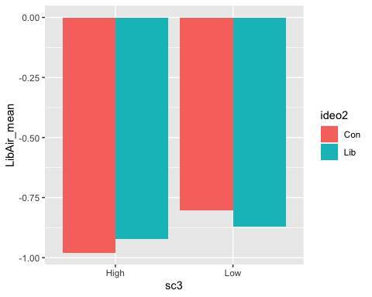

airmod1 <- lm(LibAir ~ 1, data = dfd2_lc)  
summary(airmod1)

##   
## Call:  
## lm(formula = LibAir ~ 1, data = dfd2_lc)  
##   
## Residuals:  
## Min 1Q Median 3Q Max   
## -2.1752 -1.1752 -0.1752 0.8248 3.8248   
##   
## Coefficients:  
## Estimate Std. Error t value Pr(>|t|)   
## (Intercept) -0.82485 0.07176 -11.49 <2e-16 ***  
## ---  
## Signif. codes: 0 '***' 0.001 '**' 0.01 '*' 0.05 '.' 0.1 ' ' 1  
##   
## Residual standard error: 1.59 on 490 degrees of freedom

airmod2 <- lm(LibAir ~ rav_scoredz, data = dfd2_lc)  
summary(airmod2)

##   
## Call:  
## lm(formula = LibAir ~ rav_scoredz, data = dfd2_lc)  
##   
## Residuals:  
## Min 1Q Median 3Q Max   
## -2.5557 -1.1456 -0.3096 0.9365 4.0185   
##   
## Coefficients:  
## Estimate Std. Error t value Pr(>|t|)   
## (Intercept) -0.82209 0.07161 -11.480 <2e-16 ***  
## rav_scoredz -0.13107 0.07224 -1.814 0.0702 .   
## ---  
## Signif. codes: 0 '***' 0.001 '**' 0.01 '*' 0.05 '.' 0.1 ' ' 1  
##   
## Residual standard error: 1.586 on 489 degrees of freedom  
## Multiple R-squared: 0.006687, Adjusted R-squared: 0.004656   
## F-statistic: 3.292 on 1 and 489 DF, p-value: 0.07023

anova(airmod1, airmod2)

## Analysis of Variance Table  
##   
## Model 1: LibAir ~ 1  
## Model 2: LibAir ~ rav_scoredz  
## Res.Df RSS Df Sum of Sq F Pr(>F)   
## 1 490 1238.9   
## 2 489 1230.7 1 8.2851 3.2921 0.07023 .  
## ---  
## Signif. codes: 0 '***' 0.001 '**' 0.01 '*' 0.05 '.' 0.1 ' ' 1

airmod3 <- lm(LibAir ~ sc_scoredz + rav_scoredz, data = dfd2_lc)  
summary(airmod3)

##   
## Call:  
## lm(formula = LibAir ~ sc_scoredz + rav_scoredz, data = dfd2_lc)  
##   
## Residuals:  
## Min 1Q Median 3Q Max   
## -2.6877 -1.1600 -0.3303 1.0284 4.1016   
##   
## Coefficients:  
## Estimate Std. Error t value Pr(>|t|)   
## (Intercept) -0.82161 0.07151 -11.490 <2e-16 ***  
## sc_scoredz -0.11439 0.07413 -1.543 0.123   
## rav_scoredz -0.11884 0.07257 -1.638 0.102   
## ---  
## Signif. codes: 0 '***' 0.001 '**' 0.01 '*' 0.05 '.' 0.1 ' ' 1  
##   
## Residual standard error: 1.584 on 488 degrees of freedom  
## Multiple R-squared: 0.01151, Adjusted R-squared: 0.00746   
## F-statistic: 2.841 on 2 and 488 DF, p-value: 0.05931

anova(airmod1, airmod3)

## Analysis of Variance Table  
##   
## Model 1: LibAir ~ 1  
## Model 2: LibAir ~ sc_scoredz + rav_scoredz  
## Res.Df RSS Df Sum of Sq F Pr(>F)   
## 1 490 1238.9   
## 2 488 1224.7 2 14.261 2.8413 0.05931 .  
## ---  
## Signif. codes: 0 '***' 0.001 '**' 0.01 '*' 0.05 '.' 0.1 ' ' 1

airmod4 <- lm(LibAir ~ AirCong + sc_scoredz + rav_scoredz, data = dfd2_lc)  
summary(airmod4)

##   
## Call:  
## lm(formula = LibAir ~ AirCong + sc_scoredz + rav_scoredz, data = dfd2_lc)  
##   
## Residuals:  
## Min 1Q Median 3Q Max   
## -2.6581 -1.1592 -0.3372 1.0363 4.0736   
##   
## Coefficients:  
## Estimate Std. Error t value Pr(>|t|)   
## (Intercept) -0.86049 0.10571 -8.140 3.34e-15 ***  
## AirCong 0.07214 0.14436 0.500 0.6175   
## sc_scoredz -0.11786 0.07451 -1.582 0.1143   
## rav_scoredz -0.12030 0.07268 -1.655 0.0986 .   
## ---  
## Signif. codes: 0 '***' 0.001 '**' 0.01 '*' 0.05 '.' 0.1 ' ' 1  
##   
## Residual standard error: 1.585 on 487 degrees of freedom  
## Multiple R-squared: 0.01202, Adjusted R-squared: 0.005931   
## F-statistic: 1.975 on 3 and 487 DF, p-value: 0.1169

anova(airmod1, airmod4)

## Analysis of Variance Table  
##   
## Model 1: LibAir ~ 1  
## Model 2: LibAir ~ AirCong + sc_scoredz + rav_scoredz  
## Res.Df RSS Df Sum of Sq F Pr(>F)  
## 1 490 1238.9   
## 2 487 1224.0 3 14.889 1.9745 0.1169