FOR IMMEDIATE RELEASE


presents
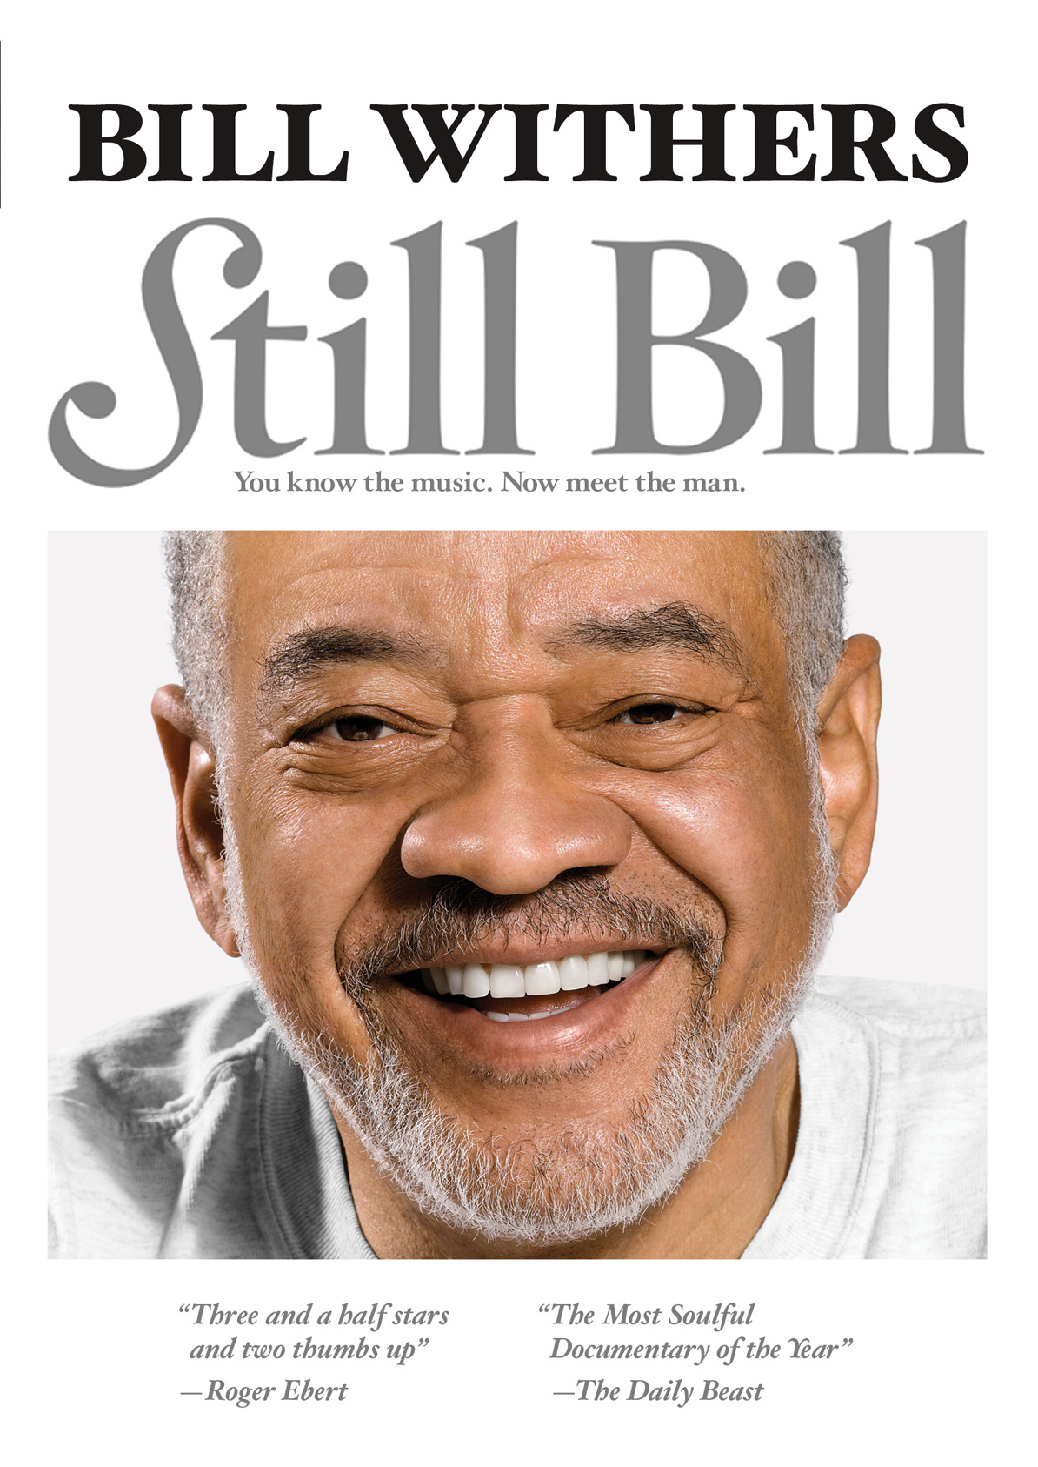
“THE MOST SOULFUL DOCUMENTARY OF THE YEAR,”
TO BE RELEASED ON DVD, DIGITAL AND VOD ON JANUARY 25

December 3, 2010 – Experience a personal journey into the life of a complex, fascinating and profound man. Eight years ago, filmmakers Damani Baker and Alex Vlack had what seemed like a simple idea: make a film about music legend Bill Withers. Little was known about the man who wrote the classics “Ain’t No Sunshine,” “Lean on Me,” and “Just the Two of Us” since he’d left the business to live a low-key, private family life. Four hours of interviews with Withers became forty hours. Forty hours became three hundred…

This year, STILL BILL debuted in theaters to rave reviews, including “three and a half stars and two thumbs up” from Roger Ebert and praise from The Chicago Tribune for being “a little truer, a little warmer, a little wiser and more intuitively right than the average doc.” The Daily Beast claims STILL BILL simply as “the most soulful documentary of the year.”

As a child in Slab Fork, West Virginia, Bill Withers was asthmatic and a stutterer. His greatest influence was his Grandma Galloway, who nurtured him and let him know that he had a gift – she was the woman he would immortalize later with the classic “Grandma’s Hands.” Since leaving the recording business nearly 25 years ago, Withers has been living a quiet life, raising his children with his wife in Los Angeles. His son is now in law school and his daughter is revealing her own clear and resonant singing voice.

STILL BILL accompanies Withers through intimate life experiences including his 70th birthday, his high school reunion, and a trip to New York for an Our Time Theatre Company gala performance in his honor and a tribute concert in Brooklyn’s Prospect Park.


“Bill’s focus is the core of life: family, friends, love, goodness, humility—his entire outlook on life, like his lyrics, is simple and yet profound, at once obvious and deeply moving.”(Damani Baker and Alex Vlack).

Through interviews with Dr. Cornel West, Tavis Smiley, Sting, Angelique Kidjo, Jim James of My Morning Jacket, Withers’ family, and his closest friends – along with Withers himself, STILL BILL presents an artist who has written some of the most beloved songs of our time and a man who truly understands the meaning of soul.

Exclusive bonus features include performances of “Ain’t no Sunshine” by Jim James (Yim Yames) and of “Who is He and What is He to You?” by Living Colour lead singer, Corey Glover. Additional features include footage of Withers’ recent concert performances.

STILL BILL is produced by Damani Baker, Alex Vlack and Jon Fine; edited by Jon Fine and Sakae Ishikawa.

Pricing: $29.95 US
Runtime: 76 mins., plus bonus features
Rating: N/A
Catalog #: NNVG237310
Language: English
Color: Color
Audio Format: Dolby Digital 5.1 Stereo
Genre: Documentary

About Docurama Films
Docurama Films is dedicated to making critically acclaimed and cutting-edge documentaries available digitally and on home video. In 1999, New Video launched Docurama Films with the release of the first feature documentary on DVD, D.A. Pennebaker’s Bob Dylan: Don’t Look Back. Over a decade later and a line of over 250 award-winning and highly acclaimed documentary titles, Docurama continues its mission to unearth and release the great classic documentaries of the last fifty years while spreading the word about filmmakers who are taking the form to new heights. The Docurama catalog features a wide span of titles from varying genres including the arts, history/politics, environmental, ethnic interest, LGBT, music, and socio-cultural as well as theatrical fan-favorites like The Wild Parrots of Telegraph Hill and Andy Goldsworthy: Rivers and Tides. Releases in 2010 include the screwball comedy The Yes Men Fix the World, the empowering music celebration Soundtrack for a Revolution and the crowd-pleasing Best Worst Movie. www.docuramafilms.com

About New Video
New Video is a leading independent privately-held distributor of quality entertainment via DVD, Blu-ray, download and streaming platforms, and cable VOD. We are the proud home to some of the most prestigious names in the industry like A&E®, HISTORY™, Lifetime®, Major League Baseball®, Scholastic Storybook Treasures™, Arthouse Films and Tribeca Film as well as our own lines Docurama Films®, and the newly launched Flatiron Film Company®. Since 1991, our mission has been to discover first-rate content and deliver to audiences through traditional platforms and evolving new media. We selectively handpick our library while collaborating directly with our brand partners and filmmakers to cultivate a superior product and fresh new viewing experiences for our audiences. We are headquartered in New York City, but have an international presence in 45 territories. www.newvideo.com.

For more information, please contact:
Sommer Hixson
646-259-4138
shixson@newvideo.com

For box art, please visit:
http://www.newvideo.com/docurama/still-bill/

Or visit the Press Room at:
http://www.newvideo.com/pressroom/

