FOR IMMEDIATE RELEASE
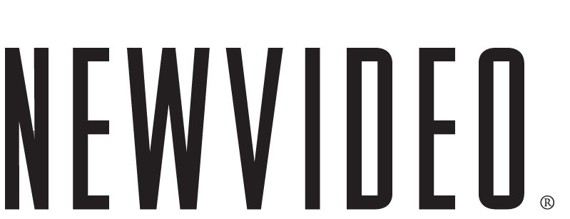

Magical and Mesmerizing
Academy Award®-Nominated Best Animated Feature
The Secret Of Kells
Comes to Brilliant Life on DVD and Blu-Ray!

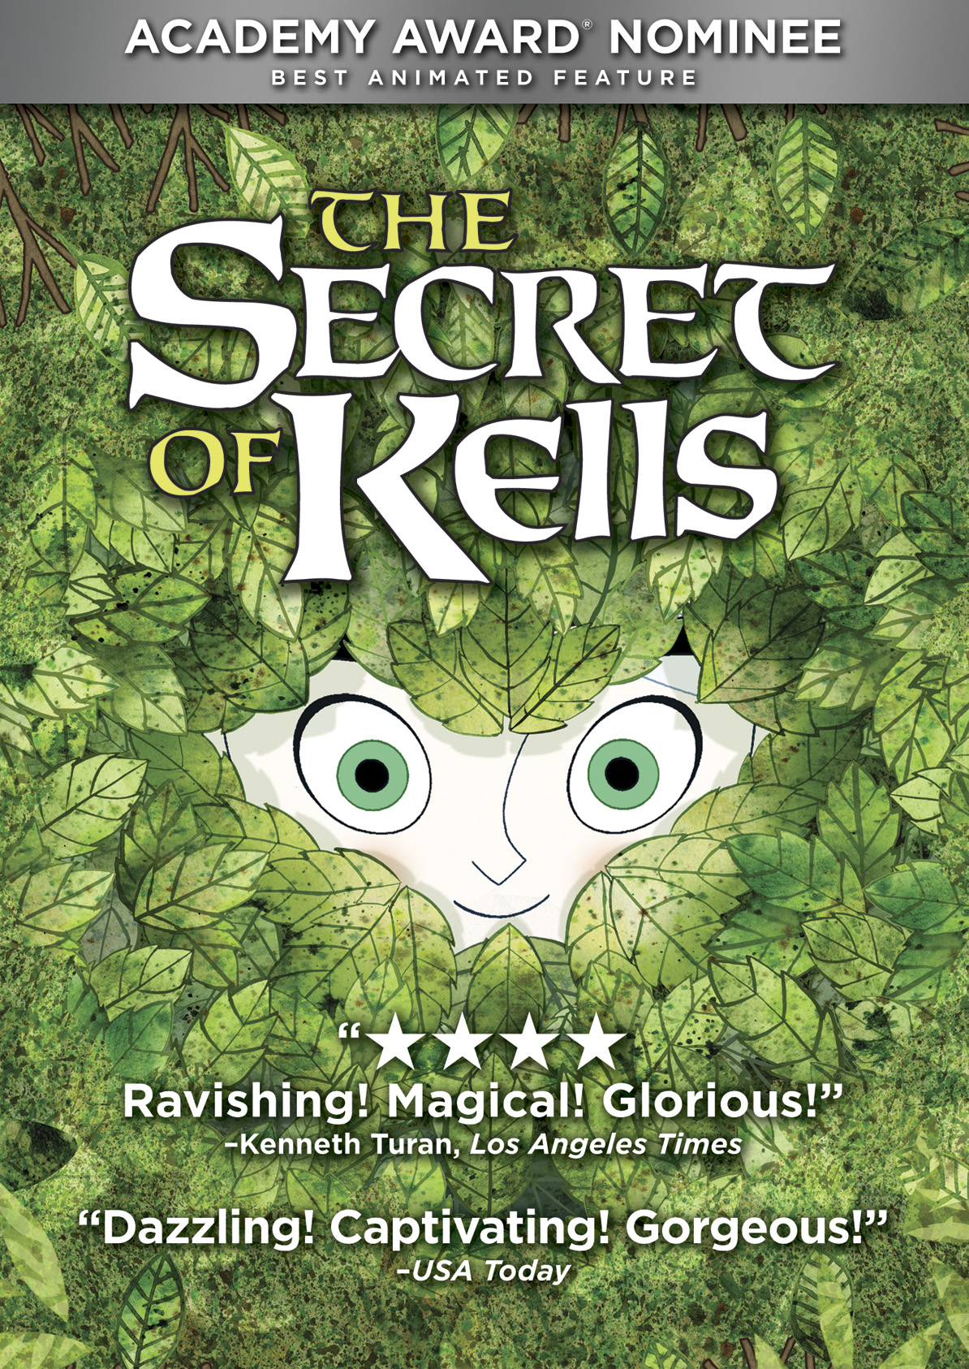

“Critics Pick! Extraordinary” – New York Times

“Dazzling! A magical adventure unlike anything we've seen before.” – USA Today

New York, NY, September 22, 2010 – The Academy Award®-nominated Best Animated Feature, The Secret of Kells, a stunning, sweeping adventure about the power of imagination, comes to DVD and Blu-ray from New Video’s Flatiron Film Company on October 5, 2010. The delightful and dazzling animated movie will captivate audiences of all ages with astounding imagery and a universally-powerful and uplifting story. The Secret of Kells will also be distributed day-and-date (October 5) on video-on-demand (VOD) and on digital platforms via New Video’s partners.

The Secret of Kells, directed by Tomm Moore, transports viewers to a remote medieval outpost of Ireland, where young Brendan (Evan McGuire) embarks on a forbidden adventure that begins when a celebrated master illuminator named Aidan (Mick Lally) arrives from foreign lands carrying a book brimming with secret wisdom and powers. To help complete the magical book, Brendan must overcome his deepest fears to travel on a dangerous and mysterious quest that takes him away from his uncle Abbot Cellach (Brendan Gleeson) and into the enchanted forest. He meets the fairy Aisling (Christen Mooney), an enigmatic young wolf-girl, who helps him along the way. But, with the barbarians closing in, will Brendan’s determination and artistic vision help illuminate the darkness and prevail against evil?

“We are extremely proud of and bowled over by the response to Kells. That audiences at home can revel in the excitement of the film is vitally important to us,” said Mr. Moore. “Families and kids across the country have been inspired by Kell’s imagery and storyline. We hope the film remains a treasure for them for years to come.”

Hailed by critics and audiences alike as one of the most beautiful animated films of recent times, The Secret of Kells (75 minutes) is the surprise nomination for Best Animated Feature at this year’s Academy Awards.

The Secret of Kells DVD (SRP $29.95) and DVD/Blu-ray combo pack ($39.95) feature two hours of fascinating exclusive bonus content, including audio commentary with the director, co-director and art director; a special “The Voices of Ireland” segment that includes voice recording sessions with Brendan Gleeson, Evan McGuire, Christen Mooney and Mick Lally; a director’s presentation of pre-production sketches and inspirational images, and more. In addition, the DVD/Blu-ray combo includes a special collectible 24-page full-color prequel graphic novel by Mr. Moore that follows Aisling’s and Brendan’s adventures that took place before the story in the film begins.

Credits:

GKIDS presents a film by Tomm Moore; Co-Director Nora Twomey; Script, Fabrice Ziolkowski; Art Director, Ross Stewart; Music by Bruno Coulais, featuring original music by Kila. A Les Armateurs-Vivi Film-Cartoon Saloon-France 2 Cinema Production.

DVD TECHNICAL INFORMATION:
Catalog #: NNVG229021 Language: English
Running Time: 75 mins + extras Audio Format: Stereo
Genre: Animation Price: $29.95

DVD-BD TECHNICAL INFORMATION (2-Disc):
Catalog #: NNVG229030 Language: English
Running Time: 75 mins + extras Audio Format: Stereo
Genre: Animation Price: $39.95

For box art:
http://www.newvideo.com/flatiron-film-company/the-secret-of-kells/

About New Video
New Video is the world’s leading independent Blu-ray, DVD and digital distributor specializing in cutting-edge documentaries, independent films, cult hits, collectible television series, sports and classic kids programming. Home to some of the most prestigious names in entertainment, including A&E®, HISTORY™, Lifetime®, Major League Baseball®, Major League Soccer®, Scholastic Storybook Treasures™, Arthouse Films, Docurama Films®, NEWVIDEO NYC, and Flatiron Film Company, New Video showcases over 5,000 titles in its catalog. As the digital distributor arm, New Video Digital provides over 11,000 hours of film and television programming from more than 120 trusted brands to download and streaming platforms including iTunes, Hulu, Netflix, Xbox, Sony PlayStation and Amazon. Since 1990, the company’s mission has been to further the goal of providing audiences with top-notch special interest content. www.newvideo.com.

# # #
Press contacts:
Grand Communications

Alison Grand Jaymie Presberg Gabrielle Torello
212-584-1133 212-584-1133 201-678-2824
Alison@grandcommunications.com jaymie@grandcommunications.com gabtpr@yahoo.com

