For Immediate Release:

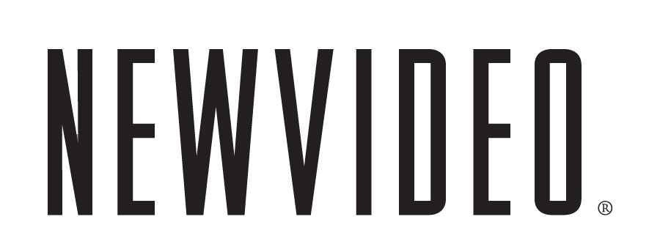

NEW VIDEO Adds Arthouse Films to the Family
New Video becomes the U.S. DVD partner for Arthouse Films

NEW YORK, October 20 -- New Video has inked a deal as the U.S. DVD distributor for Arthouse Films, with the first title slated for a December street date.
New Video continues to build their DVD library with titles that fall under home brands Docurama Films and NEWVIDEO NYC and distributes well-known brands such as A&E®, HISTORY™, Major League Baseball®, and Scholastic Storybook Treasures™.
Under the new deal, Arthouse Films titles will be released under the Arthouse Films label. The first title released -- HERB & DOROTHY, a documentary about the Vogels, a postal worker and a librarian who, despite modest means, purchased works of art in the 60’s which later became one of most important art collections in the world-- arrives on DVD retail shelves on December 15th of this year. The film is currently in select theaters experiencing a very successful theatrical run. Other DVD titles scheduled to roll out in 2010 include Milton Glaser: To Inform & Delight, Rem Koolhaas: A Kind of Architect and Visual Acoustics.
New Video will debut new releases as well as repackage at least 10 titles from their back catalog including The Cool School: Story of the Ferus Art Gallery, Painters Painting: The New York Art Scene 1940-1970, Black White + Gray: A Portrait of Sam Wagstaff and Robert Mapplethorpe, The Cats of Mirikitani, Alice Neel doc, A Walk into the Sea: Danny Williams & the Warhol Factory, The Universe of Keith Haring, Jack Smith & the Destruction of Atlantis, Obcene: a Portrait of Barney Rosset & Grove Press, and Next: a Primer on Urban Painting.
Arthouse Films is an independent film production and distribution label based in NY and LA and acquires, produces, and distributes 20+ titles per year that are theatrically released. Their focus on film and art and culture was a selling point for New Video.
“The quality and subject matter of Arthouse Film’s titles elevate our appreciation of the arts in various disciplines. There is certainly a cultural need and a healthy market for these films.
We are very proud and excited to add them to our family,” said Susan Margolin, Co-Principal of New Video.
“We are delighted that New Video will be making our films more accessible via DVD distribution,” said David Koh, Lilly Bright, and Stanley Buchthal of Arthouse Films. “They have a deep-rooted history in the independent film world and in documentaries and share an understanding of how to speak to a niche market, which is key in reaching the right audience.”
In addition to major retail outlets, New Video’s marketing and distribution strategy will include targeting museum gift stores, book shops and art friendly retail shops.

About Arthouse Films
Arthouse Films is an independent film distribution & production label based in NY and LA and acquires, produces, co-produces and distributes 20+ titles per year. Upcoming and current titles include: JEAN-MICHEL BASQUIAT: THE RADIANT CHILD by Tamra Davis, WILLIAM KUNSTLER: DISTURBING THE UNIVERSE by Sarah and Emily Kunstler, VISUAL ACOUSTICS: THE MODERNISM OF JULIUS SHULMAN by Eric Bricker, PICASSO & BRAQUE GO TO THE MOVIES by Arne Glimcher, HERB & DOROTHY by Megumi Sasaki, MILTON GLASER: TO INFORM & DELIGHT by Wendy Keys, BEAUTIFUL LOSERS by Aaron Rose, REM KOOLHAAS: A KIND OF ARCHITECT by Markus Heidingsfelder and Min Tesch, THE UNIVERSE OF KEITH HARING by Christina Clausen, OBSCENE by Neil Ortenberg and Daniel O'Connor, PAINTERS PAINTING by Emile de Antonio, and the HENRI CARTIER-BRESSON DVD Boxed Set.
About New Video
New Video is an entertainment company bringing top television, cutting edge documentaries, independent film, professional sports, and children’s programming to DVD and to the digital marketplace. Home to some of the most prestigious names in entertainment, including A&E®, HISTORY™, Major League Baseball®, Major League Soccer® and Scholastic Storybook Treasures™, as well as Docurama Films and NEWVIDEO NYC, New Video showcases well over 5,000 titles in its DVD catalog. As the world’s largest independent digital video distributor, New Video Digital provides over 10,000 hours of film and television from more than 100 trusted brands to download and streaming platforms, including iTunes, Hulu, YouTube, Netflix, Xbox, and Amazon. www.newvideo.com

# # #

For more information contact:

John Squires, New Video
646-259-4138/ jsquires@newvideo.com

