FOR IMMEDIATE RELEASE


Presents

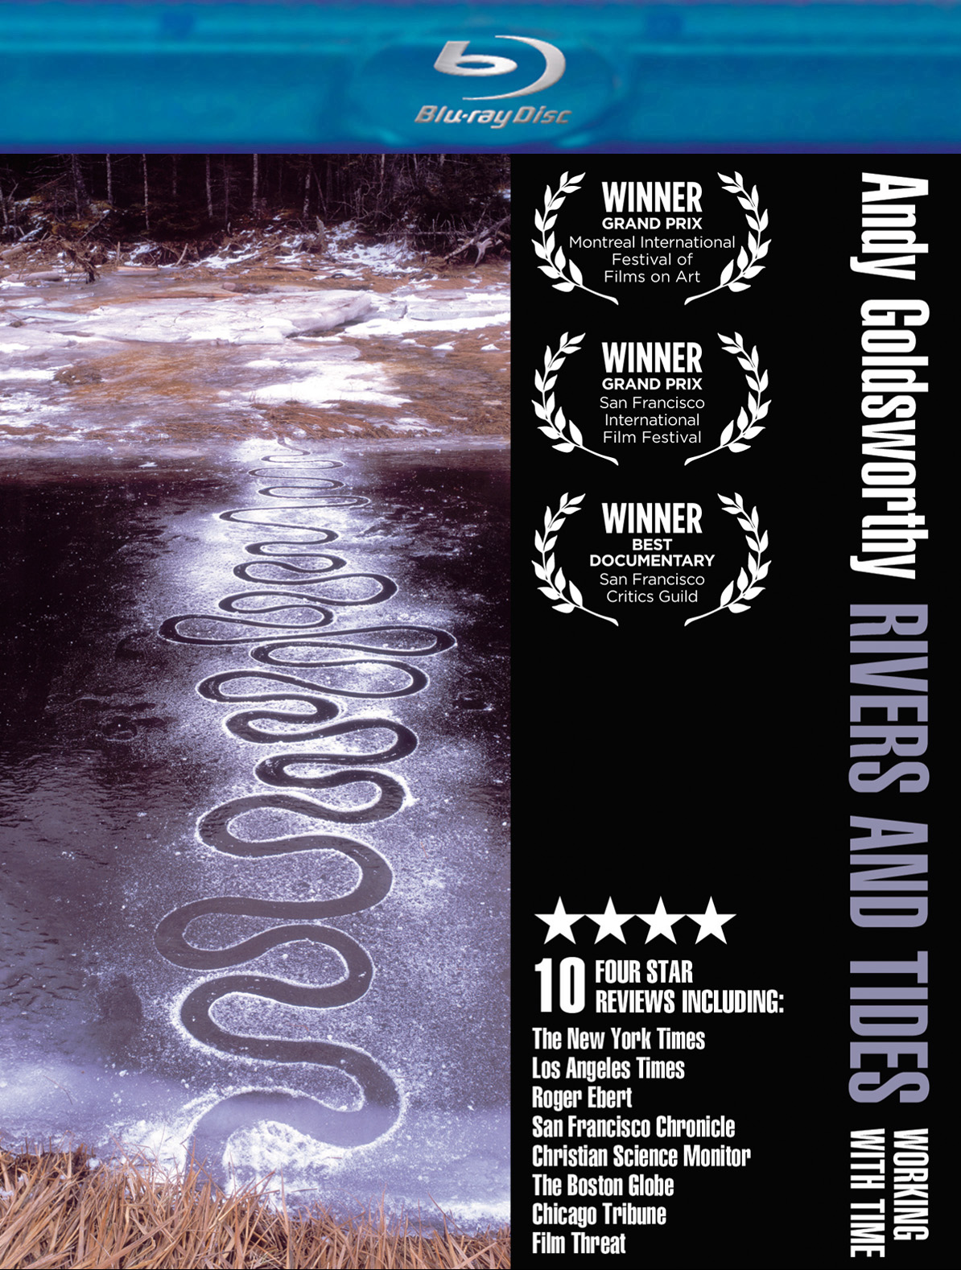

CRITICALLY ACCLAIMED THEATRICAL PHENOMENON
“ANDY GOLDSWORTHY: RIVERS AND TIDES, WORKING WITH TIME”
DEBUTS MARCH 8 ON BLU-RAY

New HD transfer also available on Digital

“A surprisingly magical experience…intoxicating.”-- Kenneth Turan, Los Angeles Times
“Ravishingly beautiful…”-- Stephen Holden, The New York Times

February 25, 2011 -- Depicting the magical relationship between art and nature while painting a visually intoxicating portrait of world-renowned Scottish artist Andy Goldsworthy, RIVERS AND TIDES follows the bohemian free spirit all over the world as he demonstrates and discusses his creative process and artistic philosophies.

From his long-winding rock walls and icicle sculptures to his interlocking leaf chains and multicolored pools of flowers, Goldsworthy’s painstakingly intricate masterpieces are made entirely of materials found in Mother Nature – an unpredictable “critic” who threatens and often succeeds in destroying his art, sometimes before it is even finished.

In celebration of the 10th anniversary of the film’s stunning theatrical debut, New Video’s Docurama Films is releasing RIVERS AND TIDES for the first time on Blu-ray in a new high-definition transfer, which will also be available on digital viewing platforms. Already dazzling visuals are heightened in the transfer from the film’s original negative, overseen by director Thomas Riedelsheimer. More than an hour of bonus material includes:

- 7 short films including Storm King Wall, Leaf Horn and Ice Arch
- Bonus film Snowballs in Summer, featuring thirteen giant snowballs placed on the streets of London, left to melt in the heat of the longest day of the year. As they disappear, the public witnesses the surprise materials that Goldsworthy packed into the snow sculptures.
- 45-minute interview with Riedelsheimer, who discusses his experiences over the year of filming with Goldsworthy and candidly reveals the genius behind the famed artist.
- Photo Gallery



“Goldsworthy takes what he discovers [in nature] and makes it into something that
for a moment is like a dream of nature made real.”
-- Roger Ebert

With several 4-star reviews from the country’s top critics and numerous festival awards, RIVERS AND TIDES serenely captures Goldsworthy on-camera in the midst of constructing his trademark ephemera, each image more extraordinary than the last. Interweaving an elegant, minimalist soundtrack composed and performed by avant-garde virtuoso Fred Frith, RIVERS AND TIDES is a mesmerizing cinematic experience that helps us to appreciate nature in new and enchanting ways.

Pricing: $29.95 US
Runtime: 90 mins., plus extras
Rating: N/A
Catalog #: NNVG234401
Language: English
Color: Color
Audio Format: Dolby Digital 5.1 Stereo
Genre: Documentary

About Docurama Films
Docurama Films is dedicated to making critically acclaimed and cutting-edge documentaries available digitally and on home video. In 1999, New Video launched Docurama Films with the release of the first feature documentary on DVD, D.A. Pennebaker’s Bob Dylan: Don’t Look Back. More than a decade later and a library of more than 250 award-winning, highly acclaimed documentary titles, Docurama continues its mission to unearth and release the great classic documentaries of the last fifty years while spreading the word about filmmakers who are taking the form to new heights. The Docurama catalog features a roster of titles from genres including the arts, history, politics, environmental, ethnic interest, LGBT, music, and socio-cultural, as well as theatrical fan-favorites like The Wild Parrots of Telegraph Hill. Recent releases include Gasland, The Age of Stupid and Best Worst Movie. www.docuramafilms.com

About New Video
New Video is a leading independent privately-held distributor of quality entertainment via DVD, Blu-ray, download and streaming platforms, and cable VOD. We are the proud home to some of the most prestigious names in the industry like A&E®, HISTORY™, Lifetime®, Major League Baseball®, Scholastic Storybook Treasures™, Arthouse Films and Tribeca Film as well as our own lines Docurama Films®, and the newly launched Flatiron Film Company®. Since 1991, our mission has been to discover first-rate content and deliver to audiences through traditional platforms and evolving new media. We selectively handpick our library while collaborating directly with our brand partners and filmmakers to cultivate a superior product and fresh new viewing experiences for our audiences. We are headquartered in New York City, but have an international presence in 45 territories. www.newvideo.com.

For more information, please contact:
Sommer Hixson
646-259-4138
shixson@newvideo.com

For materials, please visit:
http://www.newvideo.com/docurama/rivers-and-tides-blu-ray-edition/

Or visit the Press Room at:
http://www.newvideo.com/pressroom/

