

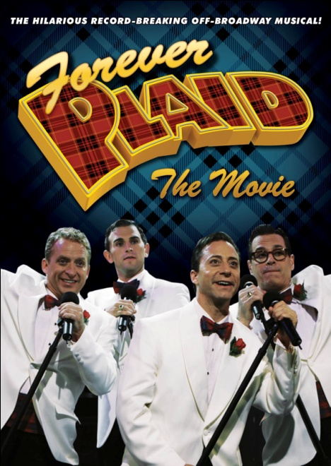

NEW VIDEO’S FLATIRON FILM COMPANY PRESENTS
“FOREVER PLAID: THE MOVIE”

20th Anniversary Presentation of Off-Broadway’s #1 Musical Available
September 20 on DVD and Digital Platforms

“Hilarious. Letter perfect!” – The New York Times
“Glorious” – TIME Magazine
”Tugs at the heart as well as the funny bone…a musical mix that makes the theater reverberate with pleasure.” –Los Angeles Times

August 31, 2011 – New York, NY – FOREVER PLAID is one of the most popular and successful Off-Broadway musicals in history, generating multi-millions of dollars in ticket sales since its premiere in 1990. On September 20, the 20th Anniversary Presentation of this affectionate revue of the close-harmony guy groups of the 1950s will be available from New Video’s Flatiron Film Company on DVD and digital platforms.
The premise: Broadsided by a bus full of Catholic school girls in 1964 on their way to the Ed Sullivan Show, The Plaids are wiped out while driving their red ’54 Mercury convertible to their first real singing gig. FOREVER PLAID begins with the quartet – Jinx, Smudge, Sparky and Francis – returning from the afterlife nearly 50 years later for one final chance at musical glory.

Interspersed with witty and insightful dialogue about the love of music, finding success, and the courage we need to face life every day, FOREVER PLAID is Happy Days meets Jersey Boys meets Tony Bennett. The crowd-pleasing score consists of unforgettable classics including “Three Coins in the Fountain,” “Chain Gang,” “Cry,” “Heart and Soul,” “Rags to Riches,” and many more.

As The Plaids begin their earthly journey and appear on stage, a voice from heaven (David Hyde Pierce) explains their inter-terrestrial trek from the astral plane to where they are standing and then lays down the stakes: there is a perfect harmonic chord buried in the song “Love is a Many Splendored Thing,” a chord The Plaids never fully hit in life but now they must for their spectral visit to earth. They attack the opportunity with wild, comedic abandon, never letting their fears or nerves prevent them from giving their all. The result is the happy resolution of their redemptive arc. The harmonic chord is finally found and sung. It resonates with the harmony we all want in our lives and in our worldview, all across America and around the world.

FOREVER PLAID ran for 5 years in New York and 8 years in Las Vegas, and has played in nearly every major metropolitan market in the United States. George Bush, Bill Clinton and the Queen of England have enjoyed performances of FOREVER PLAID; the album is one of the most successful off-Broadway soundtracks ever.

In addition to writing and directing the original New York production, Stuart Ross has directed stage productions of PLAID in major cities in the U.S. and around the world, including Los Angeles, Chicago, Boston, London-West End, Washington D.C, Minneapolis, Cleveland, Detroit, Tokyo, and Las Vegas, among many others.

FOREVER PLAID: THE MOVIE reunites 3 of the 4 original cast members – Stan Chandler, David Engel and Larry Raben – with original Jersey Boy, Daniel Reichard, and was taped from a live performance in 2009. The presentation then aired in 2010 in more than 500 select movie theaters in the U.S. as a National CineMedia Fathom Event. FOREVER PLAID: THE MOVIE began airing on PBS television stations in July 2011.

FOREVER PLAID: THE MOVIE:
SRP: $26.95 U.S. $29.95 CAN
Format: DVD Single
Packaging: Swing Amaray
Length: Approx. 83 mins + extras
Language: English
Color: Color
Audio format: Stereo
Genre: Musical
www.newvideo.com/flatiron-film-company/forever-plaid/
About New Video
Celebrating its 20th anniversary in 2011, New Video is a leading entertainment distributor and the largest aggregator of independent digital content worldwide. Headquartered in New York City, with an international presence in 45 territories, the company delivers feature films, TV programs and web originals via digital download, streaming media, video-on-demand, Blu-ray and DVD, and theatrical release. New Video streamlines the distribution and marketing process for filmmakers, producers and brand partners to bring a wide variety of fresh content to new audiences. The company’s library includes original TV series and movies from A+E® Home Entertainment, HISTORY™, and Lifetime®, unforgettable games and trophy sets from Major League Baseball®, storybook treasures from Scholastic®, award-winning documentaries from Docurama Films®, Arthouse Films, and Plexifilm, next-gen indies and web hits from Flatiron Film Company®, the best in Chinese cinema from China Lion, and festival picks from Tribeca Film. New Video is proud to distribute the 2011 Oscar®-nominated films Gasland, Waste Land and, on digital, Restrepo.

For additional press information, please contact:
Sommer Hixson, Media Relations, 646-259-4138; shixson@newvideo.com

For more information on FOREVER PLAID, please visit the official website located at:
http://www.foreverplaid.com
Visit us on Facebook at:
http://www.facebook.com/ForeverPlaidTheMovie

