FOR IMMEDIATE RELEASE:


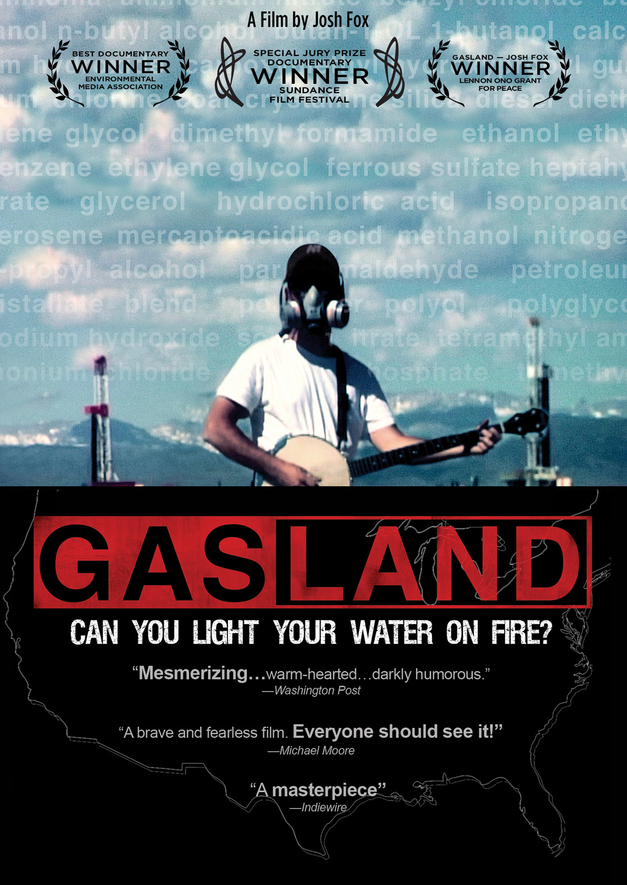

AWARD-WINNING, CRITICALLY ACCLAIMED DOCUMENTARY, GASLAND,
TO BE RELEASED ON DVD ON DECEMBER 14

“Incredibly inspiring and heart-wrenching”—Variety

"On the want-to-see- scale, GASLAND tops the list”—Washington Post

Winner - Special Jury Prize Documentary Sundance Film Festival

Is “fracking” safe? When filmmaker Josh Fox received an unexpected offer of $100,000 for the natural gas drilling rights to his property in the Delaware River Basin, on the border of New York and Pennsylvania, he resisted the urge to accept. Instead, he set off on a cross-country journey to investigate the risks of agreeing to this deal.

The largest domestic natural gas drilling boom in history has swept across the United States. Beneath our continent lies a vast underground ocean of natural gas waiting to be harvested. The Halliburton-developed drilling technology of "fracking" (hydraulic fracturing) - exempt by the Bush-Cheney Energy Policy Act of 2005 from our national Safe Drinking Water Act and the Clean Air Act - has unlocked a "Saudia Arabia of natural gas" just beneath us. Across the country, in major cities such as New York, Los Angeles and Dallas-Ft. Worth - where drilling is slated to take place or is already occurring directly in nearby water-supply areas - a crisis looms that could affect millions.

A nearby, recently-drilled Pennsylvania town has reported that its residents are able to light their drinking water on fire. This is just one of the many absurd and astonishing revelations of a new country called GASLAND. Other stops on Fox’s journey:

- Dimock, Pennsylvania - the town closest to the New York City watershed, where residents’ farm and domestic animals started losing hair after drilling started, presumably from drinking contaminated water;
- Wyoming - where Fox visits ranchers whose water well erupted for three days with a geyser of natural gas;
- Dish, Texas - where emissions from natural gas wells and pipelines measure 55-times the acceptable public health level for cancer-causing benzene and 107-times the health standard for carbon disulfide, a neurotoxin;
- Dallas-Ft. Worth, Texas - where approximately 10,000 gas wells produce air emissions from gas drilling that are greater than all the air pollution from all cars and trucks in that metropolitan area, the fourth largest in America.

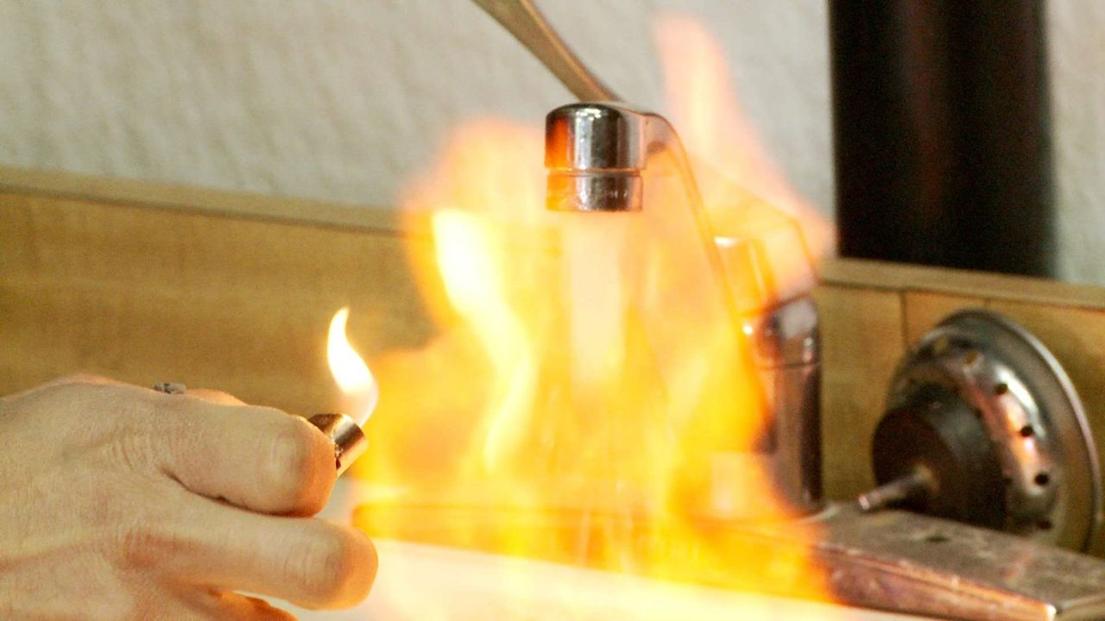

Gas companies have now turned their attention to the massive Marcellus Shale Field, where Fox’s Pennsylvania home rests. Stretching from the Catskill region of New York State to West Virginia, the area is also home to the country’s largest unfiltered watershed, supplying water to millions of Americans, including the residents of New York City. Thousands of leases have already been purchased by drilling companies, prompting a public controversy.

GASLAND is going a long way in spreading public awareness about the risks fracking poses on human and environmental health. The fight against hydraulic fracturing has now moved to Congress, where lobbyists are trying to prevent legislation that would require the chemicals used in the fracking process to once again be subject to the Safe Drinking Water Act.

Part verité travelogue, part exposé, part mystery, part bluegrass banjo meltdown, and part showdown, GASLAND premiered on HBO in June 2010. The 107-minute DVD features deleted interviews and scenes from the film.

GASLAND is directed by Josh Fox; produced by Trish Adlesic; Josh Fox, Molly Gandour; edited by Matthew Sanchez.

Pricing: $29.95 US
Runtime: 107 minutes, plus bonus features
Rating: N/A
Catalog #: NNVG236681
Language: English
Color: Color
Audio Format: Dolby Digital 2.0 Stereo
Genre: Documentary

About Docurama Films
Docurama Films is dedicated to making critically acclaimed and cutting-edge documentaries available digitally and on home video. In 1999, New Video launched Docurama Films with the release of the first feature documentary on DVD, D.A. Pennebaker’s Bob Dylan: Don’t Look Back. Over a decade later and a line of over 250 award-winning and highly acclaimed documentary titles, Docurama continues its mission to unearth and release the great classic documentaries of the last fifty years while spreading the word about filmmakers who are taking the form to new heights. The Docurama catalog features a wide span of titles from varying genres including the arts, history/politics, environmental, ethnic interest, LGBT, music, and socio-cultural as well as theatrical fan-favorites like The Wild Parrots of Telegraph Hill and Andy Goldsworthy: Rivers and Tides. Releases in 2010 include the screwball comedy The Yes Men Fix the World, the empowering music celebration Soundtrack for a Revolution and the crowd-pleasing Best Worst Movie. www.docuramafilms.com

About New Video
New Video is a leading independent privately-held distributor of quality entertainment via DVD, Blu-ray, download and streaming platforms, and cable VOD. We are the proud home to some of the most prestigious names in the industry like A&E®, HISTORY™, Lifetime®, Major League Baseball®, Scholastic Storybook Treasures™, Arthouse Films and Tribeca Film as well as our own lines Docurama Films®, and the newly launched Flatiron Film Company®. Since 1991, our mission has been to discover first-rate content and deliver to audiences through traditional platforms and evolving new media. We selectively handpick our library while collaborating directly with our brand partners and filmmakers to cultivate a superior product and fresh new viewing experiences for our audiences. We are headquartered in New York City, but have an international presence in 45 territories. www.newvideo.com.

For more information, please contact:
Sommer Hixson
646-259-4138
shixson@newvideo.com

For box art, please visit:
http://www.newvideo.com/docurama/gasland/

Or visit the Press Room at:
http://www.newvideo.com/pressroom/

