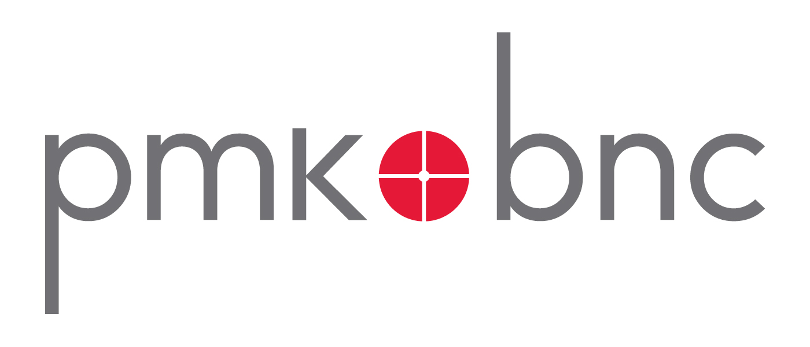
‘THE BEST AND THE BRIGHTEST’ HITS THEATRES ON JUNE 24, 2011
FOLLOWED BY VOD, DIGITAL & DVD RELEASE ON AUGUST 16
Josh Shelov-Directed All-Star Comedy Cast Includes Neil Patrick Harris, Bonnie Somerville,
Amy Sedaris, Christopher McDonald, John Hodgman and Kate Mulgrew

New York, NY [Tuesday, May 10, 2011] – New Video’s Flatiron Film Company and PMK*BNC announced today the platform release schedule for director Josh Shelov’s comedy, The Best and the Brightest. Following a successful sneak preview campaign spearheaded by Big Indie Pictures, the film, which world-premiered at the 2010 Philadelphia Film Festival and stars Neil Patrick Harris, will open theatrically in New York and Los Angeles on Friday, June 24, 2011. A VOD, digital and DVD release is slated for August 16.
Compared by Movie City News to A Fish Called Wanda and Ruthless People, The Best and the Brightest, co-written by Shelov and Michael Jaeger, is a modern-day comedy set in the world of New York City’s elite private schools. The Jasinskis (Harris, Bonnie Somerville) are a middle-class couple from Delaware who move to New York City with their five-year-old daughter for a last chance at “the big time.” Upon arrival, they experience a big problem: they can't get their daughter into a single private kindergarten. The couple desperately turns to kindergarten consultant, Sue Lemon (Amy Sedaris), who recommends Jeff pose as a high-profile poet to gain kudos from the VIPs who are deciding between two child candidates for the last coveted slot at Coventry Day School (John Hodgman, Christopher McDonald and Kate Mulgrew). An innocent ploy quickly turns into sexual blackmail and creative persuasion as the Jasinskis battle to enroll their child.
“We’re thrilled to be working with New Video and PMK*BNC,” said Josh Shelov, director of The Best and the Brightest. “In an exciting time when movie-going audiences can access content via multiple platforms, their cohesive and streamlined distribution plan presents our film with the opportunity to be seen by a wide and diverse audience.”
The Best and the Brightest is directed and co-written by Josh Shelov and produced by Robert and Patricia Weiser (High Treason Pictures), Nicholas Simon, and Declan Baldwin (Big Indie Pictures). Richard Schiffrin (Wellfleet Phantasy Productions) is the executive producer. The film stars Neil Patrick Harris, Bonnie Somerville, Amy Sedaris, Jenna Stern, Christopher McDonald, Peter Serafinowicz, Bridget Regan, Kate Mulgrew and John Hodgman.

For more information on The Best and the Brightest, please visit the official website at http://www.bestnbrightestmovie.com/.

For more information on New Video, please visit www.newvideo.com or for PMK*BNC, please visit www.pmkbnc.com.
Press Contacts:
Sommer Hixson, New Video - shixson@newvideo.com – 646-259-4138
George Nicholis, PMK*BNC – george.nicholis@pmkbnc.com – 212-373-6113
###

