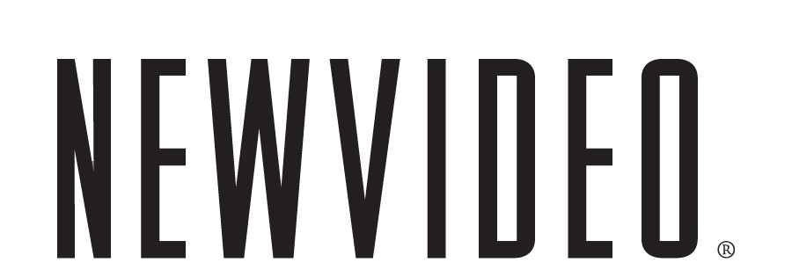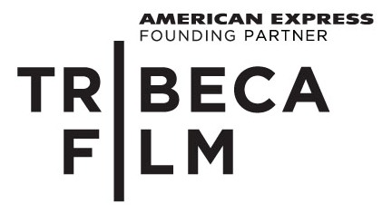
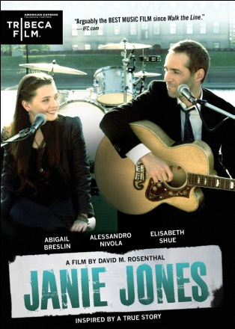

ABIGAIL BRESLIN, ALESSANDRO NIVOLA AND ELIZABETH SHUE
STAR IN “JANIE JONES”

ROCKIN’ INDIE, FEATURING ORIGINAL SONGS PEFORMED BY THE CAST,
RELEASES ON DIGITAL & DVD ON JANUARY 31

“Breslin floods the screen with luminosity. Nivola is pitch perfect.” – The Huffington Post
“Arguably the best music film since ‘Walk the Line.’” – IFC.com
December 15, 2011 – New York, New York -- Rocker Ethan Brand (Alessandro Nivola, Laurel Canyon, Coco Before Chanel) and his band are on the comeback trail when a former flame (Academy Award® nominee Elisabeth Shue, Leaving Las Vegas, “CSI”) drops a bomb in his lap: their 13-year-old daughter, Janie Jones (Academy Award® nominee Abigail Breslin, Little Miss Sunshine). JANIE JONES releases on standard digital platforms and DVD on January 31, following a theatrical and VOD release in October 2011.

Inspired by events in writer-director David M. Rosenthal’s life, the story of JANIE JONES begins when the young girl’s mom suddenly leaves her with Ethan for rehab, and Janie has no place to go but into the tour bus and on the road with the band. With no feel for fatherhood, Ethan continues his hard-living ways, giving Janie a crash course of the not-so-glamorous life on the road. As Ethan’s self-destructive spiral threatens the group’s future, his band members desert him one by one, until he and Janie are left alone. Desperate to finish the tour and revive his career, Ethan stays on the road as a solo act with Janie in tow, where her surprising musical talents help guide him down the rocky road to redemption.

JANIE JONES features Nivola and Breslin singing and performing in the film—the 14 original songs in the film range from Ethan’s raw, rock ’n’ roll club performances to the sweet and soulful ballads with which Janie consoles herself. Award-winning Irish singer and songwriter Gemma Hayes created Janie’s evocative music. Eef Barzelay of Clem Snide scored the film and wrote all of Ethan’s songs. The film also stars Brittany Snow (Prom Night), Frank Whaley (Swimming with Sharks), Frances Fisher (Titanic), and Peter Stormare (Fargo).

JANIE JONES premiered at the 2011 Toronto Film Festival and released day-and-date in theaters and on VOD in October 2011. The film is produced by Keith Kjarval and Eric Bassett. Alan Heim is editor; Anastas Michos, Cinematographer. Written and directed by David M. Rosenthal.
Pricing: $26.95 US
Runtime: 101 min + extras
Rating: NR
Catalog #: NNVG253940
Language: English
Color: Color
Audio Format: Dolby Digital 2.0 Stereo
Genre: Drama
Bonus: An Interview with the JANIE JONES team, Presented by American Express; Deleted Scenes
About Tribeca Film
Tribeca Film is a comprehensive distribution label dedicated to acquiring and marketing independent films across multiple platforms, including video-on-demand, theatrical and home video. It is an initiative from Tribeca Enterprises designed to provide new platforms for how film can be experienced, while supporting filmmakers and introducing audiences to films they might not otherwise see. American Express continues its support of Tribeca and the independent film community by serving as the Founding Partner of Tribeca Film.

About New Video
Celebrating its 20th anniversary in 2011, New Video is a leading entertainment distributor and the largest aggregator of independent digital content worldwide. Headquartered in New York City, with an international presence in 45 territories, the company delivers feature films, TV programs and web originals via digital download, streaming media, video-on-demand, Blu-ray and DVD, and theatrical release. New Video streamlines the distribution and marketing process for filmmakers, producers and brand partners to bring a wide variety of fresh content to new audiences. The company’s library includes original TV series and movies from A&E® Home Video, HISTORY™, and Lifetime®, unforgettable games and trophy sets from Major League Baseball®, storybook treasures from Scholastic®, award-winning documentaries from Docurama Films®, Arthouse Films, and Plexifilm, next-gen indies and web hits from Flatiron Film Company®, the best in Chinese cinema from China Lion, and festival picks from Tribeca Film.

For more information, please contact:
Sommer Hixson, Media Relations shixson@newvideo.com; 646-259-4138

