FOR IMMEDIATE RELEASE


presents

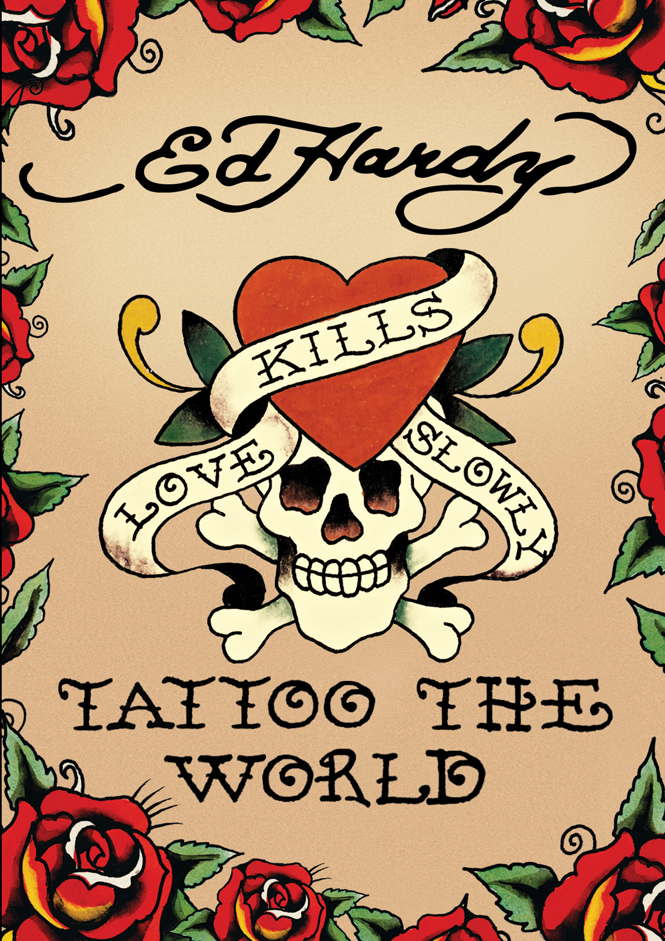

ED HARDY: TATTOO THE WORLD:
AN INTIMATE GLIMPSE INTO THE LIFE OF A CULTURAL PHENOMENON

Available September 20 on VOD, Digital and DVD

JUNE 29, 2011 – In 1955, most 10-year-old boys dreamed of growing up to be a fireman or jet pilot. Young Don “Ed” Hardy had the wild idea of being a tattoo artist. Now in his 60s, Hardy’s iconic images do, indeed, cover the world. His designs have also caught the eye of celebrities including Madonna, Britney Spears and Kanye West. ED HARDY: TATTOO THE WORLD, releasing on September 20 on VOD, digital platforms, and DVD, highlights an artist’s journey and the evolution of his vibrant personal art.

From award-winning filmmaker Emiko Omori (Rabbit in the Moon), this feature documentary is a retrospective of the man behind the $500-million-a-year merchandise empire. It spans Hardy’s beatnik days as an art student in San Francisco, years of tattooing in military ports, tattooing in Japan, and on to his return to an artist’s life in Hawaii and San Francisco. It is an empire built out of his passion.

Through extended interviews with Hardy himself and a treasure trove of archival photos, the early days of back-alley tattoos – and the sailors and carnies who were the nascent art form’s primary aficionados – come to life. Hardy shares his vast knowledge of art history and his influences, from hot rod cars cruising through his hometown of Newport Beach, CA, to famous tattooists such as Sailor Jerry Collins and Phil Sparrow, icons of the tattoo world who introduced him to the business.

At 10 years old, Hardy began to draw fake tattoos on his friends using eyeliner and colored pencils. He then became obsessed with surfing and cultural expressions deeply rooted in Hispanic and Asian culture. These early years played an important role in shaping his artistic style while paving the way towards a career as a tattooist.

At the age of 18, Hardy was accepted to the San Francisco Art Institute and took classes with Gordon Cook, whom he reveres to this day. While at school, he focused on lithography and etching. After graduation, Hardy turned down a scholarship to Yale to pursue his childhood obsession – tattoos.

“It erases to me barriers of time, culture, ethnicity, but the reality is, it just brings art into people’s lives,” Hardy said about tattoos.

In 1973, Hardy traveled to Japan to work with Japanese classical tattoo master, Horihide. Hardy was the first Westerner to work in the highly secretive world of Japanese tattooing. Later that year he returned to California and, in 1974, opened Realistic Tattoo Shop in San Francisco – the first “private” tattoo studio in the U.S. – and began to draw full-body Japanese-style tattoos by appointment only.

Before TATTOO THE WORLD, Omori made Tattoo City, a documentary focused on Hardy’s first San Francisco walk-in parlor, which burned down in 1978. She and Hardy enjoyed talking about moving images then and, after researching and meeting people with large tattoos, she became fascinated with this art form. After her first tattoo from Hardy, she insisted that she would not get another, but Hardy assured her that she would be back. She returned after a few years, this time with a movie camera to capture the living art form of tattoos by filming Hardy’s body art on live models. This deeper involvement with the art led Omori to commission a full back tattoo for herself.

In 1987, Hardy first published an influential magazine called Tattootime that featured “New Tribalism,” which triggered a global tattoo craze inspired by the virtually vanished body art of pre-technological societies. Along with his tattoo work, Hardy’s subsequent writing, publishing, and exhibitions ignited the incredible global resurgence of tattooing from the late 1980s to the present day. His designs eventually caught the eye of the fashion world, and, in 2005, the first Ed Hardy store opened in Los Angeles. In 2009, 70 Ed Hardy stores opened worldwide, generating global sales of $700 million. From clothes to mugs to fragrances, Hardy has taken tattoo imagery from the shadowy fringes into the bright lights of pop culture.

ED HARDY: TATTOO THE WORLD is directed and edited by Emiko Omori and produced by Wendy Slick and Omori. The DVD includes a temporary tattoo of Hardy’s design and over an hour of bonus features, including deleted scenes.

Pricing: $24.95US
Runtime: 75 mins., plus extras
Rating: NR
Catalog #: NNVG249370
Language: English
Color: Color
Audio Format: Dolby Digital 2.0 Stereo
Genre: Documentary

About Docurama Films
In 1999, NEW VIDEO launched Docurama Films® with the first feature documentary available on DVD: D.A. Pennebaker’s Bob Dylan: Dont Look Back. Twelve years and 250 award-winning, highly-acclaimed documentary titles later, Docurama continues to discover and release the greatest non-fiction films of our time while spreading the word about filmmakers who are taking the form to new heights. Docurama’s catalog features an array of topics including the performing and visual arts, history, politics, the environment, ethnic and gender interests, and all-time favorites including The Wild Parrots of Telegraph Hill, Andy Goldsworthy: Rivers and Tides and King Corn. Recent releases include The End of the Line, Best Worst Movie, the 2011 Oscar®-nominated film, Gasland, and the first-ever Blu-ray release of Dont Look Back.
www.docuramafilms.com

About New Video
Celebrating its 20th anniversary in 2011, New Video is a leading entertainment distributor and the largest aggregator of independent digital content worldwide. Headquartered in New York City, with an international presence in 45 territories, the company delivers feature films, TV programs and web originals via digital download, streaming media, video-on-demand, Blu-ray and DVD, and theatrical release. New Video streamlines the distribution and marketing process for filmmakers, producers and brand partners to bring a wide variety of fresh content to new audiences. The company’s library includes original TV series and movies from A+E® Home Entertainment, HISTORY™, and Lifetime®, unforgettable games and trophy sets from Major League Baseball®, storybook treasures from Scholastic®, award-winning documentaries from Docurama Films®, Arthouse Films, and Plexifilm, next-gen indies and web hits from Flatiron Film Company®, the best in Chinese cinema from China Lion, and festival picks from Tribeca Film. New Video is proud to distribute the 2011 Oscar®-nominated films Gasland, Waste Land and, on digital, Restrepo.
www.newvideo.com

For more information, please contact:
Luis Garza
646-259-4144
lgarza@newvideo.com

For box art, please visit:
http://www.newvideo.com/docurama/XXXX

Or visit the Press Room at:
http://www.newvideo.com/pressroom/

