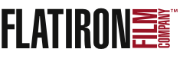
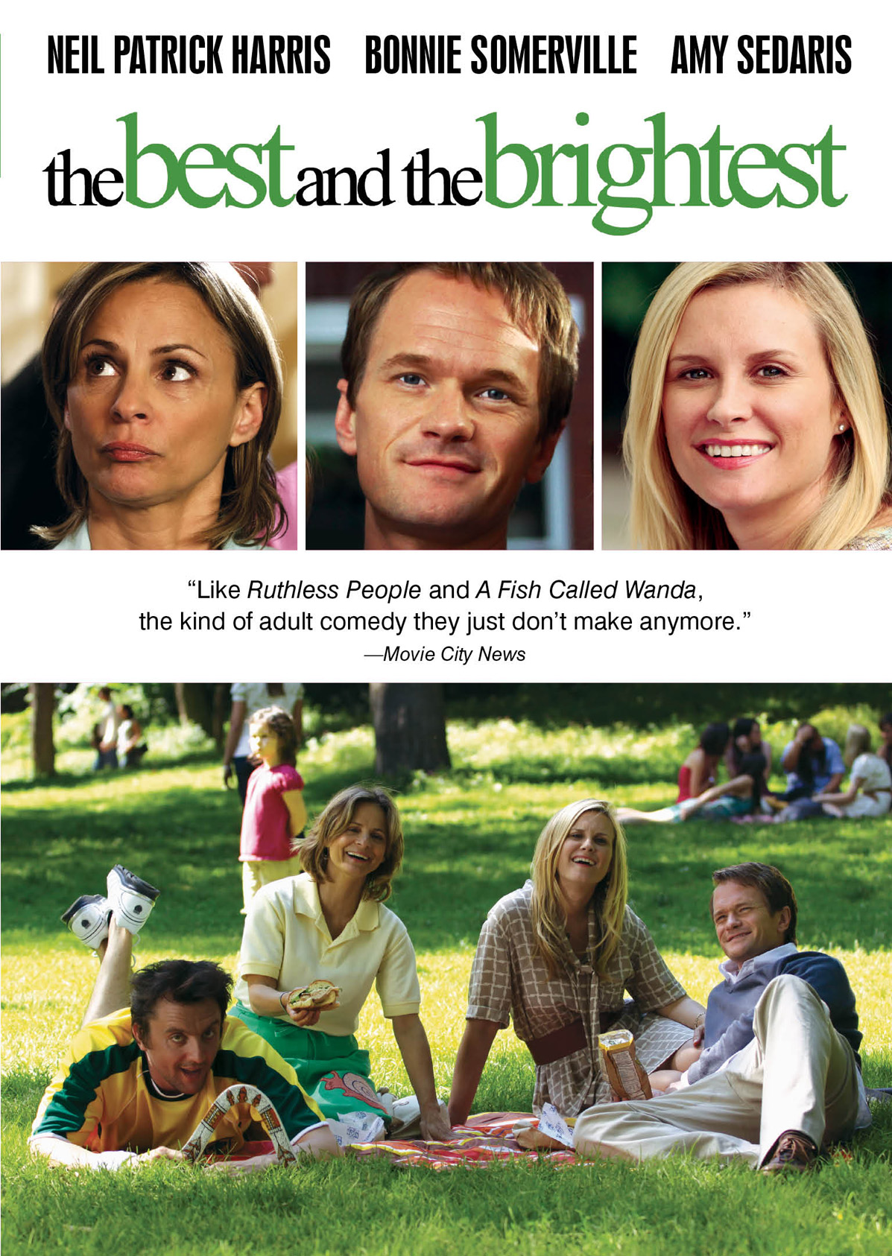
“THE BEST AND THE BRIGHTEST,” STARRING NEIL PATRICK HARRIS AND AMY SEDARIS, HITS VOD, DIGITAL & DVD ON AUGUST 16
All-Star Comedy Cast Also Includes Bonnie Somerville, Christopher McDonald, John Hodgman,
Peter Serafinowicz and Kate Mulgrew

New York, NY – June 28, 2011 – Following sold-out grassroots screenings and a theatrical release in June 2011, THE BEST AND THE BRIGHTEST, a new comedy directed by Josh Shelov, makes its way to VOD, digital platforms and DVD on August 16.
Featuring an all-star cast including Neil Patrick Harris (How I Met Your Mother), Bonnie Somerville (The Ugly Truth), Amy Sedaris (Strangers with Candy), Christopher McDonald (Harry’s Law), Kate Mulgrew (Star Trek: Voyager), John Hodgman (The Daily Show with Jon Stewart), Peter Serafinowicz (Couples Retreat), Jenna Stern (Game Change) and Bridget Regan (Legend of the Seeker), THE BEST AND THE BRIGHTEST offers a refreshingly “adult” twist on contemporary parenting.
Compared by Movie City News to A Fish Called Wanda and Ruthless People, THE BEST AND THE BRIGHTEST is a modern-day farce set in the world of New York City’s elite private schools. The Jasinskis (Harris, Somerville) are a middle-class couple from Delaware who move to New York City with their five-year-old daughter for a last chance at “the big time.” Upon arrival, they experience a big problem: they can't get their daughter into a single private kindergarten. The couple desperately turns to kindergarten consultant, Sue Lemon (Sedaris), who recommends Jeff pose as a high-profile poet to gain kudos from the VIPs (Hodgman, McDonald and Mulgrew) who are deciding between two child candidates for the last coveted slot at Coventry Day School.

An innocent ploy quickly turns into sexual blackmail and creative persuasion as the Jasinskis battle to enroll their child. The film also stars Nina Lisandrello (The Bleeding House), and Emily Tremaine (Collar).

"Easily the funniest movie I've seen in years." —The New Haven Register
THE BEST AND THE BRIGHTEST premiered at the 2010 Philadelphia International Film Festival and was shown in more than 200 movie theaters across the country in “sneak peek” screenings, prior to its theatrical premiere in June 2011 in New York and Los Angeles.

The Best and the Brightest is directed and co-written by Shelov and produced by Robert and Patricia Weiser (High Treason Pictures), Nicholas Simon, and Declan Baldwin (Big Indie Pictures). Richard Schiffrin (Wellfleet Phantasy Productions) is the executive producer.
“A masterful farce.”—The Jewish Exponent
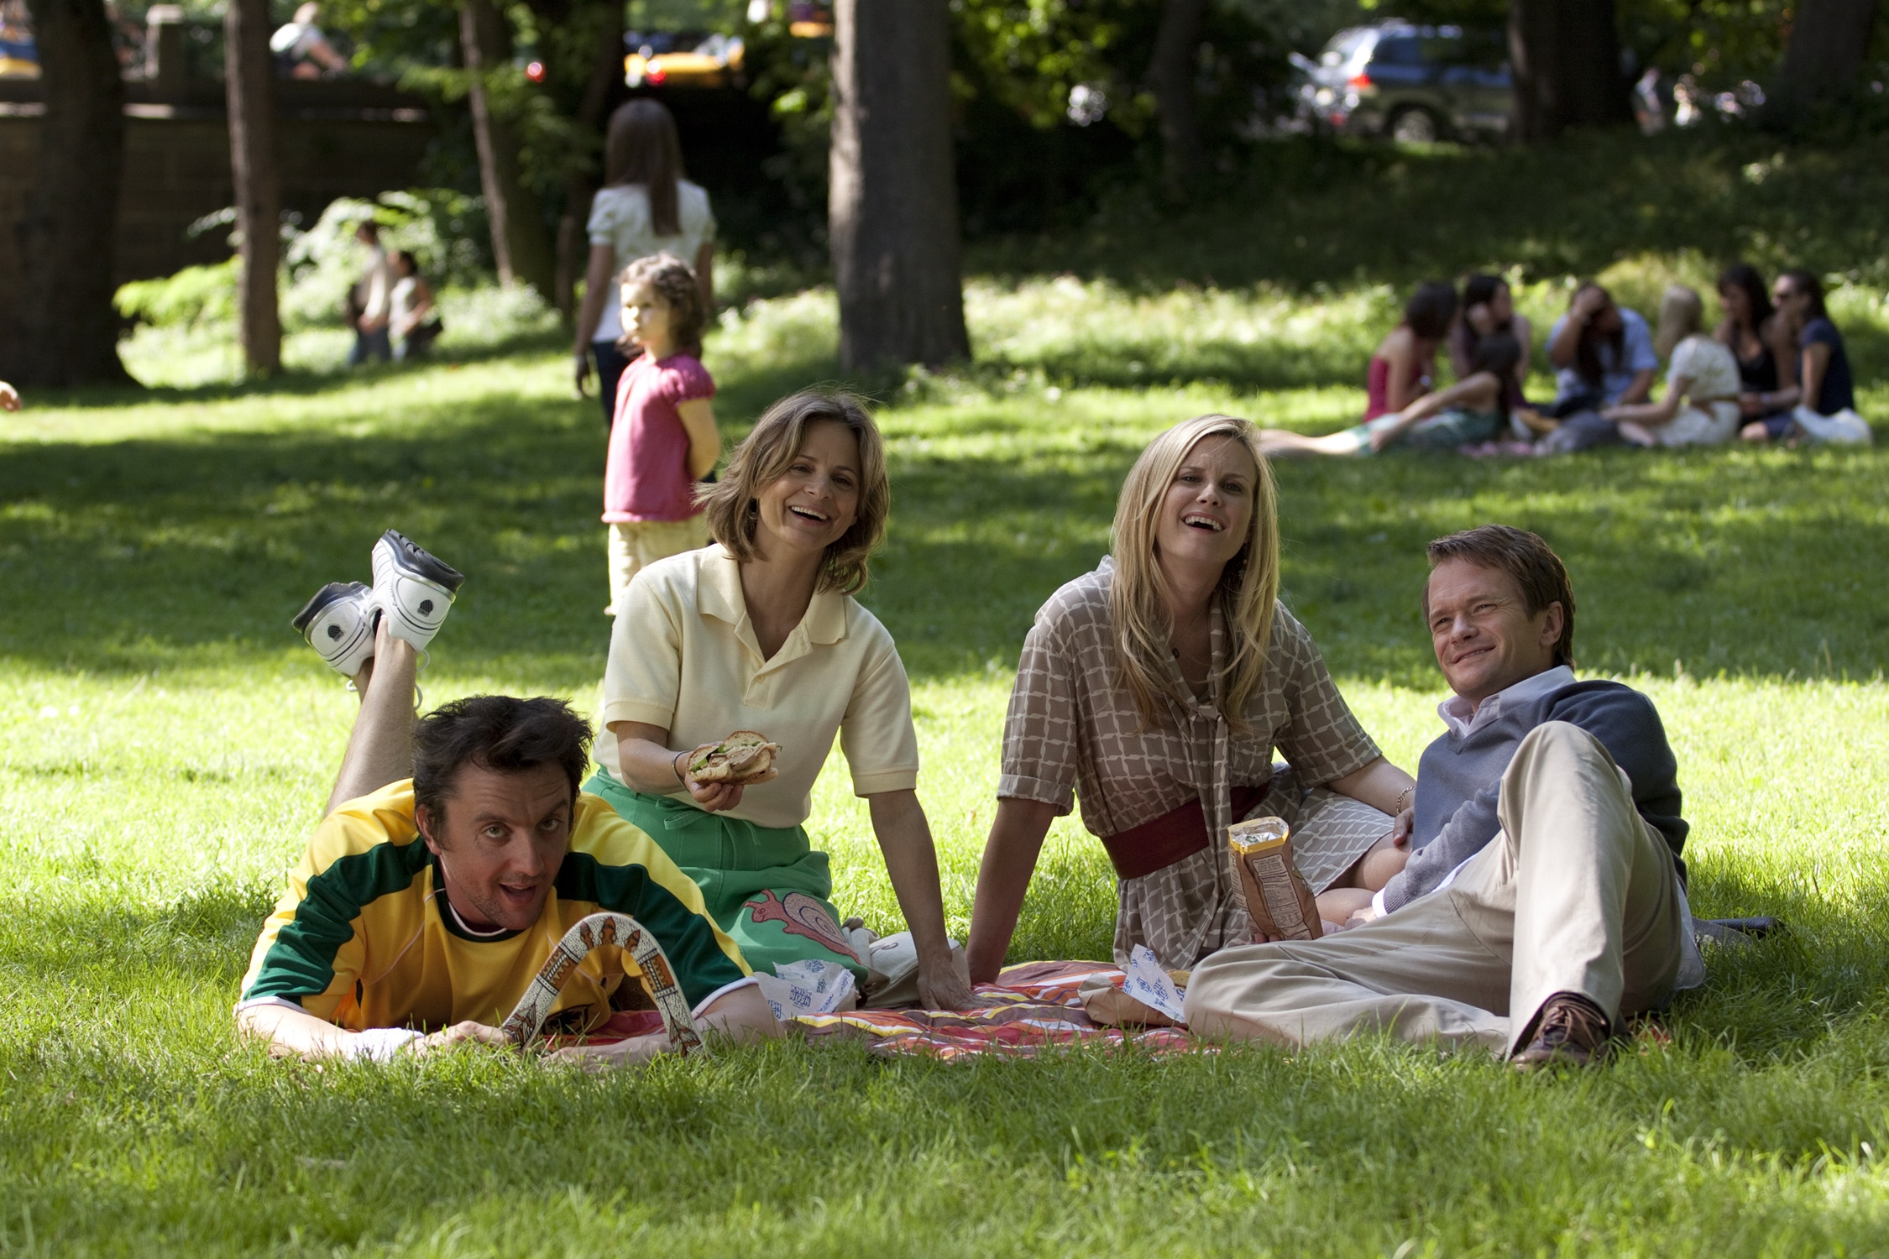
THE BEST AND THE BRIGHTEST
$26.95 US / $29.95 CAN
93 mins. + extras
Catalogue: NNVG249351
Extras include: Cast interviews with Neil Patrick Harris, Amy Sedaris, and Christopher McDonald, among others; audition footage; deleted scenes.
For box art and title information, please visit:
http://www.newvideo.com/flatiron-film-company/the-best-and-the-brightest/

For more press information, please contact:
Sommer Hixson, Media Relations
shixson@newvideo.com; 646-259-4138

