FOR IMMEDIATE RELEASE


Presents



“JEWS AND BASEBALL: AN AMERICAN LOVE STORY”
AVAILABLE APRIL 19 ON DVD AND DIGITAL

New Documentary Features Rare Sandy Koufax Interview, with
Recollections from Ron Howard, Larry King, Bob Feller,
Bud Selig, Marvin Miller, Al Rosen, and Hank Greenberg

Narrated by Dustin Hoffman

March 4, 2011, New York, NY – Baseball is seen as the quintessentially American sport with good reason. Emerging by the mid-19th century as the nation's most popular game, baseball provided each new wave of immigrants with an avenue into American culture. JEWS AND BASEBALL: AN AMERICAN LOVE STORY, tracing the impact of Jewish players on America’s national pastime and the game’s impact on them, debuts on DVD and digital platforms on April 19, on the heels of a successful festival and theatrical run encompassing more than 100 screenings, and its public television premiere in March.

From the first – Lipman Pike – and on through Moe Berg, Hank Greenberg, Al Rosen, Sandy Koufax, Shawn Green and Kevin Youkilis, JEWS AND BASEBALL records the contributions of Jewish players and the recollections of Jewish fans, spanning the history of the game. Major League Baseball has had top-tier Jewish players almost uninterrupted from its very beginning and, through vintage newsreels and new and archival interviews, the story is woven together by Academy Award winner, Dustin Hoffman, as narrator.

A highlight of JEWS AND BASEBALL is a rare interview with Hall of Fame pitcher Sandy Koufax, who shares stories from his remarkable career, including missing a World Series game for a Jewish holiday and pitching a perfect game – one of his four no-hitters. Director Ron Howard, a young Dodger fan when Koufax pitched, talks about rooting for Sandy as a youngster, and about his shock and embarrassment when he discovered that he was making more money as “Opie” on the Andy Griffith Show than Koufax was pitching for the Dodgers.

The film also includes recollections from Hank Greenberg (archival), Greenberg’s son Steve, Al Rosen, Larry King, author Roger Kahn, Commissioner Bud Selig, Players Association’s Marvin Miller, former Montreal Expos owner Charles Bronfman, the Mets’ Fred Wilpon, players Yogi Berra, Bob Feller, Norm Sherry, Ron Blomberg, Shawn Green, Kevin Youkilis, and a delightful opening scene in which actor Dennis Leary, as a guest in the Red Sox broadcast booth, discovers that Youkilis is Jewish.

Among the discoveries for viewers at home: the co-author of “Take Me Out to the Ballgame” was Jewish; Washington’s Buddy Myer was a Jewish batting champion, and the New York Giants were frequented by Jewish talent (including Andy Cohen, Sid Gordon, Harry Danning and Phil Weintraub).

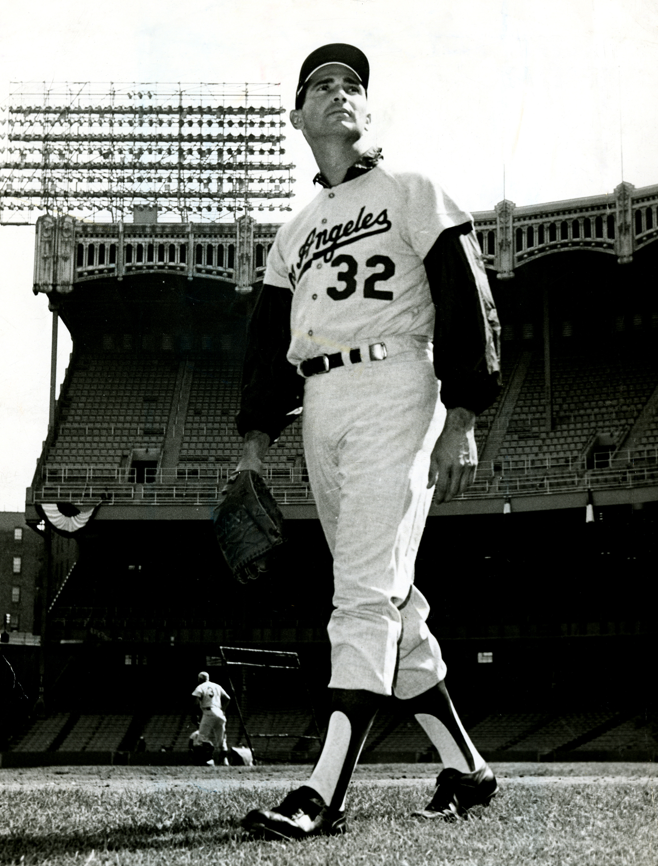
JEWS AND BASEBALL is directed by Peter Miller, and produced by Miller and Will Hechter. Pulitzer Prize-winner Ira Berkow wrote the script. Amy Linton edits. DVD extras included deleted scenes, newsreels from the 1963 and 1965 World Series, jazz artist Sophie Milman performing “Take Me Out to the Ballgame.”

Pricing: $29.95 US/$34.95 CAN
Runtime: 91 minutes, plus extras
Rating: NR
Catalog #: NNVG243250
Language: English
Color: Color, Black & White
Audio Format: Dolby Digital 2.0 Stereo
Genre: Documentary

About Docurama Films
Docurama Films is dedicated to making critically acclaimed and cutting-edge documentaries available digitally and on home video. In 1999, New Video launched Docurama Films with the release of the first feature documentary on DVD, D.A. Pennebaker’s Bob Dylan: Don’t Look Back. More than a decade later and a library of more than 250 award-winning, highly acclaimed documentary titles, Docurama continues its mission to unearth and release the great classic documentaries of the last fifty years while spreading the word about filmmakers who are taking the form to new heights. The Docurama catalog features a roster of titles from genres including the arts, history, politics, environmental, ethnic interest, LGBT, music, and socio-cultural, as well as theatrical fan-favorites like The Wild Parrots of Telegraph Hill and Andy Goldsworthy: Rivers and Tides. Recent releases include Gasland, The Age of Stupid and Best Worst Movie. www.docuramafilms.com

About New Video
New Video is a leading independent privately-held distributor of quality entertainment via DVD, Blu-ray, download and streaming platforms, and cable VOD. We are the proud home to some of the most prestigious names in the industry like A&E®, HISTORY™, Lifetime®, Major League Baseball®, Scholastic Storybook Treasures™, Arthouse Films and Tribeca Film as well as our own lines Docurama Films®, and the newly launched Flatiron Film Company®. Since 1991, our mission has been to discover first-rate content and deliver to audiences through traditional platforms and evolving new media. We selectively handpick our library while collaborating directly with our brand partners and filmmakers to cultivate a superior product and fresh new viewing experiences for our audiences. We are headquartered in New York City, but have an international presence in 45 territories. www.newvideo.com.

For more information, please contact:
Sommer Hixson
646-259-4138
shixson@newvideo.com

For box art and press materials:
http://www.newvideo.com/docurama/jews-and-baseball/

