FOR IMMEDIATE RELEASE
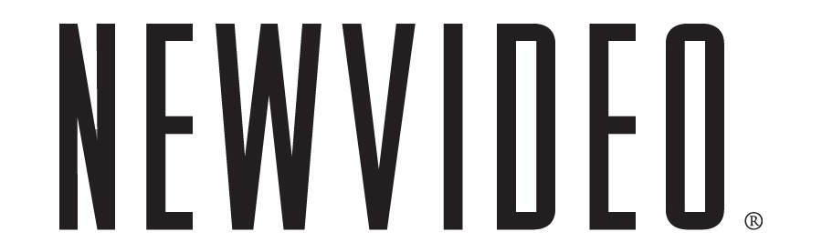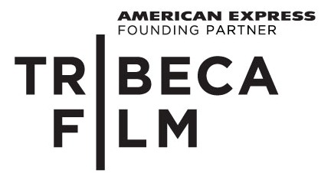

THE WILD AND WONDERFUL WHITES OF WEST VIRGINIA BLASTS ONTO DVD
OCTOBER 26 FROM TRIBECA FILM AND NEW VIDEO
***
No-Holds-Barred Documentary from Jackass Producers Features Cult Hero of Dancing Outlaw
***
“Add this remarkable movie to your must-see list” –Variety’s SoundCheck
NEW YORK, September 7, 2010 – Shoot-outs, robberies, gas-huffing, drug dealing, pill popping, and tap dancing — what do these all have in common? The White Family. A documentary portrait like no other, The Wild and Wonderful Whites of West Virginia is blazing a trail to DVD on October 26 from Tribeca Film and distributed by New Video.
From executive producers Johnny Knoxville and Jeff Tremaine (Jackass) comes a shocking, up-close look at Boone County, West Virginia’s most notorious and surly family. Director Julien Nitzberg spends a year with multiple generations of the White family in this outlandish story, which features the family’s high-stepping muse, Jesco White (star of the cult classic documentary Dancing Outlaw). The film also features Hank Williams III.
“Move over Osbournes, hit the road Kardashians,” the Los Angeles Times raves. “There’s a new dysfunctional family in town.” Director Julien Nitzberg “nailed it as few filmmakers do,” proclaims Boing-Boing.com. “Whites is an unlikely masterpiece.” The Louisville Courier-Journal says, “It’s impossible not to be entertained by these charismatic lunatics.”
The single disc comes packed with hours of no-holds-barred bonus features, including making-ofs, interviews with director Julien Nitzberg and producer Johnny Knoxville and behind-the-scenes featurettes.
The release of The Wild and Wonderful Whites of West Virginia is among the first of 10 Tribeca Film titles scheduled to be distributed by New Video in 2010 and 2011. Tribeca Film is a distribution platform acquiring and releasing films year-round and is supported by Founding Partner American Express. The films range from award-winning dramas and revealing documentaries to uproarious comedies and stunning animated features, many of which premiered at the 2010 Tribeca Film Festival prior to theatrical runs in New York and Los Angeles. The films from the Tribeca Film slate were also available on video on demand in 40 million U.S. homes simultaneously with their Festival screenings through relationships with leading telecom, cable and satellite providers.
New Video plans to release one to two titles per month leading up to the 2011 Tribeca Film Festival.
Special Features
- My Tribeca Story
- Interview with the “Wild and Wonderful Whites” production team
- More of the Whites
  - Do the White Thing: The Making of The Wild and Wonderful Whites of West Virginia
  - Lost Jesco Tapes
  - Interview with Hank Williams III
  - Sociological Strip Mining Convo – Attempt 1
  - Sociological Strip Mining Convo – Attempt 2
  - County Jail Rap and Tap
  - God and the Devil
  - Don’t Mess with Annie Mae
  - Les is More & Les on the Lam
  - Ponty’s Camper Meets Jesco
  - A Gift for Bertie Mae
  - Tattoo Me
  - The Awesomeness that is Derkie
  - Now You Gonna Die, Fool
  - Mamie’s Missing Moonshine

THE WILD AND WONDERFUL WHITES OF WEST VIRGINIA

Street Date: October 26, 2010
Pricing: $24.95 U.S. (DVD)
Runtime: 88 minutes, plus bonus features
Rating: N/A
Catalog #: NNVG231520
Language: English
Color: Color
Audio Format: Stereo
Genre: Documentary
Distributor: Tribeca Film/New Video

About Tribeca Film
Tribeca Film is a comprehensive distribution platform dedicated to acquiring and marketing independent films across multiple platforms, including video-on-demand, theatrical and home video. It is an initiative from Tribeca Enterprises designed to provide new platforms for how film can be experienced, while supporting filmmakers and introducing audiences to films they might not otherwise see. American Express continues its support of Tribeca and the independent film community by serving as the Founding Partner of Tribeca Film.

About New Video®
New Video is a leading independent privately-held distributor bringing you quality entertainment via DVD, Blu-ray, download and streaming platforms and cable VOD. We are the proud home to some of the most prestigious names in the industry like A&E®, HISTORY™, Lifetime®, Major League Baseball®, Scholastic Storybook Treasures™, Arthouse Films and Tribeca Film as well as our own lines Docurama Films®, and the newly launched Flatiron Film Company®. Since 1991, our mission has been to unearth first-rate content and deliver them to audiences through traditional platforms and evolving new media. We selectively handpick our library while collaborating directly with our brand partners and filmmakers to cultivate a superior product and fresh new viewing experiences for our audiences. We are headquartered in New York City, but have an international presence in 45 territories.

Press Contacts:

Dade Hayes, Rubenstein Communications

212-843-8022 /dhayes@rubenstein.com

Tammie Rosen, Tribeca Enterprises

212-941-2003/trosen@tribecaenterprises.com

Sommer Hixson, New Video
646-259-4138/ shixson@newvideo.com
# # #

