FOR IMMEDIATE RELEASE


presents

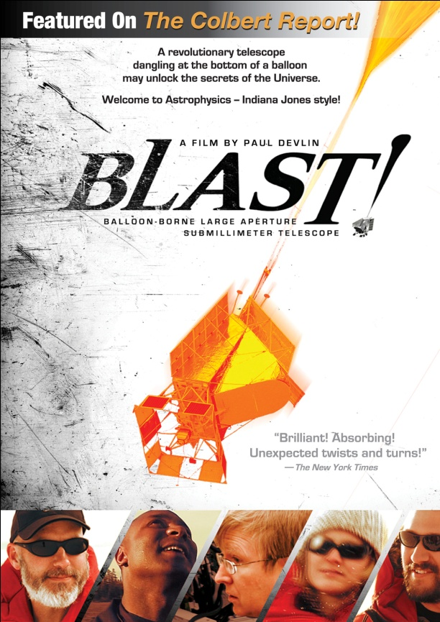

DISCOVER THE SURPRISING WORLD OF ADVENTURE SCIENCE IN BLAST!,
AVAILABLE JUNE 28 ON DIGITAL AND DVD

A spectacular and suspenseful story of space exploration,
BLAST! is astrophysics Indiana Jones-style

May 6, 2011 – To many, the Universe is an enigma that cannot possibly be understood. That has not stopped countless researchers from striving to comprehend bits and pieces, one measurement at a time. How did the universe evolve from smooth gas at its beginnings to an ordered structure made up of billions of galaxies, planets and stars? How did we get here? These and other questions are explored in BLAST!
Five-time Emmy® winner Paul Devlin directed this feature-length science adventure story, which follows his brother, astrophysicist Mark Devlin, and his team from Arctic Sweden to Antarctica as they attempt to launch a revolutionary telescope beneath a NASA high-altitude balloon. In the history of space exploration, this is the first time a telescope has been specifically designed to look back in time to observe the birth and evolution of stars, as well as a hidden universe of never-before-seen galaxies.
“Astrophysicists have an opportunity to revolutionize what our culture thinks of our place in the universe,” said Mark Devlin.
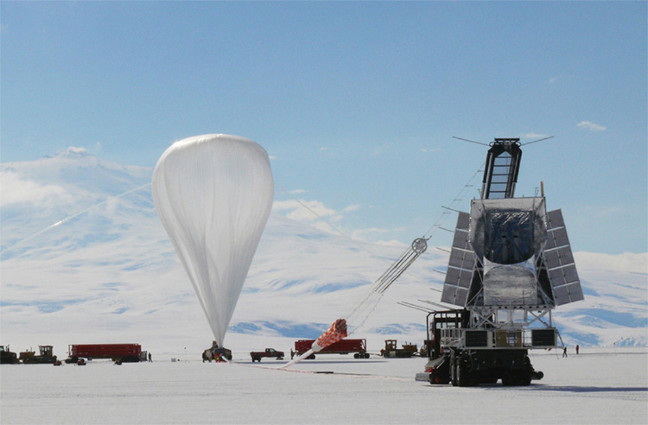
The Balloon-borne Large Aperture Sub-millimeter Telescope – BLAST – is launched underneath a specialized NASA helium balloon that inflates to the size of a football stadium as it reaches the top of the atmosphere. BLAST floats with the wind while the sophisticated detectors map the sky for 10-12 days. Then BLAST is dropped 35 kilometers by parachute, with the hope that the scientists can execute a difficult recovery in extremely remote locations to find the hard drives and their precious data intact.
BLAST! follows the action as it happens across five continents, all the way to Antarctica, revealing the struggles and mishaps the team endure. With unprecedented access through his brother, Paul boldly breaks with the conventions of science content, focusing on the humanity of scientists. We experience first-hand the hardships that ambitious scientific research places on the families of scientists, as Mark spends many months away from his wife and children. The philosophical implications of such research are explored by Mark, an agnostic, and his colleague Barth Netterfield, a born-again Christian.
From catastrophic failure to transcendent triumph, BLAST! exposes the surprising real life of scientists.
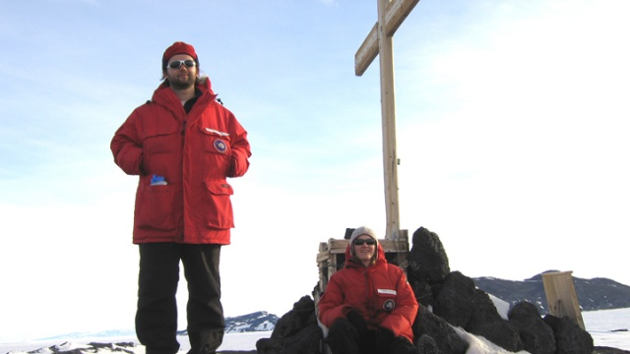

“This absorbing documentary leads to some unexpected twists and turns and comedic
hand-wringing,” said The New York Times.

BLAST! was an official selection at the Hot Docs, Sheffield, Florida, Hawaii, and Thessaloniki film festivals and is the winner of the best documentary award at Vedere La Scienza Festival in Milan. BLAST! has broadcast extensively in international territories, including a global broadcast on BBC World News reaching up to 120 countries. In the U.S., BLAST! has broadcast on PBS and has been featured on NPR’s Science Friday and in an interview by Stephen Colbert with Mark Devlin on The Colbert Report.
The scientific results from BLAST made headlines when they were published in Nature, which declared that BLAST had discovered “a hidden Universe of star-burst galaxies.” BLAST - the experiment and the movie – is the cover story of the June 2011 issue of Sky and Telescope, one of the most popular science magazines.
"This adventuresome spin on breakthrough science should wow 'em!" - Variety

BLAST! is directed by Paul Devlin; produced by Devlin, Claire Missanelli and Louise Rosen; edited by Devlin and Laura Minnear. The DVD features additional scenes including “Werner Herzog visits BLAST”; and theatrical trailers.

Pricing: $29.95 US
Runtime: 74 mins., plus extras
Rating: NR
Catalog #: NNVG247881
Language: English
Color: Color
Audio Format: Dolby Digital 2.0 Stereo
Genre: Documentary
About Docurama Films
In 1999, NEW VIDEO launched Docurama Films® with the first feature documentary available on DVD: D.A. Pennebaker’s Bob Dylan: Dont Look Back. Twelve years and 250 award-winning, highly-acclaimed documentary titles later, Docurama continues to discover and release the greatest non-fiction films of our time while spreading the word about filmmakers who are taking the form to new heights. Docurama’s catalog features an array of topics including the performing and visual arts, history, politics, the environment, ethnic and gender interests, and all-time favorites including The Wild Parrots of Telegraph Hill, Andy Goldsworthy: Rivers and Tides and King Corn. Recent releases include The End of the Line, Best Worst Movie, the 2011 Oscar®-nominated film, Gasland, and the first-ever Blu-ray release of Dont Look Back.
www.docuramafilms.com

About New Video
Celebrating its 20th anniversary in 2011, New Video is a leading entertainment distributor and the largest aggregator of independent digital content worldwide. Headquartered in New York City, with an international presence in 45 territories, the company delivers feature films, TV programs and web originals via digital download, streaming media, video-on-demand, Blu-ray and DVD. New Video streamlines the distribution and marketing process for filmmakers, producers and brand partners to bring a wide variety of fresh content to new audiences. The company’s library includes original TV series and movies from A&E®, HISTORY™, and Lifetime®, unforgettable games and trophy sets from Major League Baseball®, storybook treasures from Scholastic®, award-winning documentaries from Docurama Films®, Arthouse Films, and Plexifilm, next-gen indies and web hits from Flatiron Film Company® and festival picks from Tribeca Film. New Video is proud to distribute the 2011 Oscar®-nominated films Gasland, Waste Land and, on digital, Restrepo.
www.newvideo.com.

For more information, please contact:
Sommer Hixson
646-259-4138
shixson@newvideo.com

For box art, please visit:
http://www.newvideo.com/docurama/blast/

Or visit the Press Room at:
http://www.newvideo.com/pressroom/

